Supporting Information
Structural, medicinal, and toxicological study of Cephalosporin degradation products: A DFT and in-silico approach

Al-Masum Hossain ^{1, 2, #}, Kazi MD Sakib Hassan ^{1, 2, #}, Pritu Dey ^{1, 3, #}, Farhana Mansoor Priya ^{1, 4}, Md. Mahmudul Hasan ^{1, 5}, Md. Liton Hossain ^{1, 5}, Monir Uzzaman ^{1, 5, 6, ✉}

¹ Department of Drug Design, Computer in Chemistry and Medicine Laboratory, Dhaka, Bangladesh
² Faculty of Science, Department of Pharmacy, Comilla University, Cumilla, 3500, Bangladesh
³ Faculty of Science, Department of Applied Chemistry and Chemical Engineering, University of Chittagong, Chittagong, 4331, Bangladesh
⁴ Faculty of Biological Science, Department of Microbiology, Noakhali Science and Technology University, Noakhali, 3814, Bangladesh
⁵ Faculty of Science, Department of Chemistry, University of Chittagong, Chittagong, 4331, Bangladesh
⁶ Department of Applied Chemistry, Graduate School of Engineering, Mie University, Tsu, Mie 514-8507, Japan
# These authors contributed equally to this work
✉ Corresponding author: monircu92@gmail.com

Table of Contents
Name | Page
1. Degradation pathway of CPS. | 2
2. Chemical Structure and IUPAC name of CPS and it’s degradants. | 3-4
3. Some selected FT-IR frequencies of CPS and it’s degradants. | 4-6
4. Electronic absorption of CPS and its degradants. Calculated at TD-DFT/6-311g+ (d, p) level of theory. | 6-7
5. Interactions of CPS and it’s degradants with the receptor protein (3A3F). | 7-8
6. 3D optimized structures of CPS and it’s degradants. | 9
7. HOMO-LUMO of CPS and it’s degradants. | 10-12
8. Molecular electrostatic potential map of CPS and it’s selected degradants. | 12
9. FT-IR Spectra and UV–Visible spectra of CPS and it’s degradants. | 13
10. Nonbonding interactions and hydrogen bond surface area of some of the CPS degradants with the receptor protein 3A3F. | 13-15
11. Supplementary reference | 15

Fig. S1 Degradation pathway of CPS.

Table S1 Chemical Structure of CPS and its degradants.
Name | Structure | IUPAC Name
CPS |  | (6S,7S)-7-acetamido-3-ethyl-8-oxo-5-thia-1-azabicyclo [4.2.0] oct-2-ene-2-carboxylic acid
C1 |  | N-(2-acetyl-3-ethyl-8-oxo-5-thia-1-azabicyclo [4.2.0] oct-2-en-7-yl) acetamide
C2 |  | 7-acetamido-3-ethyl-8-oxo-5-thia-1-azabicyclo [4.2.0] oct-2-ene-2-carboxamide
C3 |  | methyl 7-acetamido-3-(hydroxymethyl)-8-oxo-5-thia-1-azabicyclo [4.2.0] oct-2-ene-2-carboxylate
C4 |  | trifluoromethyl 7-acetamido-3-ethyl-8-oxo-5-thia-1-azabicyclo [4.2.0] oct-2-ene-2-carboxylate
C5 |  | 7-acetamido-3-(acetoxymethyl)-8-oxo-5-thia-1-azabicyclo [4.2.0] oct-2-ene-2-carboxylic acid
C6 |  | 7-acetamido-3-(aminomethyl)-8-oxo-5-thia-1-azabicyclo [4.2.0] oct-2-ene-2-carboxylic acid
C7 |  | 7-(2-aminoacetamido)-3-ethyl-8-oxo-5-thia-1-azabicyclo [4.2.0] oct-2-ene-2-carboxylic acid
C8 |  | 7-acetamido-3-((carbamoyloxy)methyl)-8-oxo-5-thia-1-azabicyclo [4.2.0] oct-2-ene-2-carboxylic acid
C9 |  | 7-amino-3-((carbamoyloxy)methyl)-8-oxo-5-thia-1-azabicyclo [4.2.0] oct-2-ene-2-carboxylic acid
C10 |  | 7-acetamido-3-(hydroxymethyl)-8-oxo-5-thia-1-azabicyclo [4.2.0] oct-2-ene-2-carboxylic acid

Table S2 Some selected FT-IR frequencies of CPS and its degradants.
Name | Assignment | Scaled value [1]
CPS | vC-H  vC=O  vC=O^{R}  vC=O^{C}  vC-S  vN-H  vC=C | 2994  1693  1780  1728  731  3495  1605
C1 | vC-H  vC=O  vC=O^{R}  vC-S  vN-H  vC=C | 2994  1697  1771  809  3304  1583
C2 | vC-H  vC=O  vC=O^{R}  vC-N^{R}  vC-S  vN-H  vC=C | 2982  1696  1738  1314  807  3535  1588
C3 | vC-H  vC=O  vC=O^{R}  vC=O^{C}  vN-H  vC=C  vN-C  vN-C^{R}  vO-H  vC-C | 2972  1696  1785  1713  3452  1590  1289  1340  3701  931
C4 | vC-H  vC=O  vC=O^{R}  vC=O^{C}  vC-S  vN-H  vC=C  vC-O  vC-F  vN-C  vN-C^{R} | 3010  1695  1792  1772  697  3510  1584  1106  1171  1348  1069
C5 | vC-H  vC=O  vC=O^{R}  vC=O^{C}  vO-H^{C}  vC-S  vN-H  vC=C | 2977  1695  1801  1747  3565  710  3490  1608
C6 | vC-H  vC=O  vC=O^{R}  vC=O^{C}  vO-H^{C}  vC-S  vN-H  vC=C  vN-C  vN-C^{R} | 2997  1692  1787  1721  3619  736  3500  1603  1479  1361
C7 | vC-H  vC=O  vC=O^{R}  vC=O^{C}  vO-H^{C}  vC-S  vN-H  vC=C  vN-C | 3040  1687  1780  1728  3615  804  3481  1605  1184
C8 | vC-H  vC=O  vC=O^{R}  vC=O^{C}  vO-H^{C}  vC-S  vN-H  vC=C  vN-C  vN-C^{R} | 2968  1695  1784  1726  3616  805  3477  1606  1469  1361
C9 | vC-H  vC=O  vC=O^{R}  vC=O^{C}  vO-H^{C}  vC-S  vN-H  vC=C^{R}  vC-O  vN-C^{R} | 2968  1730  1778  1724  3616  744  3477  1604  1137  1265
C10 | vC-H  vC=O  vC=O^{R}  vC=O^{C}  vO-H^{C}  vC-S  vN-H  vC=C  vN-C  vN-C^{R} | 2874  1694  1783  1720  3618  802  3496  1606  1470  1081
^{C} Carboxylic Acid, ^{R} Ring, Scaling factor = 0.9613

Table S3 Electronic absorption of CPS and it’s degradants. Calculated at TD-DFT/6-311g+ (d, p) level of theory.
Name | Transition state | Wavelength (nm) | Excitation  energy (eV) | Configuration composition | Oscillator Strength
CPS | S₀→S₁ | 1381.47 | 0.89 | (0.70) H→L  (0.69) H-1→L | 0.0079
C1 | S₀→S₁ | 1857.04 | 0.67 | (0.70) H→L | 0.0036
C2 | S₀→S₁ | 1846.34 | 0.67 | (0.707) H→L  (0.69) H→L+1 | 0.0080
C3 | S₀→S₁ | 1530.30 | 0.81 | (0.70) H→L  (0.68) H→L+1 | 0.0068
C4 | S₀→S₁ | 1633.04 | 0.76 | (0.70) H→L  (0.69) H→L+1 | 0.0078
C5 | S₀→S₁ | 1370.20 | 0.90 | (0.70) H→L  (0.68) H→L+1 | 0.0049
C6 | S₀→S₁ | 1536.04 | 0.81 | (-0.13) H-1→L  (0.69) H→L | 0.0034
C7 | S₀→S₁ | 1612.40 | 0.77 | (0.70) H→L  (0.68) H→L+1 | 0.0051
C8 | S₀→S₁ | 1894.44 | 0.65 | (0.71) H→L  (0.69) H-1→L | 0.0029
C9 | S₀→S₁ | 1458.99 | 0.85 | (0.70) H→L  (0.68) H→L+1 | 0.0035
C10 | S₀→S₁ | 1408.50 | 0.88 | (0.70) H→L  (0.68) H→L+1 | 0.0050

Table S4 Interactions of CPS and it’s degradants with the receptor protein.
Name | Residue | Types | Distance (Å)
CPS | SER423  LYS309  SER310  GLY422  LYS309 | CHB  CHB  CHB  C  C | 2.21  2.54  1.83  2.76  2.72
C1 | ARG364  ARG364  LYS425  LEU424  PHE167  LEU362  ILE159  LEU362 | CHB  CHB  CHB  C  PS  A  A  A | 2.11  2.25  1.93  2.24  4.77  4.61  4.35  4.91
C2 | SER423  LYS309  SER310  THR421  SER423  LYS309 | CHB  CHB  CHB  CHB  C  C | 2.27  2.46  1.89  2.32  2.76  2.60
C3 | SER69  SER69  SER310  ARG405  ARG405  SER69  GLY422  SER423  LEU362 | CHB  CHB  CHB  CHB  CHB  C  C  C  A | 2.64  2.54  1.96  2.46  2.72  2.45  2.81  2.83  5.42
C4 | ILE159  ARG364  ARG364  ASP162  LEU362  LEU362  ILE159  ARG364  LEU362  LEU424  PHE167 | CHB  X (F)  CHB  CHB  X (F)  X (F)  X (F)  A  A  A  A | 2.42  2.58  1.99  3.39  3.45  2.96  3.84  5.04  4.61  5.14  5.30
C5 | GLY40  ASN42  ALA43  TYR59  ASN60  THR34  GLU39  THR34  GLN35 | CHB  CHB  CHB  CHB  CHB  C  C  C  C | 2.39  2.17  2.86  2.05  2.30  3.39  3.49  3.58  3.51
C6 | SER310  ASN312  SER423  SER423  SER310  SER310  THR421  GLY422 | CHB  CHB  CHB  CHB  C  C  C  C | 2.47  2.22  2.13  2.35  2.88  2.98  2.54  2.97
C7 | SER69  SER423  SER310  GLN313  PHE167  SER69  GLY422  SER310  LYS420  LYS72  LYS309  THR421  ASN312 | CHB  CHB  CHB  CHB  CHB  C  C  C  CHB  CHB  CHB  CHB  CHB | 1.84  2.07  2.04  2.61  2.44  2.75  2.50  3.00  2.71  3.01  2.15  1.59  2.13
C8 | SER69  SER310  ARG405  LYS72  LYS420  ARG462  THR401  THR421  GLY422 | CHB  C  CHB  CHB  CHB  CHB  CHB  C  C | 1.66  2.02  2.38  2.64  2.15  2.15  2.43  1.58  2.74
C9 | ASP153  THR256  GLN254  THR256  ASP257 | CHB  CHB  CHB  CHB  CHB | 2.19  2.07  2.35  2.65  2.40
C10 | SER69  SER310  LYS420  SER423  SER423  SER310  SER69  SER69  GLY422 | CHB  CHB  CHB  CHB  CHB  CHB  C  C  C | 2.57  1.86  2.84  1.99  2.03  2.11  2.81  2.76  2.55
^{C} Carbon Hydrogen Bond, ^{CHB} Conventional Hydrogen Bond, ^{A} Alkyl, ^{X} Halogen Bond, ^{PS} Pi-Sulfur

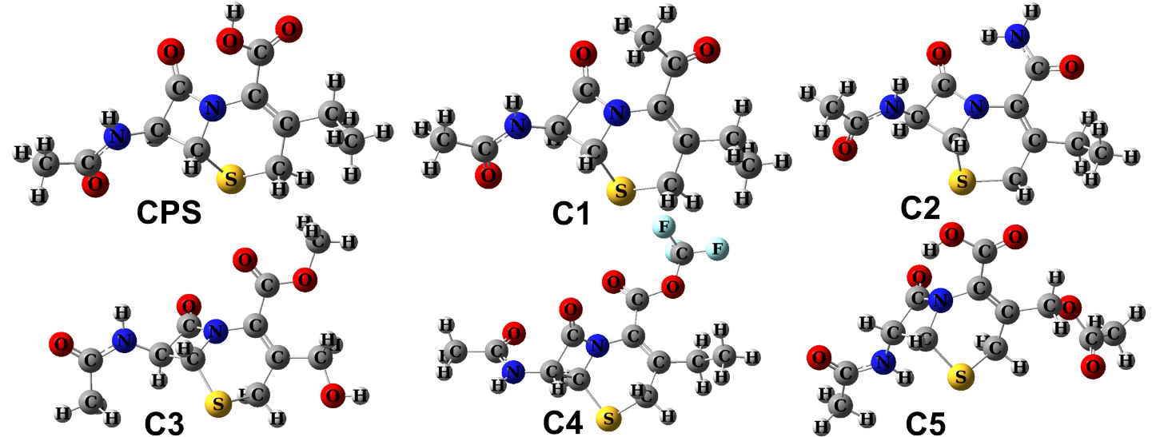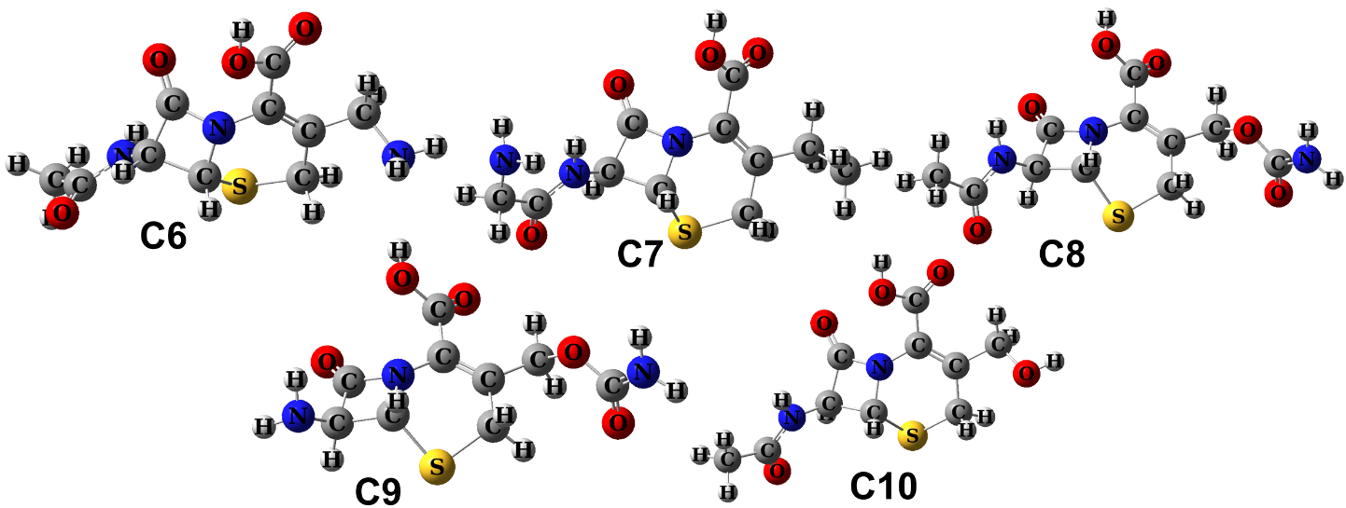
Fig. S2 3D optimized structures of CPS and it’s degradants obtained from DFT calculations.
Name | HOMO | LUMO
CPS | 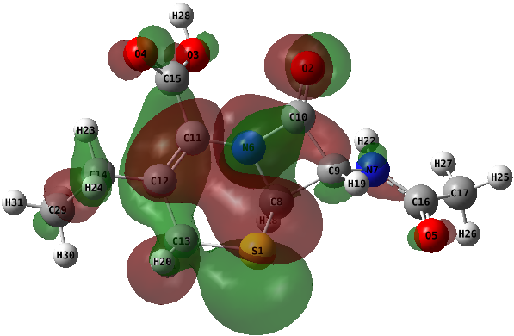 | 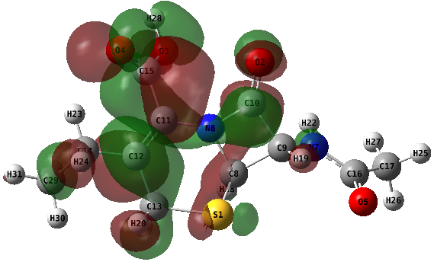
C1 | 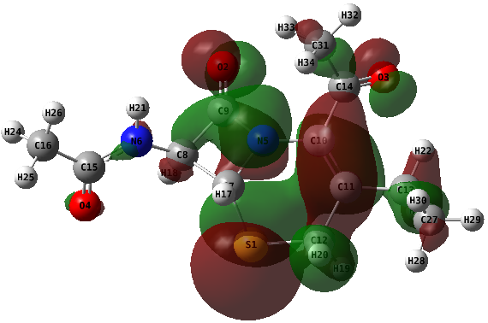 | 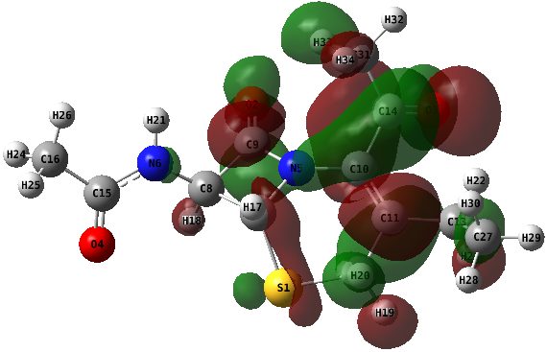
C2 | 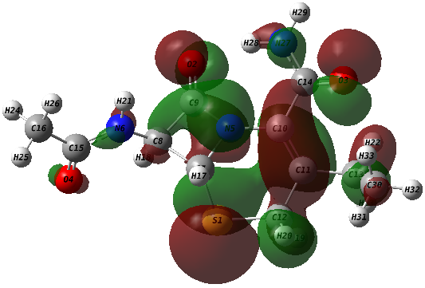 | 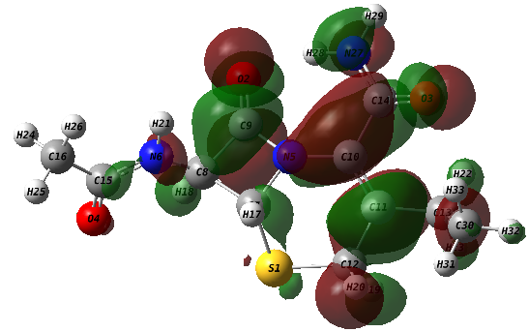
C3 | 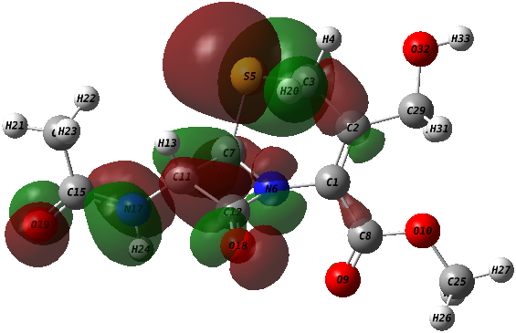 | 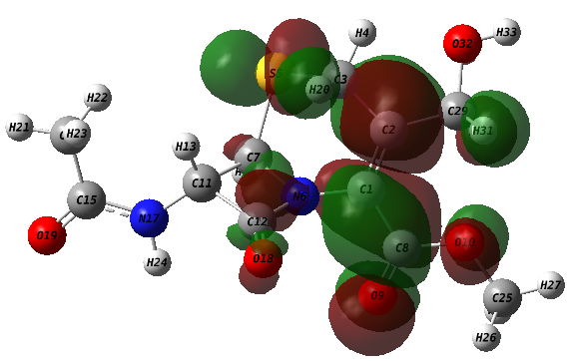
C4 | 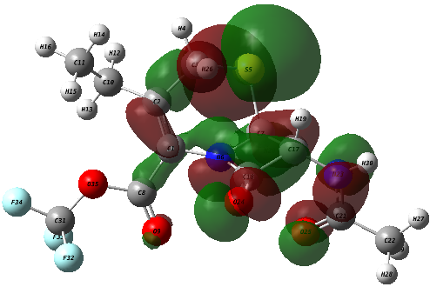 | 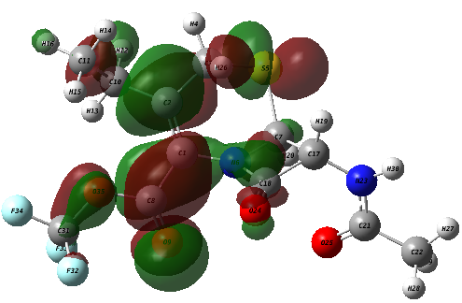
C5 | 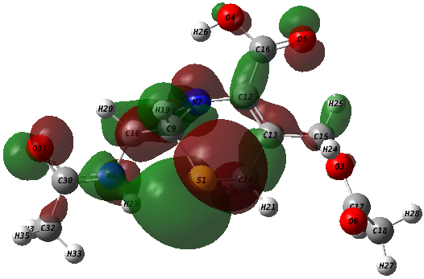 | 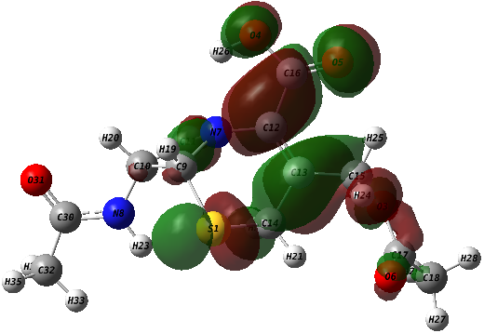
C6 | 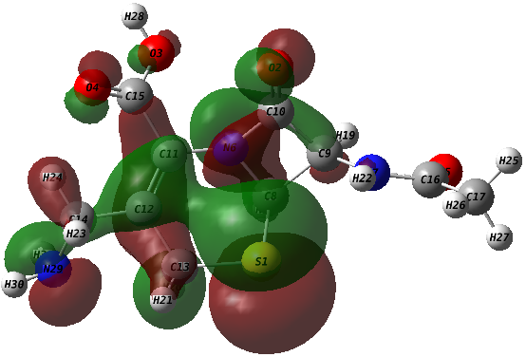 | 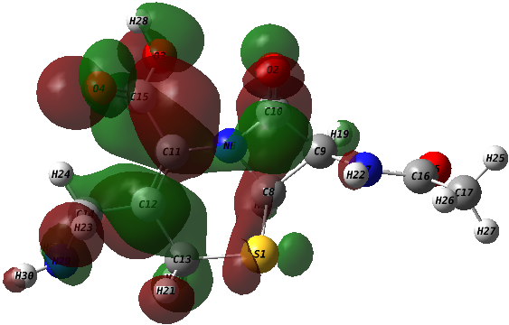
C7 | 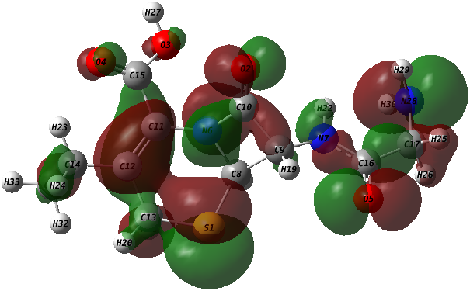 | 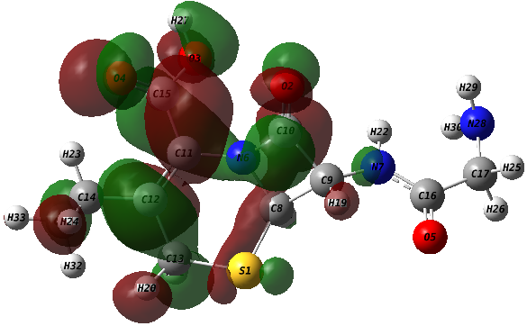
C8 | 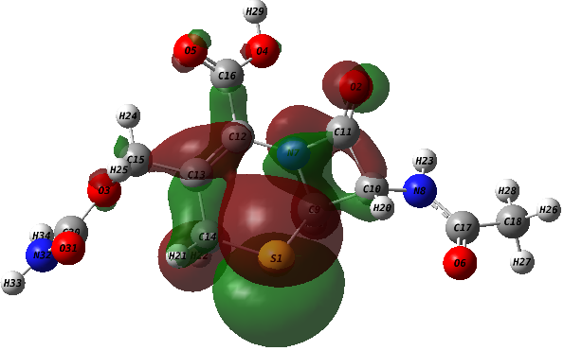 | 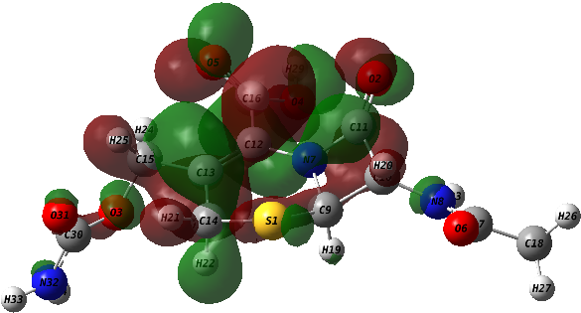
C9 | 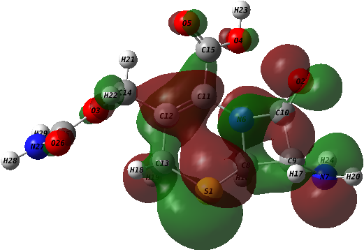 | 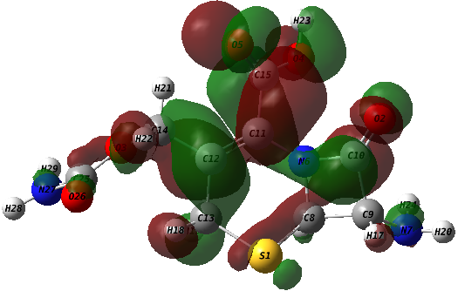
C10 | 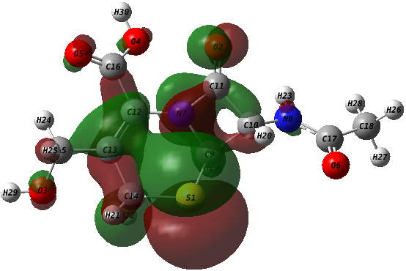 | 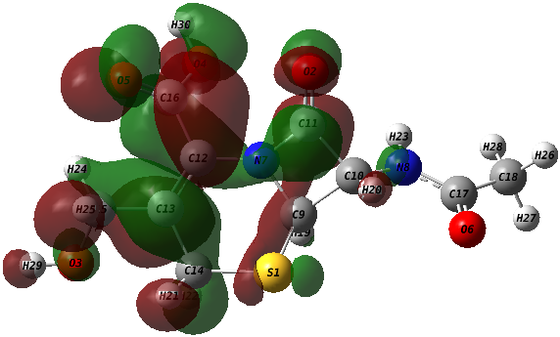
Fig. S3 HOMO-LUMO of CPS and its degradants.

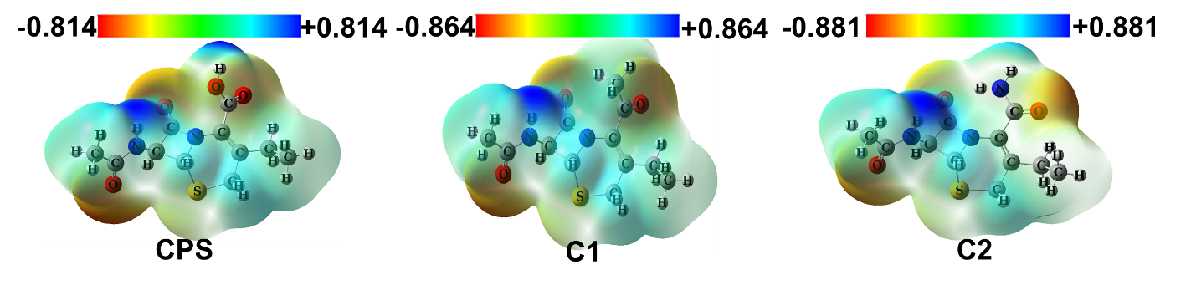
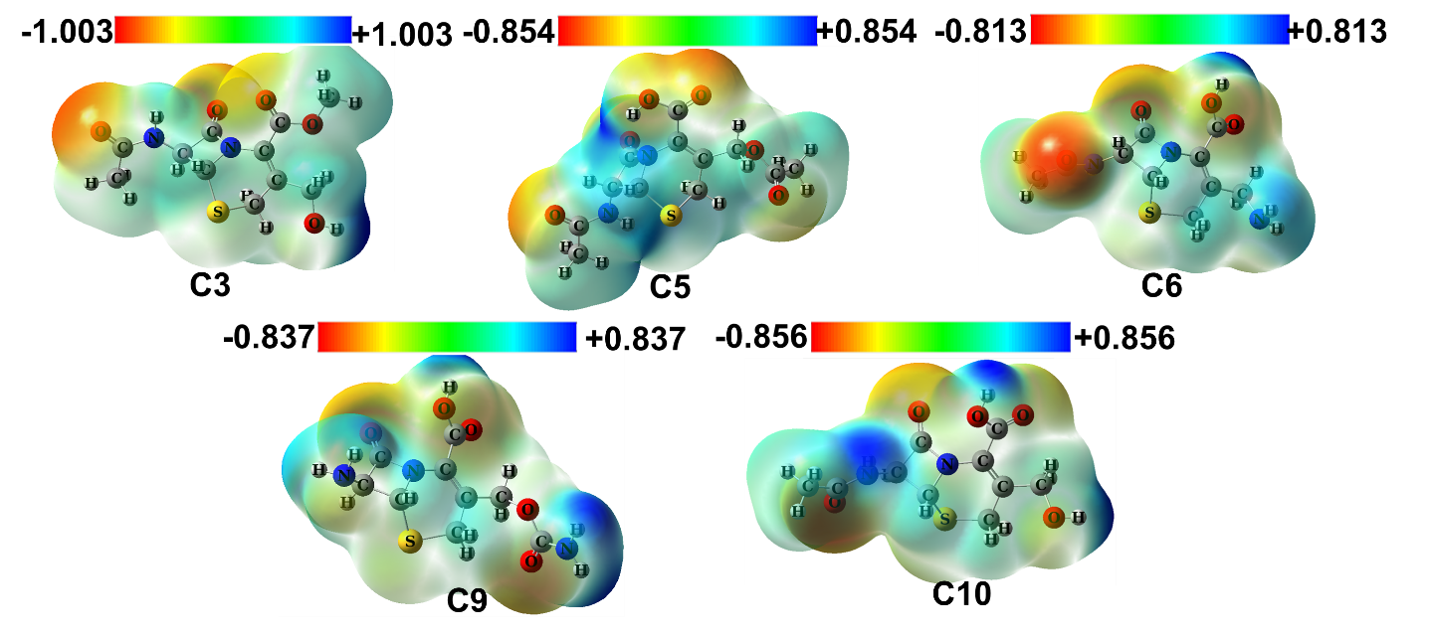
Fig. S4 Molecular electrostatic potential (MEP) map of CPS and its selected degradants illustrating the distribution of electron density, highlighting electron-rich regions (red) and electron-deficient regions(blue).
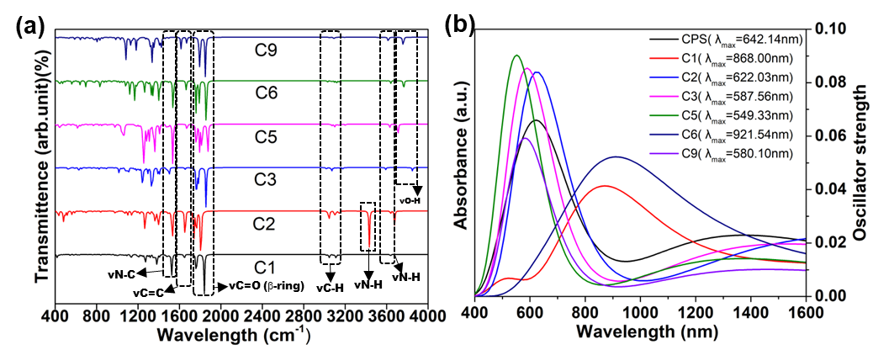
Fig. S5 (a) FT–IR and (b) UV–visible spectra of CPS and some of it’s degradants.

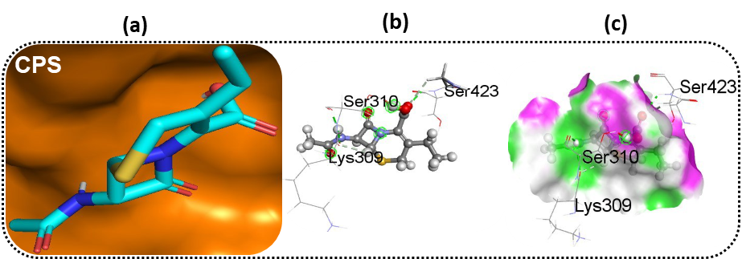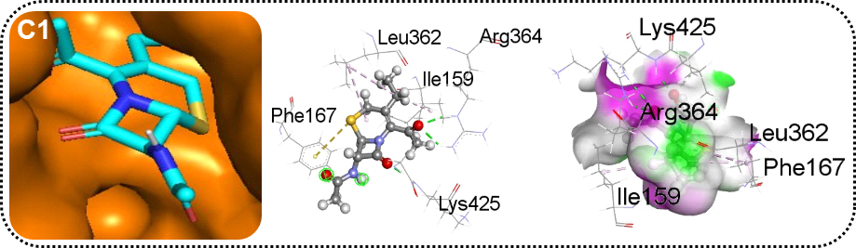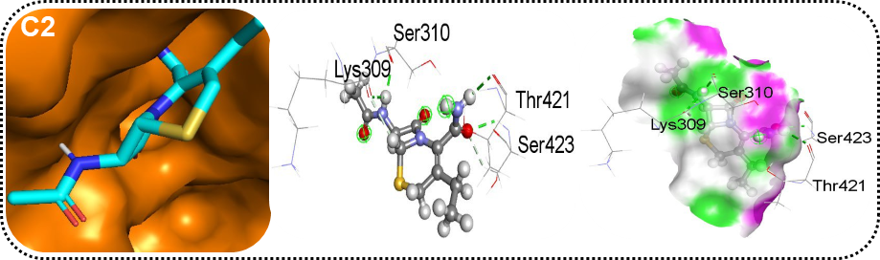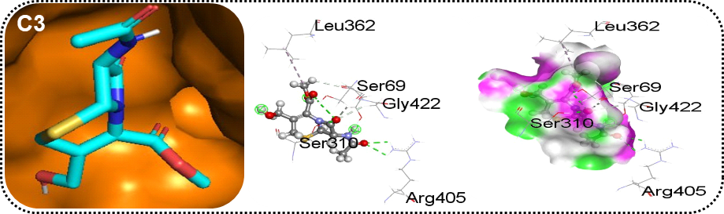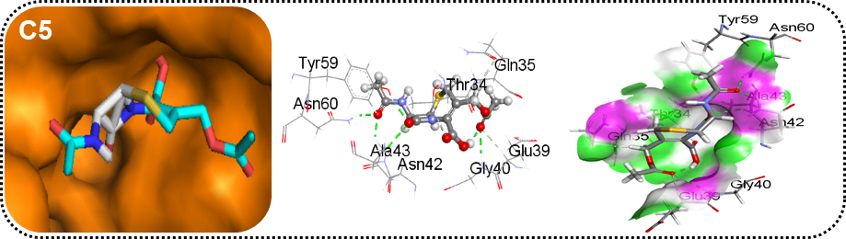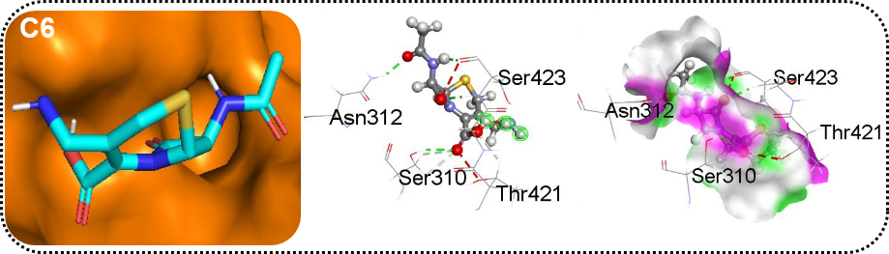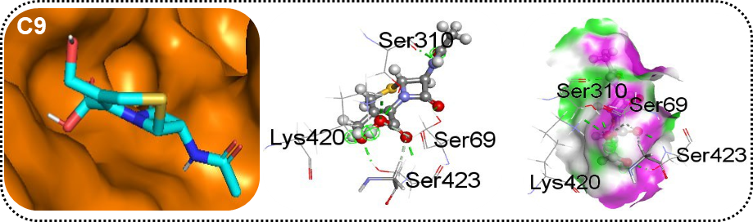
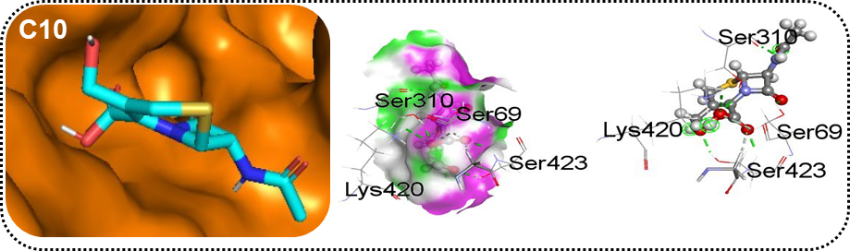
Fig. S6 (a) Docked conformation of CPS derivatives at inhibition binding site of receptor protein 3A3F (b) Non-bonding interactions and, (c) Hydrogen bond surface area of all CPS degradants with the receptor protein.

Supplementary reference
[1] Andersson MP, Uvdal P, “New Scale Factors for Harmonic Vibrational Frequencies Using the B3LYP Density Functional Method with the Triple-ζ Basis Set 6-311+G(d,p),” J Phys Chem A,2005, 109, 2937–2941, doi: 10.1021/jp045733a.

