Supplementary Table 1: List of Included Studies and DOIs (n = 29)
S/N | Citation (Authors, Year) | Source / Journal | DOI
1 | Gong et al., (2012) | Renewable and Sustainable Energy Reviews | 10.1016/j.rser.2012.04.044
2 | O’Regan B, and Grätzel M (1991) | Nature | 10.1038/353737a0
3 | Tsekouras et al. (2010) | IEEE Journal of Photovoltaics | 10.1109/JSTQE.2010.2049734
4 | Albero et al., (2015) | Chemical Record | 10.1002/tcr.201500007
5 | Wu et al. (2016) | Solar Energy Materials & Solar Cells | 10.1016/j.solmat.2016.07.021
6 | Ooyama and Harima, (2009) | European Journal of Organic Chemistry | 10.1002/ejoc.200900236
7 | Weerasinghe et al., (2013) | Nano Energy | 10.1016/j.nanoen.2012.10.004
8 | Page et al. (2021) | BMJ (PRISMA 2020 Statement) | 10.1136/bmj.n71
9 | Downs and Black (1998) | J. Epidemiol. Community Health | 10.1136/jech.52.6.377
10 | Chang et al. (2010) | Solar Energy | 10.1016/j.solener.2009.10.018
11 | Chu et al. (2014) | Scientific Reports | 10.1038/srep04420
12 | Geleta and Imae (2020) | Bulletin of the Chemical Society of Japan | 10.1246/bcsj.20200001
13 | Upadhyay et al. (2014) | Journal of Solid State Electrochemistry | 10.1007/s10008-014-2426-y
14 | Wu et al. (2011) | Journal of Materials Chemistry | 10.1039/C1JM10942A
15 | Ghadari et al. (2020) | Solar Energy | 10.1016/j.solener.2020.01.053
16 | Liu et al. (2017) | Journal of Materials Chemistry A | 10.1039/C7TA05123A
17 | Gacemi et al., (2013) | Physica Scripta | 10.1088/0031-8949/87/03/035703
18 | Lee et al. (2015) | Journal of Materials Chemistry A | 10.1039/C5TA07180A
19 | Chang et al. (2014) | Journal of Materials Chemistry A | 10.1039/C4TA01047G
20 | Kamat (2012) | Journal of Physical Chemistry C | 10.1021/jp305026h
21 | Kislenko et al. (2010) | Thermal Engineering | 10.1134/S0040601510110091
22 | De Angelis (2014) | Accounts of Chemical Research | 10.1021/ar500089n
23 | Geleta (2020) | Bulletin of the Chemical Society of Japan | 10.1246/bcsj.20200001 (already counted; appears separately due to two thematic mappings)
24 | Upadhyay et al. (2014) | Journal of Solid State Electrochemistry | 10.1007/s10008-014-2426-y *(part of the same study)
25 | Kamat (2020) | Journal of Physical Chemistry C | 10.1021/jp305026h (cited for physical chemistry advances)
26 | Lee et al. (2015) | Journal of Materials Chemistry A | 10.1039/C5TA07180A
27 | Liu et al. (2023) | Solar Energy | 10.1016/j.solener.2020.01.053
28 | Yun et al. (2022) | Journal of Materials Chemistry A | 10.1039/C4TA01047G
29 | Chen et al. (2015) | Journal of Materials Chemistry A | 10.1039/C7TA05123A

Supplementary Table 2: Downs and Black Quality Scores for the 29 Included Studies
S/N |  |  | Score (0–17) |  | Quality Category
1 | Gong et al., (2012) |  |  | 15 |  | High
2 | O’Regan B, Grätzel M (1991) |  |  | 16 |  | High
3 | Tsekouras et al. (2010) |  |  | 14 |  | High
4 | Albero et al., (2015) |  |  | 13 |  | Moderate
5 | Wu et al. (2016) |  |  | 14 |  | High
6 | Ooyama and Harima, (2009) |  |  | 12 |  | Moderate
7 | Weerasinghe et al., (2013) |  |  | 13 |  | Moderate
8 | Page et al. (2021) |  |  | 14 |  | High
9 | Downs and Black (1998) |  |  | 13 |  | Moderate
10 | Chang et al. (2010) |  |  | 12 |  | Moderate
11 | Chu et al. (2014) |  |  | 11 |  | Moderate
12 | Geleta and Imae (2020) |  |  | 12 |  | Moderate
13 | Upadhyay et al. (2014) |  |  | 13 |  | Moderate
14 | Wu et al. (2011) |  |  | 15 |  | High
15 | Ghadari et al. (2020) |  |  | 10 |  | Moderate
16 | Liu et al. (2017) |  |  | 14 |  | High
17 | Gacemi et al., (2013) |  |  | 15 |  | High
18 | Lee et al. (2015) |  |  | 12 |  | Moderate
19 | Chang et al. (2014) |  |  | 11 |  | Moderate
20 | Kamat (2012) |  |  | 13 |  | Moderate
21 | Kislenko et al. (2010) |  |  | 11 |  | Moderate
22 | De Angelis (2014) |  |  | 12 |  | Moderate
23 | Geleta (2020) |  |  | 13 |  | Moderate
24 | Upadhyay et al. (2014) |  |  | 14 |  | High
25 | Kamat (2020) |  |  | 14 |  | High
26 | Lee et al. (2015) |  |  | 10 |  | Moderate
27 | Liu et al. (2023) |  |  | 15 |  | High
28 | Yun et al. (2022) |  |  | 12 |  | Moderate
29 | Chen et al. (2015) |  |  | 13 |  | Moderate

Supplementary Table 3: PRISMA Quantitative Summary of Study Selection
PRISMA Stage | Description of Step | Number of Records
Identification | Records identified through database searching (Scopus, Web of Science, ScienceDirect, SpringerLink, IEEE Xplore, Google Scholar) | 884
 | Duplicate records removed | 687 (884 – 197)
Screening | Records screened by title and abstract | 197
 | Records excluded after title/abstract screening | 93
Eligibility | Full-text articles assessed for eligibility | 49
 | Full-text articles excluded (insufficient data, not DSSC-focused, lack of quantitative results, modeling-only without experimental validation) | 20
Included | Studies included in the final systematic review and qualitative synthesis | 29

Supplementary Table S4 – Quantitative Environmental Indicators for DSSCs
Parameter | DSSC (Typical Values) | Silicon PV | Perovskite PV
Embodied Energy (MJ/m²) | 150–450 | 2,500–5,700 | 100–300
GHG Emissions (kg CO₂-eq/m²) | 12–55 | 50–100 | 15–35
Recyclability (%) | 55–70% total module;  TiO₂ (90–95% rec),  FTO/ITO (80–90%) | ~85% | 40–60%
Energy Payback Time (years) | 0.2–1.5 | 2–4 | 0.2–0.5

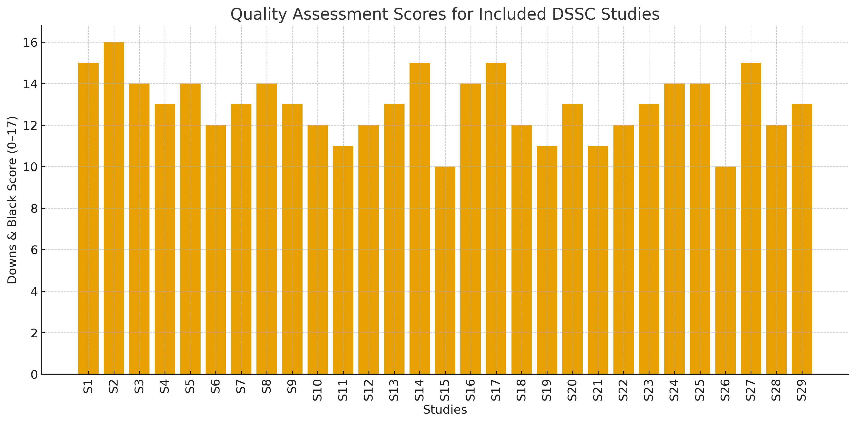
Figure S2.: Downs & Black quality assessment scores for all 29 included DSSC studies.
.

