Exploring 1,2,3-Cyclohexatriene Reactivity with Furan Derivatives: Insights into Structural and Electronic Factors
Lalitha Ravichandran
Department of Chemistry, School of Chemical and Biotechnology
SASTRA Deemed University, Thanjavur, India
Email: lalithravi@gmail.com

Table S1. Ground and excited state energies of benzene and triene in Hartree. The difference in energies is in kcal/mol.
Molecule | S0 | S1 | T1 | ΔE_{S1-S0} (kcal/mol) | ΔE_{T1-S0} (kcal/mol)
Benzene (1) | -232.33736 | -232.14222 | -232.16132 | 122.44 | 110.46
Triene (2) | -232.16912 | -232.09399 | -232.12958 | 47.14 | 24.81

Fig S1: Scheme used for calculating Isodesmic Reaction Energies for various trienes.

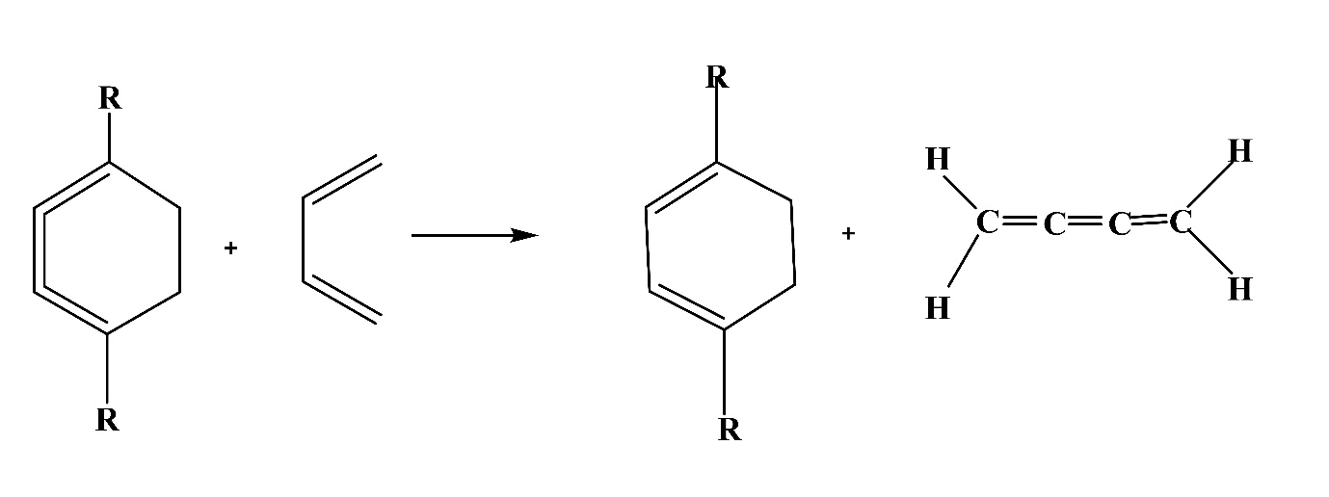
Table S2: Isodesmic Reaction Energies for various trienes in kcal/mol

R | Strain (kcal/mol)
Methyl | 49.21
Ethyl | 48.27
Iso-propyl | 47.17
t- butyl | 44.85

Table S3. IP, EA, HOMO and LUMO and Hardness (in eV) of various substituted benzenes and trienes.
Molecule | IP-ΔSCF | EA-ΔSCF | Hardness | HOMO | LUMO | LUMO-HOMO
1 | 9.26 | -1.65 | 5.46 | -7.06 | -0.39 | 6.67
1a | 8.80 | -1.60 | 5.20 | -6.73 | -0.35 | 6.38
1b | 8.40 | -1.56 | 4.98 | -6.43 | -0.32 | 6.11
1c | 8.74 | -1.59 | 5.16 | -6.73 | -0.33 | 6.40
1d | 8.69 | -1.55 | 5.12 | -6.73 | -0.34 | 6.39
1e | 8.64 | -1.52 | 5.08 | -6.72 | -0.33 | 6.39
1f | 8.31 | -1.53 | 4.92 | -6.45 | -0.29 | 6.16
1g | 8.23 | -1.50 | 4.87 | -6.46 | -0.27 | 6.19
1h | 8.17 | -1.48 | 4.82 | -6.45 | -0.22 | 6.23
2 | 8.30 | -0.12 | 4.21 | -6.11 | -2.00 | 4.11
2a | 7.92 | -0.17 | 4.04 | -5.85 | -1.86 | 3.99
2b | 7.57 | -0.21 | 3.89 | -5.61 | -1.73 | 3.88
2c | 7.85 | -0.16 | 4.00 | -5.83 | -1.83 | 4.00
2d | 7.81 | -0.13 | 3.97 | -5.84 | -1.82 | 4.02
2e | 7.77 | -0.11 | 3.94 | -5.84 | -1.81 | 4.03
2f | 7.47 | -0.14 | 3.80 | -5.61 | -1.73 | 3.88

Table S4. Reactant, product and TS energies are obtained at the B3LYP/ def2TZVP level with zero-point correction in Hartree and activation energy in kcal/mol
Reaction | Reactant  (Hartree) |  | Products  (Hartree) |  | TS  (Hartree) |  | Activation energy  (kcal mol⁻¹)
Reaction | Energy | ZPE | Energy | ZPE | Energy | ZPE | Activation energy  (kcal mol⁻¹)
A | -462.28339 | 0.16662 | -462.38318 | 0.17368 | -462.28018 | 0.16791 | 2.96
B | -540.95609 | 0.22153 | -541.05511 | 0.22812 | -540.86470 | 0.22279 | 3.75
C | -619.62563 | 0.27688 | -619.71276 | 0.28372 | -619.52442 | 0.27830 | 6.50

Table S5: Enthalpy and Free energies of reactions (in Hartree). ΔH and ΔG in kcal/mol.
Reaction | Reactant  (Hartree) |  | Products  (Hartree) |  | ΔH  (kcal/mol) | ΔG  (kcal/mol)
Reaction | H | G | H | G | ΔH  (kcal/mol) | ΔG  (kcal/mol)
A | -462.1051 | -462.1687 | -462.2016 | -462.2430 | -60.5427 | -46.6145
B | -540.7199 | -540.7916 | -540.8152 | -540.8632 | -59.8016 | -44.9296
C | -619.3327 | -619.4122 | -619.415628 | -619.470219 | -52.0381 | -36.4074

Fig S2: Pictorial representation of σ bond formation from NBO overlap along various IRC points for reaction B.
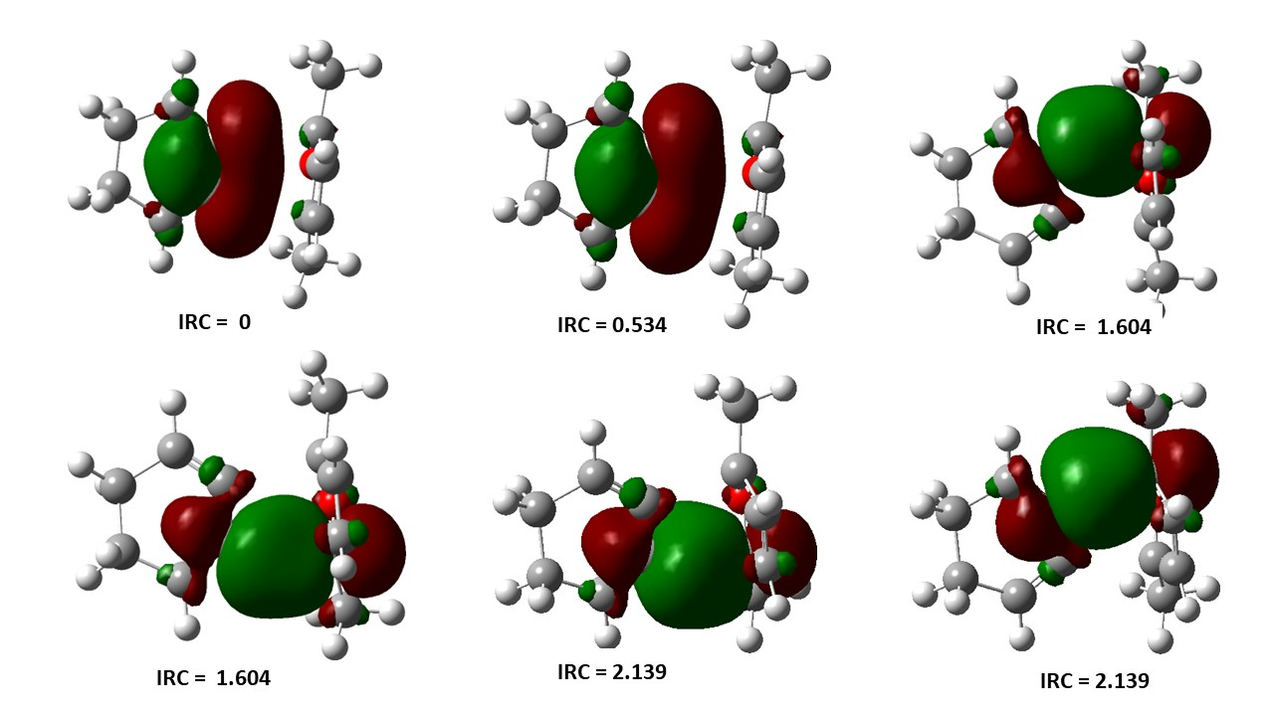

Fig S3: Bond angle and bond length change for reaction B

Fig S4: NBO pictures of furan and triene along various points of IRC during reaction C.

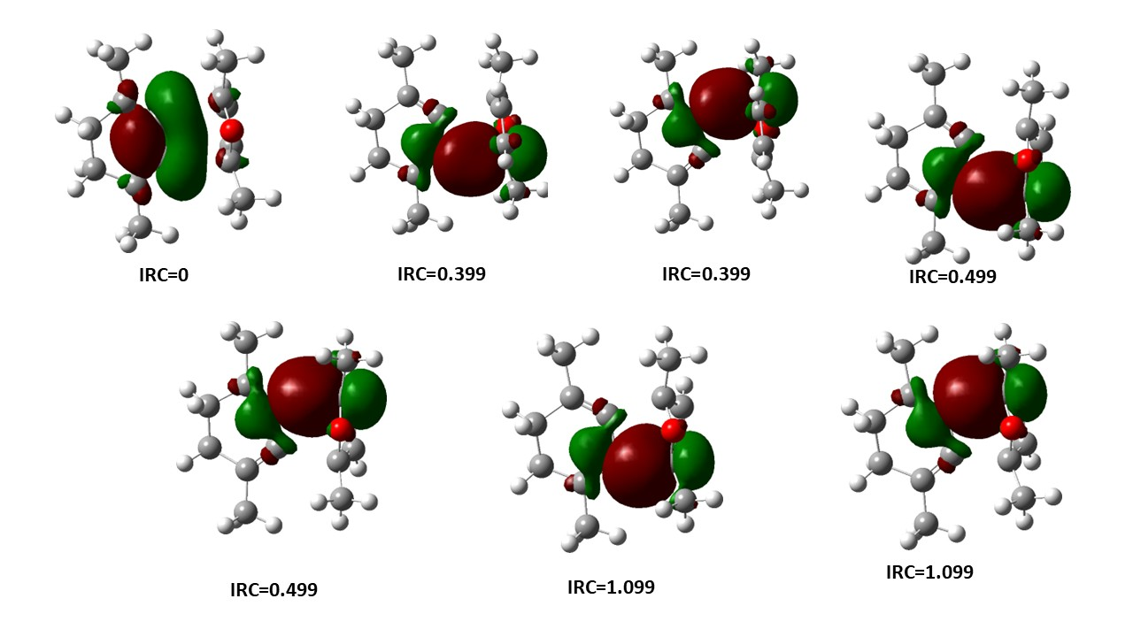

Fig S5: Bond angle and bond length change for reaction C

Table S6: Second order energies E(2) for reactions A, B and C at the TS in kcal/mol.

 | E(2)
 | Reaction A | Reaction B | Reaction C
$π$C13C14- $π*$C2C3 | 10.73 | 9.19 | 12.63
$π$C15C16- $π*$C2C3 | 8.76 | 9.57 | 10.89

