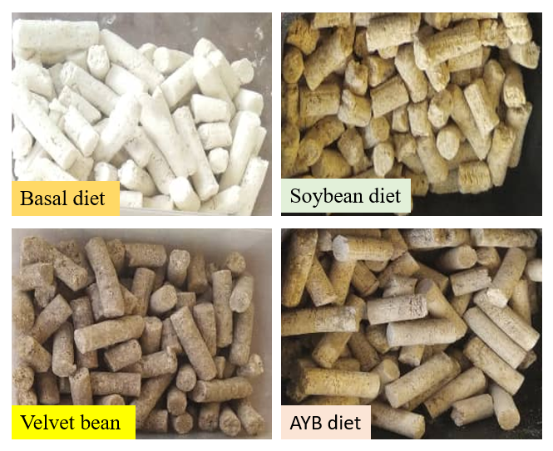
Figure S1: Experimental diets formulated in pellet form
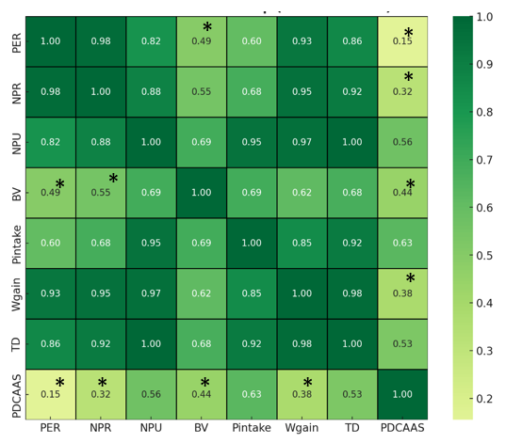
Figure S2. Pearson correlation coefficients among protein quality parameters.
Values marked with * are not statistically significant at p < 0.05.
Table S1: Proximate composition of the formulated diets (g/100g d.w)
Composition | Basal diet | Soy diet (RD) | Test diet 1 (VB) | Test diet 2 (AYB)
Moisture | 3.18±0.14^{c} | 5.12±0.08ª | 4.32±0.11^{b} | 3.48±0.13^{c}
Protein | 0.00 | 10.03±0.14ª | 10.21±0.12ª | 9.98±0.42ª
Fat | 9.92±0.34^{d} | 16.82±0.19ª | 13.98±0.05^{c} | 15.42±0.16^{b}
Ash | 3.20±0.02^{c} | 4.96±0.26ª | 3.54±0.52^{bc} | 4.26±0.14^{b}
Fiber | 3.48±0.18^{b} | 4.13±0.16ª | 2.09±0.09^{c} | 3.84±0.28^{ab}
Carbohydrate | 80.38±2.04ª | 60.19±1.33^{d} | 66.26±0.68^{b} | 63.08±2.54^{c}
Caloric value  (Kcal/100g) | 410.8±3.24^{b} | 432.82±0.18ª | 432.80±0.54ª | 432.78±0.33ª
Energy values used to demonstrate iso-caloric formulation were calculated on a dry-matter basis using Atwater factors. Data are expressed as mean ± standard deviation of triplicate values. Mean followed by different letters within each row are significantly different (p ≤ 0.05).

