1 C 2
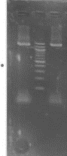
PLATE: Agarose gel electrophoresis of the bacterial isolates. Lanes 1 - 2 represent 16SrRNA gene bands (1500bp). Lane C represents the 100bp Molecular ladder.
1500bp
100bp

