Table 1S The mean of certain agro-morphological characteristics of desi-type chickpea in Mashhad.
Genotype (MCC) | Plant height (cm) | SE | Lowest pod height (cm) | SE | Branch No. | SE | No. Sub-branch | SE | Filled pod (%) | SE | 100-grain weight (g) | SE | Seed weight  (g plant⁻¹) | SE | Biomass  (g plant⁻¹) | SE
194 | 38.9^{b-h} | 3.6 | 12.2d-f | 0.8 | 3.3 | 0.8 | 6.0 | 0.8 | 50.1a-c | 3.6 | 20.2a-c | 0.8 | 11.7 | 5.7 | 33.7 | 10.5
199 | 47.3ab | 4.0 | 18.6ab | 0.3 | 4.0 | 0.5 | 4.9 | 0.5 | 47.5 a-d | 4.7 | 17.8c-f | 0.1 | 8.7 | 2.6 | 28.4 | 4.2
207 | 36.2 c-i | 4.1 | 12.9c-f | 0.7 | 3.8 | 0.5 | 3.8 | 1.2 | 45.8 a-d | 1.4 | 14.8f-j | 1.7 | 6.2 | 3.0 | 28.8 | 7.2
212 | 32.4f-j | 0.9 | 14.7b-e | 1.5 | 3.2 | 1.5 | 4.3 | 1.2 | 47.1 a-d | 7.3 | 17.0c-g | 0.1 | 8.4 | 6.8 | 22.5 | 11.3
259 | 37.3c-i | 2.8 | 17.3a-d | 0.0 | 2.3 | 0.7 | 3.9 | 0.5 | 16.4d | 8.2 | 13.1h-l | 2.6 | 0.5 | 0.2 | 13.8 | 1.7
29 | 41.7a-f | 2.7 | 16.3a-e | 2.7 | 3.0 | 0.2 | 4.8 | 0.8 | 49.1 a-d | 8.8 | 18.3c-e | 1.0 | 8.3 | 3.7 | 26.0 | 7.0
291 | 32.9f-j | 3.6 | 17.2 a-d | 0.8 | 3.7 | 0.8 | 4.0 | 0.5 | 38.1 a-d | 8.0 | 17.9c-f | 0.7 | 2.1 | 0.7 | 12.9 | 2.8
32 | 39.6b-g | 3.2 | 16.2a-e | 1.7 | 4.0 | 0.4 | 5.9 | 1.1 | 36.5 a-d | 8.7 | 13.7h-k | 0.9 | 6.8 | 3.5 | 27.1 | 4.3
40 | 34.9 c-j | 2.1 | 14.3b-f | 0.0 | 2.8 | 0.2 | 4.8 | 0.8 | 54.6 ab | 2.8 | 15.1e-i | 0.5 | 6.8 | 3.9 | 24.4 | 6.1
505 | 42.2a-e | 2.6 | 13.0c-f | 1.7 | 2.8 | 0.6 | 4.9 | 0.9 | 61.5ab | 8.2 | 12.7i-l | 0.1 | 10.2 | 3.4 | 28.4 | 3.3
576 | 34.9 c-j | 5.3 | 18.7ab | 3.0 | 3.2 | 0.7 | 5.5 | 0.9 | 50.9a-c | 7.8 | 16.0d-h | 0.6 | 14.8 | 7.3 | 28.6 | 15.1
580 | 33.2e-j | 1.9 | 14.7b-e | 3.2 | 2.3 | 0.6 | 4.1 | 0.6 | 18.2cd | 3.4 | 14.1g-k | 0.9 | 1.6 | 0.6 | 15.0 | 2.5
600 | 28.1ij | 4.6 | 9.4f | 1.9 | 2.6 | 0.4 | 4.3 | 1.2 | 32.3b-d | 12.8 | 13.6h-k | 0.1 | 6.1 | 3.1 | 13.6 | 7.2
605 | 37.1 c-i | 1.5 | 16.5 a-e | 0.7 | 2.1 | 0.3 | 5.2 | 0.2 | 66.7a | 10.4 | 18.9b-d | 0.5 | 7.6 | 1.1 | 19.7 | 2.6
607 | 37.9c-h | 3.4 | 17.8a-c | 1.6 | 3.4 | 0.5 | 5.4 | 0.8 | 35.4 a-d | 12.4 | 17.1c-g | 0.8 | 5.6 | 2.3 | 32.2 | 4.6
613 | 49.2a | 3.1 | 15.9a-e | 1.2 | 3.2 | 0.2 | 6.4 | 1.5 | 40.1 a-d | 14.5 | 16.1d-h | 0.8 | 8.1 | 4.0 | 29.7 | 3.2
751 | 31.1g-j | 2.6 | 16.0a-e | 3.3 | 2.8 | 0.4 | 3.0 | 0.4 | 63.4ab | 6.0 | 21.9ab | 0.1 | 4.3 | 0.8 | 16.6 | 5.8
754 | 31.1g-j | 2.1 | 16.2a-e | 1.0 | 3.1 | 0.7 | 3.8 | 0.3 | 43.5 a-d | 14.1 | 19.7a-c | 1.8 | 0.9 | 0.3 | 14.0 | 2.3
83 | 25.8j | 6.8 | 11.3ef | 0.5 | 4.1 | 0.8 | 3.2 | 0.5 | 59.7 ab | 0.9 | 17.2c-g | 0.3 | 7.4 | 0.1 | 13.1 | 7.3
884 | 37.4c-h | 4.4 | 15.1b-e | 1.8 | 2.6 | 0.3 | 5.9 | 0.4 | 53.0ab | 14.5 | 11.6j-l | 0.3 | 6.8 | 3.7 | 28.0 | 8.8
885 | 42.8a-d | 4.6 | 15.2b-e | 1.8 | 2.5 | 0.8 | 5.7 | 0.9 | 48.6 a-d | 3.2 | 12.9h-l | 1.2 | 10.9 | 5.6 | 37.0 | 13.7
901 | 30.2h-j | 0.9 | 13.2c-f | 2.7 | 2.4 | 0.9 | 3.2 | 0.2 | 33.1b-d | 14.6 | 20.0a-c | 0.9 | 3.0 | 1.5 | 14.4 | 1.7
911 | 38.2b-h | 3.4 | 17.4a-d | 2.9 | 3.7 | 0.0 | 4.7 | 1.0 | 36.0 a-d | 16.6 | 15.3e-i | 3.5 | 5.2 | 2.7 | 21.1 | 0.9
913 | 34.5d-j | 0.2 | 12.9c-f | 0.4 | 2.3 | 0.5 | 4.9 | 0.6 | 60.8 ab | 3.1 | 14.3g-k | 0.2 | 8.1 | 0.6 | 19.5 | 2.6
914 | 36.4 c-i | 2.2 | 14.1b-f | 1.1 | 3.2 | 0.1 | 5.4 | 0.4 | 60.5 ab | 3.1 | 10.3^{l} | 0.0 | 6.8 | 2.1 | 22.4 | 3.9
922 | 44.1a-c | 0.9 | 21.0a | 3.1 | 3.8 | 0.5 | 6.6 | 0.3 | 67.1a | 5.0 | 11.2kl | 0.2 | 6.0 | 1.7 | 29.1 | 3.1
Saral | 42.2a-e | 2.2 | 12.3d-f | 1.0 | 3.3 | 0.5 | 5.2 | 0.6 | 49.3a-d | 7.1 | 22.8a | 1.3 | 12.0 | 4.2 | 39.3 | 10.4
P-Value | <0.0001 |  | <0.05 |  | NS |  | NS |  | <0.01 |  | <0.0001 |  | NS |  | NS
NS: non significant; SE: standard error

Table 2S The mean of certain agro-morphological characteristics of desi-type chickpea in Jolgeh rokh.
Genotype (MCC) | Plant height (cm) | SE | Lowest pod height (cm) | SE | Branch No. | SE | No. Sub-branch | SE | Filled pod (%) | SE | 100-grain weight (g) | SE | Seed weight  (g plant⁻¹) | SE | Biomass  (g plant⁻¹) | SE
194 | 37.6ab | 1.6 | 10.2b-e | 1.1 | 2.0 | 0.5 | 5.1 | 0.9 | 87.0 ab | 1.2 | 23.3cd | 0.8 | 21.9 | 4.4 | 40.9 | 5.6
199 | 35.7a-c | 2.1 | 11.7ab | 1.0 | 1.7 | 0.5 | 6.9 | 0.8 | 88.2 ab | 1.7 | 22.3c-f | 0.4 | 39.9 | 9.1 | 74.2 | 14.9
207 | 26.0d-g | 1.6 | 8.2 d-g | 0.9 | 1.1 | 0.1 | 4.7 | 0.7 | 85.8 ab | 3.8 | 18.3h-j | 1.6 | 20.2 | 2.8 | 39.3 | 5.7
212 | 37.3ab | 1.9 | 9.1 c-g | 0.9 | 1.9 | 0.1 | 5.8 | 0.5 | 72.5bc | 4.7 | 20.3e-h | 1.7 | 21.9 | 10.0 | 46.6 | 14.7
259 | 28.8b-g | 2.6 | 9.2 b-g | 0.9 | 1.8 | 0.5 | 6.4 | 0.9 | 93.4a | 1.3 | 23.0c-e | 0.3 | 29.0 | 3.4 | 52.0 | 3.5
29 | 31.1a-f | 1.9 | 8.2 d-g | 0.1 | 1.0 | 0.0 | 5.6 | 0.8 | 70.9bc | 11.0 | 23.6cd | 1.0 | 24.1 | 6.9 | 41.0 | 10.9
291 | 27.2c-g | 3.5 | 8.7 c-g | 0.6 | 1.3 | 0.3 | 5.4 | 1.4 | 69.8bc | 4.7 | 19.2hi | 0.8 | 17.0 | 7.3 | 33.5 | 11.2
32 | 35.6 a-c | 2.6 | 9.2 b-g | 1.1 | 1.0 | 0.0 | 4.9 | 0.4 | 86.4 ab | 3.3 | 15.2l-n | 0.7 | 13.9 | 3.4 | 29.7 | 8.0
40 | 33.2 a-d | 1.1 | 8.4 c-g | 0.3 | 1.3 | 0.2 | 4.8 | 0.1 | 79.5 a-c | 10.3 | 18.7hi | 1.7 | 19.3 | 5.4 | 42.8 | 8.3
505 | 35.4 a-c | 5.0 | 8.8 c-g | 1.2 | 1.8 | 0.3 | 5.2 | 1.2 | 84.8 ab | 4.2 | 13.8mn | 0.4 | 15.5 | 7.7 | 34.0 | 14.7
576 | 28.8 b-g | 3.3 | 10.2 b-e | 0.9 | 1.2 | 0.2 | 5.1 | 0.5 | 87.4 ab | 2.9 | 18.0h-k | 1.2 | 27.4 | 3.2 | 49.3 | 5.9
580 | 31.7 a-f | 2.5 | 9.3b-g | 0.8 | 1.1 | 0.1 | 4.0 | 0.2 | 75.5 a-c | 10.0 | 17.6i-l | 0.5 | 17.8 | 6.5 | 39.8 | 7.7
600 | 27.7c-g | 3.3 | 7.8 e-g | 0.5 | 1.1 | 0.1 | 3.0 | 0.2 | 63.0c | 0.2 | 15.4k-m | 0.5 | 8.4 | 3.9 | 18.8 | 5.4
605 | 32.9a-d | 4.8 | 10.9bc | 0.8 | 2.4 | 1.3 | 8.3 | 4.2 | 80.6 a-c | 7.1 | 21.9d-g | 1.3 | 27.0 | 4.7 | 62.2 | 16.9
607 | 28.8 b-g | 2.0 | 10.2 b-e | 0.9 | 1.4 | 0.2 | 4.0 | 0.2 | 89.9 ab | 1.0 | 24.6c | 1.3 | 29.6 | 7.0 | 52.8 | 12.3
613 | 38.6a | 3.5 | 13.7a | 1.0 | 1.2 | 0.1 | 4.6 | 0.4 | 89.9 ab | 0.4 | 22.2c-f | 0.5 | 32.7 | 2.1 | 56.9 | 1.8
751 | 31.1 a-f | 1.3 | 9.2 b-g | 0.9 | 1.0 | 0.0 | 5.4 | 1.9 | 77.1 a-c | 9.5 | 30.7a | 0.8 | 29.8 | 13.2 | 56.5 | 22.8
754 | 36.6 a-c | 1.6 | 8.9 c-g | 0.9 | 2.3 | 0.6 | 8.6 | 2.6 | 70.6bc | 4.7 | 27.7b | 1.3 | 18.4 | 9.2 | 41.8 | 12.2
83 | 27.8c-g | 3.3 | 8.9 c-g | 0.3 | 1.2 | 0.2 | 4.8 | 0.2 | 62.7c | 8.0 | 19.8f-i | 0.9 | 10.0 | 3.7 | 26.0 | 6.1
884 | 31.4 a-f | 3.6 | 9.1 c-g | 1.1 | 1.7 | 0.5 | 4.7 | 0.5 | 92.2a | 2.8 | 13.7mn | 0.6 | 23.2 | 6.6 | 43.1 | 12.8
885 | 24.6e-g | 3.8 | 7.6fg | 1.1 | 1.3 | 0.2 | 5.0 | 0.7 | 84.7 ab | 4.1 | 19.2g-i | 0.7 | 16.9 | 4.1 | 31.3 | 7.7
901 | 32.3a-d | 3.6 | 10.9bc | 0.6 | 2.0 | 0.5 | 5.7 | 0.9 | 85.0 ab | 6.2 | 24.4cd | 0.3 | 22.9 | 6.1 | 44.1 | 10.1
911 | 26.7d-g | 0.3 | 8.8 c-g | 1.2 | 1.2 | 0.1 | 4.9 | 0.9 | 86.3 ab | 1.5 | 23.2cd | 1.1 | 23.0 | 4.8 | 41.5 | 7.8
913 | 28.7 b-g | 3.6 | 10.7b-d | 1.0 | 1.6 | 0.4 | 4.9 | 0.6 | 82.6a-c | 5.4 | 17.9h-k | 0.2 | 19.8 | 3.3 | 38.6 | 7.3
914 | 26.6d-g | 3.0 | 7.0g | 0.5 | 1.3 | 0.2 | 6.2 | 0.4 | 90.0ab | 2.5 | 12.5n | 0.7 | 23.2 | 3.0 | 42.8 | 6.9
922 | 37.6ab | 2.4 | 10.2 b-e | 0.1 | 1.9 | 0.3 | 6.9 | 1.1 | 90.3ab | 0.8 | 15.8j-m | 0.5 | 29.8 | 5.0 | 58.7 | 6.2
Saral | 36.1a-c | 0.1 | 9.6 b-f | 1.7 | 1.2 | 0.1 | 5.1 | 0.6 | 78.6 a-c | 6.5 | 28.3ab | 1.3 | 21.2 | 5.7 | 45.4 | 6.5
P-Value | <0.01 |  | <0.01 |  | NS |  | NS |  | <0.01 |  | <0.0001 |  | NS |  | NS
NS: non significant; SE: standard error

Table 3S The mean of certain agro-morphological characteristics of desi-type chickpea in Shirvan.
Genotype (MCC) | Plant height (cm) | SE | Lowest pod height (cm) | SE | Branch No. | SE | No. Sub-branch | SE | Filled pod (%) | SE | 100-grain weight (g) | SE | Seed weight  (g plant⁻¹) | SE | Biomass  (g plant⁻¹) | SE
194 | 34.7ab | 2.8 | 11.7b-g | 0.7 | 1.7 | 0.4 | 6.7 | 0.2 | 91.3a-d | 1.0 | 23.9b-d | 0.3 | 7.0 | 1.6 | 14.2 | 2.3
199 | 32.0a-e | 1.9 | 14.6a | 0.4 | 1.3 | 0.2 | 6.6 | 1.0 | 89.8a-e | 1.4 | 22.0d-f | 0.6 | 7.6 | 0.7 | 14.3 | 0.6
207 | 28.2d-f | 1.5 | 9.6fg | 0.9 | 1.6 | 0.1 | 6.2 | 1.0 | 91.6a-d | 1.8 | 20.0f-i | 0.6 | 5.5 | 1.2 | 10.0 | 1.7
212 | 26.1ef | 2.7 | 9.8e-g | 1.3 | 1.3 | 0.2 | 6.0 | 0.2 | 90.9a-e | 5.8 | 18.4h-j | 0.9 | 6.1 | 3.0 | 12.4 | 4.1
259 | 29.8b-f | 1.8 | 11.0c-g | 0.3 | 2.3 | 0.7 | 9.1 | 2.3 | 90.1a-e | 2.4 | 21.7d-f | 1.5 | 10.5 | 5.1 | 20.4 | 9.0
29 | 36.9a | 1.2 | 13.9ab | 1.2 | 1.9 | 0.6 | 5.8 | 0.9 | 86.8c-e | 1.3 | 20.5e-h | 0.8 | 6.3 | 1.7 | 13.0 | 2.3
291 | 30.3b-f | 1.5 | 10.6d-g | 1.8 | 1.8 | 0.5 | 8.8 | 1.4 | 95.3a-c | 3.3 | 16.9j-m | 1.1 | 6.0 | 3.0 | 13.4 | 4.2
32 | 28.4c-f | 1.4 | 10.1d-g | 1.3 | 1.4 | 0.1 | 5.4 | 0.8 | 92.3a-c | 2.7 | 15.6lm | 0.4 | 5.9 | 1.1 | 9.2 | 2.1
40 | 28.4c-f | 3.4 | 9.7e-g | 0.7 | 1.6 | 0.4 | 9.4 | 1.7 | 86.8c-e | 3.4 | 18.4h-j | 0.2 | 10.9 | 1.4 | 21.2 | 3.7
505 | 33.0a-d | 0.3 | 11.8a-g | 0.5 | 1.3 | 0.3 | 7.1 | 1.3 | 95.8a-c | 1.5 | 13.0no | 0.9 | 8.3 | 2.0 | 16.0 | 3.6
576 | 26.1ef | 1.2 | 9.1g | 0.9 | 1.6 | 0.4 | 6.7 | 0.7 | 95.4a-c | 1.4 | 19.1g-j | 0.2 | 6.6 | 1.1 | 13.0 | 2.4
580 | 27.2 d-f | 1.4 | 10.7d-g | 0.7 | 1.2 | 0.2 | 5.7 | 0.7 | 94.2a-c | 2.7 | 18.0i-k | 0.6 | 6.0 | 2.1 | 11.8 | 2.8
600 | 25.4f | 1.7 | 9.4fg | 1.4 | 1.4 | 0.3 | 6.8 | 0.2 | 98.4ab | 0.5 | 14.7mn | 0.1 | 9.9 | 2.2 | 16.0 | 2.5
605 | 34.4ab | 0.1 | 13.6a-c | 1.0 | 2.0 | 0.5 | 10.8 | 3.4 | 95.5a-c | 1.4 | 22.2d-f | 0.6 | 9.5 | 1.9 | 16.1 | 3.2
607 | 29.6b-f | 3.2 | 10.4d-g | 0.6 | 1.7 | 0.2 | 6.8 | 0.8 | 91.4a-d | 4.8 | 21.2e-g | 0.6 | 6.9 | 1.0 | 13.1 | 1.6
613 | 28.8b-f | 1.3 | 9.1g | 0.7 | 1.2 | 0.2 | 4.6 | 0.7 | 87.0c-e | 6.5 | 20.1f-i | 0.2 | 4.9 | 2.0 | 10.8 | 2.9
751 | 31.3a-f | 1.7 | 10.1d-g | 0.7 | 1.6 | 0.2 | 7.1 | 0.9 | 90.5a-e | 2.6 | 29.7a | 0.6 | 8.6 | 1.2 | 15.2 | 3.6
754 | 27.8 d-f | 1.0 | 9.0g | 0.7 | 1.4 | 0.1 | 8.1 | 0.7 | 85.5c-e | 1.4 | 25.7b | 2.0 | 9.2 | 2.2 | 18.8 | 4.4
83 | 32.9a-d | 2.4 | 12.1a-f | 1.5 | 1.6 | 0.1 | 9.4 | 0.8 | 94.5a-c | 0.9 | 18.2h-j | 1.1 | 6.1 | 1.9 | 13.7 | 2.7
884 | 34.3a-c | 3.6 | 12.7a-d | 1.1 | 1.3 | 0.2 | 6.6 | 1.2 | 93.1a-c | 2.9 | 15.8k-m | 0.5 | 6.4 | 1.3 | 12.3 | 3.0
885 | 27.4 d-f | 1.7 | 10.1d-g | 0.7 | 1.1 | 0.1 | 6.1 | 0.4 | 94.7a-c | 2.4 | 16.9j-m | 0.4 | 7.5 | 0.8 | 12.9 | 1.2
901 | 28.0 d-f | 3.7 | 12.7a-d | 0.9 | 1.7 | 0.2 | 7.3 | 0.7 | 90.1a-e | 1.7 | 22.5c-e | 0.7 | 6.6 | 1.1 | 14.1 | 2.5
911 | 33.1a-d | 1.8 | 9.6fg | 0.6 | 2.2 | 0.6 | 8.3 | 1.0 | 80.3e | 6.9 | 21.3e-g | 1.0 | 10.6 | 1.1 | 22.5 | 0.5
913 | 31.1a-f | 1.5 | 12.4a-e | 1.4 | 1.2 | 0.1 | 6.1 | 1.8 | 88.8b-e | 4.6 | 17.4j-l | 0.6 | 5.2 | 1.1 | 10.5 | 1.9
914 | 28.1 d-f | 1.9 | 9.9d-g | 0.3 | 1.1 | 0.1 | 6.1 | 0.7 | 100.0a | 0.0 | 12.2o | 0.1 | 7.9 | 2.3 | 13.7 | 3.5
922 | 29.8b-f | 2.9 | 11.4b-g | 1.3 | 1.8 | 0.3 | 8.6 | 1.4 | 80.5e | 9.5 | 14.7mn | 0.8 | 5.7 | 1.7 | 13.6 | 2.7
Saral | 36.4a | 0.3 | 10.4d-g | 1.3 | 1.3 | 0.2 | 5.2 | 0.6 | 81.5de | 6.9 | 24.9bc | 1.7 | 3.9 | 0.5 | 8.8 | 1.1
P-Value | <0.01 |  | <0.01 |  | NS |  | NS |  | <0.05 |  | <0.0001 |  | NS |  | NS
NS: non significant; SE: standard error

Table 4S Deviation from the overall mean in cluster groups (cluster analysis) of chickpea genotypes in Mashhad, Jolgeh rokh, and Shirvan.
Cluster group  Mashhad |  | Deviation from the total mean
Cluster group  Mashhad |  | Plant height | Lowest pod height | Filled pod | 100-grain weight | Seed yield | Biological yield | Harvest index
1 |  | -1.8 | -2.0 | 5.9 | -0.1 | -0.063 | -0.28 | 0.63
2 |  | -5.2 | 1.3 | -2.7 | 3.7 | -0.584 | -1.50 | -11.50
3 |  | 8.7 | 2.8 | 4.2 | -0.2 | 0.227 | 1.15 | -0.55
4 |  | 0.1 | 1.0 | -15.8 | -1.9 | 0.052 | 0.38 | -0.41
5 |  | -0.3 | 2.8 | -3.4 | -0.4 | 0.702 | 0.86 | 15.60
Total mean |  | 36.9 | 15.2 | 46.8 | 16.1 | 0.810 | 3.22 | 24.80
Jolgeh rokh
1 |  | 3.8 | 1.7 | 3.1 | 3.3 | 0.7 | 1.7 | 1.4
2 |  | -4.4 | -0.4 | 5.7 | -0.8 | -0.1 | -0.4 | 4.8
3 |  | 2.5 | -0.2 | 3.0 | -4.6 | -0.4 | -0.9 | -1.2
4 |  | 1.0 | -0.6 | -8.7 | 3.9 | 0.0 | 0.0 | -1.1
5 |  | -4.0 | -1.1 | -19.0 | -2.8 | -0.4 | -0.6 | -17.1
Total mean |  | 31.7 | 9.4 | 81.8 | 20.4 | 0.71 | 1.61 | 43.74
Shirvan
1 |  | 4.1 | 2.4 | 0.5 | 1.5 | 0.2 | 0.5 | 1.5
2 |  | -2.3 | -0.3 | 2.9 | -2.4 | 0.0 | -0.3 | 6.2
3 |  | -1.3 | -0.8 | -2.6 | -0.1 | 0.2 | 0.5 | -1.7
4 |  | 0.0 | -1.1 | -3.7 | 5.3 | -0.3 | -0.5 | -3.6
5 |  | 1.7 | 0.6 | 4.4 | -3.3 | -0.4 | -0.7 | -7.4
Total mean |  | 30.4 | 10.9 | 90.8 | 19.4 | 1.052 | 2.37 | 43.02

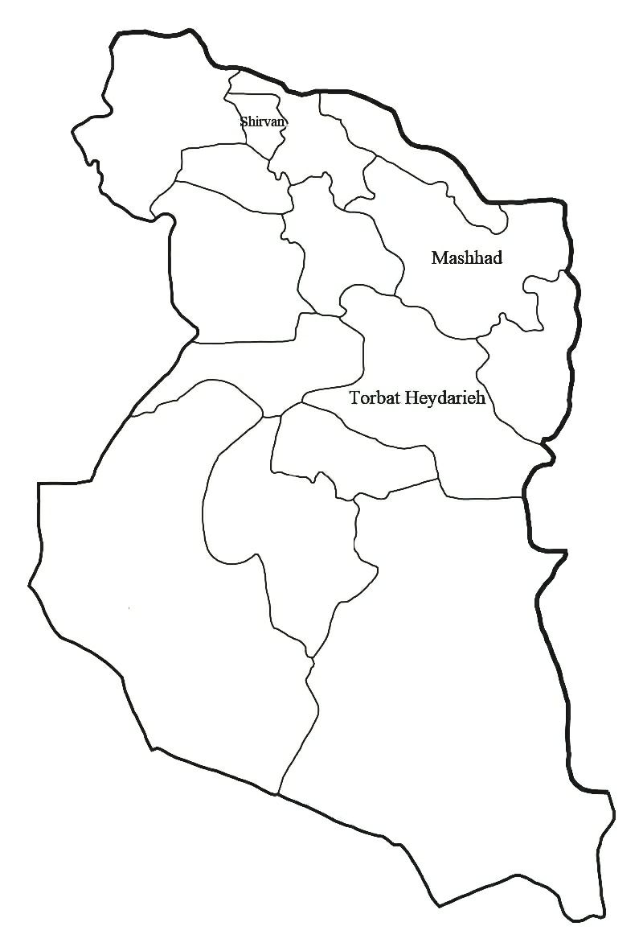
Figure 1S Map of Northeastern Iran and Study Areas (Mashhad, Jolgeh rokh Torbat Heydarieh, and Shirvan).
The distance from Ferdowsi University of Mashhad to Jolgeh Rokh Torbat Heydarieh is approximately 121 kilometers. The distance from Jolgeh Rokh Torbat Heydarieh to the Dryland Agricultural Research Institute (Shirvan Station) is approximately 321 kilometers. Additionally, the distance from Ferdowsi University of Mashhad to the Dryland Agricultural Research Institute (Shirvan Station) is approximately 200 kilometers.
Figure 2S Distribution of chickpea genotypes based on the first two components in three regions.
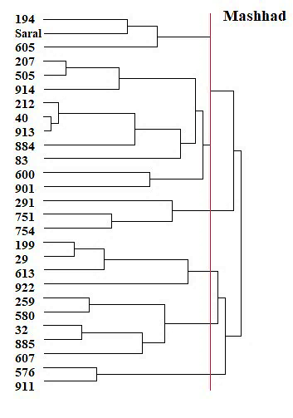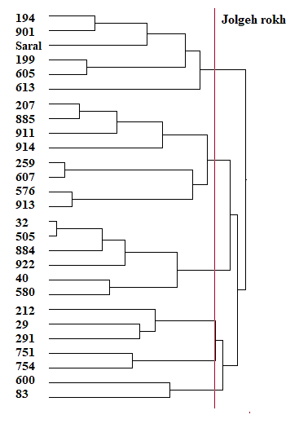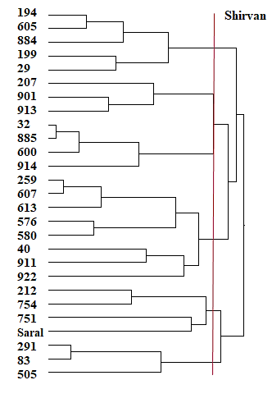
Figure 3S Dendrogram illustrating the cluster analysis of the 27 chickpea genotypes using Ward's method and the Euclidean distance.

