Protein profiling by SDS-PAGE: -

L- for Ladder in kDa (Molecular weights = 35-245 kDa) and C = control, MF = magnetic field, MW = magnetized water

L C MF MW C MF MW

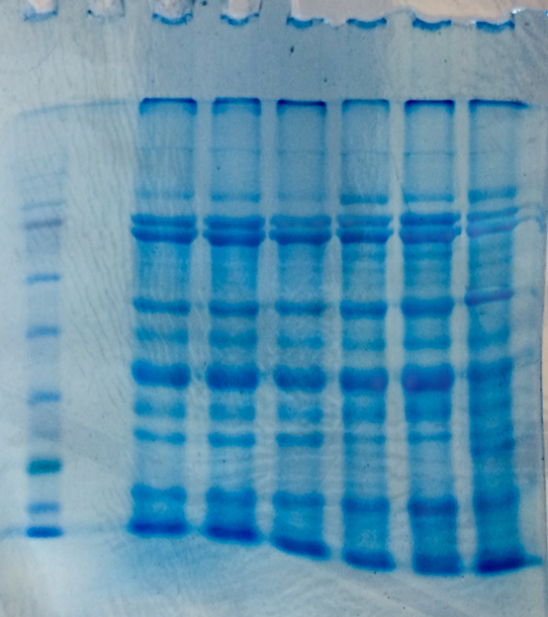

Fig. 9a. SDS‒PAGE profiling of the KDS-344 and MACS-1188 soybean varieties.

L C MF MW C MF MW
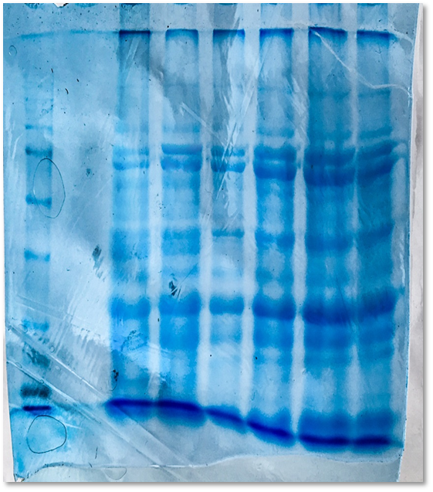
Fig. 9b. SDS‒PAGE profiling of the MACS-1281 and JS-9305 soybean varieties

Fig. 9. SDS‒PAGE profiling of the KDS-344, MACS-1188, MACS-1281 and JS-9305 soybean varieties (C = control, MF = magnetic field, MW = magnetized water, kDa = kilodaltons, molecular weights = 35–245 kDa).

Determination of available nitrogen, phosphate and potassium in soil.

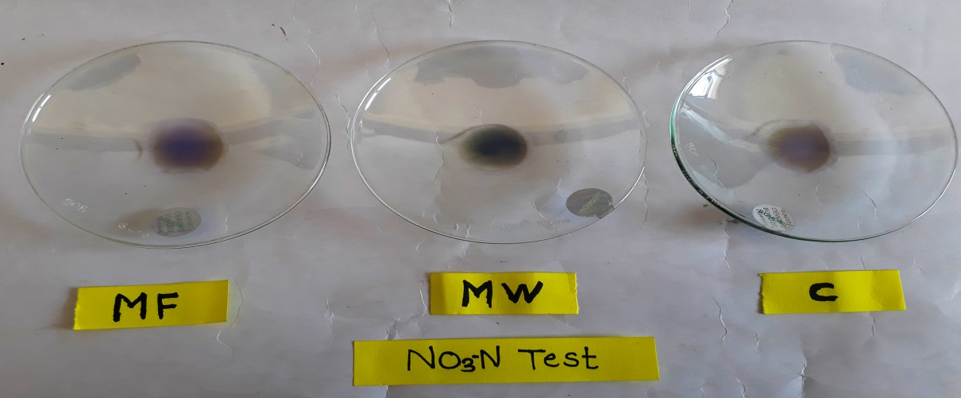
Determination of available nitrogen in soil
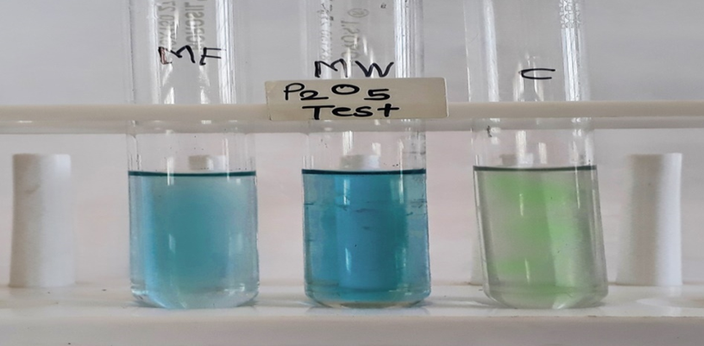
Determination of available phosphate (P₂O₅) in soil
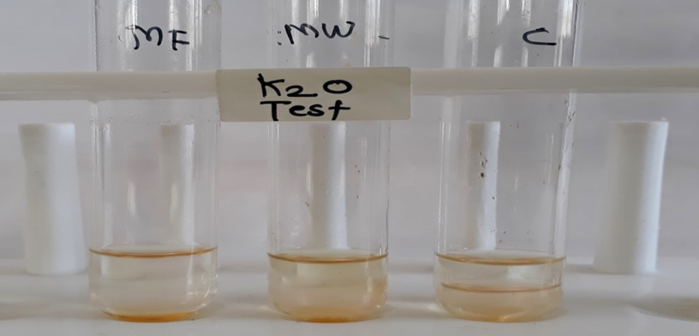
Determination of available potassium in soil

