Figure 1: Life cycle and infection mechanism of Fusarium spp. associated with wilt disease in brinjal (Solanum melongena L.)
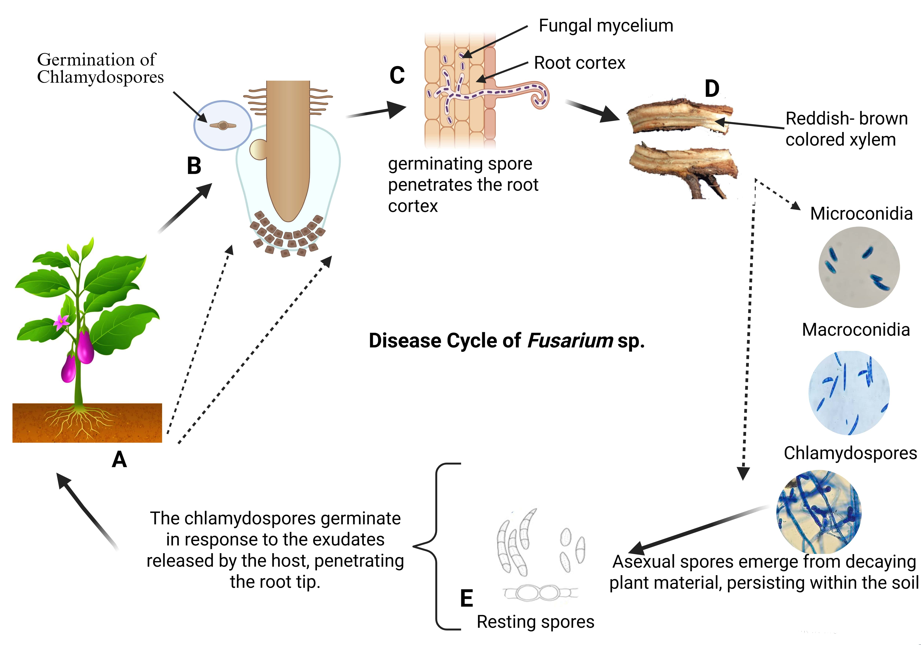

Supplementary Figure Captions
Supplementary Figure 1. Life cycle and infection mechanism of Fusarium spp. associated with wilt disease in brinjal (Solanum melongena L.)
Schematic representation of the infection process and disease cycle of Fusarium spp. in brinjal. (A) Brinjal plant showing wilt symptoms. (B) Germination of chlamydospores in response to root exudates. (C) Penetration of the root cortex by germinating spores and development of fungal mycelium. (D) Vascular discoloration due to colonization of the xylem tissue. (E) Formation of resting structures including microconidia, macroconidia, and chlamydospores which persist in the soil and contribute to disease recurrence.

