Supplementary Table 1: Correlations between soil available nutrients with yield attributing parameter of black cumin
 | pH | EC | OC | N | P | K | Fe | Mn | Cu | Zn | YIELD
pH | 1
EC | 0.358 | 1
OC | .415* | .981** | 1
N | 0.369 | .977** | .971** | 1
P | 0.344 | .985** | .971** | .972** | 1
K | 0.372 | .981** | .978** | .991** | .963** | 1
Fe | 0.233 | .934** | .899** | .923** | .943** | .912** | 1
Mn | 0.253 | .963** | .958** | .945** | .970** | .948** | .965** | 1
Cu | -0.140 | -.463* | -.386* | -.392* | -0.365 | -.436* | -0.203 | -0.298 | 1
Zn | 0.239 | .898** | .901** | .838** | .887** | .872** | .894** | .953** | -0.288 | 1
YIELD | 0.261 | .890** | .861** | .860** | .928** | .848** | .928** | .918** | -0.200 | .836** | 1
*. Correlation is significant at the 0.05 level (2-tailed).
**. Correlation is significant at the 0.01 level (2-tailed).

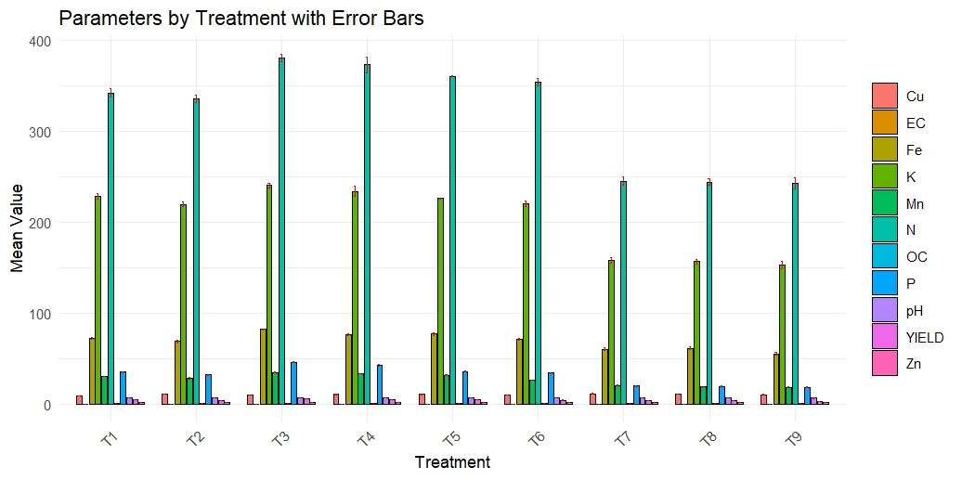
Supplementary Figure 1: The graph illustrates the mean values of key soil and nutrient parameters (pH, EC, OC, N, P, K, Fe, Mn, Cu, Zn) and the corresponding crop yield (YIELD) for each treatment, with error bars representing the standard error of the mean.

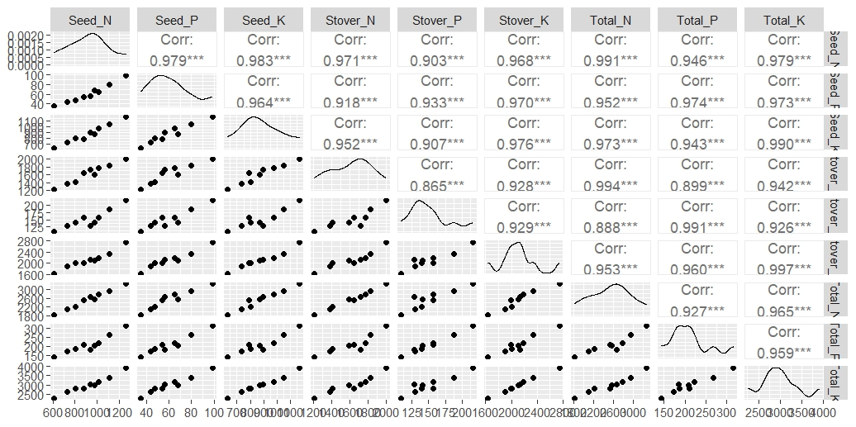

Supplementary Figure 2: Correlation plot of nutrient uptake of N, P and K (seed, stover, and total) across treatments (T1–T9).

