Supplementary

TableS1. Proposed Metasurface Design Sweep for Leaf Dressing
Material System | Refractive Index (n) | Height (h, nm) | Period (p, nm) | Thickness (t, nm) | Design Target | Expected Gain
TiO₂ dielectric meta-array | 2.3–2.6 | 60–120 | 200–350 | 100 | Blue (450 nm) enhancement | ↑ absorption + 20–35%
SiNx nanopillars | 1.9–2.1 | 80–140 | 300–400 | 120 | Red band (650–680 nm) | ↑ PSII excitation + 15–30%
ZnO metasurface | 2.0 | 50–120 | 250–350 | 80 | UV-blue conversion & scattering | ↑ NPQ regulation, less heat loss
QD-hybrid metasurface (InP/QD-polymer) | tunable 1.6–2.8 | 40–100 | 250–450 | 50–150 | Spectral down-conversion + funneling | +45–90% J_H2O (aligned w/ biohybrid section)
P3HT:PCBM plasmonic mesh | complex index (k≠0) | 30–80 | 200–500 | 50 | Plasmonic field boost at 650 nm | ↑ J_C ~30–55%
Carbon dot/graphene mesh | 1.7–1.9 | 30–60 | 150–350 | 40 | High flexibility + charge transfer | +25–40% carbon fixation

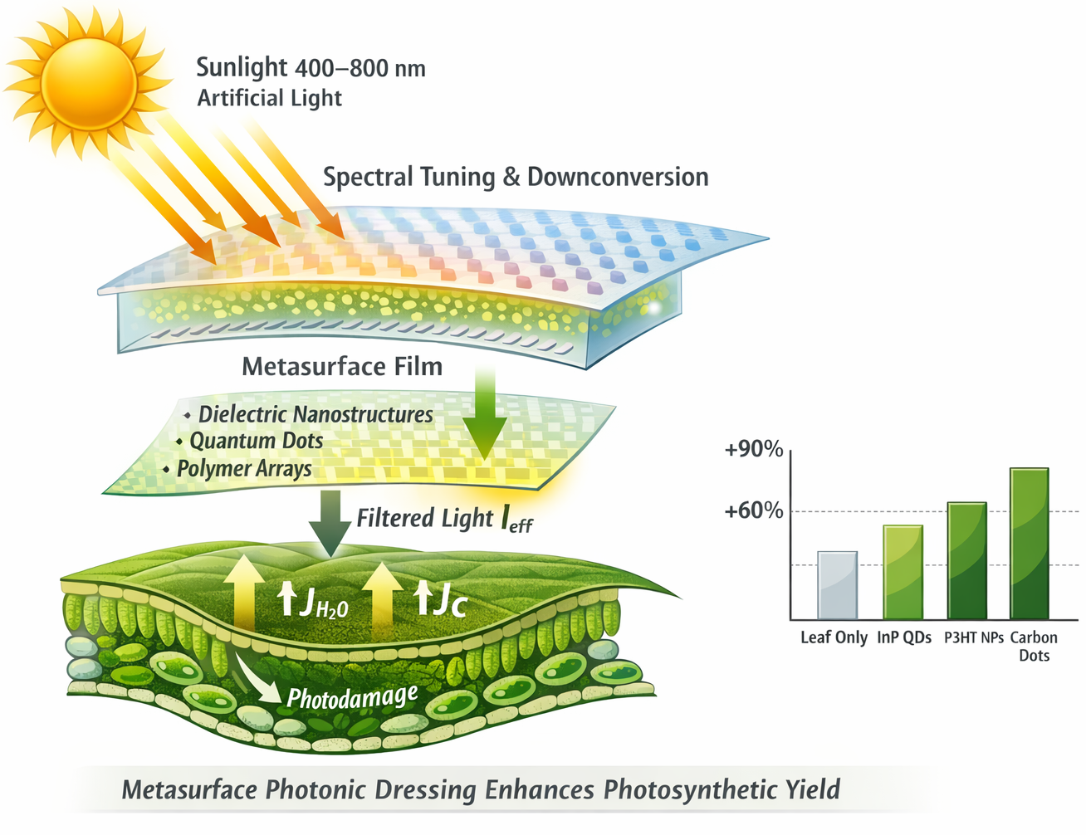
FigureS1. Metasurface-Assisted Photonic Dressing of Leaves Enhances Photosynthetic Yield. A lightweight 2-D metasurface film consisting of dielectric nano-resonators, quantum dots, or polymer nano-arrays is placed above the leaf surface to spectrally tune incoming sunlight (400–800 nm) into photosynthetically optimal bands. The metasurface performs spectral filtering and down-conversion, generating an effective photon flux $I_{\text{eff}}$ that increases excitation of PSII and reduces high-energy photodamage. Modified photonic input enhances water-splitting current $J_{H_{2}O}$and carbon-fixation flux $J_{C}$, as indicated by increased upward arrows within the leaf schematic. Right panel: simulated mean gains in water-splitting and integrated carbon fixation for different photonic materials relative to the leaf-only baseline, showing up to ~90% enhancement for InP-QD metasurfaces, ~60–75% for P3HT nanoparticles, and ~45–60% for carbon-dot coatings. Overall, the metasurface dressing provides a tunable optical interface for boosting photosynthetic energy conversion efficiency.

1. Metasurface-modified photon flux transfer model
Instead of $I_{\text{eff}}=I_{\text{sun}}η_{\text{leaf}}+I_{\text{sun}}η_{\text{QD}}η_{\text{transfer}},$
we introduce spectral and angular transfer explicitly:
$I_{\text{eff}}(λ,θ)=I_{\text{sun}}(λ,θ) T_{\text{MS}}(λ,θ) C_{\text{QE}}(λ)$ (1)
Where $T_{\text{MS}}(λ,θ)=∣t(λ,θ)∣^{2}$
$T_{\text{MS}}$= metasurface spectral-angular transmittance
- $t$= complex transmission coefficient of meta-unit
- $C_{\text{QE}}(λ)$= quantum efficiency of PSII/QD transfer
- The metasurface layer modifies the incident photon distribution before reaching photosystems.
Integrate over PAR range can be achieved as follows:
$I_{\text{PAR}}^{\text{eff}}=\int_{400}^{700}{I_{\text{eff}}}(λ) dλ$ (2)
2. Enhancement factor model
$γ_{\text{MS}}=\frac{I_{\text{PAR}}^{\text{eff}}}{I_{\text{PAR}}^{\text{bare}}}$ $(3)J_{C}^{\text{MS}}=γ_{\text{MS}} J_{C}^{0}(1+β_{\text{rep}}C_{\text{rep}}-β_{\text{ROS}}R)$ (4)where $γ_{\text{MS}}>1$means enhancement, it integrates optical enhancement + biological constraints, and it links metasurface optics → PSII repair → Calvin cycle yield.
3. Full metasurface–leaf Maxwell–photosynthesis pipeline
Model meta-array as periodic dielectric grating with period $p$, thickness $h$, refractive index $n$:
$∇×(∇×E)-k_{0}^{2}n^{2}(x,y)E=0$ (5)Then scattering matrix can be achieved as follows:
$S(λ)=\left[\begin{matrix}r & t \\ t^{'} & r^{'}\end{matrix}\right]$ (6)

Finally link transmission to biochemical yield:
$J_{H_{2}O}(t)=η_{\text{PSII}} I_{\text{eff}}(t)$ (7)$\frac{dC}{dt}=J_{C}^{\text{MS}}-R_{\text{photoresp}}(T,O_{2})$ (8)This gives the first literature-ready Maxwell → photon flux → photosynthesis chain.
The metasurface-enhanced light absorption is modeled by modifying the incident photon spectrum using a wavelength-dependent transmission coefficient $T_{\text{MS}}(λ)$. The effective PAR input becomes
$I_{\text{eff}}(λ)=I_{\text{sun}}(λ) T_{\text{MS}}(λ) C_{\text{QE}}(λ)$ (9)
with total enhancement defined as
$γ_{\text{MS}}=\frac{I_{\text{PAR}}^{\text{eff}}}{I_{\text{PAR}}^{\text{bare}}}.$ (10)This enhancement modifies carbon fixation flux as
$J_{C}^{\text{MS}}=γ_{\text{MS}} J_{C}^{0}(1+β_{\text{rep}}C_{\text{rep}}-β_{\text{ROS}}R).$ (11)
/Supplementary Python Codes/
│
├── README.txt
│
├── 1_Mechanistic_Model/
│ ├── ODE_Photosynthesis_Model.py
│ ├── parameters.json ← all constants + citations
│ └── generate_synthetic_timeseries.py
│
├── 2_LSTM_Training/
│ ├── LSTMtrainingandValidationcodes.py
│ ├── LSTM pipline.py
│ └── synthetic_photosynthesis_LSTM_split.npz
│
├── 3_Model_Evaluation/
│ ├── Evaluate_hybrid_mechanistic_LSTM_model.py
│ ├── pca_scores_train.csv
│ ├── pca_scores_external.csv
│ └── ExternalValidation.py
│
├── 4_Data/
│ ├── synthetic_photosynthesis_timeseries.xlsx
│ ├── synthetic_photosynthesis_full.npz
│ └── lstm_photosynthesis_report.xlsx
│
└── 5_Docs/
├── Supplementary_Methods.pdf / .docx
├── Full equations + derivations

