Supporting Information

Plant-Mediated Synthesis of Silver Nanoparticles from Vinca rosea and Their Application Against Wheat Pathogenic Fungi
Ramandeep Kaur, ª*# Parul Sharma^{b#}, and Urvashi Bhardwajª
ªDepartment of Chemistry, College of Basic Sciences and Humanities, Punjab Agricultural University, Ludhiana, India-141004
^{b}Department of Chemistry, Oklahoma State University, Stillwater, Oklahoma, USA-74075
*Corresponding author- ramansaini@pau.edu

Methods and Procedures
The information regarding the various experimental procedures utilized during the research work is provided as follows. Reagents, instruments, extraction, and purification techniques (such as thin layer chromatography (TLC) and column chromatography) used for the extraction and isolation of bioactive compounds from the extracts of leaves of V. rosea are mentioned, along with the antifungal studies of all the extracts and isolated compound against the wheat fungi Fusarium graminearum and Bipolaris sorokiniana. GC-MS data were obtained from the Central Instrumentation Laboratory (CIL), Panjab University, Chandigarh. FT-IR spectra were performed using the Perkin Elmer-Spectrum RX-IFTIR spectrophotometer, available at the Department of Soil Science, Punjab Agricultural University (PAU) Ludhiana. SEM was obtained at Sophisticated Analytical Instrumentation Facility (SAIF), Panjab University, Chandigarh. The same chemical shifts were shown using δ (ppm) values, and the abbreviations ‘s,’ ‘d’, ’t,’ and ‘m’ were expressed for singlet, doublet, triplet, and multiplet, respectively. LC-MS spectra were recorded at the Sophisticated Analytical Instrumentation Facility (SAIF), Panjab University, Chandigarh, using Waters Micromass Q-Tof Micro. UV-visible spectra were recorded at the Central Laboratory, Department of Chemistry, Punjab Agricultural University (PAU), Ludhiana. Mineral analysis of leaves of V. rosea was carried out by the Department of Soil Science, Punjab Agricultural University (PAU), Ludhiana, using Inductively Coupled Plasma Atomic Absorption Emission Spectroscopy (ICP-AES).

MATERIALS
The various adsorbents, reagents, solvents, and apparatus used during the experiments are listed below:
Adsorbents
- Aluminium oxide (Al₂O₃) activity grade III for column chromatography: S.D. Fine Chemicals Limited
Pore size: ~150 mesh
pH value: 6.0
Chlorides: 0.06%
Silicate: <0.03 per cent
- Silica gel GF 254 for thin layer chromatography (TLC): Qualigens fine chemicals, Mumbai
Pore size: 0.7-0.85 cm³/g
pH value: 7±0.5
Chlorides: 0.02 per cent
- Silica gel G for thin-layer chromatography: S.D. Fine Chemicals Limited
pH value: 7
Chlorides: 0.02 per cent
Iron: 0.02 per cent
CaSO₄: 13.0 per cent
Chemicals and Solvents
Chemicals
- Agar-Agar, Aluminium chloride, Copper sulfate, Dextrose, Ferric chloride, Folin-Ciocalteu reagent, Potassium acetate, Potassium hydroxide, Sodium hydroxide, Sodium carbonate, Tween 80, Vanillin - S.D. Fine Chemicals Limited, Mumbai.
- Sodium sulfate, Activated charcoal – Qualigens Fine Chemicals, Bombay.
Solvents
- Acetone, n-butanol, Diethyl ether, Glacial acetic acid, Ethanol, Methanol, Petroleum ether, Ammonia, Hydrogen chloride, Sulfuric acid - S.D. Fine Chemicals Limited, Mumbai.
- Benzene, Chloroform, Hexane - LobaChemie Private Limited, Mumbai.

PROXIMATE ANALYSIS OF V. rosea LEAVES AND FLOWERS
The leaves and flowers of V. rosea were collected, shade-dried, and powdered. Proximate analysis of powdered leaves and flowers of V. rosea for moisture, dry matter, ash, acid-insoluble ash, water-soluble ash, fat, protein, carbohydrate, crude fiber, and nitrogen content was performed following the procedure given in the AOAC (2005).
Moisture content and dry matter determination
The moisture content of V. rosea leaves and flower powder was obtained by taking 2.0 g of fresh leaves and flower samples in a dried silica crucible. The sample was heated for a period of 3 h in the moisture extraction oven at 105 ºC. After that, the sample was kept in the desiccator and reweighed after cooling. The percentage of moisture content of leaves and flowers was calculated as follows:
Moisture (%) = $\frac{\text{Loss in weight }(g)}{\text{Original weight of sample }(g)}$×100
Dry matter (%) = 100 - % moisture
Ash content determination
The Ash content of V. rosea leaves and flower powder was determined by taking 2.0 g of the sample in the crucible, and then it was dried in the oven for 3 h at 100 °C. Then, it was in the muffle furnace at 550 °C till it became white and carbon-free. The crucible was removed from the furnace and kept in the desiccator until it cooled. Then, the crucible was reweighed after cooling. The weight of the residue ash was calculated using the formula as follows:
Ash (%) = $\frac{\text{Weight after ignition }(g)}{\text{Weight of sample }(g)}$×100
Acid insoluble ash determination
The acid-insoluble ash content of V. rosea leaves and flower powder was obtained by boiling 0.2 g of ash sample and 25.0 ml of 3N hydrochloric acid (HCl) for 5 min and then collecting the insoluble matter. The insoluble matter left behind was dried, cooled, and then weighed. The acid-insoluble ash content was determined by using the formula:
Acid insoluble ash (%) = $\frac{\text{(Weight of ash taken - weight of acid insoluble ash) × ash content}}{\text{Weight of ash taken (g)}}$× 100
Water Soluble ash determination
Water-soluble ash content was measured using the ash sample of powdered leaves and flowers of V. rosea. 1.0 g of ash sample was subjected to boiling along with 25.0 ml of distilled water for 5 min. The insoluble material was collected and dried, ignited, and reweighed. The percentage of water-soluble ash content was determined by using the formula:
Water soluble ash (%) = $\frac{\text{(Weight of ash taken - weight of ash after ignition) × ash content}}{\text{Weight of ash taken (g)}}$× 100
Fat content determination
The fat content of the sample was estimated using a soxhlet extractor with continuous refluxing for a period of 14-16 h. It was determined by taking a 5.0 g sample of leaves and flowers of V. rosea in a thimble. The sample was placed in the soxhlet extraction apparatus along with 50.0 ml of petroleum ether at 60 °C for a period of 16 h. The solvent obtained after the extraction was distilled off and evaporated using a rotatory vacuum evaporator. The residue left behind was weighed, and the fat content of the leaves and flowers of V. rosea was calculated using the formula:
Fat (%) = $\frac{\text{Weight of extract }(g)}{\text{Weight of sample }(g)}$×100
Estimation of crude protein and nitrogen content determination
After soxhlet extraction of 20.0 g of powdered leaves and flowers of V. rosea using petroleum ether at 40-60 ºC, the residue obtained was heated separately with 20.0 ml of concentrated sulfuric acid (H₂SO₄) along with the mixture of potassium sulfate: copper sulfate (98:2) in the long-necked Kjeldahl flask. Nitrogen present in the sample is converted into ammonium sulfate ((NH₄)₂SO₄), which is further boiled with 12-16 ml of 60% sodium hydroxide (NaOH) to liberate ammonia gas (NH₃). The ammonia gas released is passed through the conical flask containing 10.0 ml of 2% boric acid (H₃BO₃) till 20-40 ml of distillate is collected. Excess of ammonia was titrated using 0.1N concentrated sulfuric acid mixed with methyl red: methylene blue (2:1) indicator. The endpoint of the titration was obtained at the reversion of the color to greenish-blue. For blank boric acid, the indicator was run along with the sample. The nitrogen and protein content of the leaves and flowers of V. rosea was calculated using the following formula:
Nitrogen (%) = $\frac{\text{(ml standard acid - ml blank) × N of acid ×14 × 100}}{\text{Original weight of sample taken }(g)}$
Crude protein (%) = % Nitrogen × 6.25
Crude Fiber content determination
A 5.0 g fat-free sample of V. rosea leaves and flowers was mixed with 200.0 ml of 1.25% sulfuric acid (H₂SO₄) for 30 min. The sample mixture was filtered using a Buchner funnel and washed with distilled water until it became acid-free. The residue collected was boiled again with 200.0 ml of 1.25% sodium hydroxide (NaOH) for 30 min. It was again filtered and washed several times with distilled water until it became alkali-free. The residue collected was washed twice with 10% hydrochloric acid (HCl), then with ethanol twice, followed by petroleum ether thrice. The residue left behind of leaves and flowers sample was kept in the crucible and dried overnight at 105 ºC in an oven. The sample was placed in the desiccator, and then after cooling, it was ignited in a muffle furnace for 45 min at 500 ºC to obtain the final weight of the residue.
Crude Fiber (%) = $\frac{\left(\begin{aligned}&Weight of crucible+ \\ &dried residue before ashing\end{aligned}\right)-\left(\begin{aligned}&Weight ofcrucible+ \\ &content of ashing\end{aligned}\right)}{\text{Original weight of sample }(g)}$×100
Carbohydrate content estimation
The Carbohydrate content of the leaves and flowers of V. rosea was determined by subtracting the total of ash, fat, protein, and crude Fiber by using the following formula:
Carbohydrate (%) = 100- (Protein + Fat + Ash + Crude Fiber)
Table S1: Proximate analysis of leaves and flowers of V. rosea
Composition | Leaves | Flowers
Acid insoluble ash | 0.27±0.028 | 0.21±0.021
Ash content | 8.66±0.395 | 8.36±0.127
Carbohydrate | 41.165±1.294 | 31.2±0.148
Crude fibre | 1.93±0.113 | 1.03±0.028
Dry matter | 28.65±1.202 | 56.5±0.466
Moisture content | 71.35±1.202 | 43.1±0.021
Nitrogen content | 1.325±0.035 | 0.6±0.113
Protein content | 8.145±0.091 | 4.06±0.120
Fat content | 5.93±0.070 | 6.25±0.212
Water soluble ash | 1.495±0.685 | 1.01±0.042
The results were expressed as Mean ± Standard deviation.
MINERAL ANALYSIS
The macro and micronutrients of the leaves and flowers of V. rosea were determined according to the methodology given by Biswas et al. (2017). A powdered sample of leaves and flowers (1.0 g) was digested with dilute nitric acid (HNO₃) in the ratio of 2:1 (conc. HNO₃: distilled water). The mixtures of the sample were boiled vigorously till all the organic substances in it were decomposed. Then, the mixtures were allowed to cool at room temperature. Double distilled water (H₂O) was used to filter the mixtures. The residues left behind were washed repeatedly with dilute nitric acid (HNO₃). The quantitative analysis used inductively coupled plasma atomic emission spectroscopy (ICP-AES).
Elements | Leaves | Flowers
Aluminium | 27.8 | 24.5
Calcium | 2066 | 345.37
Cadmium | 0.058 | 0.043
Chromium | 1.035 | 0.89
Copper | 12.2 | 4.06
Iron | 969 | 535
Potassium | 11394 | 11566
Magnesium | 4087 | 1394
Manganese | 227 | 34.92
Sodium | 1930 | 945
Lead | 1.23 | 0.94
Zinc | 45.7 | 95.37
Phosphorous | 1841 | 1536
Table S2: Mineral analysis of V. rosea leaves and flowers powder

The results were expressed in mg/kg.
QUANTITATIVE ANALYSIS OF PLANT SAMPLE
Quantitative analyses of the powder of leaves and flowers of V. rosea for alkaloid, saponin, phenol, tannin, flavonoid, and glycoside content were performed in accordance with the procedure given by Khan et al. (2011a, 2011b).
Alkaloid determination
A sample of 10.0 g of powdered leaves and flowers of V. rosea was weighed into a beaker separately. 200.0 ml of 10% acetic acid (CH₃COOH) in ethanol (C₂H₅OH) was added to the sample. Then, it was allowed to stand for 4 h. The extract obtained was filtered and concentrated on the rotary evaporator to one-fourth of its volume. Then, the concentrated ammonium hydroxide (NH₄OH) was added dropwise into the extract until the precipitation was complete. The solution was allowed to stand undisturbed till the precipitates settled completely. Precipitates were collected, and the supernatant was decanted off; then, the precipitates were washed with dilute ammonium hydroxide (NH₄OH), filtered, and weighed. The percentage of the alkaloid content was calculated using the formula:
Alkaloid content (%) = $\frac{\text{Weight of the precipitate }(g)}{\text{Original weight of sample }(g)}$×100
Saponin determination
20.0 g powder of V. rosea leaves, and flowers were weighed in a beaker, and 100.0 ml of 20% aqueous ethanol (C₂H₅OH) was added to it. Then, the beaker was heated in the water bath at 55 °C with constant stirring for 4 h. The mixture was filtered, and the residue was again subjected to extraction with 200.0 ml of 20% ethanol (C₂H₅OH). The extract obtained from both extractions was combined and evaporated using a rotary evaporator to one-fourth of its volume. The extract obtained after reduction was transferred into a separatory funnel, and 20.0 ml of diethyl ether was added to it with constant stirring. The aqueous layer obtained after stirring was collected, and the diethyl ether layer was discarded. The process for purification was repeated by adding 60.0 ml of n-butanol (C₄H₁₀O). The combined n-butanol extracts were washed again and again with 10.0 ml of 5% aqueous sodium chloride (NaCl). The remaining solution obtained was evaporated using a water bath. After complete evaporation, the sample obtained was dried in the oven, cooled, and weighed. The percentage of saponin content was calculated using the formula given:
Saponin content (%) = $\frac{\text{Weight of the extract obtained }(g)}{\text{Original weight of the sample }(g)}$×100
Phenol determination
The phenolic content of powdered leaves and flowers was determined by defatting 2.0 g of sample with 100.0 ml of diethyl ether ((C2H5)2O) for 2 h in the Soxhlet extraction apparatus. Then, the fat-free sample was further boiled with 50.0 ml of diethyl ether for 15 minutes to extract phenolic content. 5.0 ml of extract was pipetted into a 50.0 ml beaker, and then 10.0 ml of distilled water was added. 2.0 ml of ammonium hydroxide solution (NH₄OH) and 5.0 ml of concentrated amyl alcohol (C₅H₁₂O) were added. The sample was made up to the mark and kept in the dark for 1 h. A UV-visible spectrophotometer measured the absorbance of color at λ=505 nm. The results are expressed as milligrams of gallic acid equivalents per gram of dry weight (mg GAE/g dw).
Tannin determination
Tannin content was determined by dissolving 1.0 g of a sample of leaves and flowers into 50.0 ml of distilled water in a conical flask. The flask was shaken in the mechanical shaker for a period of 2 h, and then the filtrate was collected in 50.0 ml of volumetric flask and made up to the mark using distilled water. 5.0 ml of filtrate was pipetted out into the test tube and was mixed with 2.0 ml of 0.1 M ferric chloride (FeCl₃) in 1.0 ml of 0.1 N hydrochloric acid (HCl) and 0.008 M potassium ferrocyanide (K₄Fe (CN)₆). The sample was kept in the dark for 30 min. The absorbance of the color was measured using a UV-visible spectrophotometer at λ=120 nm. The results are expressed as milligrams of gallic acid equivalents per gram of dry weight (mg GAE/g dw).
lFlavonoid determination
The Flavonoid content of the leaves and flowers of V. rosea was determined by repeatedly extracting 10.0 g of each plant sample with 100.0 ml of 80% methanol (CH3OH) at room temperature. The solution was filtered through Whatman filter paper No. 2. The filtrate was evaporated using a rotary evaporator. The mixture was incubated for 5 min, and then 0.15 ml of 10% aluminium chloride (AlCl3) solution was added to it and allowed to stand for 10 min. Then 2.0 ml of 4% sodium hydroxide (NaOH) solution was added, and the volume was made to the 5 ml mark using distilled water. The mixture was vortexed and then kept in the dark for 15 min at room temperature. The mixture was shaken well and left as such for 15 min at room temperature. The appearance of the pink color showed the presence of flavonoids. The absorbance of the color was measured using a UV-visible spectrophotometer at λ=510 nm. The total flavonoid content is expressed as milligrams of quercetin equivalent per gram of dry weight (mg QE/g dw) based on the standard curve.
Glycoside determination
For glycoside determination, 10.0 g of dried powdered leaves and flowers of V. rosea and 250.0 ml of methanol were subjected to Soxhlet extraction. Again, the powdered sample was subjected to a Soxhlet extractor using 250.0 ml of methanol, and the filtrate was collected. The alcoholic extract was then treated with lead acetate solution to precipitate proteins, coloring matter, tannins, and other non-glycoside parts. The precipitate was filtered out, and the filtrate was collected in a conical flask. Hydrogen sulfide (H₂S) gas was passed through the filtrate to remove excess lead as lead sulfide (PbS) precipitates, which were then removed by filtration. The filtrate obtained was evaporated to dryness using a rotary evaporator or water bath. The residue was dried, collected, and weighed. The glycoside content was calculated according to the formula:
Glycoside content (%) = $\frac{\text{Weight of the precipitate obtained }(g)}{\text{Original weight of sample }(g)}$×100
Quantitative analysis of V. rosea leaves and flower powder
Composition | Leaves | Flowers
Alkaloid | 13.25 ±0.42 | 5.55 ±0.47
Phenol | 0.32 ±0.01 | 0.42 ±0.03
Tannin | 0.75 ±0.02 | 0.85 ±0.04
Flavonoid | 0.51 ±0.04 | 0.63 ±0.05
Saponin | 0.47 ±0.02 | 0.35 ±0.04
Glycoside | 1.815 ±0.09 | 0.72 ±0.02

The results were expressed as Mean ± Standard deviation.

PREPARATION OF EXTRACTS USING DIFFERENT EXTRACTION TECHNIQUES
Extracts were prepared using different extraction techniques (maceration, sonication, and Soxhlet extraction) and solvents (methanol, acetone, chloroform, and hexane) to compare their yield and phytochemical constituents.
Maceration extraction technique:
Dried leaves and flower powder (50.0 g) were extracted by maceration technique at room temperature using different solvents (100.0 ml), i.e., methanol, ethanol, acetone, aqueous, chloroform, and hexane, for 48 h for each solvent. The extracted solutions were filtered using Whatman filter paper No. 2, and the excess solvent was evaporated using a rotary evaporator and stored at 4 ºC for further analysis.
Sonication extraction technique:
Dried leaves and flower powder (50.0 g) of V. rosea in 100.0 ml of solvent (methanol, ethanol, acetone, aqueous, chloroform, and hexane) were subjected to sonication extraction technique by using SB-5200 DTDN ultrasonic cleaner for 10, 20 and 30 min respectively. The extracts were filtered, and excess solvent was evaporated under reduced pressure and stored at 4 ºC for future use.
Soxhlet extraction method:
Dried leaves and flower powder (50.0 g) of V. rosea were used to prepare a plant extract using 100.0 ml of solvent (methanol, ethanol, acetone, aqueous, chloroform, and hexane). Soxhlet extraction was carried out for 24 hours. The extract was evaporated and stored in the refrigerator at 4 ºC for further use.
Yield estimation
The percentage yield (w/w) of various extracts prepared using three different extraction techniques was calculated using the formula:
Yield (%) = $\frac{\text{Weight of extract recovered}}{\text{Weight of dry powder}}$× 100
Yield of extracts obtained from leaves and flowers of V. rosea plant
Extract | MA | SX | SOª | SO^{b} | SO^{c} | MA | SX | SOª | SO^{b} | SO^{c}
 | Leaves |  |  |  |  | Flowers
Methanol | 9.3 | 8.5 | 8.2 | 8.4 | 8.7 | 8.9 | 9.6 | 8.5 | 8.8 | 9.1
Acetone | 8 | 7.6 | 6.9 | 7.3 | 7.7 | 7.8 | 8.3 | 7.2 | 7.5 | 7.8
Chloroform | 5 | 3.8 | 2.8 | 3.4 | 3.9 | 4.1 | 5.3 | 3.9 | 4.4 | 4.8
Hexane | 4.4 | 4.5 | 2.1 | 2.8 | 3.6 | 3.9 | 5.7 | 3.3 | 3.7 | 4.1
The data mentioned above are expressed in Percentage (%).
MA- Maceration (48 h), SX- Soxhlet (24 h), SO-Sonication (10ª, 20^{b} and 30^{c} min)

QUALITATIVE ANALYSIS OF EXTRACTS
Qualitative analysis of various extracts of leaves and flowers of V. rosea was carried out using the procedure given by Parbuntari et al. (2018), Gul et al. (2017), and Kapoor and Rani (2019).
Alkaloids: The extracts (1.0 ml) were taken in the test tubes, and 2.0 ml of concentrated hydrochloric acid (HCl) was added into it along with a few drops of Mayer’s reagent, which is prepared by mixing 1.36 g of mercuric chloride (HgCl₂) and 5.0 g of potassium iodide (KI) in 100.0 ml of water. The formation of yellow-colored precipitates detected the presence of alkaloids.
Amino acids: 2.0 ml of extract was taken in the test tubes and treated with one drop of 2% copper sulfate solution (CuSO₄). To this, 1.0 ml of 95% ethanol (C₂H₅OH) followed by an excess of potassium hydroxide (KOH) pellets. The purple color in the ethanolic layers indicated the presence of amino acids.
Carbohydrates: 1.0 ml of the extract and 1.0 ml of Fehling solutions A and B were boiled in a water bath. The Formation of a red precipitate indicated the presence of carbohydrates.
Flavonoid: 0.5 ml of extract was taken in the test tubes separately. Then, a few pieces of magnesium turnings were added to the solution, along with a few drops of concentrated hydrochloric acid (HCl). The formation of a red or pink solution indicated the presence of flavonoids.
Glycosides: 1.0 ml of glacial acetic acid (CH₃COOH) was added into 2.5 ml of plant extract, followed by the addition of 1 drop of 2.0% ferric chloride solution (FeCl₃) and 0.5 ml of concentrated sulfuric acid (H₂SO₄). The formation of a reddish-brown steroidal ring indicated the presence of glycosides.
Phenol: The presence of phenols was tested by adding 3-4 drops of ferric chloride (FeCl₃) to 2.0 ml of plant extract. The formation of a dark green color solution indicated the presence of phenol.
Saponin: 1.0 ml of plant extract and 5.0 ml of distilled water (H2O) were taken in the test tubes. The obtained mixture was subjected to a vortex and shaken vigorously. The formation of stable foam indicated the presence of saponin.
Tannins: 2.0 ml of plant extract was treated with 10% alcoholic ferric chloride solution (FeCl₃). The appearance of the solution's dark blue or greenish-grey color indicated the presence of tannins.
Terpenoids: 1.0 ml of extract and 1.0 ml of chloroform (CHCl3) were taken in the test tubes. Then, concentrated sulfuric acid (H2SO4) was carefully added to form a layer. The appearance of a reddish-brown color at the interface showed the presence of terpenoids.
Cardiac glycoside: 5.0 ml of extract was mixed with 2.0 ml of sodium picrate reagent (C6H2N3NaO7). The mixture's yellow-to-orange color confirmed the presence of cardiac glycosides.
Phytochemical analysis of different extracts obtained from V. rosea leaves and flowers
Constituents | Methanol | Acetone | Chloroform | Hexane | Methanol | Acetone | Chloroform | Hexane
 | Leaves |  |  |  | Flowers
Alkaloids | + | + | - | - | + | + | - | -
Amino Acid | + | + | - | - | + | + | - | -
Carbohydrates | + | - | - | - | + | - | - | -
Flavonoids | + | + | + | + | + | + | + | +
Glycosides | + | - | - | - | + | - | - | -
Phenol | + | + | + | + | + | + | + | +
Saponin | + | + | - | + | + | + | - | -
Tannin | + | + | - | + | + | + | + | +
Terpenoid | + | + | + | + | + | + | - | +
Cardiac Glycosides | + | - | - | - | + | - | - | -
(+) = Presence and (-) = Absence

ISOLATION OF VINDOLINE FROM THE LEAVES OF V. rosea
Vindoline was isolated from the leaves of V. rosea using the procedure given in the patent by Jovanovic et al. (1978) with slight modifications. The isolation of specific alkaloids was performed by controlling the solution's pH level at every separation stage. Vindoline was extracted using the acidic pH of the solution.
For the extraction of vindoline alkaloid, a comprehensive process was followed. 250.0 ml of methanol, 65.0 ml of 2% of aqueous sulfuric acid, and 1.25 L of toluene were added to 250.0 g of dried leaves with constant stirring for 1 h 15 min. The exact amount of toluene (1.25 L) was added again twice to the above mixture. Then, the solution was filtered using the Whatman filter paper No. 2. The toluene phase was separated from the mixture in the separatory funnel using 1.25 L of 2% aqueous sulfuric acid. After the addition of sulfuric, two distinct layers were visible. The mixture was separated until no alkaloid traces could be detected (two different colored layers were visible). These phases were combined and labelled as aqueous acid solutions.
The next step was the meticulous separation of chlorophyll and other coloring agents from it. The acid aqueous layer obtained in the above step was shaken twice with 1.0 L of cyclohexane in the separatory funnel. Two layers obtained were formed. The green-colored layer (upper layer) was carefully discarded, and the lower layer was labelled an aqueous layer. The pH value of the aqueous layer was adjusted to 8.5-9 with 25% ammonium hydroxide solution. After changing the pH, the solution was extracted with 200.0 ml of cyclohexane four times. The cyclohexane layers obtained were combined and concentrated using a rotary evaporator. These layers contain a mixture of di-indole alkaloids, and the solution left behind was termed mother liquid I.
The next step involves diluting the solution of the mother liquid 1 using 1.5 L of distilled water. Then, the solution's pH was adjusted to 2.7-3.0 using glacial acetic acid. After changing the pH, the acid solution was extracted with 500 ml cyclohexane in the separatory funnel. This step was repeated five times, using 500 ml of cyclohexane each time. The acid aqueous layer was discarded, and all the cyclohexane layers were collected and evaporated to dryness using a rotary evaporator.
The residue was dissolved in 12.0 ml cyclohexane and shaken with 0.5 g of activated charcoal. Then, the mixture was passed through an alumina layer and washed with 150-200 ml of cyclohexane. The cyclohexane layer obtained after passing through alumina was evaporated to dryness using a rotary evaporator. Then, the residue was dissolved in 5.0 ml of diethyl ether and left undisturbed for 24 h to form needle-like crystals of vindoline (Pure compound 4) having mp 167 °C. Then, these crystals were subjected to spectral analysis to confirm their structure. It was recrystallized again to purify the compound.

250.0 g of dried leaves + 250.0 ml of methanol + 65.0 ml of 2% aqueous sulfuric acid + 1.25 L of toluene

1.25 L of toluene was added to the above mixture
Stir the mixture for 1.5 h

Mixture was filtered using Whatman filter paper No 2
The toluene phase was separated from aqueous phase with 1.25 L of 2% aqueous sulfuric acid (two layers are visible)

Chlorophyll and other coloring agents were separated from acid aqueous solution using 1.0 L of cyclohexane twice as two distinct layers were visible

The coloring reagent layer was discarded
The aqueous phase was separated and kept aside for further used

The pH value of aqueous phase obtained was adjusted between 8.5-9 with 25% ammonium hydroxide solution

The alkaline solution was then extracted using 200 ml of cyclohexane and this step was repeated 4 times with 200 ml of cyclohexane

All the cyclohexane layers were combined and evaporated using rotary evaporator.
The liquid after this separation was termed as Mother Liquid I

Mother Liquid I was diluted using 1.5 L of distilled water and its pH was adjusted between 2.7-3.0
The residue obtained after evaporation contain the mixture of diindole alkaloid

After adjusting the pH, the solution was extracted with 500 ml of cyclohexane and this step was repeated five times

The cyclohexane layers were collected and evaporated to dryness using rotary evaporator
The acid aqueous layers were discarded

The residue obtained was dissolved in 12 ml of cyclohexane and shaken with 0.5 g of activated charcoal. The mixture obtained was passed through alumina layer (activity grade III) using 150-200 ml of cyclohexane

The cyclohexane layers obtained was evaporated to dryness and then the residue was dissolved in 5 ml of diethyl ether and left undisturbed for 24 h for the formation of needle like crystals of vindoline (Pure compound 4) having mp 167 °C.

Scheme 1: Procedure for the isolation of vindoline from the leaves of V. rosea
ANTIFUNGAL ACTIVITY
The fungicidal potential of leaves extracts and the isolated compound was studied at different concentrations, viz. 125, 250, 500, and 1000 µg/ml against wheat fungal pathogens using the poisoned food technique.
Tested fungi and source
Wheat isolates of F. graminearum and B. sorokiniana were procured from the Wheat section; the Department of Plant Breeding and Genetics, PAU, Ludhiana, were used in this experiment. These fungi were cultured on Potato dextrose agar (PDA) slants at 25 ± 2 °C in a BOD incubator for 7-10 days and were stored at 4 ºC for further use.
Preparation of stock solution and test solutions
The stock solution (20,000 µg/ml) was prepared by dissolving 200.0 mg of the compound in 0.5 ml tween, and the final volume was made to 10.0 ml using distilled water. The test solutions, i.e., 10,000, 5,000, and 2,500 µg/ml, were prepared by serial dilution method using distilled water. In this method, the concentration was 20 times the required concentration because of the dilution during the mixing. Thus, instead of 125, 250, 500, and 1000 µg/ml, we prepare 2,500, 5,000, 10,000, and 20,000 µg/ml solutions.
Preparation of PDA media
Small pieces of peeled potatoes (200.0 g) were boiled in distilled water (1000.0 ml), and the extract was filtered through a double layer of muslin cloth. 20.0 g each of dextrose and agar was added to the extract, and the final volume was made 1.0 L using distilled water. The media was then poured into flasks, plugged, and sterilized in an autoclave at 121.6 °C and 15.0 psi for 30 minutes.
Poisoned food technique
The poisoned food technique evaluated the antifungal activity against F. graminearum and B. sorokiniana (Grover & Moore, 1962). Autoclaved distilled water was used to prepare the stock solution to avoid contamination. Different concentrations (125, 250, 500, and 1000 µg/ml) were prepared from the stock solution in the PDA media flask and poured into the sterilized Petri plates. The medium was then allowed to solidify. A bit of 5 mm size was cut from actively growing cultures of F. graminearum and B. sorokiniana and inoculated in the center of the Petri plate. There were five replications for each treatment. Plates without the amended medium served as a negative control, and Petri plates amended with propiconazole served as a positive control. The Petri plates were then sealed with parafilm and kept in an incubator at 25 ± 2 °C. After 7 days, the average diameter of growth of the fungus was measured, and percentage inhibition was calculated by using the formula (Gupta & Tripathi, 2011):
Percent Mycelial growth inhibition = $\frac{\text{AMC-AMT}}{\text{AMC}}×100$
AMC = Average mycelial growth in control
AMT = Average mycelial growth in treatment
The activity of V. rosea leaves extracts, and isolated compound was compared with standard fungicide propiconazole (Tilt 25 EC) and represented in terms of ED₅₀ and ED₉₀ values (effective dose which inhibits 50 and 90 percent mycelial growth).
Statistical analysis
The data was analyzed using two-way ANOVA using CPCS1 software. The level of significance was kept at five percent, and the comparison of test components was made using the Tukey multiple range test through SPSS1 software.
Table S1: Antifungal activity of extracts and vindoline against Fusarium graminerium
COMPONENTS | CONCENTRATIONS (µg ml⁻¹) |  |  |  | TUKEY TEST MEAN | ED₅₀  (µg/ml ) | ED₉₀  (µg/ml)
COMPONENTS | 125 | 250 | 500 | 1000 | TUKEY TEST MEAN | ED₅₀  (µg/ml ) | ED₉₀  (µg/ml)
Methanol Extract | 78.25 ± 1.30 | 90.79 ± 1.48 | 96.69 ± 0.67 | 99.05 ± 0.36 | 91.472^{ab} | 80 | 240
Ag NPs | 45.18 ± 2.02 | 57.74 ± 1.99 | 72.39 ± 1.09 | 86.19 ± 1.25 | 65.374^{c} | 173 | >1000
Aqueous Extract | 47.28 ± 0.94 | 57.32 ± 1.54 | 71.12 ± 1.44 | 79.49 ± 2.07 | 63.801^{c} | 156 | >1000
Hexane Extract | 12.13 ± 1.40 | 17.15 ± 1.39 | 23.00 ± 2.46 | 34.72 ± 1.34 | 21.508^{d} | >1000 | >1000
Isolated Compound
Vindoline | 88.17 ± 0.87 | 93.45 ± 1.62 | 97.89 ± 0.71 | 99.77 ± 0.73 | 94.563^{ab} | 68 | 160
Tilt (25 EC) | 100.00 ± 0.00 | 100.00 ± 0.00 | 100.00 ± 0.00 | 100.00 ± 0.00 | 100.00ª | 62.5 | 110
Experiments were replicated five times and represented as percentage inhibition ± standard deviation. The mean values having the same superscript are non-significant (p > 0.05) as per Tukey multiple range test C.D. (5%) Components: 0.483, Concentrations: 0.292, Interaction: 0.967 CD (1 % interaction): Components (A): 0.477 Concentration (B): 0.477 (A) x (B): 0.954
Percent inhibition of all the components was significantly different from each other with P-value of 0.01.

Table S2: Antifungal activity of extracts and vindoline against Bipolaris sorokiniana
COMPONENTS | CONCENTRATIONS (µg ml⁻¹) |  |  |  | TUKEY TEST MEAN | ED₅₀  (µg/ml ) | ED₉₀  (µg/ml)
COMPONENTS | 125 | 250 | 500 | 1000 | TUKEY TEST MEAN | ED₅₀  (µg/ml ) | ED₉₀  (µg/ml)
Leaves
Methanol Extract | 78.58 ± 1.20 | 88.40 ± 0.69 | 96.29 ± 0.34 | 98.01 ± 0.39 | 90.532^{ab} | 76 | 290
Ag NPs | 46.42 ± 1.72 | 59.36 ± 2.35 | 71.87 ± 1.35 | 82.59 ± 1.34 | 65.083^{cd} | 156 | >1000
Aqueous Extract | 29.01 ± 1.84 | 50.45 ± 1.03 | 65.62 ± 2.10 | 75.89 ± 1.35 | 55.243^{d} | 250 | >1000
Hexane Extract | 12.49 ± 1.46 | 14.73 ± 0.11 | 18.30 ± 0.85 | 28.56 ± 1.33 | 18.519^{f} | >1000 | >1000
Isolated Compound
Vindoline | 85.71 ± 0.67 | 91.95 ± 1.40 | 95.53 ± 1.56 | 99.11 ± 0.77 | 93.075^{ab} | 97 | 207
Tilt (25 EC) | 100.00 ± 0.00 | 100.00 ± 0.00 | 100.00 ± 0.00 | 100.00 ± 0.00 | 100.00ª | 62.5 | 110
Experiments were replicated five times and represented as percentage inhibition ± standard deviation. The mean values having the same superscript are non-significant (p > 0.05) as per Tukey multiple range test C.D. (5%) Components: 0.483, Concentrations: 0.292, Interaction: 0.967 CD (1 % interaction): Components (A): 0.477 Concentration (B): 0.477 (A) x (B): 0.954
Percent inhibition of all the components was significantly different from each other with P-value of 0.01.

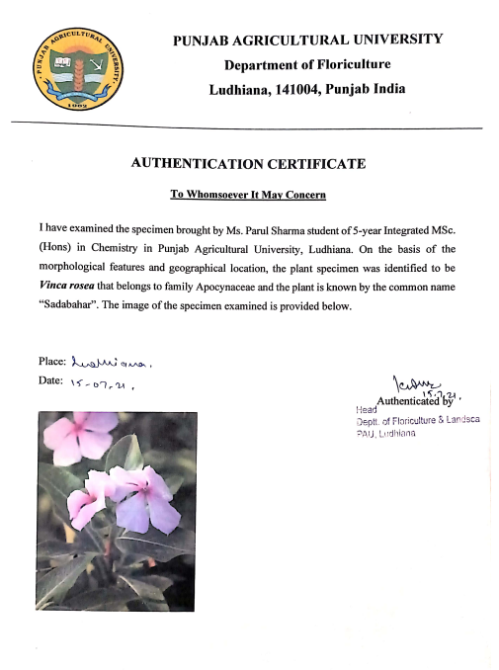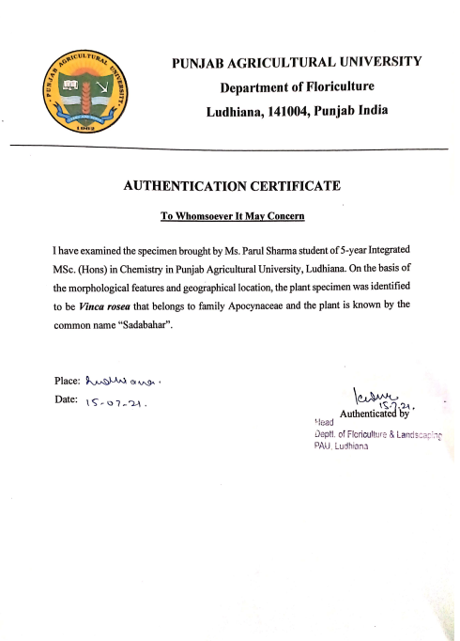
Authentication Certificate

Vindoline Mass Spectra (ANNEXURE I)

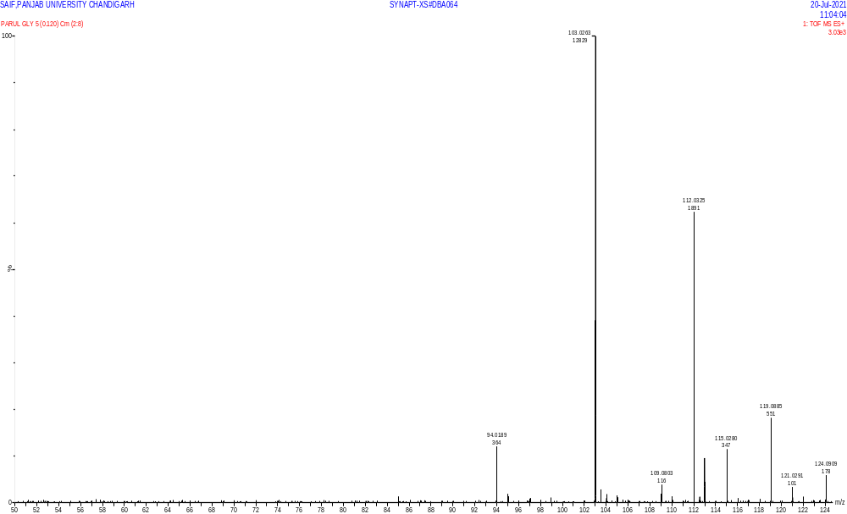

Vindoline ¹HNMR Spectra (ANNEXURE II)
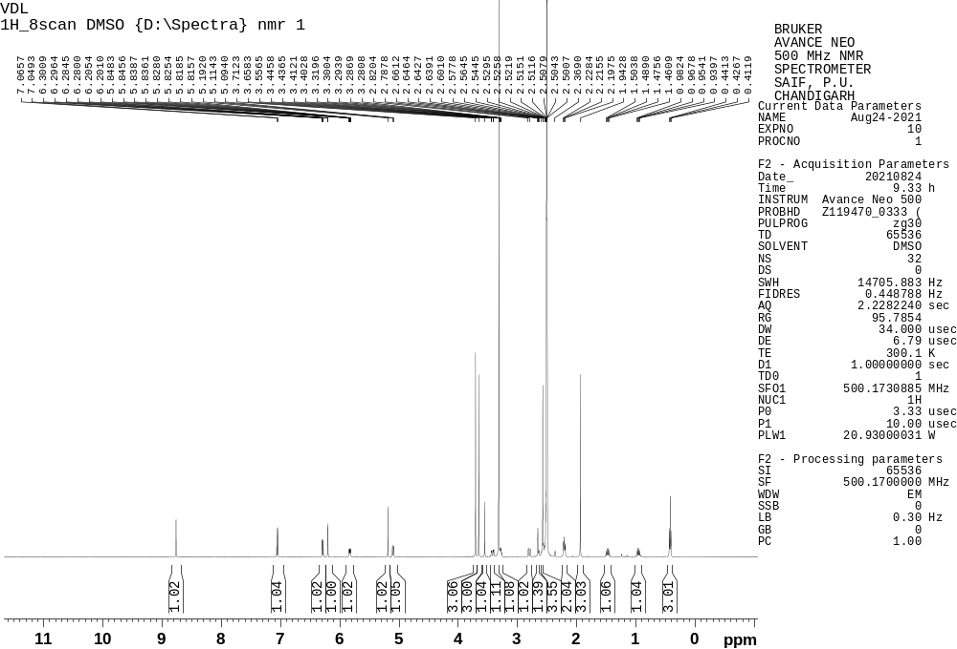
Vindoline ¹³C NMR Spectra (ANNEXURE III)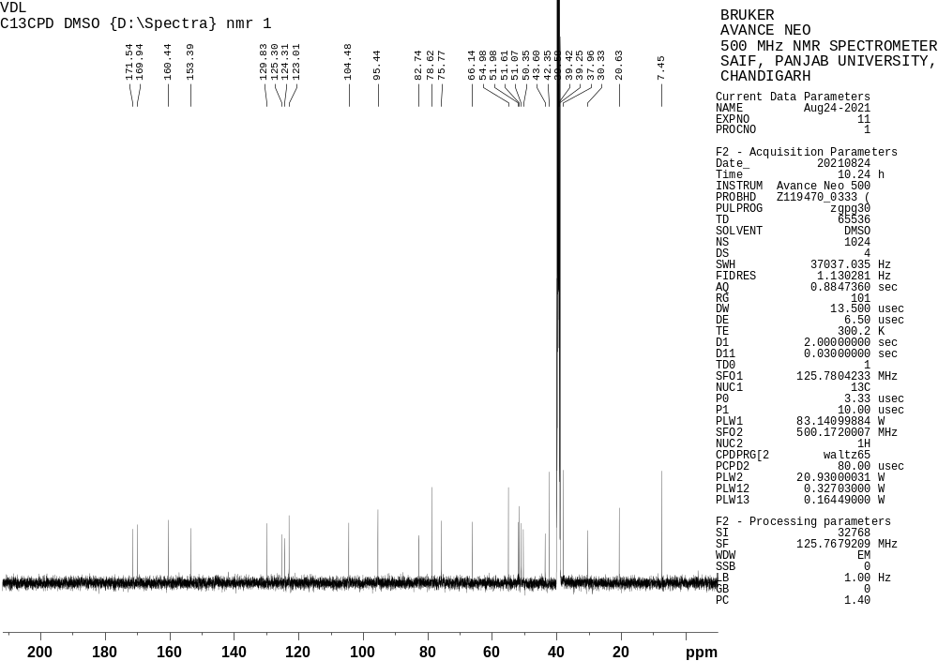

Vindoline IR Spectra (ANNEXURE IV)