
A

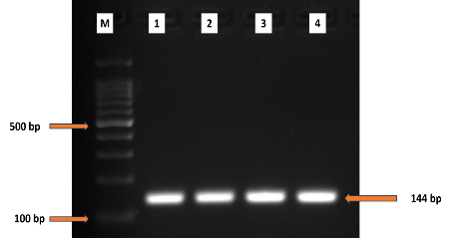
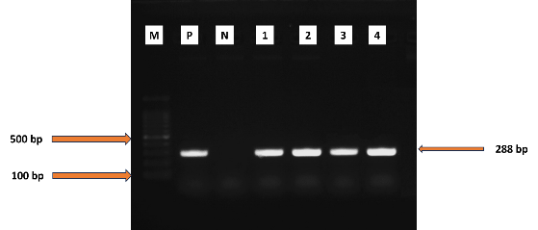
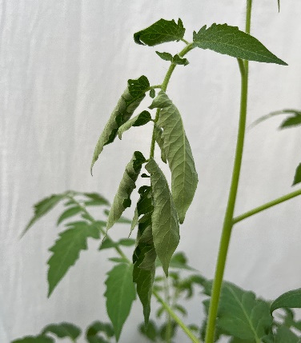
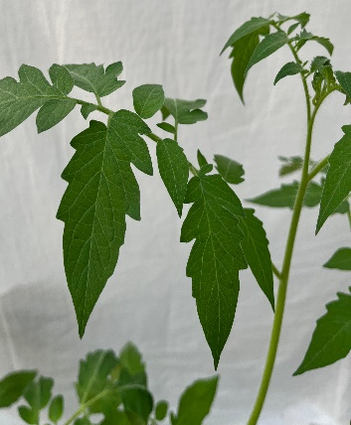
`
E
D
C
B

Figure S1: Characterization of R. solanacearum F1C1 strain. (A) Pure culture in Phi media with TTC plate. (B) Leaflet of a healthy tomato plant (C) Leaflet of a tomato plant showing bacterial wilt symptom after inoculation of R. solanacearum F1C1 strain. (D) PCR detection using R. solanacearum specific primers and (E) phylotype specific primers. M: Ladder, P: Positive control, N: Negative control, 1-4 : Replicates

