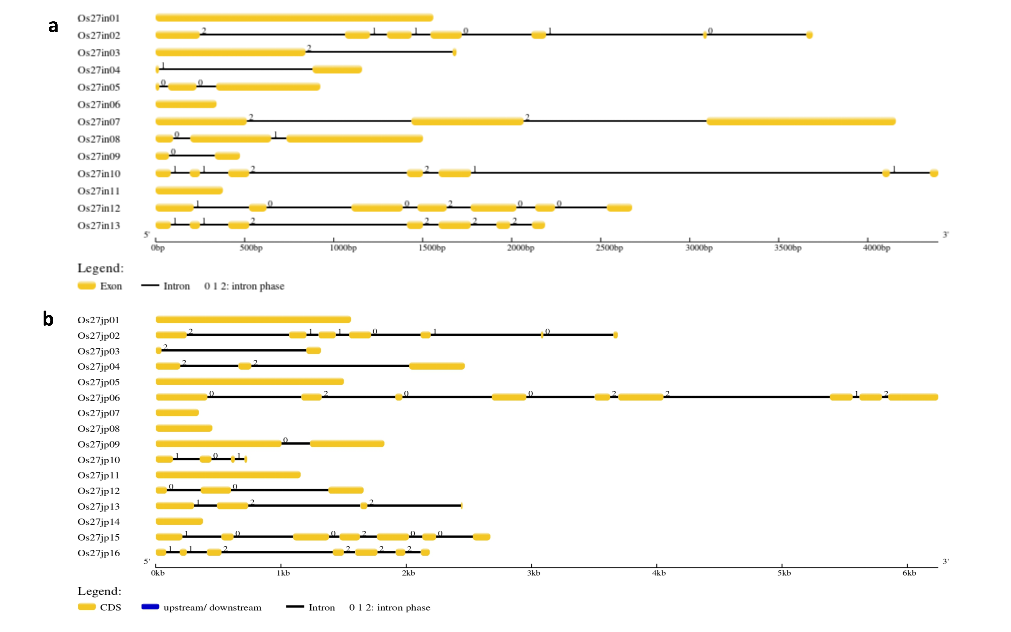

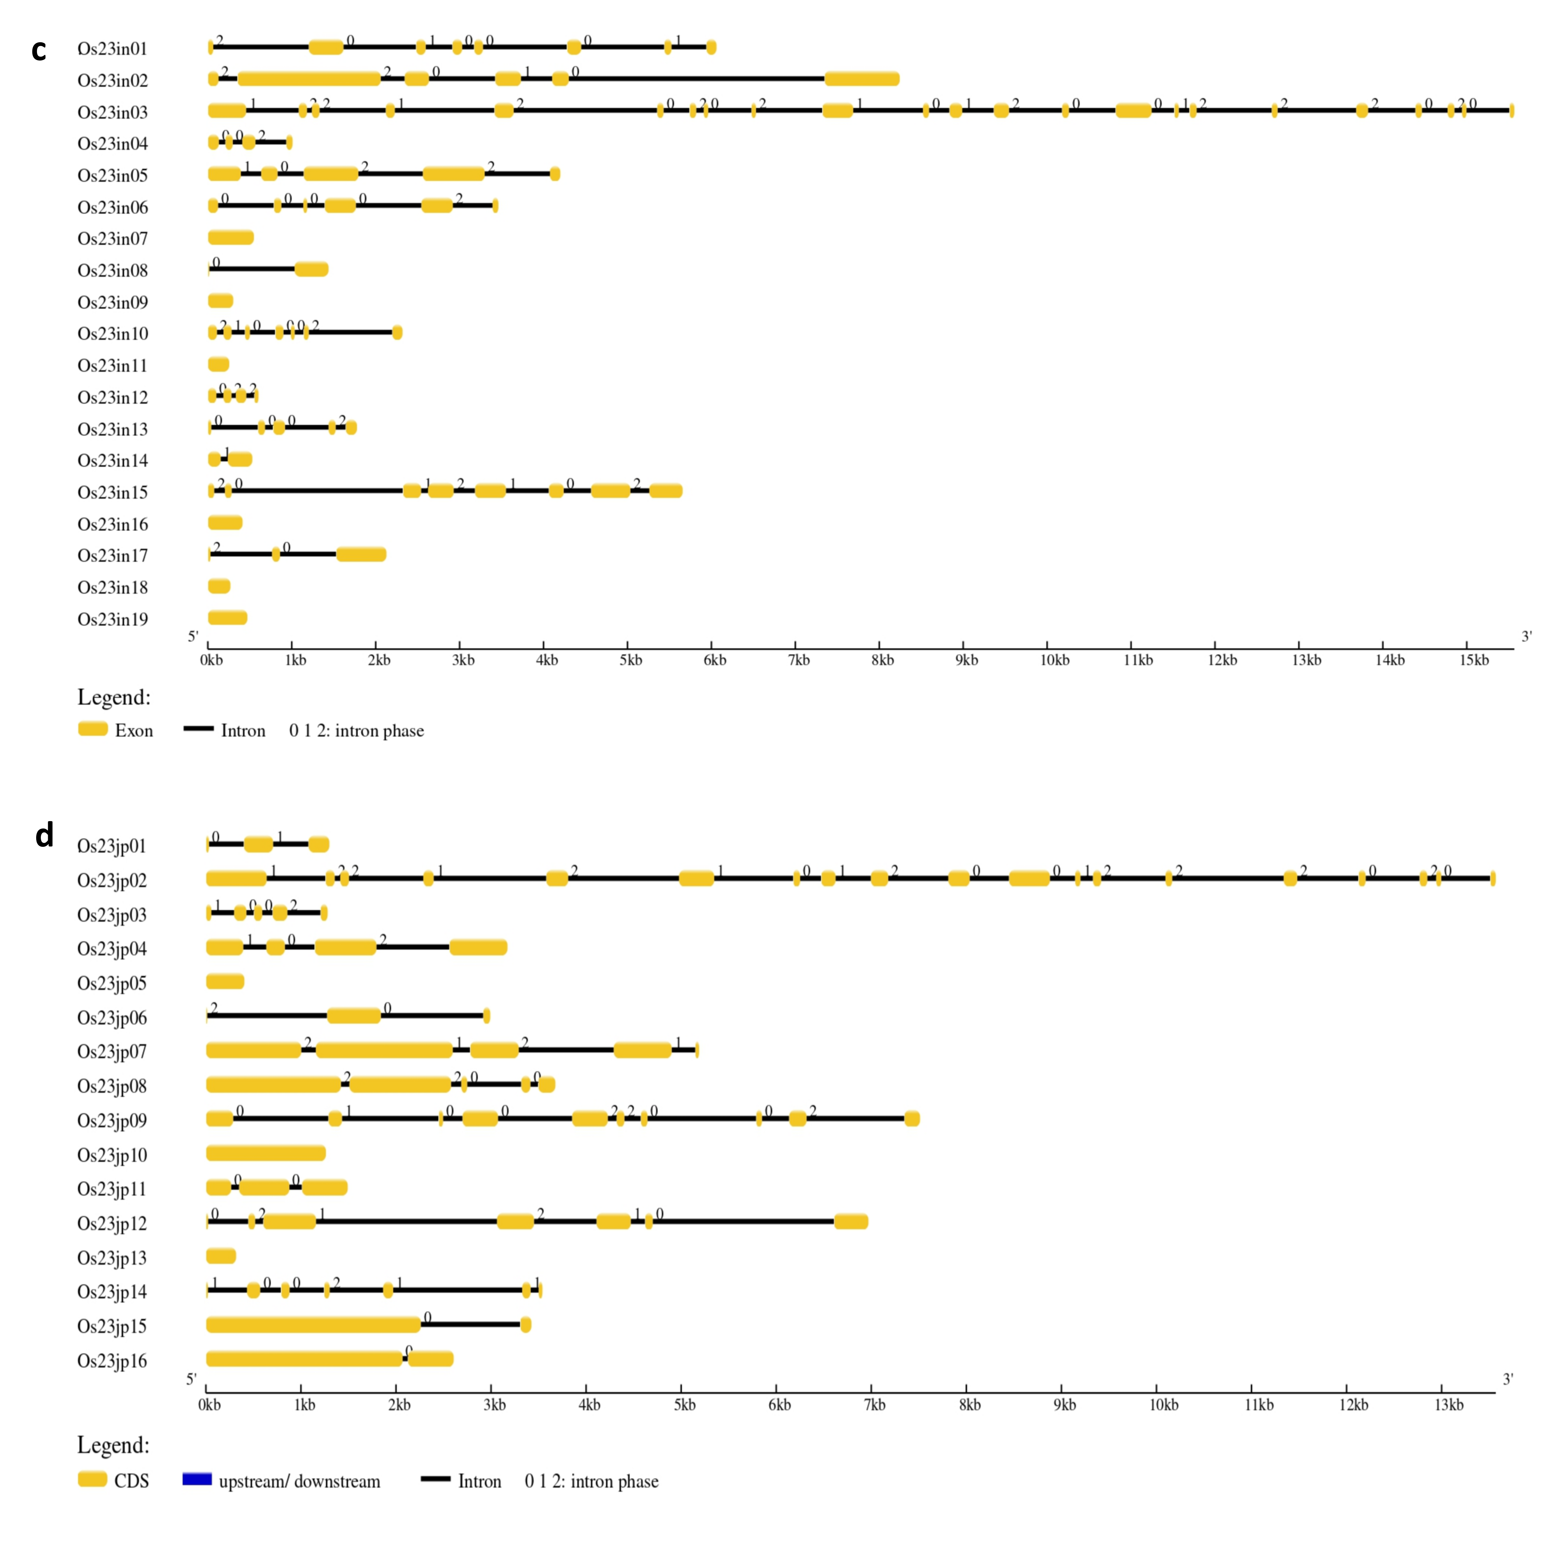

Fig S1: Detailed analysis was conducted on all predicted genes, and the structural visualization of each gene was generated using the Gene Structure Display Server, accessible at http://gsds.gao-lab.org/. Yellow solid lines are marked as exons while black thin lines as introns; (a) Predicted gene structure of Xa27 indica. (b) Predicted gene structure of Xa27 japonica. (c) Predicted gene structure of Xa23 indica. (d) Predicted gene structure of Xa23 japonica.
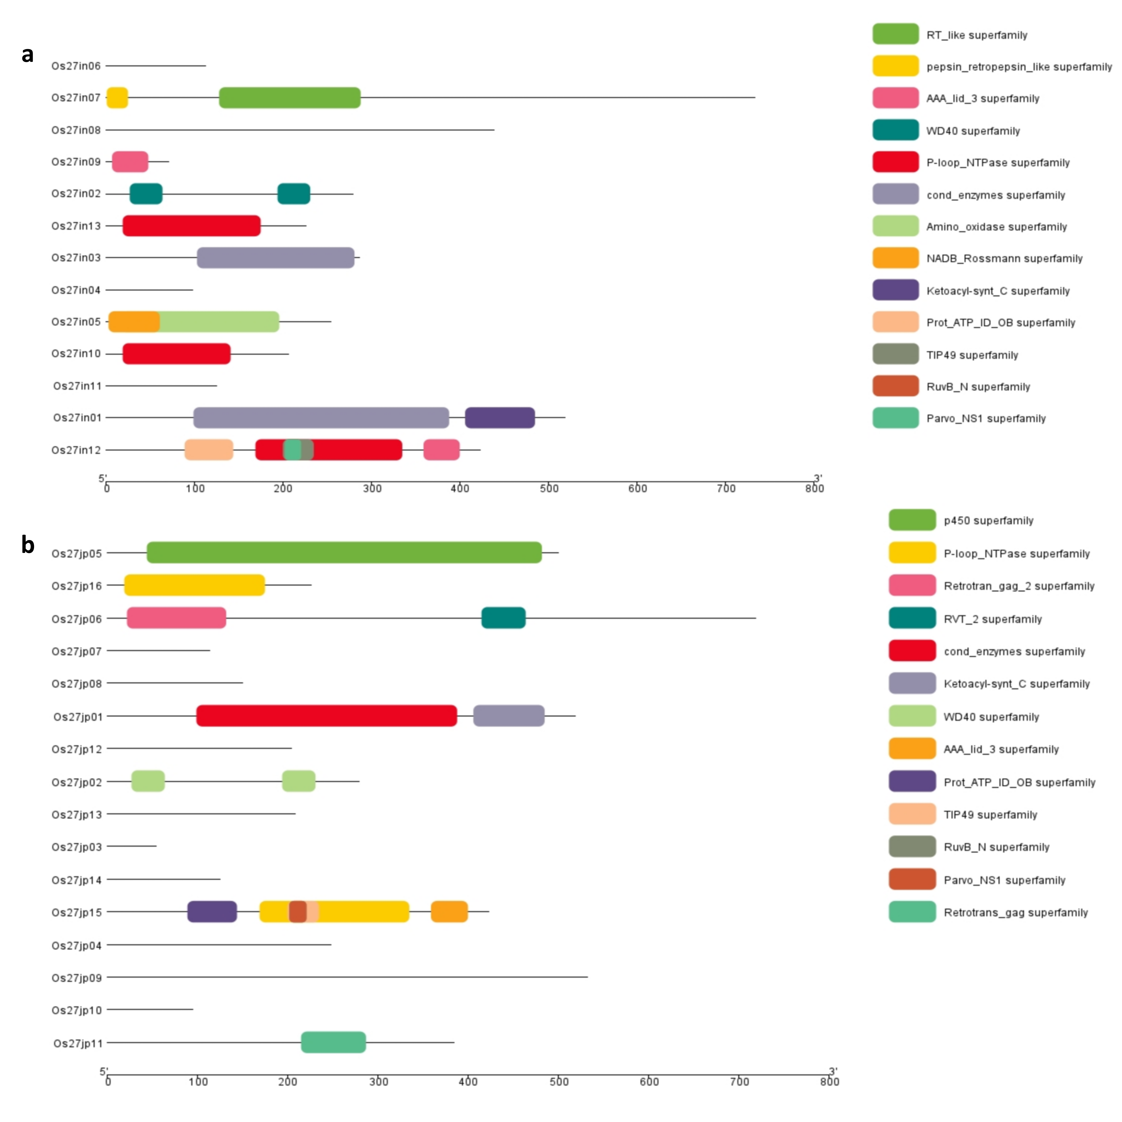

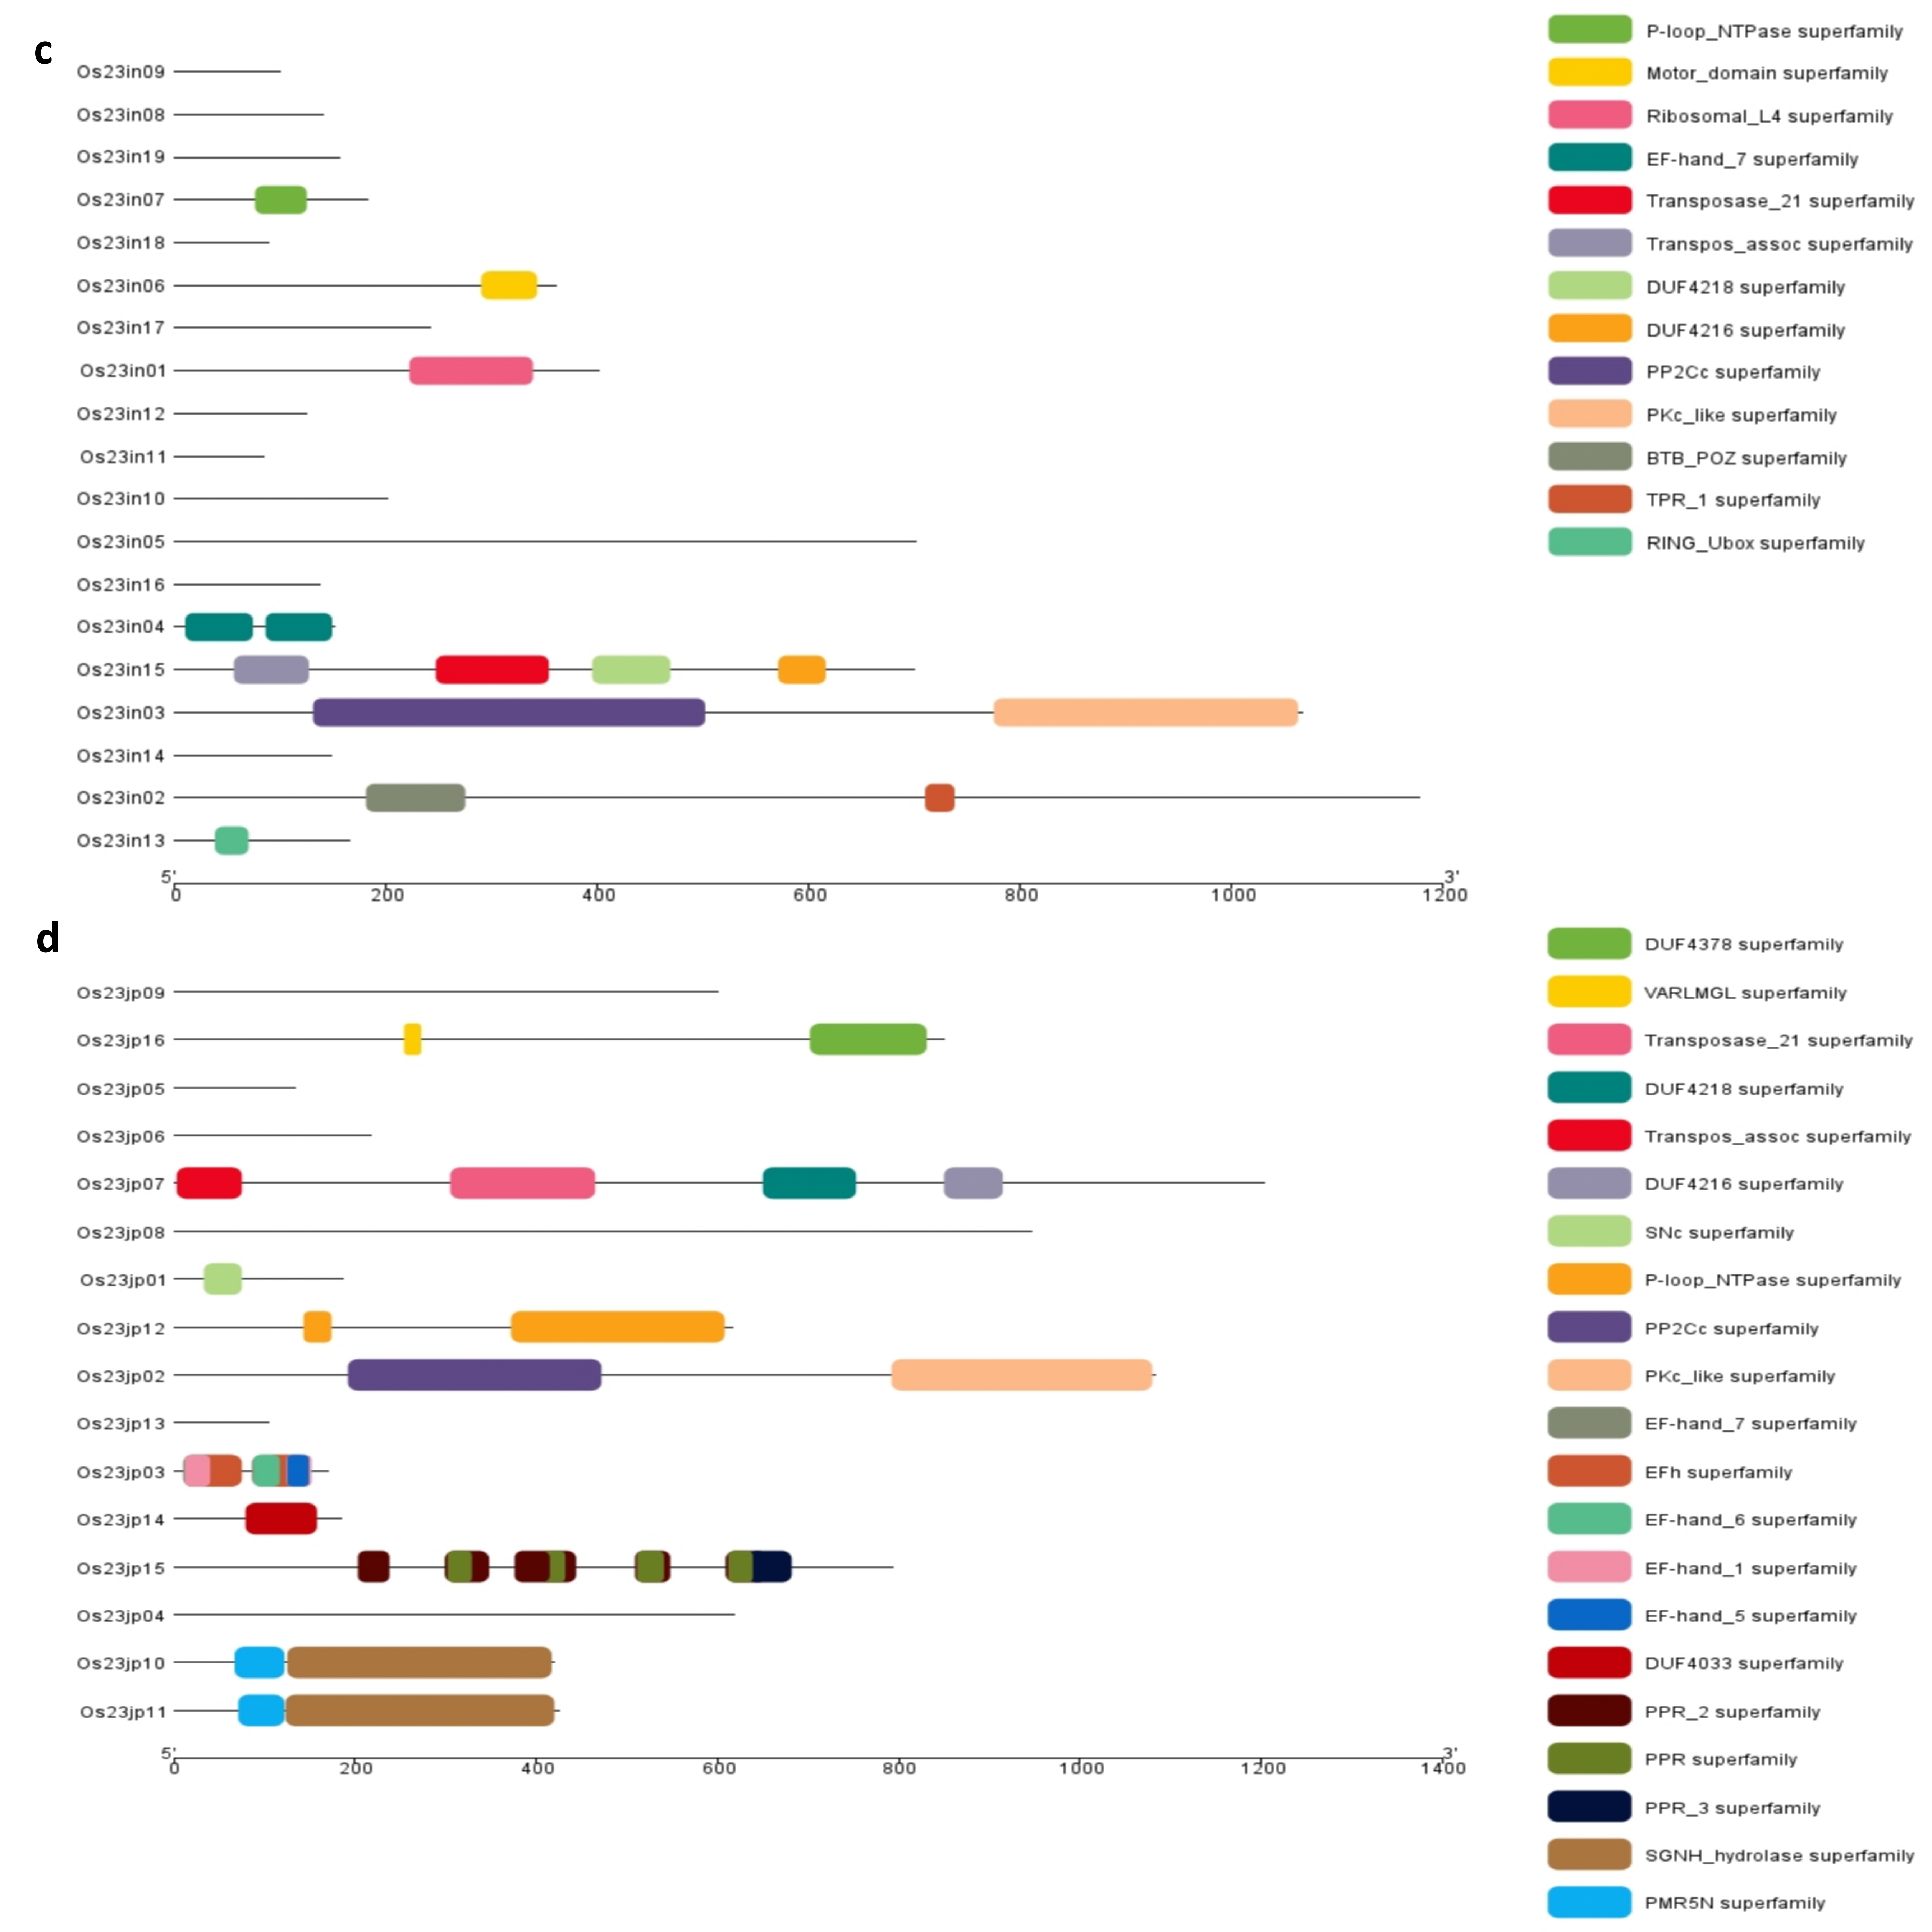

Fig S2: Identified the conserved domains within the predicted genes of both indica and japonica cultivars associated with the Xa27 and Xa23 loci. NCBI Batch CD-search, accessible at nih.gov was used to findout the conserved super families; (a) Conserved domain super families identified in Xa27 indica. (b) Conserved domains super families identified in Xa27 japonica. (c) Conserved domains super families identified in Xa23 indica. (d) Conserved domains super families identified in Xa23 japonica.

