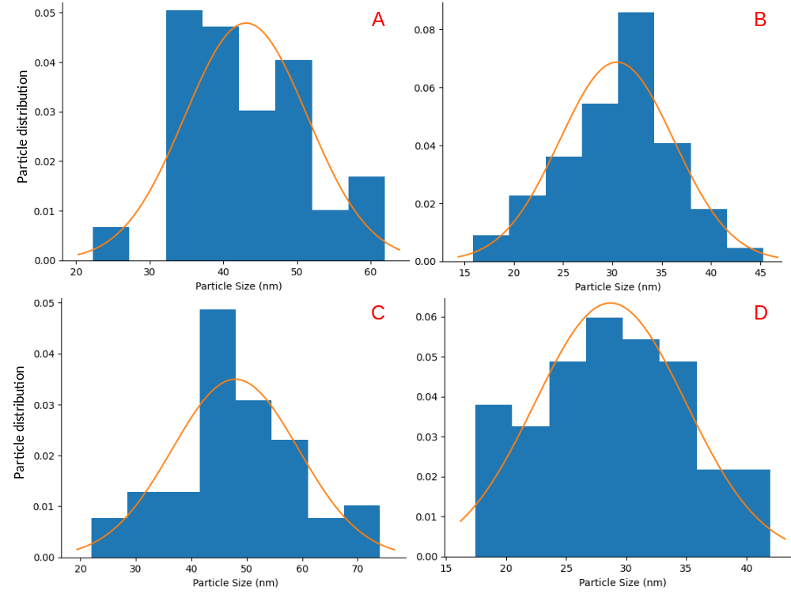
Fig. S1. HR-TEM Particle size distribution of biosynthesized silver nanoparticles (AgNPs) and zinc oxide nanoparticles (ZnONPs) synthesized from Trichoderma asperellum culture filtrates. (A & C: AgNPs and ZnONPs synthesized using isolate PDKV_SN_F3; B & D: AgNPs and ZnONPs synthesized using isolate PDKV_SN_F5).

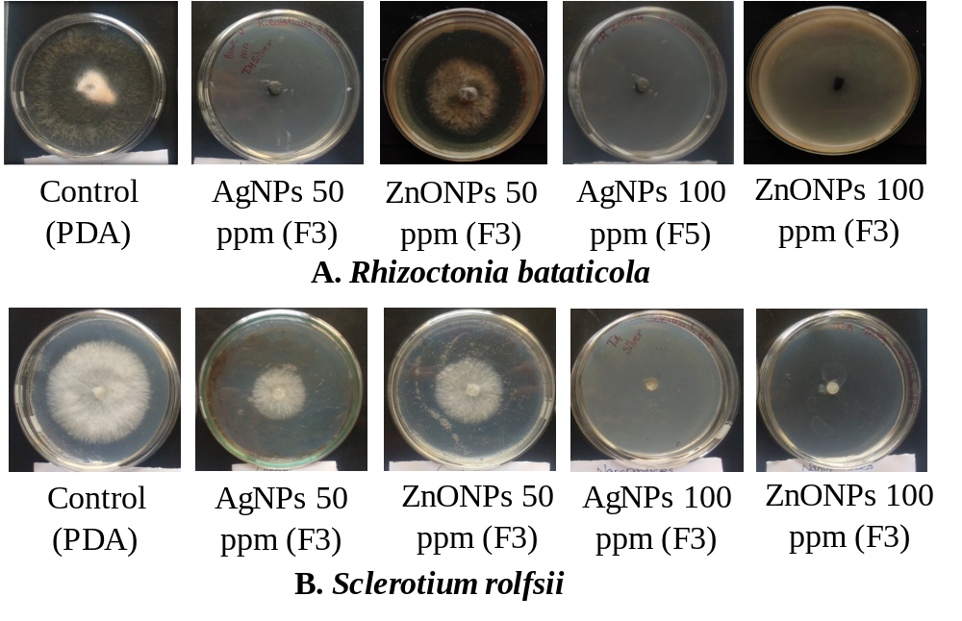
Fig. S2. Representative Petri plate images showing in vitro antifungal activity of biosynthesized AgNPs and ZnONPs against Rhizoctonia bataticola and Sclerotium rolfsii. Control plates show normal radial growth, whereas nanoparticle-treated plates demonstrate dose-dependent inhibition of mycelial development.

Table S1. HR-TEM particle size distribution of biosynthesized AgNPs and ZnONPs synthesized using Trichoderma asperellum isolates PDKV_SN_F3 and PDKV_SN_F5.
Isolate | Nanoparticle Type | Size Range (nm) | Mean ± SD (nm) | n (particles) | Morphology | Dispersion
PDKV_SN_F3 | AgNP | 18–62 | 43.1 ± 8.4 | 60 | Spherical | Moderately monodispersed
PDKV_SN_F5 | AgNP | 15–48 | 30.4 ± 5.9 | 60 | Spherical | Moderately monodispersed
PDKV_SN_F3 | ZnONP | 22–74 | 47.9 ± 11.5 | 60 | Spherical to quasi-spherical | Polydispersed
PDKV_SN_F5 | ZnONP | 14–42 | 28.7 ± 6.3 | 60 | Spherical | Moderately polydispersed
Table S2. HR-TEM and DLS characterization of biosynthesized nanoparticles
Nanoparticle | Isolate | TEM Size Range (nm) | TEM Mean ± SD (nm) | Hydrodynamic Diameter (nm) | PDI
AgNP | PDKV_SN_F3 | 18–62 | 43.1 ± 8.4 | 118.80 | 0.18
AgNP | PDKV_SN_F5 | 15–48 | 30.4 ± 5.9 | 116.85 | 0.14
ZnONP | PDKV_SN_F3 | 22–74 | 47.9 ± 11.5 | 185.25 | 0.21
ZnONP | PDKV_SN_F5 | 14–42 | 28.7 ± 6.3 | 260.40 | 0.13

