Supplementary material
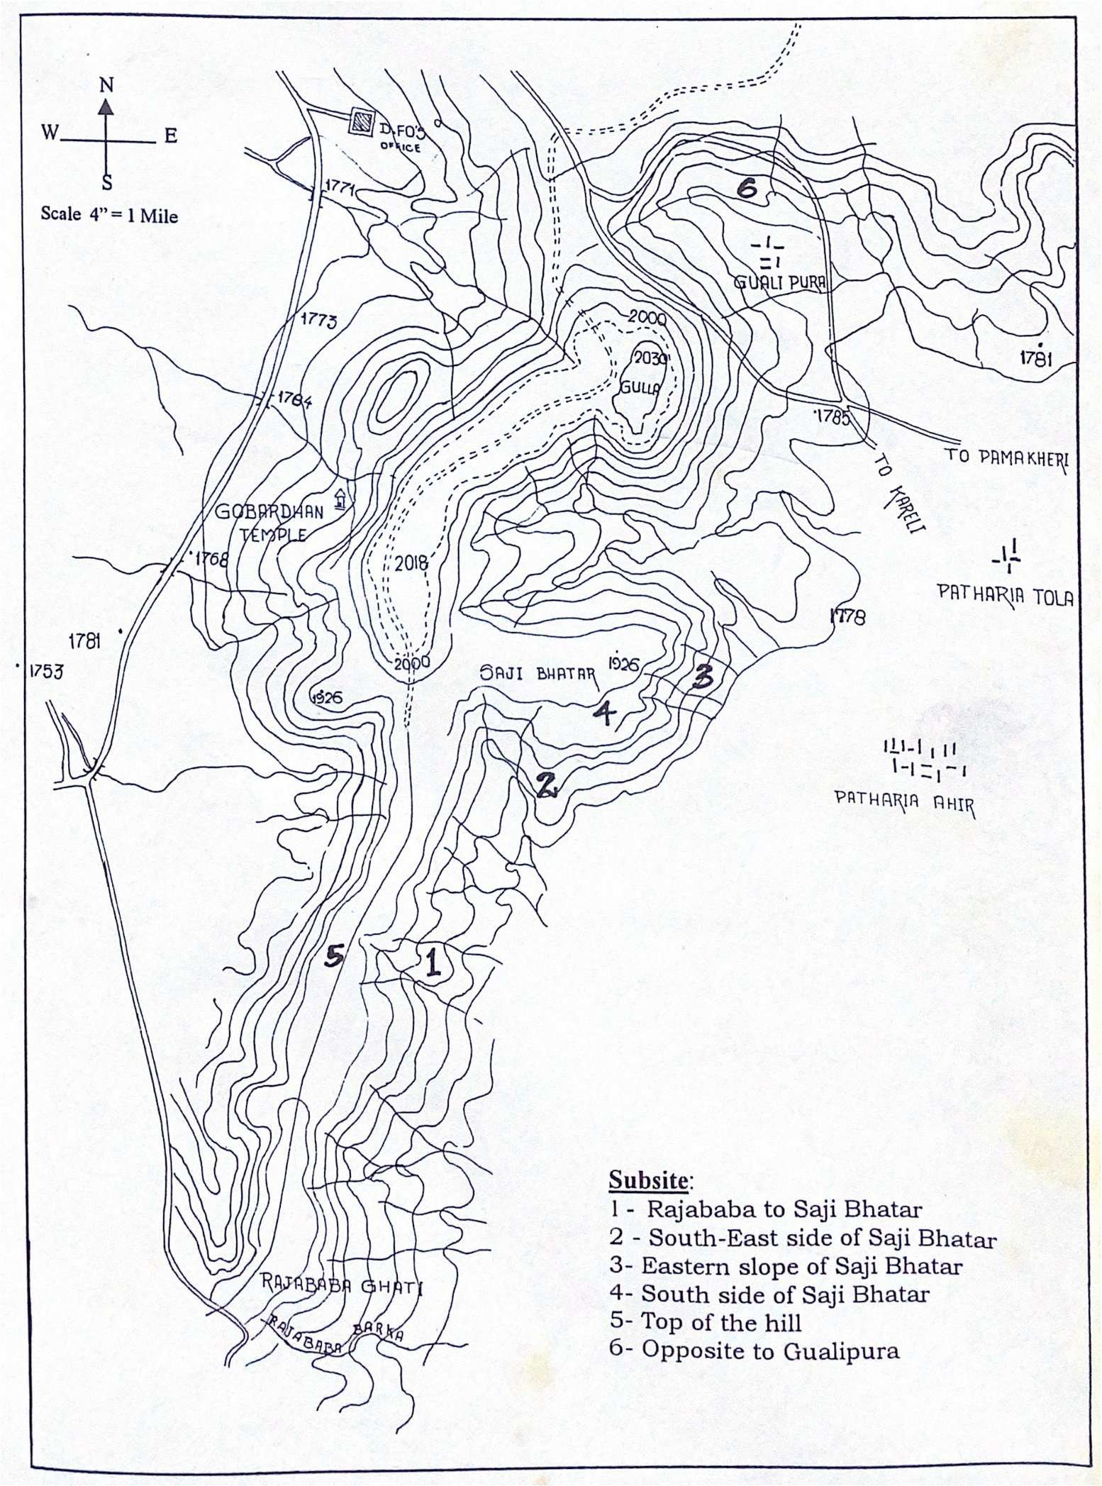
Fig. S1 Contour map of the Pathariya Hill Complex. Source (Misra and Joshi 1952).
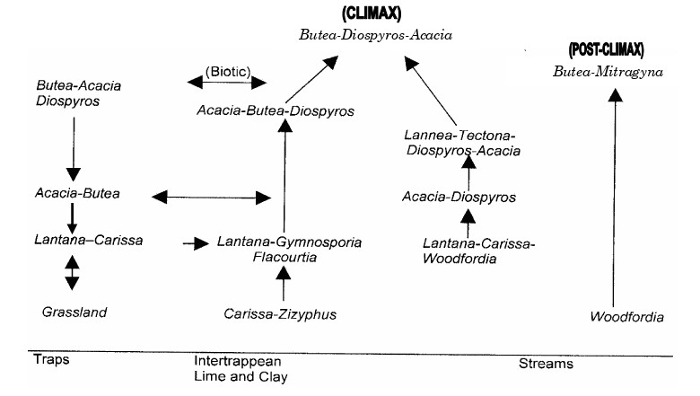
(a)
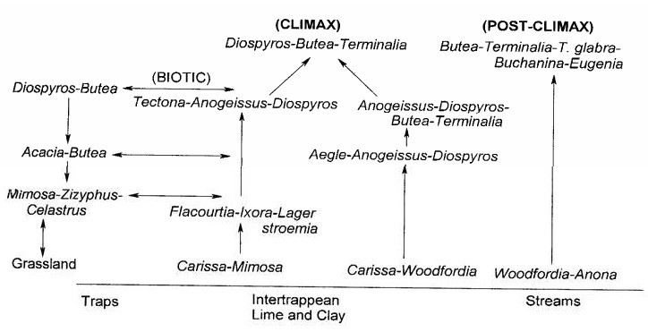
(b)
Fig. S2 Successional diagram of Pathariya hill forest complex during (a) 2001-02 (Thakur and Khare 2010) and (b) 1951-52 (Misra and Joshi 1952).

