Supplementary File

Integrated Taxonomic, Phylogenetic, and Metabolomic Characterization of Uncaria lanosa (Rubiaceae) from Mindanao, Philippines

Mark Lloyd G. Dapar^{1,2,3}, Jason C. Alcano^{4,5}, Joryll D. Pulmones¹, Noel E. Lagunday^{1,3}, Victor B. Amoroso^{1,3}, Lovelle Mae Galia-Marasigan⁴, Genevieve Dable-Tupas^{4,6}, Veneracion G. Cabana⁷

¹Institute of Biological Sciences, College of Arts and Sciences, Central Mindanao University, Musuan, Bukidnon 8710, Philippines
²Microtechnique and Systematics Laboratory, Natural Science Research Center (NSRC), Central Mindanao University, Musuan, Bukidnon 8710, Philippines
³Center for Biodiversity Research and Extension in Mindanao (CEBREM), Central Mindanao University, Musuan, Bukidnon 8710, Philippines
⁴Mass Spectrometry Facility, Center for Research and Development, Davao Medical School Foundation, Inc., A. Gahol Avenue, Bajada, Davao City 8000, Philippines
⁵Chemistry Department, School of Arts and Sciences, Ateneo de Davao University, Davao City 8000, Philippines
⁶Department of Pharmacology, College of Medicine, Davao Medical School Foundation, Inc., A. Gahol Avenue, Bajada, Davao City 8000, Philippines
⁷Research Office, Philippine Countryville College, Panadtalan, Maramag, Bukidnon 8710, Philippines

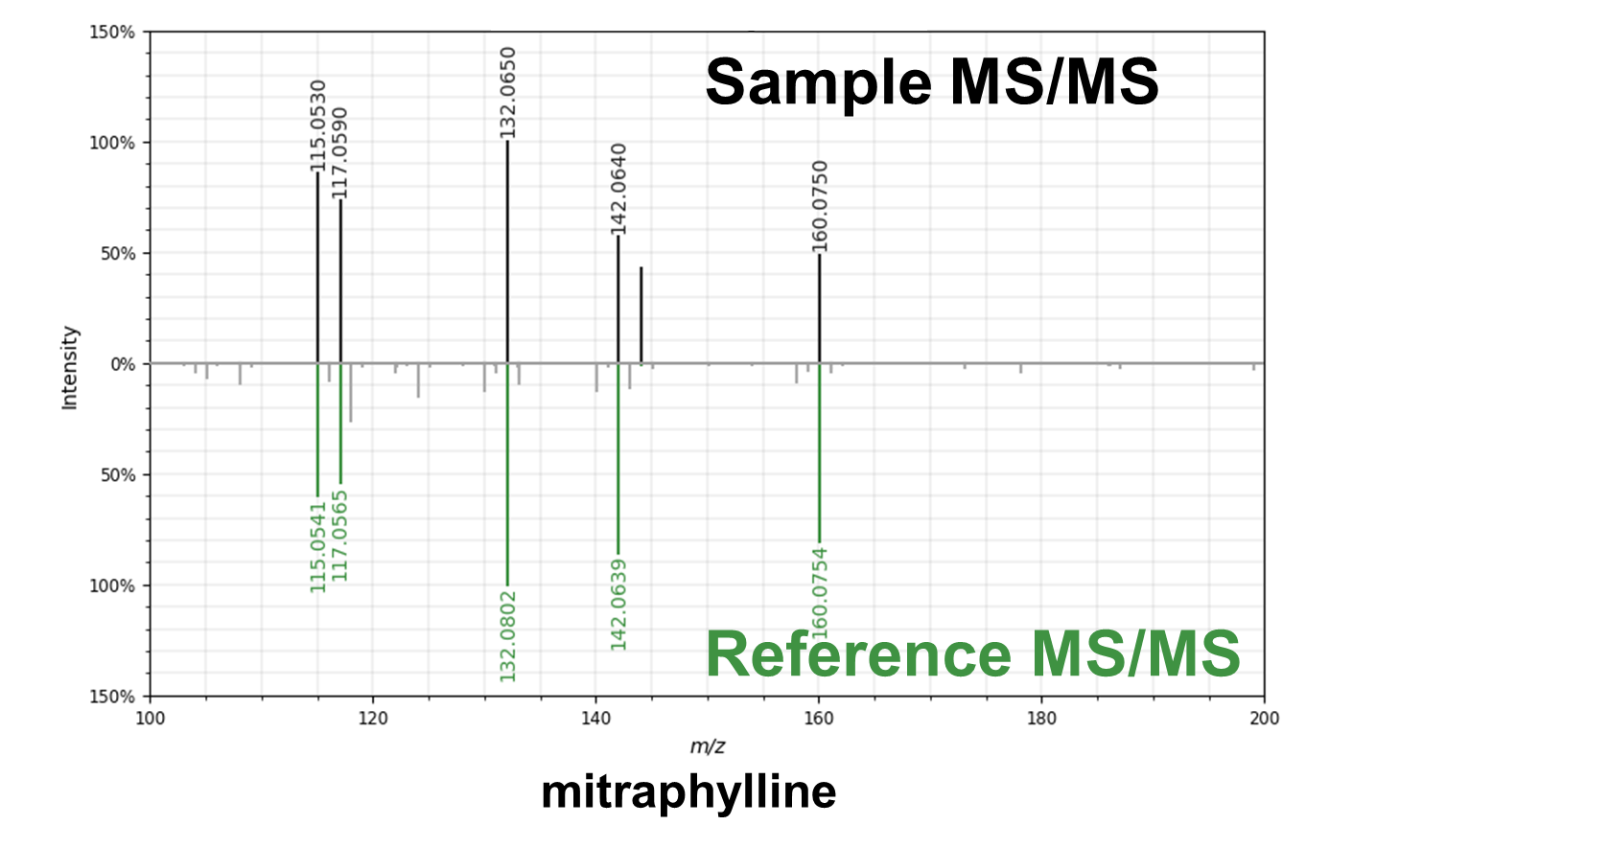
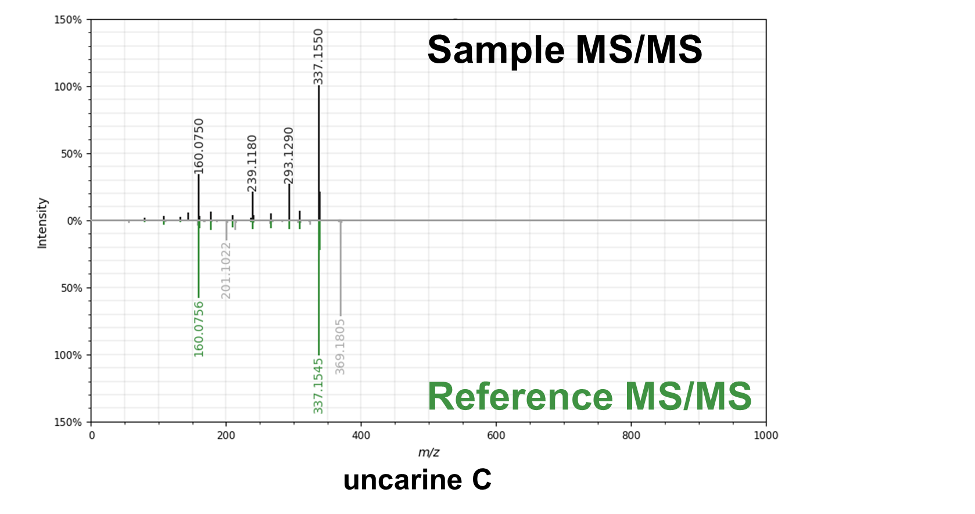
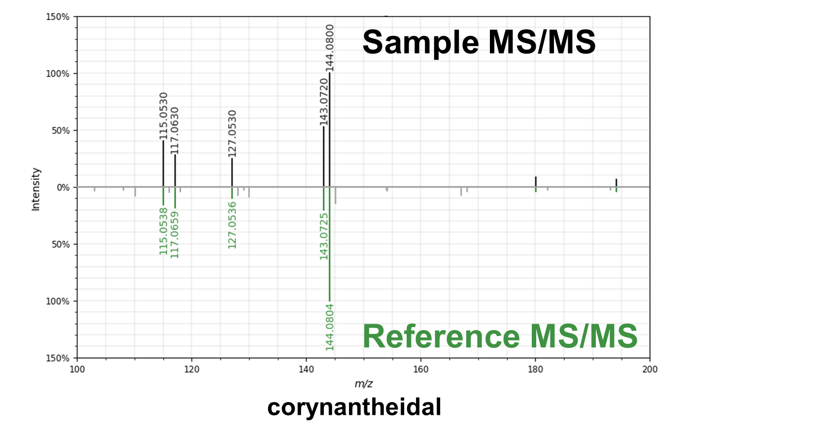
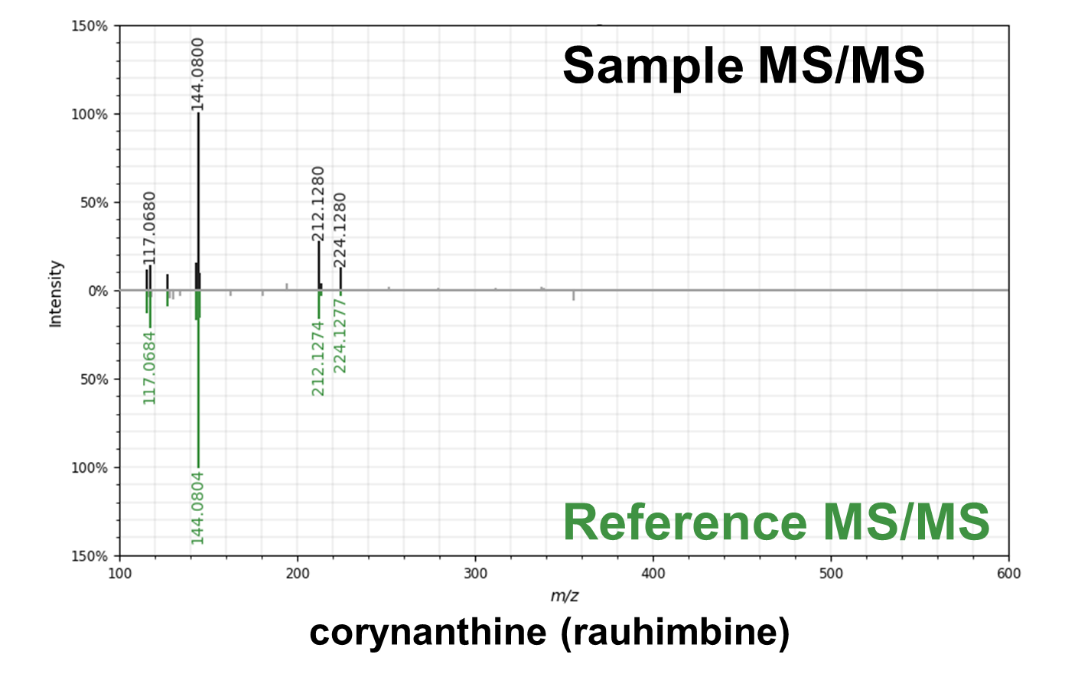
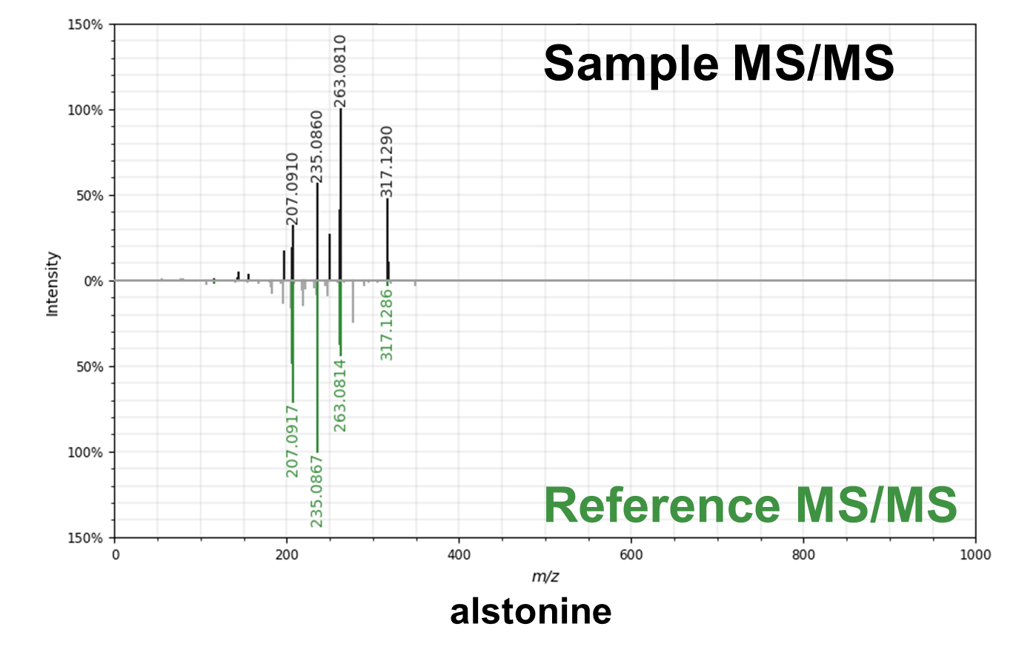
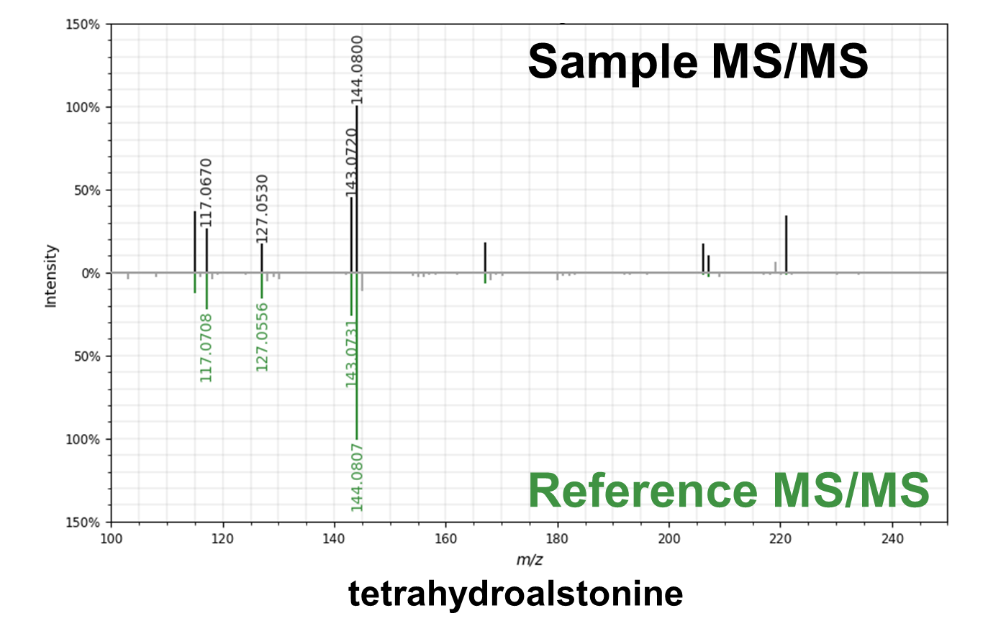

Supplementary Figure 1. Tandem MS tail-to-tail alignment of annotated compounds from U. lanosa extract

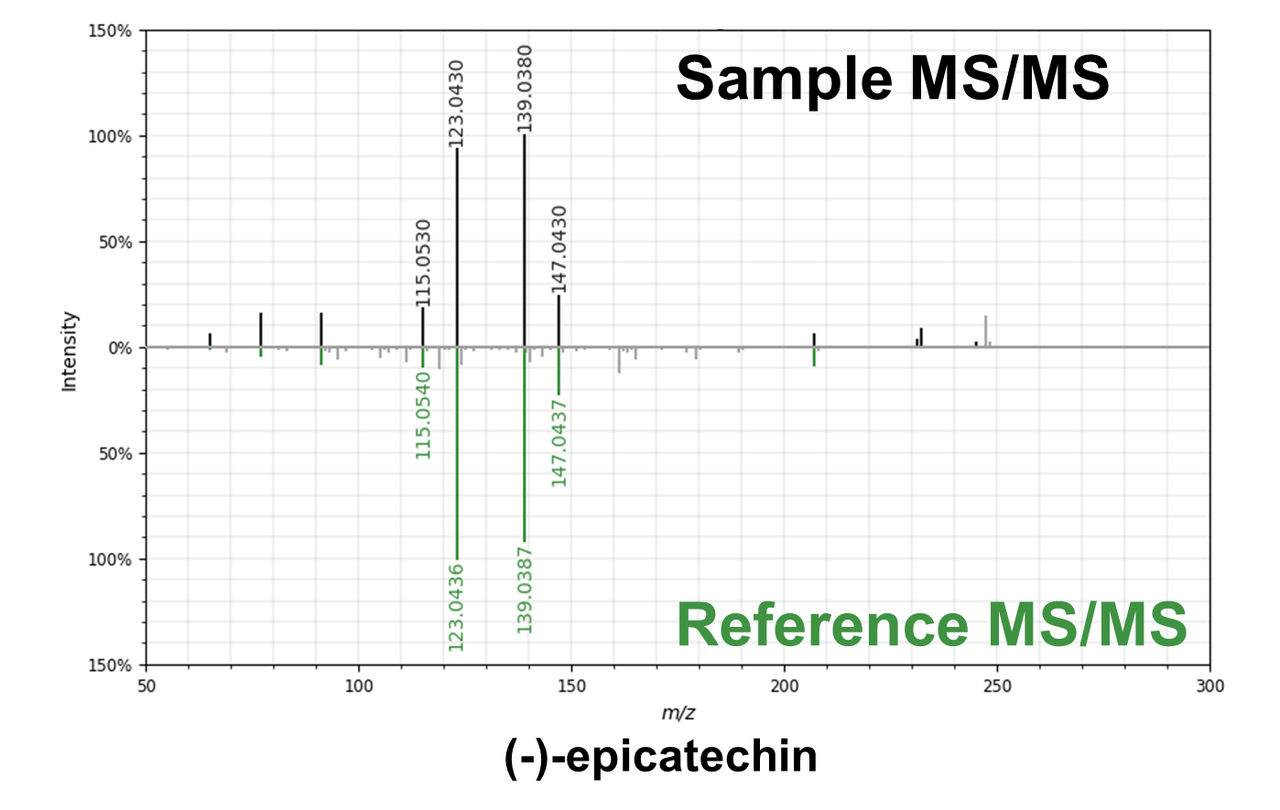
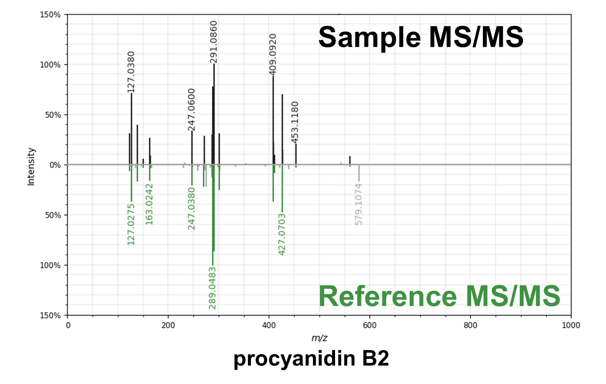
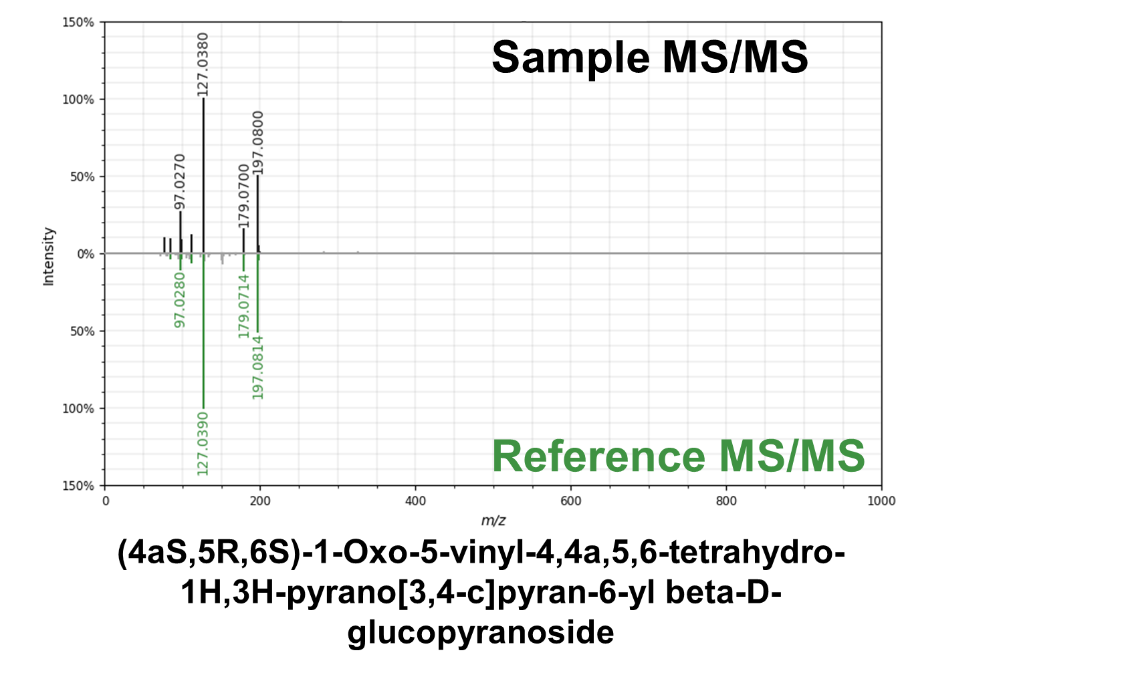
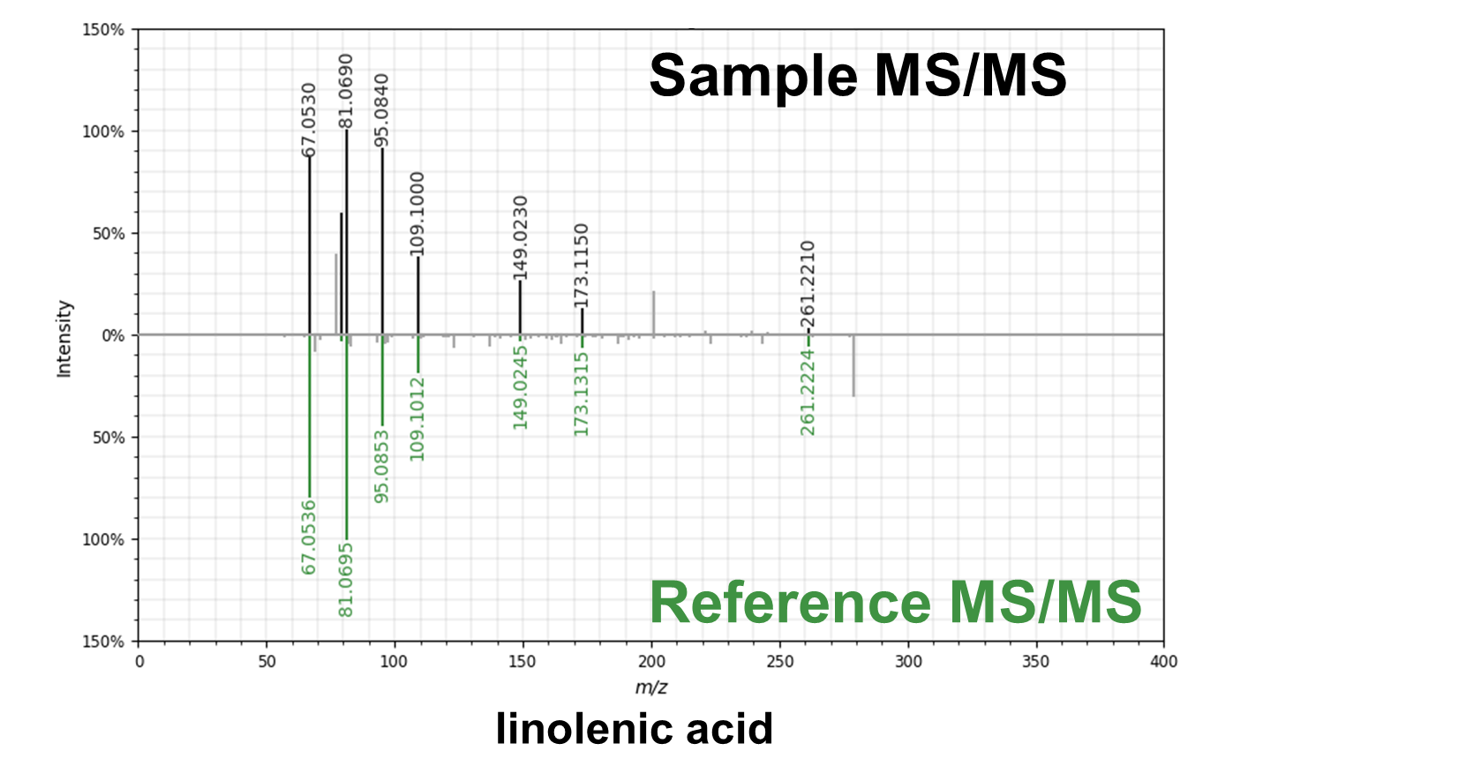
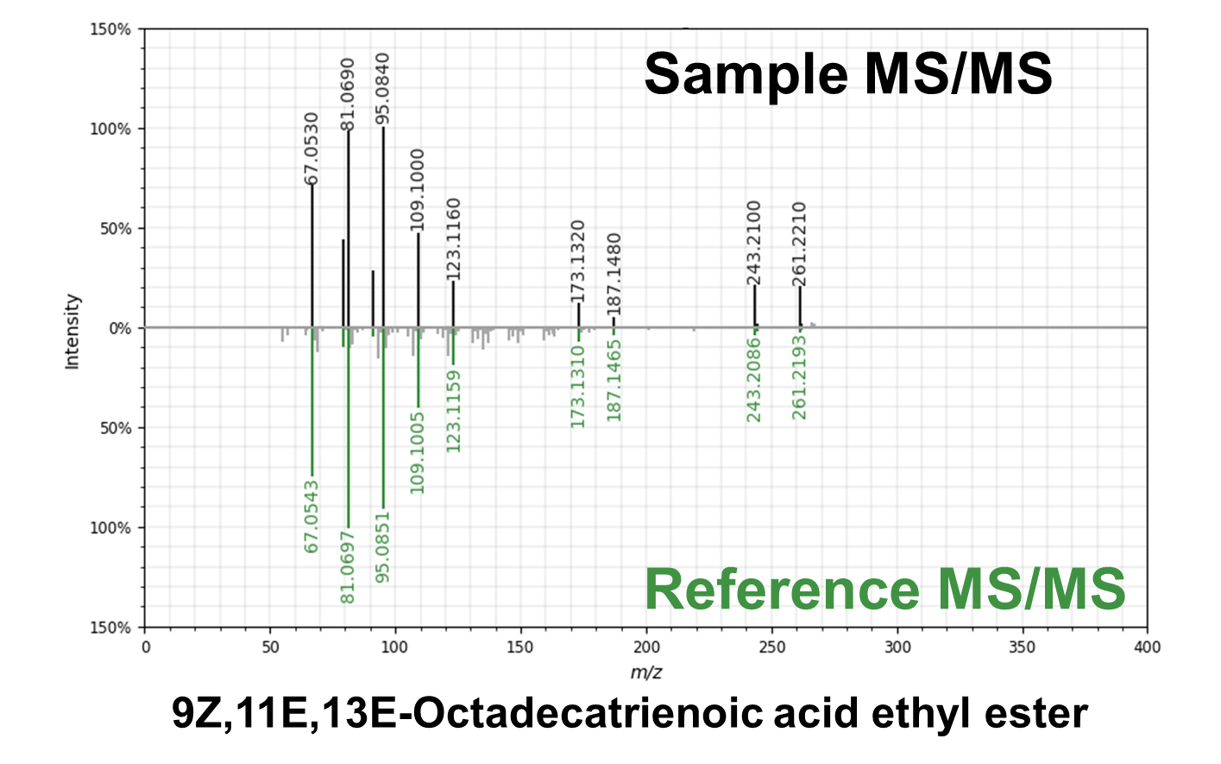
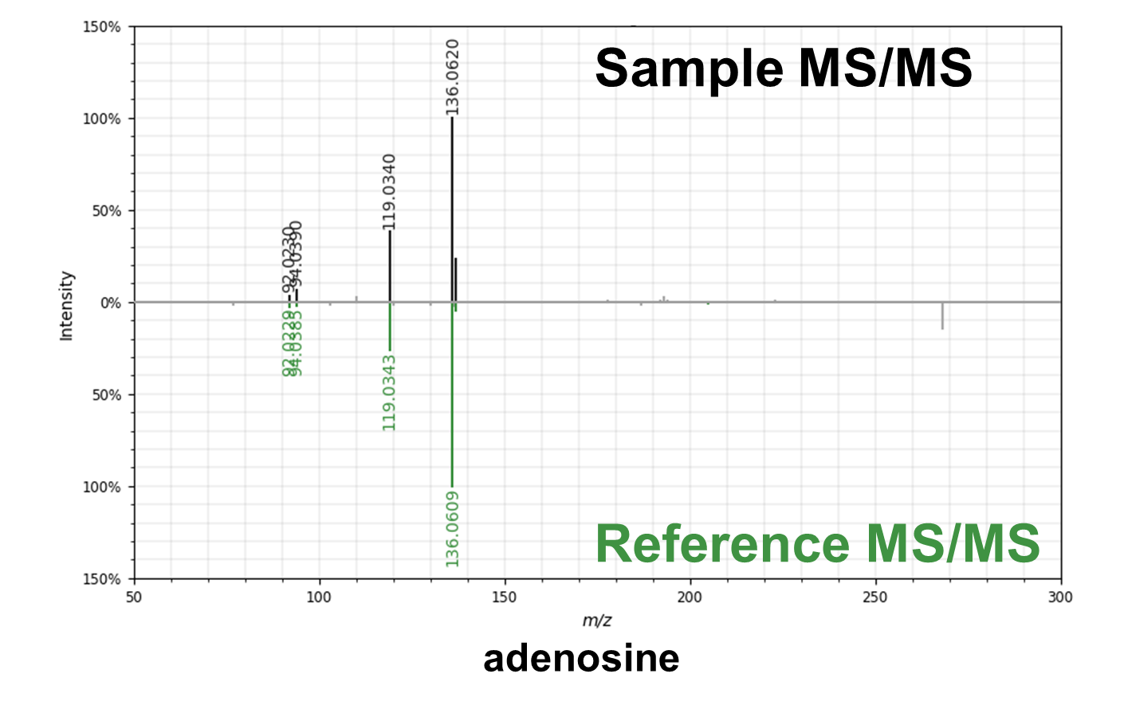

Supplementary Figure 1. continued

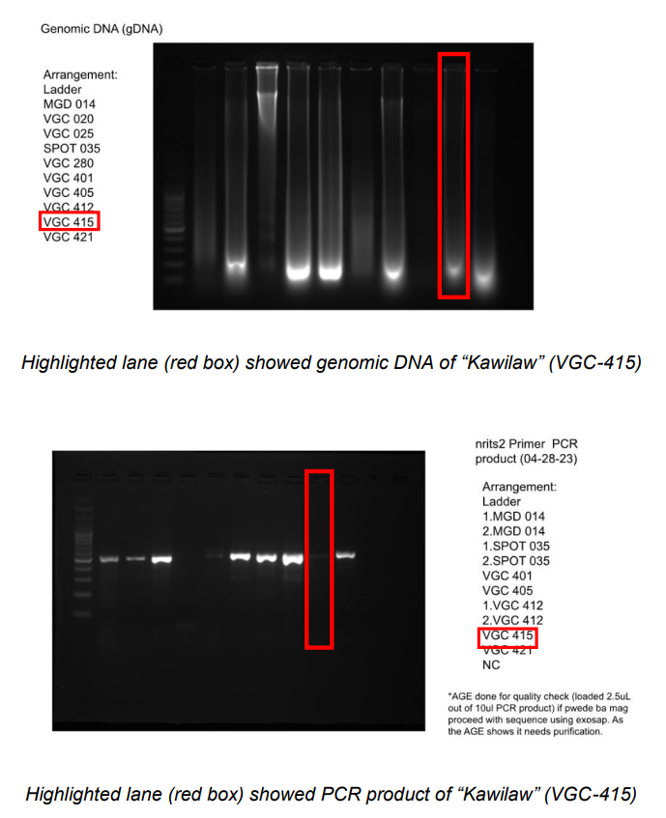

Supplementary Figure 2. Gel Electrophoresis Profile of VGC-415 “KAWILAW”

