Development of sensor based on electrochemical impedance spectroscopy for the detection of Vitamin D3 using molecularly imprinted polymer@MoSe₂ nanosheets
Archana Aª, Sandhya Rani Majhi^{b}, Harshulika Singhª, Pratima R Solanki*ª
a Nano-bio Laboratory, Special Centre for Nanoscience, Jawaharlal Nehru University, New Delhi-110067
b Department of Life Sciences, Central University of Jharkhand, Ranchi, Jharkhand-835222
*Corresponding author: pratimarsolanki@gmail.com; partima@mail.jnu.ac.in
Supplementary Information
Introduction
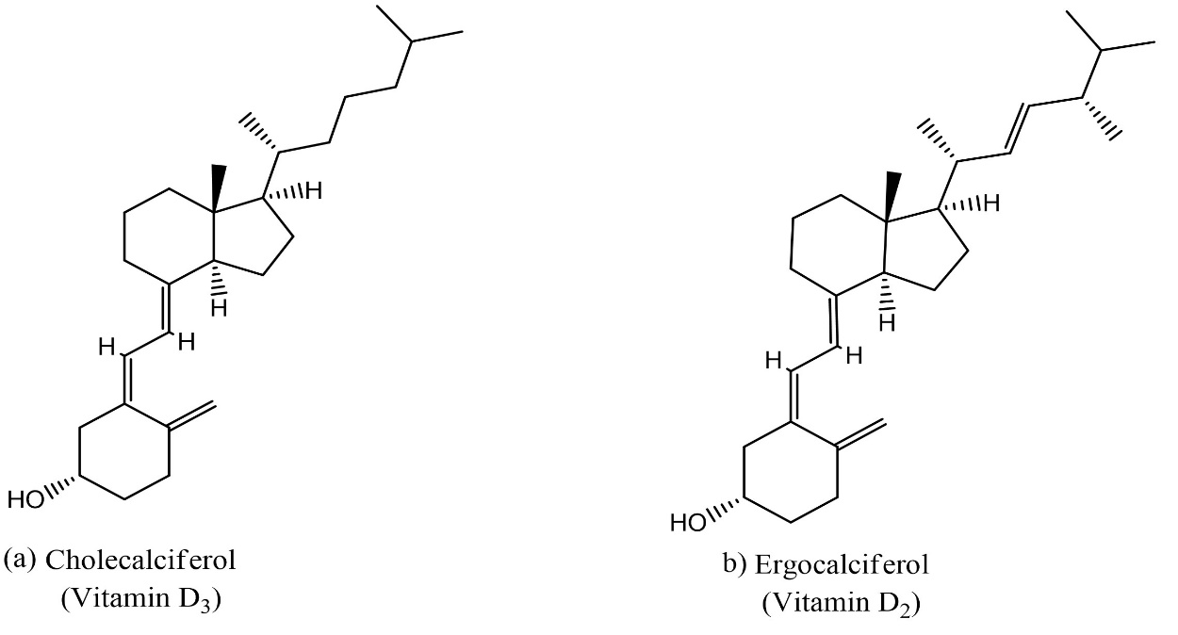
Figure S1: Structures of Vitamin D₃

4.1.3 Electrochemical sensing of Vitamin D3 using PDA@MoSe₂ -MIP/SPCE
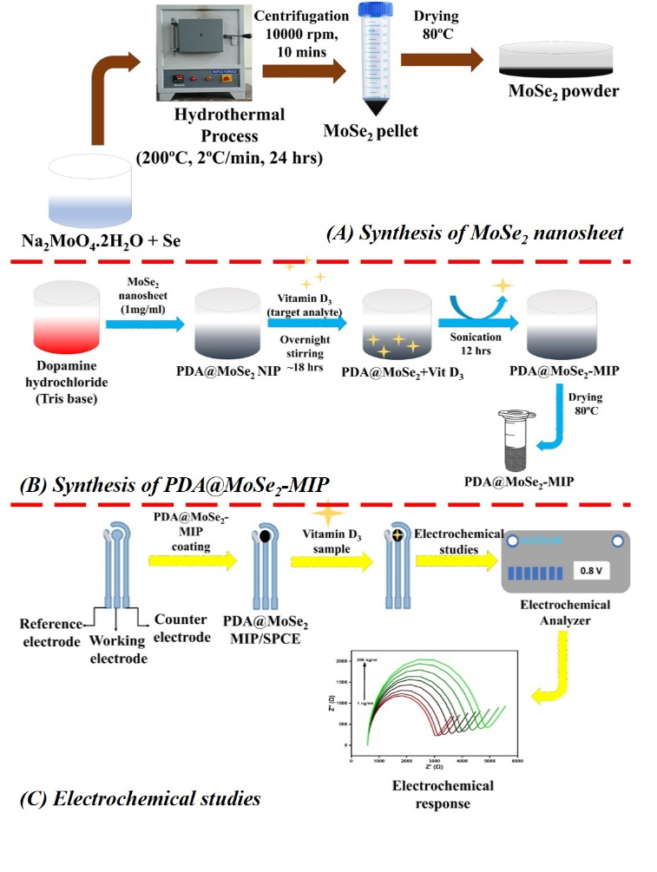

Scheme S1: Synthesis of PDA@MoSe₂-MIP and electrochemical sensing mechanism
4.1.3 Electrochemical sensing of Vitamin D3 using PDA@MoSe₂ -MIP/SPCE

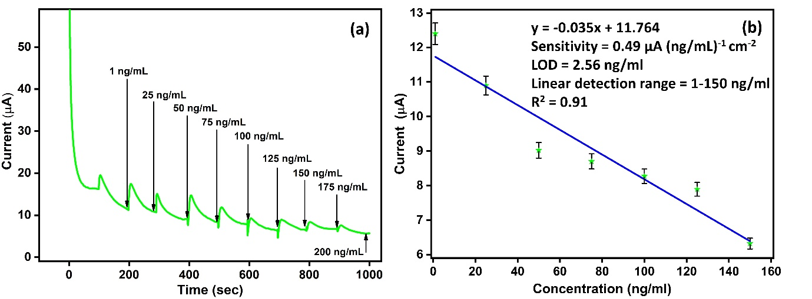
Figure S2: Sensing current and linear plot obtained from steady state amperometry

