Systematic refinement of experimental practices to improve repeatability in flow battery cycling – Supplementary Information
Hugh O’Connor, Alexander H. Quinn, Fikile R. Brushett, Oana Istrate, Stephen Glover, Josh J. Bailey*, Peter Nockemann*

Affiliations
Hugh O’Connor, Josh J. Bailey, Peter Nockemann: The QUILL Research Centre, School of Chemistry and Chemical Engineering, Queen's University Belfast, David Keir Building, 39-123 Stranmillis Rd, Belfast BT9 5AG, UK
Alexander H. Quinn, Fikile R. Brushett: Department of Chemical Engineering, Massachusetts Institute of Technology, Cambridge, Massachusetts 02139, USA
Stephen Glover, Oana Istrate: School of Mechanical and Aerospace Engineering, Queen's University Belfast, Ashby Building, Stranmillis Rd, Belfast BT9 5AG, UK
*j.bailey@qub.ac.uk
*p.nockemann@qub.ac.uk

Contents
Cell design iterations 3
Tank and degassing apparatus 6
Nominal cell geometry 7
Electrolyte formulation 8
Electrolyte initial charging 8
Performance metrics 10
Peristaltic pump flow rates 13
Cell capacities 14
References 16

Cell design iterations
The cell design described in our prior work[1] can be seen in Figure S1a with four simple guides on the current collector side of the cell to prevent lateral movement of the graphite and brass components before they are clamped into the flow frame. Between the previous study and the work presented here, several changes were made to the cell design to improve the ease of assembly and reduce the chance of component misalignment.
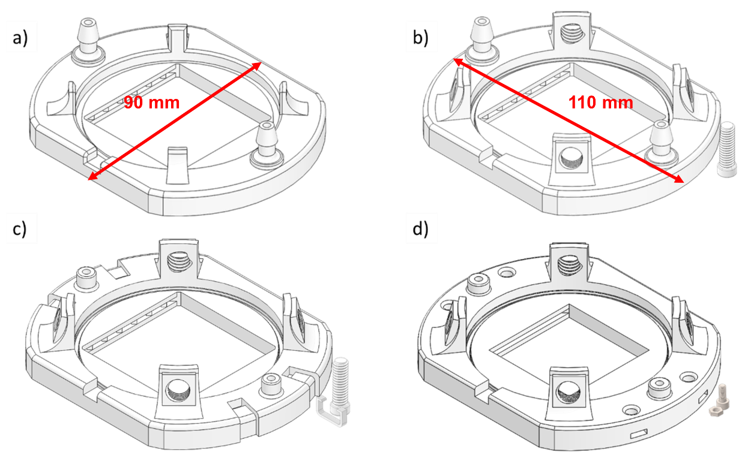
Fig. S1 CAD images of final half-cell design refinements. a) Prior published cell design, reproduced from [1]. b) Addition of guide screws c) Clips added to secure two half-cells during assembly with nozzle height reduced d) 3D-printed clips replaced with M3x5.5 mm square nuts and M3 bolts to hold cells in place more efficiently during assembly.
The next cell design iteration (Figure S1b) addressed a problem faced during the assembly process whereby components would move in the “z-direction” during assembly and clamping. Occasionally this resulted in electrodes becoming trapped between the cell bodies or the cell body and current collectors. To rectify this issue, threaded holes were added to the current collector guides, into which 3D-printed screws can be inserted. The threaded holes are angled at 30° to ensure that the components are held tightly in place for the assembly process. The assembly guides can be seen in Figure S2a.
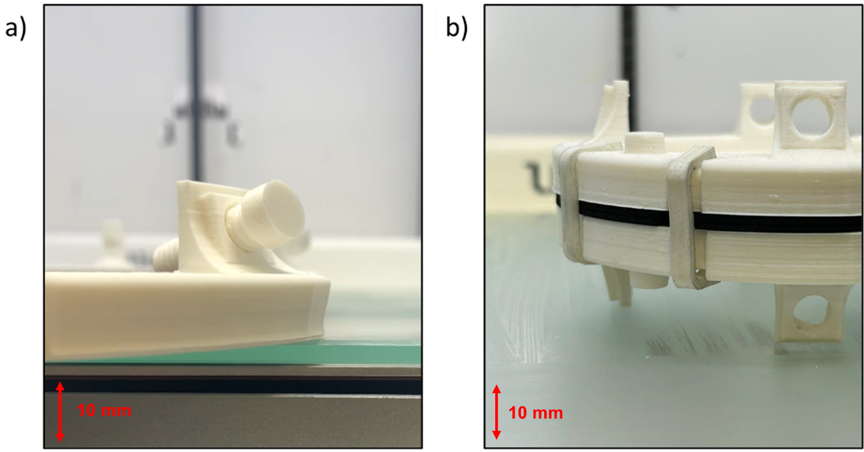
Fig. S2 Photographs showing 3D-printing refinements to assist in cell assembly. a) Screw design to secure current collectors. b) Clip design to hold cells together before compression.
For a similar purpose, four “clip grooves” were added to the exterior of the cell, as seen in Figure S1c. 3D-printed clips then served to hold the two half-cells together before clamping. This allowed the cell assembly to be handled freely and accurately positioned in the centre of the clamp to ensure even compression. These clips can be seen in Figure S2b. In subsequent iterations, these clips were exchanged for a small, M3 stainless-steel square nut and bolt (Figure S1d). A slot was added to one half-cell to insert the nut, and a bolt was screwed through both half-cells securing them together before compression. The stainless-steel square nuts M3x5.5 mm square nuts and M3 bolts (RS Components, UK) are located outside the O-ring channel recess to ensure these components do not contact potentially corrosive electrolytes. The clips and screws used in the designs shown in Figure S1c and d, were subsequently removed after compression. In all cases, the compression applied did not result in any visible deformation of the 3D-printed flow frames.
The final design change before use in this work (illustrated in Figures S1c and d) is the adjustment of the 3D-printed nozzle shapes and sizes. Although improved from early prototypes, durability of the nozzles connecting the cells to peristaltic pump tubing was still an intermittent problem, resulting in the need to re-print half-cells if breakage occurred. To reduce the likelihood of these breakages, the height of the nozzles was reduced from 16 mm to 4.5 mm and the diameter was increased from 6.5 mm to 8 mm. As a result of the reduction in height, the “barb” that can be seen in Figures S1a and b was removed, and tubing was therefore held in place using nylon snap grip hose clamps (5.5 to 6.5 mm ID, RS Components, UK).
The designs depicted in Figures S1c and S1d were employed for all experiments conducted in this study. Specifically, the design shown in Figure S1c was used until the “pump calibration” dataset, during which it was gradually phased out and replaced with the design shown in Figure S1d. It is important to note that these design modifications were made solely to enhance ease of assembly and are not expected to influence performance, as the cell active area remained constant throughout the study. However, this assumption has not been explicitly tested. A detailed guide is provided in Figure S3, outlining the steps followed for assembling cells used in the experiments described in the main text. The CAD files used to produce the 3D-printed flow cell components in this study, along with subsequent design iterations, are available upon request. Interested researchers are encouraged to contact the corresponding author for access and further information.
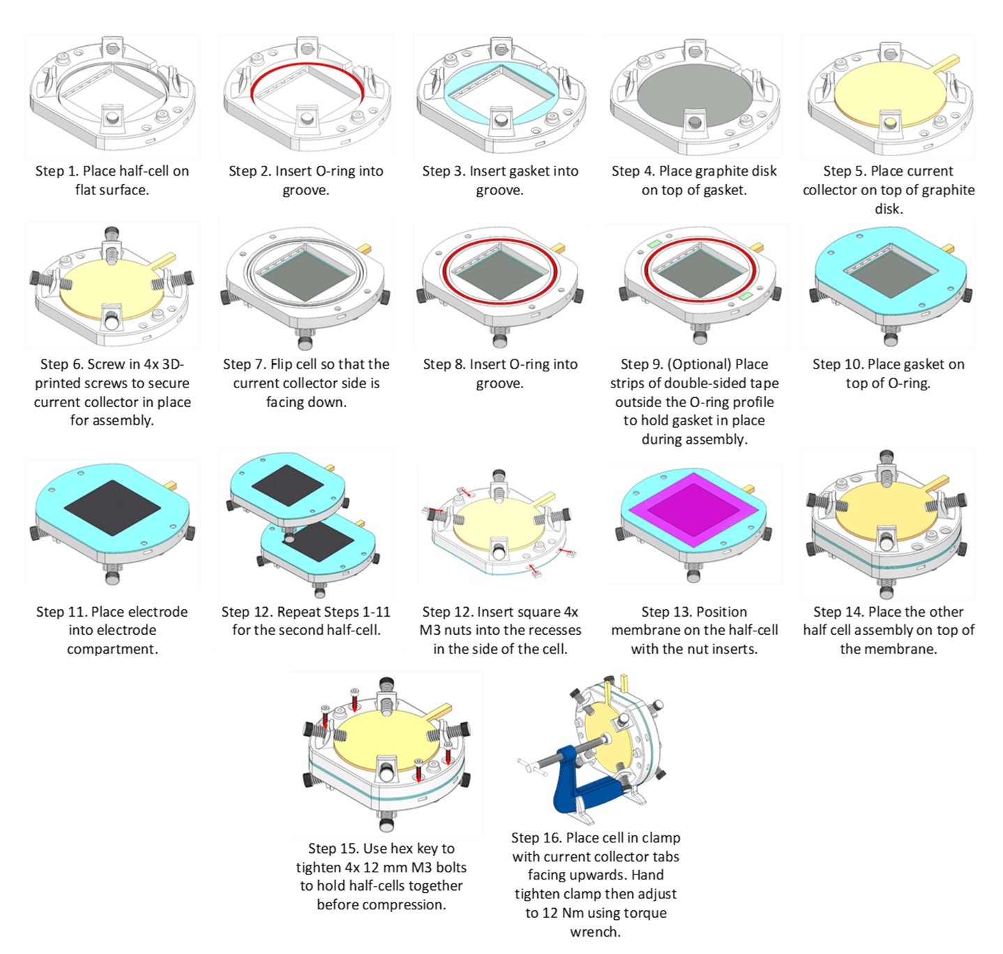
Fig. S3 Schematic showing assembly steps for the updated 3D-printed lab-scale cell.

Tank and degassing apparatus
The custom glass tank used as electrolyte reservoirs for this work is shown in Figure S4a, along with approximate dimensions of the tanks in Figure S4b. After the gas outlet of the tanks, the oil trap depicted in Figure S4c was used to ensure a constant pressure was maintained and to indicate gas flow.
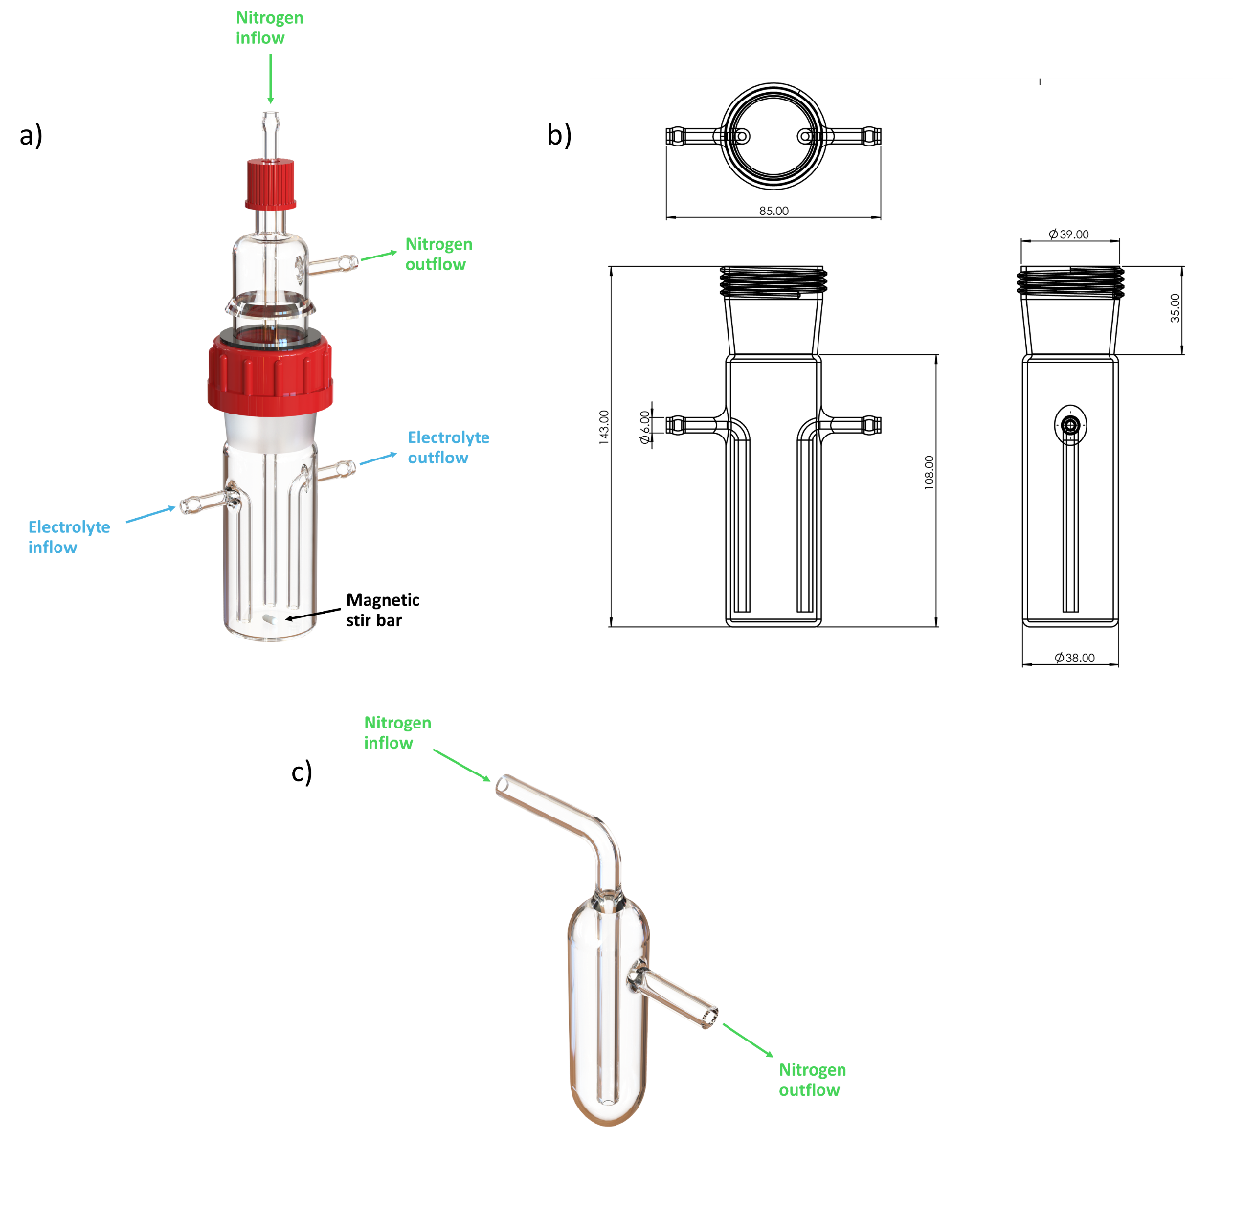
Fig. S4 a) Rendering of electrolyte tank used for all experiments in this work. b) Dimensions of tanks used for all experiments. c) Oil trap used to ensure positive pressure and to indicate gas flow.

Nominal cell geometry
Electrochemical testing was performed on cells with a nominal geometric active area of 16 cm². A circular electrode topology was used with a radius of 22.6 mm. A simple manifold to direct electrolyte flow to/from the inlet/outlet was designed, with manifold walls tangential to the walls of the electrode cavity. The key cell dimensions can be seen in Figure S5. The electrode compartment thickness is 6 mm and the manifold thickness 2 mm.
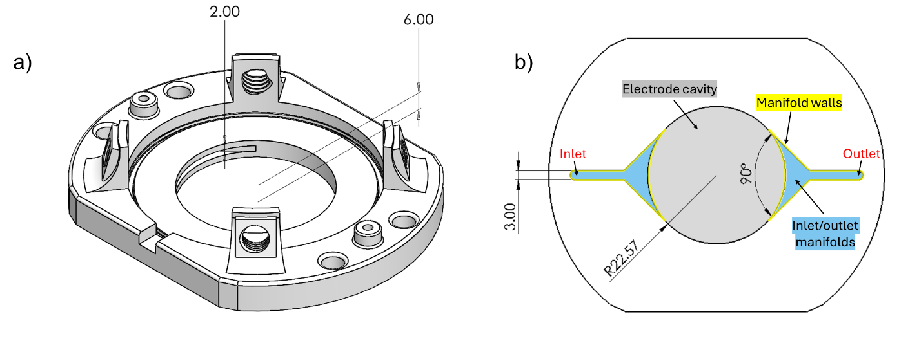
Fig. S5 CAD images showing circular cell geometry used for testing. a) CAD model of cell, b) 2D drawing showing cell dimensions and key features.

Electrolyte formulation
The specifications of the electrolyte as supplied by the manufacturer are shown in Table S1.
Table S1. Electrolyte formulation as supplied by Oxkem Ltd.
 | Nominal | Max | Min
[Free Sulfuric Acid] (M) | 2.0 | 2.1 | 1.8
[Total Sulfate] (M) | 4.2 | 4.3 | 4.1
[Phosphoric Acid] (M) | 0.05 | 0.06 | 0.046
[Total Vanadium] (M) | 1.6 | 1.62 | 1.58
Vanadium (lll) | 50% | 52% | 50%
Vanadium (lV) | 50% | 50% | 48%
Specific Gravity (g cm⁻³) | 1.35 | 1.38 | 1.32
The following typical impurities were also listed in the specification sheet: copper (<2 ppm), iron (<20 ppm), chromium (<10 ppm), sodium (<10 ppm), tin (<2 ppm), and nickel (<20 ppm).

Electrolyte initial charging
As-received from the manufacturer, the vanadium electrolyte used in this study consisted of a 50:50 mixture of V³⁺ and V⁴⁺, and thus an initial charge was required to oxidise and reduce all of the electrolyte in the positive and negative half-cells to V⁵⁺ and V²⁺, respectively. For the initial charge, a constant current, constant voltage (CCCV) charge was applied[2]. In this case, the applied current density was 50 mA cm⁻², and the voltage limit was set to 1.65 V, to reduce electrode degradation and the potential for side reactions[3]. During the constant voltage (CV) step, the current was typically observed to plateau at between 2 and 3 mA cm⁻² rather than tapering to zero. This plateau indicates that the cell had reached a state as close to full charge as possible. This behaviour likely reflects system characteristics, such as reaction kinetics, side reactions, or minor electrolyte imbalances/crossover, which prevent further charging beyond this point. Consequently, the current threshold was set at 3 mA cm⁻², as reliable charging could not be maintained below this level. A typical initial charging step can be seen in Figure S6.
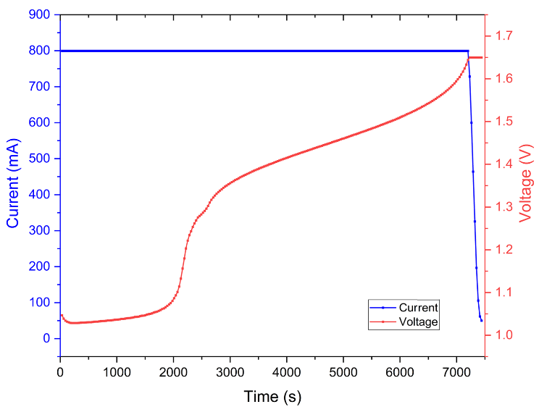
Fig. S6 Plot showing typical initial charging procedure for electrolyte consisting of a 50/50 mixture of 1.6 M V³⁺ and V⁴⁺ in 2 M H₂SO₄. Cell operated at 50 mL min⁻¹ and applied current density of 50 mA cm⁻² during CC phase using Nafion® 117 membrane and SGL Carbon 4.65 EA electrodes.

Performance metrics
Voltage efficiency (VE) is the ratio of the average discharge voltage of a cell to its average charge voltage. It measures the effect of voltage losses on the cell. Voltage efficiency is calculated using Equation (3) where $V_{chg}$ (V) is the charge voltage, $V_{dchg}$(V) is the discharge voltage, $t_{dchg}$ (s) is the duration of the discharge, and $t_{chg}$ (s) is the duration of the charge step:
 | $$VE (\%)=\frac{\int{V_{dchg}dt}/t_{dchg}}{\int{V_{chg}dt}/t_{chg}}×100$$ | (3)
Voltage efficiency (VE) is influenced by several factors, including current density, and mass transport limitations[4]. Other key variables include temperature[5], electrode compression ratio[6], electrode material properties[7], and membrane resistance[8].
Coulombic efficiency (CE) is also examined for each replicate test. CE is most useful for evaluating the charge reversibility of each cycle[9]. It is defined as the ratio of the total charge output by the cell during discharge ($Q_{dchg}$), to the total charge delivered to the cell during charge ($Q_{chg}$), calculated using Equation (4):
 | $$CE (\%)=\frac{Q_{dchg} }{Q_{chg}}×100$$ | (4)
CE is maximised by reducing self-discharge processes (such as diffusion across the membrane) and side reactions (such as hydrogen and oxygen evolution)[5].
Energy efficiency (EE) is the ratio of actual energy discharged by the cell compared to the energy required to charge it, as defined by Equation (5):
 | $$EE \left(\%\right)=\frac{\int{I_{dchg}V_{dchg}dt}}{\int{I_{chg}V_{chg}dt}}×100=\frac{E_{dchg}}{E_{chg}}×100$$ | (5)
Where $I_{chg}$ (A) and$I_{dchg}$(A) are the cell currents during charging and discharging. EE is a function of both VE and CE, and as such, is a good indicator of the overall electrochemical performance of the cell. When a cell is operated in constant current mode, it can also be calculated from the product of voltage and energy efficiencies, as shown in Equation (6)[5]:
 | $$EE=CE×VE$$ | (6)
where $EE$ represents energy efficiency, $CE$ represents Coulombic efficiency and $VE$ represents voltage efficiency.
The final performance metric used in this work is electrolyte utilisation (EU). This is a measurement of the effectiveness of the use of the active species in the electrolyte. Electrolyte utilisation increases with flow rate and reduced overpotentials as cells can be charged to a greater SOC before reaching a given cut-off voltage. It can be defined as the ratio of the actual discharge capacity to the theoretical capacity of the battery[10]:
 | $$EU=Q_{dchg }/Q_{t}$$ | (7)
Where $Q_{dchg }$(mAh) is the discharge capacity of the battery and $Q_{t}$ (mAh) is the theoretical capacity stored in a given electrolyte volume. This can be determined using Equation (8)[11]:
 | $$Q_{t}=n×c×V_{T}×F/3.6$$ | (8)
Where n is the number of electrons transferred per molecule of active species converted (here, n = 1), $c$ (mol L⁻¹) is the concentration of the dissolved active species, $V_{T}$ (L) is the electrolyte volume, $F$ is Faraday’s constant (96485 C mol⁻¹), and 3.6 is a conversion factor (C mAh⁻¹).
The most common way to quantify error between replicates is by calculating the standard deviation of the data. Standard deviation can be described as the “spread” of a dataset. The standard deviation, $s,$ of a series of, $n,$ datapoints can be calculated using Equation (9)[12]:
 | $$s=\sqrt{\frac{\sum_{i=1}^{n}{{\left(x_{i}-\overline{x}\right)}^{2}}}{\left(n-1\right)}}$$ | (9)
where$x_{i}$ is the value of the $i$th datapoint and $\overline{x}$ is the mean of the $n$ datapoints considered.
Capacity loss is defined as the percentage of the initial capacity that has been lost by a given time or cycle. In this work, the capacity loss was examined between the initial discharge capacity of the first and 12th cycles.
 | $$Q_{loss}\left(\%\right)=\frac{Q_{{dchg}_{initial}-}Q_{{dchg}_{final}}}{Q_{{dchg}_{final}}}$$ | (10)
The “average capacity loss” was then calculated for each dataset by taking the average of the capacity loss for each repeat test.

Peristaltic pump flow rates
To investigate the effect of tubing wear on the flow rates provided by peristaltic pumps, the flow rate in mL min⁻¹ was calculated for each rotor of the dual-head peristaltic pumps used for testing (BT100M YZ1515x, Chonry Peristaltic Pump Co., Ltd, China).
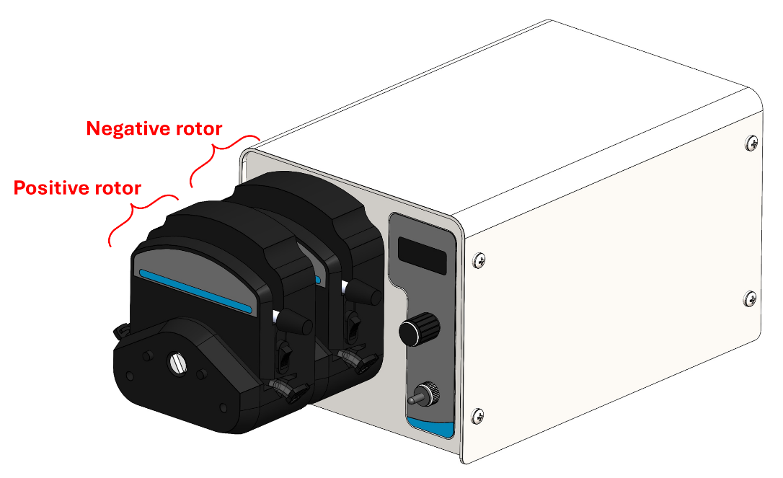
Fig. S7 Render showing the dual-head peristaltic pumps used in this work
Eight tubing samples of varying degradation (having been used for previous flow cell testing) were tested using diH₂O to determine the volumetric flow rate. Measurements were taken from each rotor for comparison and are shown in Table S2.
Table S2. Measured peristaltic pump flow rates.
Tubing sample | Positive half-cell rotor flow rate  (mL min⁻¹) | Negative half-cell rotor flow rate  (mL min⁻¹) | Largest Δ from set value of 50 mL min⁻¹  (%) | Δ between rotors  (%)
1 | 46.0 | 45.5 | 9.0 | 1.1
2 | 45.0 | 49.5 | 10.0 | 9.1
3 | 47.0 | 51.0 | 6.0 | 7.8
4 | 46.5 | 48.0 | 7.0 | 3.1
5 | 46.5 | 50.0 | 7.0 | 7.0
6 | 46.5 | 48.0 | 7.0 | 3.1
7 | 46.5 | 49.5 | 7.0 | 6.1

Cell capacities
The average initial charge capacity, average discharge capacity, and average capacity losscan be seen in Figures S8 a, b, and c, respectively.
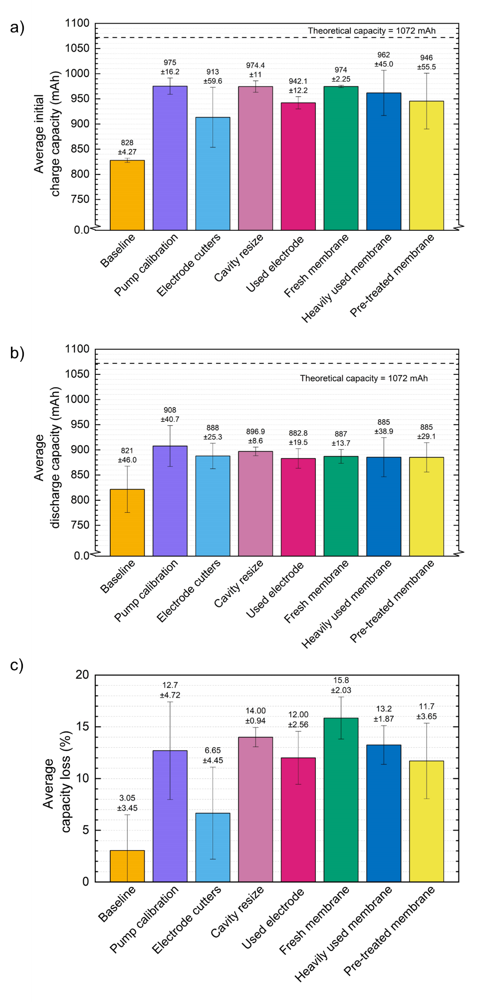
Fig. S8 Bar charts showing a) average initial charge capacity, b) average discharge capacity, and c) average capacity loss for all datasets.

Example testing protocol
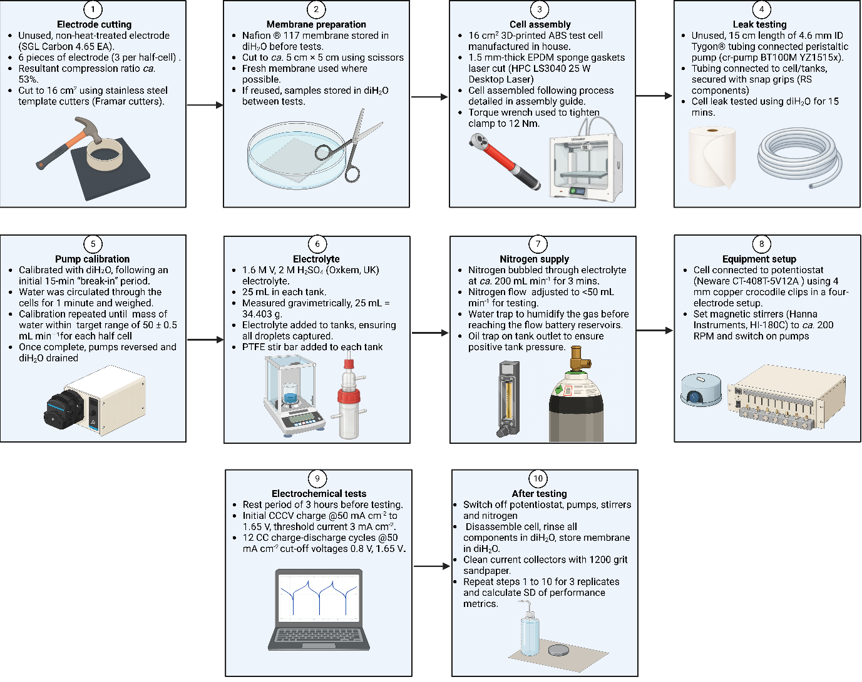
Fig. S9 Flow chart detailing protocol followed for the testing carried out in this work.[13]

References
[1] H. O’Connor, J.J. Bailey, O.M. Istrate, P.A.A. Klusener, R. Watson, S. Glover, F. Iacoviello, D.J.L. Brett, P.R. Shearing, P. Nockemann, An open-source platform for 3D-printed redox flow battery test cells†, Sustain Energy Fuels 6 (2022) 1529–1540. https://doi.org/10.1039/d1se01851e.
[2] D. Aaron, Z. Tang, A.B. Papandrew, T.A. Zawodzinski, Polarization curve analysis of all-vanadium redox flow batteries, J Appl Electrochem 41 (2011) 1175–1182. https://doi.org/10.1007/s10800-011-0335-7.
[3] I. Derr, A. Fetyan, K. Schutjajew, C. Roth, Electrochemical analysis of the performance loss in all vanadium redox flow batteries using different cut-off voltages, Electrochim Acta 224 (2017) 9–16. https://doi.org/10.1016/j.electacta.2016.12.043.
[4] D.K. Kim, S.J. Yoon, J. Lee, S. Kim, Parametric study and flow rate optimization of all-vanadium redox flow batteries, Appl Energy 228 (2018) 891–901. https://doi.org/10.1016/j.apenergy.2018.06.094.
[5] M. Skyllas-Kazacos, C. Menictas, T. Lim, Redox flow batteries for medium-to large-scale energy storage, in: Electricity Transmission, Distribution and Storage Systems, Elsevier Ltd, 2013: pp. 398–441. https://doi.org/10.1533/9780857097378.3.398.
[6] L.D. Brown, T.P. Neville, R. Jervis, T.J. Mason, P.R. Shearing, D.J.L. Brett, The effect of felt compression on the performance and pressure drop of all-vanadium redox flow batteries, J Energy Storage 8 (2016) 91–98. https://doi.org/10.1016/j.est.2016.10.003.
[7] B. Sun, M. Skyllas-Kazacos, Modification of graphite electrode materials for vanadium redox flow battery application—I. Thermal treatment, Electrochim Acta 37 (1992) 1253–1260. https://doi.org/10.1016/0013-4686(92)85064-R.
[8] C.H.L. Tempelman, J.F. Jacobs, R.M. Balzer, V. Degirmenci, Membranes for all vanadium redox flow batteries, J Energy Storage 32 (2020) 101754. https://doi.org/10.1016/j.est.2020.101754.
[9] T. Puleston, A. Clemente, R. Costa-Castelló, M. Serra, Modelling and Estimation of Vanadium Redox Flow Batteries: A Review, Batteries 8 (2022). https://doi.org/10.3390/batteries8090121.
[10] N.Y. Hsu, N. Devi, Y.I. Lin, Y.H. Hu, H.H. Ku, A. Arpornwichanop, Y.S. Chen, Study on the effect of electrode configuration on the performance of a hydrogen/vanadium redox flow battery, Renew Energy 190 (2022) 658–663. https://doi.org/10.1016/j.renene.2022.03.151.
[11] Y. Yao, J. Lei, Y. Shi, F. Ai, Y.C. Lu, Assessment methods and performance metrics for redox flow batteries, Nat Energy 6 (2021) 582–588. https://doi.org/10.1038/s41560-020-00772-8.
[12] S. Bell, The Beginner’s Guide to Uncertainty of Measurement, 2001.
[13] Created in BioRender. O'Connor, H. (2025) https://BioRender.com/m05k7qp

