Electrocatalytic Detection and Adsorptive Removal of Rose Bengal Dye from Wastewater
Maria Khanª, Afzal Shahª*, Mohsin Javedª
ªDepartment of Chemistry Quaid-i-Azam University, Islamabad 45320, Pakistan
Correspondence*: afzals_qau@yahoo.com

Supporting Information

Table S1: Chemicals catalog listing and associated purity standards and suppliers.
S. No. | Chemicals | Purity (%) | Supplier
1. | Acetone | 99 | Riedel-deHaen
2. | Ammonia solution | 25% | Merck
3. | Bismuth nitrate pentahydrate | ˃99 | Sigma Aldrich
4. | Dimethylformamide | 99 | Riedel-deHaen
5. | Disodium hydrogen phosphate dihydrate | ˃99 | Merck
6. | Ethanol | 99.8 | Riedel-deHaen
7. | Iron nitrate nonahydrate | >99 | Sigma Aldrich
8. | Potassium chloride | 99 | Sigma Aldrich
9. | Potassium hexacyanoferrate | ˃99 | Sigma Aldrich
10. | Rose bengal | Extra pure | Sigma Aldrich
11. | Sodium hydroxide | 97 | Fluka
12. | Sodium dihydrogen phosphate monohydrate | ˃99 | Merck
13. | Sulfuric acid | 98 | Merck
14. | Zinc nitrate hexahydrate | 98 | Sigma Aldrich

Table S2: Parameters obtained from CV analysis.
Working electrode | Electroactive surface area (cm²) | Peak separation  (mV)
Bare GCE | 0.035 | 105
Fe-ZnO/GCE | 0.053 | 93
MWCNTs/GCE | 0.087 | 90
Fe-ZnO/MWCNTs/GCE | 0.112 | 85

Table S3: Parameters obtained from recovery of RB in distilled and tap water.
Sample | Spiked amount (µM) | Found (n=3) (µM) | RSD (%) | Recovery (%)
Distilled water | 15 | 14.97 | 1.42 | 99.8
Tap water | 15 | 14.26 | 4.30 | 95.1

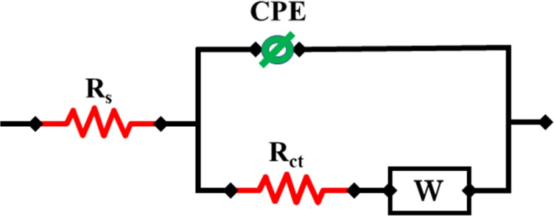
Figure S1: Equivalent circuit used for assessment of EIS parameters.

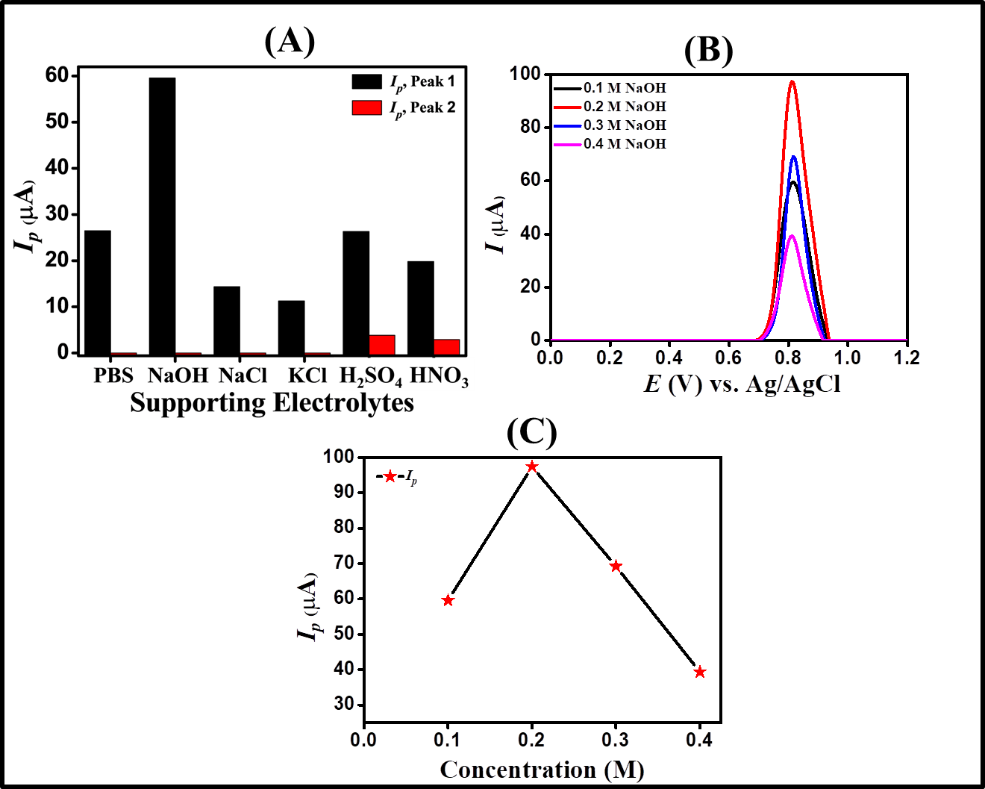
Figure S2: (A) Bar graph between I_{p} vs various supporting electrolytes, (B) SWVs of RB were recorded in NaOH solution with concentrations ranging from 0.1 M to 0.4 M by using Fe-ZnO/MWCNTs as a modifier, and (C) I_{p} vs various concentration of NaOH as electrolyte.

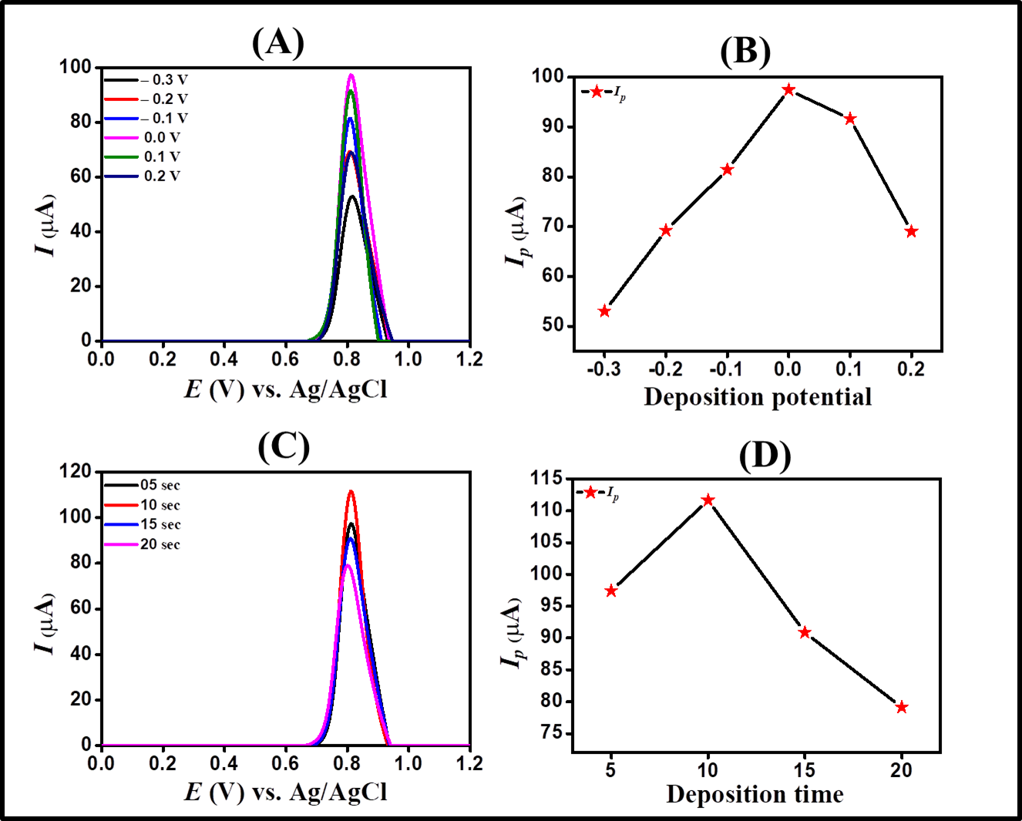
Figure S3: (A) Impact of deposition potential on SWV peak current of 30 µM RB, (B) I_{p} vs deposition potential, (C) The impact of accumulation time on the anodic peak current of 30 µM RB, and (D) I_{p} vs deposition time.

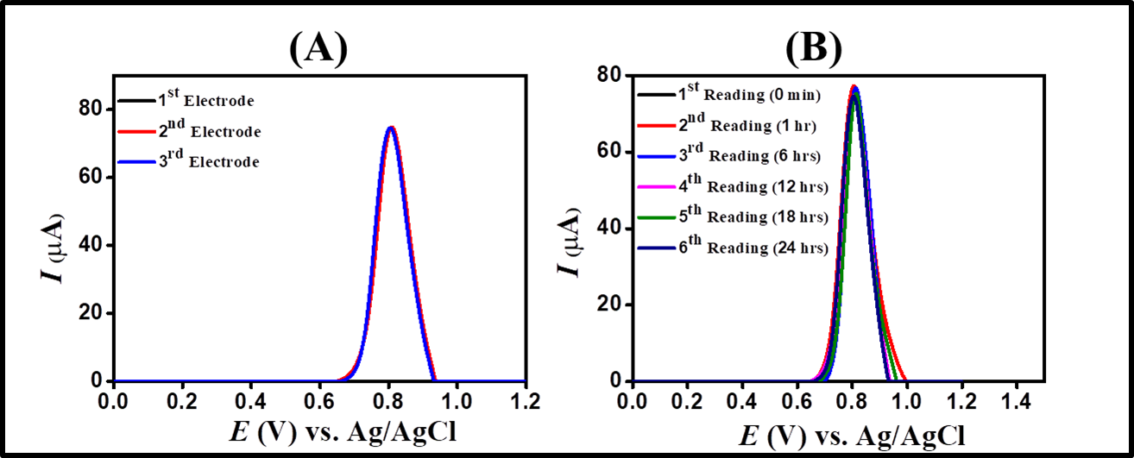
Figure S4: (A) SWVs of 20 µM RB using different modified GCEs in 0.2 M NaOH, and (B) SWVs showing repeatability for electroanalysis of 20 µM RB at different time intervals
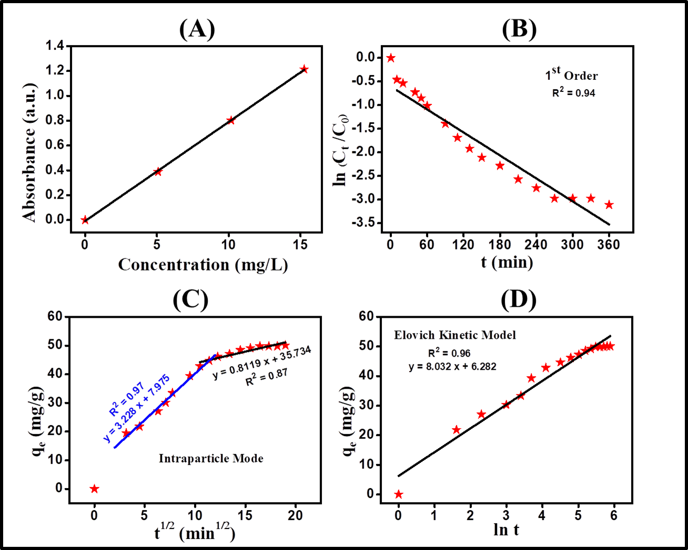
Figure S5: (A) Linear calibration curve of absorbance vs concentration for RB, (B) pseudo-first-order kinetic, (C) Intraparticle diffusion kinetics, and (D) Elovich model.

