Gravimetric and Microstructural Assessment of Schiff Base Inhibitors in Nigerian Tar Sand Processing
Mutairu O. Ajiboye¹, Ayodele A. Daniyan¹, Paul C. Okonkwo², Lukman A. Aminu¹, Lukman Olasunkanmi³, Ibrahim Waziri⁴, Lasisi E. Umoru¹, Oludolapo A. Olanrewaju⁵, Oladeji O. Ige^{1,5,}*
¹Department of Materials Science and Engineering, Obafemi Awolowo University, Ile-Ife, Nigeria
²Department of Mechanical and Mechatronics Engineering, Dhofar University, Şalālah, Oman
³Department of Chemistry, Obafemi Awolowo University, Ile-Ife, Nigeria
⁴Department of Chemistry, University of Maiduguri, Maiduguri, Nigeria
⁵Department of Industrial Engineering, Durban University of Technology, Durban, South Africa
*Corresponding author: ige4usa@yahoo.com
https://orcid.org/0000-0002-1090-8376

1.0 Partial Electrochemistry Resolved
In addressing the electrochemical techniques challenges, conductivity tests and separate electrode compartments (crafted from 3D-printed ABS material) were implemented to investigate the simulated hot water processing environment for bitumen extraction from tar sand. The following sections detail the measurement parameters and the results obtained from this research.
1.1 Methods
1.1.1 Conductivity test
The conductivity test measured the ionic concentration of the various solutions and acted as a key indicator of ion mobility of the simulated hot water processing environment for bitumen extraction from tar sand with and without Schiff base inhibitors (SB1, SB2 and SB3) at 90 °C. The materials and equipment used in the test included a calibrated digital JENWAY 4510 conductivity meter, beakers, mild steel samples, NaOH solution, tar sand, heat source, and the Schiff base inhibitors.

1.1.2 Electrochemical measurements
Electrochemical measurements were carried out using a CORRTEST CS310 M, by the methods described by Okonkwo et al. [1]. The experimental procedures included open circuit potential, polarization resistance, and electrochemical impedance spectroscopy (EIS) measurements. Open circuit potential measurements were conducted for 5 minutes while the electrode was polarized from the open circuit potential by ± 20 mV, with a scanning rate of 0.5 mV/s. The EIS measurements spanned a frequency range from 10000 to 0.01 Hz and were performed again, usually in triplicate, to ensure data reliability and accuracy.
1.2 Results
1.2.1 Conductivity:

Table S1 shows the conductivity results for the simulated hot water processing environment for bitumen extraction from tar sand with and without Schiff base inhibitors (SB1, SB2, and SB3) at 90 ⁰C. The conductivity values ranged from 73.4 to 105.5, and the conductivity values across all conditions demonstrate that the electrolyte is highly conductive and capable of supporting electrochemical reactions. The comparison with the 3.5% NaCl solution shows that the system's conductivity is even higher, [2], especially under heated conditions, negating the hypothesis that low conductivity might be the reason for poor electrochemical test performance. Instead, the observed issues with electrochemical techniques likely arise from other factors. This observation aligns with the literature [3].

1.2.2 Electrochemical results

Figure S1 presents a typical OCP measurement conducted over 6 hours. Throughout this period, the potential demonstrates a continuous upward trend characterized by a wavy pattern, failing to stabilize. The LPR results indicated a non-linear, curvilinear relationship in all instances, diverging from the anticipated linear trend shown in Figure S2. The EIS analysis yielded inconclusive results in both Nyquist and Bode plots due to electrolyte instability, as noted by Kohan et al. [4]. The results are possibly affected by factors like temperature fluctuations and gas bubble formation disrupted impedance measurements, underscoring the challenges of obtaining reliable electrochemical data in experimental conditions.
Table S1: Solution conductivity (mS/cm) for uninhibited and inhibited mild steel systems in tar sand environments
Conductivity (mS/cm) | Uninhibited | Mild steel + SB1 | Mild steel + SB2 | Mild steel + SB3
NaOH (0.58 M) | 74.1 | 74.6 | 73.4 | 74.3
NaOH +Tar sand | 73.3 | 73.6 | 73.9 | 74.9
NaOH +Tar sand + Heat + Inhibitors | 105.5 | 94.3 | 99.4 | 89.8
3.5% NaCl (Zhang, 2016) | 55

Figure S1: A typical open circuit potential scan for 6 h

Figure S2: LPR result after an OCP scan of 6 hours

1.3 Recommendation:
Further study will explore the possibility of using other materials like porcelain and porous glass as containers or porous membranes to examine the electrochemical techniques of the tar sand hot water processing environments.

References:
- Okonkwo, P. C., Oluwasegun, K. M., Daniyan, A. A., and Ige, O. O. (2025): The Role of Shear Stress and pH on Mild Steel Corrosion Rate in a Simulated Mine Water, Portugaliae Electrochimica Acta 43: 205-217
- Guo, H. and Keppler, H. (2019): Electrical conductivity of NaCl‐bearing aqueous fluids to 900 C and 5 GPa, Journal of Geophysical Research: Solid Earth, 124(2), 1397-1411.
- Adamu, A. A., Jadhawar, P. S., Akanji, L., and Aphale, S. S. (2024): Unlocking Efficiency in Radio-Frequency Heating: Eigenfrequency Analysis for Resonance Identification and Propagation Enhancement in Nigerian Tar Sands. ACS omega, 9(2), 2931-2944.
- Kohan, E., Salami-Kalajahi, M., Khoshnavazi, R., Hosseini, M., and Salimi, A. (2024): Considerate instability factors in mono and divalent metal ion batteries: from fundamentals to approaches. Journal of Materials Chemistry A.

2.0 Schiff bases synthesis
The Schiff bases, denoted as SB1, SB2, and SB3, were obtained from Obafemi Awolowo University's Chemistry Department in Ile Ife, Osun State, Nigeria. Specifically, the Schiff bases were formed using substituted anilines and salicyaldehyde with a generalized procedure as outlined in previous works (46- 47). The detailed synthesis process for the inhibitors is described in supplementary materials and the chemical reactions are presented in scheme 1.

The synthesis process begins by preparing a solution of the chosen aldehyde in an appropriate solvent, typically anhydrous ethanol. For SB1 and SB2, 2-hydroxybenzaldehyde, also known as salicylaldehyde, is added while adding 2,4-dichloro-6-hydroxybenzaldehyde for SB3. The resultant solution is thoroughly mixed, and the corresponding aniline derivative is introduced. For SB1, 2-trifluoromethylaniline is put in dropwise to encourage proper mixing. In the synthesis of SB2, 2-bromo-4-chloroaniline is added gradually to prevent any potential oxidation, while for SB3, 4-methoxy aniline is added in a single portion. To facilitate the condensation reaction, glacial acetic acid is introduced as a catalyst; the amount varies slightly, with 0.5 mL used for SB1 and SB2 and 0.6 mL for SB3. The mixture is then heated under reflux at 80°C, with stirring throughout the reaction duration. The reaction times vary, with SB1 and SB2 requiring three hours, while SB3 necessitates four hours. As the reaction proceeds, a characteristic colour change occurs: a yellow hue for SB1, an orange-yellow for SB2, and a deep yellow for SB3, signalling the formation of the desired imine intermediates.
Thin-layer chromatography (TLC) was used to monitor the reaction progress by utilizing suitable mobile phases for each compound. SB1 used a hexane-acetate mixture in a 7:3 ratio, while SB2 employed an 8:2 toluene ratio, and SB3 was monitored using dichloromethane in a 9.5:0.5 ratio. The precipitation of the reaction products occurred by cooling at room temperature but before they were ice bath chilled. The resulting solid is isolated through vacuum filtration and washed with cold ethanol (and diethyl ether for SB2) to eliminate impurities. Then, the purified solid is dried under reduced pressure, with specific temperatures and durations tailored to each compound—40°C for SB1, 45°C for SB2, and 50°C for SB3. Finally, SB1 emerges as a yellow crystalline solid, SB2 as an orange-yellow crystalline solid, and SB3 as a bright yellow crystalline powder.

3.0 FTIR spectra

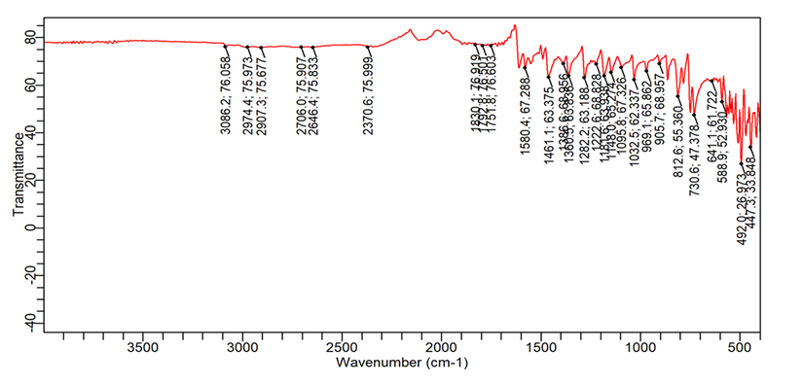

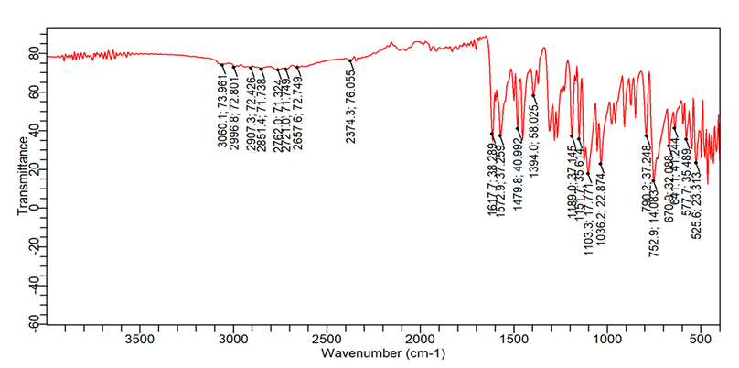
(b)

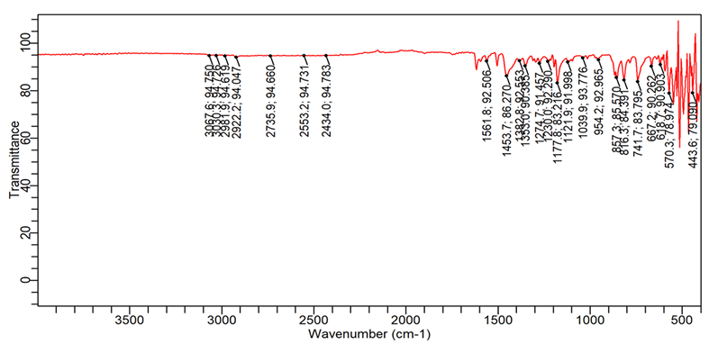
(c)

Figure S3: FTIR spectra of synthesized Schiff base inhibitors (a) SB1, (b) SB2, and (c) SB3

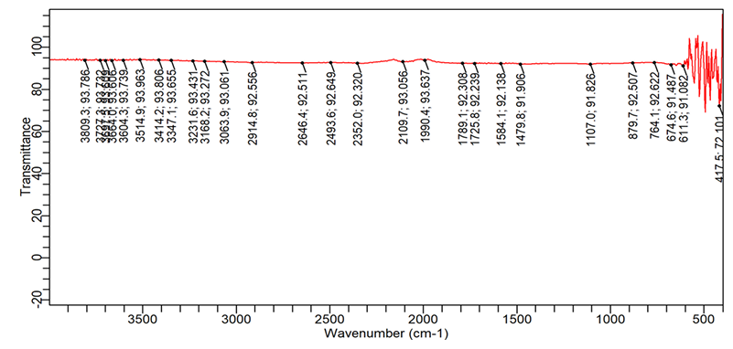

Figure S4: FTIR of uninhibited steel after immersion

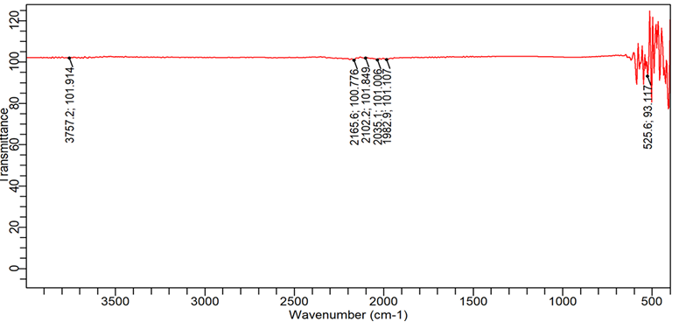

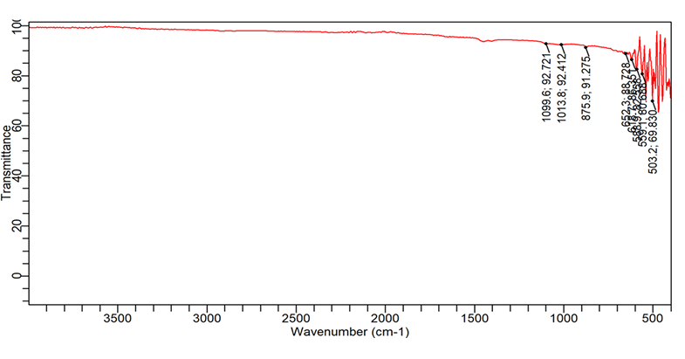
(b)

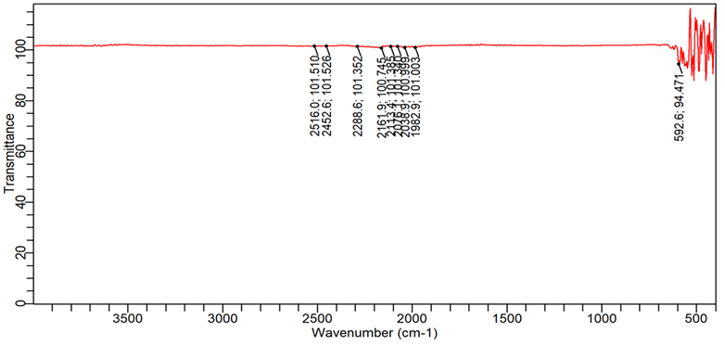

(c)
Figure S5: FTIR spectra of inhibited samples (a) SB1, (b) SB2, and (c) SB3

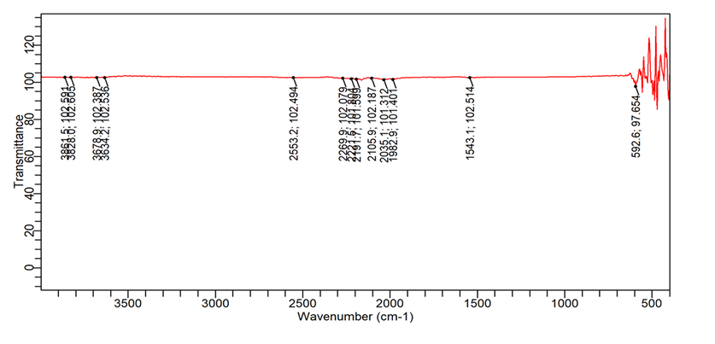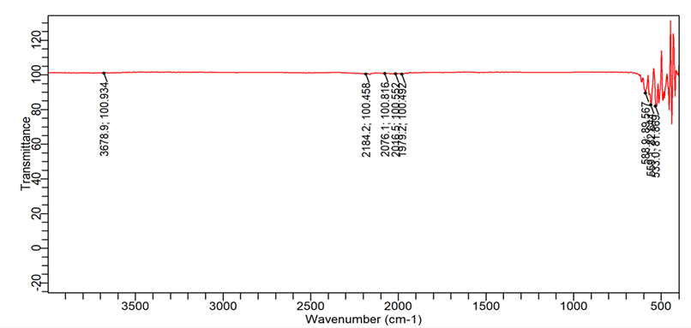
- (b)

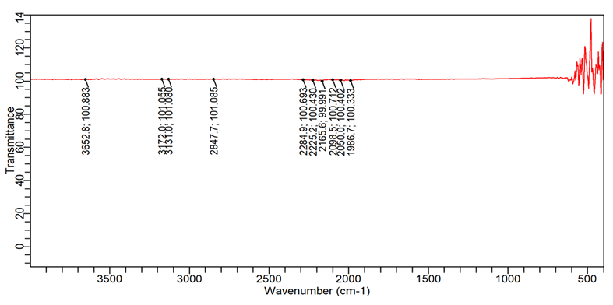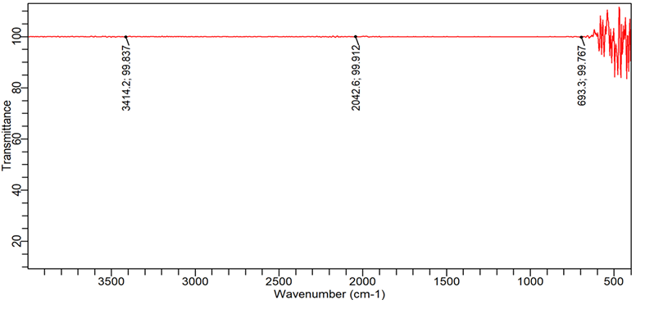
(c) (d)
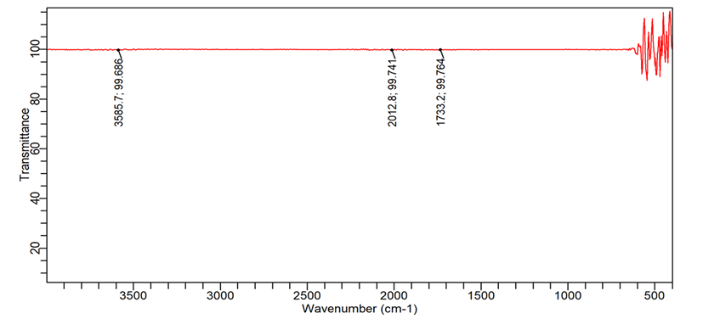
(e) (f)

Figure S6: a typical FTIR spectra showing the effect of SB 3 inhibitor (a) 25 ppm, (b) 50 ppm, (c) 75 ppm, (d) 100 ppm, and (e) 125 ppm, and (f) 150 ppm
4. Adsorption isotherms
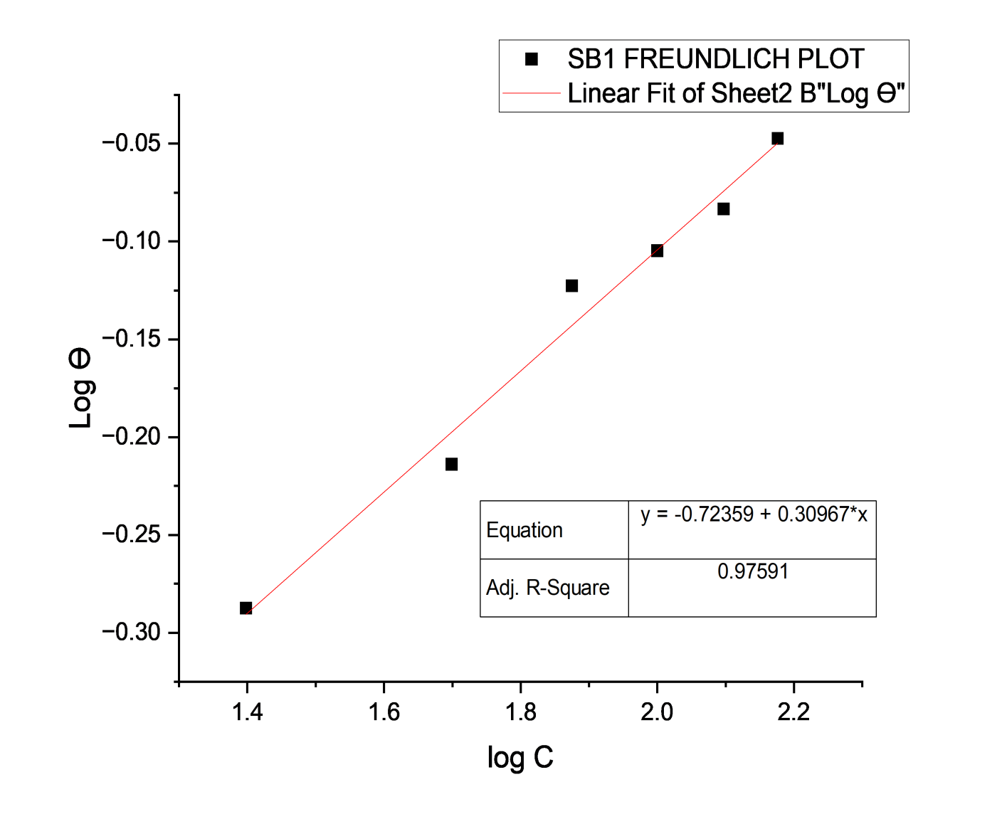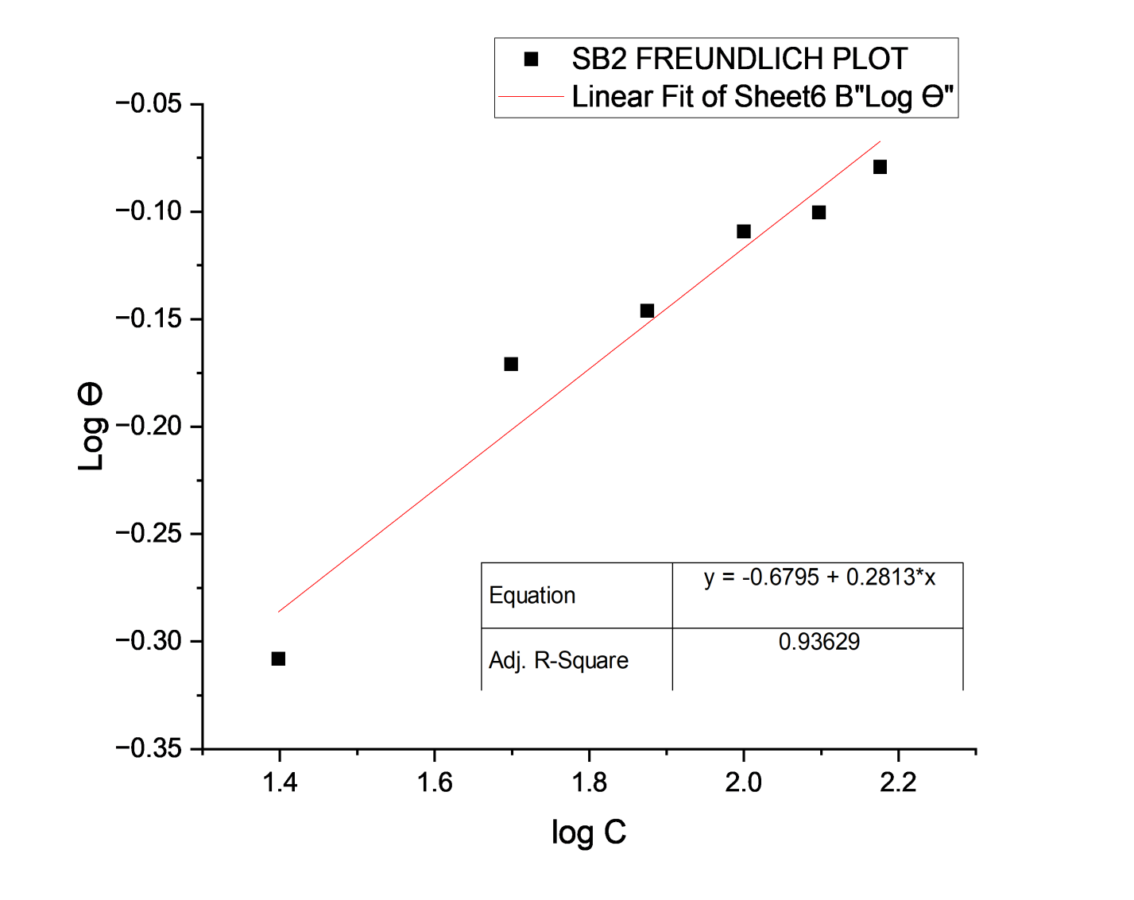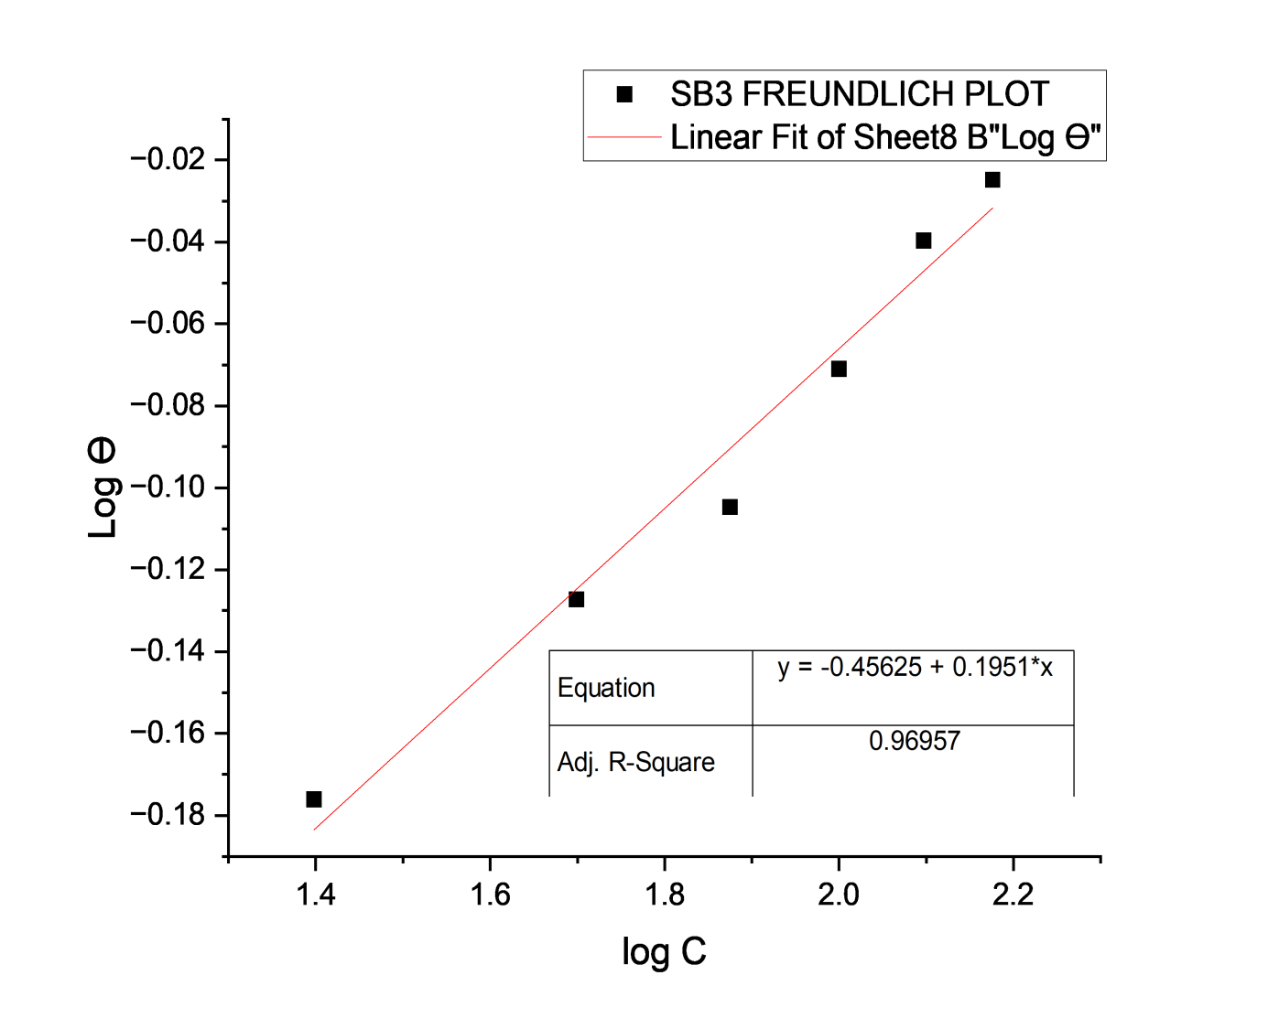
- (b) (c)
Figure S5: Freundlich isotherm adsorption: (a) SB1, (b) SB2, and (c) SB3 on mild steel in tar sand process environment
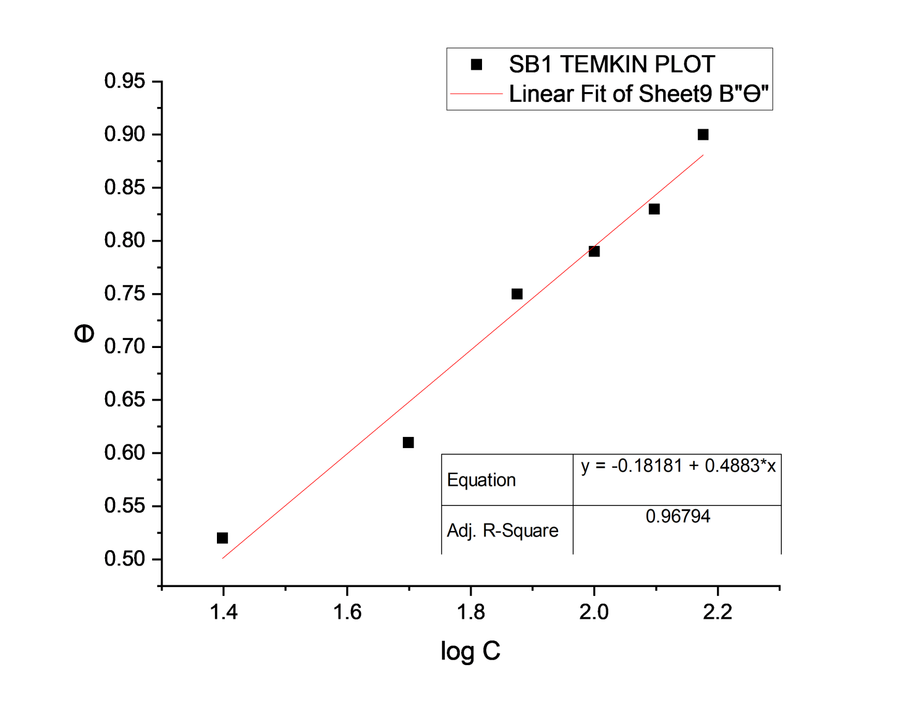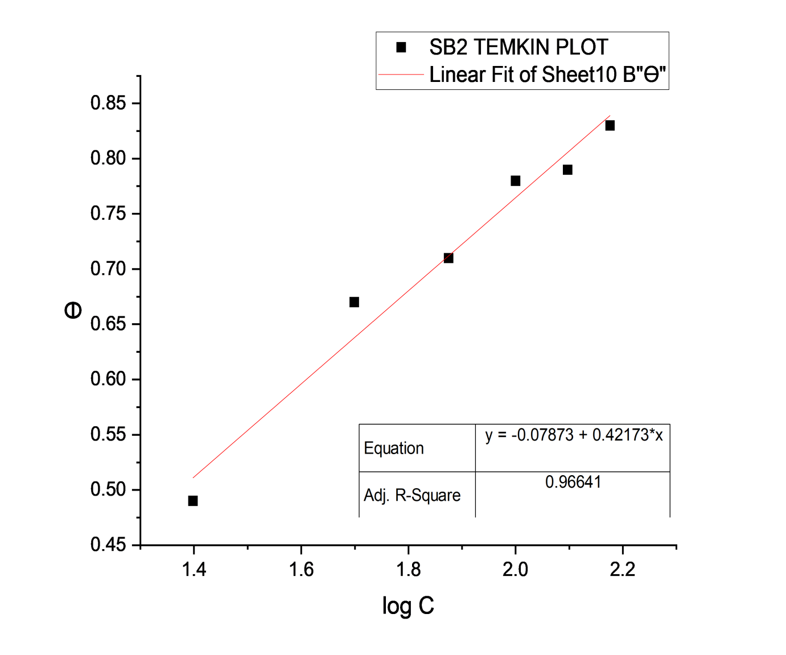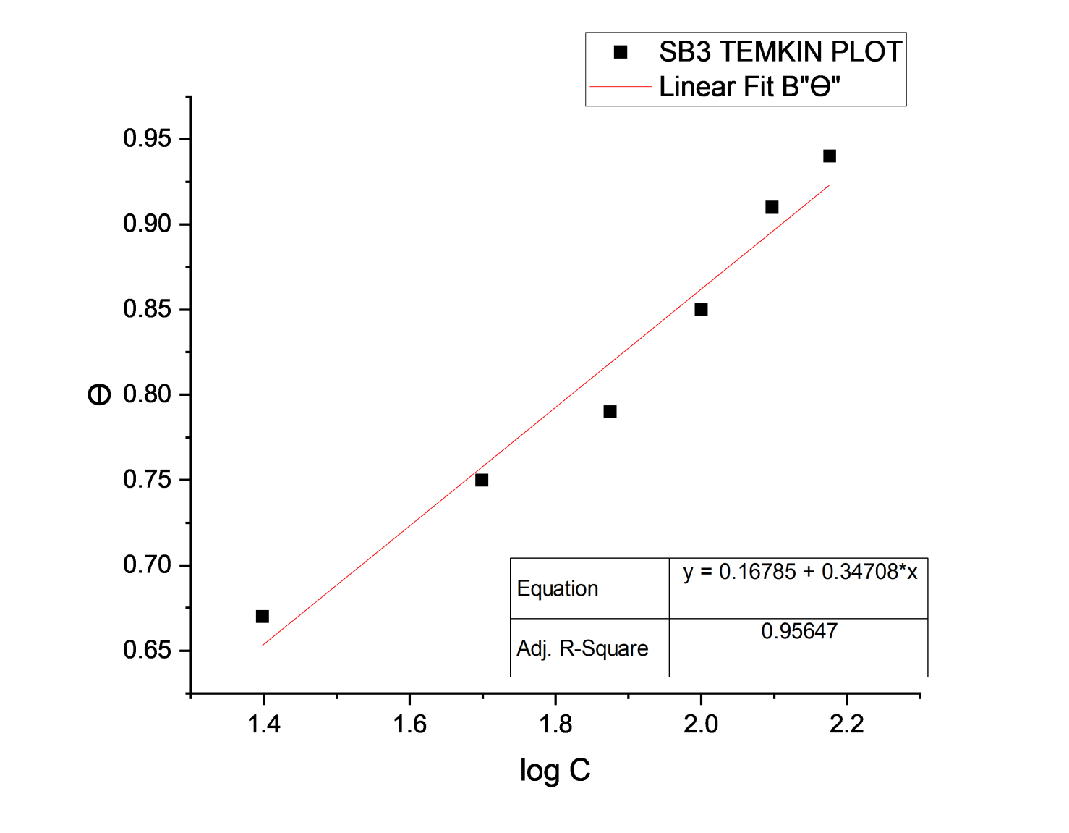
- (b) (c)

Figure S7: Temkin isotherm adsorption: (a) SB1, (b) SB2, and (c) SB3 on mild steel in tar sand process environment

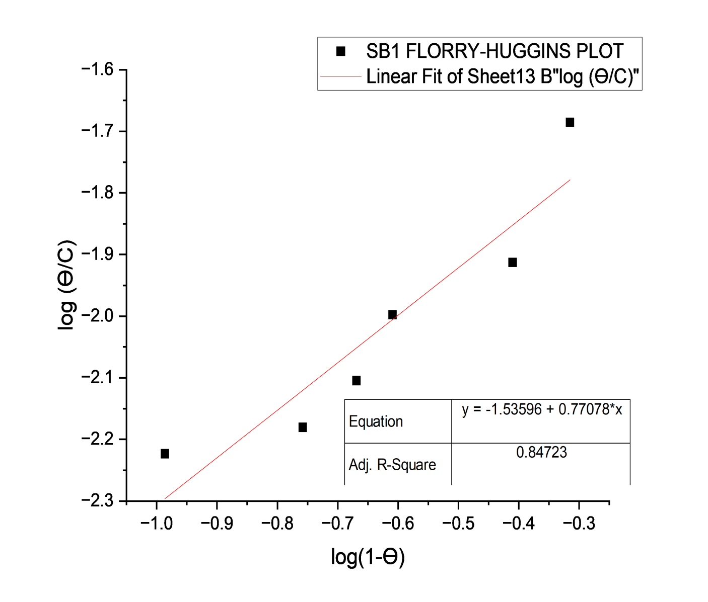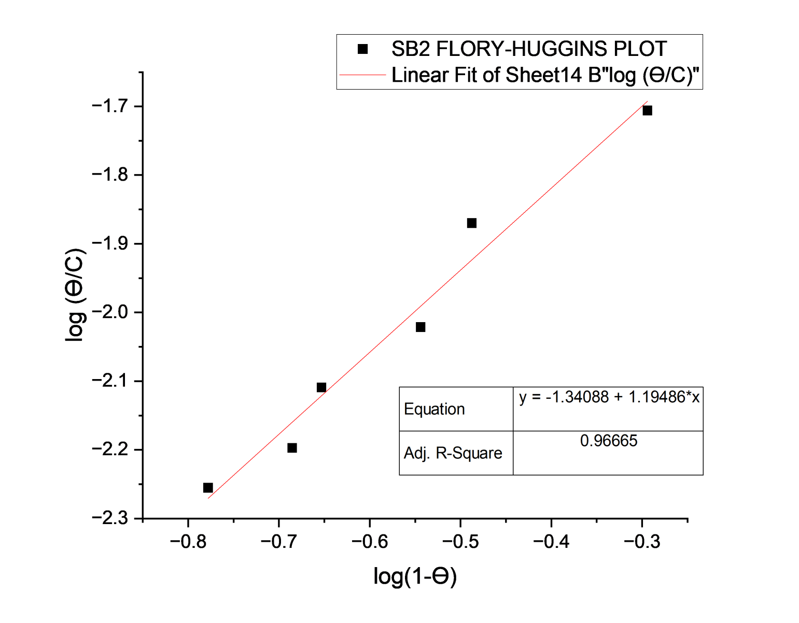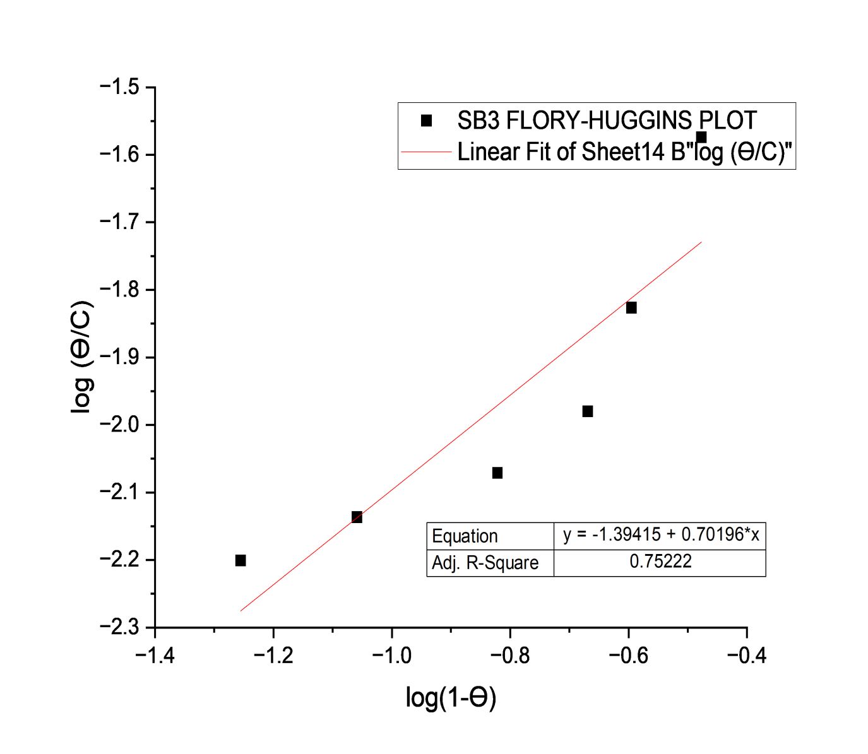
- (b) (c)
S8: Florry-Huggin’s isotherm adsorption: (a) SB1, (b) SB2, and (c) SB3 on mild steel in tar sand process environment
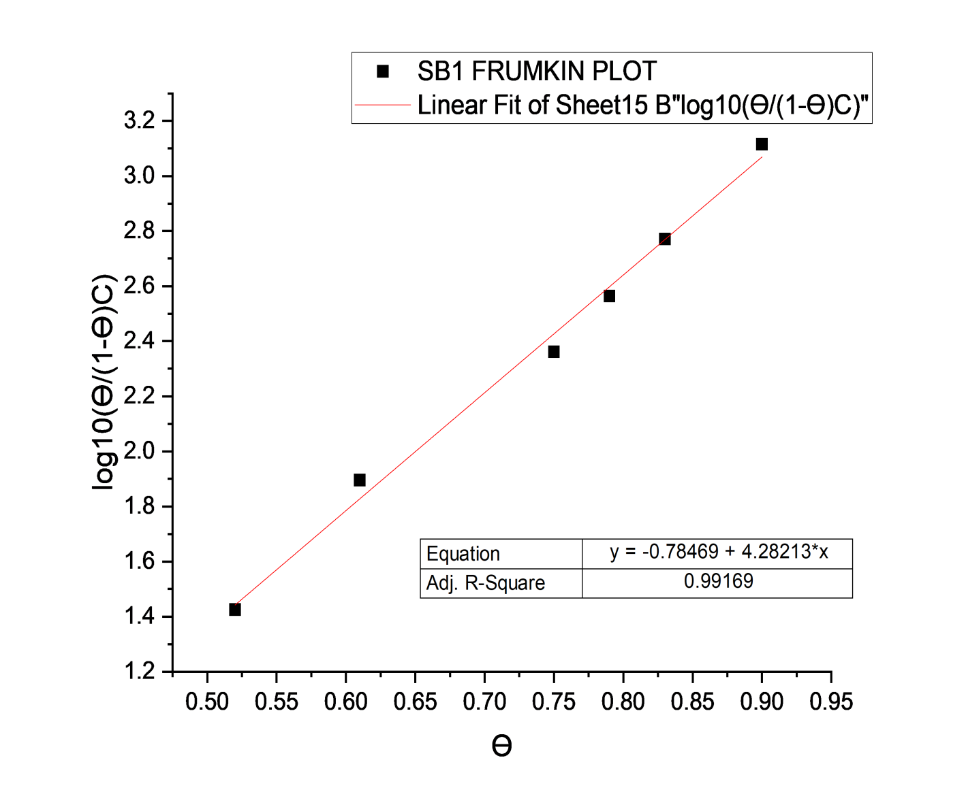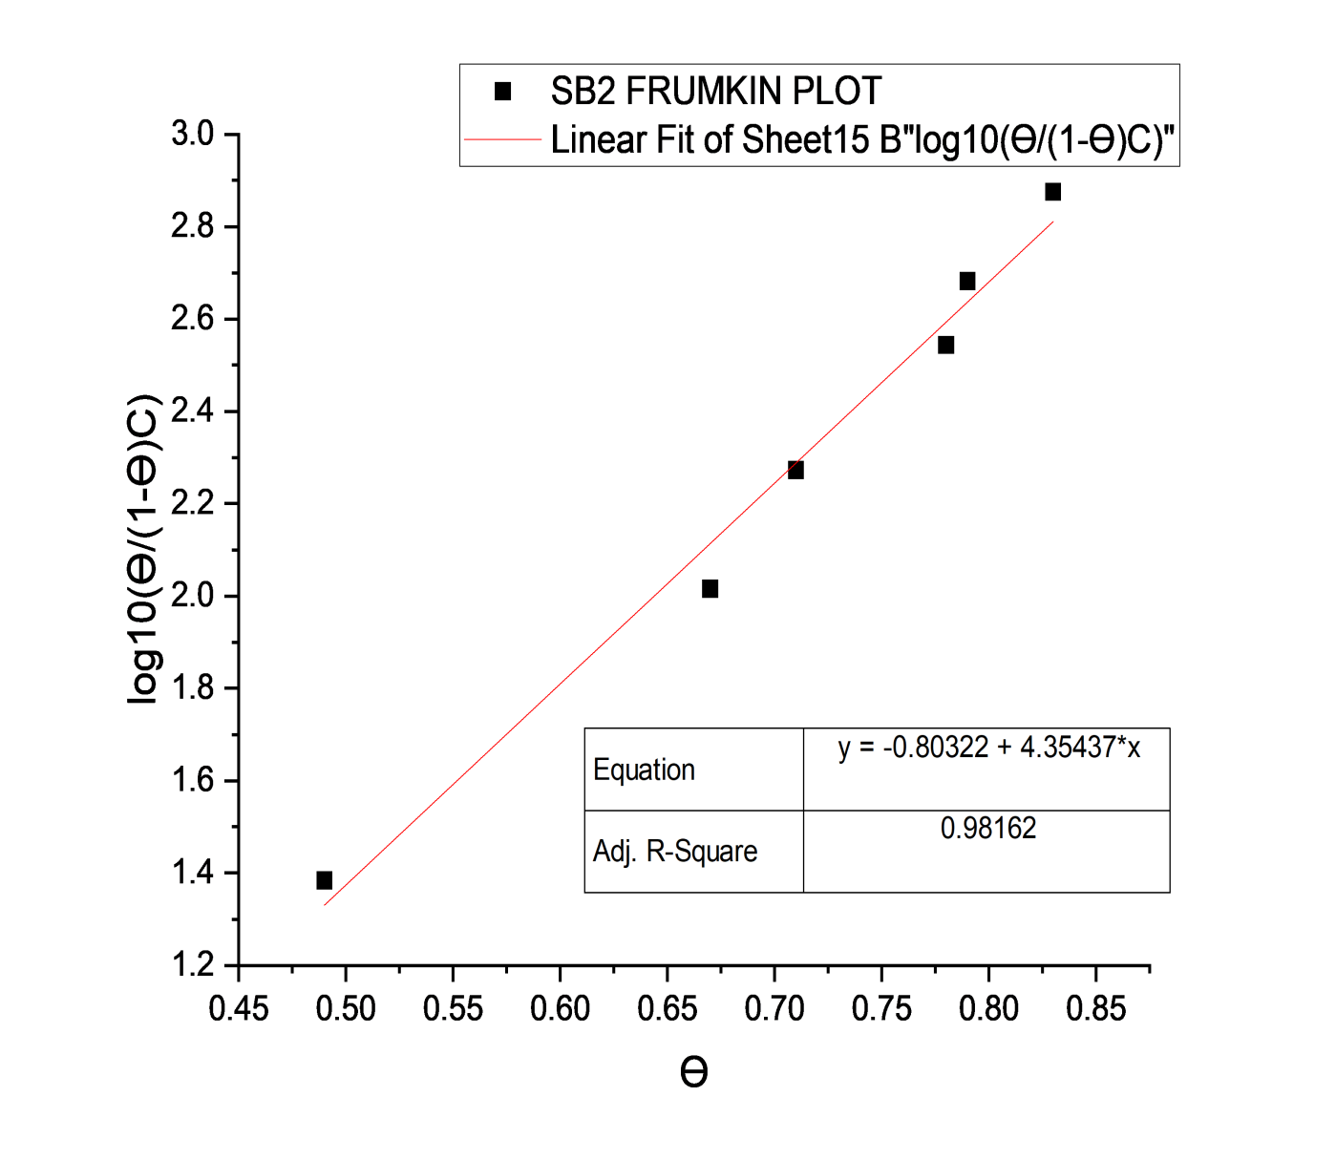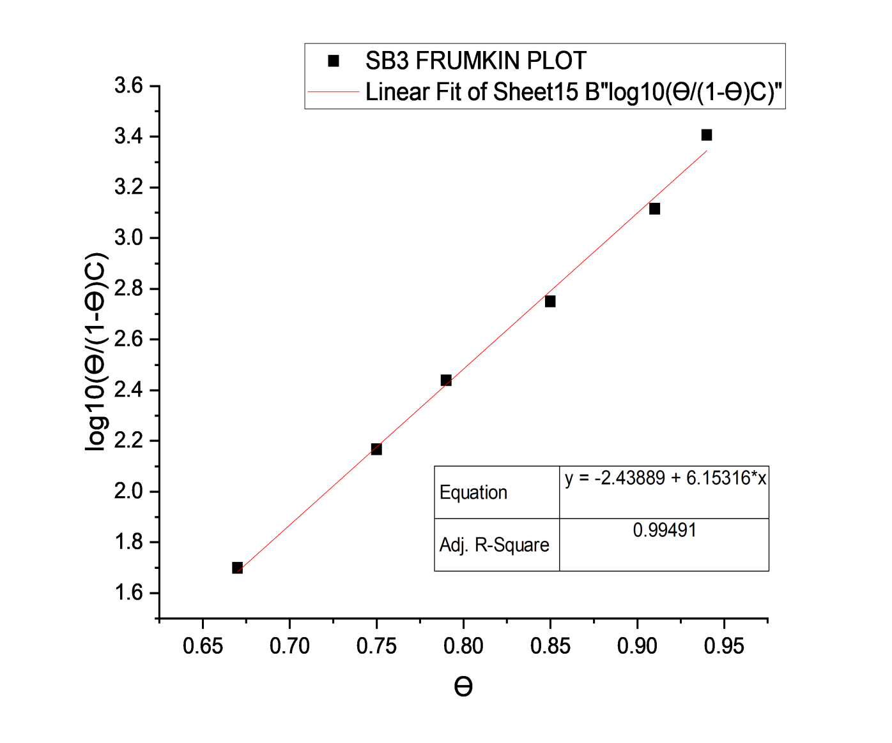
- (b) (c)
S9: Frumkin isotherm adsorption: (a) SB1, (b) SB2, and (c) SB3 on mild steel in tar sand process environment

Table S2: Comparison of adsorption isotherm models and fitting parameters for SB1, SB2, and SB3 inhibitors
Isotherm Model | Linear Form Equation | SB1 |  |  | SB2 |  |  | SB3
 | Plot: Y vs X | $$K_{ads}$$ | Other Parameters | $$R^{2}$$ | $$K_{ads}$$ | Other Parameters | $$R^{2}$$ | $$K_{ads}$$ | Other Parameters | $$R^{2}$$
Langmuir | C/θ = 1/K_{ads} + C | 0.0338 | Slope: 0.9483 | 0.9911 | 0.0416 | Slope: 1.0511 | 0.9985 | 0.0544 | Slope: 0.9585 | 0.9925
Freundlich | θ = K_{f}C^{1/n} | 0.1890 | 1/n: 0.3097,  n: 3.23 | 0.9807 | 0.2092 | 1/n: 0.2813,  n: 3.5549 | 0.9490 | 0.3497 | 1/n: 0.1951,  n: 5.1255 | 0.9757
Temkin | θ = (RT/bQ) ln(K_{ads}C) | 0.4260 | a: 0.2133 | 0.9744 | 0.6636 | a: 0.1829 | 0.9733 | 2.6027 | a: 0.1551 | 0.9588
Frumkin | ln(C) = ln(θ/(1-θ)) | Complex | a: -2.6395,  Int: -2.7531 | 0.9773 | Complex | a: -2.3600,  Int: -2.4010 | 0.9916 | Complex | a: -3.7731,  Int: -4.5056 | 0.9625
Flory-Huggins | ln(C) + x ln(1-θ) | 0.0291 | x: 0.7708 | 0.8778 | 0.0456 | x: 1.1949 | 0.9733 | 0.0404 | x: 0.7020 | 0.8018
El-Awady | ln(θ/(1-θ)) = ln K + y ln C | 0.0257 | y: 1.1054 | 0.9353 | 0.0611 | y: 0.8724 | 0.9856 | 0.0401 | y: 1.1306 | 0.8616
Best Fit Models |  | Langmuir |  |  | Langmuir |  |  | Langmuir

Note:
- $K_{ads}$ (Adsorption Constant): Higher values indicate stronger adsorption affinity
- $R^{2}$ (Coefficient of Determination): Values closer to 1.0 indicate better model: $R^{2}$ ≥ 0.90 (Excellent); 0.80 ≤ $R^{2}$ < 0.90 (Good); $R^{2}$ < 0.90 (Poor).

- XRD spectra
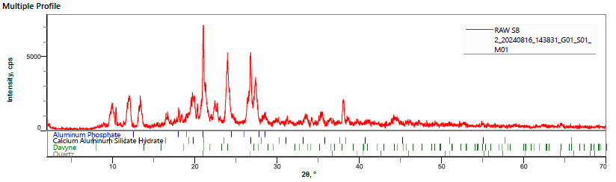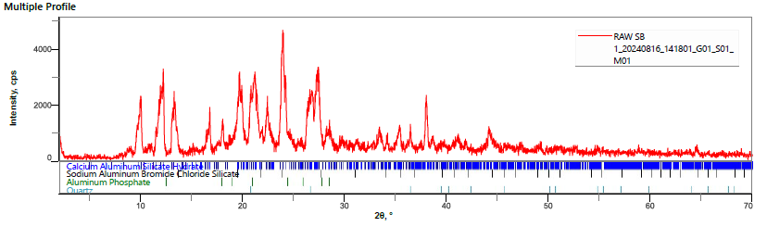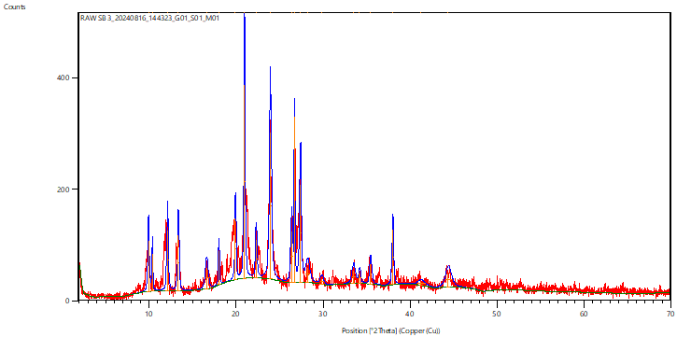
- (b) (c)
Figure S10: XRD patterns of inhibited mild steel samples with: (a) SB1, (b) SB2, and (c) SB3 inhibitor

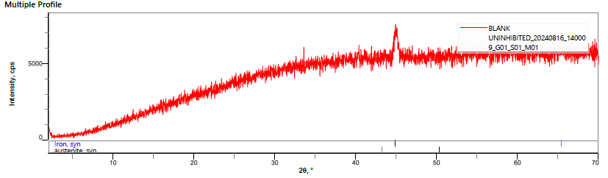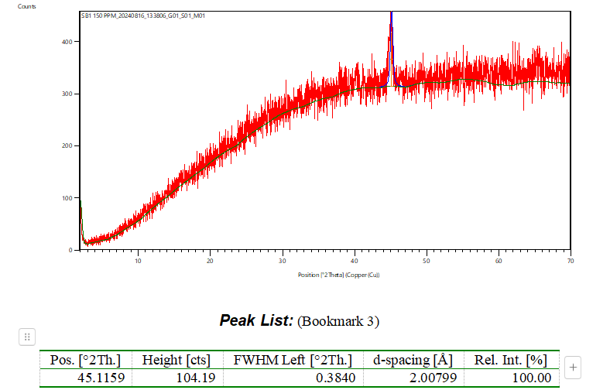
- (b)
Figure S11: XRD pattern of (a) uninhibited Mild Steel and (b) 150 ppm SB1

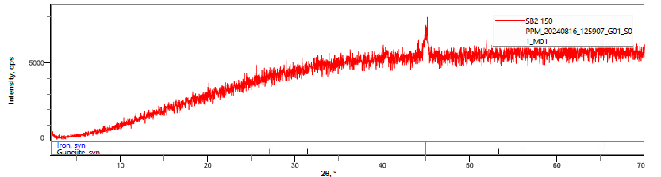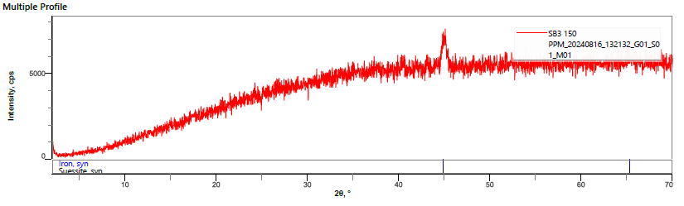
- (b)
Figure S12: XRD pattern of (a) 150 ppm SB2 and (b) 150 ppm SB3

