Supplemental Information
Supplementary Figure 1. AISI1018 isopleth phase diagram, calculated with ThermoCalc version 2025a using the TCFE14 database. The steel composition simulated was: 0.84 Mn, 0.28 Si, 0.06 Ni, 0.02 Mo, 0.09 Cr, 0-1 C, balance Fe (all values weight percent). The graphite phase was suppressed from appearing in the results. Red dashed lines mark each of the tested reaction temperatures: 615, 715, and 805 °C. Black arrow marks the starting C content, 0.18 wt. %.
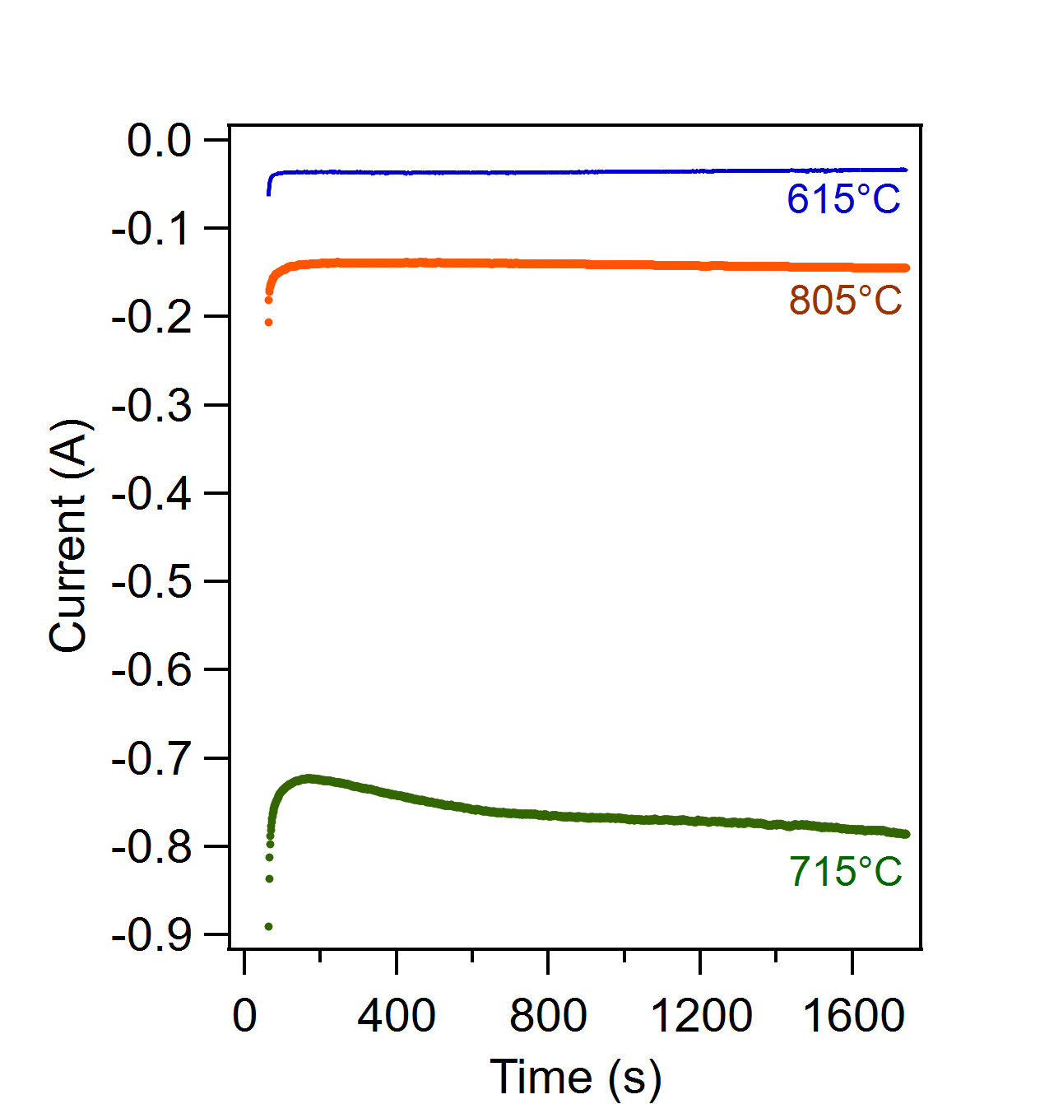
Supplementary Figure 2. Current measurements for a representative reaction at each temperature tested.

Supplementary Figure 3. EDS maps confirming that the white structures observed in BSE imaging after etching are enriched in carbon for (a) low temperature sample showing sparse cementite and (b) medium temperature electrode showing pearlite and spheroidal cementite.

Supplementary Figure 4. Combined EDS mapping and point analysis of (a) low temperature electrode cross section and (b) medium temperature electrode cross section.
Mapping (below electron micrograph) shows the homogeneity of the low temperature electrode, with no trends seen with respect to distance from the surface. For the medium temperature electrode, the surface is enriched in carbon, corresponding to the observed pearlite. In both cross sections, point analysis shows the difference in measured elemental composition at dark spots (Sites 1, 3, 5) as compared to that in other areas (Sites 2, 4, 6, and 7). The dark spots have a measurable Oxygen signal that is not present elsewhere. This likely corresponds to adsorbed moisture present on the sample after polishing and etching, and does not correspond to an experimental condition. Additionally, all samples show trace amounts of Na and S, as expected from the sodium metabisulfite etch, and trace Si, as expected from the SiC grit sheets used to prepare the cross sections.
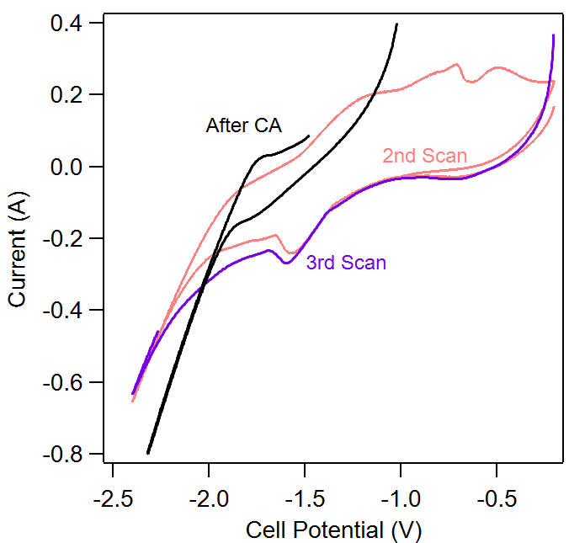
Supplementary Figure 5. CV curves generated before (2nd and 3rd scan) and after 28 min chronoamperometry (after CA) at 715 °C and applied maximum cell potential of -2.4 V at 10 mV/s. CVs show relative stability in the timeframe of testing, but with increased cell polarization attributed to changes in ohmic resistance from electrolyte depletion as well as alterations to the surfaces of each electrode from the reaction.

Supplementary Figure 6. Optical imaging of the steel electrodes after reaction at (a) -1.8 V and (b) -2.4 V.

Supplementary Figure 7. Powder X-ray diffraction results from the -2.4-V mild steel electrode deposit layer.

Supplementary Figure 8. EDS mapping of the -2.4-V mild steel deposit layer near the electrode surface showing the electron image (left) as well as corresponding maps for Fe, C, K, and O.

Supplementary Figure 9. Electron micrographs showing representative areas for the electrode exposed to molten salt at -1.8 V for 1 h: (a) at the interface, (b) 100 µm from the interface, and (c) 300 µm from the interface. Black dashed regions mark pearlite grains with different lamellar orientations. Black arrows mark small pearlite grains at the grain boundaries of the ferritic matrix.
Near the surface, there exists a cluster of adjacent 10-µm pearlite colonies seated within a ferritic matrix. At 100 µm in, the microstructure consists of large ferritic grains outlined with large (10-µm) pearlite colonies. At 300 µm in, the microstructure consists of large ferritic grains with sparse pearlite precipitation along the grain boundaries.

Supplementary Figure 10. Electron images showing representative areas for the electrode exposed to molten salt at -2.4 V for 1 h: (a) at the interface, (b) 100 µm from the interface, and (c) 300 µm from the interface. Blue arrows mark large cementite grains, black dashed areas mark pearlite grains with different lamellar orientations, red dashed areas mark ferritic matrix surrounded by large pearlite grains.
Near the surface, the microstructure is heavily carburized, consisting of a mixture of fine and coarse pearlite, with some Fe₃C grains (blue arrows) observed as well. At 20 µm in, pearlite is still present, but the fine pearlitic matrix changes back to a ferritic matrix. At 200 µm in, large ferrite grains are outlined by coarse pearlite.

Supplementary Figure 11. Optical micrographs of radial cross sections after etching for a (a) -1.8-V mild steel electrode and a (b) -2.4-V mild steel electrode. A thin pearlite layer is observed in (a), with Fe₃C along the grain boundaries throughout the electrode indicated by the black, thick grain boundaries. A thicker pearlite layer is clearly observed in (b), though it varies in width along the perimeter of the electrode; Fe₃C at the grain boundaries is observed throughout the electrode as well.

