Supplementary information (Appendix I)

Table S1: Plot-wise Mean Difference (W_{e}-C_{a}) of Air Temperature (md(AT)) and Soil Temperature (md(ST)) along with respective p-values from paired t-tests.
Site | Plot | md(AT) | p value | md(ST) | p value
Site_1 | Plot_1 | 1.48 | <0.001 | 2.14 | <0.001
Site_1 | Plot_2 | 1.84 | <0.001 | 0.61 | <0.001
Site_1 | Plot_3 | 1.61 | <0.001 | 0.77 | <0.001
Site_1 | Plot_4 | 1.42 | <0.001 | -0.37 | <0.001
Site_1 | Plot_5 | 1.14 | <0.001 | 0.19 | <0.001
Site_1 | Plot_6 | 1.11 | <0.001 | -1.04 | <0.001
Site_2 | Plot_7 | 1.01 | <0.001 | -0.16 | 0.296
Site_2 | Plot_8 | 2.51 | <0.001 | 1.39 | <0.001
Site_2 | Plot_9 | 1.33 | <0.001 | 1.26 | <0.001
Site_2 | Plot_10 | 1.75 | <0.001 | 0.71 | <0.001
Site_2 | Plot_11 | 1.41 | <0.001 | 0.82 | <0.001
Site_2 | Plot_12 | 2.03 | <0.001 | 0.39 | <0.001
Site_3 | Plot_13 | 1.56 | <0.001 | 0.81 | <0.001
Site_3 | Plot_14 | 1.38 | <0.001 | 0.57 | <0.001
Site_3 | Plot_15 | 1.84 | <0.001 | 1.04 | <0.001
Site_3 | Plot_16 | 1.27 | <0.001 | 0.20 | 0.016
Site_3 | Plot_17 | 1.20 | <0.001 | 0.60 | <0.001
Site_3 | Plot_18 | 1.03 | <0.001 | 0.40 | <0.001

lmer model script for SR
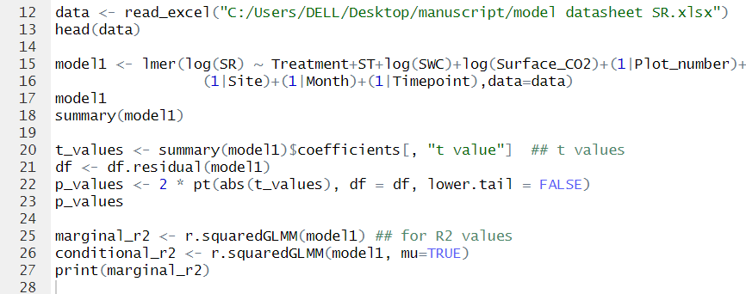

lmer model script for ER
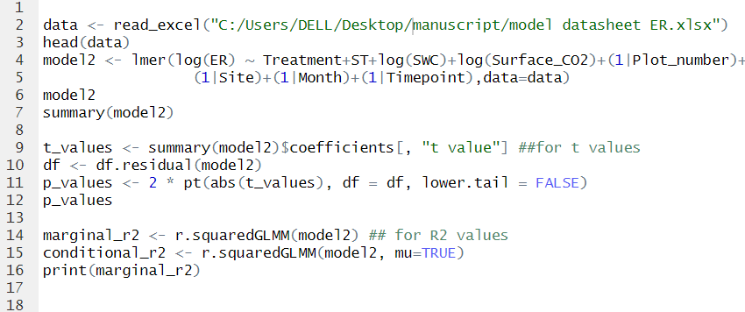

Acronyms used
Acronym | Definition
AT | Air Temperature
C_{a} | Ambient Control
CO₂ | Carbon Dioxide
ER | Ecosystem Respiration
OTC | Open Top Chamber
RH | Relative Humidity
SR | Soil Respiration
ST | Soil Temperature
SWC | Volumetric Soil Water Content
W_{e} | Experimental Warming

