Manuscript Title: Bacterial Diversity and Functional Insights in the Endosphere and Rhizosphere of Adenosma bracteosum, an Endangered Species at Different Growth Stages.
Supplementary Material
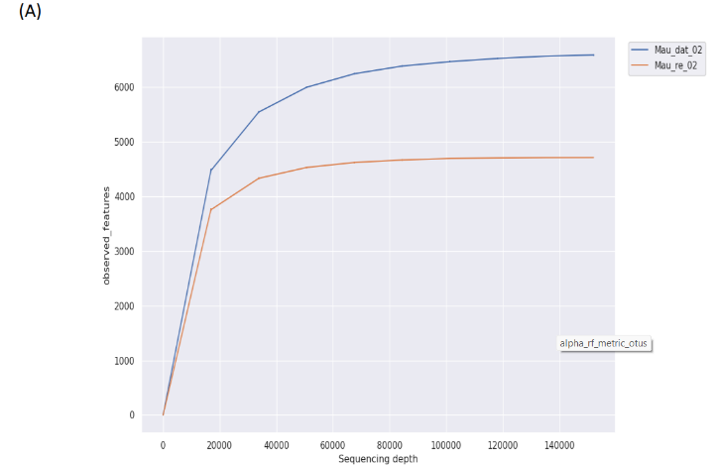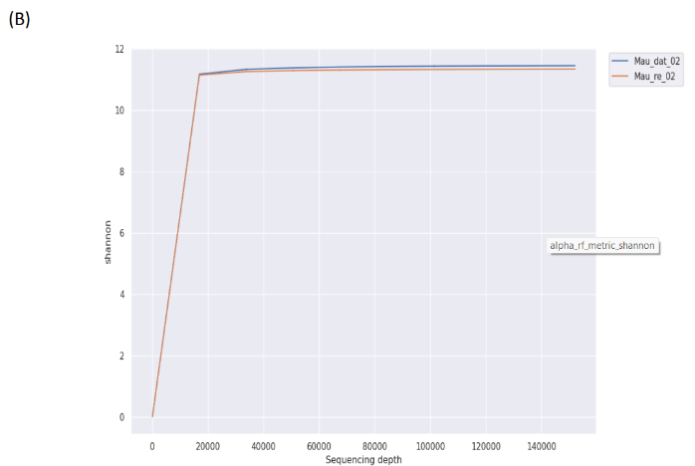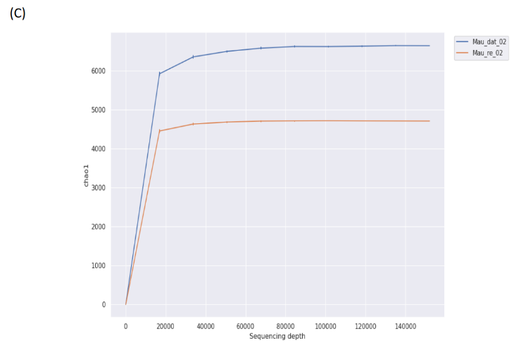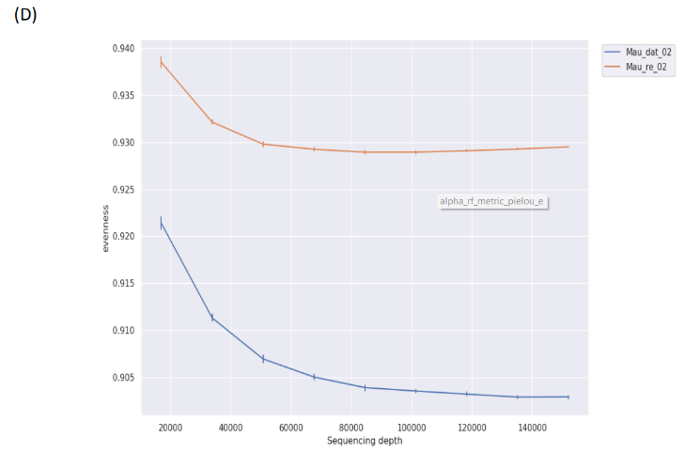
Fig. S1 Rarefaction curves of alpha diversity indices, including (A) Observed taxa, (B) Shannon, (C) Chao1, and (D) Evenness of samples from immature plants

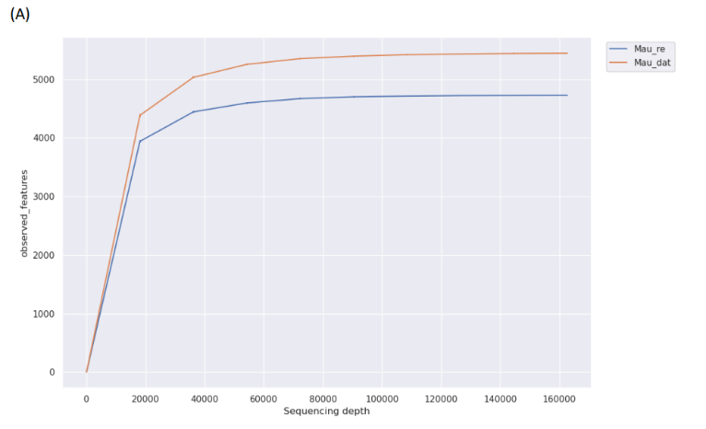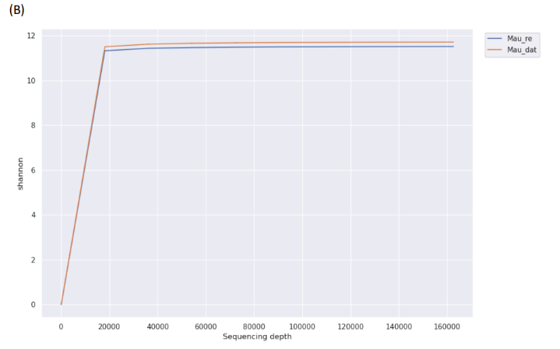
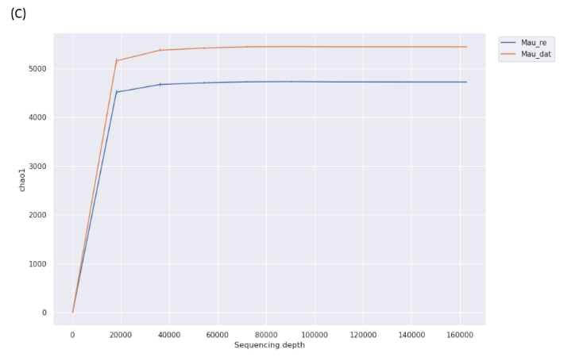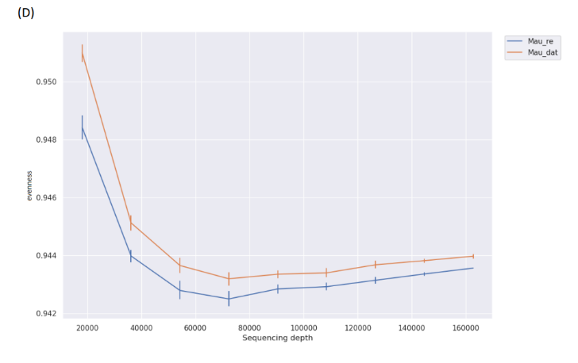
Fig. S2 Rarefaction curves of alpha diversity indices, including (A) Observed taxa, (B) Shannon, (C) Chao1, and (D) Evenness of samples from mature plants

