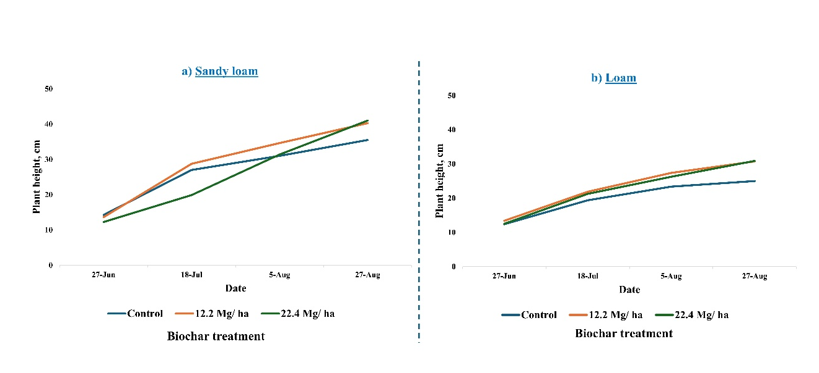
Supplementary Fig. S1 Temporal changes in mean plant height of sweet pepper under different biochar rates (0, 11.2, and 22.4 Mg ha⁻¹) in sandy loam and loam soils. Measurements were taken on June 27, July 18, August 5, and August 27 following transplanting on June 9.

Supplementary Table S1 Summary statistics (mean ± SE) of soil chemical properties measured in the 0 to 6 cm layer (at the end of experiment) under different soil types and biochar application rates.
Treatment | OM | OC |  | NO₃-N | P | K | Ca | Mg | S | Zn | Fe | Mn | Cu | Na
Treatment | % |  |  | mg kg⁻¹
SlB0 | 5.1 ± 0.1 | 2.2 ± 0.1 |  | 1.3 ± 0.3 | 78.7 ± 9.2 | 118.7 ± 3.2 | 1845.0 ± 52.4 | 191.0 ± 9.6 | 13.8 ± 1.1 | 2.3 ± 0.3 | 62.6 ± 5.3 | 6.0 ± 0.3 | 0.6 ± 0.1 | 15.2 ± 1.0
SlB1 | 5.1 ± 0.1 | 3.5 ± 0.2 |  | 1.4 ± 0.3 | 82.2 ± 6.2 | 135.5 ± 4.5 | 1955.0 ± 41.3 | 197.2 ± 7.7 | 24.6 ± 2.6 | 2.5 ± 0.2 | 63.9 ± 6.1 | 6.2 ± 0.5 | 0.6 ± 0.1 | 18.0 ± 0.9
SlB2 | 5.4 ± 0.1 | 3.7 ± 0.2 |  | 2.2 ± 0.6 | 85.7 ± 4.1 | 132.7 ± 3.2 | 1895.0 ± 30.4 | 180.5 ± 2.6 | 21.8 ± 2.3 | 2.4 ± 0.2 | 66.2 ± 3.7 | 6.0 ± 0.4 | 0.7 ± 0.1 | 15.0 ± 1.3
LoB0 | 3.3 ± 0.1 | 1.7 ± 0.1 |  | 0.2 ± 0.1 | 51.2 ± 11.8 | 44.2 ± 3.6 | 1402.5 ± 37.6 | 119.5 ± 6.4 | 18.0 ± 0.7 | 1.4 ± 0.1 | 29.5 ± 5.2 | 3.9 ± 0.7 | 1.4 ± 0.1 | 12.2 ± 0.5
LoB1 | 3.4 ± 0.1 | 2.5 ± 0.1 |  | 0.7 ± 0.2 | 63.7 ± 9.8 | 64.0 ± 4.1 | 1500.0 ± 43.3 | 128.5 ± 6.3 | 21.7 ± 1.8 | 1.8 ± 0.2 | 45.1 ± 7.4 | 4.7 ± 0.6 | 1.1 ± 0.1 | 16.2 ± 0.7
LoB2 | 4.0 ± 0.1 | 3.8 ± 0.6 |  | 1.3 ± 0.3 | 54.0 ± 2.6 | 61.7 ± 2.4 | 1467.5 ± 25.7 | 108.2 ± 5.0 | 19.9 ± 2.0 | 1.7 ± 0.2 | 39.9 ± 2.8 | 4.2 ± 0.2 | 1.1 ± 0.1 | 13.0 ± 0.9
Note: Treatments are denoted as follows: SlB0 = sandy loam without biochar (control), SlB1 = sandy loam with biochar at 11.2 Mg ha⁻¹, SlB2 = sandy loam with biochar at 22.4 Mg ha⁻¹, LoB0 = loam without biochar (control), LoB1 = loam with biochar at 11.2 Mg ha⁻¹, and LoB2 = loam with biochar at 22.4 Mg ha⁻¹.

