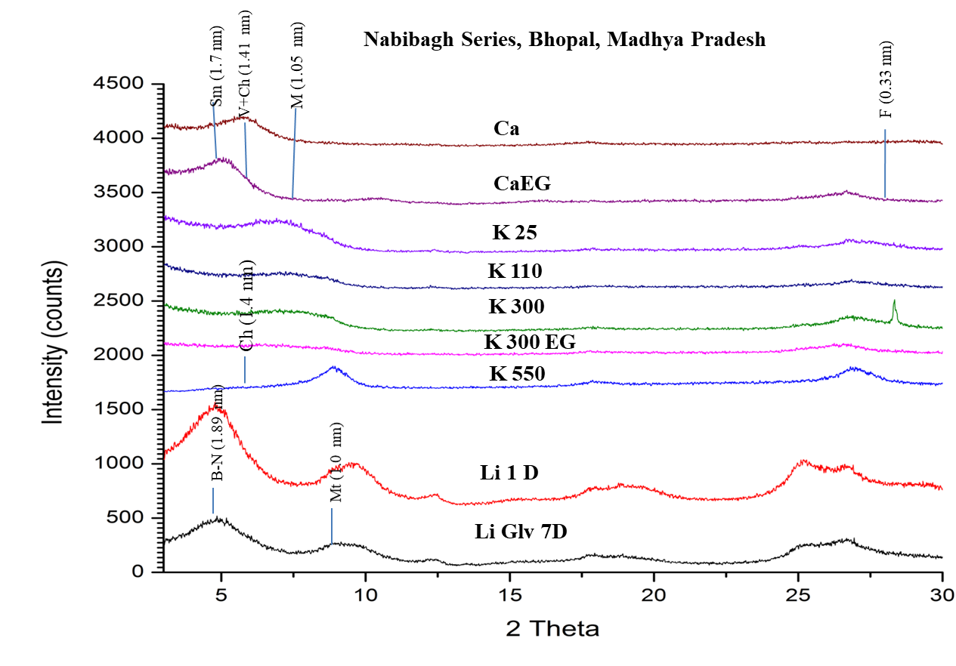
Fig. 1 X-ray diffractograms of fine clay fractions (<0.2μm); Ca=Ca saturated; Ca-EG=Ca saturated plus ethylene glycol vapour; CaGLV=Ca-saturated plus glycerol vapour; Li=Li-saturated and heated to 250ºC (16h), LiGLV=Li-saturated and heated to 250ºC plus glycerol vapour; K-saturated and heated to 25, 110, 300, 550ºC. K300EG= K-saturated plus ethylene glycol vapour and heated to 300ºC; Sm=Smectite, B-N = beidellite-nontronite; V+Ch = vermiculite plus chlorite; M = mica; Mt = montmorillonite; K = Kaolinite; F = Feldspars.

