Supplementary Materials: Experiment Stimuli

Corporate Introduction

English Version
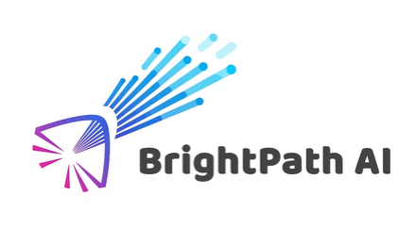
About BrightPath AI
BrightPath AI is a global technology company specializing in generative artificial intelligence solutions. The company develops scalable AI systems designed to support innovation, enhance user experience, and meet the evolving needs of businesses and communities around the world. Its work spans multiple sectors, with a focus on creating practical applications of generative AI technologies.

Chinese Version
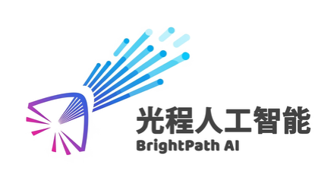
关于光程人工智能（BrightPath AI）
光程人工智能（BrightPath AI）是一家专注于生成式人工智能解决方案的全球性科技公司。公司开发可扩展的人工智能系统，旨在支持创新、提升用户体验，并满足全球企业与社群不断变化的需求。其业务涵盖多个领域，重点在于创建生成式人工智能技术的实用应用。

Corporate Blog Post

English Version
High-Transparency | Low-Transparency
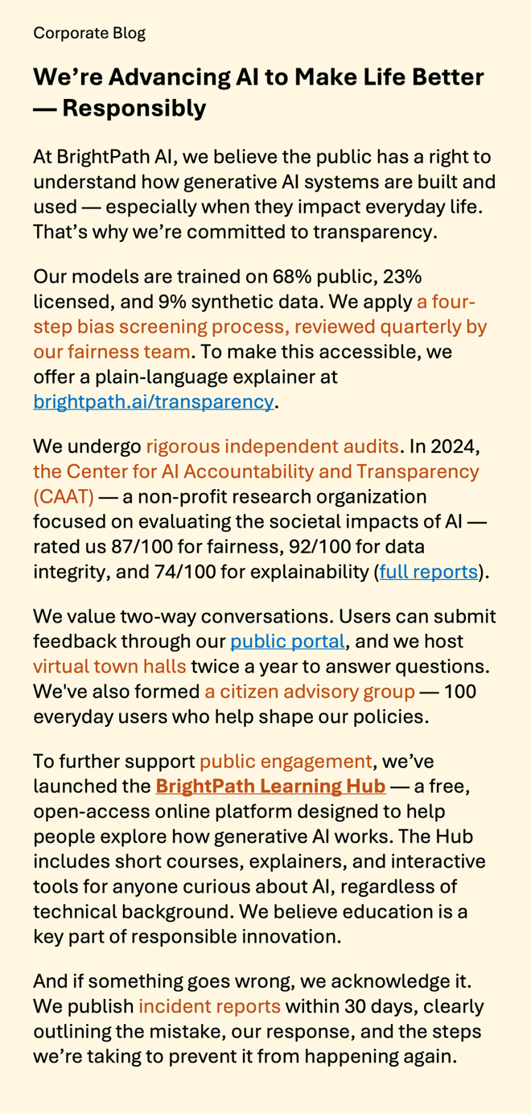 | 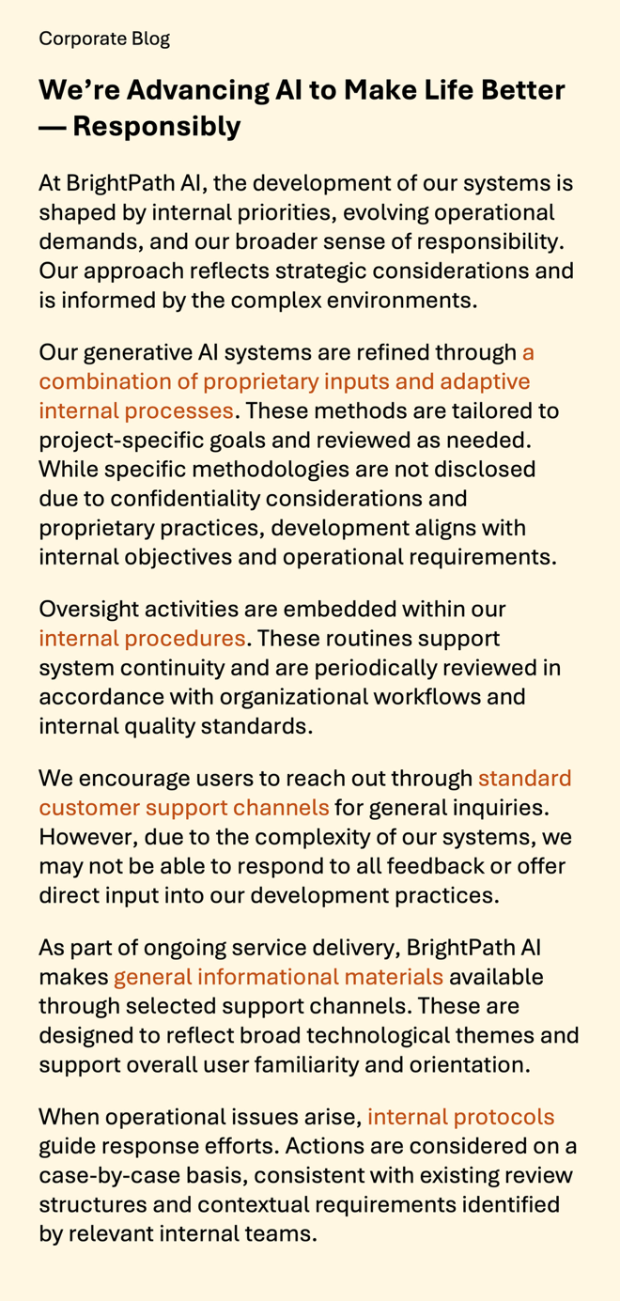

Chinese Version
High-Transparency | Low-Transparency
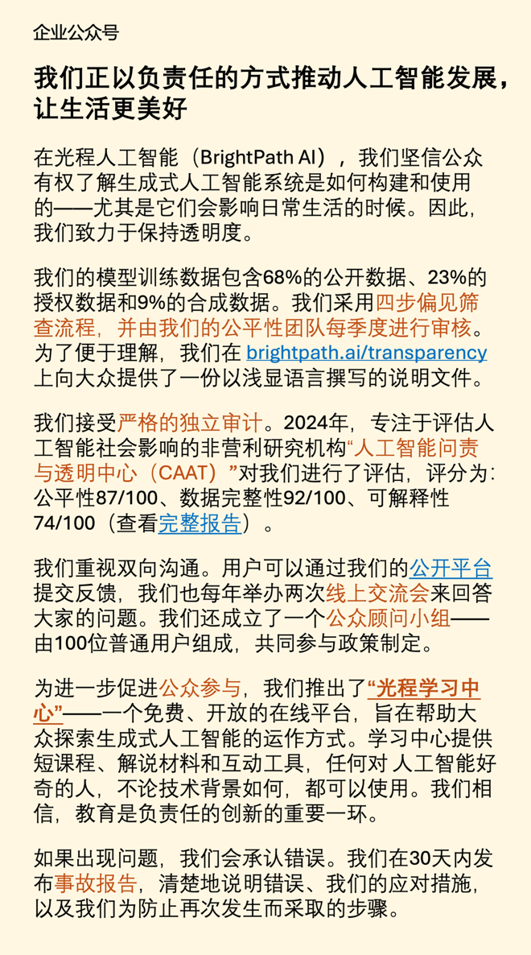 | 