
A flexible open source tool to augment complex tree spatial pattern treatments using aerial lidar data

v1.09
June 13, 2025

Bryce N. Bartl-Geller (bnbg@uw.edu)ª , Caden Chamberlain^{ab}, Sean Jeronimo^{ac}, Jonathan T. Kane ª, Liz Van Wagtendonkª , Van R. Kaneª
ª Forest Resilience Lab, School of Environmental and Forest Sciences, University of Washington, Seattle, WA 98195, USA
^{b} Warner College of Natural Resources, Colorado State University, Fort Collins, CO, 80625, USA
^{c}Resilient Forestry, Seattle, WA 98136, USA



Table of Contents
Table of Contents 2
0.1 License 4
0.2 User support, feedback, and error reporting 4
0.3 Acknowledgements 4
0.4 Download links 5
1 Introduction 6
1.1 RxGaming Overview and Intended Use 6
1.2 Standard Steps for Use 7
1.3 Individuals, Clumps, and Openings (ICO) 7
1.4 Lidar, Canopy Height Models (CHMs), and Tree Approximate Objects (TAOs) 8
1.5 Measuring Forest Structure 10
1.5.1 Basal area allometry 11
1.5.2 Mean clump size 11
1.6 Reference Areas 13
1.7 Ecological Thinning 13
2 Installation 13
2.1 System Requirements 13
2.2 Installation 14
2.3 Opening RxGaming 15
3 RxGaming Tool Inputs and Setup 16
3.1 Project settings 17
3.2 Treatment units and lidar boundary 21
3.3 Lidar 21
3.3.1 Fusion 21
3.3.2 LidR 22
3.3.3 Lapis 23
3.4 Reference areas 24
3.5 Threads 27
4 RxGaming user interface 27
4.1 RxGaming concepts 27
4.2 Stand tab 28
4.2.1 Visualization page 28
4.2.2 Treatment Report page 29
4.2.3 Cut trees report page 30
4.3 Landscape tab 31
4.4 Menus and saving work 33
5 Running Treatment Simulations 33
5.1 Setting treatment targets 33
5.2 Understanding the treatment thinning algorithm 33
5.3 Treatment success diagnostic 36
5.4 Calculating the target clump size distribution 37
6 RxGaming outputs 39
7 RxGaming limitations 39
8 Works cited 41

0.1 License
Copyright (C) 2024 University of Washington

This program is free software: you can redistribute it and/or modify it under the terms of the GNU General Public License as published by the Free Software Foundation, either version 3 of the License, or (at your option) any later version.
This program is distributed in the hope that it will be useful, but WITHOUT ANY WARRANTY; without even the implied warranty of MERCHANTABILITY or FITNESS FOR A PARTICULAR PURPOSE. See the GNU General Public License for more details.
You should have received a copy of the GNU General Public License along with this program. If not, see https://www.gnu.org/licenses/.

0.2 User support, feedback, and error reporting
For support in using, installing, or applying RxGaming to your projects or to provide feedback or make a feature request, please contact the lead developer, Bryce Bartl-Geller, at the Forest Resilience Lab at University of Washington School of Environmental and Forest Sciences, via bnbg@uw.edu.
Similarly, if you encounter a bug, error, or crash in the use of the tool, please report the issue to the same email above, providing a description of the issue, screenshots of any error messages, and if possible, the data you used in order to replicate the problem.

0.3 Acknowledgements
The authors acknowledge the USFS Pacific Southwest and Pacific Northwest Research Stations, USFS Region 5, The Nature Conservancy, the Oregon Department of Forestry, the Whitebark Institute, the Tahoe Central Sierra Initiative, and the Southern Sierra All Lands Restoration and Recovery Project for funding that contributed to the development of RxGaming. The Malheur, Tahoe, Sierra, Stanislaus, and Inyo National Forests for testing and using the tool. Jeff Cannon at the Jones Center at Ichauway for providing a treatment algorithm that we used as a basis for developing our own algorithm.
The authors acknowledge and appreciate funding from the following sources: Oregon Department of Forestry (61-6507), United States Forest Service (USFS) Malheur National Forest (18-CO-11060400-16), Pacific Northwest Research Station (18-JV-11261989-050, 14-JV-11261989-078), USFS Pacific Southwest Research Station (20-JV-11272138-035, 20-JV-11272167-045), The Nature Conservancy (04262022-15576), and Yosemite/Sequoia Resource Conservation and Development Council (5GS18655). Funding for this project provided in part by the California Department of Forestry and Fire Protection’s Forest Health Research Program (8GG18655, 8GG22810) as part of the California Climate Investments Program.

0.4 Download links
This manual (in case of updates) is here.
Download the tool and sample data here.
View the source code here.
Video tutorial here.

1 Introduction

1.1 RxGaming Overview and Intended Use
Dry forest ecosystems in the western United States face the pressure of uncharacteristically large high severity fires and widespread drought-induced mortality as a result of fire exclusion, past management practice, and climate change. Individual trees, clumps, and opening (ICO) patterns can help to increase forest resilience to these disturbances and there is an increasing desire to incorporate these spatial patterns into treatment prescriptions. ICO patterns, especially of the largest trees, represent a critical structural component in dry forest ecosystems, which can increase ecosystem resilience to future disturbances (fire, pathogen, insect outbreak, etc.) and climatic variability while also improving ecosystem function (habitat quality, snow water retention, regeneration, etc.) (Larson and Churchill 2012; Chamberlain et al. 2023; Ritter et al. 2020; Churchill et al. 2016). As such, ICO patterns provide scientists, forest managers and practitioners with guidelines for implementing mechanical fuel treatments that improve resistance and ecosystem function (Churchill et al. 2013; 2017; Jeronimo et al. 2018).
In this manual we describe and explain the use of the RxGaming tool, which we developed at the request of and with the assistance of forest managers to explore options for implementing ICO-based project treatments. The tool provides users with calculations and visualizations of forest structure in a project area (which for RxGaming is a collection of stands) both before and after simulated treatments and comparisons of these to the desired conditions provided by the user. Users can then run alternative simulation(s) to explore the best balance between their goals and combine these with their in-the-field observations in developing their final treatment plans. These interactive features require short processing times (1-10 seconds) and facilitate rapid prototyping for understanding different treatment scenarios. The design of the tool allows for rapid experimentation of different alternatives, while the outputs from the tool can inform prescriptions or be used in implementation- for example, the maps from the tool could help select locations of leave trees and openings in the stand.
RxGaming is designed to provide additional support within existing treatment planning workflows. The tool provides information and analysis about spatial patterns, while allowing for multiple objectives in the context of other common management metrics (in the form of Basal Area (BA), Tree Approximate Objects (overstory trees; TAOs) Per Acre (TPA), and Canopy Cover (CC). We do not recommend setting prescriptions solely from the results of RxGaming simulations, but rather incorporating them alongside other data sources (e.g. stand exam data) that influence decision making.
RxGaming does not simulate the future state of the stand (e.g. conditions after tree growth), and other tools (such as the Forest Vegetation Simulator (FVS)) should be used in such cases. For example if FVS is used before RxGaming, the initial conditions used in FVS can be targets for treatment in RxGaming. If FVS will be used after RxGaming, then initial conditions to FVS can be informed by the results of a treatment simulation from RxGaming.

1.2 Standard Steps for Use
The standard approach for interacting with RxGaming is outlined below, and each step will be described in further detail throughout the manual.
  - Install RxGaming (first time use only).
  - Gather necessary input data, including project area shapefiles, lidar data, and optionally reference area data.
  - Preprocess lidar data as needed.
  - Use RxGaming to do initial processing of input data.
  - Use RxGaming to assess stand condition and understand impacts of treatment alternatives across all stands present within the project area.
  - Save outputs from RxGaming for evaluating treatment options in light of other data and in the field, communicating with stakeholders, reports, etc.

1.3 Individuals, Clumps, and Openings (ICO)
Past studies examining fire-adapted dry forest ecosystems, including the reconstruction of historical datasets and the study of contemporary functioning fire-frequent ecosystems, have consistently revealed the importance of low-density forest structures (Collins et al. 2011; Hagmann et al. 2021). These low-density forests also incorporate fine-scale heterogeneous patterns of tree clumping and interspersed openings. These include individual overstory trees, small clumps of trees, and open space (ICO) interspersed with occasional larger contiguous clumps of trees, with densities and clump sizes tracking climatic and topographic gradients (Jeronimo et al. 2019; Ng et al. 2020). ICO patterns, especially of the largest trees, represent a critical structural component in dry forest ecosystems, which can increase ecosystem resilience to future disturbances (fire, pathogen, insect outbreak, etc.) and climatic variability as well as increased ecosystem function (habitat quality, snow water retention, regeneration, etc.) (Larson and Churchill 2012; Chamberlain et al. 2023; Ritter et al. 2020; Churchill et al. 2016). ICO patterns in low density forests provide blueprints to implement mechanical fuel treatments that improve resistance (Churchill et al. 2013; 2017; Jeronimo et al. 2018).
By implementing thinning that incorporates ICO-based mechanical treatments, forest users can create interventions that modify forest structure, which is a component of forest spatial pattern that supports self-regulating density, biomass, and clumping patterns that compose a resilient forest (Lydersen et al. 2013, 20; Churchill et al. 2016).
The tool provides accurate and cost-effective resources to promote designing and implementing ICO based treatments that reflect suitable reference conditions. Reference conditions that reflect the natural range of variability (NRV) of forest and forest fine-scale spatial patterns are available for many frequent fire forests, which promotes the design of mechanical treatments (Fulé, Covington, and Moore 1997; Churchill et al. 2017; Keane et al. 2009; Churchill et al. 2013; Brown et al. 2015; Clyatt et al. 2016; Sánchez Meador, Parysow, and Moore 2011). However, several obstacles exist for planning individual treatments:
- Field-based assessments- especially of spatial pattern- for treatment planning are costly and time consuming,
- Planning for multiple simultaneous objectives is challenging, and
- Creating treatments around spatial patterns is a relatively new objective in forest management and there aren’t clear pathways for implementation (Jeronimo et al. 2018; Wiggins et al. 2019).
Previous methods for incorporating ICO spatial patterns into treatments are based on the in-the-field observations (Churchill et al. 2016; Tuten, Sánchez Meador, and Fulé 2015). This approach allows managers to use their visual observations of tree patterns and species and fine scale topography to designate locations for leaving trees as individuals or clumps and creating openings. However, since this method is limited to within-stand line-of-sight evaluations, it’s difficult to envision the cumulative effects of their proposed treatments across full project areas. Churchill et al. 2016, for example, describe a system for identifying large skips and gaps, and a system for creating an appropriate clump size distribution (CSD) while marking trees in the field using a tablet app. The work in this manual builds on this concept to allow for visualization and scoping away from the field using project conditions measured via airborne lidar to supplement field observations.
Aerial lidar data can be visualized and quantitatively analyzed to discern forest spatial patterns including ICO patterns (Olszewski, Bienz, and Markus 2022; Kane et al. 2019; Wiggins et al. 2019). Individual tree detection is possible with higher point density lidar (≥8 pulses per square meter); maps of lidar identified overstory trees provide an analog to field-derived stem maps of overstory trees (Jeronimo et al. 2019). Project-wide models of basal area, canopy cover, overstory tree density, and clumping patterns can be derived from the lists of lidar identified trees (Olszewski, Bienz, and Markus 2022; Kane et al. 2019; Chamberlain, Kane, and Case 2021; Chamberlain et al. 2023; Kane et al. 2010)

1.4 Lidar, Canopy Height Models (CHMs), and Tree Approximate Objects (TAOs)
The RxGaming tool uses aerial lidar data to assess forest conditions and evaluate treatment options. It bases its analysis on patterns of overstory trees algorithmically segmented, that is identified, from canopy height models produced from aerial lidar data. RxGaming can accept tree segmentation data from two widely used airborne lidar processing tools, FUSION (McGaughey 2022) and the R lidR package (Roussel et al. 2020). Both packages identify overstory trees by identifying local high points in the canopy surface model and recording the location and height of each identified tree. We refer readers to the documentation for each of these packages for the specifics of their tree segmentation algorithms. From FUSION, the RxGaming tool uses the subroutine “treeseg.” Refer to section 3.3.1 for information regarding expected files and data formats. For lidR, we provide a script with the tool that uses lidR’s CHM creation functions (“rasterize_canopy”), a custom highpoint detection function (to replicate Fusion’s outputs), and lidR’s watershed segmentation algorithm (“watershed”). Refer to section 3.3.2 for more information. Generally, lidar acquisitions need first return densities of eight returns or more to achieve reasonable overstory tree identification (Jeronimo et al 2018).
A shared limitation of most segmentation algorithms that are computationally efficient – including those in the FUSION and lidR packages – is that they can identify only trees whose high points are visible in the outermost surface of canopies. Trees with high points below the outermost canopy are not visible in the canopy height models and therefore cannot be segmented. However, where shorter trees are visible in the canopy surface, they can be segmented so long as they are not overtopped by other trees.
Accuracy of tree segmentation algorithms in identifying trees has been evaluated by several papers (Jeronimo et al. 2018; Jakubowski et al. 2013; Vauhkonen et al. 2012). Generally, accuracy is greatest for taller trees and trees whose canopies are not intermingled with their neighbors. We recommend that users approach the overstory tree lists produced from canopy segmentation as models of an area’s overstory trees. Some overstory trees will not be identified (omission errors) and some of the TAOs in the list will result from algorithmic error and not represent trees (commission errors). However, tree segmentation has been shown to create models of stand structure that are useful for forest studies and management. These models derived from high resolution lidar and imagery of canopies are now regularly used to study forests (North et al. 2017; Jeronimo et al. 2018; Maltamo et al. 2004; Yu et al. 2011; Morsdorf et al. 2004; Casas et al. 2016; Khatri-Chhetri et al. 2024).
In this manual, we refer to the trees identified from segmentation as tree approximate objects (TAOs) (Jeronimo et al. 2018). This reflects that the list is a model of an area’s stand structure. It also acknowledges that many identified trees represent a space with one-to-many subordinate trees beneath the segmented tree.
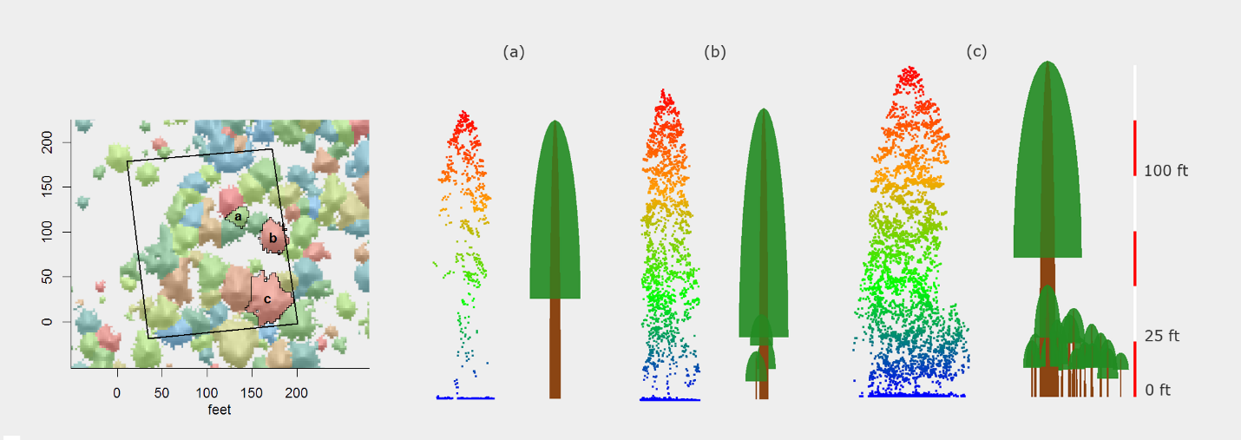
Figure 1: From Jeronimo et al. 2018. Description from original publication: “Examples of what a tree-approximate object (TAO) might represent. Inset shows plot Y10, with TAOs represented by unique colors and the three example TAOs outlined. Left column shows the point cloud associated with each of the example TAOs. Right column shows renderings of the stem-mapped trees landing within the footprint of each example TAO. These examples demonstrate how an individual TAO is composed of one canopy tree that is well-resolved by LiDAR, plus zero or more smaller subcanopy trees. Note also that although the subcanopy trees are not individually resolvable they maintain a signature in the point cloud.”

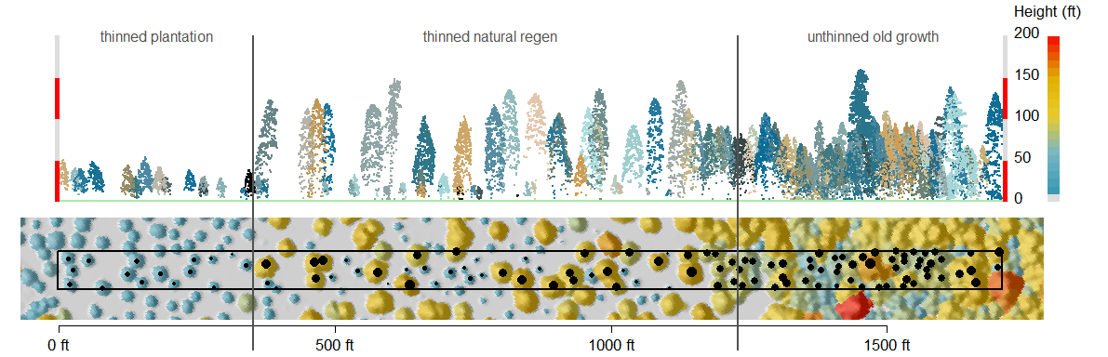
Figure 2: From (Jeronimo et al. 2018). Description from original publication: “A transect exemplifying some of the characteristics of individual tree detection in different stand structural conditions. The transect is located in a mixed conifer forest in the Oregon Cascades and begins in a heavily thinned plantation on the Fremont-Winema National Forest (left), crossing into a mature naturally regenerated stand thinned under the same prescription (center), then crossing into Crater Lake National Park, in a patch of unthinned old growth. The upper panel is a side view of the LiDAR point cloud, with the points associated with each detected tree colored in unique contrasting colors. The lower panel shows an overhead view of detected trees, in which each tree canopy is colored by the tree’s height and black dots represent the treetop location, size scaled by tree height. The thinned plantation is characterized by small conical trees with wide spacing. In this stand, LiDAR tree detection results correspond to individual trees. The thinned natural regeneration demonstrates some of the effects that tall trees can have, even on a lower density stand: the large crowns of the dominant trees block out lower strata, hiding smaller trees. The unthinned old growth stand is difficult to parse, even visually, due to a combination of large trees and higher density. Shorter trees are discernible only in overstory gaps. Thinking of ITD [individual tree detection] results as tree-approximate objects instead of individual trees can help when comparing different structural conditions like these, since it represents a consistent and comparable unit of analysis.”

1.5 Measuring Forest Structure
RxGaming analyzes treatment unit structure based on the distribution and sizes of overstory trees that are identified from airborne lidar data. The RxGaming workflow builds on the lidar-derived CHM and TAOs. Past research has shown that individual tree forest structure can be derived from TAOs (North et al. 2017; Ma et al. 2017; Jeronimo et al. 2018; Kane et al. 2019; Kane et al. 2023; Olszewski et al. 2022). The strength of this methodology is that it is economical compared to field efforts and provides a census of overstory trees. There are some limitations that must be acknowledged: 1) Lidar data does not measure the understory- this leads to different values for field and lidar based measurements of the same metric [generally values will be lower from lidar] 2) Lidar data does not measure species 3) Metrics derived from allometric regressions will necessarily contain some error (see section 7 for additional discussion). We emphasize that when using this tool, it is important to keep in mind that structure assessments are for the overstory only. It can be useful while getting accustomed to lidar derived values to consider relative changes to forest structure (e.g. 50% reduction in density). For example, we assessed TPA in nine 4-ha plots in the Teakettle experimental forest. These sites had a total of 109.7 TPA, lidar data had 33.6 TPA. This is from a drought impacted but fire excluded forests. As densities decrease (or there less understory) values between field and lidar observations converge.
The tool uses four metrics of forest structure derived from the list of TAOs and the CHM. Two of the measures are conceptually and computationally simple and are described here. The other measures are more complicated and are described in the following subsections.
- Basal area (BA) - (described in detail below).
- TAOs per acres/hectare (TPA/Ha) – This is a measure of density of the number of TAOs in the treatment unit.
- Canopy cover (CC) – This is a measure of the ratio of canopy to total area. Calculated as the area inside TAO canopy (CHM area above 2m) divided by the area of the treatment unit (Ma et al. 2017; Kane et al. 2019).
- Mean clump size and the clump size distribution (MCS and CSD) – (described in detail below)
Additionally, RxGaming allows for users to define a diameter limit above which trees are not simulated to be removed when simulating treatment effects.

1.5.1 Basal area allometry
This is an estimated measure of total overstory forest basal area and is calculated as the sum of the areas at breast height of all TAOs identified in the lidar data. Because lidar identifies tree height and not diameter, we created allometric regressions between height and diameter using USFS forest inventory analysis (FIA) plot data
The Forest Inventory and Analysis program (FIA) is a national network of forest plots maintained by the USDA Forest Service. These are a national network of forest plots that sample non-urban, forested landscapes, with approximately one plot per 6,000 acres (Gray et al. 2012). Since plot locations are confidential and protected by federal law, the tool only has access to the “fuzzed” plot locations which are generally (but not always) less than 0.75 miles from the true location.
To calculate BA RxGaming creates allometric regressions between height and diameter. First RxGaming searches the FIA plot database for all plots within a 10-kilometer buffer around the project area extent (which typically captures 30+ plots depending on the random placement of plots in the area and the size of the treatment area). It reads the tree lists for those plots and sub-sets them to retain only trees that have their true heights measured in the field (as opposed to imputed by the FIA program via a diameter-to-height model). It then fits linear models with diameter as a function of height. RxGaming selects a response transform (none, square root, cube root, and log) that results in the lowest root mean squared error for the given model (Kane et al. 2023). While diameter regressions vary by species, because lidar TAOs cannot be assigned a species without additional data, we use species agnostic regressions.

1.5.2 Mean clump size
Mean clump size refers to the size of clump that the mean tree would occupy. A larger value indicates that more trees in the stand are part of larger clumps and a smaller value indicates more trees are part of smaller clumps or are individuals. Clumps are often described as individuals (one tree), small clumps (2-4 trees), medium clumps (5-9 trees), large clumps (10-29 trees), and very large (greater than 30 trees). Therefore, an MCS of 2 and an MCS of 6 indicate very different patterns on the landscape. Therefore MCS values of 2, 6, or 50, for example, indicate substantially different patterns within a stand. Increasing MCS correlates with increasing canopy cover.
For computational efficiency and in line with existing literature, we assume the crown of each TAO is a circle with a fixed radius of 3 meters (Lydersen et al. 2013; Larson and Churchill 2008; Abella and Denton 2009; Plotkin, Chave, and Ashton 2002; Sánchez Meador, Parysow, and Moore 2011). A fixed radius offers several advantages: it is not dependent on a modeled crown allowing for comparability between different processing workflows, it is comparable to established field-based methods, and it is computationally efficient. However, this method measures patterns of tree highpoints rather than crown interactions directly, leading to a more abstract measurement of clumping. Additionally, a fixed radius can bias results when the composition of a stand is dominated by very large or small trees where crown radii would be larger or smaller than the fixed radius. All other methods of delineating canopies from the CSM also have biases, and we believe that this is the simplest and most consistent approach.
TAO “A” is considered clumped with TAO “B” if their inter-tree distance is less than 6 meters (i.e. the fixed crown radii overlap). Clump membership percolates so that any other TAOs clumped to TAO “B” are also considered clumped with “A.” Each TAO is assigned a clump size value equal to the number of TAOs in its clump. The clump size distribution is calculated from the clump sizes of all TAOs within a treatment unit, and the mean clump size is the mean of that distribution (Churchill et al. 2013; Lydersen et al. 2013; Kane et al. 2019; Olszewski et al. 2022; Jeronimo et al. 2019).

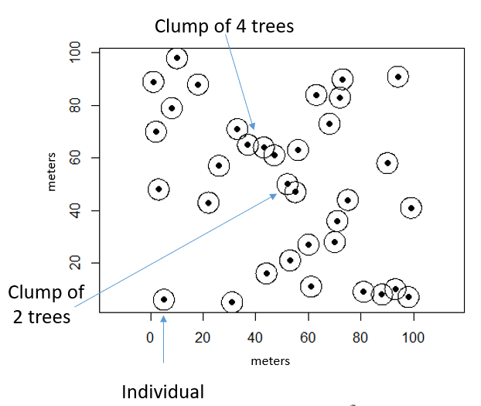
Figure 3: Simplified demonstration of TAO clumping, where each black dot represents the high point of a TAO and the corresponding circle represents its crown. In this visualization a constant crown radius/area was used, but in the RxGaming tool each TAO will have a crown area derived from the CHM and tree segmentation algorithm.

1.6 Reference Areas
An optional input to RxGaming is a dataset of sites whose structure will be displayed for “reference” against treatment units. For the tool, a reference site is a location that exhibits the desired structures, patterns, and processes that are desired by managers to achieve their selected goals, such as greater wildfire resilience, in a given forest system. This is a flexible framework allowing users to decide what constitutes desired conditions. This tool was primarily designed with disturbance from fire in mind, but it will work with reference datasets that define desired conditions based on other objectives (i.e. drought resilience, snow water retention, pathogen resilience, wildlife habitat, etc.) provided those structural conditions can be met with removal of trees to create spatial patterns (as opposed to e.g. planting trees) (Kaufmann et al. 1998; Moore, Wallace Covington, and Fulé 1999).
Once the user has selected areas that exhibit desired forest structure or have defined conceptual ranges of conditions that define desired forest structure, RxGaming provides a framework for choosing treatment targets in context of those conditions. A database of reference areas for mixed conifer stands with active fire regimes in the Sierra Nevada derived from Chamberlain et al. 2023 is provided with the tool. However, users can provide their own database for a different reference objective or geographic region, so long as it includes the structural metrics described in section 1.8 above and its format is the same as the default supplied table (section 3.4). It is best practice to derive reference site measurements from lidar data, such that an equal comparison between treatment unit structure and reference structure can be made. If using field derived measurements, careful assessment of how field and lidar derived measurements differ must be made before setting targets from those reference conditions.

1.7 Ecological Thinning
The RxGaming Tool is built around an “ecological thinning” paradigm. The objective is to simulate treatments that balance both an objective to remove timber from a stand as well as enhance some ecological function via the pattern of trees left remaining on the stand. This emulates reality where managers are often balancing multiple objectives in creating treatments. A few potential ecological functions that could be improved through ecological thinning are resilience to fire, focal species habitat, disturbance resilience, or snow-water retention. RxGaming principally focuses on improving post treatment overstory resilience to fire in the form of ICO patterns, though these conditions can overlap with other ecological functions.

1.8 RxGaming in the project planning process
Managers are often working with multiple conflicting restrictions in their treatment planning, such as the need to decrease stand density for fire resistance and the need to retain canopy cover for habitat of species of concern (Stevens et al. 2016). Furthermore, pre-treatment conditions have the largest influence on potential treatment outcomes, and the desired management objective may not be achievable. A primary aim of the tool is to make the process of exploring treatments that incorporate spatial patterns more accessible.
RxGaming is not designed to supersede existing tools or workflows, but rather to provide additional support within existing workflows. The tool provides information and analysis about spatial patterns while allowing for multiple objectives in the context of other common management metrics (in the form of BA, TPA, CC, and diameter limit). We do not recommend setting prescriptions solely from the results of RxGaming simulations, but rather incorporating them alongside other data sources (e.g. stand exam data) that influence manager decision making.
The analyses from RxGaming supplement on-the-ground surveys of project areas and, importantly, can add spatial context to those ground assessments. RxGaming also does not simulate the future state of the stand (e.g. conditions after tree growth). Other tools such as the Forest Vegetation Simulator (FVS) can be used for this purpose (Crookston and Dixon 2005). For example, if FVS has been used prior to RxGaming, the initial conditions used in FVS could be used to set targets in RxGaming (i.e. RxGaming can be used to explore treating the stand to a predefined state). Or if FVS will be used after RxGaming, initial conditions to FVS can be informed by the results of a treatment simulation from RxGaming.
Based on working with different project teams, we propose that managers consider using RxGaming in a workflow such as this (which is the one we applied to the case studies in section 1.9):
- Consider the history of the stand and current condition as well as any existing treatment objectives. Is there some existing structural complexity in the stand? Has this stand been harvested in the past/is the stand even-age? Is this stand good habitat for focal species or is creation of habitat a treatment objective? Is this stand in the WUI or are fuels concerns a priority? How diverged from reference conditions is this stand? Observing the existing condition CHM in RxGaming for existing horizontal and vertical heterogeneity, size class distributions reports, and the reference context component of RxGaming can help inform answers to these questions.
- Create an initial set of treatment targets in an attempt to balance the desired objectives and have RxGaming simulate the treatment. Evaluate the result. Did this treatment meet the overall objectives? If not, perhaps diameter limit obstructs treatment success and future simulations could modify that. Was desired spatial heterogeneity created? Assess the visualization of post treatment structure and compare against the reference conditions? Was the treatment effective or could further BA removal create more heterogeneous conditions? If BA removal is increased, would that reduce canopy cover below some critical threshold? What is the distribution of TAO size classes that were removed? Questions such as these can inform the user about treatment success, stand and/or prescription challenges.
- Iterate. Explore variations in treatment targets based on what was learned from the previous simulated treatment. New treatment scenarios can be hypothetical- they could be more aggressive or less aggressive than would actually be implemented. They could prioritize an objective that will not be prioritized in reality. The goal is to learn more about the impacts of treatment possibilities. For example, over several simulations it might become clear that some patterns remain consistent across prescriptions (e.g. clumps of large TAOs, or locations to create openings).
- Save outputs of interesting treatments for further examination or reference when using other planning tools. RxGaming produces spatially explicit maps that can be viewed on many phones or tablets – consult these in the field when viewing conditions on the ground. We have found this to be especially useful when discussing treatment effects and alternatives with stakeholders in field visits.

1.9 Example case studies
To illustrate the RxGaming tool’s ability to address common treatment problems and incorporate ICO concepts, we present three sites from actual project areas (Figure 4). Because the sites are in the mixed conifer forests of the Sierra Nevada, we compared current and simulated treatment conditions against climatically and topographically matched reference conditions (Section 1.6; Chamberlain et al. 2023). For each site, we evaluated two treatment scenarios which were designed based on 1) personal communications with managers actively involved in planning these projects and 2) structural patterns derived from Sierra Nevada reference sites (Figure 5). Specific values for current and simulated treatment stand structures are in the tables in figure 6. We analyzed the overstory TAO structure present at the time of lidar acquisition and present analyses of the overstory structure that would remain based on each simulated treatment. Structure metrics and figures presented here are standard outputs from the RxGaming tool. For most sites, we used a 30” DBH cutoff for large TAOs that would mandatorily be retained, which is standard for this ecoregion. One scenario explored a 40” cutoff.
Our study areas fell within three existing lidar acquisitions. The Tahoe National Forest (TNF) acquisition was collected in 2013 and 2014 by the National Center for Airborne Laser Mapping; the Tahoe Basin west shore acquisition was collected in 2018 by the NASA Jet Propulsion Lab; and the Creek Fire acquisition was collected in 2021 by NV5. We processed TNF and Creek Fire acquisitions through the USFS FUSION utilities and Tahoe West through lapis. In this study, we manually selected sites from the reference database that represented analogous climatic conditions for each study site (Jeronimo et al. 2019).

Name | Vendor | Survey Dates | Average point density (pts/m^2)
TNF 2013 | NCALM | 10/24/2013 - 11/24/2013 | 11.61
TNF 2014 | NCALM | 06/10/2014 - 06/30/2014 | 8.93
Tahoe Basin | NASA JPL | 2018* | 14.91
Creek Fire | NV5 | 05/26/2021 – 05/28/2021 | 22.88

Table 1: Information about each of the lidar acquisitions used in this study. TNF: Tahoe National Forest; NCALM: National Center for Airborne Laser Mapping; NASA JPL: National Aeronautics and Space Administration Jet Propulsion Laboratory. *exact campaign dates unknown due to lack of metadata associated with this acquisition.

Site | # reference sites | Average size (acres)
Roush | 58 | 58
Yuba | 121 | 59
Tahoe West | 47 | 47

Table 2: Information about reference sites for each case study.
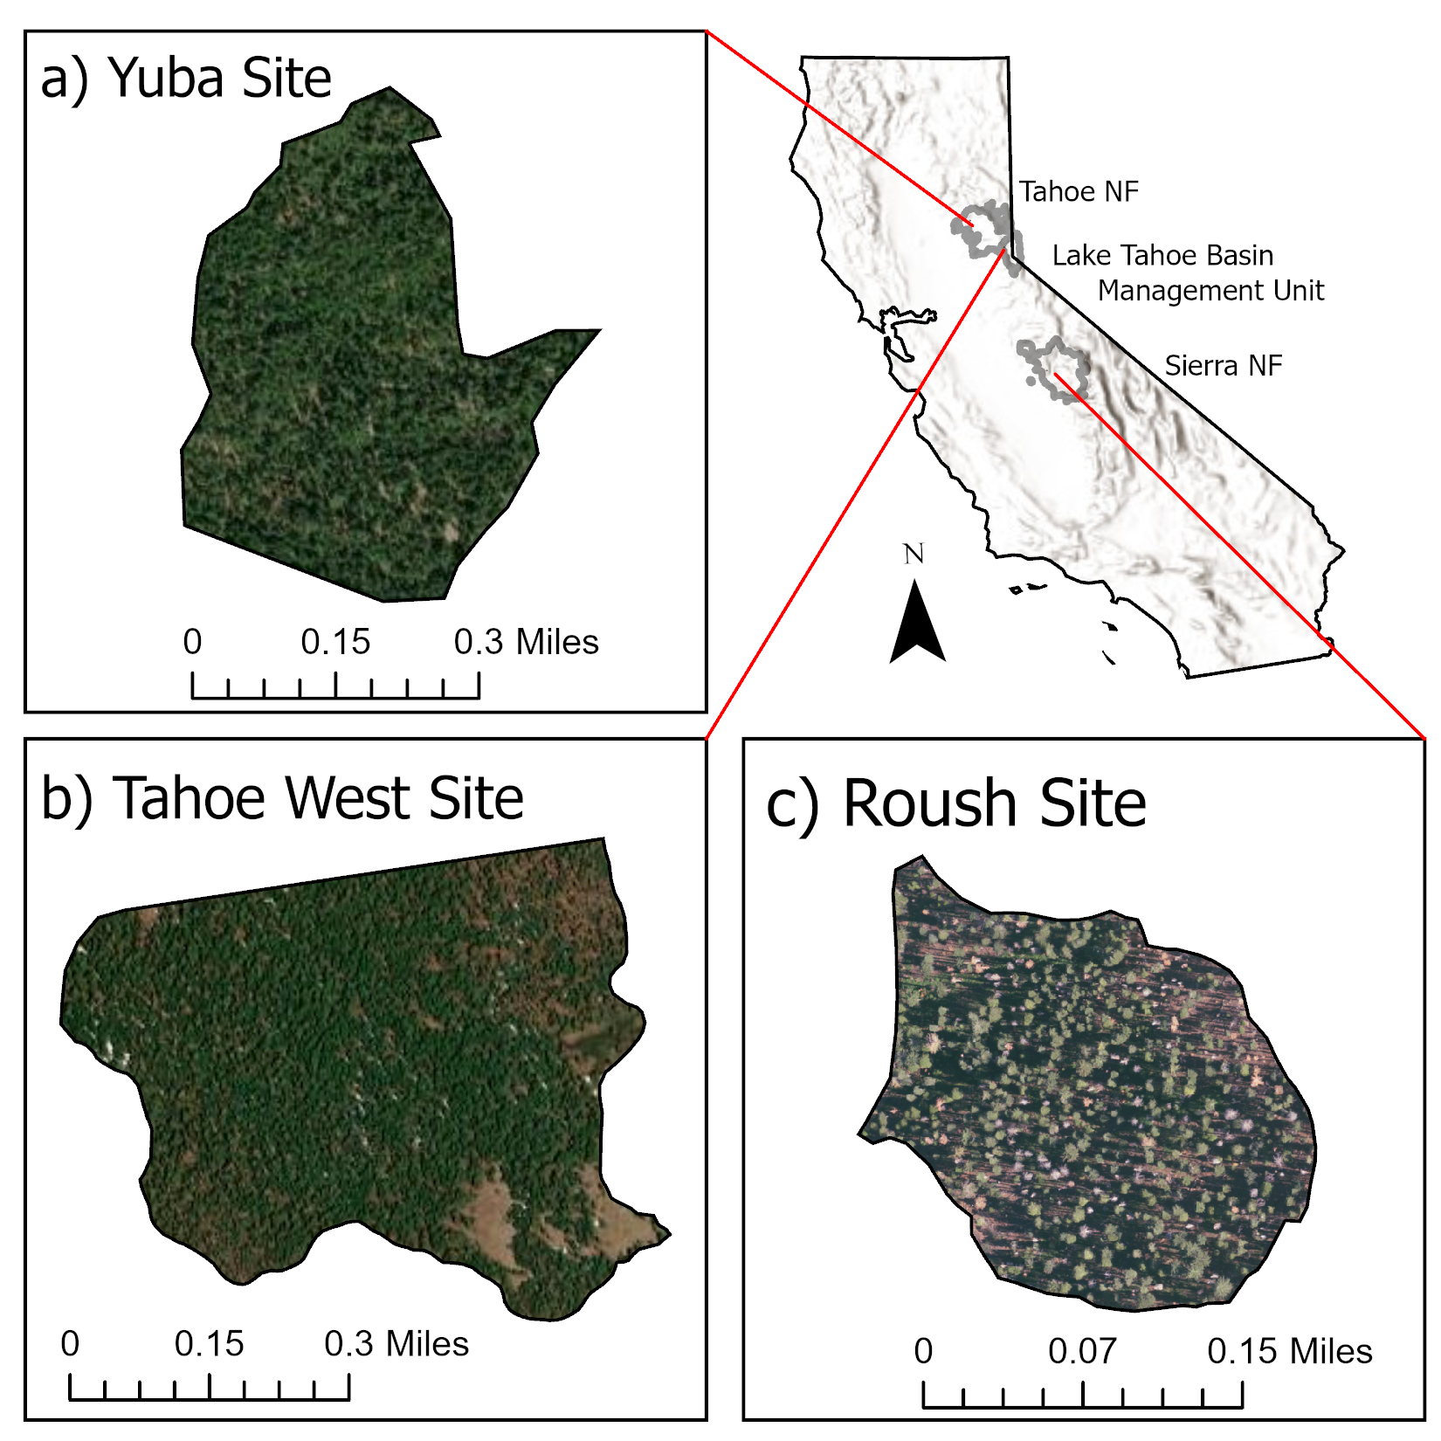
Figure 4: Study area showing locations of case study sites and National Forest boundaries (smoothed for visualization) that they fall in. All three study sites are within the Sierra Nevada Ecoregion, California, USA. NF: National Forest. Imagery for Yuba and Tahoe West sites is from ESRI World Imagery base layer which sources imagery from Maxar, USGS, and Earthstar Geographics. Imagery for the Roush site is from USDA NAIP 2022

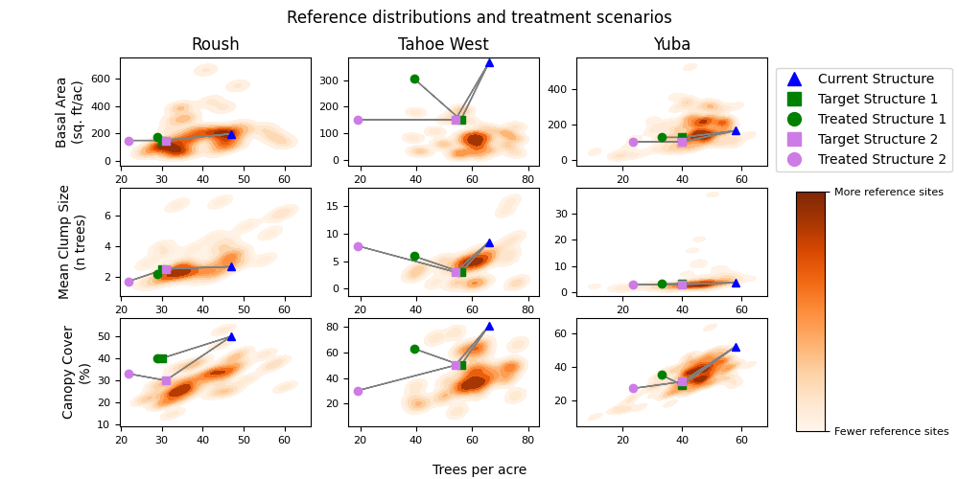
Figure 5: Comparison of the RxGaming tool’s current, target, and simulated treatment structure values against reference area structure values. Current structure (blue triangle), target structure (squares) for two different treatment scenarios (green and purple), and simulated treated structures (circles) are connected via a grey line. Background 2d kernel density estimates in orange show structure metric distributions for reference sites representing the same climate class as the case study sites, which can be a tool for informing treatment targets. Targets and results have been jittered where they overlap for visual clarity
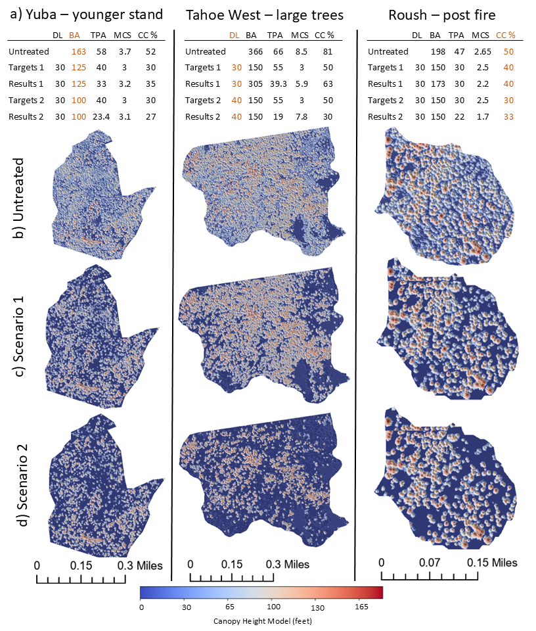
Figure 6: Visualizations of the three case studies. a) Tabular information showing the structure metrics for the untreated condition as well as treatment scenario targets and resultant structure. b) Visualization of stands in their initial untreated condition. c) Results of treatment scenario 1. d) Results of treatment scenario 2. The left column varies BA between the scenarios, the middle column varies diameter limit, and the right column varies CC. DL- diameter limit. MCS- mean clump size

1.9.1 Yuba - younger stand
This site (145 acres) is part of the North Fork Yuba Landscape Resilience Project Galloway project area. The area around this site had a long history of logging, including high grading and partial logging in the past with minimal recent intervention potentially due to terrain limiting access, and represented a site with high overstory tree densities (BA: 163 ft² ac⁻¹; TPA 58) (personal communication; Kyle Taylor, silviculturist, TNF, Yuba River Ranger district). This site lacked large and mature trees that are often used as anchors for ICO treatments (Churchill et al. 2016; Jeronimo et al. 2018), and consisted primarily of relatively young trees and even-aged structures.
Stands with young, even-aged conditions are common across many dry forest landscapes as a result of harvest and planting histories (Stephens and Moghaddas 2005). As a result, managers commonly encounter stands that lack a “backbone” of large trees, which are essential for anchoring treatments and creating vertical structural heterogeneity. For stands like this, managers might seek to increase horizontal spatial heterogeneity such that retained trees grow to maturity and increase vertical structural diversity (Malcolm P. North et al. 2019).
Compared to reference sites from the same climate class, this site had an in-range BA and MCS but higher TPA and CC than comparable reference sites. As such, we chose treatment goals to focus on reductions in TPA and CC. Scenario 1 centered around a small reduction in BA while aiming to reduce TPA, clump size, and canopy cover. Scenario 2 involved a larger reduction in BA to explore a more substantial restructuring of the stand.
Scenario 1’s higher treatment BA target led to fewer openings and more canopy cover than scenario 2 with its lower BA target. Both treatments increased structural diversity by reducing MCS, TPA and CC, and creating interspersed openings. Both treatments also maintained a clump of somewhat larger TAOs in the bottom center of the unit, demonstrating how the treatment algorithm prioritized retention of larger TAOs despite the relatively low number of large TAOs on the site.
Given these initial conditions, RxGaming allowed us to evaluate and compare treatment scenarios that addressed challenges associated with treating young, homogenous stands. In scenario 1, we focused on moving structure within the range of reference conditions which, in turn, led to only modest changes to stand structure. In scenario 2, we focused on decreasing BA below reference conditions which resulted in smaller clump sizes and more interspersed openings. The greater treatment intensity of scenario 2 may lend greater longevity to treatment-driven heterogeneity and reductions in canopy fuel, thereby reducing the need for future treatments. Choosing between these two treatment scenarios would be a qualitative judgment based on management objectives, future plans for the site, and the broader landscape context.

1.9.2 Tahoe West - many large trees
The Tahoe West study site (190 acres) had a less intense harvest history than the Yuba site and represented a higher elevation site part of the Tahoe Basin West Shore WUI Healthy Forest and Fuels Reduction Project (personal communication; Brian Garrett, Asst. Vegetation Management Staff Officer, Tahoe National Forest, Lake Tahoe Basin Management Unit). This site had a high BA and density (BA: 281 ft² ac⁻¹; TPA: 68). BA and CC were all highly departed from reference conditions, while MCS was slightly higher than reference conditions. The site also had a high proportion of existing large trees >30” DBH, which resulted in the high BA. It had a mixed conifer species composition: red fir dominant with a significant pine component.
While these conditions are not the predominant condition in this ecoregion, managers will encounter them in areas that were never or only lightly harvested, or in productive sites that have supported the rapid growth of larger trees following fire suppression (Knapp et al. 2013). These sites are important habitat for focal wildlife species or have special social value (Kane et al. 2023; Kramer et al. 2021; Malcolm P. North et al. 2017; Blomdahl et al. 2019; Zielinski et al. 2004).
Both treatment scenarios centered around a significant reduction in BA with additional goals to reduce clump sizes and canopy continuity, while retaining as many large trees as possible. The scenarios used the same BA targets but differed in their minimum large tree retention DBH threshold. Scenario 1 used the ecoregion standard of 30” but scenario 2 explored the effects of a 40” limit.
Scenario 1 was unable to achieve the BA target due to the diameter retention limit – there were simply too many TAOs with >30” DBH. And while it did reduce CC to 56%, this remained high compared to reference conditions. This simulation resulted in the creation of a few larger openings, but much of the stand retained high canopy continuity.
Scenario 2 set the same BA target but relaxed the diameter limit to 40”. This allowed for the removal of more large TAOs to hit the BA target and create an MCS of 7.9 and CC of 30%, close reference conditions. Openings were more dispersed in this simulation. While relaxing the diameter limit allows the treatment algorithm to remove larger TAOs, it is designed to retain as many as possible. This allows the algorithm to break up larger clumps of TAOs that it may not be able to otherwise. In this case, the lower BA target necessitated the removal of some large TAOs. Both treatments reduced the TPA of the stand well below that observed in the reference sites, indicating that there were more large trees in this site than observed in the reference sites.
Sites such as this, where there are too many large trees rather than too few, pose a rare challenge to managers in this ecoregion (Kane et al. 2023). Large trees are of high ecological and social importance, therefore the decision to remove them requires careful consideration (Lutz et al. 2012; 2013). Removing larger trees may be particularly controversial with wildlife managers and public stakeholders. However, retaining all large trees may leave the stand with high leaf area and high canopy fuel connectivity, lacking resilience to subsequent disturbances and climate change (Agee and Skinner 2005). RxGaming simulations can help managers and stakeholders understand the costs and benefits of different treatment outcomes, and their effects on large trees and associated values.

1.9.3 Roush - post-fire treatment
The third study site (20 acres) was part of the Roush project area in the Sierra National Forest. This site represented a lower overstory tree density, moderate productivity location (BA: 198 ft^2/ac; TPA: 47). It had an existing population of large trees >30” DBH, but was not dominated by them. Compared to the reference sites, the Roush study site was within the range but on the high end of observed conditions for BA and TPA. However, most comparable reference sites exhibited lower CC than those observed in the Roush study site. This site experienced past thinning activities and in 2020 the Creek fire burned the stand at 42% low, 48% moderate, and 10% high severities as measured by the composite burn index using the layers described in Cova et al. 2023. This past fire activity contributed to some of the existing structural complexity on the site (personal communication; James Simmons, Timber Management Officer, Sierra National Forest, Bass Lake Ranger District).
We selected BA targets that would satisfy the 40% CC minimum that is common in this landscape. Scenario 1 set targets to remove modest BA but more significantly target lower TPA and create smaller clumps, while adhering to the CC minimum. Scenario 2 relaxed the CC target, allowing for more BA removal and a more open canopy.
Scenario 1 was unable to achieve the BA target due to the CC minimum, however density was effectively reduced and there were some effects on clumping and openings. With the more relaxed CC minimum, scenario 2 was able to reduce BA to the target and create a lower MCS and more openings.
Stands in this condition can afford managers flexibility in their treatment designs – they are not too far diverged from reference conditions and have large trees to anchor tree clumps. Additionally, it is likely that management strategies will increasingly utilize wildfire as an agent for restoration (M P North et al. 2021). One challenge managers may face with stands such as this is canopy cover minimums. The reference sites in this region typically have open canopies with covers between 20 and 30%. However, in this ecoregion there are CC minimums (commonly >40%) to prioritize retention of habitat for focal species such as the California spotted owl (Strix occidentalis occidentalis) and the pacific fisher (Martes pennanti) (Malcolm P. North et al. 2017; Blomdahl et al. 2019; Kramer et al. 2021). On the other hand, this stand doesn’t need much structural intervention compared to the Tahoe West case study site, so there is less benefit to relaxing diameter limits. Rxgaming can help managers and stakeholders understand how, where, and when to emphasize these different objectives.

2 Installation

2.1 System Requirements
- RxGaming is a Microsoft Windows only application and has only been tested on Windows 10 and later versions.
- The tool is distributed as a zip file requiring 0.5gb of space and occupies 1.34gb of space once decompressed.
- Drive space to store RxGaming inputs, outputs, and save states is required. The amount required varies based on project area and lidar acquisition. We recommend a solid state drive (for faster disk I/O, but hard disk drives will work) with 512gb of storage. Smaller storage space can be used, but may require subsetting of the lidar data and/or project area.
- The tool will run on a single thread, but will run faster (especially during initial processing) with additional threads. PC threads can be checked by opening the task manager, then clicking performance. Number of threads is listed in the bottom right under the label “Logical Processors.” 5 threads are a reasonable number to handle most moderate size project areas, but it is recommended to leave 25% of threads free for use by the operating system and other applications. Therefore 8 threads are a baseline recommendation for the computer system. Threads will be discussed in further detail in the project settings section (3.1).
- Memory or RAM is the most crucial resource for RxGaming. The more RAM on the system, the more treatment units RxGaming (treatment units are the individual areas for assessment, section 3.2) can process and game at once. View RAM on the system by opening Task Manager > Performance > Memory. 16gb is sufficient for most small to moderate, spatially aggregated project areas (treatment units are located close to each other).. Less RAM may require the processing of fewer units at a time.
- RxGaming has low graphical requirements and an integrated or dedicated graphics system will suffice.

2.2 Installation
First download the most recent version RxGaming from the tool’s drive page. The source code can be found on the bitbucket page. The tool will download with a filename similar to what is shown in figure 7, which provides information about the version number of RxGaming and the date the version was hosted.
Extract this zip file to the location you would like to install RxGaming.
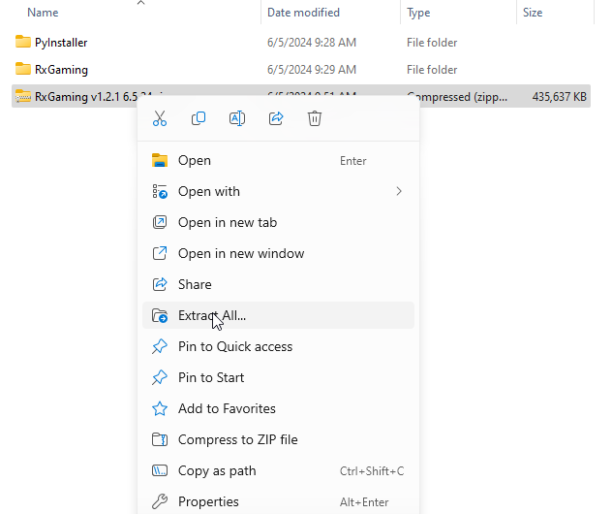
Figure 7: RxGaming distributable and extraction

2.3 Opening RxGaming
To open RxGaming, double click on RxGaming.exe in the folder where it was extracted.
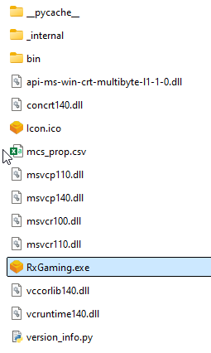
Figure 8: Opening RxGaming.

3 RxGaming Tool Inputs and Setup
Upon startup, the RxGaming tool presents the menu in figure 9. These selections dictate whether a new project will be started or a saved project or project settings should be loaded. When loading a saved project, the user will be prompted to select the RxGaming save file. See sections 3.1 and 4.4 for more information on saving work.
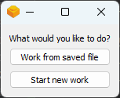
Figure 9: The RxGaming opening menu.

3.1 Project settings
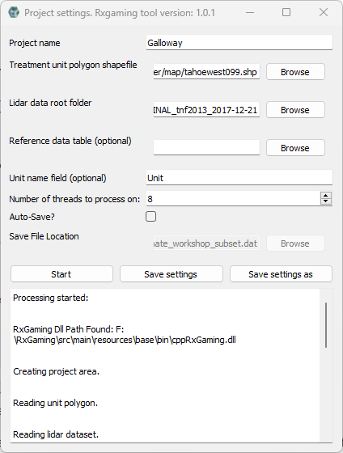
Figure 10: The project settings window.

When the user selects start new work or loads a project settings save file, the window in figure 10 will display.
In this window the user will input the necessary data for running RxGaming. In the instance of a loaded save file, the fields will contain the previously entered values. Each input is briefly described here, with further details provided in subsequent sections.
- Project name – An arbitrary name the user specifies to associate with this project. The name will show up on maps and figure outputs from the RxGaming tool.
- Treatment unit polygon shapefile – a .shp vector file describing the spatial extent of the treatment units, wherein each feature in the shapefile represents an individual treatment unit. See section 3.2
- Lidar data root folder – the folder containing the pre-processed lidar data that encompasses the project area, including tree segmentation and canopy height models. See section 3.3
- Reference data table – an optional input (.csv) containing structural information regarding reference sites, that when loaded, can be compared against treatment unit structure. See sections 3.4 and 4.3
- Unit name field – an optional input that specifies which column from the treatment unit polygon shapefile attribute table has unique identifiers for each treatment unit. This is used for identifying treatment units within the program as well as a label in outputs from the tool. If left blank, or if the supplied column does not exist units will be labeled as “unnamed.”
- Number of threads to process on – this specifies the number of threads to create when doing initial data processing. The minimum number is 1, the maximum is based on the number of cores available in the computer’s CPU. A higher number of threads will decrease the initial processing time, but increase the peak memory and CPU usage.
- Auto-save – if this box is checked, the following “Save file location” text input field will become enabled. When these are both set, the program will automatically save the RxGaming scenario after initial processing is complete. This is useful in cases where the computer will be left unattended during processing (e.g. overnight). The automatic saving provides some insurance against unplanned computer restarts, for example.
The “Save settings as” button will prompt the user to save the project settings to file, which can be loaded for future use, whereas the “Save settings” button will save the settings to an existing save file if one exists. The user will also be asked if they wish to save upon closing the project settings window.
When the user clicks the start button, RxGaming will load the required lidar data and subset it to the treatment areas, as well as doing initial structure assessments. Below the buttons is a text output which reports on processing progress
During initial processing, the RxGaming tool loads the required lidar data based on the treatment units in the unit polygon, and calculates initial structural information to begin gaming with the tool. The process can be monitored through the output box at the bottom of the project settings window, and through the program terminal (figure 12). If the program encountered an error during this initial processing, a pop-up window will describe the encountered error. Information is provided there to report the error to the developer if desired.
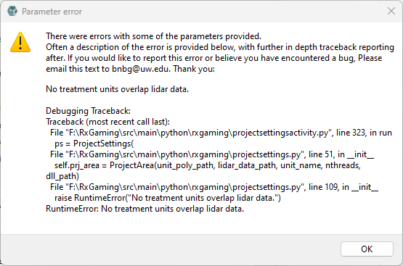
Figure 11: An example of an error encountered in the RxGaming tool. The first section of text describes that an error occurred and how to report it. The second section gives a short description of the issue (in this case the treatment unit polygon layer does not overlap the lidar data). The last section shows more technical information about what the issue was, and is primarily useful if reporting the error to the developer (section 0.2).

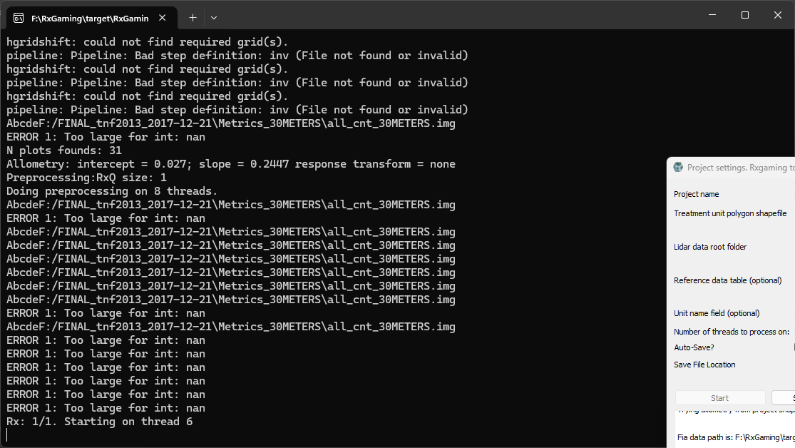
Figure 12: The terminal window that opens alongside the RxGaming tool. This window has additional output about tool processing beyond what is reported in the output box on the project settings window. For many users, interacting with this window is unnecessary, but if the user is processing many units at once, progress on the processing will be reported in this window.

3.2 Treatment units and lidar boundary
RxGaming uses the model below when combining the different spatial extents of the treatment units and the lidar data. The treatment units will be intersected with the lidar boundary. The term treatment unit and stand are used interchangeably when describing an area of interest that is defined by a feature in the input shapefile. A collection of stands is referred to as a project area.
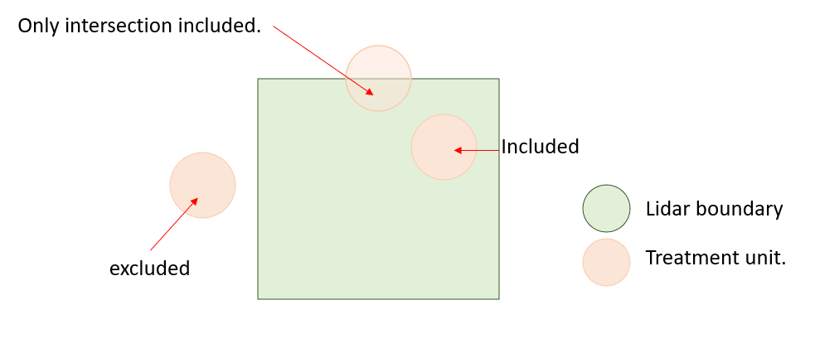
Figure 13: Illustration of relationship between treatment units and lidar data boundary.

3.3 Lidar
RxGaming accepts input lidar data in a few formats. Regardless of input format, it requires tree segmentation and a high-resolution CHM. Currently supported processing pipelines include the USFS FUSION software, outputs from the lidR package for the R coding language, and Lapis which is a publicly available lidar processing tool developed in the Forest Resilience Lab at the University of Washington (where RxGaming was developed). In all three cases, RxGaming expects a folder as the input, with subfolders containing the various products needed to run RxGaming. Input the parent folder to RxGaming when setting the project settings.

3.3.1 Fusion
If processing the lidar data through the USFS FUSION software, RxGaming expects the user to provide a file path to the parent folder enclosing FUSION’s processed files. Specifically, RxGaming expects the 0.75 meter (or 2.4606 feet) cell size CHM and tree segmentation. RxGaming expects FUSION’s standard file naming protocol.
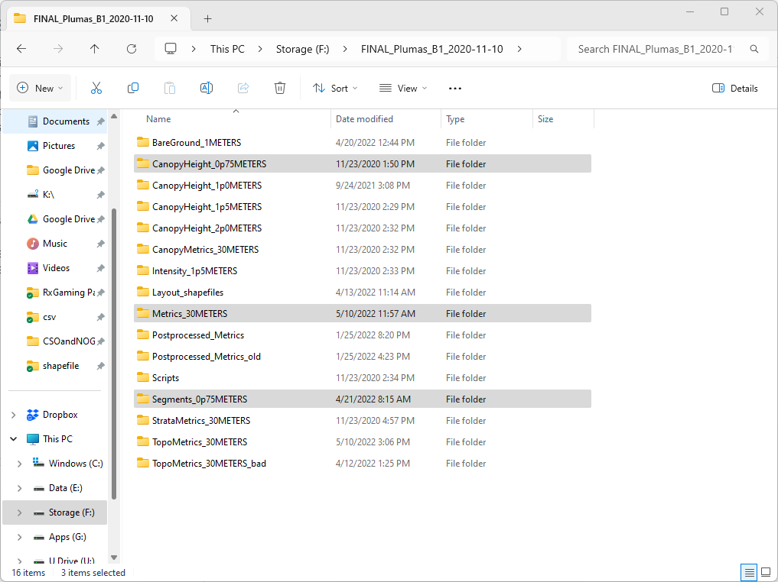
Figure 14: An example of a FUSION folder with the necessary folders highlighted.

3.3.2 LidR
Included with the downloads of RxGaming is an R script titled “lidR.r” This script accepts as input lidar point data “.las” or “.laz” files, the shapefile of treatments to be processed, the unique identifier column from the treatment units shapefile, and the output directory for lidR write files to. Upon execution of the script, the lidar data will be processed over each treatment unit and appropriate outputs will be created that will be interpretable by RxGaming.
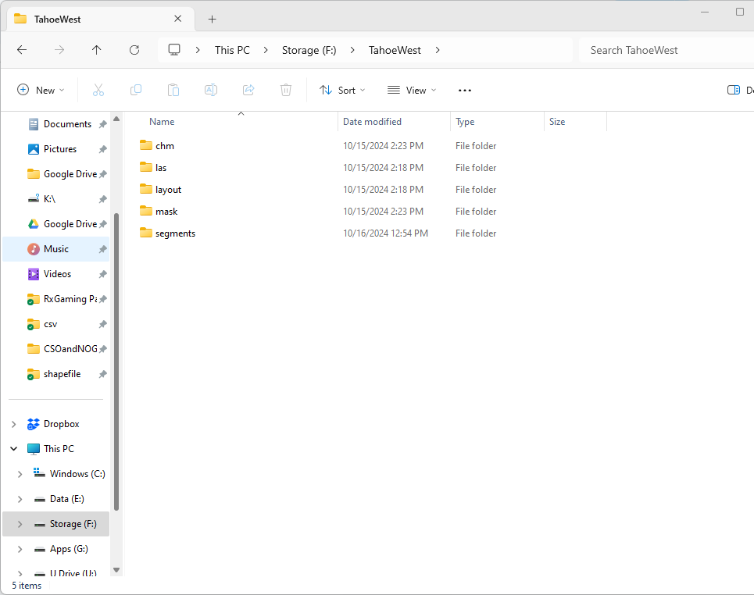
Figure 15: An example of the data created from the “lidR.r” script and the file structure the RxGaming tool expects.

3.3.3 Lapis
Lapis is an open source lidar processing tool developed in the Forest Resilience Lab, and therefore the outputs can be read by RxGaming when processed with the same parameters as FUSION (0.75m tree segmentation). For additional information on Lapis, follow this link: github.com/jontkane/Lapis.
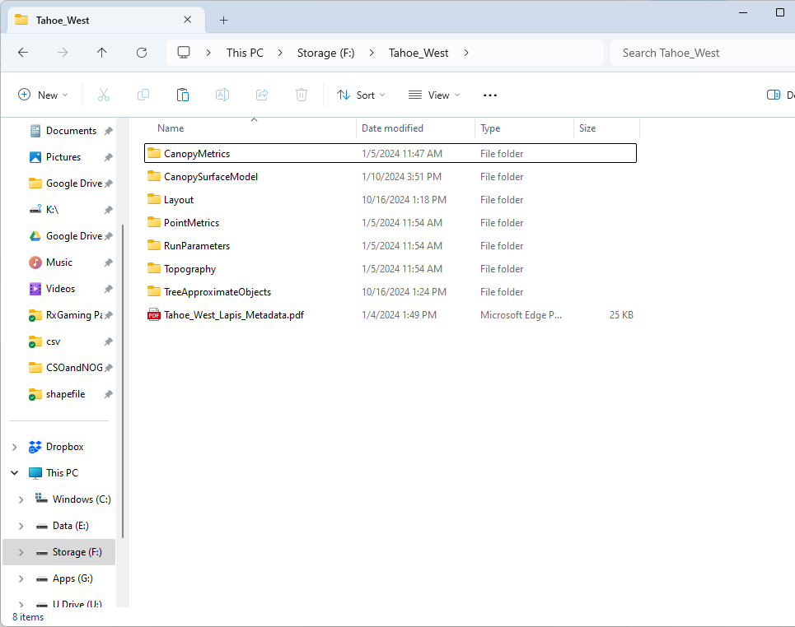
Figure 16: An example of the file structure that the RxGaming tool expects from lapis

3.4 Reference areas
For an overview of the reference area concept, see section 1.4.

Once the user has selected areas that exhibit desired forest structure or have defined conceptual ranges of conditions that define desired forest structure (i.e. expert opinion), RxGaming provides a framework for choosing treatment targets in context of those conditions. This is purely based on graphical visualization of reference conditions in comparison with treatment units, and any decisions based on these visualizations can be entered as treatment targets by the user (see section 4.3 for this graphic visualization).
A database of reference areas for mixed conifer stands with active fire regimes in the Sierra Nevada derived from Chamberlain et al. 2023 is provided in the tool downloads. However, users can provide their own database for a different reference objective or ecoregion, so long as it includes the structural metrics described in section 2.3 above and its format is the same as the default supplied table.

 | ba | tph | mcs | cc
site 1*
site 2*
…*
*site 1, site 2, etc is not expected to be in the table, but we put it here to describe how each row in the table represents a different reference site.

Table 3: the data format expected for the reference database, which is case sensitive and expected to be provided as a comma separated values document (.csv).

Column header | Description
ba | basal area measured in square meters per hectare.  1 square meter per hectare = 4.356 square feet per acre
tph | trees per hectare.  1 hectare = 2.47105 acres
mcs | mean clump size.
cc | canopy cover as a proportion (values ranging from 0 to 1).

Table 4: Descriptions of the columns in the reference data table.

Column header | Description
name | The reference unit name (as taken from the reference sites provided by Chamberlain et al. 2023).
id | Reference sites are subdivided into landscape management units (LMUs) following the protocol outlined in Underwood et al. 2010. See also. “Id” refers to the unique LMU id for each LMU in the reference site.
type | LMUs are classified as valleys, ridges, NE facing slopes, and SW facing slopes. Type refers to the code referring to which landform the LMU is: 0 = valley; 1 = ridge; 2 = NE facing slope; 3 = SW facing slope.
osi | The open space index for the reference. A value between 0 and 1 representing the proportion of the reference site in area greater than 6m from canopy edge (canopy in a lidar context is area greater than 2m in the CHM). A measure of gappiness that emphasizes larger, aggregated gaps.
c1 | Proportion of trees in the reference site that are individuals.
c2to4 | Proportion of trees in the reference site that are in clumps of 2-4 trees.
c5to9 | Proportion of trees in the reference site that are in clumps of 5-9 trees.
c10to14 | Proportion of trees in the reference site that are in clumps of 10-14 trees.
c15to29 | Proportion of trees in the reference site that are in clumps of 15-29 trees.
c30to35 | Proportion of trees in the reference site that are in clumps of 30+ trees. Despite the label giving an upper limit of 35 trees, this column refers to clumps 30 and up.
aet | Mean actual evapotranspiration on the stand as measured from the BCM climate normals.
cwd | Mean climatic water deficit on the stand as measured from the BCM climate normals.
tmn | Mean January minimum temperature on the stand as measured from the BCM climate normals.

Table 5: Other columns can exist in the database (and are present in the provided database), but are not required or used in RxGaming. We describe the other columns in the default database here.

3.5 Threads
RxGaming can do parallel processing during the preprocessing step to speed up the initial processing wait time. The tool will run on a single thread, but will run faster (especially during initial processing after clicking start in project settings - section 3.1) with additional threads. PC threads can be checked by opening the task manager, then clicking performance. Number of threads is listed in the bottom right under the label “Logical Processors.” 5 threads are a reasonable number to handle most moderate size project areas, but it is recommended to leave 25% of threads free for use by the operating system and other applications. Therefore 8 threads are a baseline recommendation for the computer system.

4 RxGaming user interface

4.1 RxGaming concepts
The RxGaming interface is designed around two primary tabs- the Stand tab and the Landscape tab. The Stand tab is where the user interfaces with visualizations of a treatment unit, sets targets for treatment, sets diameters limits, and assesses the results of treatments. The landscape tab displays all the treatment units against the reference sites for assessment of the treatment units’ structure in comparison to each other and to the reference sites.

4.2 Stand tab

4.2.1 Visualization page

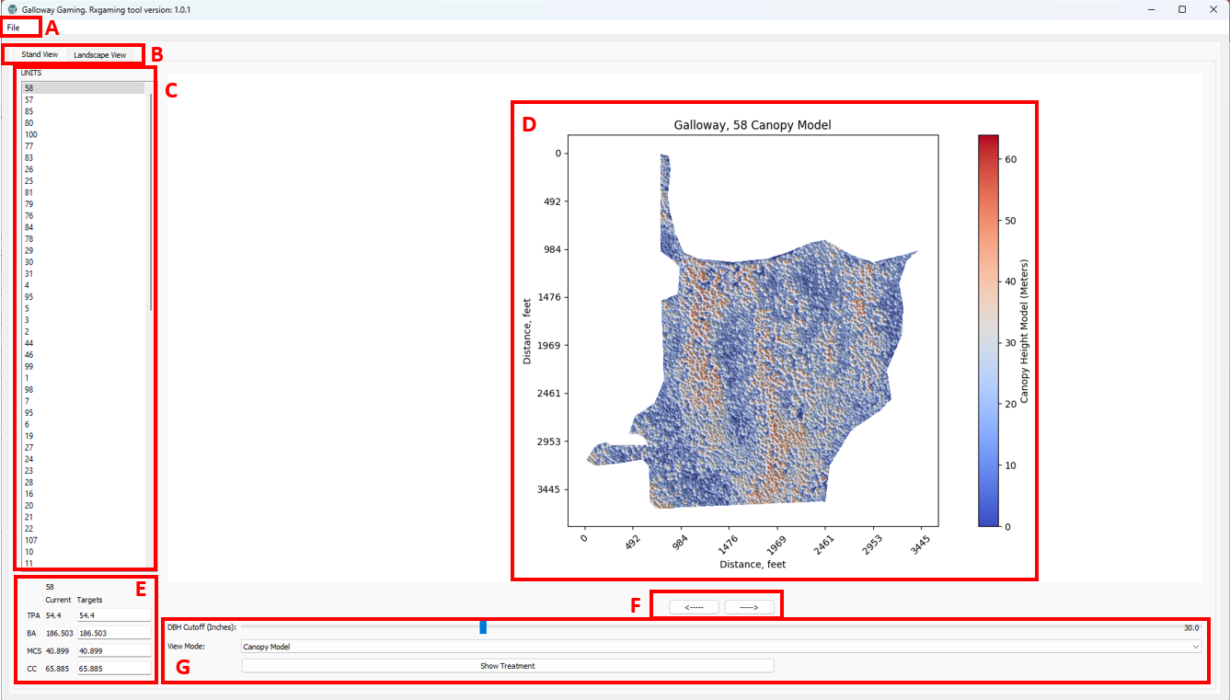
Figure 17: The visualization page:
- File - menu, see section 4.4
- Switch between Stand tab (section 4.2) and Landscape tab (section 4.3)
- Select treatment unit for viewing and treatment simulation. The name shown on the list corresponds to the “unit name field” supplied in the project settings (section 3.1).
- Stand visualization - display the CHM of the selected treatment unit. The view mode can be changed to display heights, unique trees, or clump sizes (see G). This visualization is either pre-treatment or post-treatment if the show treatment button is checked (see G).
- Set treatment targets - Displays the treatment unit name, the current TPA, BA, MCS, and CC, and the input fields to set the treatment targets for the same metrics.
- Change the between the visualization page (section 4.2.1), the treatment report page (section 4.2.2), and the cut trees report page (section 4.2.3).
- Treatment options - a slider to change the diameter limit for the treatment, in inches (currently selected diameter limit is shown on the right end of the slider). A dropdown menu to change the view mode between canopy model (canopy model heights), basins (individual trees), and clumps of trees.

4.2.2 Treatment Report page

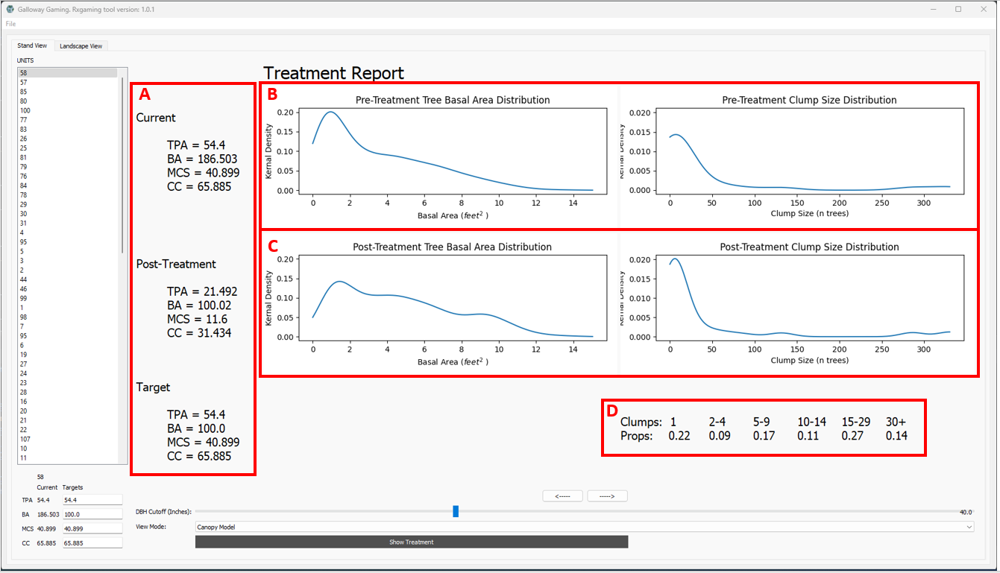
Figure 18: The treatment report page:
- The current TPA, BA, MCS, CC of the selected stand, followed by the structure remaining after simulated treatment and the targeted structure.
- The distribution of basal areas and mean clump sizes of the individual trees in the stand, pre-treatment.
- The distribution of basal areas and mean clump sizes of the individual trees in the stand, post-treatment.
- The target clumps size distribution, in terms of proportions of trees in each size class. See section 5.3 for more information.

4.2.3 Cut trees report page

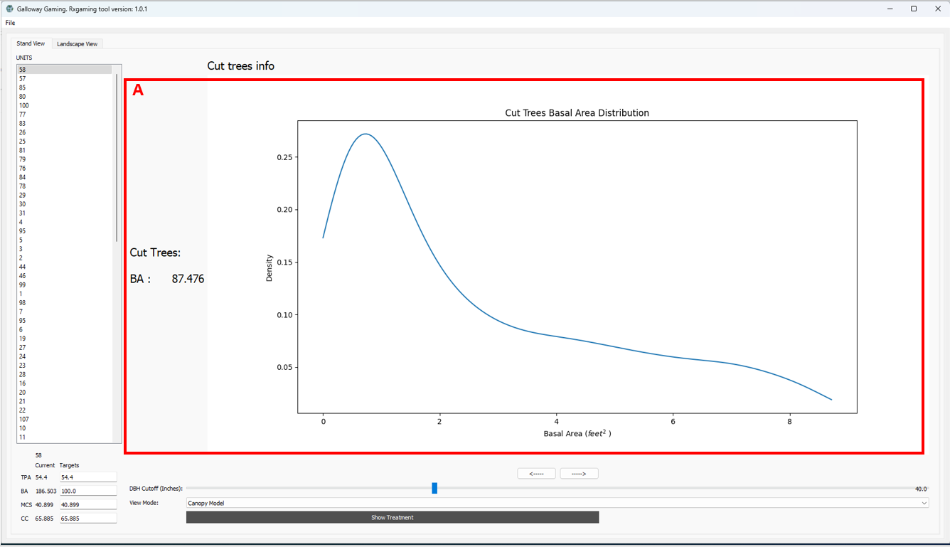
Figure 19: The cut trees report page:
- Basal area distribution and sum of the cut trees/trees removed during simulated treatment.

4.3 Landscape tab
The landscape tab provides context of treatment units against other treatment units and against reference conditions, if a reference data table was supplied during the project settings stage. On this tab three scatter plots show the 4 different structure metrics. On the x axis for all the plots is trees per acre. The y axis shows basal area, mean clumps size, and canopy cover respectively.

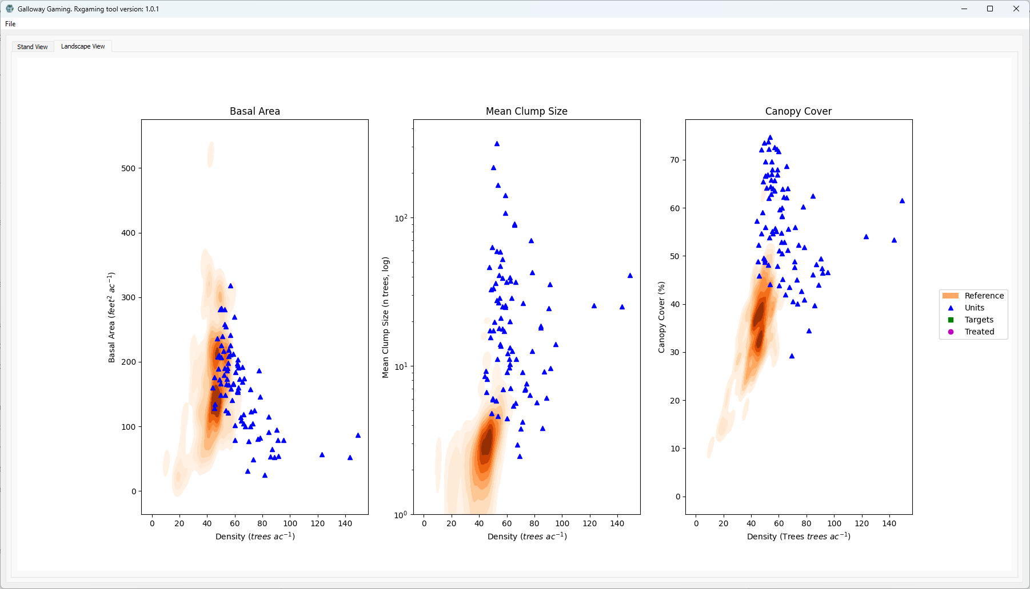
Figure 20: The landscape tab.
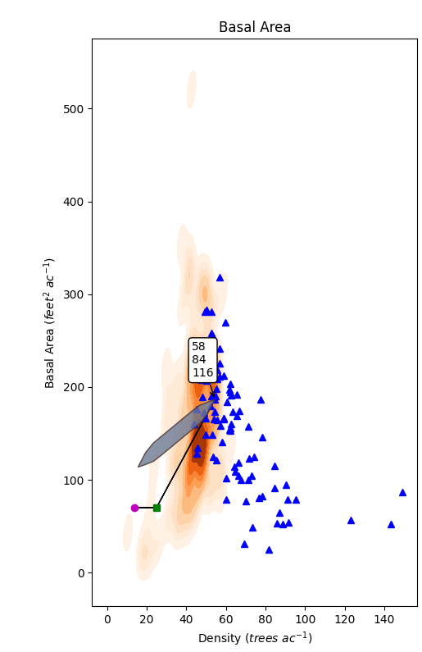
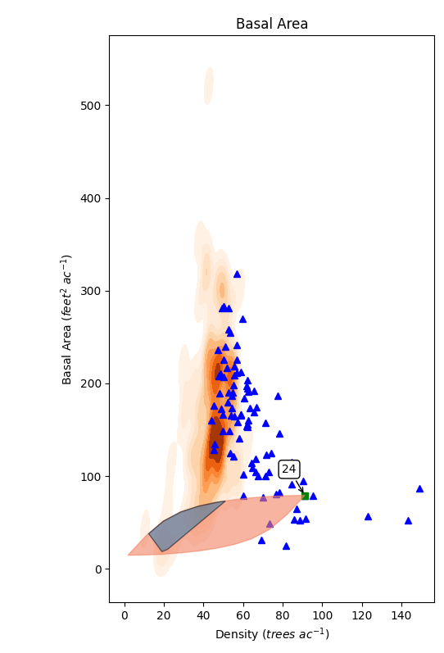
Figure 21: Details of the graphs displayed on the landscape tab:
- Each blue dot represents the current structural condition of one of the loaded treatment units.
- The orange gradients represent the density of loaded reference sites at given structural conditions. Darker orange colors indicate more reference sites exhibit that structural condition.
- Upon hovering the mouse cursor over a unit, several things pop up:
  - A box showing the name(s) of the treatment unit(s) under the cursor.
  - A green square representing the user input treatment targets
  - A magenta circle indicating the results of the simulated treatment towards those treatment targets
  - A line connecting the three shapes.
  - A polygon showing an exploratory assessment of the range of treatment conditions - this is not exhaustive and is calculated by permuting the treelist 30 times.
    - Starting with only trees above a 30” diameter, measure structure.
    - Add one tenth of the remaining trees and remeasuring structure, shortest trees first. Repeat iteratively until all trees are measured.
    - Repeat but add trees tallest first.
    - Repeat but add trees randomly.
This creates a distribution of measured structural conditions which are displayed in the polygon. This does not measure all possible structures, nor does it measure treatment with a different diameter limit (as is displayed in the left image above).
In gray areas are where the unit structure distribution overlaps the reference distribution, and in salmon are areas where the unit structure distribution does not overlap the reference distribution.

4.4 Menus and saving work
Work can be saved by selecting File > save (to overwrite the current save file) or File > save as (to create a new save file). The program also prompts the user to save upon exiting (File > Exit, Ctrl+Q, or the X is in the top right corner of the program).

5 Running Treatment Simulations

5.1 Setting treatment targets
Treatment targets can be set in the bottom left of the stand tab. The treatment algorithm foremost attempts to hit the BA target and therefore BA has the largest impact on treatment result. Second it tries to create a clump size distribution that averages out the input MCS. Finally, TPA and CC are targeted via an internal weighting factor that emphasizes trees that contribute to those targets. Therefore these 2 metrics have the least impact on treatment. These treatments are simulations and are not infallible. If stand conditions do not allow achieving the selected targets, sometimes odd results can arise. A common scenario is that diameter limits do not allow completion of a treatment or a high BA target does not allow for targeted reduction in MCS.

5.2 Understanding the treatment thinning algorithm
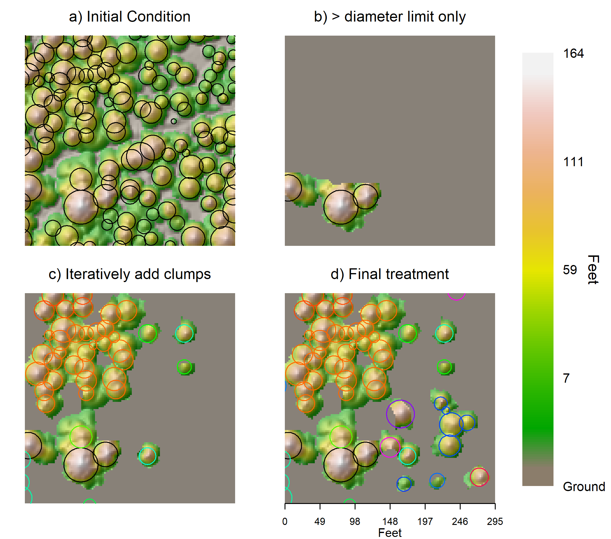
Figure 22: Visualizations of the canopy height model and modeled TAO crown radii (superimposed circles). a) Initial condition shows all the TAOs as captured by the lidar data. b) All TAOs < diameter limit removed as initial step of treatment simulation. c) Visualization of treatment algorithm reintroducing clumps of trees midway through simulation. Superimposed crown radii are colored by the discrete step in which the TAOs were added back into the CHM. d) Visualization of CHM upon simulation completion. Crown radii colored with the same method as described for panel c.

The goal of the treatment thinning algorithm is to create a simulated removal of TAOs in a way that is, in theory, operationally possible to apply in the field. We designed the algorithm to meet the BA target objective, to create a clump size distribution (CSD) that best matches the target CSD, and to use a clump of trees as the fundamental unit (rather than a single tree). The objective is not to provide a treatment prescription for direct implementation but rather to allow efficient visualization and exploration of spatially explicit overstory thinning options.
Rather than iteratively removing TAOs from the treatment unit, the algorithm approaches the problem from the other direction, starting with no TAOs retained and iteratively selecting clumps of TAOs from the TAO list until the BA target is met. Before TAOs have been explicitly retained or cut, they are candidates that can be considered for retention. When selecting TAOs to retain, the algorithm is weighted toward those with larger diameters. When selecting clump sizes to create, the algorithm picks sizes that contribute most favorably to aligning the resultant CSD against the target CSD. A brief summary of the treatment algorithm is below, with a thorough description and flowchart in figure 23:
- For a given treatment area, start by retaining all TAOs on the site that are greater than the user specified diameter limit (obligated to keep these trees). All other trees are candidates.
- Retain a new clump of trees:
  - Choose a TAO randomly, weighted towards large basal area TAOs (including the TAOs > diameter limit that were retained in step 1, but not those retained in 2d or removed in 2e) that contributes favorably to canopy cover and density targets. We use a weighted seeded random approach to incorporate stochasticity into the treatment results while still allowing for reproducibility.
  - Find all TAOs that form a clump with the selected TAO (their canopies overlap).
  - From the clump distribution goals, choose a clump size to create (contingent on the total clump size (step 3)), that contributes favorably to the target CSD.
  - Select and retain a subset of TAOs in the clump to create the new clump of the desired size. Those TAOs are selected using the same weighting as in step 2a.
  - Simulate cutting all TAOs below the diameter limit that are not in the subset clump from step 5, but still directly connect to it (effectively locking in the clump size- those trees cannot be retained in another clump during future iterations; other trees not directly adjacent can be considered for other clumps; trees above diameter limit will not be cut).
- Assess progress towards targets. If resultant BA is below target BA, repeat step 2 if there are still TAOs to consider retaining (some targets cannot be met, due to diameter limits e.g.)
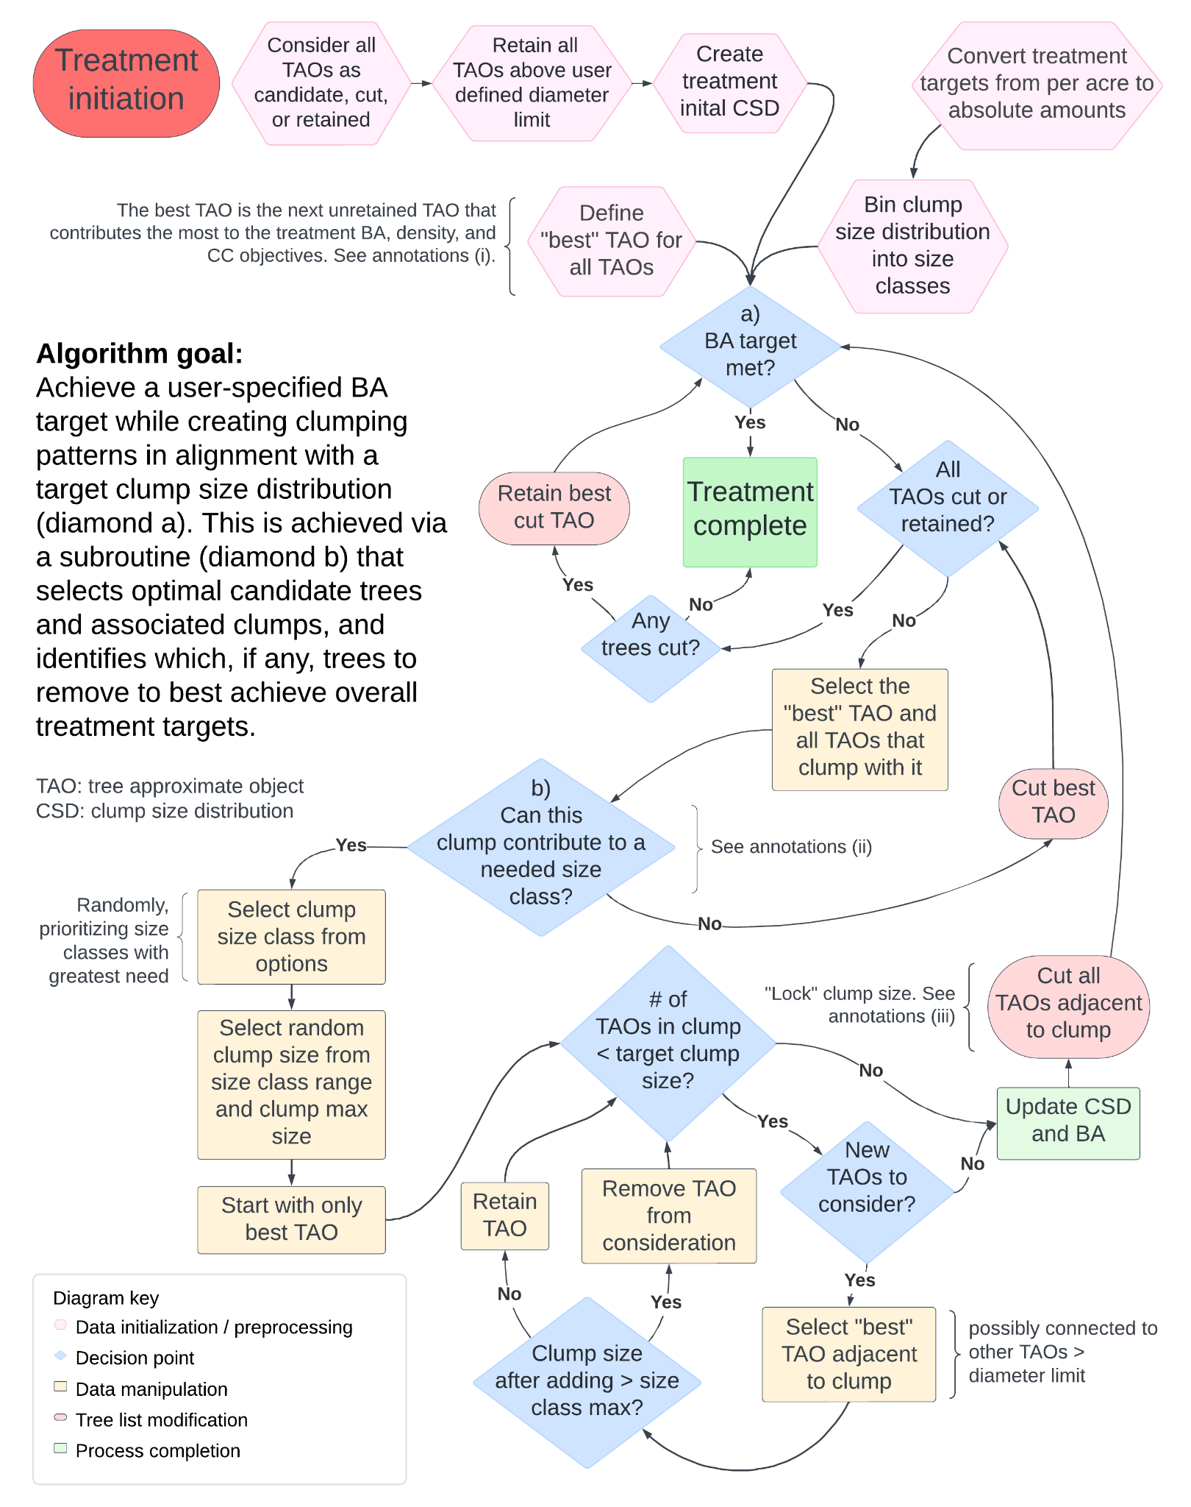
Figure 23: Flowchart describing the function of RxGaming’s internal treatment simulation algorithm. Pink hexagons represent data initialization or preprocessing steps. Blue diamonds represent decision points with binary answers. Green boxes indicate completion of a process or subprocess. Tan boxes represent data manipulations. Red ovals represent modifications to the treelist.
Annotations:
- To define the best TAO, create 2 ratios:
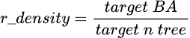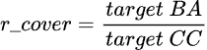
Important note: in this scenario, BA refers to total basal area for the target (not BA per hectare/acre), similarly CC refers to the total canopy area targeted for the treatment. The TAO that contributes most favorably towards reaching those two ratios is considered best:
Where BA_{i} is the basal area of the i-th TAO and cover_{i} is the canopy area of the i-th TAO. This creates a weighting value that generally prefers the largest diameter trees, but the ratios allow for selection of the largest trees that contribute most favorably to density and cover targets.
- In order for a clump to contribute to a needed size class: 1) the BA target for the clump size bin must not be met. 2) The minimum clump size for the bin is less than the max clump size of the selected clump. 3) The max clump size for the bin is greater than the min clump size of selected the clump.
- This fixes the size of the clump. After this step future clumps cannot add TAOs that will modify this clump's size. Because of the way TAOs are selected for inclusion in the clump, TAOs greater than the diameter limit will not be adjacent to the clump.

5.3 Treatment success diagnostic
In the event that the RxGaming tool is unable to achieve the BA target due to diameter limits inhibiting further removal of trees, a message noting this will display in the map title.
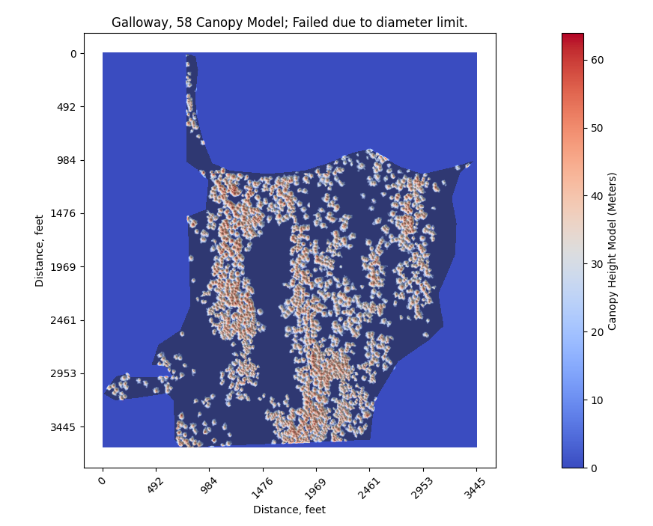
Figure 24: A treatment that was unable to complete due to diameter limit preventing removal of sufficient amount of BA.

5.4 Calculating the target clump size distribution
Because the user sets a target MCS, the tool must translate that value into a clump size distribution (CSD). Since the tool is not directly selecting reference sites for treatment targets we have created a table that translates a given MCS into a suitable reference distribution. This data (Table 6) was created by selecting all reference sites from Jeronimo et al. 2019 within the described MCS range and calculating the mean proportion in different clump sizes for those sites.

 |  |  | Prop. in | size | class
MCS min | MCS max | 1 | 2to4 | 5to9 | 9to14 | 15to30 | gt30
1 | 1.25 | 0.94 | 0 | 0 | 0 | 0.06 | 0
1.25 | 1.5 | 0.69 | 0 | 0 | 0.02 | 0.29 | 0
1.5 | 1.75 | 0.6 | 0 | 0.02 | 0.01 | 0.37 | 0
1.75 | 2 | 0.53 | 0 | 0.03 | 0.05 | 0.39 | 0
2 | 2.25 | 0.49 | 0 | 0.08 | 0.02 | 0.41 | 0
2.25 | 2.5 | 0.46 | 0.01 | 0.1 | 0.04 | 0.39 | 0
2.5 | 2.75 | 0.43 | 0.02 | 0.14 | 0.03 | 0.38 | 0
2.75 | 3 | 0.41 | 0.03 | 0.15 | 0.04 | 0.36 | 0.01
3 | 3.25 | 0.37 | 0.03 | 0.16 | 0.03 | 0.4 | 0.01
3.25 | 3.5 | 0.38 | 0.04 | 0.17 | 0.01 | 0.38 | 0.02
3.5 | 3.75 | 0.35 | 0.06 | 0.18 | 0 | 0.4 | 0.01
3.75 | 4 | 0.36 | 0.05 | 0.18 | 0.01 | 0.37 | 0.03
4 | 4.25 | 0.33 | 0.05 | 0.21 | 0.03 | 0.35 | 0.03
4.25 | 4.5 | 0.33 | 0.05 | 0.2 | 0 | 0.37 | 0.05
4.5 | 4.75 | 0.3 | 0.09 | 0.18 | 0 | 0.38 | 0.05
4.75 | 5 | 0.3 | 0.07 | 0.2 | 0.01 | 0.36 | 0.06
5 | 6 | 0.29 | 0.09 | 0.21 | 0.03 | 0.31 | 0.07
6 | 7 | 0.24 | 0.1 | 0.21 | 0.02 | 0.34 | 0.09
7 | 8 | 0.25 | 0.08 | 0.19 | 0.02 | 0.31 | 0.15
8 | 9 | 0.25 | 0.1 | 0.18 | 0.04 | 0.31 | 0.12
9 | 10 | 0.25 | 0.08 | 0.18 | 0.05 | 0.27 | 0.17
10 | 15 | 0.22 | 0.09 | 0.17 | 0.11 | 0.27 | 0.14
15 | 20 | 0.24 | 0.04 | 0.13 | 0.17 | 0.27 | 0.15
20 | 25 | 0.19 | 0.07 | 0.14 | 0.22 | 0.27 | 0.11
25 | 50 | 0.15 | 0.08 | 0.15 | 0.28 | 0.24 | 0.1
50 | 75 | 0.13 | 0.09 | 0.13 | 0.37 | 0.19 | 0.09
75 | 100 | 0.15 | 0.04 | 0.11 | 0.41 | 0.2 | 0.09
100 | 9999 | 0.1 | 0.03 | 0.08 | 0.59 | 0.12 | 0.08

Table 6: The lookup table used to convert MCS values to CSDs.

6 RxGaming outputs
RxGaming provides several output options, all pre or post treatment, which can be created using File > Export. All data will be in the projection of the input lidar data. An example geotiff output is provided in the “sample data” folder alongside the tool.

Geotiffs - These are tif images of the stand tab content. These can be used to save the visualizations as they appear on the screen (e.g. with or without a treatment) or the report pages if they are on the screen. If the visualizations are saved, the resulting image will be georeferenced (for use in gis software such as Avenza or Arcpro). The resulting file will have the hillshade (that gives the trees dimensions) and have text information about the unit structure displayed on the left hand side.
Rasters - These will export the displayed visualization as a raster. This will be only the canopy height model, with none of the post processing used to aid visualization in the tool. Applicable for further analysis as the values of the raster will represent the canopy height (in meters).
Points - This will create a point shapefile representing the highpoints of the trees in the displayed raster.
Csv’s - This will create a csv file containing the X, Y, Area (square meters), Height (meters), and crown radius (meters) of the displayed trees.

RxGaming outputs have been used in the development of designation by prescription implementations. Currently this requires post processing of outputs but if funding becomes available we wish to add additional support. Three approaches have been used, in all cases the outputs from RxGaming have only been one component of a larger prescription description.
The first approach is to post process the geopdf based on analysis of the map and field observations of the stand into subdesignation regions (e.g. openings, dense clumps, open clumps). The second is to convert the CHM raster output into a binary canopy/opening layer and use this as a “soft mask”- a baseline upon which the other prescription rules easily override or alter the decisions. The final option is to provide the geotiff directly to the operator, but this requires so training with the operators about how to interpret the map and deviate from it where site conditions warrant. For support developing designation by prescription workflows or to be connected with existing users, contact the authors.

7 RxGaming limitations
Lidar data and RxGaming have limitations that must be considered when using this tool to make management decisions.
First, lidar data primarily measures overstory structure and therefore assessments made through RxGaming are of the dominant trees only. Surface and ladder fuels play a critical role in forest resilience, having a major impact on fire behavior and severity (Prichard, Peterson, and Jacobson 2010; Battaglia, Smith, and Shepperd 2008; Agee and Skinner 2005). Because metrics derived from a CHM (as used by RxGaming) do not directly measure those features, additional assessment and interventions (such as prescribed fire) to address this component of restoration must be made. Note, other lidar metrics derived from the point cloud can measure ladder fuels.
Second, lidar does not measure species, and therefore RxGaming allows for species agnostic assessments only. Species composition influences the spatial and temporal characteristics of fires, droughts, insect outbreaks, and disease (M. North, Innes, and Zald 2007; Zald et al. 2008; 2024). Because RxGaming does not assess tree species when simulating tree removal/retention, consideration from other data sources should be included when setting full prescriptions. We will discuss three stand composition scenarios and how they could be considered while using RxGaming: 1) stands with desired species composition, 2) stands with undesired compositions, but desired species are present 3) stands lacking desired compositions. Not all stands will fit cleanly into these groups and there is overlap between them but we will discuss some ways to address them.
Stands with desired species composition are fairly straightforward to deal with. As long as the composition is consistent among size classes or in the overstory, treatments similar to what is proposed by the tool should not maintain the species composition. If the predicates are not the case, the stand would need to be considered similarly to scenario 2 or 3.
In stands undesired compositions, but where there are desired species present, will require willingness to deviate from outputs of the RxGaming tool (which should always be the case). For example, if retention of ponderosa pine is a priority then implementation can require that retaining those trees overrides the result from the tool. The way this changes resultant heterogeneity could be accounted for by increasing treatment in other areas of the stand, but this requires additional decision making from managers or machinery operators (as in a designation by prescription context). If the pine component of the stand is minimal, then the impact to resultant structure would also be small even if no compensation is made. If the pine component is larger, allowing removal of some pine (if deemed appropriate) could allow for maintaining ICO results. If all pine is retained and it significantly changes the resultant pattern, we suggest that the resultant treatment that considered and made some attempt to introduce spatial heterogeneity is still favorable to one that disregarded it.
Stands lacking desired species and when shifting species composition as an objective require different kinds of treatment than the RxGaming tool simulates, probably planting of those species. In this case, one could use the RxGaming tool to simulate a heavier treatment than otherwise with the knowledge that there will be regeneration efforts in the stand. We do acknowledge that the utility of the RxGaming tool decreases as stand composition is dominated by younger trees and by undesired tree species. We hope this discussion emphasizes our mentality that the tool be used as a component of a larger decision making framework that balances all the objectives and conditions of the stand and larger landscape.
Third, diameter measurements derived from allometric regressions will contain error. An expected diameter for a given height is calculated, but actual value can vary based on many factors such as site/micro-site condition, vigor/disease, damage to tree changing height (e.g. lightning strike or damage from wind or another tree falling and colliding), past disturbance (drought, fire), species etc. Additionally, the longer a tree is alive the more those effects have had time to influence growth, therefore models of diameter are inherently heteroskedastic (the error increases as tree size increases). This is another reason that we emphasize that decisions should not be made purely from tool outputs, nor should they be made at the granularity of the individual tree. While trends across stands and project areas will hold, error is present in the fine scale information.
Finally, the tool does not apply models of tree mortality status to the TAOs. Tree mortality in a stand can influence treatment objectives and outcomes. This is a planned feature for a future version of the tool.

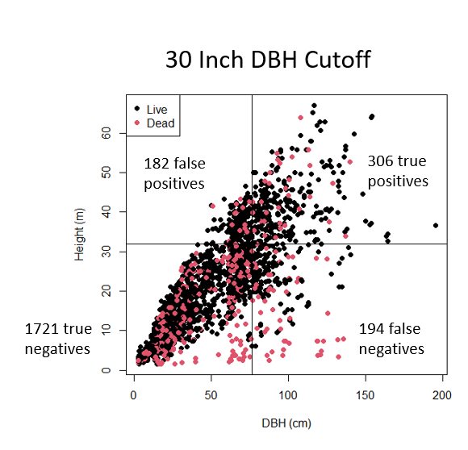
Figure 25: Illustration of heteroskedasticity of tree height-diameter distributions. Data is sampled from FIA plot data. Lines illustrate how classification error is sensitive to height and diameter cutoff selection. Color illustrates how mortality status affects error.

8 Works cited

Abella, Scott R., and Charles W. Denton. 2009. “Spatial Variation in Reference Conditions: Historical Tree Density and Pattern on a Pinus Ponderosa Landscape.” Canadian Journal of Forest Research 39 (12): 2391–2403. https://doi.org/10.1139/X09-146.
Agee, James K., and Carl N. Skinner. 2005. “Basic Principles of Forest Fuel Reduction Treatments.” Forest Ecology and Management, Relative Risk Assessments for Decision –Making Related To Uncharacteristic Wildfire, 211 (1): 83–96. https://doi.org/10.1016/j.foreco.2005.01.034.
Battaglia, Mike A., Frederick W. Smith, and Wayne D. Shepperd. 2008. “Can Prescribed Fire Be Used to Maintain Fuel Treatment Effectiveness over Time in Black Hills Ponderosa Pine Forests?” Forest Ecology and Management 256 (12): 2029–38. https://doi.org/10.1016/j.foreco.2008.07.026.
Blomdahl, Erika M., Craig M. Thompson, Jonathan R. Kane, Van R. Kane, Derek Churchill, L. Monika Moskal, and James A. Lutz. 2019. “Forest Structure Predictive of Fisher (Pekania Pennanti) Dens Exists in Recently Burned Forest in Yosemite, California, USA.” Forest Ecology and Management 444 (July):174–86. https://doi.org/10.1016/j.foreco.2019.04.024.
Brown, Peter M., Michael A. Battaglia, Paula J. Fornwalt, Benjamin Gannon, Laurie S. Huckaby, Chad Julian, and Antony S. Cheng. 2015. “Historical (1860) Forest Structure in Ponderosa Pine Forests of the Northern Front Range, Colorado.” Canadian Journal of Forest Research 45 (11): 1462–73. https://doi.org/10.1139/cjfr-2014-0387.
Casas, Ángeles, Mariano García, Rodney B. Siegel, Alexander Koltunov, Carlos Ramírez, and Susan Ustin. 2016. “Burned Forest Characterization at Single-Tree Level with Airborne Laser Scanning for Assessing Wildlife Habitat.” Remote Sensing of Environment 175 (March): 231–41. https://doi.org/10.1016/j.rse.2015.12.044.
Chamberlain, Caden P., Gina R. Cova, C. Alina Cansler, Malcolm P. North, Marc D. Meyer, Sean M. A. Jeronimo, and Van R. Kane. 2023. “Consistently Heterogeneous Structures Observed at Multiple Spatial Scales across Fire-Intact Reference Sites.” Forest Ecology and Management 550 (December):121478. https://doi.org/10.1016/j.foreco.2023.121478.
Chamberlain, Caden P., Van R. Kane, and Michael J. Case. 2021. “Accelerating the Development of Structural Complexity: Lidar Analysis Supports Restoration as a Tool in Coastal Pacific Northwest Forests.” Forest Ecology and Management 500 (November):119641. https://doi.org/10.1016/j.foreco.2021.119641.
Churchill, Derek J., Gunnar C. Carnwath, Andrew J. Larson, and Sean A. Jeronimo. 2017. “Historical Forest Structure, Composition, and Spatial Pattern in Dry Conifer Forests of the Western Blue Mountains, Oregon.” Gen. Tech. Rep. PNW-GTR-956. Portland, OR: U.S. Department of Agriculture, Forest Service, Pacific Northwest Research Station. 93 p. 956. https://doi.org/10.2737/PNW-GTR-956.
Churchill, Derek J, Sean MA Jeronimo, Andrew J Larson, Paul Fischer, Matt C Dahlgreen, and Jerry F Franklin. 2016. “The ICO Approach to Quantifying and Restoring Forest Spatial Pattern: Implementation Guide,” October.
Churchill, Derek J., Andrew J. Larson, Matthew C. Dahlgreen, Jerry F. Franklin, Paul F. Hessburg, and James A. Lutz. 2013. “Restoring Forest Resilience: From Reference Spatial Patterns to Silvicultural Prescriptions and Monitoring.” Forest Ecology and Management 291 (March):442–57. https://doi.org/10.1016/j.foreco.2012.11.007.
Clyatt, Kate A., Justin S. Crotteau, Michael S. Schaedel, Haley L. Wiggins, Harold Kelley, Derek J. Churchill, and Andrew J. Larson. 2016. “Historical Spatial Patterns and Contemporary Tree Mortality in Dry Mixed-Conifer Forests.” Forest Ecology and Management 361 (February):23–37. https://doi.org/10.1016/j.foreco.2015.10.049.
Collins, Brandon M., Scott L. Stephens, Gary B. Roller, and John J. Battles. 2011. “Simulating Fire and Forest Dynamics for a Landscape Fuel Treatment Project in the Sierra Nevada.” Forest Science 57 (2): 77–88. https://doi.org/10.1093/forestscience/57.2.77.
Cova, Gina, Van R. Kane, Susan Prichard, Malcolm North, and C. Alina Cansler. 2023. “The Outsized Role of California’s Largest Wildfires in Changing Forest Burn Patterns and Coarsening Ecosystem Scale.” Forest Ecology and Management 528 (January):120620. https://doi.org/10.1016/j.foreco.2022.120620.
Crookston, Nicholas L., and Gary E. Dixon. 2005. “The Forest Vegetation Simulator: A Review of Its Structure, Content, and Applications.” Computers and Electronics in Agriculture, Decision Support Systems for Forest Management, 49 (1): 60–80. https://doi.org/10.1016/j.compag.2005.02.003.
Fulé, Peter Z., W. Wallace Covington, and Margaret M. Moore. 1997. “Determining Reference Conditions for Ecosystem Management of Southwestern Ponderosa Pine Forests.” Ecological Applications 7 (3): 895–908. https://doi.org/10.1890/1051-0761(1997)007[0895:DRCFEM]2.0.CO;2.
Gray, Andrew, Thomas Brandeis, John Shaw, William McWilliams, and Patrick Miles. 2012. “Forest Inventory and Analysis Database of the United States of America (FIA).” Biodiversity & Ecology 4 (September):225–31. https://doi.org/10.7809/b-e.00079.
Hagmann, R. K., P. F. Hessburg, S. J. Prichard, N. A. Povak, P. M. Brown, P. Z. Fulé, R. E. Keane, et al. 2021. “Evidence for Widespread Changes in the Structure, Composition, and Fire Regimes of Western North American Forests.” Ecological Applications. 31(8): 24-. 31 (8): 1–34. https://doi.org/10.1002/eap.2431.
Jakubowski, Marek K., Wenkai Li, Qinghua Guo, and Maggi Kelly. 2013. “Delineating Individual Trees from Lidar Data: A Comparison of Vector- and Raster-Based Segmentation Approaches.” Remote Sensing 5 (9): 4163–86. https://doi.org/10.3390/rs5094163.
Jeronimo, Sean M. A., Van R. Kane, Derek J. Churchill, James A. Lutz, Malcolm P. North, Gregory P. Asner, and Jerry F. Franklin. 2019. “Forest Structure and Pattern Vary by Climate and Landform across Active-Fire Landscapes in the Montane Sierra Nevada.” Forest Ecology and Management 437 (April):70–86. https://doi.org/10.1016/j.foreco.2019.01.033.
Jeronimo, Sean M A, Van R Kane, Derek J Churchill, Robert J McGaughey, and Jerry F Franklin. 2018. “Applying LiDAR Individual Tree Detection to Management of Structurally Diverse Forest Landscapes.” Journal of Forestry 116 (4): 336–46. https://doi.org/10.1093/jofore/fvy023.
Kane, Van R., Bryce N. Bartl-Geller, Gina R. Cova, Caden P. Chamberlain, Liz van Wagtendonk, and Malcolm P. North. 2023. “Where Are the Large Trees? A Census of Sierra Nevada Large Trees to Determine Their Frequency and Spatial Distribution across Three Large Landscapes.” Forest Ecology and Management 546 (October):121351. https://doi.org/10.1016/j.foreco.2023.121351.
Kane, Van R., Bryce N. Bartl-Geller, Malcom P. North, Jonathan T. Kane, Jamie M. Lydersen, Sean M. A. Jeronimo, Brandon M. Collins, and L. Monika Moskal. 2019. “First-Entry Wildfires Can Create Opening and Tree Clump Patterns Characteristic of Resilient Forests.” Forest Ecology and Management 454 (December):117659. https://doi.org/10.1016/j.foreco.2019.117659.
Kane, Van R., Robert J. McGaughey, Jonathan D. Bakker, Rolf F. Gersonde, James A. Lutz, and Jerry F. Franklin. 2010. “Comparisons between Field-and LiDAR-Based Measures of Stand Structural Complexity.” Canadian Journal of Forest Research 40 (4): 761–73.
Kaufmann, Merrill R., Laurie S. Huckaby, Claudia M. Regan, and John Popp. 1998. Forest Reference Conditions for Ecosystem Management in the Sacramento Mountains, New Mexico. Rocky Mountain Research Station, U.S.D.A. Forest Service.
Keane, Robert E., Paul F. Hessburg, Peter B. Landres, and Fred J. Swanson. 2009. “The Use of Historical Range and Variability (HRV) in Landscape Management.” Forest Ecology and Management 258 (7): 1025–37. https://doi.org/10.1016/j.foreco.2009.05.035.
Khatri-Chhetri, Pratima, Liz van Wagtendonk, Sean M. Hendryx, and Van R. Kane. 2024. “Enhancing Individual Tree Mortality Mapping: The Impact of Models, Data Modalities, and Classification Taxonomy.” Remote Sensing of Environment 300 (January): 113914. https://doi.org/10.1016/j.rse.2023.113914.
Knapp, Eric E., Carl N. Skinner, Malcolm P. North, and Becky L. Estes. 2013. “Long-Term Overstory and Understory Change Following Logging and Fire Exclusion in a Sierra Nevada Mixed-Conifer Forest.” Forest Ecology and Management 310 (December):903–14. https://doi.org/10.1016/j.foreco.2013.09.041.
Kramer, H. Anu, Gavin M. Jones, Van R. Kane, Bryce Bartl-Geller, Jonathan T. Kane, Sheila A. Whitmore, William J. Berigan, et al. 2021. “Elevational Gradients Strongly Mediate Habitat Selection Patterns in a Nocturnal Predator.” Ecosphere 12 (5): e03500. https://doi.org/10.1002/ecs2.3500.
Larson, Andrew J., and Derek Churchill. 2008. “Spatial Patterns of Overstory Trees in Late-Successional Conifer Forests.” Canadian Journal of Forest Research 38 (11): 2814–25. https://doi.org/10.1139/X08-123.
———. 2012. “Tree Spatial Patterns in Fire-Frequent Forests of Western North America, Including Mechanisms of Pattern Formation and Implications for Designing Fuel Reduction and Restoration Treatments.” Forest Ecology and Management 267 (March):74–92. https://doi.org/10.1016/j.foreco.2011.11.038.
Lutz, James A., Andrew J. Larson, James A. Freund, Mark E. Swanson, and Kenneth J. Bible. 2013. “The Importance of Large-Diameter Trees to Forest Structural Heterogeneity.” PLOS ONE 8 (12): e82784. https://doi.org/10.1371/journal.pone.0082784.
Lutz, James A., Andrew J. Larson, Mark E. Swanson, and James A. Freund. 2012. “Ecological Importance of Large-Diameter Trees in a Temperate Mixed-Conifer Forest.” PLOS ONE 7 (5): e36131. https://doi.org/10.1371/journal.pone.0036131.
Lydersen, Jamie M., Malcolm P. North, Eric E. Knapp, and Brandon M. Collins. 2013. “Quantifying Spatial Patterns of Tree Groups and Gaps in Mixed-Conifer Forests: Reference Conditions and Long-Term Changes Following Fire Suppression and Logging.” Forest Ecology and Management 304 (September):370–82. https://doi.org/10.1016/j.foreco.2013.05.023.
Ma, Qin, Yanjun Su, and Qinghua Guo. 2017. “Comparison of Canopy Cover Estimations From Airborne LiDAR, Aerial Imagery, and Satellite Imagery.” IEEE Journal of Selected Topics in Applied Earth Observations and Remote Sensing 10 (9): 4225–36. https://doi.org/10.1109/JSTARS.2017.2711482.
Maltamo, M., K. Eerikäinen, J. Pitkänen, J. Hyyppä, and M. Vehmas. 2004. “Estimation of Timber Volume and Stem Density Based on Scanning Laser Altimetry and Expected Tree Size Distribution Functions.” Remote Sensing of Environment 90 (3): 319–30. https://doi.org/10.1016/j.rse.2004.01.006.
Moore, Margaret M., W. Wallace Covington, and Peter Z. Fulé. 1999. “Reference Conditions and Ecological Restoration: A Southwestern Ponderosa Pine Perspective.” Ecological Applications 9 (4): 1266–77. https://doi.org/10.1890/1051-0761(1999)009[1266:RCAERA]2.0.CO;2.
Morsdorf, Felix, Erich Meier, Benjamin Kötz, Klaus I. Itten, Matthias Dobbertin, and Britta Allgöwer. 2004. “LIDAR-Based Geometric Reconstruction of Boreal Type Forest Stands at Single Tree Level for Forest and Wildland Fire Management.” Remote Sensing of Environment, Forest Fire Prevention and Assessment, vol. 92 (3): 353–62. https://doi.org/10.1016/j.rse.2004.05.013.
Ng, Jan, Malcolm P. North, Alec J. Arditti, Monica R. Cooper, and James A. Lutz. 2020. “Topographic Variation in Tree Group and Gap Structure in Sierra Nevada Mixed-Conifer Forests with Active Fire Regimes.” Forest Ecology and Management 472 (September):118220. https://doi.org/10.1016/j.foreco.2020.118220.
North, M P, R A York, B M Collins, M D Hurteau, G M Jones, E E Knapp, L Kobziar, et al. 2021. “Pyrosilviculture Needed for Landscape Resilience of Dry Western United States Forests.” Journal of Forestry 119 (5): 520–44. https://doi.org/10.1093/jofore/fvab026.
North, Malcolm, Jim Innes, and Harold Zald. 2007. “Comparison of Thinning and Prescribed Fire Restoration Treatments to Sierran Mixed-Conifer Historic Conditions.” Canadian Journal of Forest Research 37 (2): 331–42. https://doi.org/10.1139/X06-236.
North, Malcolm P., Jonathan T. Kane, Van R. Kane, Gregory P. Asner, William Berigan, Derek J. Churchill, Scott Conway, et al. 2017. “Cover of Tall Trees Best Predicts California Spotted Owl Habitat.” Forest Ecology and Management 405 (December):166–78. https://doi.org/10.1016/j.foreco.2017.09.019.
North, Malcolm P., Jens T. Stevens, David F. Greene, Michelle Coppoletta, Eric E. Knapp, Andrew M. Latimer, Christina M. Restaino, et al. 2019. “Tamm Review: Reforestation for Resilience in Dry Western U.S. Forests.” Forest Ecology and Management 432 (January):209–24. https://doi.org/10.1016/j.foreco.2018.09.007.
Olszewski, Julia, Craig Bienz, and Amy Markus. 2022. “Using Airborne LiDAR to Monitor Spatial Patterns in South Central Oregon Dry Mixed-Conifer Forest.” Journal of Forestry 120 (6): 714–27. https://doi.org/10.1093/jofore/fvac020.
Plotkin, Joshua B., Jérôme Chave, and Peter S. Ashton. 2002. “Cluster Analysis of Spatial Patterns in Malaysian Tree Species.” The American Naturalist 160 (5): 629–44. https://doi.org/10.1086/342823.
Prichard, Susan J., David L. Peterson, and Kyle Jacobson. 2010. “Fuel Treatments Reduce the Severity of Wildfire Effects in Dry Mixed Conifer Forest, Washington, USA.” Canadian Journal of Forest Research 40 (8): 1615–26. https://doi.org/10.1139/X10-109.
Ritter, Scott M., Chad M. Hoffman, Mike A. Battaglia, Camille Stevens-Rumann, and William E. Mell. 2020. “Fine‐scale Fire Patterns Mediate Forest Structure in Frequent‐fire Ecosystems - Ritter - 2020 - Ecosphere - Wiley Online Library.” July 8, 2020. https://esajournals.onlinelibrary.wiley.com/doi/full/10.1002/ecs2.3177.
Sánchez Meador, Andrew J., Pablo F. Parysow, and Margaret M. Moore. 2011. “A New Method for Delineating Tree Patches and Assessing Spatial Reference Conditions of Ponderosa Pine Forests in Northern Arizona.” Restoration Ecology 19 (4): 490–99. https://doi.org/10.1111/j.1526-100X.2010.00652.x.
Stephens, Scott L., and Jason J. Moghaddas. 2005. “Silvicultural and Reserve Impacts on Potential Fire Behavior and Forest Conservation: Twenty-Five Years of Experience from Sierra Nevada Mixed Conifer Forests.” Biological Conservation 125 (3): 369–79. https://doi.org/10.1016/j.biocon.2005.04.007.
Stevens, Jens T., Brandon M. Collins, Jonathan W. Long, Malcolm P. North, Susan J. Prichard, Leland W. Tarnay, and Angela M. White. 2016. “Evaluating Potential Trade-Offs among Fuel Treatment Strategies in Mixed-Conifer Forests of the Sierra Nevada.” Ecosphere 7 (9): e01445. https://doi.org/10.1002/ecs2.1445.
Tuten, Matthew C., Andrew Sánchez Meador, and Peter Z. Fulé. 2015. “Ecological Restoration and Fine-Scale Forest Structure Regulation in Southwestern Ponderosa Pine Forests.” Forest Ecology and Management 348 (July):57–67. https://doi.org/10.1016/j.foreco.2015.03.032.
Vauhkonen, Jari, Liviu Ene, Sandeep Gupta, Johannes Heinzel, Johan Holmgren, Juho Pitkänen, Svein Solberg, et al. 2012. “Comparative Testing of Single-Tree Detection Algorithms under Different Types of Forest.” Forestry: An International Journal of Forest Research 85 (1): 27–40. https://doi.org/10.1093/forestry/cpr051.
Wiggins, Haley L., Cara R. Nelson, Andrew J. Larson, and Hugh D. Safford. 2019. “Using LiDAR to Develop High-Resolution Reference Models of Forest Structure and Spatial Pattern.” Forest Ecology and Management 434 (February):318–30. https://doi.org/10.1016/j.foreco.2018.12.012.
Yu, Xiaowei, Juha Hyyppä, Mikko Vastaranta, Markus Holopainen, and Risto Viitala. 2011. “Predicting Individual Tree Attributes from Airborne Laser Point Clouds Based on the Random Forests Technique.” ISPRS Journal of Photogrammetry and Remote Sensing 66 (1): 28–37. https://doi.org/10.1016/j.isprsjprs.2010.08.003.
Zald, Harold S. J., Andrew N. Gray, Malcolm North, and Ruth A. Kern. 2008. “Initial Tree Regeneration Responses to Fire and Thinning Treatments in a Sierra Nevada Mixed-Conifer Forest, USA.” Forest Ecology and Management 256 (1): 168–79. https://doi.org/10.1016/j.foreco.2008.04.022.
Zald, Harold S. J., Carolina J. May, Andrew N. Gray, Malcolm P. North, and Matthew D. Hurteau. 2024. “Thinning and Prescribed Burning Increase Shade-Tolerant Conifer Regeneration in a Fire Excluded Mixed-Conifer Forest.” Forest Ecology and Management 551 (January):121531. https://doi.org/10.1016/j.foreco.2023.121531.
Zielinski, William J., Richard L. Truex, Gregory A. Schmidt, Fredrick V. Schlexer, Kristin N. Schmidt, and Reginald H. Barrett. 2004. “Resting Habitat Selection by Fishers in California.” The Journal of Wildlife Management 68 (3): 475–92. https://doi.org/10.2193/0022-541X(2004)068[0475:RHSBFI]2.0.CO;2.

