Supplemental Table 1. US Forest Service Forest Inventory and Analysis (FIA) Forest Types ranked by abundance of shortleaf pine trees (> 2.54 cm diameter at breast height) across timberland within the shortleaf pine range and by natural community group.

Across shortleaf pine range
Forest Type | Total Area (ha) | Total Trees | Total Shortleaf Pine Trees | Shortleaf Pine Percent of Total Trees in Forest Type | Percent of All Shortleaf Pine Trees in Region
Shortleaf pine | 1,172,942 | 2,049,404,030 | 657,857,874 | 32.1% | 45.8%
Shortleaf pine / oak | 1,035,029 | 1,759,992,049 | 268,822,833 | 15.3% | 18.7%
Loblolly pine | 22,885,879 | 40,872,437,755 | 241,770,147 | 0.6% | 16.8%
White oak / red oak / hickory | 14,225,144 | 19,833,711,148 | 68,493,977 | 0.3% | 4.8%
Post oak / blackjack oak | 2,595,062 | 5,348,298,100 | 45,661,687 | 0.9% | 3.2%
Loblolly pine / hardwood | 4,690,428 | 8,804,418,945 | 28,551,632 | 0.3% | 2.0%
White oak | 2,869,537 | 3,637,386,561 | 18,022,790 | 0.5% | 1.3%
Mixed upland hardwoods | 6,853,850 | 10,706,385,015 | 16,507,363 | 0.2% | 1.1%
Sweetgum / yellow-poplar | 2,979,244 | 5,489,199,281 | 14,662,392 | 0.3% | 1.0%
Virginia pine | 665,239 | 1,671,039,959 | 12,875,889 | 0.8% | 0.9%
Chestnut oak / black oak / scarlet oak | 2,998,429 | 4,289,687,391 | 11,048,011 | 0.3% | 0.8%
Yellow-poplar / white oak / northern red oak | 3,058,238 | 5,200,855,586 | 8,840,800 | 0.2% | 0.6%
Virginia pine / southern red oak | 699,541 | 1,492,165,715 | 8,269,220 | 0.6% | 0.6%
Longleaf pine | 1,501,849 | 1,463,697,662 | 6,821,586 | 0.5% | 0.5%
Eastern redcedar | 676,069 | 1,354,335,272 | 5,010,603 | 0.4% | 0.3%
Chestnut oak | 1,900,597 | 2,425,738,702 | 3,281,653 | 0.1% | 0.2%
Eastern redcedar / hardwood | 967,180 | 1,774,751,646 | 2,877,453 | 0.2% | 0.2%
Slash pine | 3,333,250 | 4,109,803,996 | 2,756,732 | 0.1% | 0.2%
Yellow-poplar | 1,487,412 | 2,399,131,892 | 2,100,964 | 0.1% | 0.1%
Eastern white pine / northern red oak / white ash | 589,903 | 929,785,950 | 1,623,843 | 0.2% | 0.1%
Scarlet oak | 328,385 | 450,263,030 | 1,608,964 | 0.4% | 0.1%
Pitch pine | 223,447 | 351,979,625 | 1,378,534 | 0.4% | 0.1%
Longleaf pine / oak | 336,153 | 366,125,584 | 988,319 | 0.3% | 0.1%
Nonstocked | 1,068,396 | 138,365,080 | 888,239 | 0.6% | 0.1%
Eastern white pine | 528,073 | 692,312,980 | 829,381 | 0.1% | 0.1%
Elm / ash / black locust | 1,492,802 | 2,417,527,931 | 707,334 | 0.0% | 0.0%
Red maple / oak | 983,715 | 1,296,207,188 | 668,604 | 0.1% | 0.0%
Sassafras / persimmon | 609,288 | 1,428,692,257 | 667,414 | 0.0% | 0.0%
Cherry / white ash / yellow-poplar | 1,699,003 | 2,902,620,313 | 665,848 | 0.0% | 0.0%
Sweetgum / Nuttall oak / willow oak | 3,964,094 | 5,951,942,916 | 504,951 | 0.0% | 0.0%
Southern scrub oak | 319,765 | 1,633,927,652 | 484,715 | 0.0% | 0.0%
Other pine / hardwood | 383,838 | 622,006,342 | 333,044 | 0.1% | 0.0%
Swamp chestnut oak / cherrybark oak | 580,952 | 717,430,926 | 291,800 | 0.0% | 0.0%
Northern red oak | 938,768 | 1,123,267,544 | 261,881 | 0.0% | 0.0%
Sweetbay / swamp tupelo / red maple | 2,708,609 | 5,179,464,692 | 185,028 | 0.0% | 0.0%
Spruce pine | 28,180 | 45,428,382 | 156,217 | 0.3% | 0.0%
Sugarberry / hackberry / elm / green ash | 2,326,692 | 3,587,265,364 | 80,377 | 0.0% | 0.0%
Sycamore / pecan / American elm | 1,216,236 | 1,660,796,813 | 74,972 | 0.0% | 0.0%
Sugar maple / beech / yellow birch | 4,903,532 | 8,307,418,514 | 73,614 | 0.0% | 0.0%
Cottonwood / willow | 110,891 | 192,060,791 | 47,155 | 0.0% | 0.0%
Hard maple / basswood | 1,560,501 | 1,946,797,234 | 39,176 | 0.0% | 0.0%
Black cherry | 421,762 | 572,437,960 | 37,088 | 0.0% | 0.0%
Other hardwoods | 744,202 | 1,477,094,843 | 37,055 | 0.0% | 0.0%
Table Mountain pine | 23,800 | 44,702,370 | 12,624 | 0.0% | 0.0%
Slash pine / hardwood | 526,664 | 813,213,955 | 10,772 | 0.0% | 0.0%

Supplemental Table 1 (cont.). US Forest Service Forest Inventory and Analysis (FIA) Forest Types ranked by abundance of shortleaf pine trees (> 2.54 cm diameter at breast height) across timberland within the shortleaf pine range and by natural community group.

Interior Highlands Shortleaf Pine-Bluestem Woodlands & Interior Highlands Shortleaf Pine-Oak Forests
Forest Type | Total Area (ha) | Total Trees | Total Shortleaf Pine Trees | Shortleaf Pine Percent of Total Trees in Forest Type | Percent of All Shortleaf Pine Trees in Region
Shortleaf pine | 771,374 | 1,307,713,559 | 500,014,431 | 38.2% | 55.9%
Shortleaf pine / oak | 606,028 | 1,052,530,500 | 214,690,338 | 20.4% | 24.0%
Loblolly pine | 684,716 | 1,240,074,450 | 67,240,569 | 5.4% | 7.5%
White oak / red oak / hickory | 3,063,284 | 4,543,633,089 | 44,231,774 | 1.0% | 4.9%
Post oak / blackjack oak | 1,079,934 | 1,553,023,262 | 37,606,682 | 2.4% | 4.2%
White oak | 850,649 | 1,037,620,548 | 15,819,115 | 1.5% | 1.8%
Chestnut oak / black oak / scarlet oak | 85,437 | 104,203,833 | 2,821,329 | 2.7% | 0.3%
Eastern redcedar | 205,406 | 352,096,571 | 2,072,043 | 0.6% | 0.2%
Eastern redcedar / hardwood | 338,985 | 570,104,590 | 1,843,091 | 0.3% | 0.2%
Loblolly pine / hardwood | 77,256 | 155,861,684 | 1,713,930 | 1.1% | 0.2%
Mixed upland hardwoods | 337,112 | 514,241,066 | 1,698,206 | 0.3% | 0.2%
Sweetgum / yellow-poplar | 79,951 | 145,960,691 | 1,404,507 | 1.0% | 0.2%
Virginia pine | 2,484 | 4,877,712 | 1,048,838 | 21.5% | 0.1%
Scarlet oak | 32,461 | 35,428,361 | 980,695 | 2.8% | 0.1%
Red maple / oak | 5,592 | 14,303,191 | 513,543 | 3.6% | 0.1%
Sassafras / persimmon | 58,452 | 82,755,497 | 300,557 | 0.4% | 0.0%
Northern red oak | 79,466 | 91,254,380 | 261,881 | 0.3% | 0.0%
Nonstocked | 32,055 | 3,295,558 | 214,392 | 6.5% | 0.0%
Sweetgum / Nuttall oak / willow oak | 68,323 | 74,555,252 | 173,185 | 0.2% | 0.0%
Elm / ash / black locust | 67,135 | 95,028,616 | 108,062 | 0.1% | 0.0%
Cherry / white ash / yellow-poplar | 32,481 | 47,225,944 | 73,445 | 0.2% | 0.0%
Swamp chestnut oak / cherrybark oak | 35,662 | 32,057,311 | 70,578 | 0.2% | 0.0%

Supplemental Table 1 (cont.). US Forest Service Forest Inventory and Analysis (FIA) Forest Types ranked by abundance of shortleaf pine trees (> 2.54 cm diameter at breast height) across timberland within the shortleaf pine range and by natural community group.

Montane Longleaf Pine-Shortleaf Pine Woodlands
Forest Type | Total Area (ha) | Total Trees | Total Shortleaf Pine Trees | Shortleaf Pine Percent of Total Trees in Forest Type | Percent of All Shortleaf Pine Trees in Region
Loblolly pine | 2,467,975 | 4,657,105,498 | 38,801,519 | 0.8% | 47.3%
Shortleaf pine | 34,476 | 50,444,009 | 12,010,095 | 23.8% | 14.6%
Loblolly pine / hardwood | 601,837 | 1,187,974,435 | 7,154,198 | 0.6% | 8.7%
Shortleaf pine / oak | 47,037 | 72,352,574 | 6,094,172 | 8.4% | 7.4%
Sweetgum / yellow-poplar | 417,991 | 815,039,159 | 4,875,948 | 0.6% | 5.9%
Mixed upland hardwoods | 430,027 | 705,211,403 | 3,369,207 | 0.5% | 4.1%
White oak / red oak / hickory | 442,256 | 612,507,764 | 3,036,087 | 0.5% | 3.7%
Chestnut oak | 93,911 | 117,119,758 | 1,008,063 | 0.9% | 1.2%
Eastern redcedar | 11,345 | 11,123,103 | 951,544 | 8.6% | 1.2%
Virginia pine | 40,661 | 80,545,203 | 854,198 | 1.1% | 1.0%
Yellow-poplar / white oak / northern red oak | 188,606 | 363,316,306 | 845,465 | 0.2% | 1.0%
Chestnut oak / black oak / scarlet oak | 83,947 | 103,146,665 | 730,314 | 0.7% | 0.9%
Post oak / blackjack oak | 64,863 | 91,467,638 | 656,976 | 0.7% | 0.8%
Virginia pine / southern red oak | 26,682 | 39,856,647 | 368,326 | 0.9% | 0.4%
Longleaf pine | 43,594 | 60,914,506 | 350,406 | 0.6% | 0.4%
White oak | 146,715 | 153,698,907 | 312,683 | 0.2% | 0.4%
Pitch pine | 849 | 1,529,973 | 195,123 | 12.8% | 0.2%
Longleaf pine / oak | 26,630 | 31,258,619 | 188,219 | 0.6% | 0.2%
Scarlet oak | 10,883 | 10,985,978 | 103,305 | 0.9% | 0.1%
Yellow-poplar | 49,537 | 59,242,308 | 73,768 | 0.1% | 0.1%
Eastern redcedar / hardwood | 23,415 | 45,930,159 | 46,737 | 0.1% | 0.1%
Cherry / white ash / yellow-poplar | 28,533 | 80,431,244 | 39,535 | 0.0% | 0.0%
Sweetbay / swamp tupelo / red maple | 27,614 | 22,543,848 | 35,137 | 0.2% | 0.0%

Supplemental Table 1 (cont.). US Forest Service Forest Inventory and Analysis (FIA) Forest Types ranked by abundance of shortleaf pine trees (> 2.54 cm diameter at breast height) across timberland within the shortleaf pine range and by natural community group.

Southeast Coastal Plain & Piedmont Shortleaf Pine-Oak Woodlands
Forest Type | Total Area (ha) | Total Trees | Total Shortleaf Pine Trees | Shortleaf Pine Percent of Total Trees in Forest Type | Percent of All Shortleaf Pine Trees in Region
Shortleaf pine | 126,313 | 253,317,952 | 67,998,439 | 26.8% | 37.3%
Loblolly pine | 10,727,623 | 18,443,499,334 | 62,929,464 | 0.3% | 34.5%
Shortleaf pine / oak | 120,188 | 189,376,717 | 15,730,476 | 8.3% | 8.6%
Loblolly pine / hardwood | 2,190,717 | 4,037,111,988 | 7,527,397 | 0.2% | 4.1%
Mixed upland hardwoods | 2,369,053 | 3,615,340,513 | 6,662,220 | 0.2% | 3.7%
Longleaf pine | 1,121,913 | 1,095,575,730 | 5,233,029 | 0.5% | 2.9%
White oak / red oak / hickory | 916,157 | 1,420,093,356 | 4,094,777 | 0.3% | 2.2%
Yellow-poplar / white oak / northern red oak | 263,490 | 503,152,233 | 2,872,571 | 0.6% | 1.6%
Slash pine | 1,500,564 | 1,957,250,239 | 2,707,473 | 0.1% | 1.5%
Sweetgum / yellow-poplar | 1,179,968 | 2,104,182,757 | 2,455,685 | 0.1% | 1.3%
Chestnut oak / black oak / scarlet oak | 52,674 | 84,225,890 | 1,081,360 | 1.3% | 0.6%
Post oak / blackjack oak | 240,304 | 353,326,568 | 869,081 | 0.2% | 0.5%
White oak | 208,648 | 288,013,088 | 597,185 | 0.2% | 0.3%
Longleaf pine / oak | 232,063 | 262,419,984 | 464,981 | 0.2% | 0.3%
Sassafras / persimmon | 169,685 | 67,619,433 | 330,300 | 0.5% | 0.2%
Virginia pine | 21,342 | 31,445,598 | 186,064 | 0.6% | 0.1%
Spruce pine | 27,594 | 44,056,437 | 156,217 | 0.4% | 0.1%
Swamp chestnut oak / cherrybark oak | 229,801 | 287,695,418 | 148,108 | 0.1% | 0.1%
Eastern redcedar / hardwood | 42,107 | 72,652,838 | 74,895 | 0.1% | 0.0%
Sweetbay / swamp tupelo / red maple | 1,639,855 | 3,002,514,944 | 73,709 | 0.0% | 0.0%
Sweetgum / Nuttall oak / willow oak | 1,889,882 | 2,878,444,548 | 73,018 | 0.0% | 0.0%
Sugarberry / hackberry / elm / green ash | 468,147 | 538,099,211 | 39,552 | 0.0% | 0.0%
Yellow-poplar | 219,971 | 352,553,956 | 38,712 | 0.0% | 0.0%
Cherry / white ash / yellow-poplar | 100,752 | 176,053,934 | 38,043 | 0.0% | 0.0%
Elm / ash / black locust | 130,371 | 192,350,837 | 38,043 | 0.0% | 0.0%
Slash pine / hardwood | 282,240 | 370,497,939 | 10,772 | 0.0% | 0.0%

Supplemental Table 1 (cont.). US Forest Service Forest Inventory and Analysis (FIA) Forest Types ranked by abundance of shortleaf pine trees (> 2.54 cm diameter at breast height) across timberland within the shortleaf pine range and by natural community group.

Southern Appalachian Pine-Oak Woodlands
Forest Type | Total Area (ha) | Total Trees | Total Shortleaf Pine Trees | Shortleaf Pine Percent of Total Trees in Forest Type | Percent of All Shortleaf Pine Trees in Region
Shortleaf pine | 77,090 | 154,704,975 | 28,667,324 | 18.5% | 21.2%
Loblolly pine | 1,946,754 | 4,911,914,145 | 19,712,746 | 0.4% | 14.6%
Shortleaf pine / oak | 160,800 | 236,259,607 | 18,998,233 | 8.0% | 14.1%
White oak / red oak / hickory | 4,792,429 | 6,033,389,817 | 15,504,991 | 0.3% | 11.5%
Virginia pine | 533,534 | 1,364,948,680 | 10,549,834 | 0.8% | 7.8%
Virginia pine / southern red oak | 609,732 | 1,284,684,657 | 7,900,894 | 0.6% | 5.9%
Chestnut oak / black oak / scarlet oak | 2,183,311 | 3,045,704,676 | 6,375,007 | 0.2% | 4.7%
Yellow-poplar / white oak / northern red oak | 2,014,109 | 3,297,197,305 | 5,051,735 | 0.2% | 3.7%
Sweetgum / yellow-poplar | 622,847 | 1,143,779,488 | 4,429,780 | 0.4% | 3.3%
Loblolly pine / hardwood | 457,126 | 1,014,906,441 | 2,998,299 | 0.3% | 2.2%
Chestnut oak | 1,540,591 | 1,821,709,064 | 2,139,067 | 0.1% | 1.6%
Mixed upland hardwoods | 1,056,030 | 1,494,480,673 | 2,083,954 | 0.1% | 1.5%
Yellow-poplar | 906,133 | 1,437,369,883 | 1,959,759 | 0.1% | 1.5%
Eastern white pine / northern red oak / white ash | 285,128 | 438,940,819 | 1,566,393 | 0.4% | 1.2%
White oak | 1,015,452 | 1,287,386,575 | 1,155,784 | 0.1% | 0.9%
Post oak / blackjack oak | 136,874 | 184,328,757 | 960,365 | 0.5% | 0.7%
Eastern white pine | 196,335 | 236,820,445 | 783,909 | 0.3% | 0.6%
Eastern redcedar / hardwood | 151,588 | 237,241,248 | 726,493 | 0.3% | 0.5%
Nonstocked | 108,049 | 10,438,225 | 596,598 | 5.7% | 0.4%
Elm / ash / black locust | 391,379 | 508,642,689 | 541,827 | 0.1% | 0.4%
Scarlet oak | 210,575 | 288,636,012 | 524,964 | 0.2% | 0.4%
Cherry / white ash / yellow-poplar | 857,138 | 1,412,953,236 | 445,064 | 0.0% | 0.3%
Sweetgum / Nuttall oak / willow oak | 89,745 | 135,017,492 | 185,204 | 0.1% | 0.1%
Red maple / oak | 421,457 | 571,659,411 | 155,060 | 0.0% | 0.1%
Eastern redcedar | 121,327 | 201,248,795 | 143,578 | 0.1% | 0.1%
Longleaf pine | 11,954 | 17,734,016 | 136,330 | 0.8% | 0.1%
Pitch pine | 39,935 | 81,911,367 | 130,379 | 0.2% | 0.1%
Other pine / hardwood | 106,458 | 159,410,863 | 90,752 | 0.1% | 0.1%
Sycamore / pecan / American elm | 157,772 | 179,607,636 | 74,972 | 0.0% | 0.1%
Sugar maple / beech / yellow birch | 1,035,471 | 1,095,147,900 | 73,614 | 0.0% | 0.1%
Swamp chestnut oak / cherrybark oak | 12,621 | 18,621,104 | 73,114 | 0.4% | 0.1%
Sugarberry / hackberry / elm / green ash | 198,926 | 199,497,877 | 40,825 | 0.0% | 0.0%
Hard maple / basswood | 404,760 | 380,766,198 | 39,176 | 0.0% | 0.0%
Black cherry | 156,288 | 179,365,303 | 37,088 | 0.0% | 0.0%
Other hardwoods | 236,882 | 354,978,327 | 37,055 | 0.0% | 0.0%
Sassafras / persimmon | 141,923 | 196,121,578 | 36,557 | 0.0% | 0.0%
Sweetbay / swamp tupelo / red maple | 49,525 | 85,831,106 | 35,514 | 0.0% | 0.0%
Table Mountain pine | 21,279 | 38,883,964 | 12,624 | 0.0% | 0.0%

Supplemental Table 1 (cont.). US Forest Service Forest Inventory and Analysis (FIA) Forest Types ranked by abundance of shortleaf pine trees (> 2.54 cm diameter at breast height) across timberland within the shortleaf pine range and by natural community group.

West Gulf Coastal Plain Pine-Oak Woodlands
Forest Type | Total Area (ha) | Total Trees | Total Shortleaf Pine Trees | Shortleaf Pine Percent of Total Trees in Forest Type | Percent of All Shortleaf Pine Trees in Region
Loblolly pine | 5,326,950 | 8,522,061,103 | 50,223,859 | 0.6% | 39.9%
Shortleaf pine | 141,053 | 185,314,430 | 42,679,799 | 23.0% | 33.9%
Loblolly pine / hardwood | 1,000,065 | 1,682,780,978 | 9,079,448 | 0.5% | 7.2%
Shortleaf pine / oak | 81,140 | 129,746,382 | 8,972,077 | 6.9% | 7.1%
Post oak / blackjack oak | 528,977 | 592,085,147 | 5,462,039 | 0.9% | 4.3%
Mixed upland hardwoods | 901,705 | 1,323,182,322 | 2,655,815 | 0.2% | 2.1%
Eastern redcedar | 45,049 | 54,818,849 | 1,843,437 | 3.4% | 1.5%
Sweetgum / yellow-poplar | 302,459 | 562,769,068 | 1,496,472 | 0.3% | 1.2%
Longleaf pine | 64,748 | 49,856,575 | 1,101,821 | 2.2% | 0.9%
White oak / red oak / hickory | 278,176 | 390,239,634 | 1,098,020 | 0.3% | 0.9%
Southern scrub oak | 4,126 | 2,667,949 | 484,715 | 18.2% | 0.4%
Longleaf pine / oak | 13,855 | 9,119,496 | 335,118 | 3.7% | 0.3%
Eastern redcedar / hardwood | 83,882 | 91,379,986 | 186,237 | 0.2% | 0.1%
Nonstocked | 151,592 | 9,764,451 | 77,249 | 0.8% | 0.1%
White oak | 64,440 | 90,689,572 | 73,544 | 0.1% | 0.1%
Sweetgum / Nuttall oak / willow oak | 1,110,087 | 1,537,281,377 | 73,544 | 0.0% | 0.1%
Slash pine | 198,032 | 326,498,024 | 49,259 | 0.0% | 0.0%
Sweetbay / swamp tupelo / red maple | 94,014 | 160,239,042 | 40,668 | 0.0% | 0.0%
Cherry / white ash / yellow-poplar | 24,955 | 34,870,555 | 37,219 | 0.1% | 0.0%

Supplemental Table 2. Southern open pine community assessment metrics for Excellent rating, from Nordman et al. (2021a).

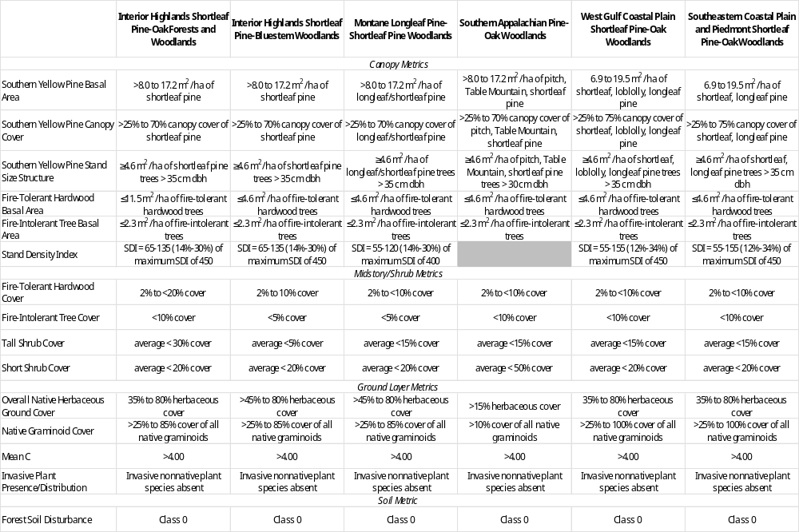

Supplemental Table 3. Listing of ecological subsections within each southern pine open community group, including extent and number of FIA plots within each subsection.

Southern open pine community group | Map unit | Ecological subsection name | Km² | FIA plots
Interior Highlands | 223Aa | St. Francois Knobs and Basins | 4120 | 35
Interior Highlands | 223Ab | Central Plateau | 24292 | 36
Interior Highlands | 223Ad | Gasconade River Hills | 4819 | 29
Interior Highlands | 223Ae | Meramac River Hills | 4571 | 43
Interior Highlands | 223Af | Current River Hills | 8081 | 193
Interior Highlands | 223Ag | White River Hills | 14522 | 100
Interior Highlands | 223Ah | Elk River Hills | 1586 | 1
Interior Highlands | 223Aj | Inner Ozark Border | 5952 | 8
Interior Highlands | 223Al | Black River Ozark Border | 3559 | 52
Interior Highlands | 223An | Springfield Plateau | 11472 | 46
Interior Highlands | 231Ga | Eastern Arkansas Valley and Ridges | 12181 | 112
Interior Highlands | 231Gb | Mount Magazine | 2616 | 38
Interior Highlands | 231Gc | Western Arkansas Valley and Ridges | 10272 | 19
Interior Highlands | M223Aa | Boston Mountains | 4202 | 22
Interior Highlands | M223Ab | Boston Hills | 12725 | 119
Interior Highlands | M231Aa | Fourche Mountains | 8797 | 208
Interior Highlands | M231Ab | West Central Ouachita Mountains | 9167 | 207
Interior Highlands | M231Ac | East Central Ouachita Mountains | 4872 | 98
Interior Highlands | M231Ad | Athens Piedmont Plateau | 6113 | 80
Montane Longleaf Pine-Shortleaf Pine Woodlands | 231Ac | Schist Plains | 10380 | 64
Montane Longleaf Pine-Shortleaf Pine Woodlands | 231Ae | Charlotte Belt | 9687 | 86
Montane Longleaf Pine-Shortleaf Pine Woodlands | 231Af | Carolina Slate | 8810 | 53
Montane Longleaf Pine-Shortleaf Pine Woodlands | 231Ah | Granite Hills | 1261 | 9
Montane Longleaf Pine-Shortleaf Pine Woodlands | 231Ai | Opelika Plateau | 3529 | 15
Montane Longleaf Pine-Shortleaf Pine Woodlands | 231Aj | Mica Rich Plateau | 5995 | 35
Montane Longleaf Pine-Shortleaf Pine Woodlands | 231Da | Chert Valley | 6025 | 28
Montane Longleaf Pine-Shortleaf Pine Woodlands | 231Db | Sandstone-Shale and Chert Ridge | 4058 | 35
Montane Longleaf Pine-Shortleaf Pine Woodlands | 231Dd | Quartzite and Talladega Slate Ridge | 3237 | 28
Montane Longleaf Pine-Shortleaf Pine Woodlands | 231Id | Carolina Slate-North | 13016 | 116
Southeastern Coastal Plain Shortleaf Pine-Oak Woodlands | 231Ba | Black Belt | 16251 | 17
Southeastern Coastal Plain Shortleaf Pine-Oak Woodlands | 231Bb | Interior Flatwoods | 2657 | 3
Southeastern Coastal Plain Shortleaf Pine-Oak Woodlands | 231Bc | Upper Clay Hills | 16224 | 87
Southeastern Coastal Plain Shortleaf Pine-Oak Woodlands | 231Bd | Upper Loam Hills | 26022 | 99
Southeastern Coastal Plain Shortleaf Pine-Oak Woodlands | 231Be | Transition Loam Hills | 3628 | 19
Southeastern Coastal Plain Shortleaf Pine-Oak Woodlands | 231Bf | Floodplains and Terraces | 4120 | 1
Southeastern Coastal Plain Shortleaf Pine-Oak Woodlands | 231Bj | Jackson Hills | 2416 | 17
Southeastern Coastal Plain Shortleaf Pine-Oak Woodlands | 231Bk | Northern Pontotoc Ridge | 5246 | 37
Southeastern Coastal Plain Shortleaf Pine-Oak Woodlands | 231Bl | Jackson Prairie | 1094 | 1
Southeastern Coastal Plain Shortleaf Pine-Oak Woodlands | 231Ha | Deep Loess Hills and Bluffs | 22109 | 34
Southeastern Coastal Plain Shortleaf Pine-Oak Woodlands | 231Hb | Northern Loessial Hills | 20532 | 127
Southeastern Coastal Plain Shortleaf Pine-Oak Woodlands | 231Hc | Deep Loess Plains | 4766 | 4
Southeastern Coastal Plain Shortleaf Pine-Oak Woodlands | 231Hh | Southern Loessial Plains | 9301 | 48
Southeastern Coastal Plain Shortleaf Pine-Oak Woodlands | 231Hi | Delmarva Upland | 2464 | 2
Southeastern Coastal Plain Shortleaf Pine-Oak Woodlands | 232Ba | Fragipan Loam Hills | 12278 | 27
Southeastern Coastal Plain Shortleaf Pine-Oak Woodlands | 232Bc | Cintronelle Plains | 818 | 2
Southeastern Coastal Plain Shortleaf Pine-Oak Woodlands | 232Bg | South Coastal Plains | 10207 | 1
Southeastern Coastal Plain Shortleaf Pine-Oak Woodlands | 232Bh | Gulf Southern Loam Hills | 4948 | 3
Southeastern Coastal Plain Shortleaf Pine-Oak Woodlands | 232Bi | The Plains | 8281 | 3
Southeastern Coastal Plain Shortleaf Pine-Oak Woodlands | 232Bj | Southern Loam Hills | 36196 | 85
Southeastern Coastal Plain Shortleaf Pine-Oak Woodlands | 232Bk | Southern Clay Hills | 4167 | 10
Southeastern Coastal Plain Shortleaf Pine-Oak Woodlands | 232Bl | Lower Loam and Clay Hills | 5865 | 19
Southeastern Coastal Plain Shortleaf Pine-Oak Woodlands | 232Bm | Lower Clay Hills | 14030 | 76
Southeastern Coastal Plain Shortleaf Pine-Oak Woodlands | 232Bn | Lower Loam Hills | 1981 | 7
Southeastern Coastal Plain Shortleaf Pine-Oak Woodlands | 232Bo | Border Sand Hills | 1470 | 5
Southeastern Coastal Plain Shortleaf Pine-Oak Woodlands | 232Bp | Wiregrass Plains | 7783 | 9
Southeastern Coastal Plain Shortleaf Pine-Oak Woodlands | 232Bs | Floodplains and Terraces | 2835 | 3
Southeastern Coastal Plain Shortleaf Pine-Oak Woodlands | 232Ca | Upper Terraces | 30517 | 1
Southeastern Coastal Plain Shortleaf Pine-Oak Woodlands | 232Cb | Lower Terraces | 23153 | 4
Southeastern Coastal Plain Shortleaf Pine-Oak Woodlands | 232Ha | Atlantic Southern Loam Hills | 33242 | 12
Southeastern Coastal Plain Shortleaf Pine-Oak Woodlands | 232Ja | Sand Hills | 21256 | 36
Southeastern Coastal Plain Shortleaf Pine-Oak Woodlands | 232Jb | Northern Loam Plains | 9244 | 2
Southeastern Coastal Plain Shortleaf Pine-Oak Woodlands | 232Jc | Southwestern Loam Hills | 4163 | 2
Southeastern Coastal Plain Shortleaf Pine-Oak Woodlands | 232Jd | Lower Loam Hills | 5845 | 13
Southeastern Coastal Plain Shortleaf Pine-Oak Woodlands | 232Je | Atlantic Southern Loam Hills | 22359 | 5
Southeastern Coastal Plain Shortleaf Pine-Oak Woodlands | 232Jf | Gulf Southern Loam Hills | 16807 | 15
Southeastern Coastal Plain Shortleaf Pine-Oak Woodlands | 232Jg | Floodplains and Terraces | 2694 | 1
Southeastern Coastal Plain Shortleaf Pine-Oak Woodlands | 232La | LA-MS Gulf Coast Flatwoods-Bays and Barrier Islands | 7705 | 3
Southeastern Coastal Plain Shortleaf Pine-Oak Woodlands | 234Da | North Mississippi River Alluvial Plain | 34823 | 1
Southeastern Coastal Plain Shortleaf Pine-Oak Woodlands | 234Db | Crowley's Ridge | 8222 | 8
Southeastern Coastal Plain Shortleaf Pine-Oak Woodlands | 234Do | St. Francis River Alluvial Plain | 4554 | 1
Southern Appalachian Pine-Oak Woodlands | 221De | Northern Piedmont | 5112 | 6
Southern Appalachian Pine-Oak Woodlands | 221Ea | Pittsburg Low Plateau | 38612 | 4
Southern Appalachian Pine-Oak Woodlands | 221Eb | Teays Plateau | 5212 | 5
Southern Appalachian Pine-Oak Woodlands | 221Ec | Ohio Valley Lowland | 10557 | 3
Southern Appalachian Pine-Oak Woodlands | 221Ef | Western Hocking Plateau | 5193 | 1
Southern Appalachian Pine-Oak Woodlands | 221Eg | Lower Scioto River Plateau | 4478 | 1
Southern Appalachian Pine-Oak Woodlands | 221En | Kinniconick and Licking Knobs | 2448 | 1
Southern Appalachian Pine-Oak Woodlands | 221Ha | Rugged Eastern Hills | 7680 | 19
Southern Appalachian Pine-Oak Woodlands | 221Hb | Kinniconick and Licking Knobs | 3604 | 8
Southern Appalachian Pine-Oak Woodlands | 221Hc | Southwestern Escarpment | 12589 | 45
Southern Appalachian Pine-Oak Woodlands | 221Hd | Sequatchie Valley | 1012 | 2
Southern Appalachian Pine-Oak Woodlands | 221He | Miami-Scioto Plain-Tipton Till Plain | 5522 | 18
Southern Appalachian Pine-Oak Woodlands | 221Ja | Rolling Limestone Hills | 11546 | 22
Southern Appalachian Pine-Oak Woodlands | 221Jb | Sandstone Hills | 4623 | 9
Southern Appalachian Pine-Oak Woodlands | 221Jc | Holston Valley | 1880 | 2
Southern Appalachian Pine-Oak Woodlands | 223Dc | Outer Western Coalfields | 9859 | 1
Southern Appalachian Pine-Oak Woodlands | 223Dj | Northern Dripping Springs | 3320 | 1
Southern Appalachian Pine-Oak Woodlands | 223Eb | Eastern Karst Plain | 9484 | 6
Southern Appalachian Pine-Oak Woodlands | 223Ec | Outer Nashville Basin | 11083 | 2
Southern Appalachian Pine-Oak Woodlands | 223Ee | Highland Rim-Hilly and Rolling | 2047 | 2
Southern Appalachian Pine-Oak Woodlands | 223Ef | Tennessee-Gasper Valley | 3289 | 2
Southern Appalachian Pine-Oak Woodlands | 223Eg | Western Pennyroyal Karst Plain | 13980 | 8
Southern Appalachian Pine-Oak Woodlands | 223Fa | Outer Bluegrass | 10995 | 1
Southern Appalachian Pine-Oak Woodlands | 231Aa | Midland Plateau Central Uplands | 30780 | 155
Southern Appalachian Pine-Oak Woodlands | 231Ab | Piedmont Ridge | 2194 | 18
Southern Appalachian Pine-Oak Woodlands | 231Ad | Lower Foot Hills | 4061 | 48
Southern Appalachian Pine-Oak Woodlands | 231Ag | Schist Hills | 2198 | 29
Southern Appalachian Pine-Oak Woodlands | 231Ca | Shale Hills and Mountain | 5588 | 15
Southern Appalachian Pine-Oak Woodlands | 231Cb | Sandstone Plateau | 2767 | 3
Southern Appalachian Pine-Oak Woodlands | 231Cc | Table Plateau | 5220 | 23
Southern Appalachian Pine-Oak Woodlands | 231Cd | Sandstone Mountain | 6480 | 14
Southern Appalachian Pine-Oak Woodlands | 231Cf | Southern Cumberland Valleys | 951 | 5
Southern Appalachian Pine-Oak Woodlands | 231Cg | Sequatchie Valley | 1452 | 8
Southern Appalachian Pine-Oak Woodlands | 231Dc | Sandstone Ridge | 3264 | 30
Southern Appalachian Pine-Oak Woodlands | 231De | Shaley Limestone Valley | 4488 | 24
Southern Appalachian Pine-Oak Woodlands | 231Ia | Midland Plateau Central Uplands-North | 13675 | 65
Southern Appalachian Pine-Oak Woodlands | 231Ib | Lynchburg Belt | 9620 | 32
Southern Appalachian Pine-Oak Woodlands | 231Ic | Charlotte Belt-North | 39364 | 171
Southern Appalachian Pine-Oak Woodlands | 231Ie | Southern Triassic Uplands | 4791 | 21
Southern Appalachian Pine-Oak Woodlands | 231If | Western Coastal Plain-Piedmont Transition | 3276 | 5
Southern Appalachian Pine-Oak Woodlands | 231Ig | Triassic Uplands | 1224 | 3
Southern Appalachian Pine-Oak Woodlands | M221Aa | Ridge and Valley | 18294 | 17
Southern Appalachian Pine-Oak Woodlands | M221Ab | Great Valley of Virginia | 13559 | 2
Southern Appalachian Pine-Oak Woodlands | M221Ac | Northern Ridge and Valley | 30512 | 2
Southern Appalachian Pine-Oak Woodlands | M221Ba | Northern High Allegheny Mountain | 2435 | 1
Southern Appalachian Pine-Oak Woodlands | M221Bd | Eastern Allegheny Mountain and Valley | 1866 | 4
Southern Appalachian Pine-Oak Woodlands | M221Ca | Western Coal Fields | 14757 | 10
Southern Appalachian Pine-Oak Woodlands | M221Cc | Black Mountains | 3097 | 2
Southern Appalachian Pine-Oak Woodlands | M221Cd | Southern Cumberland Mountains | 2595 | 2
Southern Appalachian Pine-Oak Woodlands | M221Ce | Pine and Cumberland Mountains | 916 | 1
Southern Appalachian Pine-Oak Woodlands | M221Da | Northern Blue Ridge Mountains | 6594 | 3
Southern Appalachian Pine-Oak Woodlands | M221Dc | Southern Blue Ridge Mountains | 21417 | 107
Southern Appalachian Pine-Oak Woodlands | M221Dd | Metasedimentary Mountains | 11416 | 91
West Gulf Coastal Plain Shortleaf Pine-Oak Woodlands | 231Ea | South Central Arkansas | 37324 | 162
West Gulf Coastal Plain Shortleaf Pine-Oak Woodlands | 231Eb | Southwestern Arkansas | 6780 | 21
West Gulf Coastal Plain Shortleaf Pine-Oak Woodlands | 231Ec | Ouachita Alluvial Valleys | 3681 | 3
West Gulf Coastal Plain Shortleaf Pine-Oak Woodlands | 231Ee | Southern Oklahoma Subsection | 2736 | 10
West Gulf Coastal Plain Shortleaf Pine-Oak Woodlands | 231Ef | Piney Woods Transition | 2826 | 50
West Gulf Coastal Plain Shortleaf Pine-Oak Woodlands | 231Eg | Sand Hills | 20430 | 169
West Gulf Coastal Plain Shortleaf Pine-Oak Woodlands | 231Ej | South Central Arkansas Flatwoods | 5289 | 10
West Gulf Coastal Plain Shortleaf Pine-Oak Woodlands | 231Ek | Southwestern Arkansas Blackland Prairies | 2159 | 8
West Gulf Coastal Plain Shortleaf Pine-Oak Woodlands | 231Eo | Red River Alluvial Plain | 10198 | 10
West Gulf Coastal Plain Shortleaf Pine-Oak Woodlands | 232Fa | Southern Loam Hills | 25830 | 115
West Gulf Coastal Plain Shortleaf Pine-Oak Woodlands | 232Fb | Southwest Flatwoods | 13829 | 10
West Gulf Coastal Plain Shortleaf Pine-Oak Woodlands | 232Fc | Sabine Alluvial Valley | 2641 | 5
West Gulf Coastal Plain Shortleaf Pine-Oak Woodlands | 232Fe | Piney Woods Transition | 7326 | 77
West Gulf Coastal Plain Shortleaf Pine-Oak Woodlands | 232Ff | Red River Alluvial Plain | 2270 | 2
West Gulf Coastal Plain Shortleaf Pine-Oak Woodlands | 234Aa | Southern Mississippi River Alluvial Plain | 20139 | 5
West Gulf Coastal Plain Shortleaf Pine-Oak Woodlands | 255Ad | Southern Oklahoma Grand Prairie | 7939 | 1
West Gulf Coastal Plain Shortleaf Pine-Oak Woodlands | 255Ba | Blackland Prairie | 35168 | 3
West Gulf Coastal Plain Shortleaf Pine-Oak Woodlands | 255Ca | Texas Claypan Savannah | 27397 | 9
West Gulf Coastal Plain Shortleaf Pine-Oak Woodlands | 255Ce | Trinity Alluvial Valley | 1935 | 5
West Gulf Coastal Plain Shortleaf Pine-Oak Woodlands | 255Ch | East Texas Timberlands-Cross Timbers | 7960 | 23
West Gulf Coastal Plain Shortleaf Pine-Oak Woodlands | 255Da | Texas Coastal Prairie | 19971 | 1
West Gulf Coastal Plain Shortleaf Pine-Oak Woodlands | 255Dd | Southern Texas Coastal Prairie and Savannah | 9143 | 1

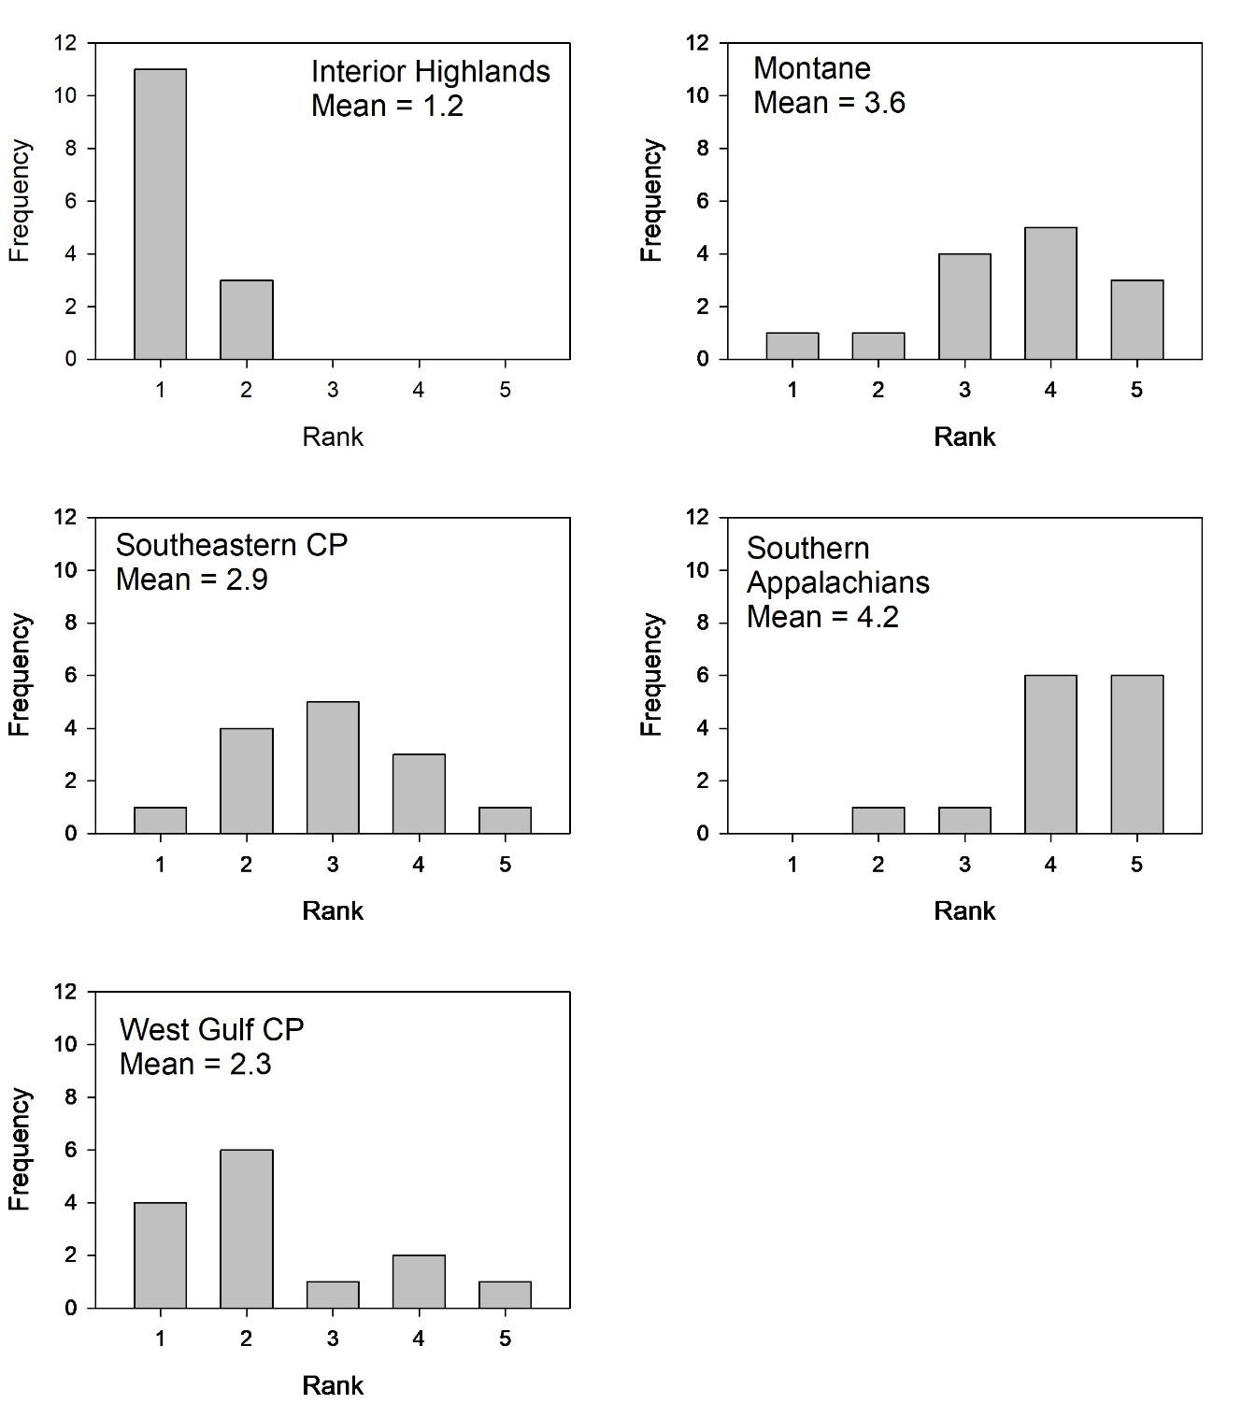

Supplemental Figure 1. Histograms of frequency in rankings of shortleaf pine natural community groups from regional assessment. Co-authors independently scored favorability for shortleaf pine management in relation to seven factors for each natural community group. Mean scores of the seven factors were calculated for each natural community group and ranked, with a rank of 1 being the highest mean score and a rank of 5 being the lowest score.

