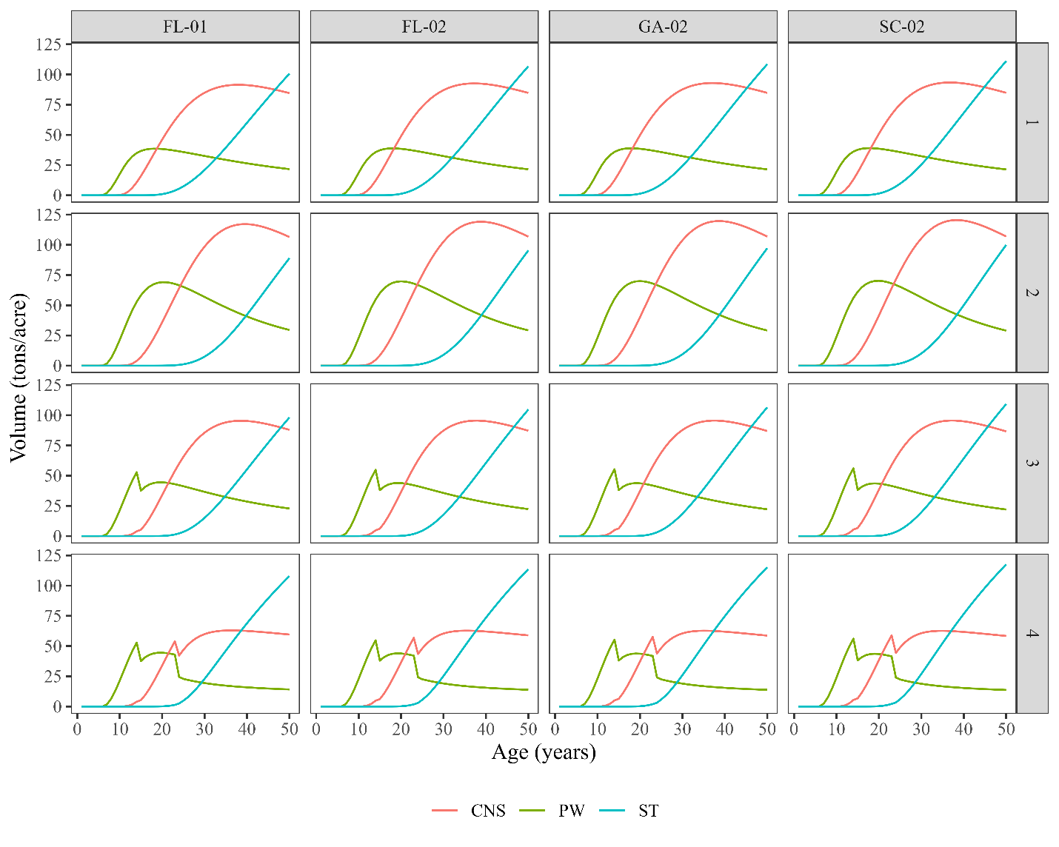
Figure 1C. Product yield curves for each treatment and region. North Florida (FL-01 and FL-02), east South Carolina (SC-02) and South Georgia (GA-02). The treatment descriptions are in Table 2.

Figure 2C. Bootstrap simulation of the land expectation value (LEV - $/acre at 4% discount rate) by silvicultural treatment (Table 2 - 1 to 4), market (FL-01, FL-02, GA-02, SC-02) and pulpwood price scenario (Historical Prices, PW = 0, PW = $\hat{PW}/2$). North Florida (FL-01 and FL-02), east South Carolina (SC-02) and south Georgia (GA-02).

