Historical trends of market coverage and competition of various wood products in Michigan
Appendices
Appendix Table A1. Sensitivity analysis of total forested market coverage area (million acres) under ±20% stumpage price scenarios across five competition levels for each wood product and study year. Percentage changes in overall market coverage are calculated relative to the base stumpage price scenario. A dash (-) indicates no forested area was mapped within that competition level under the given price scenario. Values reported for the +20% stumpage price scenario for hardwood sawlogs (2003 and 2018), softwood sawlogs (2003), and Pulpwood 2018 are not available (-) because the estimated maximum haul time under the base scenario already reached or exceeded the 300-minute ArcGIS Pro Network Analyst threshold; increasing stumpage price further reduces the available transportation budget and therefore further contracts the procurement zone, while the capped base value cannot be extended. For these cases, the −20% scenario provides a lower bound estimate.
Wood Products | Year | Competition Level |  | -20% Stumpage Price (million acres) | Base Stumpage Price (million acres) | +20% Stumpage Price (million acres) | % Change
Wood Products | Year | Competition Level |  | -20% Stumpage Price (million acres) | Base Stumpage Price (million acres) | +20% Stumpage Price (million acres) | % Change (−20% Scenario) |  | % Change (+20% Scenario)
Hardwood Sawlogs | 1985 | 1- Lowest |  | 10.52 | 6.97 | 2.28 | -0.01 | 0.11
Hardwood Sawlogs | 1985 | 2- Low |  | 6.46 | 6.91 | 6.39 | -0.01
Hardwood Sawlogs | 1985 | 3- Medium |  | 0.14 | 3.25 | 4.14 | -0.01
Hardwood Sawlogs | 1985 | 4- High |  | - | 0.00 | 3.75 | -0.01
Hardwood Sawlogs | 1985 | 5- Highest |  | - | - | 0.59 | -0.01
Hardwood Sawlogs | 1985 | Total |  | 17.12 | 17.12 | 17.14 | -0.01
Hardwood Sawlogs | 1994 | 1- Lowest |  | 7.51 | 1.58 | 0.19 | -0.12 | 0.00
Hardwood Sawlogs | 1994 | 2- Low |  | 3.99 | 6.01 | 4.96 | -0.12
Hardwood Sawlogs | 1994 | 3- Medium |  | 4.59 | 2.48 | 1.71 | -0.12
Hardwood Sawlogs | 1994 | 4- High |  | 1.88 | 4.31 | 2.16 | -0.12
Hardwood Sawlogs | 1994 | 5- Highest |  | - | 3.61 | 8.97 | -0.12
Hardwood Sawlogs | 1994 | Total |  | 17.97 | 17.99 | 17.99 | -0.12
Hardwood Sawlogs | 2003 | 1- Lowest |  | 1.27 | 0.40 | - | -3.62 | -
Hardwood Sawlogs | 2003 | 2- Low |  | 4.71 | 5.12 | - | -3.62
Hardwood Sawlogs | 2003 | 3- Medium |  | 1.34 | 0.77 | - | -3.62
Hardwood Sawlogs | 2003 | 4- High |  | 3.92 | 1.55 | - | -3.62
Hardwood Sawlogs | 2003 | 5- Highest |  | 7.63 | 11.76 | - | -3.62
Hardwood Sawlogs | 2003 | Total |  | 18.88 | 19.59 | - | -3.62
Hardwood Sawlogs | 2018 | 1- Lowest |  | 5.33 | 3.55 | - | -3.11 | -
Hardwood Sawlogs | 2018 | 2- Low |  | 1.77 | 1.98 | - | -3.11
Hardwood Sawlogs | 2018 | 3- Medium |  | 1.04 | 1.34 | - | -3.11
Hardwood Sawlogs | 2018 | 4- High |  | 2.15 | 0.95 | - | -3.11
Hardwood Sawlogs | 2018 | 5- Highest |  | 9.17 | 12.26 | - | -3.11
Hardwood Sawlogs | 2018 | Total |  | 19.46 | 20.08 | - | -3.11
Hardwood Sawlogs | 2023 | 1- Lowest |  | 8.83 | 7.88 | 5.64 | -0.32 | 0.69
Hardwood Sawlogs | 2023 | 2- Low |  | 2.35 | 1.28 | 1.36 | -0.32
Hardwood Sawlogs | 2023 | 3- Medium |  | 4.66 | 1.81 | 1.11 | -0.32
Hardwood Sawlogs | 2023 | 4- High |  | 4.30 | 6.67 | 2.05 | -0.32
Hardwood Sawlogs | 2023 | 5- Highest |  | 0.10 | 2.65 | 10.27 | -0.32
Hardwood Sawlogs | 2023 | Total |  | 20.23 | 20.30 | 20.44 | -0.32
Softwood Sawlogs | 1985 | 1- Lowest |  | 1.84 | 0.56 | 0.22 | -0.01 | 0.02
Softwood Sawlogs | 1985 | 2- Low |  | 4.16 | 2.71 | 1.40 | -0.01
Softwood Sawlogs | 1985 | 3- Medium |  | 3.43 | 2.57 | 1.66 | -0.01
Softwood Sawlogs | 1985 | 4- High |  | 3.38 | 3.70 | 2.46 | -0.01
Softwood Sawlogs | 1985 | 5- Highest |  | 4.31 | 7.58 | 11.38 | -0.01
Softwood Sawlogs | 1985 | Total |  | 17.12 | 17.12 | 17.13 | -0.01
Softwood Sawlogs | 1994 | 1- Lowest |  | 0.96 | 0.24 | 0.05 | -0.10 | 0.00
Softwood Sawlogs | 1994 | 2- Low |  | 3.08 | 1.35 | 0.56 | -0.10
Softwood Sawlogs | 1994 | 3- Medium |  | 4.07 | 2.26 | 0.87 | -0.10
Softwood Sawlogs | 1994 | 4- High |  | 2.90 | 4.38 | 3.92 | -0.10
Softwood Sawlogs | 1994 | 5- Highest |  | 6.96 | 9.76 | 12.59 | -0.10
Softwood Sawlogs | 1994 | Total |  | 17.97 | 17.99 | 17.99 | -0.10
Softwood Sawlogs | 2003 | 1- Lowest |  | 0.03 | 0.00 | - | -3.02 | -
Softwood Sawlogs | 2003 | 2- Low |  | 0.09 | 0.00 | - | -3.02
Softwood Sawlogs | 2003 | 3- Medium |  | 0.53 | 0.02 | - | -3.02
Softwood Sawlogs | 2003 | 4- High |  | 4.03 | 2.67 | - | -3.02
Softwood Sawlogs | 2003 | 5- Highest |  | 14.20 | 16.78 | - | -3.02
Softwood Sawlogs | 2003 | Total |  | 18.88 | 19.47 | - | -3.02
Softwood Sawlogs | 2018 | 1- Lowest |  | 0.65 | 0.73 | 0.01 | -0.65 | 0.00
Softwood Sawlogs | 2018 | 2- Low |  | 5.92 | 5.58 | 3.43 | -0.65
Softwood Sawlogs | 2018 | 3- Medium |  | 1.21 | 1.06 | 1.35 | -0.65
Softwood Sawlogs | 2018 | 4- High |  | 1.11 | 0.28 | 0.60 | -0.65
Softwood Sawlogs | 2018 | 5- Highest |  | 11.18 | 12.56 | 14.82 | -0.65
Softwood Sawlogs | 2018 | Total |  | 20.07 | 20.20 | 20.20 | -0.65
Softwood Sawlogs | 2023 | 1- Lowest |  | 8.62 | 6.81 | 2.26 | -2.31 | 0.28
Softwood Sawlogs | 2023 | 2- Low |  | 5.40 | 4.98 | 5.81 | -2.31
Softwood Sawlogs | 2023 | 3- Medium |  | 2.62 | 3.10 | 1.57 | -2.31
Softwood Sawlogs | 2023 | 4- High |  | 2.89 | 2.77 | 2.12 | -2.31
Softwood Sawlogs | 2023 | 5- Highest |  | 0.27 | 2.60 | 8.55 | -2.31
Softwood Sawlogs | 2023 | Total |  | 19.80 | 20.26 | 20.32 | -2.31
Pulpwood and Chips | 1985 | 1- Lowest |  | 4.67 | 7.32 | 8.17 | -48.90 | 27.61
Pulpwood and Chips | 1985 | 2- Low |  | 0.45 | 2.66 | 4.53 | -48.90
Pulpwood and Chips | 1985 | 3- Medium |  | - | 0.06 | 1.16 | -48.90
Pulpwood and Chips | 1985 | 4- High |  | - | - | - | -48.90
Pulpwood and Chips | 1985 | 5- Highest |  | - | - | - | -48.90
Pulpwood and Chips | 1985 | Total |  | 5.13 | 10.04 | 13.87 | -48.90
Pulpwood and Chips | 1994 | 1- Lowest |  | 7.64 | 8.61 | 5.05 | -27.32 | 14.33
Pulpwood and Chips | 1994 | 2- Low |  | 2.86 | 5.84 | 11.49 | -27.32
Pulpwood and Chips | 1994 | 3- Medium |  | - | - | 0.33 | -27.32
Pulpwood and Chips | 1994 | 4- High |  | - | - | - | -27.32
Pulpwood and Chips | 1994 | 5- Highest |  | - | - | - | -27.32
Pulpwood and Chips | 1994 | Total |  | 10.50 | 14.45 | 16.86 | -27.32
Pulpwood and Chips | 2003 | 1- Lowest |  | 7.54 | 3.47 | 0.14 | -9.45 | 4.25
Pulpwood and Chips | 2003 | 2- Low |  | 7.16 | 10.22 | 10.13 | -9.45
Pulpwood and Chips | 2003 | 3- Medium |  | 2.18 | 4.95 | 9.20 | -9.45
Pulpwood and Chips | 2003 | 4- High |  | - | - | - | -9.45
Pulpwood and Chips | 2003 | 5- Highest |  | - | - | - | -9.45
Pulpwood and Chips | 2003 | Total |  | 16.88 | 18.64 | 19.46 | -9.45
Pulpwood and Chips | 2018 | 1- Lowest |  | 9.24 | 6.52 | - | -5.56 | -
Pulpwood and Chips | 2018 | 2- Low |  | 9.72 | 13.56 | - | -5.56
Pulpwood and Chips | 2018 | 3- Medium |  | - | - | - | -5.56
Pulpwood and Chips | 2018 | 4- High |  | - | - | - | -5.56
Pulpwood and Chips | 2018 | 5- Highest |  | - | - | - | -5.56
Pulpwood and Chips | 2018 | Total |  | 18.96 | 20.08 | - | -5.56
Pulpwood and Chips | 2023 | 1- Lowest |  | 0.80 | 0.49 | 0.00 | -13.22 | 1.87
Pulpwood and Chips | 2023 | 2- Low |  | 11.67 | 11.77 | 5.00 | -13.22
Pulpwood and Chips | 2023 | 3- Medium |  | 4.92 | 7.60 | 11.22 | -13.22
Pulpwood and Chips | 2023 | 4- High |  | 0.01 | 0.20 | 4.21 | -13.22
Pulpwood and Chips | 2023 | 5- Highest |  | - | - | - | -13.22
Pulpwood and Chips | 2023 | Total |  | 17.40 | 20.05 | 20.44 | -13.22
Biomass Chips & Residues | 1985 | 1- Lowest |  | 0.08 | 0.48 | 1.45 | -82.85 | 66.89
Biomass Chips & Residues | 1985 | 2- Low |  | - | - | - | -82.85
Biomass Chips & Residues | 1985 | 3- Medium |  | - | - | - | -82.85
Biomass Chips & Residues | 1985 | 4- High |  | - | - | - | -82.85
Biomass Chips & Residues | 1985 | 5- Highest |  | - | - | - | -82.85
Biomass Chips & Residues | 1985 | Total |  | 0.08 | 0.48 | 1.45 | -82.85
Biomass Chips & Residues | 1994 | 1- Lowest |  | 1.63 | 3.44 | 3.66 | -59.04 | 30.64
Biomass Chips & Residues | 1994 | 2- Low |  | 0.00 | 0.54 | 2.08 | -59.04
Biomass Chips & Residues | 1994 | 3- Medium |  | - | - | - | -59.04
Biomass Chips & Residues | 1994 | 4- High |  | - | - | - | -59.04
Biomass Chips & Residues | 1994 | 5- Highest |  | - | - | - | -59.04
Biomass Chips & Residues | 1994 | Total |  | 1.63 | 3.98 | 5.74 | -59.04
Biomass Chips & Residues | 2003 | 1- Lowest |  | 1.53 | 0.45 | 1.11 | -14.47 | 21.99
Biomass Chips & Residues | 2003 | 2- Low |  | 5.05 | 5.76 | 4.15 | -14.47
Biomass Chips & Residues | 2003 | 3- Medium |  | 0.14 | 1.66 | 4.82 | -14.47
Biomass Chips & Residues | 2003 | 4- High |  | - | - | - | -14.47
Biomass Chips & Residues | 2003 | 5- Highest |  | - | - | - | -14.47
Biomass Chips & Residues | 2003 | Total |  | 6.72 | 7.86 | 10.08 | -14.47
Biomass Chips & Residues | 2018 | 1- Lowest |  | 5.41 | 7.09 | 7.66 | -18.24 | 10.33
Biomass Chips & Residues | 2018 | 2- Low |  | 4.32 | 2.31 | 2.15 | -18.24
Biomass Chips & Residues | 2018 | 3- Medium |  | 2.50 | 3.60 | 3.27 | -18.24
Biomass Chips & Residues | 2018 | 4- High |  | 0.48 | 2.53 | 4.24 | -18.24
Biomass Chips & Residues | 2018 | 5- Highest |  | - | - | - | -18.24
Biomass Chips & Residues | 2018 | Total |  | 12.70 | 15.53 | 17.32 | -18.24
Biomass Chips & Residues | 2023 | 1- Lowest |  | 7.39 | 8.39 | 7.84 | -34.93 | 25.05
Biomass Chips & Residues | 2023 | 2- Low |  | 1.00 | 4.51 | 9.27 | -34.93
Biomass Chips & Residues | 2023 | 3- Medium |  | - | - | 0.10 | -34.93
Biomass Chips & Residues | 2023 | 4- High |  | - | - | - | -34.93
Biomass Chips & Residues | 2023 | 5- Highest |  | - | - | - | -34.93
Biomass Chips & Residues | 2023 | Total |  | 8.39 | 12.90 | 17.21 | -34.93

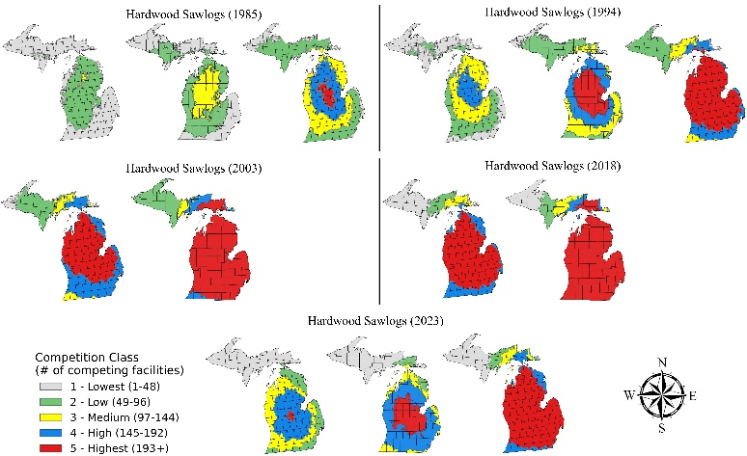 | 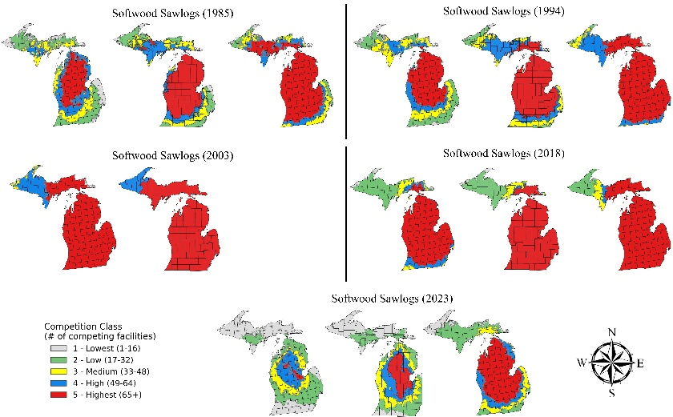
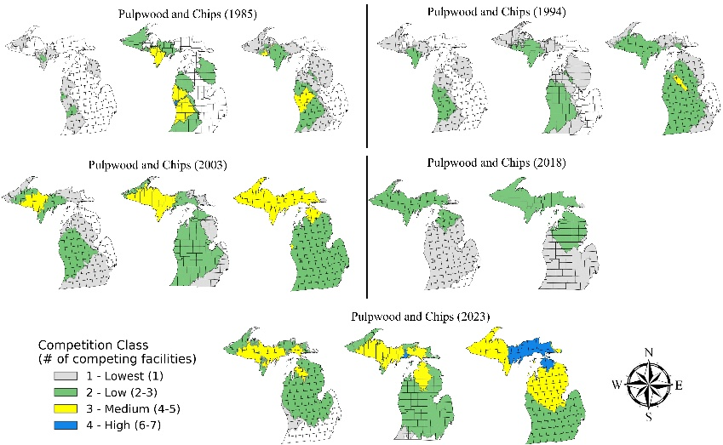 | 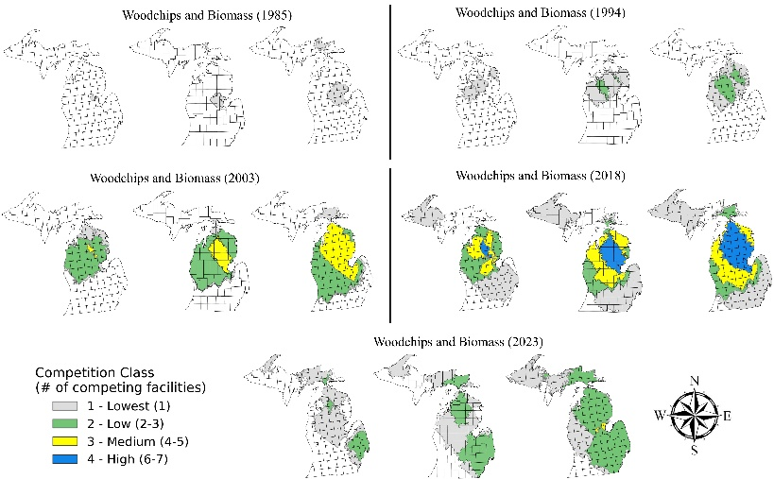

Appendix Figure A1. Spatial distribution of competition hotspots for hardwood sawlogs, softwood sawlogs, pulpwood and chips, and Biomass chips and residues under ±20% stumpage price sensitivity scenarios across all study years (1985, 1994, 2003, 2018, and 2023) in Michigan. For each product-year combination, the left map shows the competition hotspot distribution under a −20% stumpage price scenario, the center map shows the base analysis result, and the right map shows the +20% stumpage price scenario. Competition levels are classified from 1 (Lowest) to 5 (Highest), representing the number of overlapping mill procurement zones at any given location. An absence of map indicates no mapped market coverage under that scenario. Maps for hardwood sawlogs (2003 and 2018), softwood sawlogs (2003), and Pulpwood 2018 do not include a +20% scenario map as the estimated haul time under the base scenario reached the 300-minute maximum threshold in ArcGIS Pro Network Analyst. The Upper Peninsula (UP) and Lower Peninsula (LP) of Michigan are shown in each map panel.

