Table S1 Summary of biological variables and soil soluble C and N (mean ± s.e.) across litter and watering treatments for each focal plant species.
 | Microlaena stipoides |  |  |  | Plantago lanceolata
 | Drought without litter | Drought with litter | Ambient without litter | Ambient with litter | Drought without litter | Drought with litter | Ambient without litter | Ambient with litter
Plant total biomass (g) | 0.47±0.03 | 0.65±0.08 | 0.61±0.1 | 0.7±0.16 | 0.42±0.04 | 0.5±0.06 | 0.42±0.1 | 0.75±0.21
Plant shoot biomass (g) | 0.38±0.02 | 0.49±0.08 | 0.47±0.07 | 0.65±0.16 | 0.36±0.03 | 0.44±0.05 | 0.35±0.08 | 0.59±0.15
Plant root biomass (g) | 0.09±0.02 | 0.16±0.01 | 0.16±0.03 | 0.05±0.01 | 0.07±0 | 0.06±0.01 | 0.07±0.02 | 0.16±0.06
Root to shoot ratio (-) | 0.25±0.07 | 0.35±0.06 | 0.34±0.04 | 0.09±0.02 | 0.19±0.02 | 0.12±0.02 | 0.19±0.03 | 0.27±0.05
Soluble C (mg kg⁻¹) | 342.0±24.4 | 288.3±14.1 | 331.0±29.0 | 317.0±16.5 | 316.0±15.2 | 374.4±45.7 | 330.1±8.6 | 365.2±27.2
Soluble N (mg kg⁻¹) | 91.3±11.4 | 74.9±2.6 | 79.0±4.7 | 74.5±1.8 | 81.1±8.2 | 77.0±1.7 | 74.6±1.3 | 85.9±5.2
Soluble C:N ratio (-) | 3.8±0.5 | 3.8±0.2 | 4.2±0.5 | 4.3±0.2 | 4.0±0.4 | 4.8±0.6 | 4.4±0.1 | 4.3±0.3
Microbial C (mg kg⁻¹) | 665.0±52.3 | 704.5±68.6 | 820.0±41.9 | 925.6±107.9 | 738.8±134.2 | 776.9±66.2 | 857.2±80.2 | 1196.6±96.01
Microbial N (mg kg⁻¹) | 50.3±9.4 | 52.3±5.5 | 90.1±3.9 | 80.6±5.2 | 56.1±7.6 | 70.8±2.2 | 80.5±8.6 | 83.3±12.9
Microbial C:N ratio (-) | 15.41±4.06 | 13.71±1.21 | 9.16±0.63 | 11.64±1.51 | 13.39±2.51 | 11±0.99 | 10.85±1.03 | 14.91±1.52
Gram positive (μg g⁻¹) | 0.97±0.07 | 1.64±0.05 | 0.53±0.12 | 1.66±0.02 | 1.01±0.07 | 0.76±0.06 | 0.9±0.05 | 0.59±0.09
Gram negative (μg g⁻¹) | 1.26±0.13 | 2.54±0.07 | 0.62±0.16 | 2.74±0.13 | 1.6±0.22 | 0.73±0.07 | 1±0.17 | 1.04±0.23
Actinobacteria (μg g⁻¹) | 0.49±0.03 | 0.8±0.03 | 0.3±0.04 | 0.78±0.02 | 0.5±0.05 | 0.42±0.02 | 0.44±0.03 | 0.31±0.04
Protozoa (μg g⁻¹) | 0.06±0.02 | 0.18±0 | 0.02±0.01 | 0.22±0.05 | 0.11±0.04 | 0.03±0 | 0.04±0.01 | 0.04±0.01
Fungi (μg g⁻¹) | 0.15±0.01 | 0.25±0.01 | 0.06±0.01 | 0.31±0.11 | 0.13±0.02 | 0.07±0 | 0.1±0.02 | 0.11±0.02
Arbuscular mycorrhizae (μg g⁻¹) | 0.08±0.04 | 0.6±0.03 | 0.03±0.02 | 0.35±0.06 | 0.6±0.1 | 0.16±0.1 | 0.1±0.08 | 0.07±0.06
Litter mass loss (%) | - | 83±2.29 | - | 73±3.5 | - | 92±1.92 | - | 79±2

Table S2 Summary of fatty acid biomarkers (mean ± s.e.) across litter and watering treatments for each focal plant species.
 | Fatty acid biomarker | Microlaena stipoides |  |  |  | Plantago lanceolata
 | Fatty acid biomarker | Drought without litter | Drought with litter | Ambient without litter | Ambient with litter | Drought without litter | Drought with litter | Ambient without litter | Ambient with litter
Gram positive (μg g⁻¹) | 15:0 anteiso | 0.19±0.02 | 0.36±0.02 | 0.08±0.02 | 0.32±0.01 | 0.19±0.03 | 0.12±0.02 | 0.19±0.02 | 0.1±0.02
Gram positive (μg g⁻¹) | 15:0 iso | 0.37±0.04 | 0.51±0.08 | 0.29±0.09 | 0.63±0.02 | 0.32±0.04 | 0.23±0.04 | 0.36±0.05 | 0.16±0.03
Gram positive (μg g⁻¹) | 16:0 anteiso | 0.01±0 | 0.01±0 | 0 | 0.02±0 | 0.01±0 | 0.01±0 | 0.01±0 | 0.01±0
Gram positive (μg g⁻¹) | 16:0 iso | 0.24±0.01 | 0.36±0.02 | 0.09±0.04 | 0.35±0.03 | 0.27±0.03 | 0.14±0.05 | 0.18±0.03 | 0.21±0.07
Gram positive (μg g⁻¹) | 17:0 anteiso | 0.08±0.02 | 0.2±0.01 | 0.04±0.02 | 0.18±0.01 | 0.12±0.03 | 0.12±0.02 | 0.09±0.02 | 0.06±0.01
Gram positive (μg g⁻¹) | 17:0 iso | 0.08±0.02 | 0.2±0.01 | 0.04±0.02 | 0.17±0.01 | 0.11±0.04 | 0.13±0.03 | 0.08±0.02 | 0.06±0.01
Gram negative (μg g⁻¹) | 17:0 cyclo ω7c | 0.07±0.02 | 0.16±0.01 | 0.05±0.02 | 0.16±0.02 | 0.13±0.02 | 0.07±0.02 | 0.07±0.01 | 0.04±0.01
Gram negative (μg g⁻¹) | 18:1 ω7c | 0.23±0.07 | 0.7±0.08 | 0.07±0.04 | 0.62±0.02 | 0.49±0.06 | 0.19±0.03 | 0.19±0.05 | 0.25±0.06
Gram negative (μg g⁻¹) | 18:1 ω9c | 0.42±0.04 | 0.71±0.08 | 0.14±0.07 | 0.87±0.09 | 0.47±0.09 | 0.29±0.04 | 0.34±0.06 | 0.32±0.07
Gram negative (μg g⁻¹) | 19:0 cyclo ω7c | 0.54±0.1 | 0.97±0.06 | 0.36±0.08 | 1.1±0.04 | 0.51±0.15 | 0.18±0.06 | 0.41±0.07 | 0.43±0.12
Actinobacteria (μg g⁻¹) | 16:0 10-methyl | 0.25±0.02 | 0.43±0.04 | 0.08±0.05 | 0.45±0.01 | 0.23±0.04 | 0.17±0.03 | 0.24±0.02 | 0.17±0.03
Actinobacteria (μg g⁻¹) | 17:0 10-methyl | 0.04±0.01 | 0.07±0.01 | 0.02±0.01 | 0.06±0 | 0.06±0.01 | 0.06±0.01 | 0.04±0 | 0.02±0
Actinobacteria (μg g⁻¹) | 18:0 10-methyl | 0.2±0.01 | 0.29±0.03 | 0.2±0.04 | 0.26±0.02 | 0.21±0.02 | 0.19±0.04 | 0.17±0.02 | 0.12±0.03
Protozoa (μg g⁻¹) | 20:2 ω6c | 0 | 0.09±0 | 0 | 0.12±0 | 0.06±0.04 | 0 | 0 | 0.03±0
Protozoa (μg g⁻¹) | 20:3 ω6c | 0.03±0.01 | 0.06±0 | 0.01±0 | 0.05±0 | 0.04±0.01 | 0.01±0 | 0.02±0.01 | 0.01±0
Protozoa (μg g⁻¹) | 20:4 ω6c | 0.04±0.01 | 0.08±0.03 | 0.02±0.01 | 0.09±0.02 | 0.03±0.01 | 0.02±0 | 0.02±0.01 | 0.03±0.01
Protozoa (μg g⁻¹) | 20:5 ω3c | 0.01±0 | 0.02±0 | 0.01±0 | 0.05±0.02 | 0.01±0 | 0.01±0 | 0.01±0 | 0
Fungi (μg g⁻¹) | 18:2 ω6c | 0.15±0.01 | 0.25±0.01 | 0.06±0.01 | 0.31±0.11 | 0.13±0.02 | 0.07±0 | 0.1±0.02 | 0.11±0.02
Arbuscular mycorrhizae (μg g⁻¹) | 16:1 ω5c | 0.08±0.04 | 0.6±0.03 | 0.03±0.02 | 0.35±0.06 | 0.6±0.1 | 0.16±0.1 | 0.1±0.08 | 0.07±0.06

Table S3 Test statistics for three-way ANOVAs for explanatory variables with litter presence, watering treatments, and plant species interactions. Asterix * indicates significant relationships (p<0.05).
 | F_{x,y} | Litter presence |  | Plant species |  | Water treatment |  | Litter presence * Plant species |  | Litter presence * Water treatment |  | Plant species * Water treatment |  | Litter presence * Water treatment * Plant species
 | F_{x,y} | F value | Pr(>P) | F value | Pr(>P) | F value | Pr(>P) | F value | Pr(>P) | F value | Pr(>P) | F value | Pr(>P) | F value | Pr(>P)
Plant total biomass | 1,24 | 3.73 | 0.06 | 1.57 | 0.22 | 1.35 | 0.26 | 0.31 | 0.586 | 0.11 | 0.746 | 0.01 | 0.97 | 1.41 | 0.25
Plant shoot biomass | 1,24 | 4.80 | <0.05* | 0.98 | 0.33 | 1.41 | 0.25 | 0.07 | 0.799 | 0.42 | 0.525 | 0.20 | 0.66 | 0.18 | 0.68
Plant root biomass | 1,24 | 0.04 | 0.84 | 2.56 | 0.12 | 0.38 | 0.55 | 2.59 | 0.121 | 0.99 | 0.33 | 4.11 | 0.06 | 14.90 | <0.05*
Root to shoot ratio | 1,24 | 1.38 | 0.25 | 4.30 | <0.05* | 0.05 | 0.82 | 1.65 | 0.21 | 2.51 | 0.13 | 6.34 | <0.05* | 16.60 | <0.05*
Soluble C | 1,24 | 0.08 | 0.78 | 2.35 | 0.14 | 0.16 | 0.70 | 5.10 | 0.034 | 0.09 | 0.77 | 0.02 | 0.89 | 0.82 | 0.37
Soluble N | 1,24 | 0.64 | 0.43 | 0.01 | 0.98 | 0.34 | 0.56 | 3.21 | 0.086 | 2.78 | 0.109 | 0.86 | 0.36 | 0.06 | 0.81
Soluble C:N ratio | 1,24 | 0.45 | 0.51 | 1.49 | 0.24 | 0.27 | 0.61 | 0.48 | 0.493 | 0.82 | 0.375 | 0.72 | 0.40 | 1.05 | 0.32
Microbial C | 1,24 | 4.64 | <0.05* | 3.51 | 0.07 | 14.19 | <0.05* | 0.92 | 0.35 | 2.29 | 0.14 | 0.45 | 0.51 | 0.94 | 0.34
Microbial N | 1,24 | 0.21 | 0.65 | 0.66 | 0.43 | 23.71 | <0.05* | 1.35 | 0.26 | 1.18 | 0.29 | 2.11 | 0.16 | 0.01 | 0.98
Microbial C:N ratio | 1,24 | 0.19 | 0.66 | 0.01 | 0.97 | 1.54 | 0.23 | 0.02 | 0.87 | 3.60 | 0.07 | 3.01 | 0.1 | 0.16 | 0.68
Gram positive | 1,24 | 21.16 | <0.05* | 31.97 | <0.05* | 12.26 | <0.05* | 97.67 | <0.05* | 3.53 | 0.072 | 0.77 | 0.388 | 7.36 | <0.05*
Gram negative | 1,24 | 21.45 | <0.05* | 25.00 | <0.05* | 3.74 | 0.07 | 71.99 | <0.05* | 15.70 | <0.05* | 0.66 | 0.42 | 0.01 | 0.96
Actinobacteria | 1,24 | 25.28 | <0.05* | 37.93 | <0.05* | 17.04 | <0.05* | 92.87 | <0.05* | 1.64 | 0.213 | 0.29 | 0.60 | 7.37 | <0.05*
Protozoa | 1,24 | 16.75 | <0.05* | 18.45 | <0.05* | 2.51 | 0.13 | 51.10 | <0.05* | 9.38 | <0.05* | 0.34 | 0.56 | 0.34 | 0.57
Fungi | 1,24 | 10.15 | <0.05* | 13.90 | <0.05* | 0.81 | 0.38 | 19.94 | <0.05* | 7.22 | <0.05* | 1.21 | 0.28 | 0.47 | 0.50
Arbuscular mycorrhizae | 1,24 | 4.93 | <0.05* | 0.34 | 0.57 | 16.28 | <0.05* | 35.42 | <0.05* | 1.92 | 0.178 | 1.78 | 0.19 | 3.01 | 0.10
Litter mass loss | 1,12 |  |  | 29.66 | <0.05* | 8.73 | <0.05* |  |  |  |  | 0.5 | 0.49

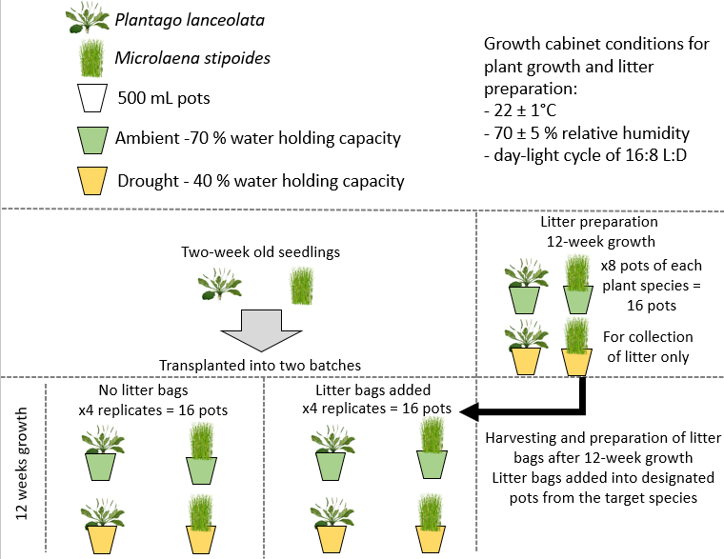
Fig. S1 Schematic diagram of experimental design

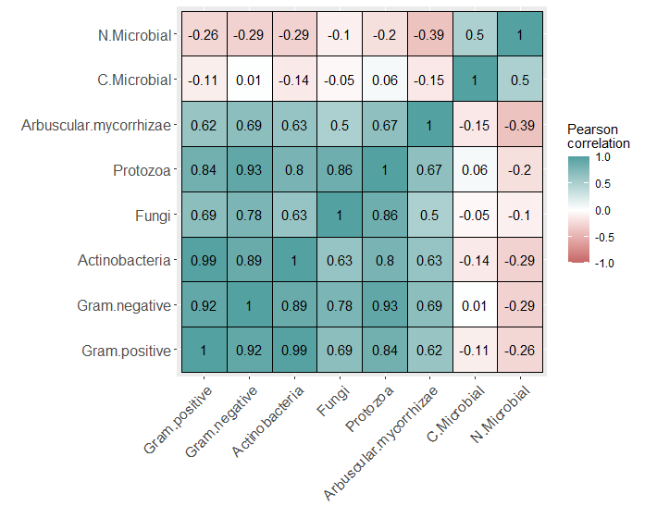
Fig. S2 Pearson correlation matrix of microbial biomass attributes (microbial biomass C and N content; microbial PLFA and NLFA biomarkers). C.Microbial: microbial biomass C; N.Microbial: microbial biomass N.

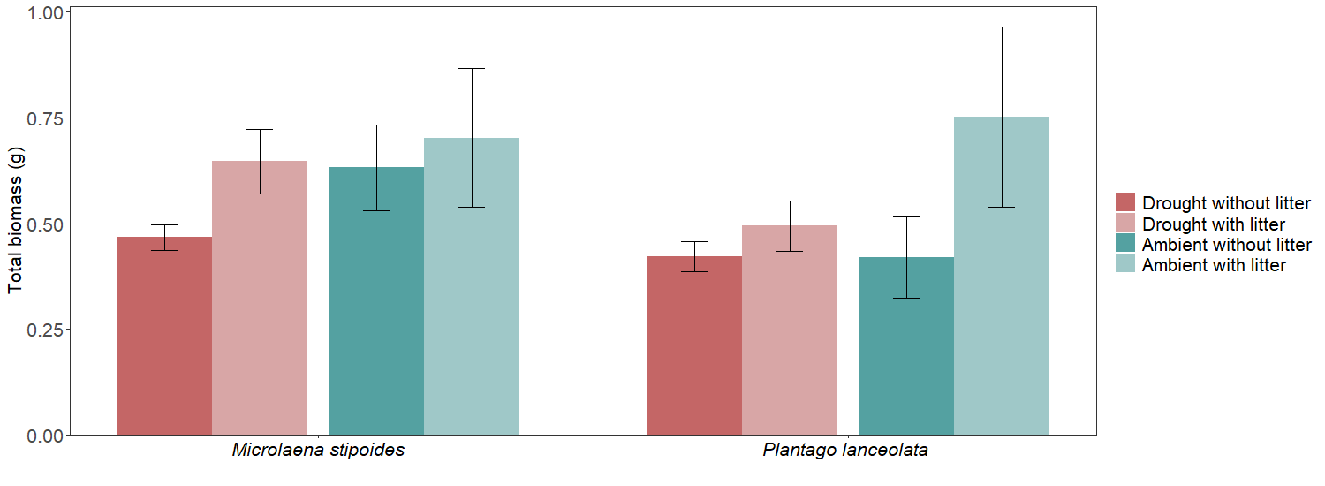
Fig. S3 Average total plant biomass of each plant species for watering and litter treatments. Bars represent standard error.
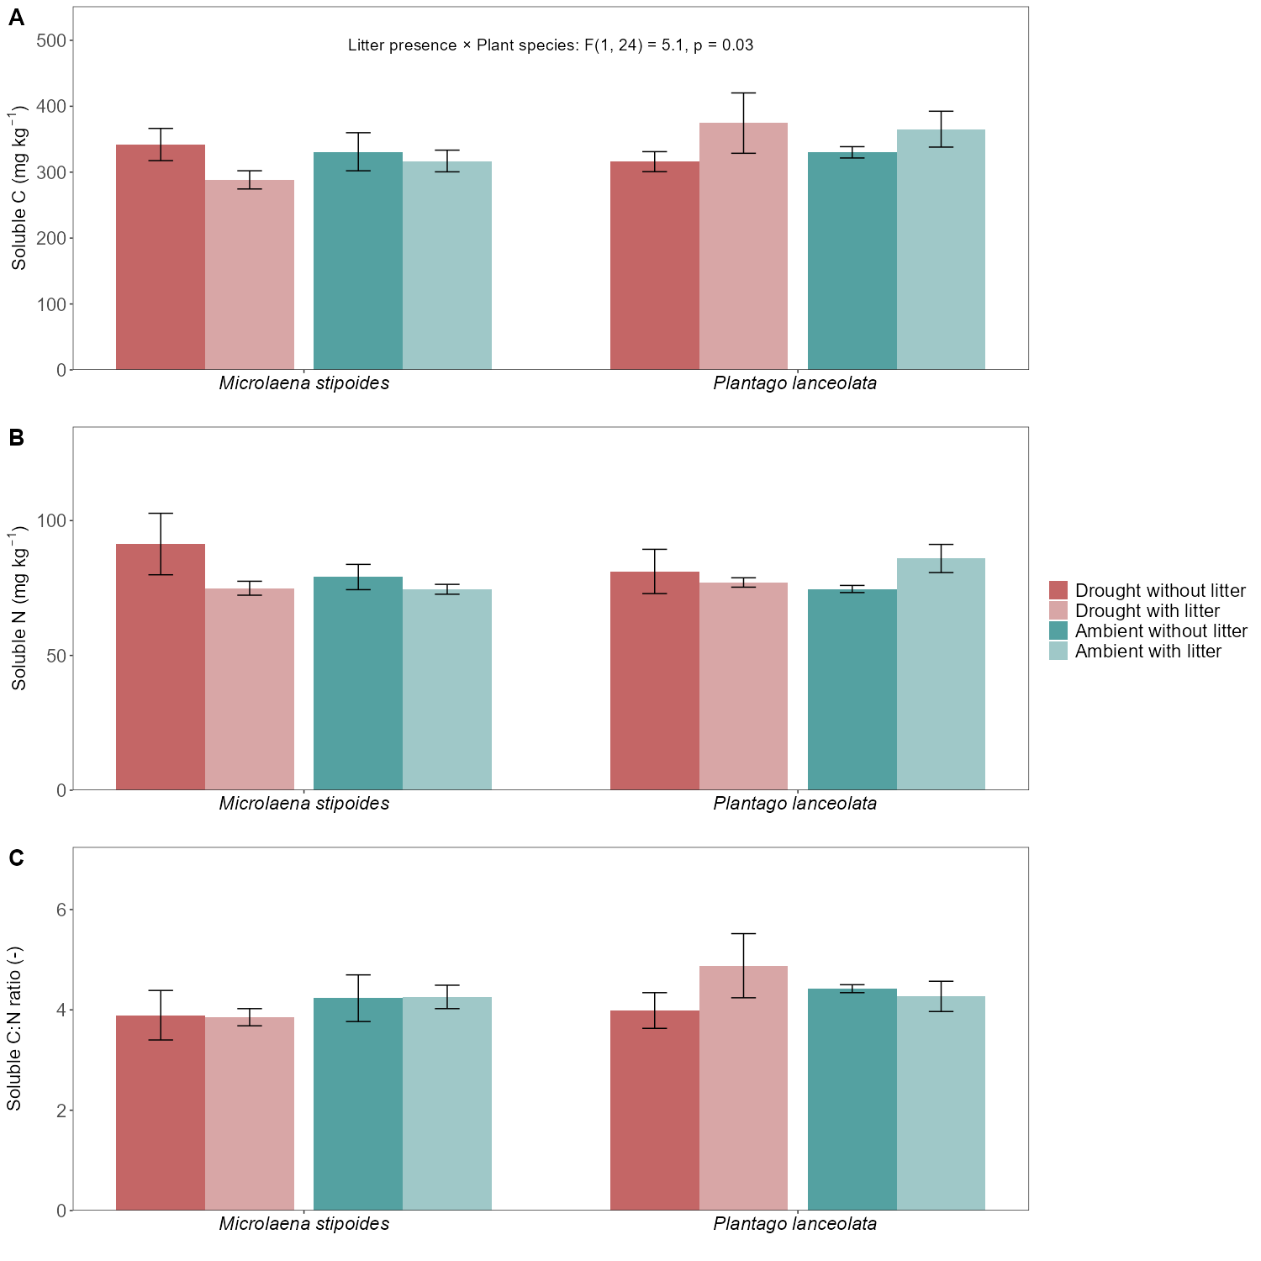
Fig. S4 Average soil soluble C (A), N (B) and soluble C:N ratio (C) in soils of each plant species for watering and litter treatments. Bars represent standard error. Test statistics are shown for significant differences among treatments or their interactions found using three-way ANOVA only.

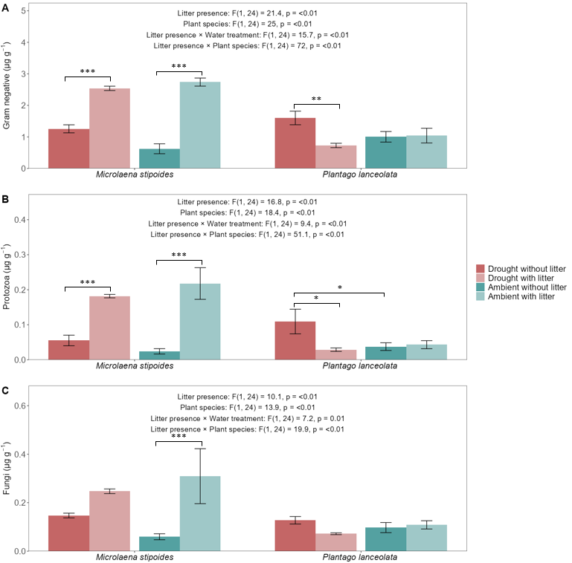
Fig. S5 Average PLFA biomarkers in soil for gram negative (A), protozoa (B) and fungi (C) for each plant species across watering and litter treatments. Bars represent standard error. Test statistics are shown for significant differences among treatments or their interactions found using three-way ANOVA. Brackets above bars indicate significant differences among litter presence and watering treatment using Tukey’s HSD test. Asterix * indicates significant relationships strength with *** p<=0.001, ** p<=0.01, * p<=0.05.

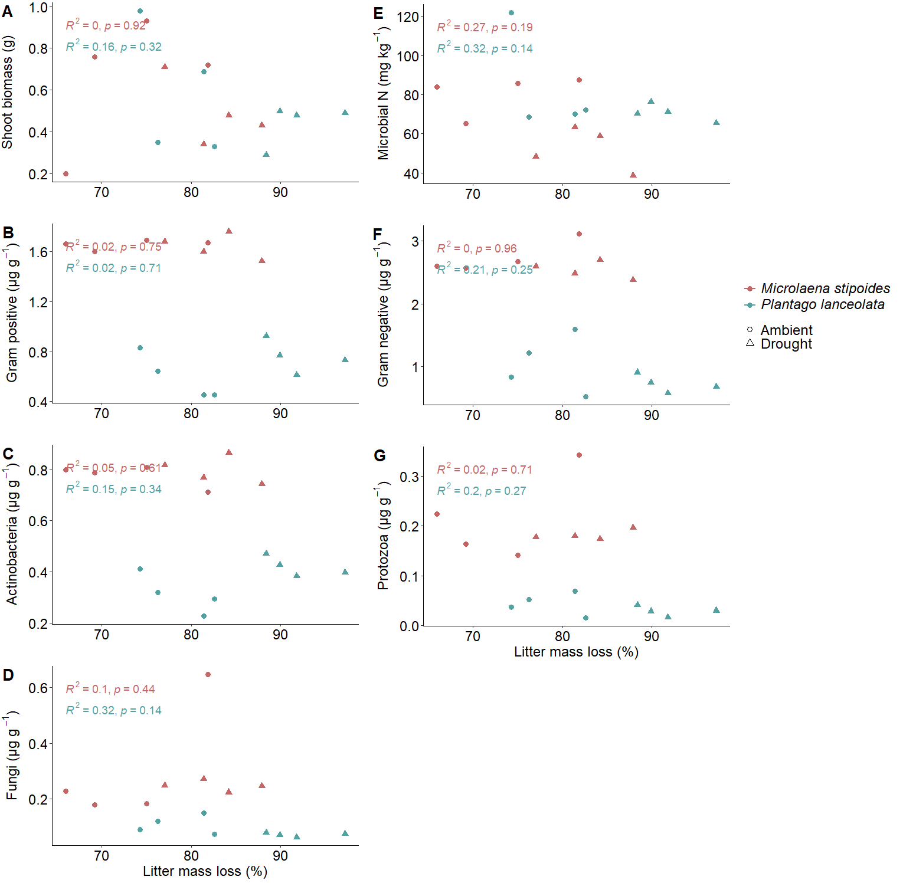
Fig. S6 Litter mass loss relationship with shoot biomass (A), gram positive (B), actinobacteria (C), fungi (D), microbial N (E), gram negative (F) and protozoa (G) between plant species affected by watering treatments. Fitted lines represent statistically significant linear relationships between microbial biomass (PLFA, NLFA, microbial C, N), plant biomass and litter mass loss.

