SUPPORTING INFORMATION
A Multiplex Chromogenic–Fluorogenic Sensor Array for Comprehensive Optical Discrimination of Chemical Warfare Agents

Soohwan Kim^{1,†}, Jin Yoo^{1,†}, Ku Kang¹, Jeongyun Kim², Myeongsik Shin¹,
Yeon Kyung Cha³, David G. Churchill^{4,5,*}, Min–Kun Kim^{6,**}and Doo–Hee Lee^{1,***}

¹ CBRN Defense Research Institute, ROK Ministry of National Defense, Seoul 06796, Republic of Korea
² Department of Chemical and Biological Engineering, Seoul National University, Seoul 08826, Republic of Korea
³ Sensor System Research Center, Korea Institute of Science and Technology (KIST), Seoul 02792, Republic of Korea
⁴ Department of Chemistry, Korea Advanced Institute of Science and Technology (KAIST), Daejeon 34141, Republic of Korea
⁵ KAIST Institute for Health Science and Technology (KIHST) (Therapeutic Bioengineering Section), Daejeon 34141, Republic of Korea
⁶Department of Materials Science and Engineering, Myongji University, Gyeonggi–do 17058, Republic of Korea

E–mail addresses of corresponding authors: dooheeleechem@gmail.com

S1. Differential Colorimetric Quantification Workflow
To ensure reproducibility and minimize variability across imaging devices, all photographs were taken using a Samsung Galaxy S20 FE smartphone (model SM-G780F, 4032×2268 px, f/1.8, ISO 50–100, exposure 1/45–1/60 s). Images were captured inside a controlled dark enclosure under either UV illumination or diffuse white LED lighting. A photograph of the initial dye or solvent on a standard white background was recorded as the calibration baseline (L₀, a₀, b₀), and all sensing responses were quantified using the color difference (ΔE) relative to this baseline. This differential colorimetric method minimizes device-dependent and ambient lighting biases, enabling robust field-deployable sensing.
Smartphone camera variability and ambient illumination can significantly influence raw RGB values through auto-exposure adjustment, sensor characteristics, and internal image-processing pipelines. To achieve device-independent reproducibility, a differential colorimetric workflow was adopted. Prior to analyte exposure, each dye solution (or solvent control) was imaged on a standardized white background to obtain baseline CIELAB values (L₀, a₀, b₀). After exposure to chemical warfare agents (CWAs) or simulants, the same sample was re-imaged without altering illumination, camera settings, distance, or orientation. The sensing response was quantified as the perceptual color difference ΔE between the post-exposure and baseline states, which reflects the net chromogenic or fluorogenic change induced by the analyte. Because both images are captured under identical environmental conditions, systematic variations caused by camera hardware, auto-exposure behavior, or illumination drift influence the two measurements equally, allowing these biases to be effectively cancelled. As a result, the extracted ΔE values isolate the true chemical response and remain stable across different sessions and devices. This differential self-referencing strategy therefore provides robust, reproducible optical quantification suitable for field-deployable sensing.
S2. Interferent Analysis
A preliminary interferent evaluation was performed to assess the sensor array’s susceptibility to chemically complex environments. Three representative potential interferents, acetone, ethanol, and ammonia, were individually mixed with each CWA at equal concentrations (500 µM). Visible and UV images were obtained under the standardized imaging conditions described in the Methods section.
Analysis of ΔE values showed that several dyes exhibited pronounced shifts upon exposure to these interferents, with certain dyes displaying greater variations under UV illumination. These observations indicate that the array has partial vulnerability to volatile organic compounds (VOCs) and polar solvents, suggesting that interference effects may arise under realistic environmental conditions. However, the overall dual-mode fingerprinting and class-level discrimination remained robust and clearly separable from the live-agent signatures. A more comprehensive investigation employing an expanded interferent panel will be addressed in future studies.
Complete ΔE profiles and visual representations are provided in Figures S1–S2.

S3. UV–Vis and Fluorescence Spectral Analysis
As shown in Figure S3, UV–vis ΔAbs and fluorescence spectra (λ_{ex} = 365 nm) of the six optimized dyes measured before and after exposure to each CWA (AC, CG, CK, HD, HN, L, PS). The absorption profiles exhibited dye- and agent-specific differences in peak position and intensity, while the fluorescence spectra showed analyte-dependent spectral shifts. These spectral features collectively illustrate the heterogeneous optical responses that underpin the differential sensing behavior of the array.

S4. Reproducibility Assessment (Triplicate Measurements)
The selected optimal dye-analyte combinations were measured in triplicate (n = 3) under identical imaging conditions to evaluate the reproducibility of the optical setup. For each replicate, samples were photographed independently using the same fixed optical geometry (illumination intensity, working distance, and exposure time) and a Samsung Galaxy S20 FE. A fixed central Region of interest (ROI) was used for RGB extraction across all replicates to minimize spatial variability. Replicates were acquired within the same controlled session to assess short-term repeatability of the dye–agent optical fingerprints (Fig. S4).
Due to strict live-agent operational limits, the full 29-dye screening was performed once per condition, while triplicate repeats were conducted for the optimized dye–analyte pairs to confirm repeatability.

S5. Comparison with Conventional Detection Methods
To contextualize the analytical performance of the proposed dual-mode array, Table S1 compares it with representative CWA detection approaches reported in the literature. Conventional instrumental methods such as gas chromatography-mass spectrometry (GC–MS) offer sub-micromolar to ultratrace sensitivity but require sophisticated instrumentation and trained personnel, limiting their practicality for field deployment. ion mobility spectrometry (IMS) and Fourier- transform infrared spectroscopy (FT-IR) methods exhibit moderate portability; however, they suffer from partial selectivity and are susceptible to calibration drift and environmental contamination. In contrast, our system achieves reliable discrimination within the 10–500 µM concentration range (≈10 µM lower limit) while operating under a fully portable, smartphone-based configuration. This tested range corresponds to approximately ~0.3–2 ppm at 10 µM and up to ~100 ppm at 500 µM, depending on analyte molecular weight. The platform therefore shows strong potential for future field application.
Figure Caption
Fig. S1. ΔE responses of selected dyes in the presence of three potential interferents (acetone, ethanol, ammonia) under visible illumination. Bars indicate mean values (n = 3), and markers represent individual interferent-induced responses.
Fig. S2. ΔE responses of selected dyes in the presence of three potential interferents (acetone, ethanol, ammonia) under UV illumination. Bars indicate mean values (n = 3), and markers represent individual interferent-induced responses.
Fig. S3. Baseline-corrected UV–vis absorbance difference spectra (ΔAbs) and fluorescence emission spectra (λ_{ex} = 365 nm) of the six optimized dyes (Dye 6, 12, 16, 20, 27, 28) before and after exposure to each of the seven chemical warfare agents (AC, CG, CK, HD, HN, L, PS).
Fig. S4. Average $∆E$responses (mean ± SD) for the selected optimal dye–analyte combinations based on triplicate measurements (n = 3). (a) Data acquired under visible-light imaging. (b) Data acquired under UV imaging. All replicates were collected independently under identical and fixed optical conditions.

Table Caption
Table. S1. Comparison of representative chemical warfare agent (CWA) detection techniques

Fig. S1
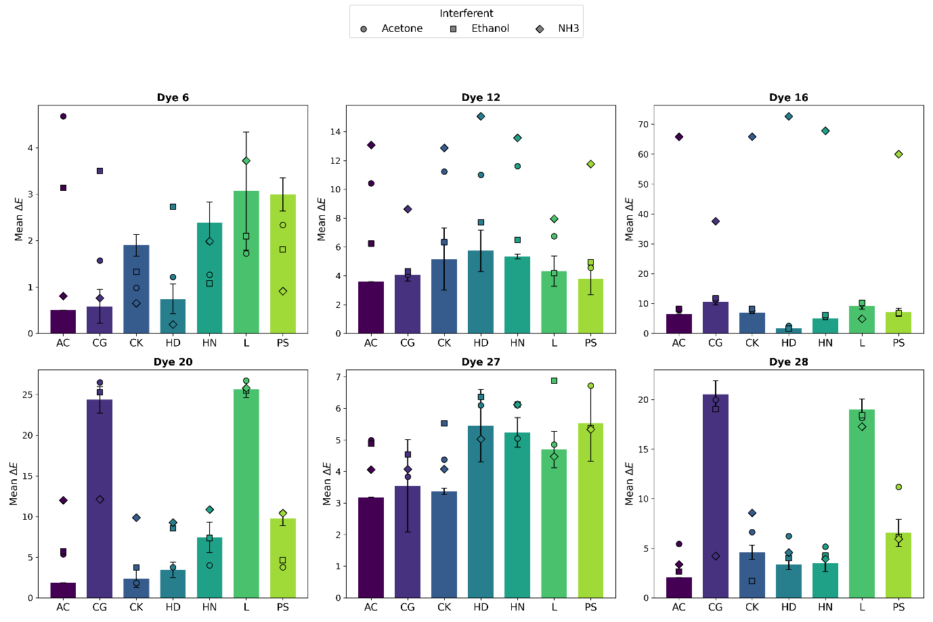

Fig. S2
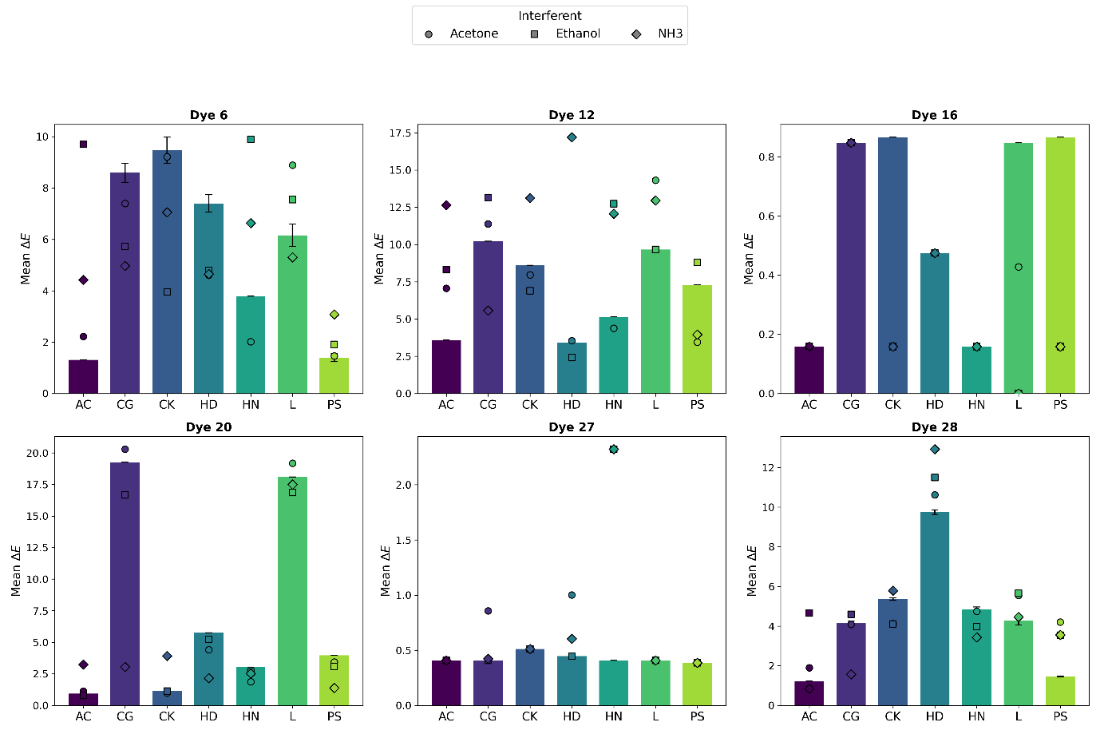
Fig. S3
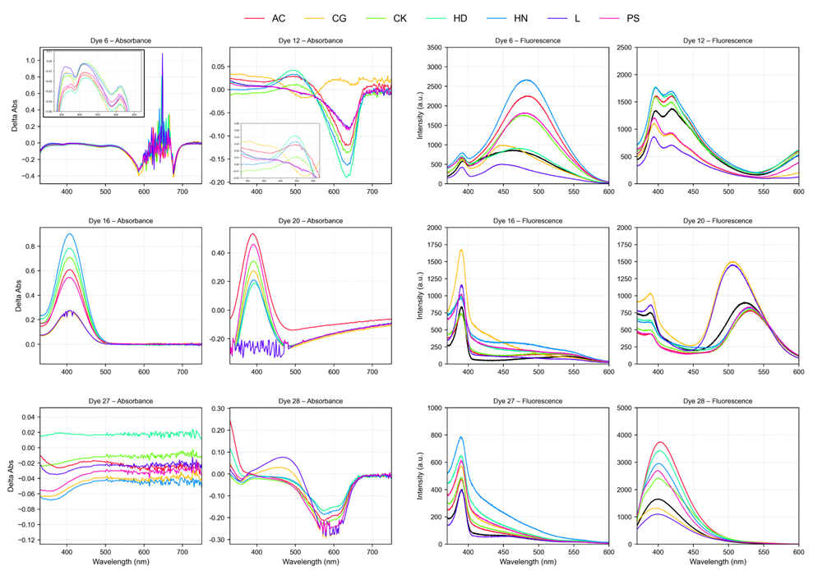

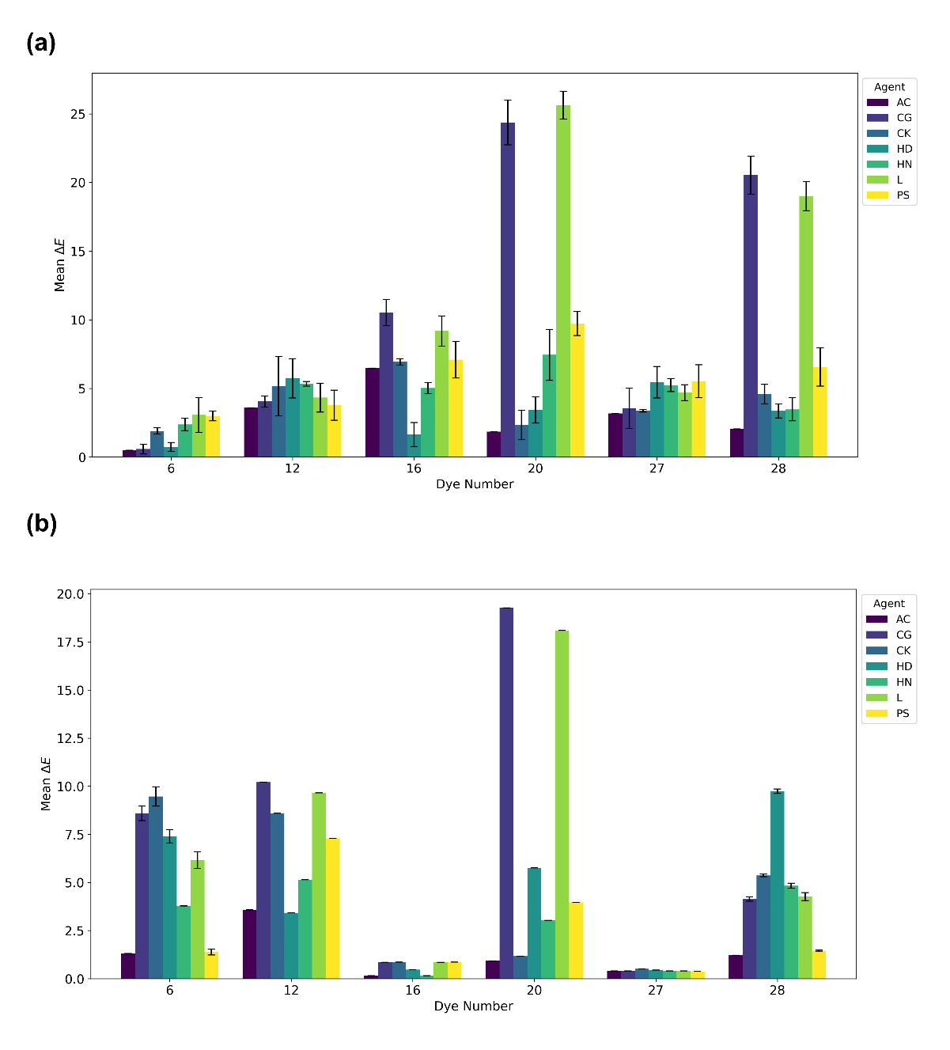
Fig. S4
Table S1
Detection  Method^{[26]} | Detection  Limit | Response  Time | Portability | Cost | User  Friendliness
GC-MS ²⁶ | Low ng/ml,  low ppb | 2~10 min | X  (benchtop) | Very  High | Low,  Trained Operator
IMS ^{27,28} | ppt-ppb | < 1 min | △  (handheld) | Medium  -High | Moderate,  Partial Selectivity
FT-IR ²⁹ | ppm | < 1 min | △  (portable) | High | Moderate, Calibration /Alignment
This work | 10–500 µM | < 2 min | ✔  (fully portable) | Very  Low | High,  Non-Expert

