SUPPLEMENTARY INFORMATION

Table S1. Word list of words in different fonts. The fonts are the following: Monotype italics, Lucida Console, Bradley Hand, Mistral, Harrington, and Calibri. For each font, there are 8 words.
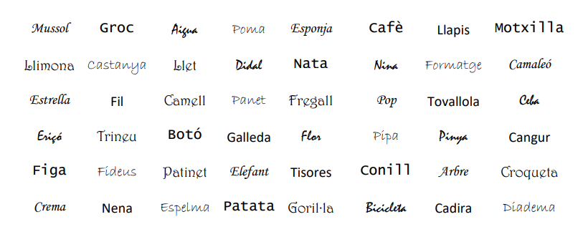

Table S2. Examples of font names, type of Serif (Yes, No), Stroke contrast (Low, Moderate, and High), and Crowding (Low, Normal, and High). Serifs are terminal extensions added to the ends of primary letter strokes. Stroke contrast refers to the intra-letter variation in stroke thickness within a typeface. Crowding* in typography is related to inter-letter spacing: as spacing decreases, crowding increases.

Font Name | Example | Serif | Stroke contrast | Crowding
Monotype Italics | Monotype Italics | Yes | Moderate | Normal
Lucida Console | Lucida Console | No | Low | Normal
Bradley Hand | Bradley Hand | No | Low | Normal
Mistral | Mistral | No | High | High
Harrington | Harrington | Yes | High | Normal
Calibri | Calibri | No | Low | Normal
*In other areas, crowding is also referred as letter spacing and kerning, which describes the distances between letter pairs [1, pag 21]
[1]. Marshall, C. (2009). Reading and writing the electronic book. Morgan & Claypool Publishers.

Figure S1. Visual examples illustrating serif features, stroke contrast, and letter crowding in different font styles.

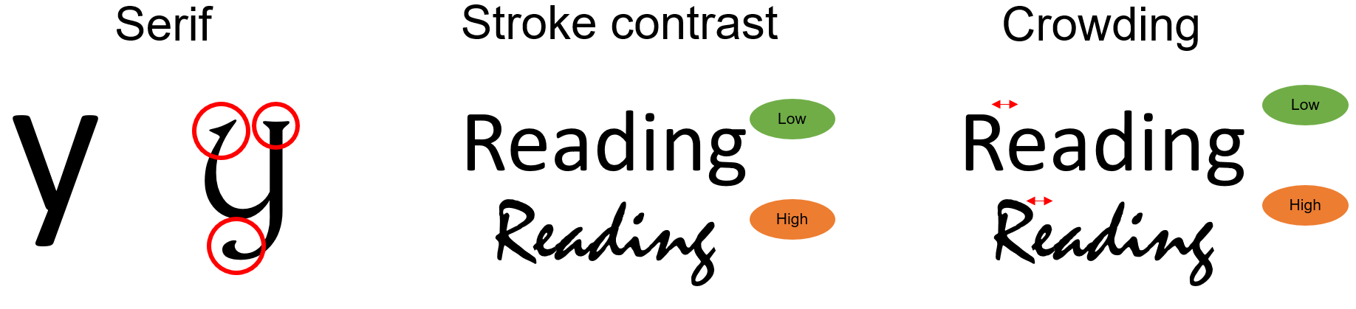

Table S3. Word list of similar words. Two lists of similar words, one of the one-syllables (on the top) for children under 9 years of age, and the other of two-syllables (on the bottom) for children aged 9 or older.

LIST OF ONE-SYLLABLES WORDS
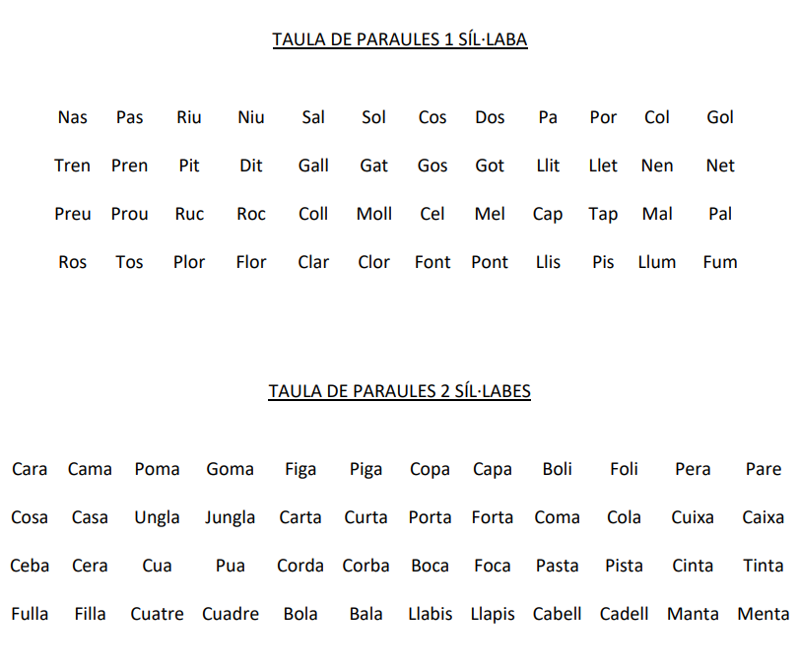
LIST OF TWO-SYLLABLES WORDS

