Pasteurized kiwifruit juice fermented by probiotic strains: study on physicochemical properties, volatile profiles, and health-related metabolomic characteristics
Shiyi Zhang ^{a,#}, Jiayi Zhang ^{a,#}, Lanqi Zhou ^{b}, Ruixue Wen ª, Yan Zhang ª, Jiale Zou ª, Peng Wang ª, Shan Wu ^{c, *}, Lin Shi ^{a, *}
ª School of Food Engineering and Nutritional Science, Shaanxi Normal University, Xi'an, Shaanxi 710119, China
^{b} College of food science and technology, Huazhong Agricultural University, Wuhan, Hubei 430070, China
^{c} Inner Mongolia Enterprise Key Laboratory of Dairy Nutrition, Health & Safety, Inner Mongolia Mengniu Dairy (Group) Co. Ltd., Huhhot 011500, China
# These authors contributed equally to this work
*Corresponding author:
Prof. Lin Shi, School of Food Engineering and Nutritional Science, Shaanxi Normal University, Xi’an, Shaanxi 710062, China. *Email: linshi198808@snnu.edu.cn ORCID: 0000-0001-9709-3394
Dr. Shan Wu, Inner Mongolia Enterprise Key Laboratory of Dairy Nutrition, Health & Safety, Inner Mongolia Mengniu Dairy (Group) Co. Ltd., Huhhot 011500, China. *Email: wushan331314@163.com

Supplemental Table

Table S1. Sensory attributes and reference points for kiwifruit juice evaluation
Sensory attributes | Standards | Score
Consistency  (15 points) | Free of suspended solids and uniform appearance in kiwifruit juice | 12～15
Consistency  (15 points) | A small amount of suspended solids or precipitation in kiwifruit juice | 8～11
Consistency  (15 points) | Obvious stratification with a small amount of precipitation in kiwifruit juice | 4～7
Consistency  (15 points) | Obvious stratification with a large amount of precipitation in kiwifruit juice | 0～3
Color  (15 points) | Uniform yellow color | 12～15
Color  (15 points) | Uniform light or deep yellow color | 8～11
Color  (15 points) | Slightly uneven yellow color | 4～7
Color  (15 points) | Uneven light or deep yellow color | 0～3
Aroma  (20 points) | Rich, intense kiwifruit aroma | 16～20
Aroma  (20 points) | Noticeable but mild kiwifruit aroma | 11～15
Aroma  (20 points) | Very weak or almost no detectable kiwifruit aroma | 6～10
Aroma  (20 points) | Distinct off-odor present | 0～5
Sour and sweet  (20 points) | Balanced, moderately sweet and sour taste | 16～20
Sour and sweet  (20 points) | Slightly sour or slightly sweet taste | 11～15
Sour and sweet  (20 points) | Distinctly sour or distinctly sweet taste | 6～10
Sour and sweet  (20 points) | Excessively sour or excessively sweet taste | 0～5
Taste  (30 points) | Pronounced kiwifruit flavor with no off-taste | 23～30
Taste  (30 points) | Moderate kiwifruit flavor with a mild refreshing quality | 16～22
Taste  (30 points) | Weak kiwifruit flavor with no refreshing quality | 8～15
Taste  (30 points) | Lacks kiwifruit flavor and has a distinctly unpleasant taste | 0～7

Table S2. Volatile compounds identified by GC-IMS in pasteurized probiotic strains-fermented kiwifruit juice at 24 h
Category | Compound | RI | NIST RI | Relative content of volatile compound (μg/mL)
 |  |  |  | NF | LP85 | LG90 | COM | P-value
Alcohols | Ethanol | 942.80 | 934.00 | 28086.48±62.83ª | 30827.17±155.49^{c} | 28837.00±120.84^{b} | 29163.25±361.59^{b} | **
Alcohols | 1-Hexanol monomer | 1366.80 | 1355.00 | 1232.64±93.62^{b} | 1319.19±43.26^{b} | 1292.62±33.29^{b} | 1998.31±86.20ª | **
Alcohols | 1-Hexanol dimer | 1368.20 | 1355.00 | 155.88±3.34^{b} | 155.22±7.83^{b} | 144.28±17.08^{b} | 244.49±49.30ª | **
Alcohols | 3-Methyl-1-butanol | 1217.90 | 1203.00 | 905.93±26.05^{b} | 1062.98±7.29^{c} | 614.19±8.46^{d} | 1307.51±10.54ª | **
Alcohols | Butan-1-ol | 1157.30 | 1145.00 | 592.13±13.08ª | 983.63±8.19^{d} | 933.13±10.45^{b} | 800.40±15.59^{c} | **
Alcohols | 1-Penten-3-ol | 1173.40 | 1147.00 | 1388.88±7.65^{bc} | 1099.26±5.60ª | 1066.85±7.98^{c} | 1133.10±28.14^{b} | **
Alcohols | Isobutanol | 1106.80 | 1091.00 | 1021.69±16.52^{b} | 1044.57±5.00^{b} | 905.74±3.06^{c} | 1439.02±17.93ª | **
Alcohols | Propan-2-ol monomer | 928.60 | 933.00 | 267.43±12.25^{c} | 307.08±6.05^{c} | 806.74±7.06ª | 725.02±38.66^{b} | **
Alcohols | Propan-2-ol dimer | 929.90 | 933.00 | 940.21±30.09^{d} | 743.06±7.50^{c} | 1462.42±8.50^{b} | 1522.91±28.24ª | **
Alcohols | Tert-butanol | 927.90 | 920.00 | 372.27±10.79^{c} | 360.87±1.03^{c} | 658.25±6.80^{b} | 934.98±80.14ª | **
Alcohols | 1-Propanol | 1053.00 | 1038.00 | 565.73±23.46^{b} | 842.54±13.37^{c} | 902.38±3.07ª | 910.15±21.97ª | **
Aldehydes | 2-Methylbutanal monomer | 924.90 | 913.00 | 1065.10±13.10^{b} | 783.65±23.09ª | 340.24±8.81^{c} | 714.34±76.38^{b} | **
Aldehydes | 2-Methylbutanal dimer | 927.30 | 913.00 | 907.90±6.90^{ab} | 851.01±8.62ª | 644.82±9.32^{b} | 931.26±176.16ª | *
Aldehydes | Hexanal monomer | 1098.30 | 1087.00 | 4861.89±63.64^{b} | 3446.64±30.23ª | 2577.28±68.82^{c} | 2730.62±102.89^{c} | **
Aldehydes | Hexanal dimer | 1100.00 | 1087.00 | 7287.14±107.95^{b} | 2153.57±46.83ª | 1033.45±39.59^{c} | 1114.45±143.44^{c} | **
Aldehydes | (E)-2-Heptenal monomer | 1330.50 | 1335.00 | 763.27±75.11ª | 979.15±33.40^{b} | 628.69±30.78^{c} | 595.36±25.37^{c} | **
Aldehydes | (E)-2-Heptenal dimer | 1330.50 | 1335.00 | 55.36±1.45ª | 75.10±1.96^{b} | 45.86±1.28^{c} | 48.17±5.00^{bc} | **
Aldehydes | (E)-2-Hexenal monomer | 1229.40 | 1227.00 | 4816.54±80.36^{c} | 2497.45±59.48ª | 2663.86±19.44^{c} | 3669.31±204.67^{b} | **
Aldehydes | (E)-2-Hexenal dimer | 1226.60 | 1227.00 | 5523.74±292.03^{c} | 958.96±14.79ª | 1066.46±12.95^{c} | 2023.02±75.36^{b} | **
Aldehydes | (E)-2-Octenal | 1437.90 | 1433.00 | 437.46±31.73ª | 523.56±5.15^{b} | 487.57±36.32^{ab} | 466.09±25.17^{ab} | *
Aldehydes | Nonanal | 1401.60 | 1400.00 | 599.80±23.20ª | 563.03±13.23ª | 476.56±35.27^{b} | 477.14±33.20^{b} | **
Aldehydes | Octanal monomer | 1298.30 | 1300.00 | 543.11±23.63^{b} | 411.29±12.84ª | 354.78±29.34^{b} | 419.08±50.66^{b} | **
Aldehydes | Octanal dimer | 1297.90 | 1300.00 | 67.16±13.19^{ab} | 48.83±10.49ª | 41.34±2.99^{b} | 43.60±2.11^{b} | *
Aldehydes | (E)-2-Pentenal monomer | 1148.10 | 1138.00 | 1018.42±57.86ª | 1366.11±17.40^{b} | 570.83±29.64^{c} | 900.24±67.16^{b} | **
Aldehydes | (E)-2-Pentenal dimer | 1149.20 | 1138.00 | 249.21±23.62ª | 417.36±12.92^{b} | 125.07±14.71^{c} | 160.44±15.84^{c} | **
Aldehydes | Acrolein | 845.60 | 838.00 | 638.58±15.33^{bc} | 549.01±7.00ª | 588.99±6.53^{ab} | 501.12±33.39^{c} | **
Aldehydes | Butanal | 875.70 | 877.00 | 700.25±14.53ª | 613.24±7.59ª | 419.76±3.33^{b} | 614.42±65.88ª | **
Aldehydes | Pentanal | 996.50 | 1005.00 | 930.84±6.01ª | 969.34±6.92^{b} | 424.41±4.41^{d} | 788.34±9.82^{c} | **
Aldehydes | Propanal monomer | 788.10 | 782.00 | 2492.86±14.96ª | 2618.90±9.26ª | 2154.13±30.35^{b} | 2405.85±164.41ª | **
Aldehydes | Propanal dimer | 786.90 | 782.00 | 2974.77±61.07ª | 4123.29±51.76^{b} | 1502.77±55.36^{c} | 2445.65±792.15^{bc} | **
Ketones | 3-Hydroxy-2-butanone monomer | 1297.40 | 1304.00 | 482.19±27.94ª | 3200.51±69.27^{b} | 436.95±71.13^{b} | 545.99±70.11^{b} | **
Ketones | 3-Hydroxy-2-butanone dimer | 1296.80 | 1304.00 | 67.37±6.24ª | 819.62±76.89^{b} | 60.70±6.53^{b} | 66.78±6.52^{b} | **
Ketones | 1-Octen-3-one | 1311.30 | 1303.00 | 322.64±25.15ª | 421.22±8.84^{b} | 195.61±10.00^{c} | 222.73±9.89^{c} | **
Ketones | 2-Heptanone monomer | 1190.30 | 1182.00 | 144.75±8.42^{c} | 678.77±11.31^{d} | 1141.56±15.77ª | 1091.25±17.27^{b} | **
Ketones | 2-Heptanone dimer | 1189.00 | 1182.00 | 28.49±2.93^{b} | 77.93±9.50^{c} | 144.08±4.49ª | 134.38±14.87ª | **
Ketones | Acetone | 817.50 | 818.00 | 8304.78±50.21ª | 10833.96±26.29^{b} | 7426.74±14.49^{c} | 8397.31±199.39^{b} | **
Ketones | Butan-2-one | 910.50 | 909.00 | 142.03±5.43ª | 234.34±2.55^{b} | 66.49±3.16^{d} | 77.84±1.00^{c} | **
Ketones | 1-Penten-3-one monomer | 1038.70 | 1057.00 | 1283.86±16.35ª | 1293.53±14.31ª | 763.19±7.67^{c} | 839.47±33.61^{b} | **
Ketones | 1-Penten-3-one dimer | 1038.00 | 1057.00 | 1234.42±30.01ª | 1356.85±16.31^{b} | 277.72±11.29^{d} | 393.16±25.21^{c} | **
Esters | Ethyl acetate monomer | 888.10 | 885.00 | 7226.59±55.41^{c} | 4079.05±9.39ª | 3334.48±15.57^{d} | 4790.95±69.34^{b} | **
Esters | Ethyl acetate dimer | 891.50 | 885.00 | 1573.57±22.75^{ab} | 1630.21±5.15^{b} | 1673.38±8.89^{ab} | 1773.26±118.15ª | *
Esters | Ethyl propanoate | 967.70 | 966.00 | 437.69±18.81^{b} | 68.18±4.67ª | 32.27±3.35^{c} | 70.71±12.42^{b} | **
Esters | Ethyl isobutyrate | 976.30 | 975.00 | 91.44±2.70^{b} | 21.29±5.21ª | 20.40±3.00^{b} | 20.55±1.64^{b} | **
Esters | Ethyl butyrate monomer | 1049.80 | 1050.00 | 2496.42±18.30^{b} | 1575.20±7.77ª | 1035.57±14.26^{c} | 1615.27±26.50^{b} | **
Esters | Ethyl butyrate dimer | 1050.60 | 1050.00 | 3410.21±71.58^{b} | 720.44±4.37ª | 213.87±6.47^{c} | 732.21±31.22^{b} | **
Esters | Methyl 2-methylbutanoate | 1011.80 | 1010.00 | 330.01±15.56^{b} | 193.67±1.89ª | 100.91±1.51^{c} | 102.14±4.64^{c} | **
Alkanes | Heptanal monomer | 1192.50 | 1184.00 | 706.11±28.09ª | 731.73±31.34ª | 484.84±21.24^{b} | 538.47±59.29^{b} | **
Alkanes | Heptanal dimer | 1191.90 | 1184.00 | 72.21±6.13ª | 85.40±7.37ª | 39.49±1.54^{b} | 46.91±10.87^{b} | **
Organic acids | Acetic acid monomer | 1501.70 | 1457.00 | 10962.21±222.51ª | 31521.18±717.59^{b} | 31797.57±1519.61ª | 31520.18±511.08ª | **
Organic acids | Acetic acid dimer | 1499.30 | 1457.00 | 1568.56±72.80ª | 24401.51±1969.90^{b} | 28211.69±3555.51ª | 25032.84±636.51ª | **
Heterocyclic compounds | 2-Pentyl furan | 1262.10 | 1258.00 | 239.39±4.46^{b} | 326.71±1.29^{c} | 314.85±7.30^{b} | 423.25±26.52ª | **
Heterocyclic compounds | 2-Butylfuran | 1122.90 | 1123.00 | 268.97±8.47^{c} | 92.45±5.79ª | 57.87±4.42^{d} | 115.61±7.58^{b} | **
Values are means ± standard deviations (n=3). Results where there are different superscript letters within each group are significant different (p < 0.05) as determined by Tukey’s test. *: p < 0.05, **: p < 0.01. Abbreviations: NF, non-fermented kiwifruit juice; LP85, kiwifruit juice fermented by Lactiplantibacillus plantarum 85; LG90, kiwifruit juice fermented by Lactobacillus gasseri 90; COM, kiwifruit juice fermented by the combination of Lactiplantibacillus plantarum 85 and Lactobacillus gasseri 90.

Table S3. The main volatile compounds in COM fermented kiwifruit juice stored under different conditions
Compound | Molecular formula | Rt/min | RI | NIST RI | Relative content of volatile compound (μg/kg)
 |  |  |  |  | COM | COM4℃  15 day | COM4℃  30 day | COM4℃  45 day | COM25℃  9 day | COM25℃  18 day | COM25℃  27 day | COM35℃  6 day | COM35℃  12 day | COM35℃  18 day
Butanoic acid, methyl ester | C₅H₁₀O₂ | 3.48 | 968.00 | 975.00 | 3055.30 ± 196.80 | 2872.90 ± 77.70 | 3736.60 ± 119.20 | 3005.20 ± 182.50 | 2409.80 ± 164.60 | 2938.00 ± 769.90 | ND | 2664.70 ± 313.30 | 1842.30 ± 609.40 | ND
Butanoic acid, ethyl ester | C₆H₁₂O₂ | 4.65 | 1049.00 | 1028.00 | 306.80 ± 23.20 | 211.70 ± 11.30 | 415.30 ± 11.90 | 278.30 ± 8.10 | 79.30 ± 4.50 | ND | ND | ND | ND | ND
Hexanoic acid, methyl ester | C₇H₁₄O₂ | 8.95 | 1165.00 | 1177.00 | 79.70 ± 38.90 | 40.00 ± 6.90 | 88.00 ± 39.20 | 115.50 ± 8.40 | ND | ND | ND | ND | ND | ND
(E)-2-Hexenal | C₆H₁₀O | 10.07 | 1210.00 | 1218.00 | 19.20 ± 2.80 | 28.50 ± 1.40 | 59.90 ± 16.10 | 68.40 ± 7.80 | ND | ND | ND | ND | ND | ND
Acetoin | C₄H₈O₂ | 12.27 | 1288.00 | 1294.00 | 181.70 ± 17.20 | 171.80 ± 12.50 | 179.70 ± 14.90 | 206.90 ± 17.70 | 5.00 ± 0.10 | ND | 29.70 ± 2.20 | 119.80 ± 10.80 | 113.50 ± 25.40 | 110.20 ± 28.90
(E)-2-Heptenal | C₇H₁₂O | 13.24 | 1326.00 | 1321.00 | 8.00 ± 3.30 | 18.80 ± 8.00 | 15.80 ± 17.50 | 46.60 ± 21.30 | 32.40 ± 10.80 | 47.60 ± 23.40 | 34.60 ± 15.60 | 24.80 ± 1.40 | 24.70 ± 0.60 | 32.60 ± 2.30
5-Hepten-2-one, 6-methyl- | C₈H₁₄O | 13.75 | 1346.00 | 1330.00 | 28.80 ± 1.90 | 34.20 ± 4.70 | 34.40 ± 2.30 | 49.60 ± 13.00 | 39.00 ± 4.40 | 51.00 ± 29.40 | 38.80 ± 12.60 | 26.90 ± 1.10 | 13.20 ± 8.60 | 27.80 ± 3.40
1-Hexanol | C₆H₁₄O | 14.64 | 1364.00 | 1348.00 | 289.20 ± 20.10 | 302.20 ± 10.00 | 322.80 ± 9.90 | 322.10 ± 4.80 | 321.70 ± 9.00 | 283.80 ± 24.60 | 242.10 ± 11.80 | 508.80 ± 19.80 | 384.30 ± 14.10 | 307.10 ± 28.70
(E)-3-Hexen-1-ol | C₆H₁₂O | 14.87 | 1367.00 | 1349.00 | 62.80 ± 7.50 | 64.60 ± 8.90 | 71.40 ± 10.50 | 75.90 ± 13.00 | 61.30 ± 16.10 | 54.20 ± 5.90 | 36.10 ± 3.90 | 51.70 ± 2.60 | 80.10 ± 3.90 | 33.70 ± 2.40
(Z)-3-Hexen-1-ol | C₆H₁₂O | 15.40 | 1361.00 | 1377.00 | 29.60 ± 1.60 | 35.10 ± 1.80 | 31.00 ± 1.00 | 24.30 ± 1.70 | ND | ND | ND | 26.10 ± 3.30 | 33.90 ± 22.80 | 30.60 ± 3.80
(Z)-2-Hexen-1-ol | C₆H₁₂O | 16.00 | 1423.00 | 1441.00 | 210.90 ± 11.40 | 199.10 ± 8.90 | 164.90 ± 114.10 | 221.60 ± 3.70 | ND | ND | ND | ND | ND | ND
Acetic acid | C₂H₄O₂ | 17.03 | 1439.00 | 1430.00 | 178.30 ± 48.40 | 212.10 ± 20.70 | 239.10 ± 81.90 | 205.90 ± 21.40 | 227.50 ± 11.30 | 324.30 ± 46.30 | 493.90 ± 191.00 | 208.80 ± 19.30 | 197.00 ± 52.00 | 277.80 ± 45.30
Butanoic acid, 3-hydroxy-, methyl ester, (S)- | C₅H₁₀O₃ | 17.85 | / | / | 8.40 ± 1.50 | 9.20 ± 0.70 | 28.10 ± 29.80 | 10.20 ± 1.00 | ND | ND | ND | ND | ND | ND
Decanal | C₁₀H₂₀O | 18.19 | 1487.00 | 1494.00 | 3.30 ± 0.30 | 3.70 ± 0.20 | 4.70 ± 0.30 | 3.90 ± 0.70 | ND | ND | ND | ND | ND | ND
Benzaldehyde | C₇H₆O | 18.52 | 1506.00 | 1511.00 | 11.00 ± 0.60 | 13.50 ± 1.70 | 18.60 ± 1.50 | 20.80 ± 2.30 | ND | ND | ND | ND | ND | ND
Linalool | C₁₀H₁₈O | 19.61 | 1560.00 | 1554.00 | 8.50 ± 1.30 | 7.90 ± 1.00 | 8.10 ± 0.40 | 10.00 ± 0.60 | 9.00 ± 0.60 | 10.10 ± 0.90 | 53.30 ± 2.50 | 8.40 ± 0.70 | 7.90 ± 0.40 | ND
Methyl 2-furoate | C₆H₆O₃ | 20.02 | 1528.00 | 1515.00 | 5.90 ± 0.40 | 5.50 ± 0.20 | 6.20 ± 0.30 | 5.60 ± 0.50 | ND | ND | ND | ND | ND | ND
2-Undecanone | C₁₁H₂₂O | 20.73 | 1584.00 | 1595.00 | 35.10 ± 5.70 | 31.50 ± 1.20 | 28.90 ± 2.00 | 29.30 ± 1.50 | 5.90 ± 0.30 | ND | ND | ND | ND | ND
Benzoic acid, methyl ester | C₈H₈O₂ | 21.01 | 1596.00 | 1600.00 | 801.40 ± 43.90 | 777.50 ± 28.90 | 819.10 ± 20.00 | 774.80 ± 53.40 | 320.80 ± 15.80 | 276.20 ± 20.70 | 207.60 ± 10.30 | 232.40 ± 11.60 | 160.00 ± 8.10 | 122.20 ± 9.90
(E)-2-Decenal | C₁₀H₁₈O | 21.75 | 1573.00 | 1579.00 | 8.00 ± 5.50 | 5.40 ± 0.30 | 8.30 ± 0.50 | 12.20 ± 0.40 | ND | ND | ND | ND | ND | ND
Benzoic acid, ethyl ester | C₉H₁₀O₂ | 22.19 | 1665.00 | 1677.00 | 193.10 ± 78.80 | 107.20 ± 36.10 | 105.20 ± 110.10 | 165.10 ± 69.30 | ND | ND | ND | ND | ND | ND
Benzyl alcohol | C₇H₈O | 30.68 | 1857.00 | 1869.00 | 51.70 ± 5.30 | 65.90 ± 10.30 | 63.00 ± 2.00 | 63.20 ± 13.60 | 68.10 ± 11.10 | 59.60 ± 6.40 | 67.80 ± 16.70 | 61.70 ± 4.00 | 60.70 ± 9.00 | 51.90 ± 6.40
Butylated Hydroxytoluene | C₁₅H₂₄O | 31.95 | 1896.00 | 1911.00 | 68.80 ± 27.70 | 81.10 ± 19.40 | 89.40 ± 25.80 | 79.90 ± 38.50 | 75.30 ± 15.60 | 52.50 ± 3.10 | 93.40 ± 11.10 | 66.00 ± 3.20 | 69.00 ± 7.10 | 71.10 ± 10.00
Phenol, 4-ethyl- | C₈H₁₀O | 36.17 | 2185.00 | 2175.00 | 16.00 ± 0.80 | 16.30 ± 1.30 | 17.20 ± 0.70 | 17.00 ± 0.90 | ND | ND | ND | 17.60 ± 0.90 | 20.30 ± 1.10 | 20.10 ± 3.70
Alanine | C₃H₇NO₂ | 2.10 | / | / | ND | ND | ND | ND | 638.20 ± 547.80 | 806.80 ± 507.30 | 1194.00 ± 1008.40 | 427.90 ± 96.20 | 383.60 ± 359.50 | 405.00 ± 256.40
Dimethyl ether | C₂H₆O | 2.85 | / | / | ND | ND | ND | ND | 3099.40 ± 253.70 | 4116.00 ± 290.00 | 10155.80 ± 655.20 | 2383.80 ± 302.40 | 3886.80 ± 751.40 | 8803.90 ± 627.60
Acetic acid, pentyl ester | C₇H₁₄O₂ | 7.17 | 1160.00 | 1183.00 | ND | ND | ND | ND | 47.50 ± 20.60 | 53.10 ± 19.20 | 75.90 ± 14.20 | 58.50 ± 2.40 | 52.00 ± 36.40 | 139.90 ± 23.70
1-Butanol, 3-methyl- | C₅H₁₂O | 10.46 | 1221.00 | 1217.00 | ND | ND | ND | ND | 1194.00 ± 65.20 | 1010.20 ± 94.00 | 935.60 ± 51.30 | 1119.60 ± 51.90 | 1474.50 ± 90.00 | 2115.50 ± 170.10
Propanoic acid, 2-hydroxy-, ethyl ester | C₅H₁₀O₃ | 14.15 | 1352.00 | 1363.00 | ND | ND | ND | ND | 26.60 ± 2.30 | 40.70 ± 3.00 | 67.00 ± 4.60 | 23.50 ± 1.30 | 62.30 ± 7.70 | 97.40 ± 6.90
Benzene, 1,3-bis(1,1-dimethylethyl)- | C₁₄H₂₂ | 16.28 | / | / | 7.20 ± 0.40 | ND | ND | ND | 114.40 ± 19.20 | 180.20 ± 10.70 | 195.60 ± 85.90 | 90.10 ± 16.20 | 141.70 ± 7.20 | 186.90 ± 34.40
Oxime-, methoxy-phenyl-_ | C₈H₉NO₂ | 27.16 | / | / | 33.00 ± 1.70 | ND | ND | ND | 53.50 ± 1.40 | 30.00 ± 35.40 | 58.70 ± 47.90 | ND | ND | ND
Phenylethyl Alcohol | C₈H₁₀O | 31.75 | 1875.00 | 1896.00 | ND | ND | ND | ND | 74.60 ± 4.40 | 112.10 ± 6.80 | 148.20 ± 24.90 | 56.90 ± 2.40 | 209.30 ± 11.90 | 392.10 ± 33.50
Phenol, 4-ethyl-2-methoxy- | C₉H₁₂O₂ | 34.10 | 2035.00 | 2023.00 | ND | ND | ND | ND | 18.80 ± 2.50 | 40.40 ± 2.30 | 54.40 ± 2.60 | 10.00 ± 0.50 | 35.40 ± 3.50 | 54.30 ± 5.20
2,4-Di-tert-butylphenol | C₁₄H₂₂O | 37.78 | 2321.00 | 2312.00 | 5.90 ± 0.30 | ND | ND | ND | 18.20 ± 2.80 | 29.50 ± 2.80 | 30.40 ± 2.30 | 22.50 ± 1.70 | 44.60 ± 7.00 | 50.50 ± 6.70
Hexanoic acid, ethyl ester | C₈H₁₆O₂ | 10.47 | 1249.00 | 1244.00 | ND | ND | ND | ND | ND | ND | ND | 10.40 ± 2.70 | 35.30 ± 1.70 | 29.80 ± 3.70
Values are means ± standard deviations (n=3). Abbreviations: ND, not detected; COM, kiwifruit juice fermented by the combination of Lactiplantibacillus plantarum 85 and Lactobacillus gasseri 90.

Table S4. Information on differential metabolites enriched in kiwifruit juice fermented by the COM.
ID | Compound | Molecular formula | MW(g mol⁻¹) | FC（COM vs. NF） | BBB permeant | Degree
C1 | Coumaric acid | C₆H₄O₄ | 140.09 | 547.91 | No | 65
C2 | Phenyllactic acid | C₉H₁₀O₃ | 166.17 | 940.62 | Yes | 29
C3 | Hydroxyisocaproic acid | C₆H₁₂O₃ | 132.16 | 414.02 | No | 23
C4 | Acetylcholine | C₇H₁₆NO₂⁺ | 146.21 | 981.70 | No | 2
C5 | Hydroxyphenyllactic acid | C₉H₁₀O₄ | 182.17 | 164.66 | No | 41
C6 | Hydroquinone | C₆H₆O₂ | 110.11 | 39.45 | Yes | 6
C7 | Diacetyl | C₄H₆O₂ | 86.09 | 168.05 | No | 17
C8 | 2-hydroxy-3-methylbutyric acid | C₅H₁₀O₃ | 118.13 | 61.22 | No | 18
C9 | (-)-epicatechin | C₁₅H₁₄O₆ | 290.27 | 9.69 | No | 71
C10 | Methysticin | C₁₅H₁₄O₅ | 274.27 | 34.54 | Yes | 38
C11 | Indolelactic acid | C₁₁H₁₁NO₃ | 205.21 | 257.95 | No | 49
C12 | DL-valine | C₅H₁₁NO₂ | 117.15 | 3.45 | No | 21
C13 | Ala-Ala | C₆H₁₂N₂O₃ | 160.17 | 3.06 | No | 17
C14 | Beta-hydroxybutyrate | C₄H₈O₃ | 104.1 | 891.42 | No | 17
C15 | Leu-Pro | C₁₁H₂₀N₂O₃ | 228.29 | 5.78 | No | 53
C16 | 16-Hydroxypalmitic acid | C₁₆H₃₂O₃ | 272.42 | 4.30 | Yes | 86
C17 | L-Carnitine | C₇H₁₅NO₃ | 161.2 | 3.81 | No | 3
C18 | Guanidoacetic acid | C₃H₇N₃O₂ | 117.11 | 18.74 | No | 7
C19 | Ala-Thr | C₇H₁₄N₂O₄ | 190.2 | 3.57 | No | 36
C20 | Norharmane | C₁₁H₈N₂ | 168.19 | 13.01 | Yes | 15
C21 | Pregna-4,16-diene-3,20-dione | C₂₁H₂₈O₂ | 312.45 | 3.85 | Yes | 36
C22 | N-acetylglutamine | C₇H₁₂N₂O₄ | 188.18 | 14.17 | No | 30
C23 | 4-hydroxyphenethyl alcohol | C₈H₁₀O₂ | 138.16 | 17.53 | Yes | 14
C24 | 3-aminobutanoic acid | C₄H₉NO₂ | 103.12 | 16.05 | No | 3
C25 | N-.alpha.-acetyl-l-ornithine | C₇H₁₄N₂O₃ | 174.2 | 5.87 | No | 23
C26 | (z)-5,8,11-trihydroxyoctadec-9-enoic acid | C₁₈H₃₄O₅ | 330.46 | 6.25 | No | 83
C27 | Isoliquiritigenin | C₁₅H₁₂O₄ | 256.25 | 31.17 | Yes | 67
C28 | Acetaminophen | C₈H₉NO₂ | 151.16 | 3.95 | Yes | 6
C29 | Dl-a-hydroxybutyric acid | C₄H₈O₃ | 104.1 | 27.45 | No | 17
C30 | N-Formylmethionine | C₆H₁₁NO₃S | 177.22 | 3.99 | No | 69
C31 | Danshensu | C₉H₁₀O₅ | 198.17 | 23.27 | No | 51
C32 | Dl-4-hydroxy-3-methoxymandelic acid | C₉H₁₀O₅ | 198.17 | 4.58 | No | 41
C33 | N-(phenylacetyl)-l-phenylalanine | C₁₇H₁₇NO₃ | 283.32 | 25.28 | Yes | 71
C35 | Terbutaline | C₁₂H₁₉NO₃ | 225.28 | 3.31 | No | 18
C36 | Indole-3-carbinol | C₉H₉NO | 147.17 | 3.26 | Yes | 2
C37 | 4-hydroxybenzyl alcohol | C₇H₈O₂ | 124.14 | 11.08 | Yes | 2
C38 | L-Proline | C₅H₉NO₂ | 115.13 | 7.37 | No | 5
C39 | Melphalan | C₁₃H₁₈Cl₂N₂O₂ | 305.2 | 22.89 | Yes | 51
C40 | 1-(2-hydroxyphenyl)-3-phenyl-1,3-propanedione | C₁₅H₁₂O₃ | 240.25 | 4.57 | Yes | 54
C41 | Norvaline, 5-phosphono- | C₅H₁₂NO₅P | 197.13 | 4.14 | No | 47
C42 | N-(4-cyanophenyl)glycine | C₉H₈N₂O₂ | 176.17 | 7.13 | No | 19
C43 | Ornithine | C₅H₁₂N₂O₂ | 132.16 | 11.61 | No | 15
C44 | 4,5-dihydroxy-3-propylcyclopent-2-en-1-one | C₈H₁₂O₃ | 156.18 | 7.11 | No | 41
C45 | Acetylcarnitine | C₉H₁₇NO₄ | 203.24 | 38.61 | No | 4
C46 | Mevalonic acid | C₆H₁₂O₄ | 148.16 | 3.65 | No | 24
C47 | N-acetyl-l-aspartic acid | C₆H₉NO₅ | 175.14 | 18.04 | No | 35
C48 | Losartan | C₂₂H₂₃ClN₆O | 422.91 | 9.24 | No | 83
C49 | 4'-demethylpodophyllotoxin | C₂₁H₂₀O₈ | 400.38 | 10.08 | No | 39
C50 | N-acetyl-l-methionine | C₇H₁₃NO₃S | 191.25 | 3.29 | No | 80
C51 | 3-hydroxydodecanoic acid | C₁₂H₂₄O₃ | 216.32 | 21.12 | Yes | 85
C52 | Arbutin | C₁₂H₁₆O₇ | 272.25 | 11.70 | No | 37
C53 | Alpha-ketoisovaleric acid | C₅H₈O₃ | 116.12 | 5.65 | No | 13
C54 | 5,7,3',4'-tetramethoxyisoflavone | C₁₉H₁₈O₆ | 342.34 | 3.66 | Yes | 34
C55 | 13(S)-HODE | C₁₈H₃₂O₃ | 296.44 | 4.20 | Yes | 106
C56 | Acetyl-dl-leucine | C₈H₁₅NO₃ | 173.21 | 15.90 | No | 40
C57 | N-acetyl-l-glutamate | C₇H₁₁NO₅ | 189.17 | 3.75 | No | 38
C58 | L-citrulline | C₆H₁₃N₃O₃ | 175.19 | 14.19 | No | 52
C59 | (z)-9,12,13-trihydroxyoctadec-15-enoic acid | C₁₈H₃₄O₅ | 330.46 | 5.82 | No | 85
C60 | Lys-Gly | C₈H₁₇N₃O₃ | 203.24 | 5.81 | No | 64
C61 | 3-hydroxymyristic acid | C₁₄H₂₈O₃ | 244.37 | 12.01 | Yes | 103
C62 | Barbatic acid | C₁₉H₂₀O₇ | 360.36 | 5.19 | No | 123
C63 | D-proline | C₅H₉NO₂ | 115.13 | 5.10 | No | 5
C64 | Tyramine | C₈H₁₁NO | 137.18 | 5.55 | Yes | 6
C65 | 2-ketohexanoic acid | C₆H₁₀O₃ | 130.14 | 5.45 | Yes | 35
C66 | Cephalexin | C₁₆H₁₇N₃O₄S | 347.39 | 5.15 | No | 78
Abbreviations: MW, molecular weight; FC, fold change; BBB, blood–brain barrier.

Supplemental Figures
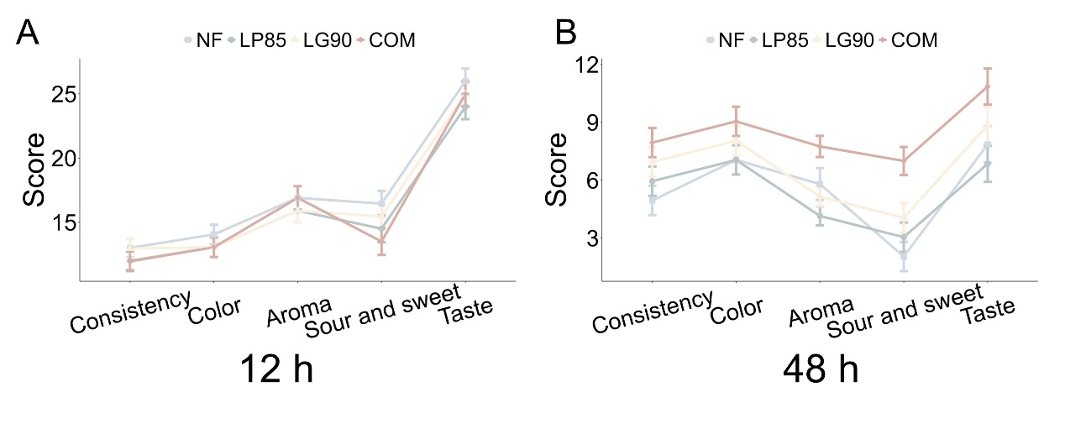
Figure.S1 Sensory score during 12 h (A) and 48 h (B) of fermentation, respectively.
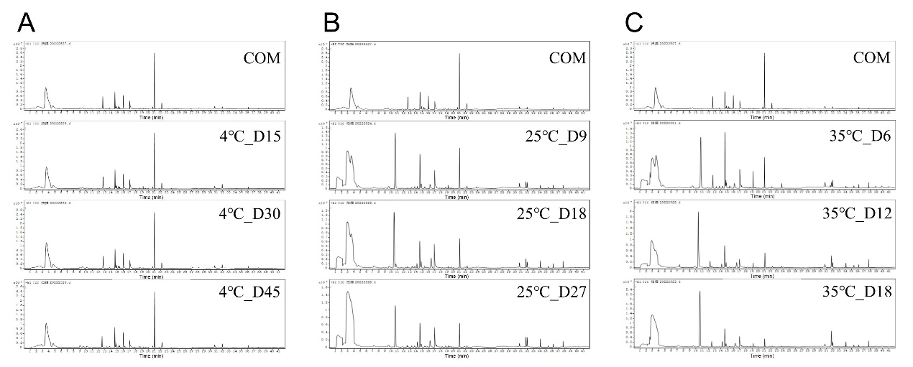
Figure.S2 Changes in the volatile substance spectrum of COM fermented kiwifruit juice at different storage temperatures. (A) the total ion chromatogram of GC-MS analysis at 4℃. (B) the total ion chromatogram of GC-MS analysis at 25℃. (C) the total ion chromatogram of GC-MS analysis at 35℃.
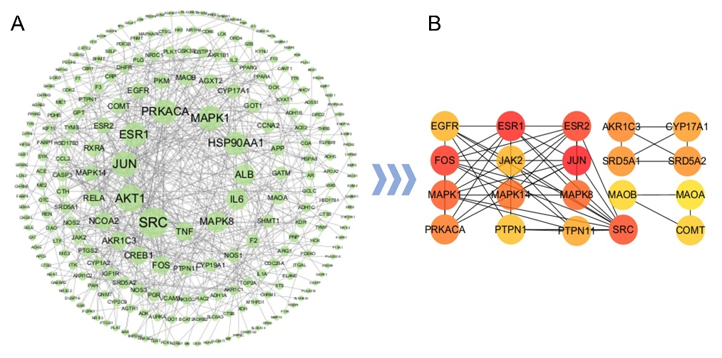
Figure.S3 Analysis of Network pharmacology in kiwifruit juice fermented by COM. (A) protein-protein interaction network diagram. (B) top 20 hubgenes.

