Supporting Information

Unveiling and Optimizing the Role of ALD-SnO₂ in Perovskite Solar Cells
Junhyuk Gong¹, Minkyu Song¹, Young Kee Kim¹, and Gyu Min Kim^{1*}
^{1*}Department of Chemical Engineering, Research Center of Chemical Technology, Hankyong National University, Anseong 17579, Gyeonggi-do, Republic of Korea.

*Corresponding author(s). E-mail(s): gyumin@hknu.ac.kr;

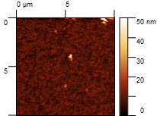
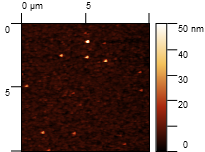
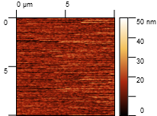
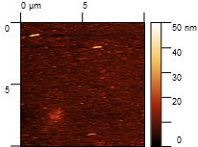
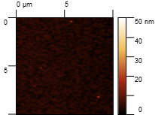
(a)
(b)
(c)
(d)
(e)
Figure S1. 2D Atomic force microscopy (AFM) surface images of various ETL configurations: (a) No ETL, (b) SC, (c) ALD, (d) SC+ALD, and (e) ALD+SC.

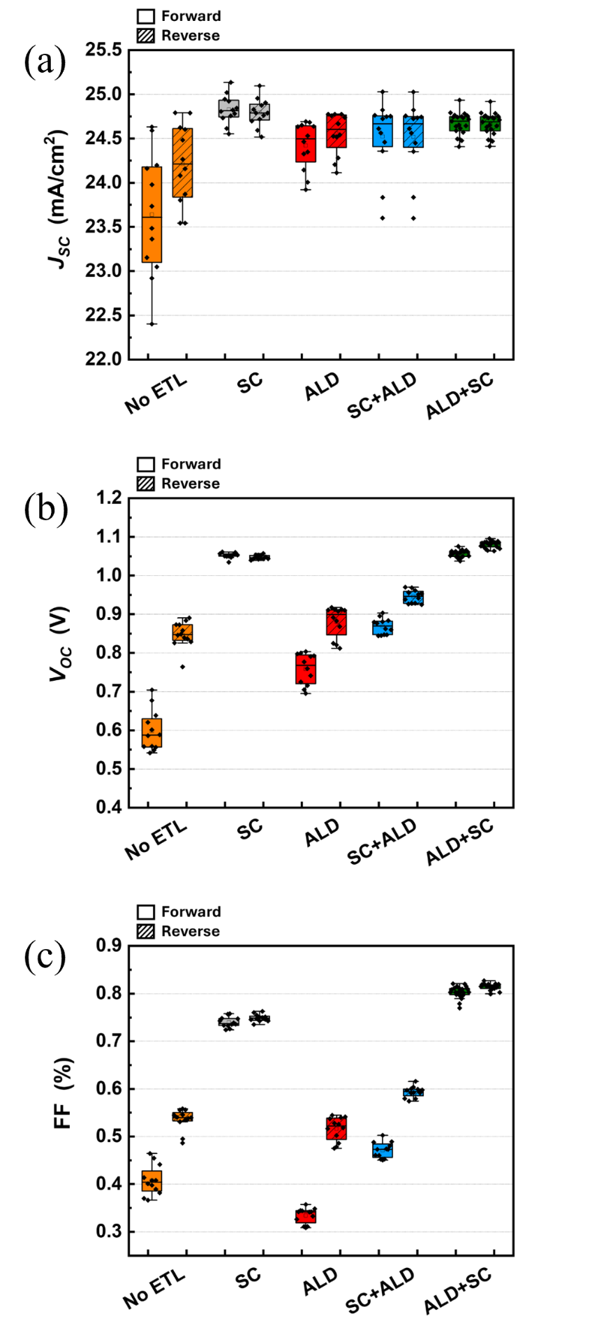
Figure S2. Box plots of (a) short-circuit current density (J_{SC}), (b) open-circuit voltage (V_{OC}), and (c) fill factor (FF), comparing the variations among different ETL structures.
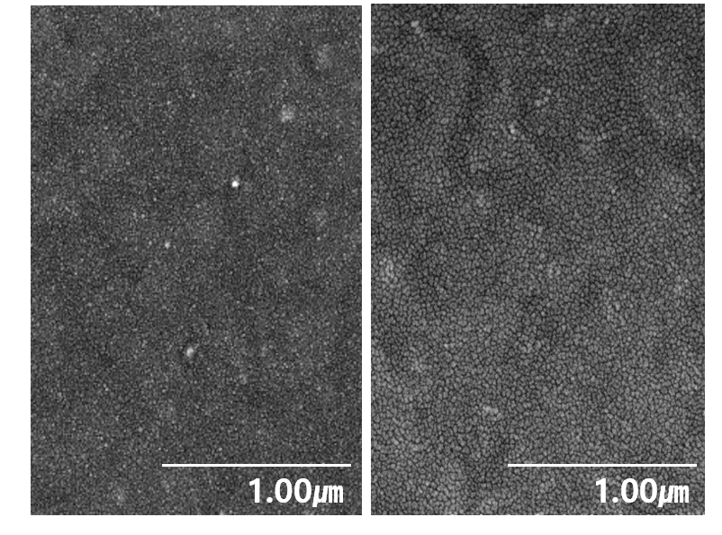

Figure S3. Scanning electron microscope (SEM) images of the perovskite films at 50k magnification: the left image shows the SC sample, and the right image shows the ALD+SC sample.

Table S1. Detailed ALD process parameters for SnO₂ film deposition using tetrakis(dimethylamino)tin (TDMASn) as the tin precursor, including pulse and purge times for each precursor and co-reactant. All time values are in seconds.
 |  | Sn assist (s) |  | Sn delay (s) |  | Sn pulse (s) |  | Sn purge (s) | H₂O pulse (s) | H₂O purge (s)
MFC flow | 60 |  | 60 |  | 60 |  | 60 |  | 60 | 60
MFC screen time | 0.2 |  | 1 |  | 1 |  | 20 |  | 0.3 | 20

