Temporal variations and characteristics of microplastics in indoor and outdoor air

Kuan-Ting Lin¹ (u109070201@cmu.edu.tw)
I-An Chen¹ (u108026487@cmu.edu.tw)
Kuan-Yuan Chen¹ (u107026496@cmu.edu.tw)
Chien-Cheng Jung^{1*} (ccjung@mail.cmu.edu.tw)

¹ Department of Public Health, China Medical University, Taichung City, Taiwan

*Corresponding author: Chien-Cheng Jung, Department of Public Health, China Medical University, No. 100, Sec. 1, Jingmao Rd., Beitun Dist., Taichung City 40640, Taiwan. (TEL: +886-4-22053366#6112, FAX: +886-4-22019901, E-mail: ccjung@mail.cmu.edu.tw)
Table S1. Summary of building characteristics and occupants’ activities from all study houses.
 | Building  characteristics | Occupants’ activities
 | Building  characteristics | Weekdays | Weekends
Volume (m-3) | 51 ± 40 | - | -
Area (m-2) | 18 ± 13 | - | -
Floor material#
Plastic | 30% | - | -
Non-plastic | 70% | - | -
Ceiling material#
Plastic | - | - | -
Non-plastic | 100% | - | -
Curtain material#
Plastic | 20% | - | -
Non-plastic | 80% | - | -
Windows opening (hr, average) | - | 9 (warm: 11; cold: 7) | 9 (warm: 7; cold: 11)
AC usage (hr, average) | - | 4 (warm: 7; cold: 0) | 3 (warm: 5; cold: 0)
Fan usage (hr, average) | - | 4 (warm: 6; cold: 0) | 4 (warm: 7; cold: 0)
Occupant stay home (hr, average) | - | 17 (warm: 17; cold: 17) | 17 (warm: 18; cold: 14)
AC: Air conditioner.
#These parameters were surveyed based on the questions below:
Please select the appropriate items based on the types of building materials:
- Floor material: □ plastic □ stone (marble, granite, or other) □ concrete □ wood □ tile □ floor cover with linseed oil □ unclear □ other
- Ceiling material: □ plastic board □ concrete cover with paint □ concrete □ wood
□ calcium silicate board or plasterboard □ wallpaper (plastic) □ wallpaper (non-plastic)
□ unclear □ other
- Curtain material: □ none □ plastic □ textile □ wood □ metal □ leather or artificial leather □ unclear □ other

Table S2. Summary of CO₂ concentrations and ventilation rates (mean ± SD) in indoor and outdoor air in study houses.
 | Indoor air | Outdoor air | p-value#
CO₂ (ppm)
Overall | 773 ± 221 (n = 34) | 518 ± 20 (n = 34) | < 0.05
Warm season | 804 ± 256 (n = 20) | 519 ± 19 (n = 20) | < 0.05
Cold season | 733 ± 167 (n = 14) | 519 ± 21 (n = 14) | < 0.05
p-value## | 0.38 | 0.95
Weekdays | 782 ± 220 (n = 17) | 518 ± 20 (n = 17) | < 0.05
Weekends | 764 ± 230 (n = 17) | 520 ± 20 (n = 17) | < 0.05
p-value### | 0.83 | 0.99
Ventilation rate (hr-1)
Overall | 2.01 ± 1.05 (n = 34) | -
Warm season | 2.14 ± 1.02 (n = 20) | -
Cold season | 1.84 ± 1.09 (n = 14) | -
p-value## | 0.78
Weekdays | 2.16 ± 1.16 (n = 17) | -
Weekends | 1.85 ± 0.93 (n = 17) | -
p-value### | 0.40
SD.: standard deviation.
#The difference between CO₂ concentrations of indoor and outdoor air is determined by using a Wilcoxon-Mann Whitney test.
##The difference between CO₂ concentrations or ventilation rates of warm and cold seasons is determined by using a Wilcoxon-Mann Whitney test.
###The difference between CO₂ concentrations or ventilation rates on weekdays and weekends is determined by using a Wilcoxon-Mann Whitney test.
Table S3. Summary of temperature and RH (mean ± SD) in indoor and outdoor air in study houses.
 | Indoor air | Outdoor air | p-value#
Temperature (℃)
Overall | 25.6 ± 3.5 (n = 34) | 24.5 ± 5.2 (n = 34) | 0.32
Warm season | 27.8 ± 2.5 (n = 20) | 27.5 ± 3.7 (n = 20) | 0.82
Cold season | 22.9 ± 2.4 (n = 14) | 20.3 ± 4.0 (n = 14) | < 0.05
p-value## | < 0.05 | < 0.05
Weekdays | 25.5± 3.7 (n = 17) | 24.5 ± 5.2 (n = 17) | 0.50
Weekends | 25.7 ± 3.3 (n = 17) | 24.6 ± 5.4 (n = 17) | 0.48
p-value### | 0.88 | 0.93
RH (%)
Overall | 67 ± 8 (n = 34) | 72 ± 7 (n = 34) | < 0.05
Warm season | 63 ± 7 (n = 20) | 71 ± 5 (n = 20) | < 0.05
Cold season | 72 ± 6 (n = 14) | 74 ± 9 (n = 14) | 0.66
p-value## | < 0.05 | < 0.05
Weekdays | 67 ± 8 (n = 17) | 72 ± 7 (n = 17) | 0.06
Weekends | 67 ± 8 (n = 17) | 72 ± 8 (n = 17) | 0.13
p-value### | 0.83 | 0.94
SD.: standard deviation.
#The difference between temperature or RH values of indoor and outdoor air is determined by using a Wilcoxon-Mann Whitney test.
##The difference between temperature or RH values of warm and cold seasons is determined by using a Wilcoxon-Mann Whitney test.
###The difference between temperature or RH values on weekdays and weekends is determined by using a Wilcoxon-Mann Whitney test.
Table S4. A questionnaire with human activity indoors.
- If any of the following activities occur during the sampling period, please record the period of each activity in the form below.
Period |  | 0:00-1:00 | 1:00-2:00 | 2:00-3:00 | 3:00-4:00 | 4:00-5:00 | 5:00-6:00 | 6:00-7:00 | 7:00-8:00 | 8:00-9:00 | 9:00-10:00 | 10:00-11:00 | 11:00-12:00 | 12:00-13:00 | 13:00-14:00 | 14:00-15:00 | 15:00-16:00 | 16:00-17:00 | 17:00-18:00 | 18:00-19:00 | 19:00-20:00 | 20:00-21:00 | 21:00-22:00 | 22:00-23:00 | 23:00-24:00
Number of occupants
Human activity | Activity |  |  |  |  | ~ |  | 06:30 |  | 09:00 |  | Example
Human activity | Open door
Human activity | Open window
Human activity | AC
Human activity | Fan
Human activity | Heater
Human activity | Air cleaner
Human activity | Smoking
Human activity | Incense burning
Human activity | Cooking
Human activity | Other

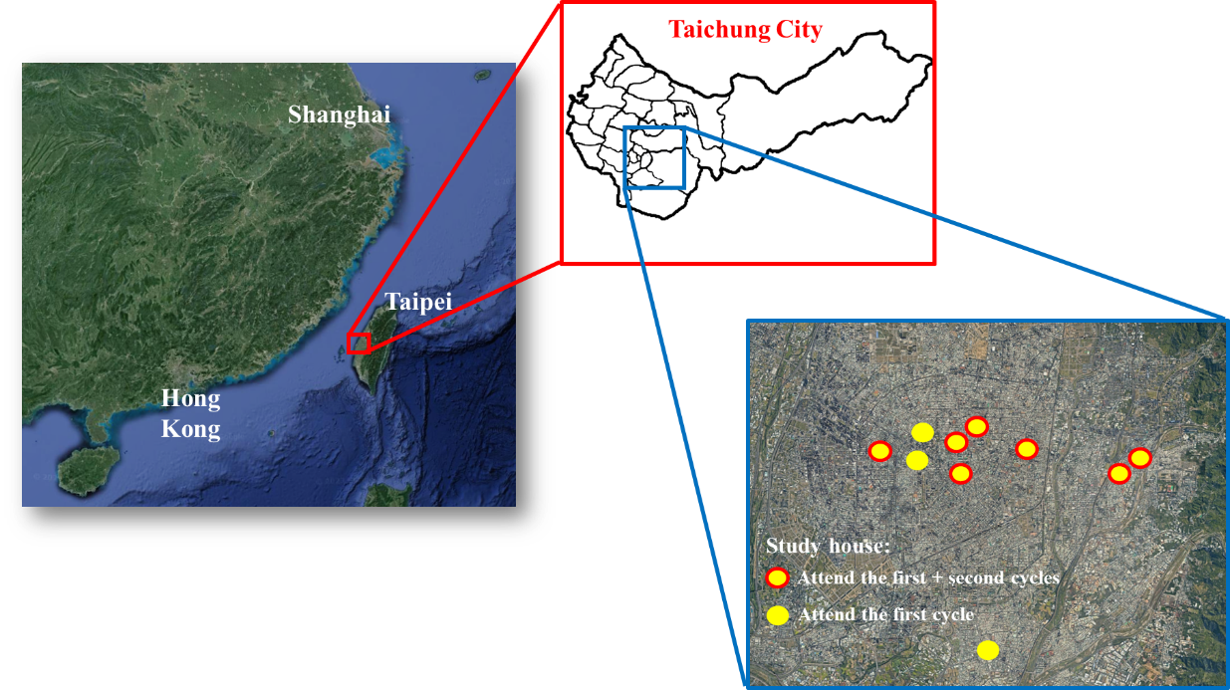
Fig. S1. The locations of study houses in the study.
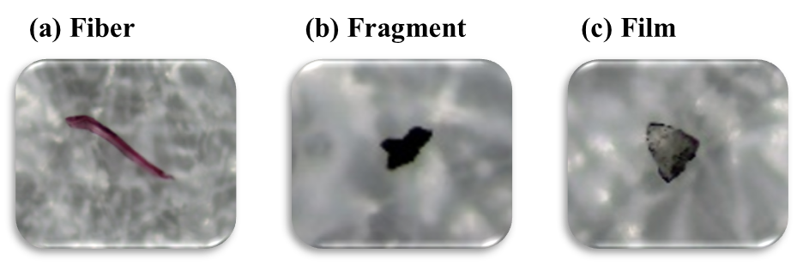
Fig. S2. Images of MPs in different shapes from samples: (a) fiber, (b) fragment, and (c) film.
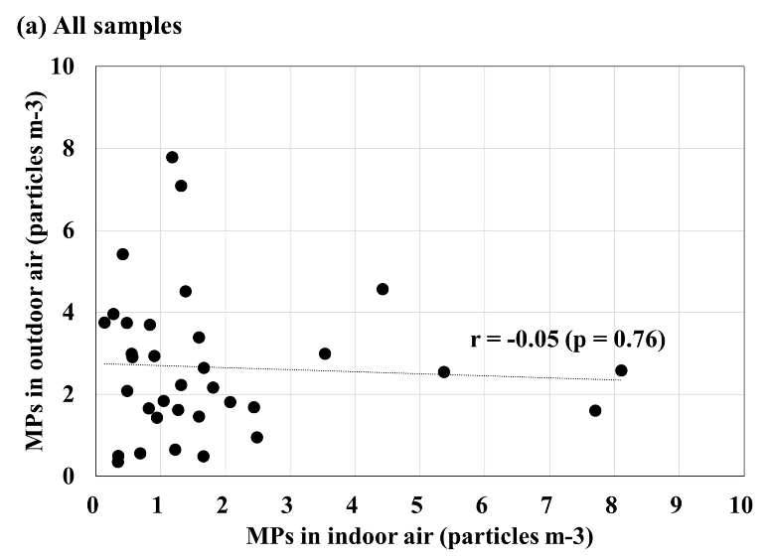
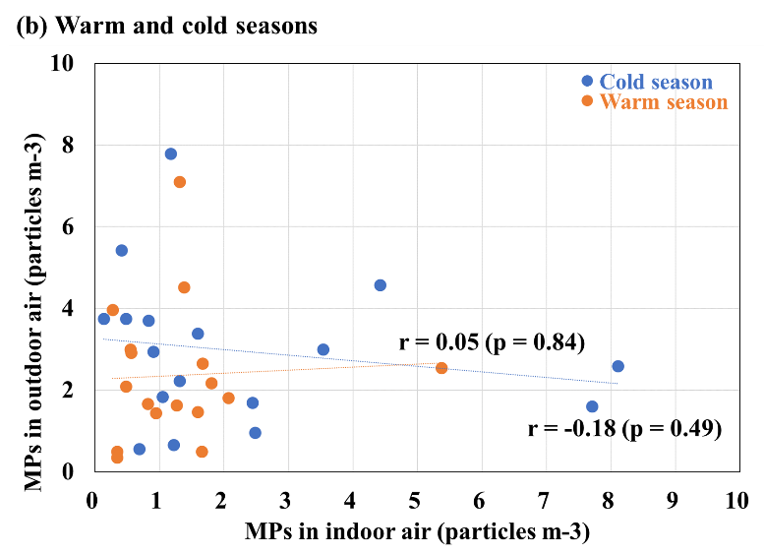
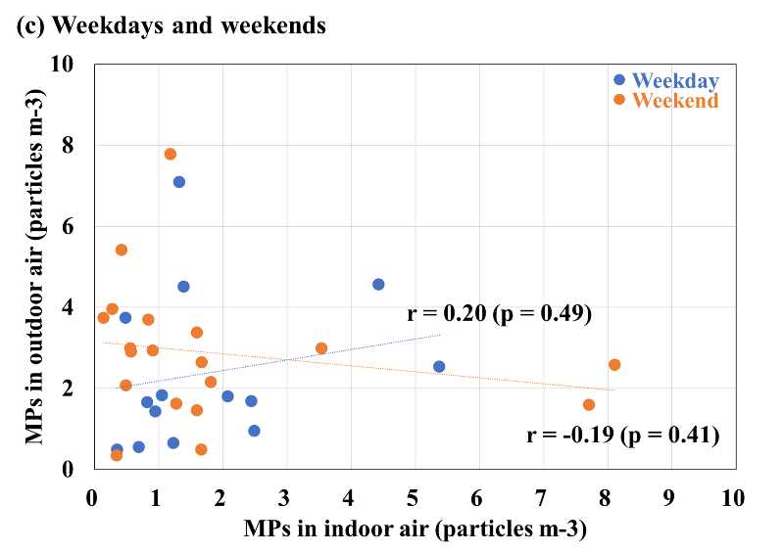
Fig. S3. Correlations between MP concentrations of indoor and outdoor air in (a) all samples, (b) warm and cold seasons, and (c) weekdays and weekends.

