Supplementary material

 |  | Percentage contribution of different chlorine species (%)
Category | Sub-category | HCl (361 Gg) | Fine particulate Cl- (174Gg) | Cl2 (18Gg) | HOCl (79Gg)
Coal combustion | Power | 5 | 1 | 4
 | Industry | 32 | 8 | 28
 | Resident | 9 | 2 | 7
 | Agriculture | 1 |  | 2
Industry Process | Cement production | 10 | 5
 | Iron production | 1 | 3
 | Steel production |  | 4
 | Hydrochloric acid production
 | Glass production
MSW incineration | MSW incineration station | 1
 | MSW open burning | 3 | 3
 | Medical waste incineration
Biomass burning | Biomass household burning | 13 | 29
 | Biomass open burning | 25 | 44
Disinfectant | Cooling tower |  |  | 1 | 2
 | Water treatment |  |  | 18 | 30
 | Waste water treatment |  |  | 25 | 42
 | Swimming pool |  |  | 6 | 9
 | Environmental disinfection |  |  | 8 | 13
 | Tap water use |  |  | 1 | 2
 | Insecticide |  |  |  | 1
Other |  |  | 1 |  | 1

Table S1: Contribution of different source categories to the anthropogenic emissions of HCl, Particulate Cl⁻, Cl₂, and HCl in 2019 in China (Li et al., 2024).

 | Cl- ion concentration in μg/m³
Sample ID | 1st cycle | 2nd cycle | Percentage of Cl⁻ in 2nd cycle
AJ8 | 0.61 | 0.13 | 20.86
AJ15 | 0.30 | 0.07 | 21.89
AJ45 | 0.62 | 0.11 | 18.19
AJ66 | 0.18 | 0.03 | 17.26
 |  | Average factor (%) | 19.55
 |  | Estimated Factor | 0.1955
Table S2. This table shows the efficiency factor calculation for the particulate Cl⁻ concentration calculation. This factor (0.1955) was multiplied with the all the readings to get the final concentration.

 | Cl- ion concentration in μg/m³
Sample ID | 1st impinger | 2nd impinger | 3rd impinger | 4th impinger | Sum (2nd+3rd +4th) | Percentage (2nd+3rd +4th)
GJNU65 | 0.137143 | 0.106286 | 0.083714 | 0.045352 | 0.235352 | 171.6108
GJNU08 | 0.068584 | 0.067446 | 0.042305 | 0.027698 | 0.137449 | 200.4101
GJNU30 | 0.088167 | 0.088457 | 0.034569 | 0.012695 | 0.135721 | 153.9363
 |  |  |  |  | Average  factor (%) | 175.3191
 |  |  |  |  | Estimated factor | 1.75
Table S3. This table shows the efficiency factor calculation for the gaseous Cl₂ concentration. This factor (1.75) was multiplied with all the reading to get the final concentration.

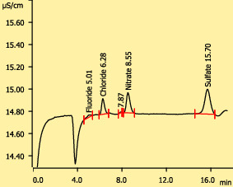
Chromatogram of a particulate sample (Sample ID: AJNU24-14)
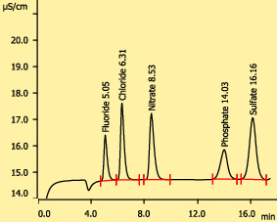Chromatogram for the standard solution of 2 PPM for the anions
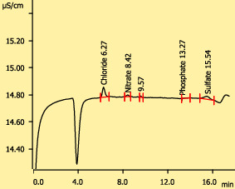
Chromatogram of a gaseous sample (Sample ID: GJNU24-14)

Figure S1. This figure shows the chromatogram of the two samples (both gaseous and particulate) along with the standard solution of 2 PPM concentration.

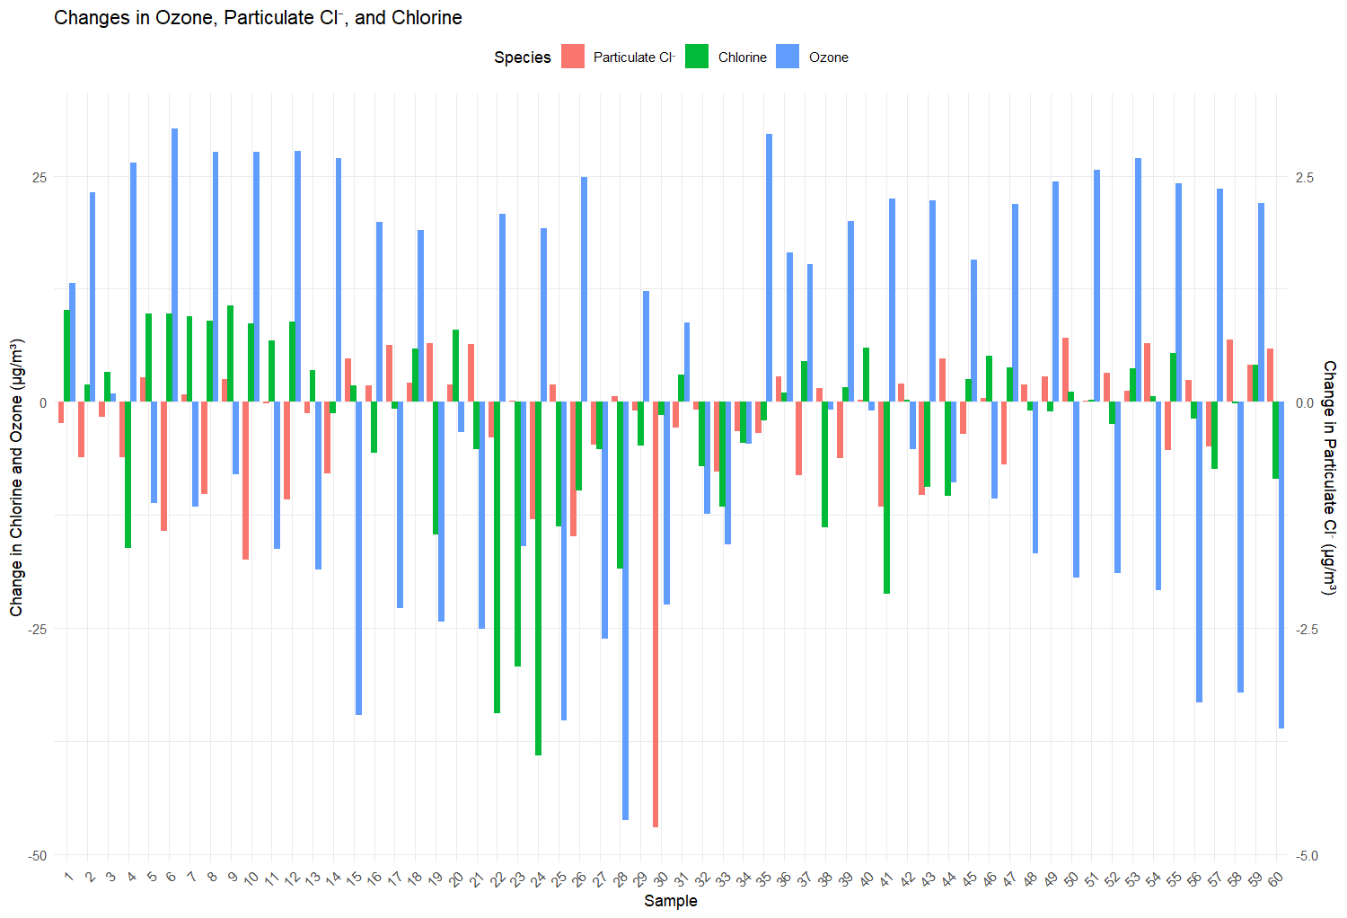
Figure S2. Representation of the changes in the ozone concentration due to changes in the concentration of the particulate Cl⁻ and chlorine in the troposphere.

References:

Li, S., Liu, Y., Zhu, Y., Jin, Y., Hong, Y., Shen, A., ... & Fan, Q. (2024). ACEIC: a comprehensive anthropogenic chlorine emission inventory for China. Atmospheric Chemistry and Physics, 24(20), 11521-11544.

