Supplementary Information
The dispersion and exposure to aerosols from toilet and urinal flushing under the effect of closing toilet lid and different ventilation rates in a public washroom

Cunteng Wang, Jingcui Xu, Haoyu Zhai, Lok Kwan So, Hai Guo*

Indoor Air and Aerosol Science Laboratory, Department of Civil and Environmental Engineering, The Hong Kong Polytechnic University, Hong Kong, China

*Corresponding email: hai.guo@polyu.edu.hk

Address: ZS933, Block Z, The Hong Kong Polytechnic University, Hung Hom, Hong Kong

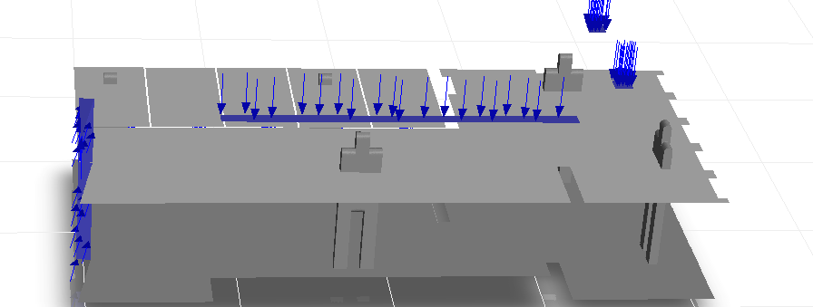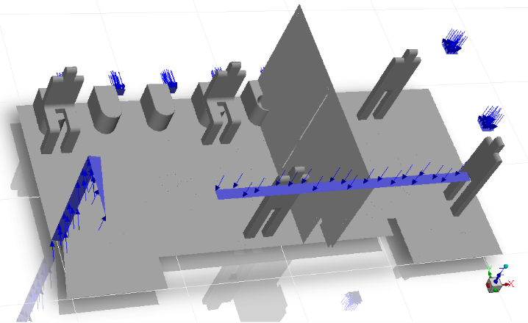
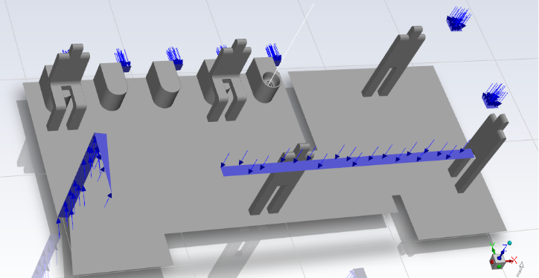
Figure S1. Plane passing the entire washroom in the z direction, plane passing toilet bowl S2, and the line passing the toilet bowl for velocity comparison.

Figure S2. Numerical settings used to validate the positions of five sampling poles.

Figure S3. Comparison of velocities along five typical lines between numerical results and experimental measurements.
Figure S4. Comparison of numerical results with experimental measurements of temperature along five typical lines.
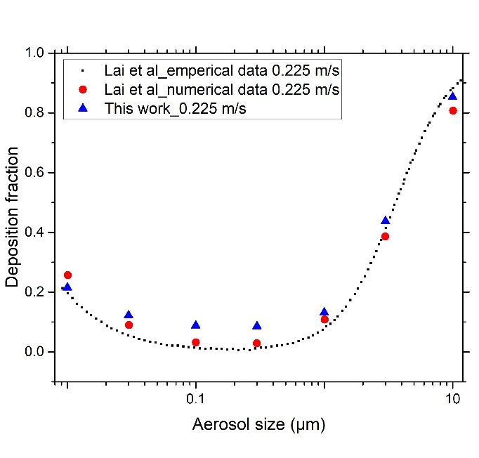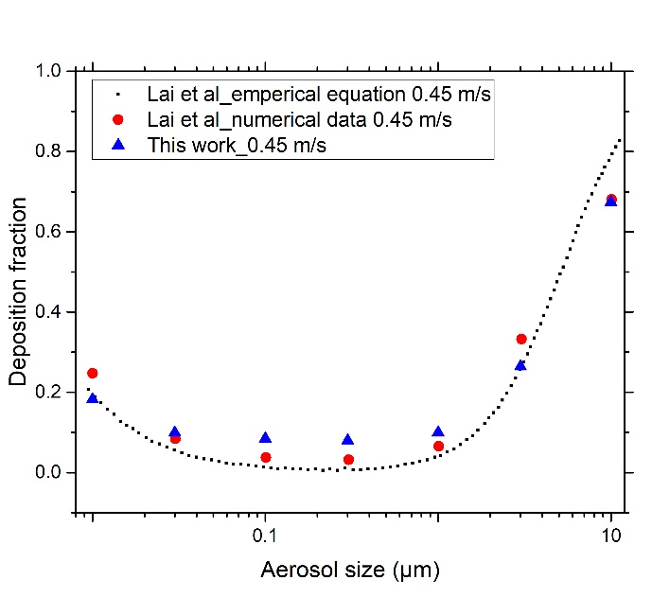
Figure S5. Comparison of the numerical modeling results in this work with the deposition fractions obtained from reference.

