Supplementary Information
Quantifying residential particulate pollution and human exposure in Ibadan, Nigeria, using low-cost sensors

Aishah I. Shittu^{1,2}, Richard J. Pope^{3,4}, Kirsty J. Pringle⁵, Stephen R. Arnold¹, Ailish M. Graham¹, Huswah O. Sideeq⁶, Godson R.E.E. Ana⁶, James B. McQuaid¹

¹Institute for Climate and Atmospheric Science, University of Leeds, Leeds, UK
²Science Laboratory Technology Department, Federal Polytechnic Ilaro, Nigeria
³School of Earth and Environment, University of Leeds, Leeds, UK
⁴National Centre for Earth Observation, University of Leeds, Leeds, UK
⁵Edinburgh Parallel Computing Center, University of Edinburgh, Edinburgh, UK
⁶Environmental Health Sciences Department, University of Ibadan, Nigeria

Corresponding Author: eeais@leeds.ac.uk

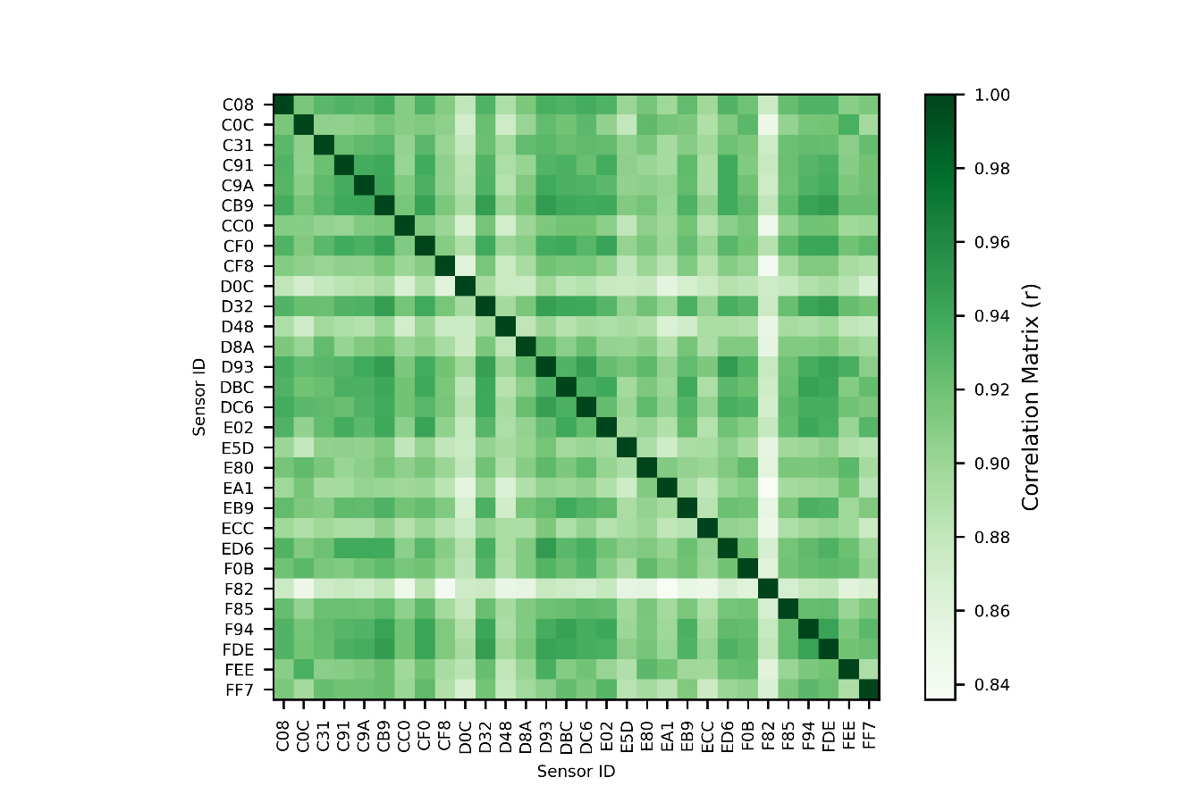
Supplementary Fig. S1. Coefficient of correlation showing inter-sensor variability of Atmotube Pro sensors collated together prior to data collection.

Supplementary Table S 1. PM_{2.5} Atmotube Pro sensor data descriptives (One-minute data)
Location |  |  |  |  |  | Percentiles
 |  | AM | SD | GM | GSD | 10th | 25th | 50th | 75th | 95th | 99th | Max
A | Indoor | 20.0 | 20.5 | 16.3 | 1.8 | 9.0 | 11.0 | 15.0 | 21.0 | 40.0 | 112.6 | 283.0
A | Outdoor | 17.1 | 20.5 | 13.7 | 1.8 | 7.0 | 9.0 | 13.0 | 19.0 | 33.0 | 82.0 | 485.0
B | Indoor | 20.3 | 13.3 | 17.5 | 1.7 | 9.0 | 12.0 | 17.0 | 24.0 | 46.0 | 65.8 | 296.0
B | Outdoor | 18.1 | 20.2 | 15.4 | 1.7 | 8.0 | 11.0 | 15.0 | 21.0 | 38.0 | 59.0 | 892.0
C | Indoor | 20.1 | 30.7 | 15.7 | 1.8 | 8.0 | 10.0 | 16.0 | 23.0 | 40.0 | 77.3 | 834.0
C | Outdoor | 16.3 | 29.9 | 12.4 | 1.9 | 6.0 | 8.0 | 12.0 | 18.0 | 33.0 | 74.0 | 886.0
D | Indoor | 17.0 | 9.9 | 14.6 | 1.8 | 7.0 | 10.0 | 15.0 | 21.0 | 39.0 | 51.0 | 64.0
D | Outdoor | 14.0 | 14.3 | 12.1 | 1.7 | 6.0 | 9.0 | 13.0 | 18.0 | 26.0 | 34.0 | 785.0
E | Indoor | 15.9 | 8.5 | 14.0 | 1.7 | 7.0 | 10.0 | 15.0 | 20.0 | 30.0 | 43.0 | 140.0
E | Outdoor | 20.6 | 12.7 | 17.7 | 1.7 | 9.0 | 12.0 | 18.0 | 27.0 | 42.0 | 57.0 | 376.0
F | Indoor | 18.5 | 12.8 | 15.3 | 1.9 | 7.0 | 10.0 | 15.6 | 23.0 | 40.0 | 70.8 | 179.0
F | Outdoor | 28.2 | 44.3 | 21.1 | 1.9 | 10.0 | 14.0 | 20.0 | 30.0 | 59.0 | 171 | 868.0
G | Indoor | 15.1 | 9.7 | 12.8 | 1.8 | 6.0 | 9.0 | 12.0 | 19.0 | 36.0 | 53.0 | 73.0
G | Outdoor | 15.6 | 7.6 | 13.9 | 1.6 | 7.0 | 10.0 | 14.0 | 20.0 | 30.0 | 39.0 | 58.0
H | Indoor | 15.4 | 14.8 | 12.7 | 1.8 | 6.0 | 9.0 | 12.0 | 19.0 | 31.0 | 46.0 | 331.0
H | Outdoor | 22.7 | 16.0 | 19.4 | 1.7 | 10.0 | 13.0 | 19.0 | 28.0 | 47.0 | 63.0 | 256.0
I | Indoor | 21.6 | 20.4 | 17.8 | 1.8 | 8.0 | 12.0 | 18.0 | 27.0 | 43.0 | 74.0 | 573.0
I | Outdoor | 19.0 | 16.1 | 16.0 | 1.8 | 8.0 | 11.0 | 16.0 | 24.0 | 41.0 | 56.0 | 567.0
J | Indoor | 17.8 | 22.4 | 14.8 | 1.7 | 7.0 | 11.0 | 15.0 | 21.0 | 36.0 | 55.0 | 793.0
J | Outdoor | 18.8 | 11.5 | 16.3 | 1.7 | 9.0 | 11.0 | 16.0 | 23.0 | 40.0 | 57.0 | 293.0
K | Indoor | 15.2 | 8.2 | 13.5 | 1.6 | 7.0 | 10.0 | 14.0 | 18.0 | 29.0 | 42.0 | 141.0
K | Outdoor | 19.3 | 10.9 | 16.9 | 1.7 | 9.0 | 12.0 | 17.0 | 24.0 | 38.0 | 53.0 | 196.0
L | Indoor | 14.5 | 10.8 | 12.1 | 1.8 | 6.1 | 8.0 | 12.0 | 17.9 | 31.0 | 40.0 | 178.9
L | Outdoor | 18.4 | 13.4 | 15.7 | 1.7 | 8.0 | 11.0 | 16.0 | 23.0 | 35.0 | 51.9 | 365.0
Key: AM = Arithmetic mean; SD = Standard deviation; GM = Geometric mean; GSD = Geometric standard deviation

Supplementary Table S 2.PM_{2.5} Purple Air sensor data descriptives (Two-minute data)
Location |  |  |  |  |  | Percentiles
 |  | AM | SD | GM | GSD | 10th | 25th | 50th | 75th | 95th | 99th | Max
AK | I | 50.3 | 40.9 | 37.2 | 2.3 | 14.8 | 23.0 | 36.9 | 66.1 | 137.2 | 189.8 | 529
AK | O | 62.7 | 50.4 | 46.8 | 2.2 | 19.3 | 28.3 | 46.7 | 81.2 | 172.6 | 240.0 | 584
UI | I | 60.6 | 61.8 | 39.8 | 2.5 | 13.7 | 22.0 | 36.2 | 77.5 | 194.2 | 277.8 | 990
UI | O | 64.3 | 61.7 | 43.7 | 2.5 | 16.8 | 24.1 | 40.4 | 82.5 | 202.5 | 287.6 | 852
School | H | 76.6 | 59.7 | 58.5 | 2.1 | 23.5 | 33.2 | 57.7 | 98.8 | 207.8 | 285.3 | 434
Key: I = Indoor; O = Outdoor; H = Hybrid; AM = Arithmetic mean; SD = Standard deviation; GM = Geometric mean; GSD = Geometric standard deviation

