Table S1 WRF and CMAQ model configurations
WRF version 4.2.1 | Settings
Microphysics | WSM 6-class graupel scheme
Radiation Physics (lw) | RRTM scheme
Radiation Physics (sw) | Dudhia scheme
Surface Layer | Revised MM5 Monin-Obukhov scheme
Land/Water Surface | unified Noah land-surface model
PBL Physics | MYNN2 scheme
Cumulus Parameterization | Grell-Freitas ensemble scheme
CMAQ version 5.5
The generalized-coordinate driver module | Yamartino scheme
The time-step initialization module | Yamartino scheme
Mass conservation error adjustment scheme | Yamartino scheme
Horizontal advection module | global mass-conserving scheme
Vertical advection module | global mass-conserving scheme
Horizontal diffusion module | diffusion coefficient based on local wind deformation
Vertical diffusion module | eddy diffusivity theory
Photolysis calculation module | In-line method and using ozone monitoring instrument (OMI) column data for photolysis input.
Gas-phase chemistry solver module | cb6r3
aerosol module | Ae7_aq
aerosol deposition velocity module | second-generation CMAQ aerosol deposition velocity routine
cloud module | ACM cloud processor that uses the ACM methodology to  compute convective mixing

Table S2 Formulas for statistical evaluation indices.
Statistical index | Formula | Variable
1. Mean Bias | 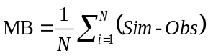 | Temp, WS, RH (hour)
2. Mean Average Gross Error | 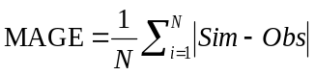 | Temp, RH (hour)
3. Root Mean Square Error | 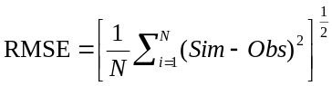 | WS (hour)
4. Index of agreement, IOA | IOA = 1 $-$ $\frac{\sum_{i=1}^{N}{{(Sim-Obs)}^{2}}}{\sum_{i=1}^{N}{({|Sim-\overline{Obs}|+|Obs-\overline{Obs}|)}^{2}}}$ | Temp, WS, RH (hour), PM_{2.5}, SO₂, NO₂ (day), NMHC, O₃ (hour),
5. Wind Normalized Mean Bias | WNMB = $\frac{\sum_{i=1}^{N}{(Sim-Obs)}}{N×360°}$ $×100\%$ | WD (hour)
6. Wind Normalized Mean Error | WNME = $\frac{\sum_{i=1}^{N}{|Sim-Obs|}}{N×360°}$ $×100\%$ | WD (hour)
7. Mean Fractional Bias | 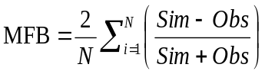$×100\%$ | PM_{2.5}, SO₂, NO₂ (day)
8. Mean Fractional Error | 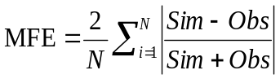$×100\%$ | PM_{2.5}, SO₂, NO₂ (day)
9. Mean Normalized Bias | 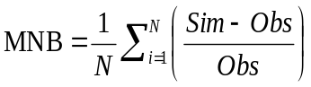$×100\%$ | NMHC, O₃ (hour)
10. Mean Normalized Error | 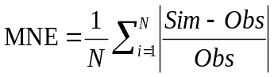$×100\%$ | NMHC, O₃ (hour)
11. Maximum Peak Normalized Bias | 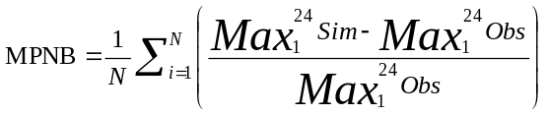 | O₃ (hour)
12. Normalized Mean Bias | 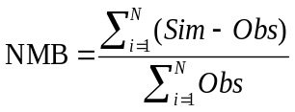$×100\%$ | PM_{2.5}, PM_{2.5} species (PM_{2.5} sampling days)
13. Normalized Mean Error | 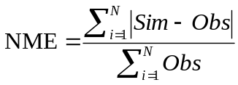$×100\%$ | PM_{2.5}, PM_{2.5} species (PM_{2.5} sampling days)
14. Fractional Bias | 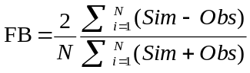$×100\%$ | PM_{2.5}, PM_{2.5} species (PM_{2.5} sampling days)
15. Fractional Error | 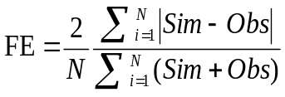$×100\%$ | PM_{2.5}, PM_{2.5} species (PM_{2.5} sampling days)
16. Correlation coefficient (r) | r = $\frac{1}{N}\sum_{i=1}^{N}{[\frac{(Sim-\overline{Sim})(Obs-\overline{Obs})}{S_{p}S_{o}}}$]  $S_{P}$ = ${\left[\frac{1}{N}\sum_{i=1}^{N}{{(Sim-\overline{Sim})}^{2}}\right] }^{\frac{1}{2}}$  $S_{o}$= ${\left[\frac{1}{N}\sum_{i=1}^{N}{{(Obs-\overline{Obs})}^{2}]}\right]}^{\frac{1}{2}}$ | NMHC, O₃ (hour) and PM_{2.5}, SO₂, NO₂ (day)
Note: Temp, WS, WD, RH represent Temperature, Wind Speed, Wind Direction, and Relative Humidity. PM_{2.5} species represent SO₄²⁻, NH₄⁺, NO₃⁻, OC, EC. PM_{2.5} sampling days (3, 9,15,21 and 27 April 2019).
Table S3 The performance of meteorological modeling results for domain 4 from 22 March to 30 April 2019.
 | Temperature |  |  |  |  | Wind Speed |  |  |  |  | Wind Direction |  | Relative Humidity
 | Avg  Mod | Avg  Obs | MB | MAGE | IOA | Avg  Mod | Avg  Obs | MB | RMSE | IOA | WNMB | WNME | Avg  Mod | Avg  Obs | MB | MAGE | IOA
Standard  Sta. | (°C) | (°C) | ±1.5 | <3 | >0.7 | (m s⁻¹) | (m s⁻¹) | ±1.5 | <3 | >0.6 | ±10% | <30% | (%) | (%) | - | -
KL | 22.1 | 22.1 | 0.0 | 0.5 | 0.99 | 2.2 | 2.6 | -0.4 | 0.7 | 0.94 | 1.7 | 11.2 | 81.3 | 81.2 | 0.1 | 3.7 | 0.91
TP | 23.0 | 23.2 | -0.2 | 0.6 | 0.99 | 2.0 | 2.3 | -0.3 | 0.6 | 0.96 | -2.3 | 12.3 | 76.9 | 76.9 | -0.2 | 4.7 | 0.93
ZZ | 17.6 | 18.6 | -0.9 | 1.2 | 0.96 | 2.4 | 1.9 | 0.5 | 0.9 | 0.93 | -3.1 | 14.4 | 92.4 | 87.2 | 5.2 | 7.5 | 0.68
AB | 17.4 | 17.1 | 0.4 | 0.8 | 0.98 | 2.4 | 2.5 | -0.1 | 1.0 | 0.88 | -10.4 | 25.5 | 92.8 | 92.5 | 0.3 | 4.3 | 0.84
FG | 20.5 | 20.2 | 0.3 | 0.7 | 0.98 | 2.1 | 2.0 | 0.1 | 0.5 | 0.95 | -1.0 | 11.0 | 86.6 | 91.6 | -5.0 | 6.6 | 0.76
WL | 19.2 | 19.7 | -0.5 | 1.1 | 0.97 | 1.9 | 1.9 | 0.0 | 0.8 | 0.92 | -2.6 | 15.1 | 88.8 | 92.7 | -3.9 | 7.3 | 0.76
TS | 22.2 | 22.1 | 0.1 | 0.8 | 0.97 | 1.8 | 1.5 | 0.2 | 0.5 | 0.95 | 1.8 | 13.8 | 82.2 | 84 | -1.8 | 4.8 | 0.87
BQ | 23.2 | 22.8 | 0.4 | 0.7 | 0.99 | 1.7 | 1.9 | -0.2 | 0.5 | 0.96 | 1.1 | 14.1 | 75.7 | 77.5 | -1.7 | 4.0 | 0.94
TY | 22.5 | 22.4 | 0.1 | 0.6 | 0.99 | 1.1 | 0.6 | 0.4 | 0.6 | 0.84 | -2.8 | 17.6 | 77.7 | 78.9 | -1.2 | 4.3 | 0.94
XW | 22.0 | 22.2 | -0.2 | 0.8 | 0.97 | 4.2 | 4.5 | -0.3 | 0.8 | 0.98 | -1.6 | 7.9 | 84.5 | 81.6 | 2.8 | 4.5 | 0.87
HC | 22.9 | 22.7 | 0.2 | 0.6 | 0.99 | 1.7 | 1.6 | 0.1 | 0.4 | 0.98 | -1.1 | 12.5 | 76.5 | 77.5 | -1.0 | 3.5 | 0.93
ML | 22.9 | 22.9 | 0.1 | 0.5 | 0.99 | 2.0 | 1.9 | 0.1 | 0.4 | 0.98 | -3.4 | 11.0 | 77.7 | 79 | -1.2 | 4.7 | 0.92
TC | 24.8 | 24.0 | 0.8 | 0.9 | 0.97 | 1.4 | 1.3 | 0.1 | 0.4 | 0.96 | 4.1 | 14.1 | 72.5 | 79.4 | -6.9 | 7.0 | 0.87
WQ | 23.6 | 23.0 | 0.6 | 0.7 | 0.98 | 3.3 | 3.9 | -0.6 | 0.9 | 0.94 | 4.0 | 8.9 | 77.2 | 79.5 | -2.3 | 4.1 | 0.86
FY | 23.6 | 22.7 | 0.9 | 1.0 | 0.97 | 1.5 | 1.3 | 0.2 | 0.3 | 0.94 | -0.7 | 10.9 | 76.5 | 84.8 | -8.4 | 9.5 | 0.82
XT | 24.1 | 23.5 | 0.6 | 0.8 | 0.98 | 1.7 | 1.5 | 0.2 | 0.4 | 0.96 | 2.7 | 15.0 | 74.6 | 79.3 | -4.7 | 5.9 | 0.89
DL | 25.2 | 24.9 | 0.3 | 0.6 | 0.99 | 1.4 | 1.4 | 0.0 | 0.3 | 0.96 | 2.5 | 13.8 | 70.9 | 75.7 | -4.7 | 6.0 | 0.90
EL | 23.8 | 23.1 | 0.8 | 0.9 | 0.97 | 2.4 | 2.5 | -0.1 | 0.5 | 0.98 | -0.3 | 8.4 | 74.7 | 88.1 | -13.4 | 13.5 | 0.69
LB | 23.5 | 23.2 | 0.3 | 0.8 | 0.97 | 2.1 | 2.0 | 0.2 | 0.4 | 0.98 | -2.4 | 9.2 | 77.3 | 85.5 | -8.2 | 8.5 | 0.83
CY | 25.1 | 24.5 | 0.6 | 1.0 | 0.97 | 1.8 | 1.8 | 0.0 | 0.4 | 0.97 | -0.3 | 11.4 | 71.7 | 76.0 | -4.2 | 5.2 | 0.89
AL | 13.8 | 11.3 | 2.5 | 2.5 | 0.78 | 1.5 | 1.4 | 0.1 | 0.4 | 0.89 | -8.8 | 22.6 | 73.3 | 80.0 | -6.7 | 9.8 | 0.90
TN | 25.3 | 25.3 | 0.0 | 0.5 | 0.99 | 2.6 | 2.7 | -0.1 | 0.5 | 0.97 | 4.8 | 10.4 | 71.9 | 73.9 | -2.0 | 3.7 | 0.92
YK | 25.5 | 25.0 | 0.5 | 0.7 | 0.98 | 2.5 | 2.6 | -0.1 | 0.5 | 0.97 | 0.9 | 8.8 | 71.0 | 74.9 | -3.9 | 4.7 | 0.87
KS | 25.3 | 26.3 | -1.0 | 1.1 | 0.90 | 2.4 | 2.2 | 0.2 | 0.4 | 0.98 | -4.2 | 10.0 | 79.9 | 74.6 | 5.4 | 6.3 | 0.75
HeC | 25.3 | 26.2 | -0.9 | 1.0 | 0.95 | 2.9 | 2.8 | 0.2 | 0.4 | 0.99 | 0.7 | 9.7 | 78.2 | 76.2 | 2.0 | 4.2 | 0.96
YL | 22.7 | 22.9 | -0.2 | 0.6 | 0.99 | 1.6 | 1.9 | -0.2 | 0.6 | 0.94 | -4.3 | 16.9 | 82.6 | 83.6 | -0.9 | 3.7 | 0.87
SA | 21.7 | 22.6 | -0.9 | 1.1 | 0.96 | 2.4 | 2.5 | -0.1 | 0.5 | 0.96 | -0.2 | 13.4 | 86.7 | 84.1 | 2.6 | 5.5 | 0.80
HL | 23.5 | 23.8 | -0.4 | 0.6 | 0.98 | 2.3 | 2.9 | -0.6 | 1.0 | 0.89 | -6.9 | 14.9 | 77.9 | 75.9 | 1.9 | 3.7 | 0.85
TT | 24.2 | 25.3 | -1.0 | 1.1 | 0.91 | 1.9 | 1.6 | 0.3 | 0.4 | 0.97 | 2.5 | 10.3 | 82.9 | 75.8 | 7.2 | 7.5 | 0.64
CG | 24.1 | 24.0 | 0.1 | 0.7 | 0.97 | 2.8 | 2.7 | 0.1 | 0.5 | 0.97 | -0.7 | 10.3 | 80.8 | 80.7 | 0.2 | 3.8 | 0.84
DW | 25.2 | 25.6 | -0.4 | 1.0 | 0.96 | 2.3 | 2.4 | -0.1 | 0.5 | 0.96 | 1.5 | 12.4 | 72.4 | 71.0 | 1.4 | 6.1 | 0.86
LY | 23.7 | 23.1 | 0.6 | 0.7 | 0.96 | 6.9 | 7.2 | -0.4 | 0.9 | 0.98 | -2.0 | 6.0 | 89.6 | 93.9 | -4.3 | 5.3 | 0.82
NT | 24.3 | 24.0 | 0.2 | 0.7 | 0.98 | 1.7 | 1.9 | -0.2 | 0.5 | 0.94 | -10.7 | 20.7 | 72.4 | 79.7 | -7.1 | 7.9 | 0.89
RY | 21.1 | 19.8 | 1.3 | 1.5 | 0.93 | 1.2 | 1.3 | -0.1 | 0.5 | 0.88 | -3.8 | 18.4 | 78 | 79.0 | -1.0 | 4.6 | 0.92
YS | 6.4 | 4.6 | 1.8 | 2.6 | 0.69 | 2.6 | 3.9 | -1.3 | 2.0 | 0.67 | -1.5 | 25.8 | 71.2 | 81.4 | -10.1 | 14.2 | 0.85
MG | 23.2 | 23.8 | -0.6 | 0.8 | 0.93 | 5.2 | 3.4 | 1.8 | 2.3 | 0.77 | 0.0 | 4.9 | 87.6 | 84.7 | 2.9 | 4.0 | 0.81
KM | 20.0 | 19.8 | 0.2 | 0.6 | 0.99 | 3.1 | 2.9 | 0.2 | 0.5 | 0.98 | -0.3 | 7.5 | 82.3 | 81.1 | 1.2 | 3.7 | 0.95
MT | 17.3 | 16.9 | 0.4 | 0.8 | 0.98 | 3.2 | 3.2 | 0.1 | 0.4 | 0.99 | 1.3 | 9.5 | 86.7 | 85.8 | 0.9 | 3.9 | 0.89
PJ | 22.2 | 21.6 | 0.6 | 1.0 | 0.96 | 6.8 | 7.1 | -0.3 | 1.6 | 0.91 | -1.2 | 4.8 | 81.1 | 82 | -0.9 | 3.5 | 0.93
DG | 24.3 | 24.6 | -0.3 | 0.5 | 0.97 | 6.3 | 6.5 | -0.2 | 1.4 | 0.95 | -2.0 | 4.6 | 77.1 | 68.5 | 8.5 | 8.6 | 0.31
Avg | 22.2 | 22.0 | 0.2 | 0.9 | 0.98 | 2.6 | 2.6 | 0.0 | 0.8 | 0.97 | -1.2 | 12.5 | 79.3 | 80.9 | -1.6 | 5.8 | 0.88
Compliance rate |  |  | 95% | 100% |  |  |  | 98% | 100% |  | 95% | 100%
Note：The above 40 weather monitoring sites in western-middle Taiwan are listed from north to south.
station | Abbreviations | station | Abbreviations
Alishan | AL | Matsu | MT
Anbu | AB | Miaoli | ML
Banqiao | BQ | Nantou | NT
Chenggong | CG | Pengjiayu | PJ
Chiayi | CY | Riyuetan | RY
Dali | DL | Suao | SA
Dawu | DW | Taichung | TC
Dongjidao | DG | Tainan | TN
Erlin | EL | Taipei | TP
Fengyuan | FY | Taitung | TT
Fugueicape | FG | Tamsui | TS
Hengchun | HeC | Taoyuan | TY
Hsinchu | HC | Wanli | WL
Hualien | HL | Wuqi | WQ
Kaohsiung | KS | Xinwu | XW
Keelung | KL | Xitun | XT
Kinmen | KM | Yilan | YL
Lanyu | LY | Yongkang | YK
Lunbei | LB | Yushan | YS
Magong | MG | Zhuzihu | ZZ
Note: The full names and their abbreviations are listed in order of starting alphabet from A to Z. The measurement brands for surface temperature, wind direction/speed, and relative humidity are R.M. Young 05103 Pt-Electrical Resistance Thermometer (R.M. Young Company), Propeller Wind Direction Anemometer (Komatsu Geophysical Instruments), and Isuzu Seisakusho 3-3122 Quartz Precision Thermo-Hygrograph (Isuzu Seisakusho Co., Ltd.), respectively.

Table S4 The performance of chemical modeling results for domain 4 from 01 April to 30 April 2019 (1/2)
daily | PM_{2.5} |  |  |  |  |  | SO₂ |  |  |  |  |  | NO₂
Standard  Sta. | Avg  Mod  (µg m⁻³) | Avg  Obs  (µg m⁻³) | r  (>0.5) | MFB  (±35) | MFE  (<55) | IOA | Avg  Mod  (ppb) | Avg  Obs  (ppb) | r  (>0.45) | MFB  (±65) | MFE  (<85) | IOA | Avg  Mod  (ppb³) | Avg  Obs  (ppb) | r  (>0.45) | MFB  (±65) | MFE  (<85) | IOA
FG | 12.9 | 16.2 | 0.88 | -22.2 | 25.1 | 0.87 | 0.7 | 0.8 | 0.62 | -12.2 | 40.9 | 0.78 | 2.7 | 3.3 | 0.83 | -27.0 | 33.7 | 0.87
KE | 14.7 | 15.0 | 0.84 | -1.1 | 14.8 | 0.91 | 1.5 | 2.0 | 0.56 | -30.9 | 37.3 | 0.65 | 13.3 | 12.2 | 0.81 | 12.9 | 24.2 | 0.88
YM | 11.1 | 11.7 | 0.83 | -3.3 | 28.9 | 0.91 | 1.5 | 1.7 | 0.43 | -17.7 | 25.5 | 0.63 | 3.9 | 2.3 | 0.53 | 47.4 | 57.2 | 0.53
WH | 18.4 | 18.7 | 0.92 | -0.9 | 16.4 | 0.92 | 2.0 | 2.5 | 0.75 | -20.2 | 24.6 | 0.77 | 18.9 | 22.6 | 0.63 | -18.3 | 23.0 | 0.71
ZS | 19.1 | 20.4 | 0.82 | -8.5 | 16.5 | 0.89 | 2.3 | 2.7 | 0.51 | -15.6 | 20.1 | 0.67 | 20.5 | 25.1 | 0.61 | -21.9 | 24.7 | 0.67
GT | 20.1 | 23.1 | 0.85 | -14.5 | 18.4 | 0.90 | 1.9 | 2.1 | 0.89 | -11.4 | 15.2 | 0.91 | 17.9 | 19.7 | 0.77 | -10.7 | 17.5 | 0.85
SS | 17.9 | 19.9 | 0.88 | -11.0 | 20.1 | 0.87 | 2.2 | 2.8 | 0.82 | -19.5 | 21.5 | 0.82 | 17.3 | 20.8 | 0.82 | -19.9 | 22.2 | 0.82
SiL | 14.6 | 18.3 | 0.84 | -24.2 | 28.4 | 0.83 | 1.9 | 2.2 | 0.72 | -13.6 | 20.9 | 0.81 | 13.0 | 13.6 | 0.81 | -1.5 | 21.6 | 0.88
TuC | 21.2 | 22.2 | 0.83 | -7.6 | 13.9 | 0.96 | 2.2 | 2.4 | 0.89 | -10.4 | 17.6 | 0.93 | 17.4 | 18.3 | 0.81 | -6.2 | 15.7 | 0.89
LK | 16.0 | 16.1 | 0.92 | -0.4 | 23.2 | 0.94 | 2.0 | 2.6 | 0.75 | -28.3 | 29.7 | 0.75 | 14.8 | 13.0 | 0.53 | 15.3 | 28.4 | 0.71
WL | 13.6 | 15.7 | 0.82 | -14.2 | 19.1 | 0.84 | 1.8 | 2.1 | 0.09 | -24.9 | 39.8 | 0.43 | 10.7 | 5.8 | 0.45 | 62.8 | 65.6 | 0.44
XZ | 17.2 | 19.1 | 0.85 | -10.9 | 16.3 | 0.90 | 2.3 | 2.8 | 0.81 | -20.3 | 23.9 | 0.83 | 18.8 | 18.4 | 0.73 | 2.7 | 19.3 | 0.85
TS | 16.4 | 15.8 | 0.88 | -1.3 | 18.9 | 0.92 | 1.7 | 2.1 | 0.41 | -21.7 | 32.9 | 0.60 | 10.5 | 9.7 | 0.47 | 8.6 | 29.8 | 0.68
XD | 16.4 | 15.7 | 0.84 | 4.0 | 21.2 | 0.93 | 1.9 | 2.1 | 0.62 | -7.2 | 13.8 | 0.75 | 15.5 | 14.3 | 0.76 | 6.2 | 18.7 | 0.85
XiZ | 18.0 | 17.5 | 0.83 | 2.4 | 15.7 | 0.94 | 2.9 | 3.2 | 0.90 | -10.7 | 11.7 | 0.92 | 17.1 | 18.4 | 0.68 | -6.7 | 19.9 | 0.80
BQ | 18.5 | 18.4 | 0.92 | 1.1 | 17.4 | 0.93 | 3.4 | 4.3 | 0.77 | -19.4 | 26.3 | 0.81 | 16.9 | 20.6 | 0.77 | -22.9 | 24.3 | 0.77
CL | 20.7 | 21.8 | 0.82 | -6.8 | 12.4 | 0.95 | 2.4 | 2.7 | 0.79 | -13.0 | 16.9 | 0.86 | 17.7 | 18.1 | 0.84 | -1.7 | 15.5 | 0.91
TY | 19.3 | 21.0 | 0.85 | -10.8 | 19.2 | 0.93 | 3.9 | 4.7 | 0.77 | -19.3 | 23.5 | 0.82 | 13.3 | 16.8 | 0.65 | -20.6 | 25.9 | 0.67
DY | 17.0 | 18.4 | 0.88 | -10.0 | 19.7 | 0.96 | 3.0 | 3.5 | 0.66 | -12.2 | 18.1 | 0.73 | 13.9 | 13.6 | 0.61 | 3.0 | 23.8 | 0.77
GY | 15.8 | 15.6 | 0.84 | 0.6 | 19.2 | 0.96 | 2.8 | 3.3 | 0.78 | -15.4 | 19.5 | 0.81 | 12.3 | 8.1 | 0.77 | 43.7 | 43.7 | 0.66
LT | 19.1 | 21.3 | 0.83 | -15.5 | 24.6 | 0.89 | 2.1 | 2.4 | 0.53 | -14.7 | 22.3 | 0.72 | 13.3 | 12.2 | 0.78 | 8.0 | 16.1 | 0.86
PZ | 19.8 | 20.4 | 0.92 | -7.5 | 17.7 | 0.94 | 2.6 | 2.9 | 0.81 | -9.0 | 14.4 | 0.87 | 14.3 | 16.5 | 0.81 | -13.8 | 18.2 | 0.82
HC | 17.7 | 16.2 | 0.82 | 5.6 | 21.6 | 0.84 | 2.0 | 2.2 | 0.75 | -7.0 | 14.7 | 0.85 | 9.0 | 12.3 | 0.55 | -30.7 | 30.8 | 0.58
ZD | 16.7 | 16.4 | 0.85 | -2.5 | 19.8 | 0.89 | 1.7 | 1.7 | 0.86 | -2.5 | 13.2 | 0.92 | 10.5 | 9.0 | 0.48 | 15.4 | 25.6 | 0.64
HK | 16.6 | 19.6 | 0.88 | -19.8 | 26.4 | 0.89 | 2.1 | 2.4 | 0.76 | -13.0 | 17.7 | 0.82 | 11.6 | 9.6 | 0.66 | 18.3 | 26.9 | 0.75
ML | 19.9 | 23.7 | 0.84 | -20.6 | 24.0 | 0.85 | 1.9 | 2.3 | 0.82 | -17.6 | 20.5 | 0.86 | 12.5 | 11.7 | 0.77 | 5.1 | 18.5 | 0.82
SY | 19.4 | 20.8 | 0.83 | -8.5 | 16.5 | 0.96 | 2.3 | 2.6 | 0.79 | -11.1 | 20.9 | 0.87 | 9.8 | 7.5 | 0.54 | 26.2 | 29.4 | 0.55
TF | 17.1 | 14.2 | 0.92 | 19.9 | 27.6 | 0.89 | 1.3 | 1.5 | 0.56 | -18.6 | 36.6 | 0.73 | 13.3 | 11.9 | 0.40 | 8.9 | 25.2 | 0.61
XT | 24.0 | 23.9 | 0.82 | -0.3 | 11.8 | 0.95 | 2.0 | 2.0 | 0.51 | -4.0 | 27.7 | 0.70 | 10.0 | 13.8 | 0.62 | -28.1 | 30.5 | 0.59
ZM | 23.1 | 20.5 | 0.85 | 10.3 | 13.6 | 0.94 | 2.2 | 2.3 | 0.30 | -6.1 | 21.4 | 0.61 | 13.8 | 14.8 | 0.85 | -5.8 | 15.4 | 0.90
FY | 20.6 | 23.2 | 0.88 | -15.6 | 20.1 | 0.92 | 1.4 | 2.3 | 0.79 | -24.4 | 24.4 | 0.74 | 8.8 | 11.1 | 0.76 | -23.0 | 25.3 | 0.75
SaL | 18.3 | 15.3 | 0.84 | 18.4 | 25.9 | 0.89 | 2.2 | 2.0 | 0.48 | -0.6 | 33.5 | 0.67 | 11.7 | 12.6 | 0.79 | -7.5 | 16.4 | 0.87
DL | 22.6 | 18.0 | 0.83 | 20.3 | 23.7 | 0.82 | 2.2 | 2.3 | 0.70 | -6.1 | 13.9 | 0.79 | 12.1 | 15.5 | 0.83 | -21.8 | 26.8 | 0.71
CH | 22.5 | 22.9 | 0.92 | -3.0 | 13.1 | 0.95 | 2.4 | 2.8 | 0.52 | -12.5 | 32.5 | 0.70 | 9.8 | 12.9 | 0.81 | -27.0 | 28.4 | 0.78
XX | 19.3 | 21.0 | 0.82 | -9.4 | 17.1 | 0.93 | 2.9 | 2.6 | 0.08 | 7.1 | 32.8 | 0.40 | 8.8 | 9.8 | 0.78 | -11.1 | 21.0 | 0.86
EL | 22.5 | 22.2 | 0.85 | -1.2 | 13.7 | 0.90 | 2.1 | 3.1 | 0.27 | -40.0 | 45.7 | 0.52 | 10.6 | 8.0 | 0.48 | 26.6 | 33.4 | 0.59
MaL | 19.5 | 18.6 | 0.88 | 4.1 | 12.6 | 0.95 | 1.6 | 1.9 | 0.66 | -16.7 | 25.2 | 0.77 | 10.4 | 8.3 | 0.62 | 22.0 | 26.4 | 0.65
TX | 17.9 | 23.0 | 0.84 | -27.6 | 30.5 | 0.80 | 2.9 | 2.8 | 0.71 | -11.0 | 22.9 | 0.72 | 10.6 | 6.7 | 0.45 | 45.3 | 47.4 | 0.46
LB | 23.7 | 24.5 | 0.83 | -5.0 | 13.9 | 0.94 | 1.9 | 2.4 | 0.52 | -18.5 | 22.5 | 0.62 | 13.3 | 8.2 | 0.08 | 44.0 | 47.4 | 0.32
DoL | 28.5 | 26.6 | 0.92 | 2.8 | 17.6 | 0.88 | 2.2 | 2.4 | 0.89 | -7.1 | 16.8 | 0.90 | 12.6 | 11.0 | 0.57 | 16.4 | 24.3 | 0.71
CY | 26.8 | 23.1 | 0.82 | 8.5 | 22.8 | 0.85 | 2.2 | 2.4 | 0.75 | -6.4 | 16.0 | 0.85 | 11.6 | 11.8 | 0.86 | -2.3 | 14.7 | 0.93
XiG | 24.9 | 26.0 | 0.85 | -7.9 | 19.4 | 0.90 | 1.9 | 2.4 | 0.55 | -23.2 | 32.1 | 0.67 | 12.1 | 9.4 | 0.41 | 25.1 | 30.2 | 0.53
PuZ | 20.6 | 21.6 | 0.88 | -11.2 | 26.9 | 0.86 | 2.0 | 2.6 | 0.00 | -25.0 | 29.1 | 0.39 | 9.5 | 8.1 | 0.38 | 16.1 | 25.7 | 0.54
TN | 22.6 | 24.6 | 0.84 | -10.2 | 17.0 | 0.92 | 2.4 | 2.6 | 0.69 | -9.7 | 15.8 | 0.78 | 9.3 | 11.8 | 0.62 | -23.4 | 25.0 | 0.61
XY | 24.5 | 19.4 | 0.83 | 19.2 | 23.5 | 0.82 | 2.1 | 2.3 | 0.79 | -6.9 | 13.9 | 0.86 | 9.0 | 10.9 | 0.67 | -19.8 | 23.6 | 0.70
SH | 23.7 | 23.7 | 0.92 | -3.6 | 17.4 | 0.89 | 2.2 | 2.5 | 0.69 | -7.5 | 21.8 | 0.80 | 12.1 | 7.7 | 0.37 | 46.8 | 47.8 | 0.42
AN | 22.4 | 23.8 | 0.82 | -8.2 | 19.4 | 0.88 | 2.1 | 2.3 | 0.35 | -13.9 | 23.1 | 0.59 | 9.0 | 11.5 | 0.45 | -24.0 | 26.6 | 0.56
ZY | 19.0 | 20.4 | 0.85 | -13.4 | 21.5 | 0.92 | 2.5 | 2.7 | 0.70 | -10.5 | 13.0 | 0.78 | 9.7 | 10.9 | 0.82 | -10.2 | 19.2 | 0.84
NZ | 24.2 | 26.4 | 0.88 | -10.9 | 16.5 | 0.91 | 2.5 | 2.4 | 0.54 | 1.1 | 18.6 | 0.72 | 14.1 | 12.1 | 0.73 | 15.6 | 18.2 | 0.78
QJ | 19.9 | 22.4 | 0.84 | -14.8 | 20.8 | 0.94 | 2.1 | 2.5 | 0.64 | -20.1 | 23.6 | 0.70 | 12.8 | 11.0 | 0.75 | 18.6 | 24.8 | 0.79
QZ | 19.1 | 19.0 | 0.83 | 1.1 | 18.3 | 0.95 | 2.1 | 2.6 | 0.60 | -21.8 | 27.5 | 0.70 | 16.8 | 16.6 | 0.80 | 1.8 | 11.3 | 0.88
XG | 19.3 | 19.5 | 0.92 | -4.1 | 13.5 | 0.94 | 3.1 | 3.3 | 0.65 | -8.9 | 16.3 | 0.79 | 21.0 | 17.6 | 0.67 | 18.4 | 22.9 | 0.72
LY | 17.5 | 21.4 | 0.82 | -22.0 | 24.4 | 0.89 | 2.5 | 3.1 | 0.66 | -24.8 | 33.1 | 0.73 | 9.8 | 9.9 | 0.76 | 0.1 | 27.3 | 0.87
DaL | 21.1 | 28.1 | 0.85 | -31.9 | 32.4 | 0.81 | 2.6 | 4.5 | 0.62 | -52.4 | 53.0 | 0.56 | 12.1 | 14.0 | 0.74 | -16.2 | 21.7 | 0.79
RW | 22.6 | 25.3 | 0.88 | -15.9 | 20.6 | 0.92 | 2.7 | 3.1 | 0.60 | -16.9 | 20.3 | 0.68 | 11.6 | 13.5 | 0.84 | -14.0 | 17.3 | 0.84
QT | 24.6 | 29.4 | 0.84 | -18.2 | 20.9 | 0.88 | 2.0 | 2.3 | 0.66 | -14.8 | 21.4 | 0.73 | 9.8 | 11.4 | 0.74 | -13.6 | 17.3 | 0.79
MN | 19.1 | 15.7 | 0.83 | 19.2 | 26.8 | 0.89 | 1.6 | 1.6 | 0.77 | -3.9 | 12.7 | 0.87 | 9.9 | 6.3 | 0.46 | 44.7 | 44.7 | 0.46
PT | 23.1 | 24.4 | 0.92 | -8.6 | 17.1 | 0.92 | 2.0 | 2.2 | 0.73 | -8.4 | 15.5 | 0.80 | 7.9 | 10.8 | 0.42 | -31.2 | 32.2 | 0.51
HeC | 8.4 | 11.6 | 0.82 | -32.6 | 34.4 | 0.68 | 1.3 | 1.4 | 0.80 | -9.7 | 18.3 | 0.87 | 5.2 | 2.1 | 0.25 | 81.2 | 81.2 | 0.24
CZ | 19.9 | 23.9 | 0.85 | -21.0 | 24.9 | 0.87 | 1.8 | 2.2 | 0.66 | -20.4 | 23.9 | 0.76 | 10.4 | 8.4 | 0.51 | 22.1 | 26.6 | 0.62
YL | 10.2 | 12.0 | 0.88 | -17.2 | 19.2 | 0.90 | 1.5 | 1.7 | 0.82 | -9.3 | 16.3 | 0.88 | 5.5 | 4.9 | 0.20 | 12.7 | 31.5 | 0.50
DS | 10.4 | 12.7 | 0.84 | -21.6 | 25.1 | 0.84 | 1.6 | 1.8 | 0.91 | -12.8 | 13.2 | 0.90 | 10.1 | 6.4 | 0.47 | 43.7 | 46.8 | 0.48
HL | 7.2 | 9.0 | 0.83 | -22.8 | 24.0 | 0.86 | 4.0 | 1.5 | -0.20 | -16.6 | 31.3 | 0.07 | 6.6 | 6.0 | 0.63 | 11.2 | 23.1 | 0.77
TT | 9.6 | 10.9 | 0.92 | -14.9 | 18.9 | 0.93 | 1.2 | 1.2 | 0.47 | -3.2 | 15.7 | 0.65 | 9.9 | 4.6 | 0.16 | 70.4 | 70.4 | 0.20
GS | 9.7 | 10.9 | 0.82 | -11.7 | 12.8 | 0.95 | 1.4 | 1.5 | 0.94 | -4.3 | 8.6 | 0.94 | 8.1 | 3.0 | 0.18 | 87.2 | 89.3 | 0.18
NT | 25.8 | 24.7 | 0.85 | 4.7 | 17.6 | 0.91 | 1.7 | 1.9 | 0.69 | -13.3 | 20.0 | 0.77 | 14.2 | 13.2 | 0.82 | 10.1 | 18.2 | 0.88
PL | 19.7 | 20.5 | 0.88 | -5.5 | 12.0 | 0.95 | 1.8 | 2.0 | 0.69 | -9.2 | 13.7 | 0.80 | 10.9 | 10.8 | 0.40 | 0.3 | 14.4 | 0.62
ZuS | 26.7 | 25.5 | 0.84 | 2.6 | 17.5 | 0.90 | 1.9 | 2.2 | 0.73 | -12.6 | 20.0 | 0.79 | 13.2 | 10.2 | 0.36 | 27.7 | 36.0 | 0.56
MG | 11.5 | 12.5 | 0.83 | -11.0 | 18.3 | 0.91 | 1.4 | 1.9 | 0.63 | -22.3 | 26.9 | 0.68 | 3.9 | - | - | - | - | -
Avg | 18.9 | 19.7 | 0.86 | -6.9 | 20.0 | 0.92 | 2.1 | 2.4 | 0.71 | -14.2 | 22.8 | 0.82 | 11.9 | 11.7 | 0.77 | 7.6 | 29.1 | 0.87
Compliance rate |  |  | 100% | 100% | 100% |  |  |  | 87% | 100% | 100% |  |  |  | 82% | 96% | 99%
Note：The above 69 air quality monitoring sites in western-middle Taiwan are listed from north to south.
station | Abbreviations | station | Abbreviations | station | Abbreviations
Annan | AN | Lunbei | LB | Toufen | TF
Banqiao | BQ | Magong | MG | Tucheng | TuC
Cailiao | CL | Mailiao | MaL | Wanhua | WH
Changhua | CH | Meinong | MN | Wanli | WL
Chaozhou | CZ | Miaoli | ML | Xianxi | XX
Chiayi | CY | Nantou | NT | Xiaogang | XG
Dali | DL | Nanzi | NZ | Xindian | XD
Daliao | DaL | Pingtung | PT | Xingang | XiG
Dayuan | DY | Pingzhen | PZ | Xinying | XY
Dongshan | DS | Puli | PL | Xinzhuang | XiZ
Douliu | DoL | Puzi | PuZ | Xitun | XT
Erlin | EL | Qianjin | QJ | Xizhi | XZ
Fengyuan | FY | Qianzhen | QZ | Yangming | YM
Fugueicape | FG | Qiaotou | QT | Yilan | YL
Guanshan | GS | Renwu | RW | Zhongming | ZM
Guanyin | GY | Sanyi | SY | Zhongshan | ZS
Guting | GT | Shalu | SaL | Zhudong | ZD
Hengchun | HeC | Shanhua | SH | Zhushan | ZuS
Hsinchu | HC | Shilin | SiL | Zuoying | ZY
Hualien | HL | Songshan | SS
Hukou | HK | Tainan | TN
Keelung | KE | Taitung | TT
Linkou | LK | Taixi | TX
Linyuan | LY | Tamsui | TS
Longtan | LT | Taoyuan | TY
Note: The full names and their abbreviations are listed in order of starting alphabet from A to Z. The measurement brands for PM_{2.5}, SO₂, NO/NO₂, O₃, NMHCs and NH₃ are BAM-1020 VEREWA-F-701 (Met One Instruments Inc., Durag Group), EC9850 (Ecotech PVT Ltd.), EC9841 (Ecotech PVT Ltd.), EC9810 (Ecotech PVT Ltd.), Horiba-APHA 360 (Horiba Ltd.), and Serinus-44 (Ecotech PVT Ltd.), respectively.

Table S4 The performance of chemical modeling results for domain 4 from 01 April to 30 April 2019 (2/2)
hourly | NMHC |  |  |  |  |  | O₃ all |  |  |  |  |  |  | O₃ above 40ppb
Standard  Sta. | Avg  Mod  (ppb) | Avg  Obs  (ppb⁻³) | r  (>0.35) | MNB  (-40  |  50) | MNE  (<80) | IOA | Avg  Mod  (ppb) | Avg  Obs  (ppb⁻³) | r | MNB | MNE | MPNB | IOA | Avg  Mod  (ppb) | Avg  Obs  (ppb) | r  (>0.45) | MNB  (±15) | MNE  (<35) | MPNB  (±10) | IOA
FG | 0.03 | 0.03 | 0.60 | 21.2 | 52.2 | 0.73 | 47.9 | 48.1 | 0.74 | 8.9 | 24.5 | -1.5 | 0.84 | 52.1 | 55.8 | 0.50 | -5.5 | 14.0 | -3.9 | 0.68
KE | 0.08 | 0.11 | 0.55 | -9.2 | 47.7 | 0.70 | 37.2 | 37.4 | 0.75 | 41.5 | 73.9 | -1.2 | 0.86 | 48.5 | 56.0 | 0.47 | -12.8 | 20.2 | -7.3 | 0.60
YM | - | - | - | - | - | - | 49.2 | 48.9 | 0.63 | 5.0 | 19.6 | 1.7 | 0.79 | 52.4 | 54.6 | 0.45 | -3.0 | 14.4 | 1.5 | 0.66
WH | - | - | - | - | - | - | 38.9 | 31.9 | 0.77 | 202.5 | 217.2 | 13.7 | 0.85 | 55.3 | 53.6 | 0.60 | 4.0 | 20.6 | 9.8 | 0.75
ZS | 0.15 | 0.19 | 0.76 | -19.4 | 30.6 | 0.81 | 37.0 | 31.6 | 0.75 | 115.4 | 135.1 | 13.0 | 0.85 | 54.3 | 53.3 | 0.58 | 2.8 | 19.9 | 8.1 | 0.74
GT | 0.13 | 0.17 | 0.77 | -17.9 | 30.8 | 0.80 | 39.4 | 35.9 | 0.8 | 50.3 | 69.4 | 6.0 | 0.88 | 52.9 | 55.4 | 0.71 | -4.4 | 17.5 | 0.9 | 0.82
SS | 0.10 | 0.15 | 0.69 | -19.3 | 35.9 | 0.75 | 38.7 | 33.8 | 0.75 | 63.7 | 83.8 | 5.3 | 0.85 | 53.1 | 54.7 | 0.65 | -2.8 | 18.0 | 0.5 | 0.77
SiL | - | - | - | - | - | - | 41.6 | 41.8 | 0.72 | 60.2 | 87.0 | -4.4 | 0.83 | 50.5 | 59.2 | 0.53 | -13.7 | 20.5 | -6.3 | 0.65
TuC | 0.15 | 0.18 | 0.65 | -13.6 | 36 | 0.79 | 38.0 | 35.3 | 0.78 | 71.2 | 98.1 | 5.9 | 0.88 | 53.0 | 56.7 | 0.68 | -6.3 | 19.7 | 2.5 | 0.80
LK | - | - | - | - | - | - | 39.0 | 42.6 | 0.75 | 5.4 | 38.7 | -3.1 | 0.85 | 46.9 | 54.9 | 0.55 | -14.3 | 20.5 | -3.4 | 0.65
WL | - | - | - | - | - | - | 39.6 | 46.5 | 0.71 | -5.7 | 33.7 | -11.3 | 0.81 | 47.5 | 60.3 | 0.51 | -20.7 | 23.6 | -12.1 | 0.58
XZ | - | - | - | - | - | - | 34.6 | 33.3 | 0.78 | 46.6 | 82.3 | 5.8 | 0.88 | 50.6 | 54.5 | 0.65 | -7.8 | 20.5 | -0.6 | 0.74
TS | - | - | - | - | - | - | 42.2 | 40.6 | 0.71 | 48.0 | 68.1 | -4.5 | 0.82 | 50.9 | 57.3 | 0.49 | -9.7 | 15.9 | -6.6 | 0.65
XD | - | - | - | - | - | - | 39.5 | 36.2 | 0.78 | 43.9 | 68.2 | 10.2 | 0.88 | 55.0 | 56.3 | 0.72 | -2.3 | 18.1 | 5.6 | 0.83
XiZ | - | - | - | - | - | - | 39.5 | 35.0 | 0.76 | 109.4 | 127.2 | 10.8 | 0.86 | 51.0 | 52.4 | 0.66 | -2.7 | 16.6 | 7.0 | 0.76
BQ | 0.17 | 0.23 | 0.76 | -21.3 | 30.4 | 0.78 | 41.5 | 31.4 | 0.8 | 106.9 | 115.0 | 23.0 | 0.84 | 60.0 | 53.0 | 0.63 | 14.3 | 21.3 | 19.9 | 0.73
CL | - | - | - | - | - | - | 39.6 | 34.9 | 0.78 | 67.2 | 85.7 | 17.0 | 0.87 | 52.6 | 52.0 | 0.62 | 1.2 | 18.2 | 15.5 | 0.75
TY | 0.11 | 0.16 | 0.64 | -19.7 | 34.8 | 0.66 | 41.8 | 29.2 | 0.72 | 108.4 | 113.9 | 37.9 | 0.73 | 57.6 | 47.2 | 0.58 | 21.8 | 25.8 | 30.5 | 0.52
DY | - | - | - | - | - | - | 38.4 | 43.0 | 0.74 | 0.7 | 32.9 | -4.2 | 0.84 | 46.2 | 55.2 | 0.60 | -16.3 | 21.0 | -6.3 | 0.65
GY | - | - | - | - | - | - | 39.1 | 42.2 | 0.76 | 3.0 | 28.4 | -0.1 | 0.86 | 46.5 | 53.2 | 0.56 | -12.4 | 17.6 | -3.3 | 0.65
LT | - | - | - | - | - | - | 41.3 | 39.0 | 0.74 | 24.0 | 42.0 | 5.4 | 0.85 | 50.7 | 54.1 | 0.67 | -6.0 | 17.7 | 5.2 | 0.78
PZ | - | - | - | - | - | - | 40.7 | 37.2 | 0.75 | 41.9 | 57.9 | 11.8 | 0.85 | 51.4 | 53.1 | 0.62 | -2.9 | 17.7 | 10.1 | 0.75
HC | 0.09 | 0.12 | 0.64 | -21.9 | 32.9 | 0.71 | 43.3 | 36.1 | 0.77 | 57.8 | 65.5 | 8.5 | 0.84 | 55.1 | 54.5 | 0.56 | 2.2 | 15.4 | 1.9 | 0.74
ZD | - | - | - | - | - | - | 40.1 | 35.5 | 0.74 | 27.7 | 45.8 | 9.3 | 0.84 | 53.3 | 53.8 | 0.62 | -0.1 | 18.5 | 6.5 | 0.77
HK | - | - | - | - | - | - | 40.2 | 41.6 | 0.82 | 9.9 | 31.8 | -0.5 | 0.90 | 49.6 | 56.0 | 0.67 | -11.2 | 17.1 | -3.4 | 0.75
ML | - | - | - | - | - | - | 38.5 | 26.8 | 0.74 | 149.3 | 155.8 | 37.4 | 0.74 | 59.3 | 47.7 | 0.52 | 24.8 | 28.1 | 28.3 | 0.51
SY | - | - | - | - | - | - | 40.3 | 36.1 | 0.74 | 22.6 | 38.0 | 14.3 | 0.84 | 53.2 | 51.9 | 0.62 | 2.7 | 19.7 | 10.2 | 0.74
TF | 0.07 | 0.08 | 0.61 | -1.1 | 42.5 | 0.72 | 38.1 | 30.5 | 0.82 | 40.1 | 48.2 | 20.9 | 0.86 | 55.8 | 50.0 | 0.49 | 12.2 | 19.6 | 13.9 | 0.62
XT | 0.10 | 0.15 | 0.56 | -17.0 | 36.2 | 0.58 | 43.6 | 33.4 | 0.79 | 74.5 | 79.6 | 18.5 | 0.83 | 58.3 | 54.2 | 0.68 | 8.3 | 17.9 | 15.0 | 0.79
ZM | 0.10 | 0.14 | 0.66 | -18.8 | 34.7 | 0.67 | 39.7 | 31.0 | 0.78 | 84.5 | 93.0 | 21.4 | 0.84 | 58.8 | 54.5 | 0.71 | 8.6 | 17.8 | 15.1 | 0.81
FY | 0.07 | 0.13 | 0.43 | -19.0 | 48.2 | 0.53 | 46.0 | 34.1 | 0.75 | 75.8 | 80.9 | 18.6 | 0.79 | 61.5 | 55.9 | 0.70 | 11.1 | 18.8 | 14.5 | 0.79
SaL | - | - | - | - | - | - | 39.6 | 35.3 | 0.76 | 35.1 | 48.7 | 6.3 | 0.85 | 51.5 | 53.4 | 0.63 | -2.9 | 16.0 | 0.7 | 0.77
DL | 0.11 | 0.17 | 0.62 | -23.9 | 38.2 | 0.60 | 42.9 | 28.8 | 0.76 | 279.9 | 283.7 | 28.6 | 0.79 | 64.6 | 58.4 | 0.72 | 12.5 | 18.8 | 16.0 | 0.81
CH | 0.09 | 0.14 | 0.63 | -24.0 | 37.1 | 0.65 | 42.2 | 30.7 | 0.73 | 96.1 | 101.7 | 29.2 | 0.77 | 58.9 | 52.8 | 0.62 | 12.3 | 20.5 | 17.5 | 0.72
XX | 0.05 | 0.21 | 0.24 | -7.3 | 65.5 | 0.28 | 41.5 | 38.2 | 0.78 | 26.9 | 39.9 | 5.9 | 0.87 | 52.0 | 55.6 | 0.69 | -6.2 | 15.7 | -1.6 | 0.80
EL | - | - | - | - | - | - | 38.6 | 29.7 | 0.79 | 53.5 | 63.4 | 32.5 | 0.83 | 58.5 | 50.4 | 0.60 | 16.1 | 23.2 | 18.6 | 0.64
MaL | 0.04 | 0.07 | 0.43 | -23.8 | 45.4 | 0.52 | 39.3 | 33.6 | 0.79 | 35.7 | 44.4 | 15.4 | 0.86 | 53.0 | 52.4 | 0.66 | 1.4 | 15.0 | 4.5 | 0.78
TX | 0.03 | 0.04 | 0.29 | 31.3 | 77.4 | 0.46 | 38.6 | 41.2 | 0.77 | 5.3 | 33.6 | -2.8 | 0.87 | 48.4 | 57.1 | 0.61 | -14.7 | 19.6 | -10.0 | 0.68
LB | - | - | - | - | - | - | 35.1 | 35.2 | 0.78 | 9.9 | 38.8 | 9.8 | 0.88 | 50.9 | 55.9 | 0.67 | -9.3 | 19.4 | 0.4 | 0.74
DoL | - | - | - | - | - | - | 39.7 | 34.3 | 0.74 | 48.0 | 64.1 | 12.5 | 0.84 | 56.2 | 58.5 | 0.61 | -2.6 | 18.8 | 3.3 | 0.77
CY | 0.08 | 0.11 | 0.77 | -15.7 | 32.2 | 0.80 | 39.8 | 31.4 | 0.8 | 56.1 | 65.2 | 20.2 | 0.85 | 59.9 | 56.1 | 0.59 | 7.7 | 18.4 | 11.6 | 0.74
XiG | - | - | - | - | - | - | 36.4 | 30.1 | 0.84 | 37.2 | 51.8 | 30.6 | 0.89 | 58.3 | 53.0 | 0.60 | 10.6 | 20.3 | 17.0 | 0.71
PuZ | - | - | - | - | - | - | 38.9 | 32.4 | 0.82 | 40.4 | 49.6 | 19.2 | 0.87 | 56.2 | 54.1 | 0.61 | 4.2 | 17.0 | 7.0 | 0.75
TN | 0.08 | 0.11 | 0.71 | -20.1 | 32.1 | 0.74 | 39.4 | 36.7 | 0.81 | 22.7 | 37.2 | 1.3 | 0.88 | 53.0 | 57.5 | 0.63 | -6.7 | 15.4 | -5.1 | 0.76
XY | 0.06 | 0.08 | 0.65 | -15.8 | 34.4 | 0.70 | 40.8 | 32.1 | 0.8 | 54.4 | 61.2 | 24.6 | 0.84 | 58.9 | 54.6 | 0.48 | 9.5 | 21.4 | 16.4 | 0.68
SH | - | - | - | - | - | - | 37.1 | 32.4 | 0.82 | 47.2 | 59.3 | 7.9 | 0.89 | 54.1 | 57.3 | 0.66 | -4.9 | 15.3 | 3.8 | 0.79
AN | 0.07 | 0.14 | 0.40 | -1.7 | 55.6 | 0.46 | 39.6 | 36.7 | 0.84 | 22.4 | 36.2 | 2.5 | 0.90 | 54.8 | 59.0 | 0.71 | -6.1 | 13.9 | -3.2 | 0.82
ZY | 0.07 | 0.11 | 0.64 | -9.1 | 47.8 | 0.71 | 39.4 | 36.6 | 0.79 | 28.6 | 45.2 | 0.3 | 0.87 | 55.5 | 60.9 | 0.55 | -7.5 | 16.9 | -2.4 | 0.71
NZ | 0.10 | 0.14 | 0.52 | -17.3 | 29.8 | 0.62 | 35.5 | 32.3 | 0.8 | 37.1 | 54.7 | 6.6 | 0.89 | 52.8 | 57.8 | 0.62 | -7.7 | 16.8 | 1.6 | 0.75
QJ | 0.07 | 0.10 | 0.72 | -17.0 | 40.1 | 0.76 | 36.5 | 36.9 | 0.78 | 11.3 | 38.3 | -1.3 | 0.87 | 51.8 | 59.6 | 0.55 | -11.7 | 20.5 | -5.8 | 0.68
QZ | 0.09 | 0.13 | 0.64 | -17.6 | 40.5 | 0.72 | 33.5 | 31.9 | 0.8 | 22.6 | 46.4 | 13.4 | 0.89 | 51.6 | 55.7 | 0.53 | -6.6 | 17.6 | 2.7 | 0.70
XG | 0.10 | 0.14 | 0.64 | -21.4 | 36.4 | 0.68 | 30.0 | 30.2 | 0.77 | 10.0 | 47.8 | 11.9 | 0.87 | 48.2 | 55.0 | 0.64 | -12.9 | 19.8 | -5.7 | 0.69
LY | 0.06 | 0.10 | 0.29 | 51.3 | 98.3 | 0.39 | 39.3 | 38.0 | 0.77 | 23.1 | 44.3 | 1.3 | 0.87 | 54.0 | 61.2 | 0.58 | -10.6 | 19.3 | -3.7 | 0.72
DaL | 0.09 | 0.15 | 0.51 | -29.4 | 42.3 | 0.59 | 37.7 | 31.1 | 0.79 | 65.7 | 75.6 | 10.3 | 0.86 | 56.4 | 59.5 | 0.58 | -3.5 | 16.5 | 0.1 | 0.75
RW | 0.08 | 0.12 | 0.68 | -10.2 | 44.1 | 0.72 | 38.2 | 33.8 | 0.81 | 33.0 | 46.9 | 8.2 | 0.88 | 55.4 | 57.7 | 0.63 | -2.9 | 15.0 | 2.6 | 0.78
QT | - | - | - | - | - | - | 39.4 | 34.5 | 0.79 | 47.6 | 59.9 | 4.4 | 0.86 | 55.2 | 59.4 | 0.59 | -5.3 | 17.1 | -3.2 | 0.75
MN | - | - | - | - | - | - | 36.9 | 29.9 | 0.84 | 35.5 | 53.6 | 19.7 | 0.88 | 58.5 | 53.6 | 0.63 | 9.8 | 19.9 | 16.3 | 0.74
PT | 0.06 | 0.09 | 0.57 | -19.1 | 34.1 | 0.65 | 43.0 | 38.2 | 0.82 | 32.2 | 42.1 | -0.7 | 0.88 | 56.8 | 59.1 | 0.68 | -2.1 | 16.1 | -2.9 | 0.82
HeC | - | - | - | - | - | - | 37.9 | 44.8 | 0.69 | -11.0 | 23.1 | -8.2 | 0.77 | 43.3 | 54.9 | 0.50 | -20.5 | 22.8 | -14.7 | 0.55
CZ | - | - | - | - | - | - | 36.7 | 34.7 | 0.76 | 32.5 | 56.6 | -0.6 | 0.86 | 52.9 | 60.3 | 0.62 | -11.7 | 21.9 | -5.1 | 0.73
YL | - | - | - | - | - | - | 45.1 | 37.7 | 0.78 | 36.0 | 40.4 | 9.9 | 0.79 | 52.2 | 51.1 | 0.44 | 3.0 | 11.8 | 6.8 | 0.67
DS | - | - | - | - | - | - | 39.2 | 33.9 | 0.76 | 30.4 | 40.8 | 10.5 | 0.83 | 48.5 | 49.2 | 0.35 | -0.7 | 14.6 | 7.5 | 0.59
HL | - | - | - | - | - | - | 41.9 | 35.1 | 0.64 | 42.9 | 51.1 | 5.9 | 0.73 | 49.2 | 51.6 | 0.17 | -3.6 | 14.3 | -0.6 | 0.50
TT | - | - | - | - | - | - | 35.0 | 24.8 | 0.68 | 50.5 | 57.0 | 47.4 | 0.66 | 53.3 | 41.7 | -0.52 | 28.4 | 29.7 | 32.0 | 0.08
GS | - | - | - | - | - | - | 35.4 | 26.6 | 0.65 | 53.0 | 63.0 | 38.2 | 0.72 | 45.2 | 42.8 | 0.14 | 5.8 | 17.7 | 14.0 | 0.28
NT | 0.08 | 0.10 | 0.65 | 14.3 | 57.8 | 0.72 | 40.2 | 22.0 | 0.77 | 143.9 | 148.2 | 69.8 | 0.69 | 70.6 | 49.7 | 0.62 | 42.5 | 42.6 | 47.3 | 0.40
PL | - | - | - | - | - | - | 47.7 | 34.5 | 0.83 | 78.7 | 82.7 | 23.4 | 0.83 | 66.4 | 59.0 | 0.65 | 15.1 | 20.4 | 16.7 | 0.76
ZuS | - | - | - | - | - | - | 40.7 | 30.8 | 0.77 | 94.2 | 108.2 | 23.4 | 0.84 | 63.0 | 60.1 | 0.66 | 6.0 | 17.3 | 10.3 | 0.79
MG | - | - | - | - | - | - | 46.1 | 50.3 | 0.79 | -3.1 | 19.2 | -6.0 | 0.85 | 52.1 | 59.3 | 0.53 | -10.9 | 15.9 | -10.4 | 0.65
Avg | 0.09 | 0.13 | 0.53 | -12.5 | 42.1 | 0.61 | 39.6 | 35.2 | 0.75 | 51.0 | 67.5 | 11.6 | 0.85 | 57.3 | 57.0 | 0.51 | 2.3 | 15.8 | 6.5 | 0.72
Compliance rate |  |  | 91% | 97% | 97% |  |  |  | 100% | 19% | 13% | 51% |  |  |  | 93% | 87% | 99% | 64%
Note：The above 69 air quality monitoring sites in western-middle Taiwan are listed from north to south.
station | Abbreviations | station | Abbreviations | station | Abbreviations
Annan | AN | Lunbei | LB | Toufen | TF
Banqiao | BQ | Magong | MG | Tucheng | TuC
Cailiao | CL | Mailiao | MaL | Wanhua | WH
Changhua | CH | Meinong | MN | Wanli | WL
Chaozhou | CZ | Miaoli | ML | Xianxi | XX
Chiayi | CY | Nantou | NT | Xiaogang | XG
Dali | DL | Nanzi | NZ | Xindian | XD
Daliao | DaL | Pingtung | PT | Xingang | XiG
Dayuan | DY | Pingzhen | PZ | Xinying | XY
Dongshan | DS | Puli | PL | Xinzhuang | XiZ
Douliu | DoL | Puzi | PuZ | Xitun | XT
Erlin | EL | Qianjin | QJ | Xizhi | XZ
Fengyuan | FY | Qianzhen | QZ | Yangming | YM
Fugueicape | FG | Qiaotou | QT | Yilan | YL
Guanshan | GS | Renwu | RW | Zhongming | ZM
Guanyin | GY | Sanyi | SY | Zhongshan | ZS
Guting | GT | Shalu | SaL | Zhudong | ZD
Hengchun | HeC | Shanhua | SH | Zhushan | ZuS
Hsinchu | HC | Shilin | SiL | Zuoying | ZY
Hualien | HL | Songshan | SS
Hukou | HK | Tainan | TN
Keelung | KE | Taitung | TT
Linkou | LK | Taixi | TX
Linyuan | LY | Tamsui | TS
Longtan | LT | Taoyuan | TY
Note: The full names and their abbreviations are listed in order of starting alphabet from A to Z.

Table S5 Performance statistics for general air pollutants for CMAQ in domain 4 (69 stations) during 01 April to 30 April 2019.
 |  | No. | Frequency | Metrics
 |  |  |  | r | Obs | Mod | MB | MNB | MNE | MFB | MFE | MPNB | IOA
 |  |  |  |  |  |  |  | (%) | (%) | (%) | (%) | (%)
PM₁₀ | µg m⁻³ | 2,139 | 24-hr | 0.87 | 37.5 | 33.2 | -4.3 | -10.3 | 17.8 | -13.1 | 19.4 | - | 0.91
Benchmark |  |  |  | >0.5 | - | - | - | - | - | <±35 | <55 | - | -
PM_{2.5} | µg m⁻³ | 2,138 | 24-hr | 0.86 | 19.7 | 18.9 | -0.9 | -3.5 | 19.6 | -6.9 | 20.0 | - | 0.92
Benchmark |  |  |  | >0.5 | - | - | - | - | - | <±35 | <55 | - | -
SO₂ | ppb | 2,110 | 24-hr | 0.71 | 2.4 | 2.1 | -0.3 | -9.3 | 21.3 | -14.2 | 22.8 | - | 0.82
Benchmark |  |  |  | >0.45 | - | - | - | - | - | <±65 | <85 | - | -
NO₂ | ppb | 2,105 | 24-hr | 0.77 | 11.7 | 11.9 | 0.3 | 18.7 | 37.0 | 7.6 | 29.1 | - | 0.87
Benchmark |  |  |  | >0.45 | - | - | - | - | - | <±65 | <85 | - | -
NO | ppb | 2,099 | 24-hr | 0.73 | 2.3 | 2.0 | -0.2 | 0.6 | 29.2 | -6.7 | 29.8 | - | 0.83
O₃ all | ppb | 50,647 | 1-hr | 0.75 | 35.2 | 39.6 | 4.4 | 51.0 | 67.5 | 16.4 | 37.6 | 11.6 | 0.85
O₃≥40 | ppb | 16,378 | 1-hr | 0.51 | 57.0 | 57.3 | 0.2 | 2.3 | 15.8 | 0.3 | 15.3 | 6.5 | 0.72
Benchmark |  |  |  | >0.45 | - | - | - | <±15 | - | - | - | <±10 | -
NO₂ | ppb | 49,316 | 1-hr | 0.54 | 11.6 | 12.0 | 0.4 | 32.4 | 74.3 | -3.7 | 53.7 | - | 0.72
Benchmark |  |  |  | >0.45 | - | - | - | -40~50 | <80 | - | - | - | -
NO | ppb | 47,588 | 1-hr | 0.50 | 2.3 | 2.1 | -0.2 | 4.7 | 74.7 | -35.4 | 75.0 | - | 0.68
NMHC | ppm | 22,509 | 1-hr | 0.53 | 0.13 | 0.09 | -0.04 | -12.5 | 42.1 | -27.9 | 46.3 | - | 0.61
Benchmark |  |  |  | >0.45 | - | - | - | -40~50 | <80 | - | - | - | -
CO | ppb | 50,048 | 1-hr | 0.63 | 0.4 | 0.3 | -0.06 | -13.2 | 26.1 | -18.9 | 28.9 | - | 0.76
NH₃ | ppb | 2,781 | 1-hr | 0.75 | 19.1 | 16.4 | -2.8 | 1.0 | 53.9 | -22.2 | 56.0 | - | 0.86
Note: Only those pollutants listed in “Taiwan Air Quality Modeling Norm” have benchmark levels.

Table S6 The performance statistics for PM_{2.5} and PM_{2.5} species for CMAQ in domain 4 (6 stations) on PM_{2.5} sampling days on 03, 09, 15, 21, 27 April 2019.
 | No. | Metrics | Values | Range | Benchmark level
 |  |  |  |  | criteria |  | goal
 |  |  |  |  | Emery et al. (2017) | Huang et al. (2021) | Emery et al. (2017) | Huang et al. (2021)
PM_{2.5} | 29 | r | 0.90 | 0.86~1.00 | >0.40 | >0.6ª | >0.70 | >0.7ª
 |  | NMB | -2.0% | -42.3%~16.1% | <±30% | <±20% | <±10% | <±10%
 |  | NME | 21.2% | 13.9%~42.3% | <50% | <45% | <35% | <35%
 |  | IOA | 0.91 | 0.69~0.91 | None | >0.7 | None | >0.8
 |  | FB | -2.0% | -53.6%~14.9% | None | <±25% | None | <±15%
 |  | FE | 21.4% | 13.2%~53.6% | None | <55% | None | <40%
SO₄²⁻ | 29 | r | 0.68 | 0.46~0.97 | >0.40 | >0.65 | >0.70 | >0.75
 |  | NMB | -52.4% | -62.2%~ -42.1% | <±30% | <±45% | <±10% | <±20%
 |  | NME | 52.7% | 43.6%~62.2% | <50% | <55% | <35% | <45%
 |  | IOA | 0.51 | 0.42~0.60 | None | >0.65 | None | >0.75
 |  | FB | -71.0% | -90.3%~ -53.4% | None | <±50% | None | <±40%
 |  | FE | 71.4% | 55.2%~90.3% | None | <75% | None | <65%
NH₄⁺ | 29 | r | 0.66 | 0.17~0.85 | >0.40 | >0.65 | >0.70 | >0.75
 |  | NMB | -30.7% | -73.0%~ -5.7% | <±30% | <±35% | <±10% | <±15%
 |  | NME | 44.2% | 31.7%~73.0% | <50% | <55% | <35% | <45%
 |  | IOA | 0.73 | 0.52~0.83 | None | >0.65 | None | >0.75
 |  | FB | -36.3% | -115.0%~ -5.9% | None | <±45% | None | <±20%
 |  | FE | 52.2% | 32.6%~115.0% | None | <75% | None | <65%
NO₃⁻ | 29 | r | 0.81 | -0.44-0.99 | None | >0.60 | None | >0.70
 |  | NMB | 39.7% | -47.6%~79.0% | <±65% | <±60% | <±15% | <±20%
 |  | NME | 72.3% | 32.2%~98.3% | <115% | <75% | <65% | <50%
 |  | IOA | 0.80 | 0.03~0.91 | None | >0.5 | None | >0.85
 |  | FB | 33.2% | -62.5%~56.6% | None | <±75% | None | <±20%
 |  | FE | 60.3% | 32.8%~76.2% | None | <80% | None | <60%
OC | 29 | r | 0.63 | 0.03-0.85 | None | >0.55 | None | >0.65
 |  | NMB | 17.7% | -65.0%~93.6% | <±50% | <±55% | <±15% | <±35%
 |  | NME | 56.5% | 39.0%~93.6% | <65% | <60% | <45% | <40%
 |  | IOA | 0.65 | 0.34~0.71 | None | >0.55 | None | >0.75
 |  | FB | 16.3% | -96.4%~63.7% | None | <±45% | None | <±25%
 |  | FE | 51.9% | 32.6%~96.4% | None | <55% | None | <45%
EC | 29 | r | 0.44 | -0.88-0.83 | None | >0.45 | None | >0.65
 |  | NMB | 21.7% | -36.5%~153.1% | <±40% | <±35% | <±20% | <±20%
 |  | NME | 94.7% | 62.8%~175.0% | <75% | <60% | <50% | <45%
 |  | IOA | 0.39 | 0.00~0.70 | None | None | None | None
 |  | FB | 19.6% | -44.6%~86.7% | None | <±55% | None | <±15%
 |  | FE | 85.5% | 57.0%~102.8% | None | <50% | None | <45%
a.The values for 1-hr data is only for PM_{2.5}, which is recommended by Huang et al. (2021).
b. References:
Emery, C., Liu, Z., Russell, A.G., Odman, M. T., Yarwood, G., Kumar, N., 2017. Recommendations on statistics and benchmarks to assess photochemical model performance, J. Air. Waste. Manage. Associa. 67:5, 582-598.
Huang, L., Zhu, Y., Zhai, H., Xue, S., Zhu, T., Shao, Y., Liu, Z., Emery, C., Yarwood, G., Wang, Y., Fu, J., Zhang, K., Li, L., 2021. Recommendations on benchmarks for numerical air quality model applications in China – Part 1: PM2.5 and chemical species. Atmos. Chem. Phys. 21, 2725-2743.

Table S7 Performance statistics of volatile organic compounds for CMAQ in domain 4.
 | No. | Obs | Mod | r | MB | MNB | MNE | IOA
 |  | (ppb) | (ppb) |  | (ppb) | (%) | (%)
ETHA | 8,235 | 2.9 | 2.3 | 0.71 | -0.6 | -17.5 | 33.6 | 0.81
ISOP | 8,125 | 1.4 | 0.9 | 0.36 | -0.5 | -19.3 | 55.9 | 0.45
PRPA | 8,220 | 2.2 | 1.5 | 0.43 | -0.7 | -18.7 | 43.0 | 0.58
XYL | 7,378 | 1.2 | 0.8 | 0.26 | -0.4 | -17.9 | 43.9 | 0.26
ETH | 6,811 | 0.2 | 0.1 | 0.40 | -0.06 | -19.7 | 66.3 | 0.54
ETHY | 7,933 | 0.3 | 0.2 | 0.35 | -0.1 | -14.2 | 52.5 | 0.53
TOL | 8,160 | 2.6 | 1.7 | 0.63 | -0.9 | -18.4 | 49.5 | 0.72
BENZENE | 7,853 | 0.9 | 0.6 | 0.61 | -0.3 | -19.1 | 47.2 | 0.75
The data monitored at PAMS stations from 01 April to 30 April 2019. The frequency and unit are 1 hour and ppb, respectively. The 12 stations include Wanhua, Tucheng, Pingzhen, Zhongming, Zhushan, Taixi, Puzi, Tainan, Qiaotou, Xiaogang, Chaozhou, and Linyuan. The eight items include ethane (ETHA), isoprene (ISOP), propane (PRPA), xylenes (XYL), ethene (ETH), ethyne (ETHY), toluene (TOL), and Benzene (BENZENE).

(a) (b)
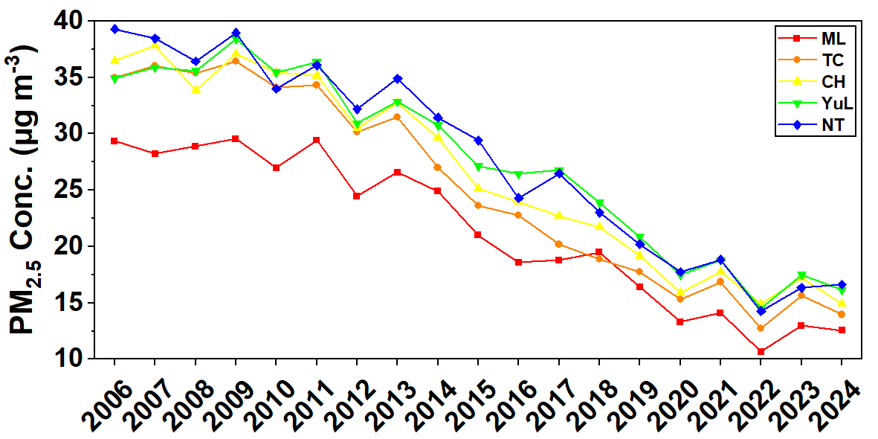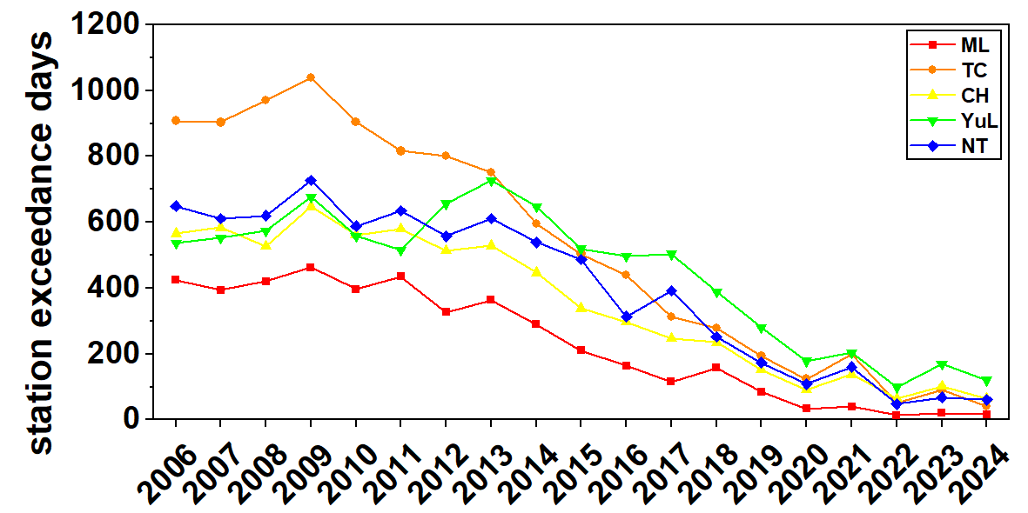
Fig. S1. The PM_{2.5} concentration (a) and the corresponding occurrence of station pollution (b) from 2006 to 2024 for Miaoli County (ML), Taichung City (TC), Changhua County (CH), Yunlin County (YuL), and Nantou County (NT).

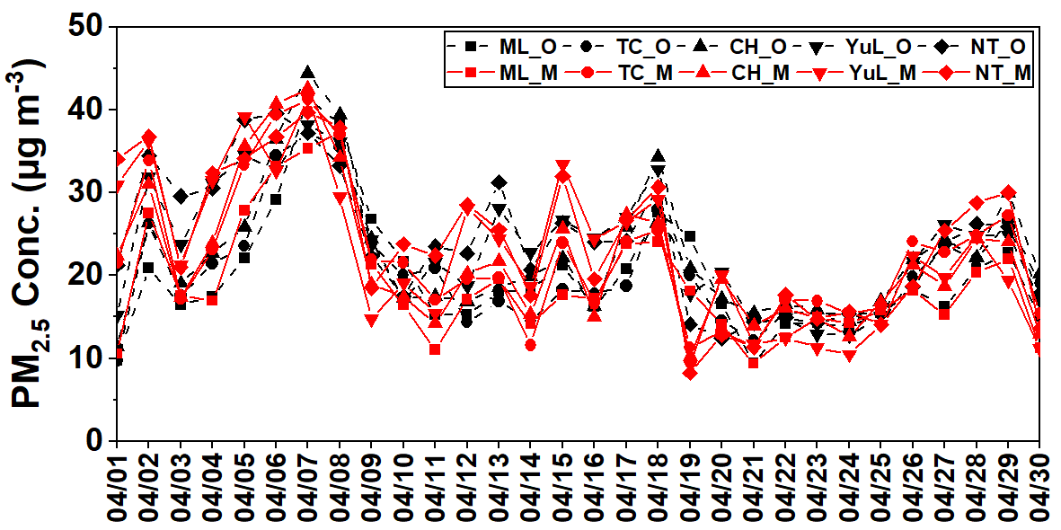
Fig. S2. The time series of modeled (M) and observed (O) PM_{2.5} concentrations for Miaoli County (ML), Taichung City (TC), Changhua County (CH), Yunlin County (YuL), and Nantou County (NT) in central Taiwan from April 1 to April 30, 2019.

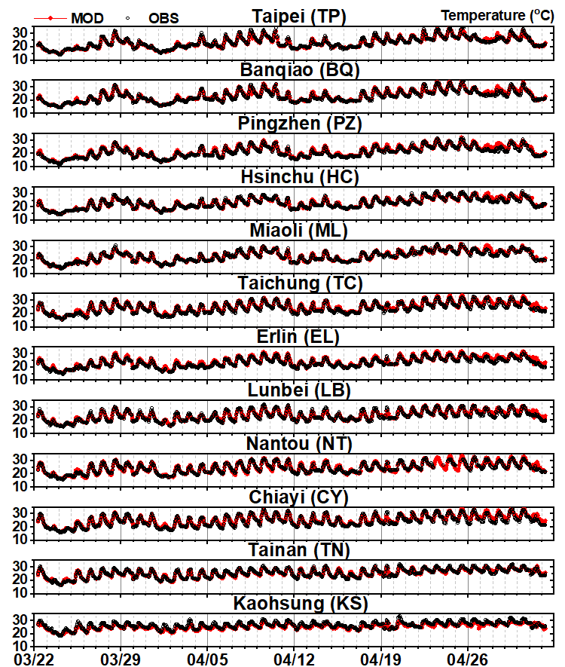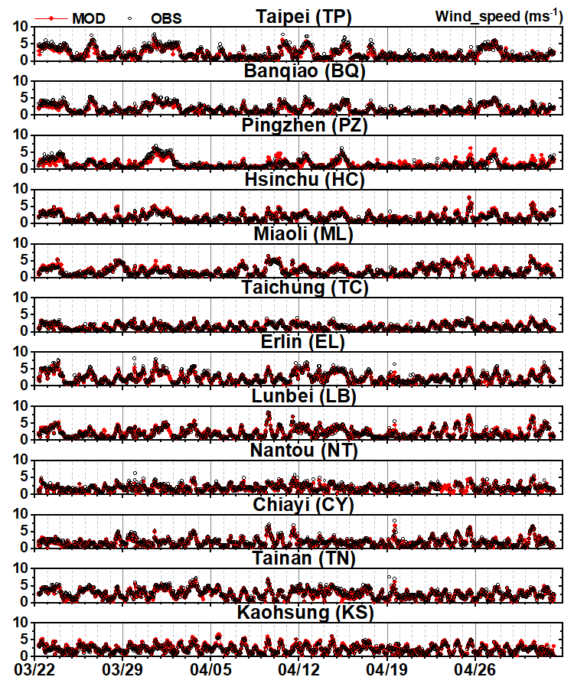
Fig. S3-1. The time series of modeled and observed temperatures at 12 representative sites in domain4. | Fig. S3-2. The time series of modeled and observed wind speed at 12 representative sites in domain4.

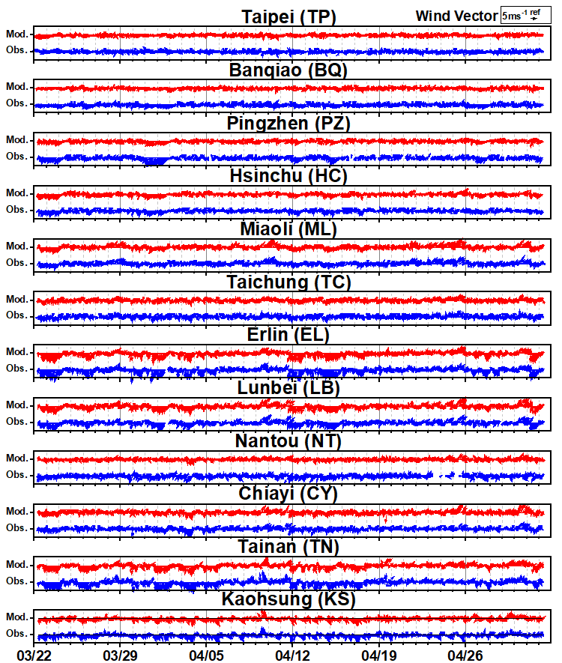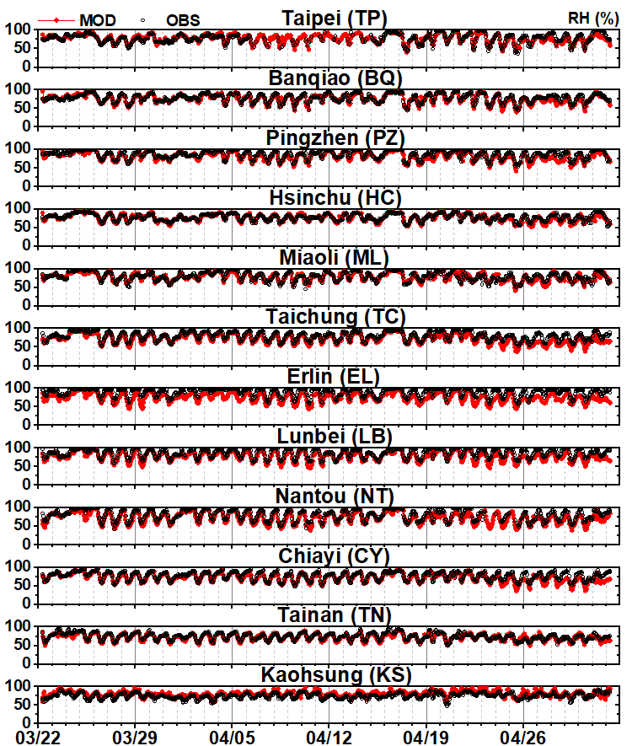
Fig. S3-3. The time series of modeled and observed wind direction at 12 representative sites in domain4. | Fig. S3-4. The time series of modeled and observed relative humidity at 12 representative sites in domain4.

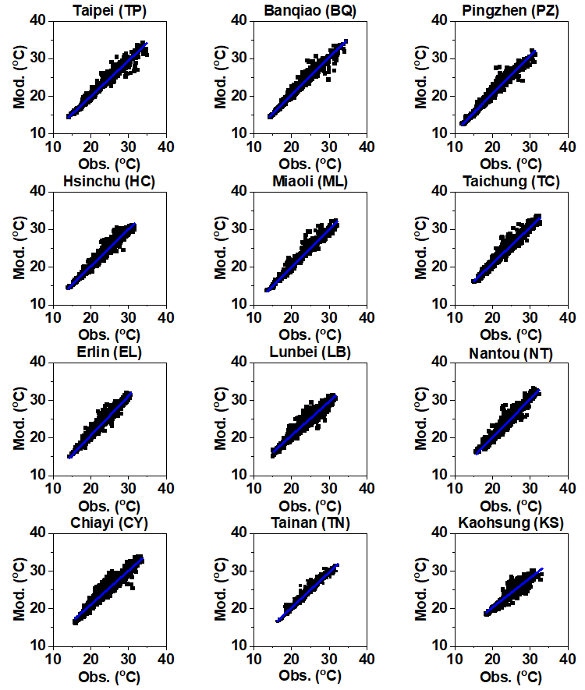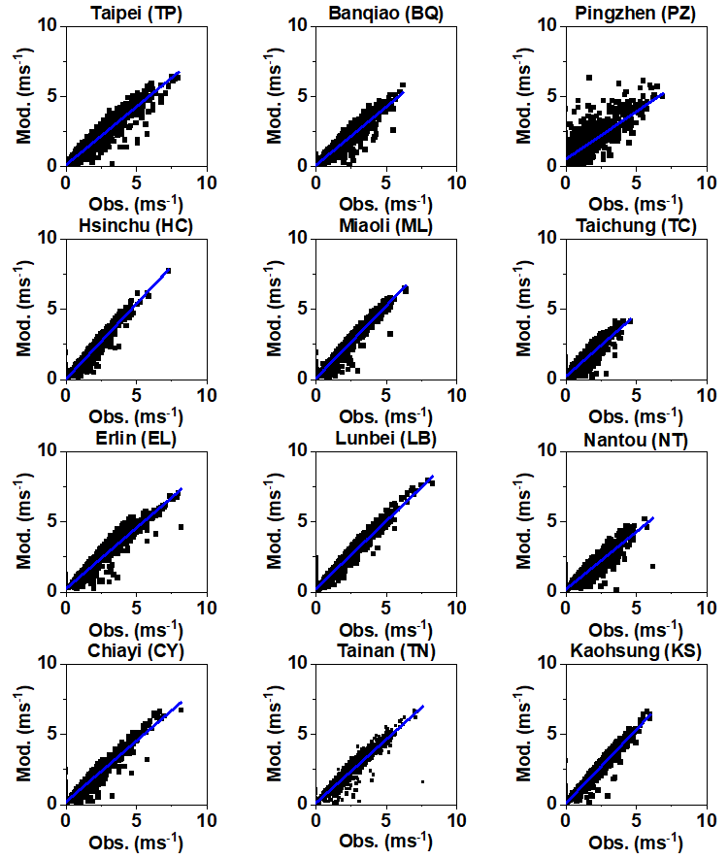
Fig. S4-1. The scatter plot of modeled (Y-axis) versus observed (X-axis) temperatures at 12 representative sites in domain4. | Fig. S4-2. The scatter plot of modeled (Y-axis) versus observed (X-axis) wind speed at 12 representative sites in domain4.

Fig. S4-3. The scatter plot of modeled (Y-axis) versus observed (X-axis) RH at 12 representative sites in domain4.

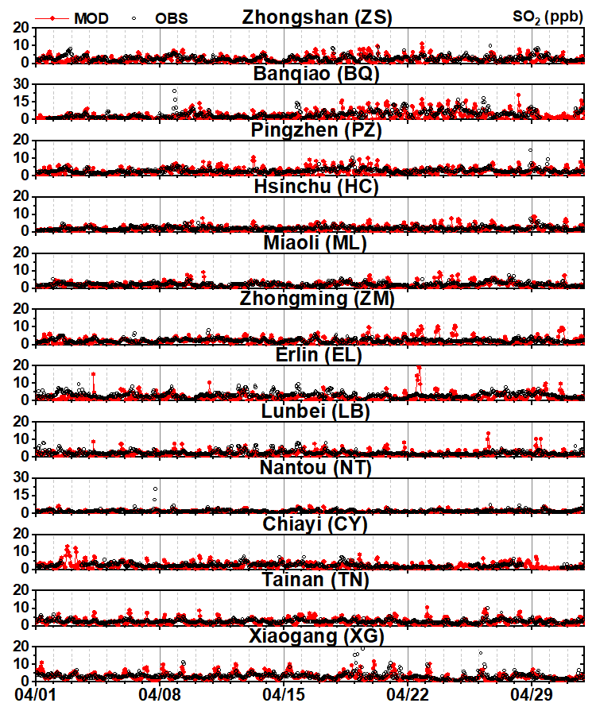
Fig. S5-1. The time series of modeled and observed PM_{2.5} at 12 representative sites in domain4. | Fig. S5-2. The time series of modeled and observed SO₂ at 12 representative sites in domain4.
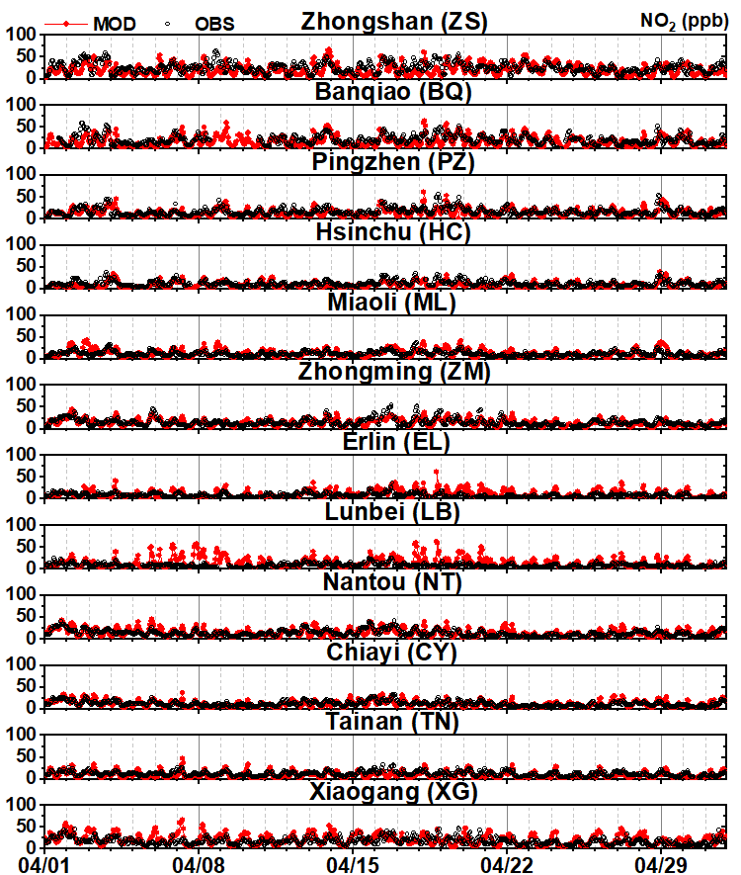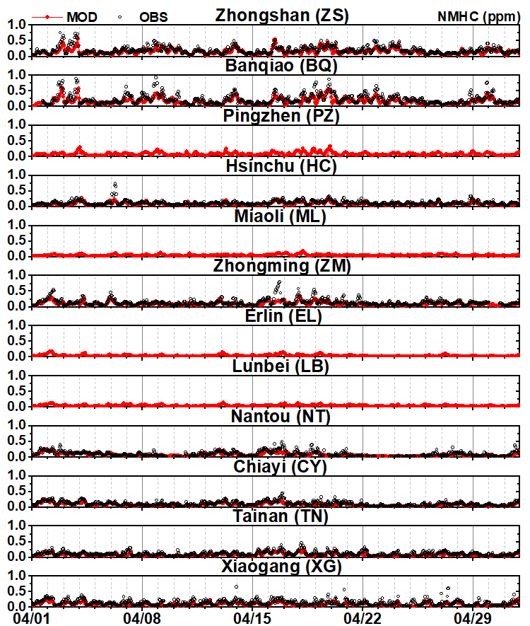
Fig. S5-3. The time series of modeled and observed NO₂ at 12 representative sites in domain4. | Fig. S5-4. The time series of modeled and observed NMHC at 12 representative sites in domain4.

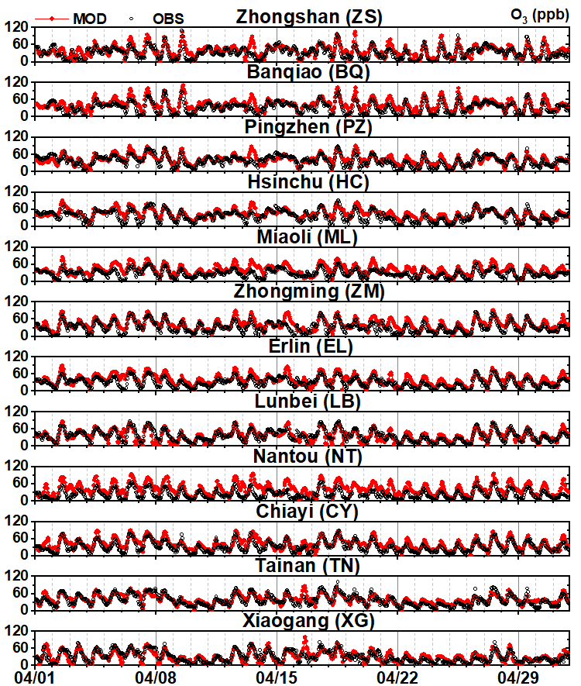
Fig. S5-5. The time series of modeled and observed O₃ at 12 representative sites in domain4. | Fig. S5-6. The time series of modeled and observed PM₁₀ at 12 representative sites in domain4.
Fig. S5-7. The time series of modeled and observed NO at 12 representative sites in domain4. | Fig. S5-8. The time series of modeled and observed CO at 12 representative sites in domain4.

Fig. S6-1. The scatter plot of modeled (Y-axis) versus observed (X-axis) PM_{2.5} at 12 representative sites in domain4. | Fig. S6-2. The scatter plot of modeled (Y-axis) versus observed (X-axis) SO₂ at 12 representative sites in domain4.

Fig. S6-3. The scatter plot of modeled (Y-axis) versus observed (X-axis) NO₂ at 12 representative sites in domain4. | Fig. S6-4. The scatter plot of modeled (Y-axis) versus observed (X-axis) NMHC at 12 representative sites in domain4.

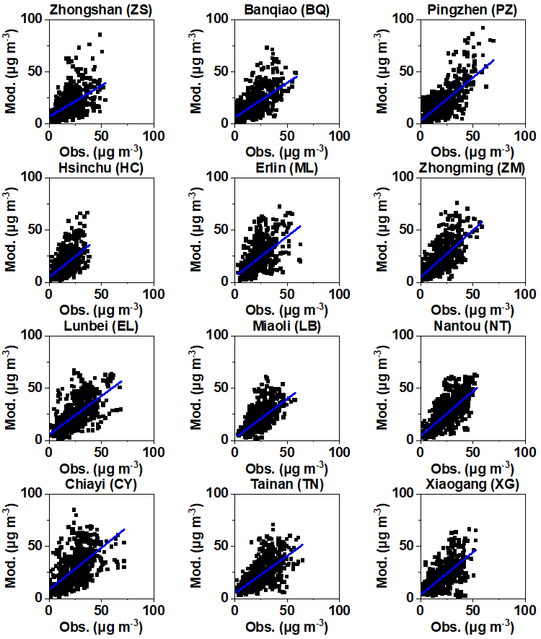
Fig. S6-5. The scatter plot of modeled (Y-axis) versus observed (X-axis) O₃ at 12 representative sites in domain4. | Fig. S6-6. The scatter plot of modeled (Y-axis) versus observed (X-axis) PM₁₀ at 12 representative sites in domain4.

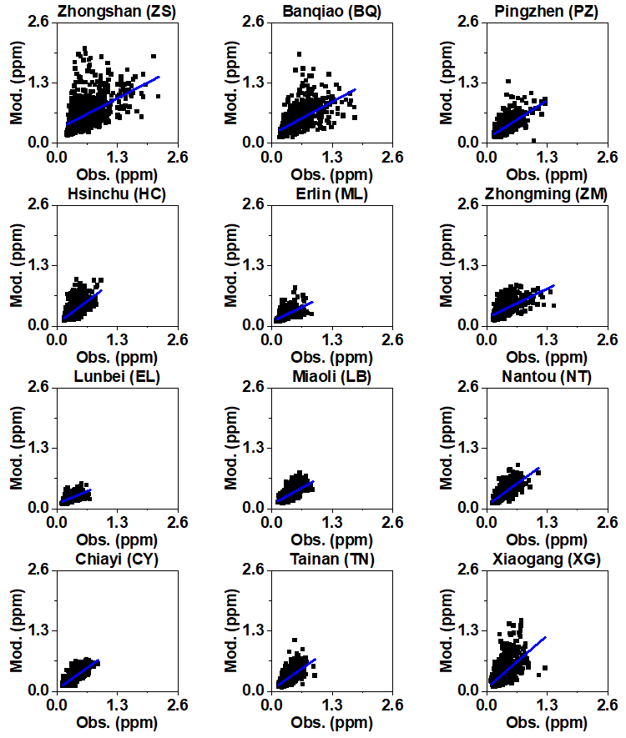
Fig. S6-7. The scatter plot of modeled (Y-axis) versus observed (X-axis) NO at 12 representative sites in domain4. | Fig. S6-8. The scatter plot of modeled (Y-axis) versus observed (X-axis) CO at 12 representative sites in domain4.

Fig. S7-1. The time series of modeled and observed PM_{2.5} and PM_{2.5} species at Banqiao (BQ) station in domain4.
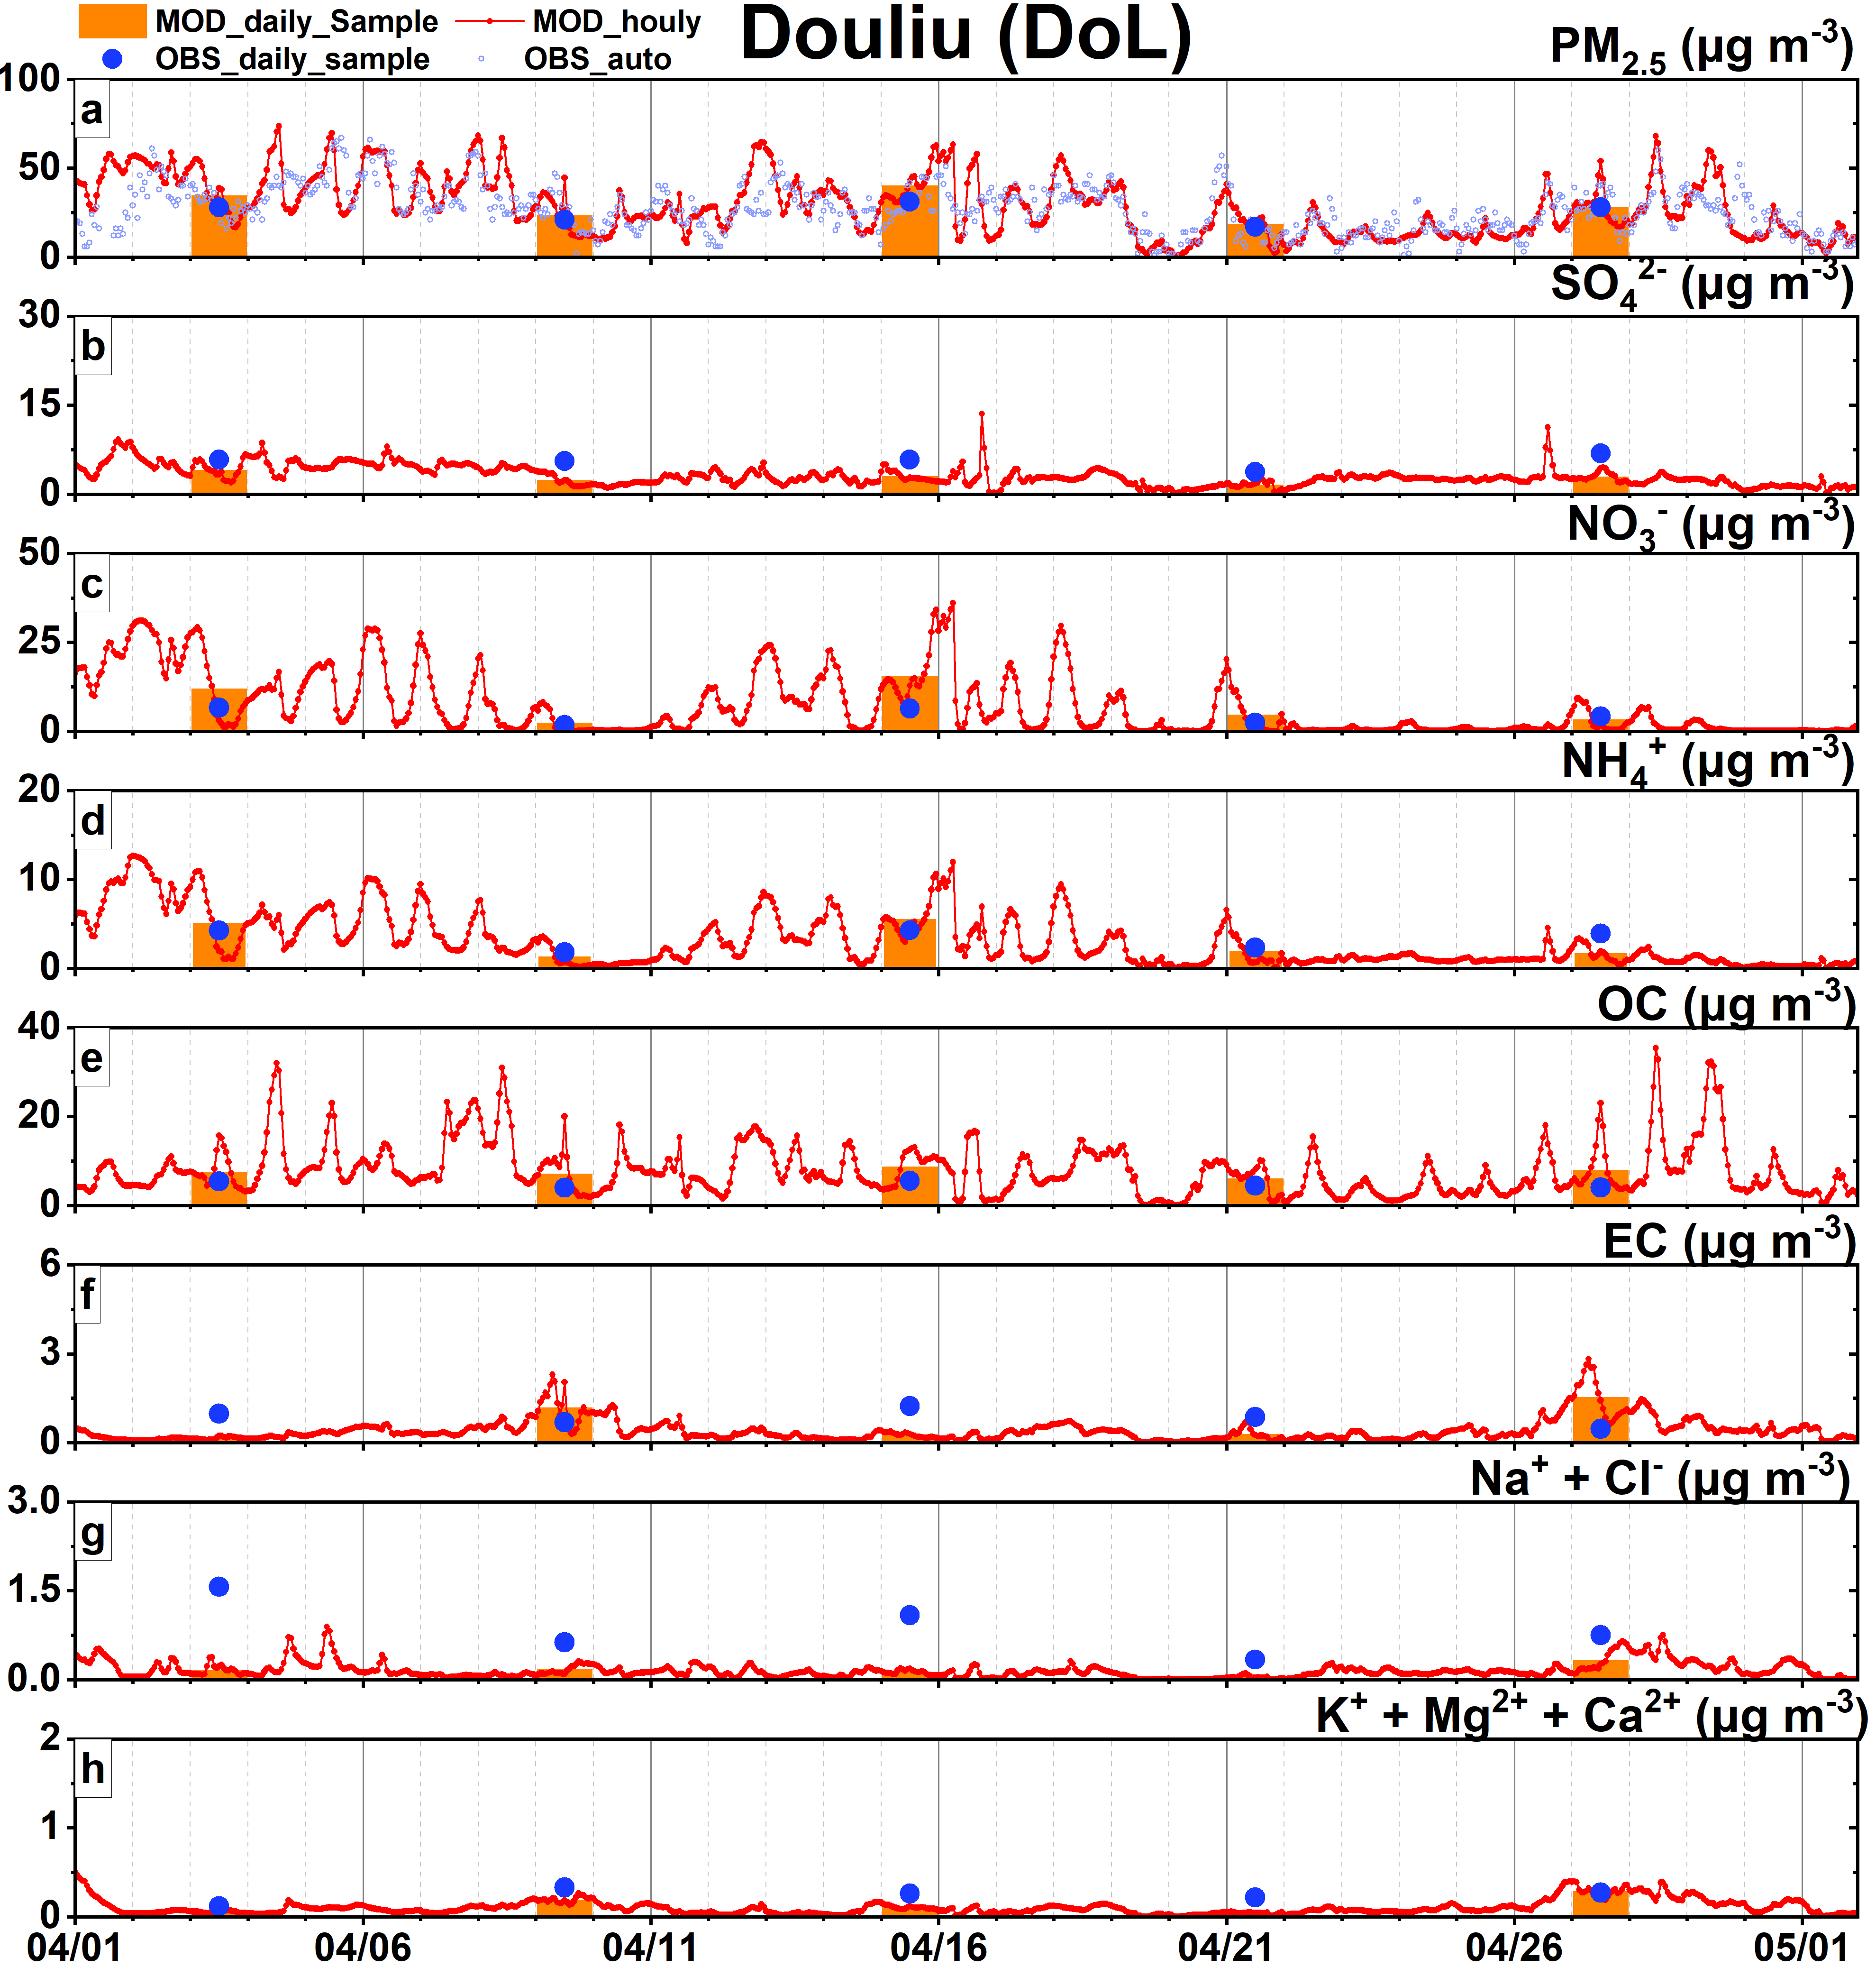
Fig. S7-3. The time series of modeled and observed PM_{2.5} and PM_{2.5} species at Douliu (DL) station in domain4. 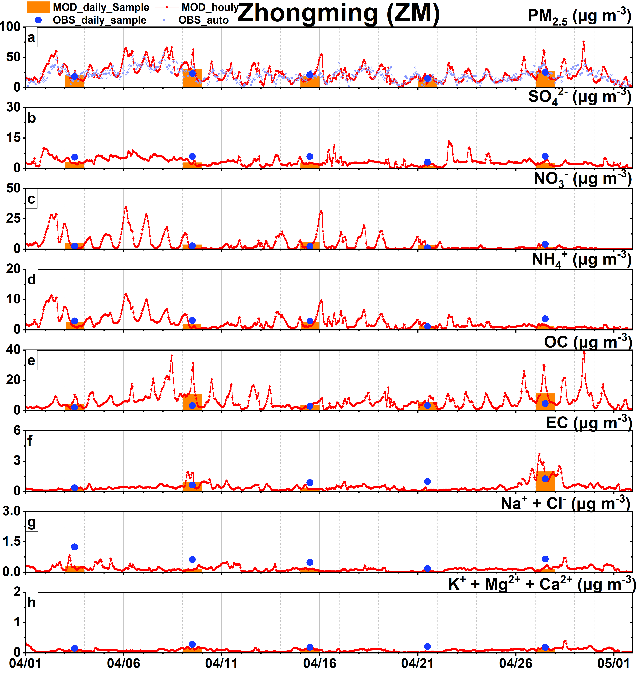
Fig. S7-2. The time series of modeled and observed PM_{2.5} and PM_{2.5} species at Zhongming (ZM) station in domain4.
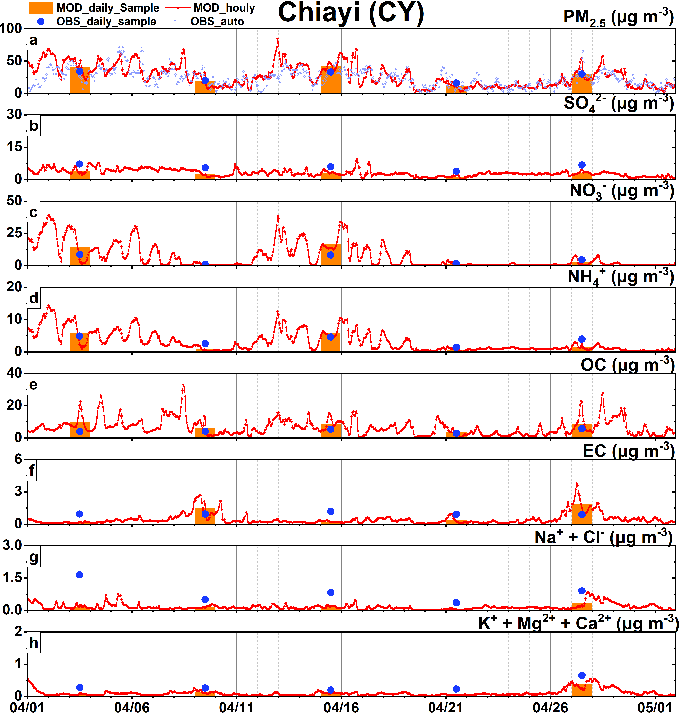
Fig. S7-4. The time series of modeled and observed PM_{2.5} and PM_{2.5} species at Chiayi (CY) station in domain4.

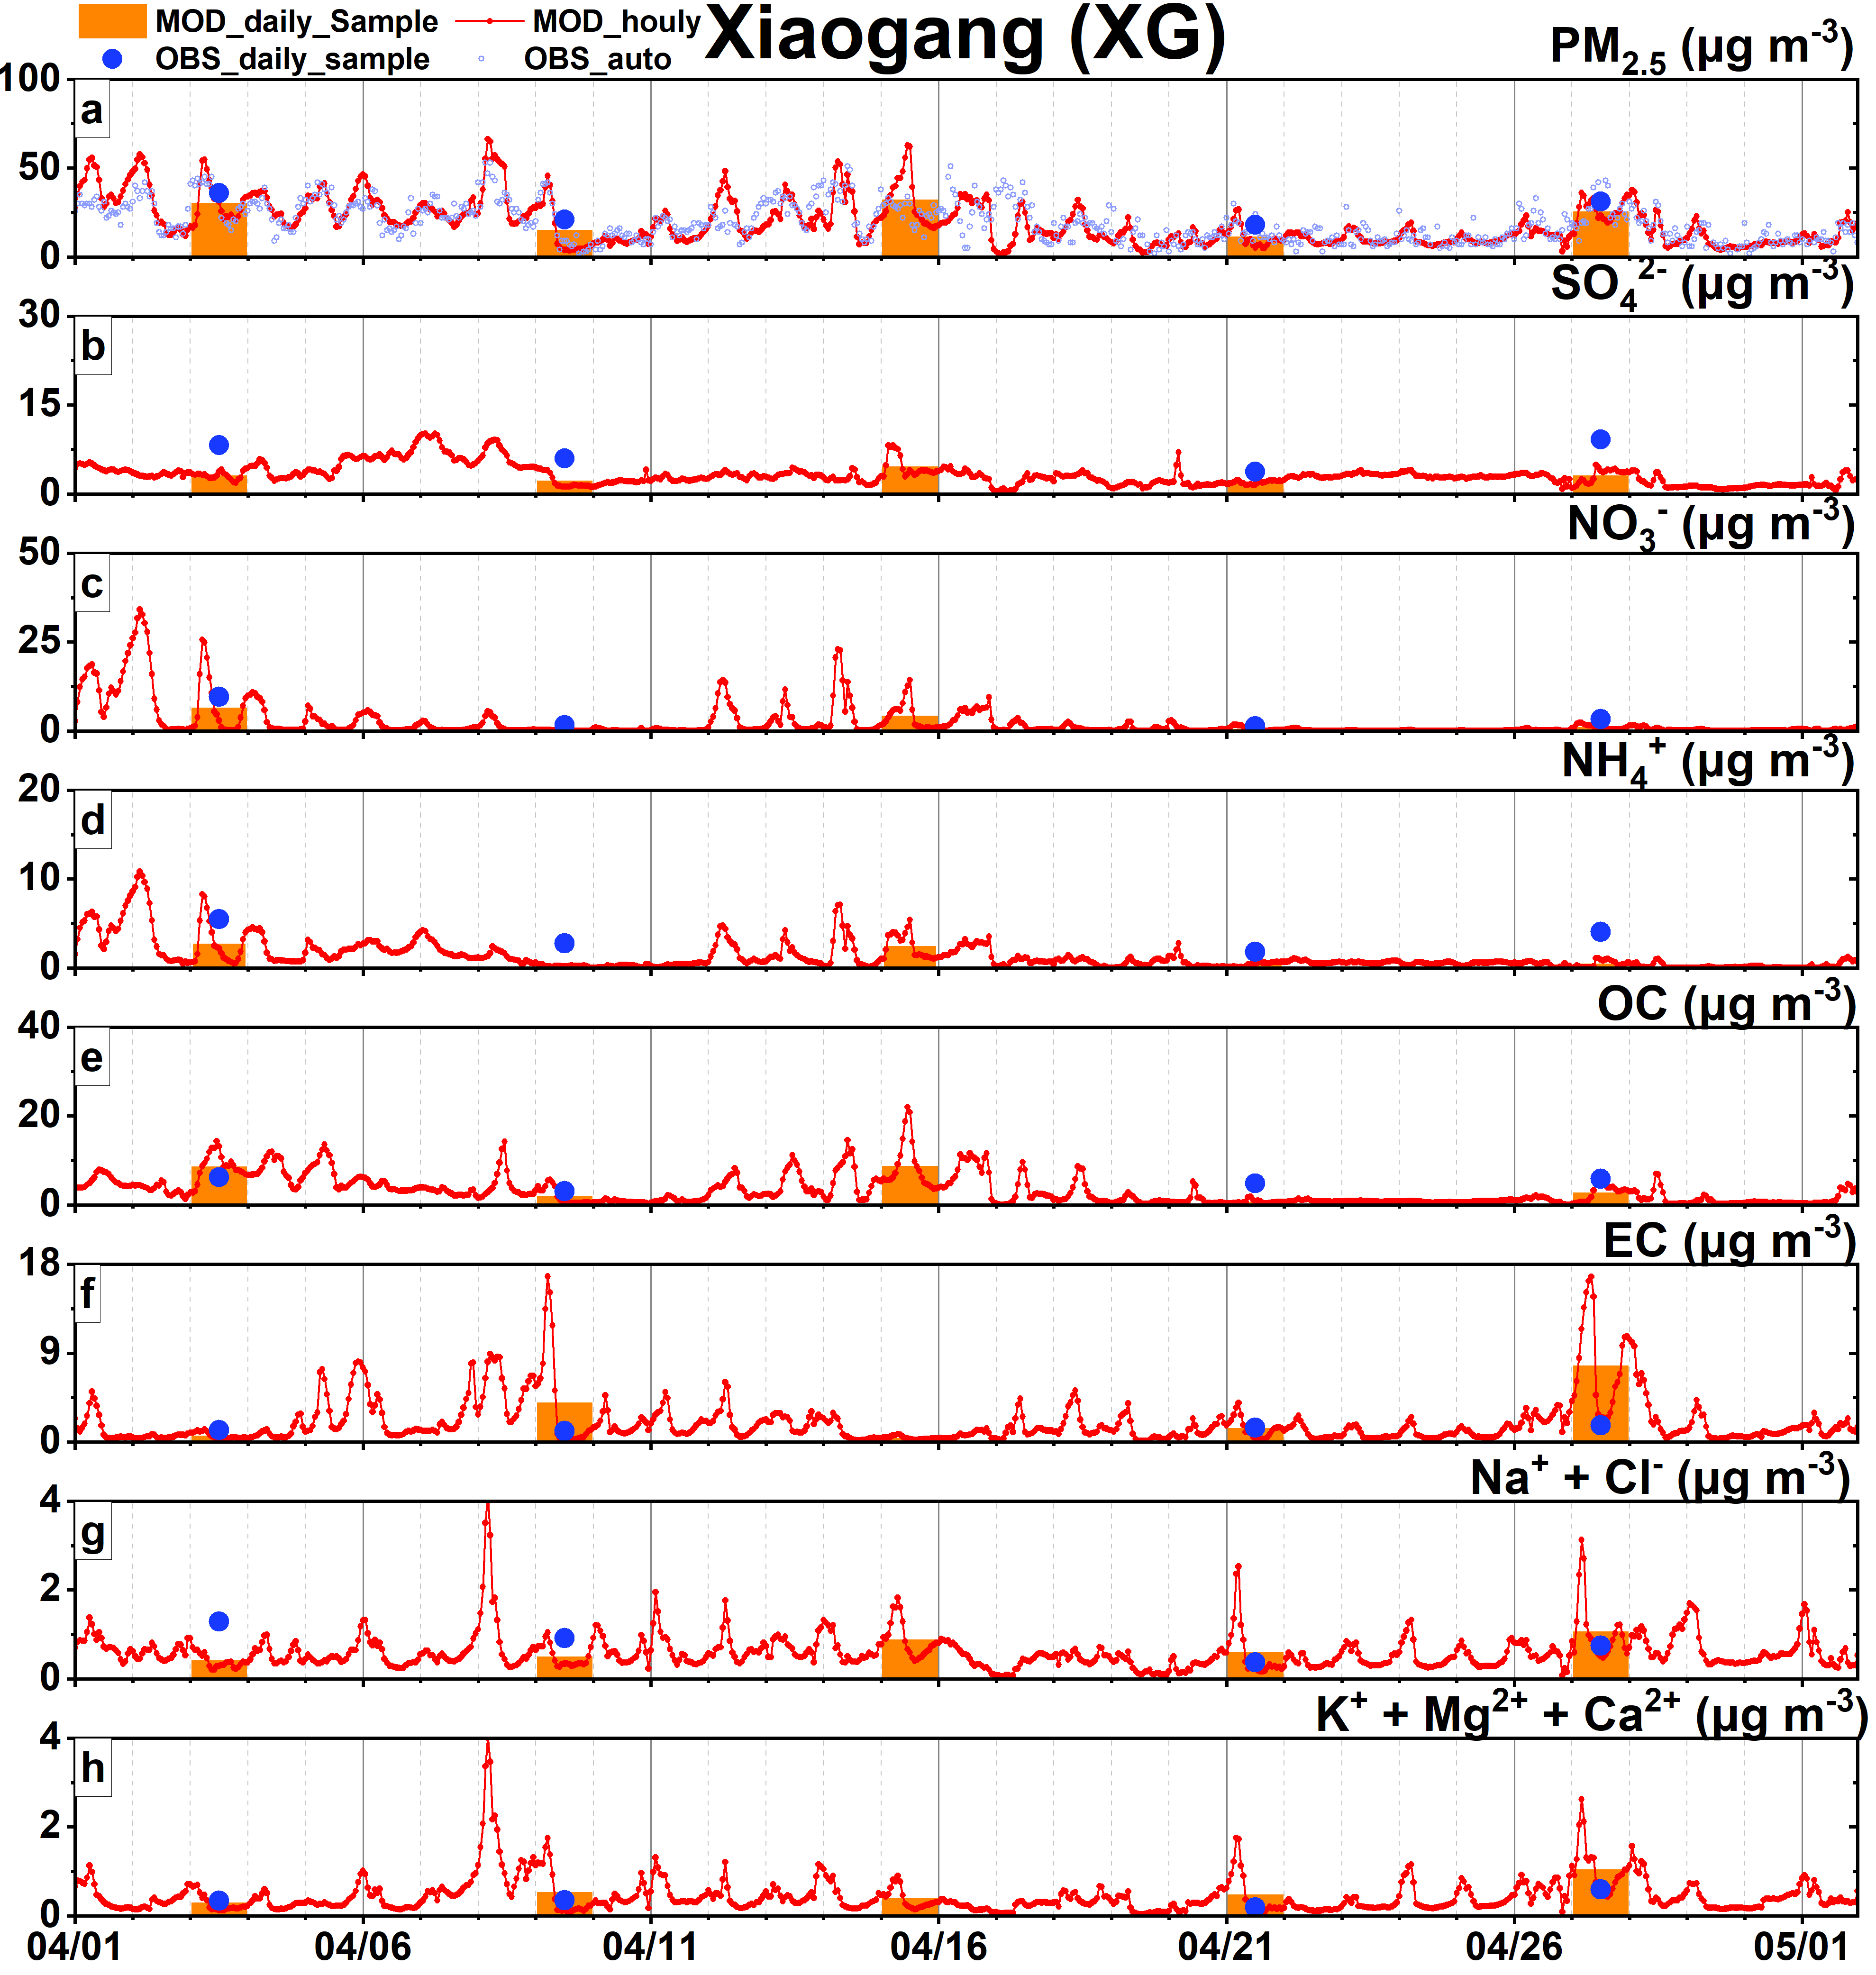
Fig. S7-5. The time series of modeled and observed PM_{2.5} and PM_{2.5} species at Xiaogang (XG) station in domain4.
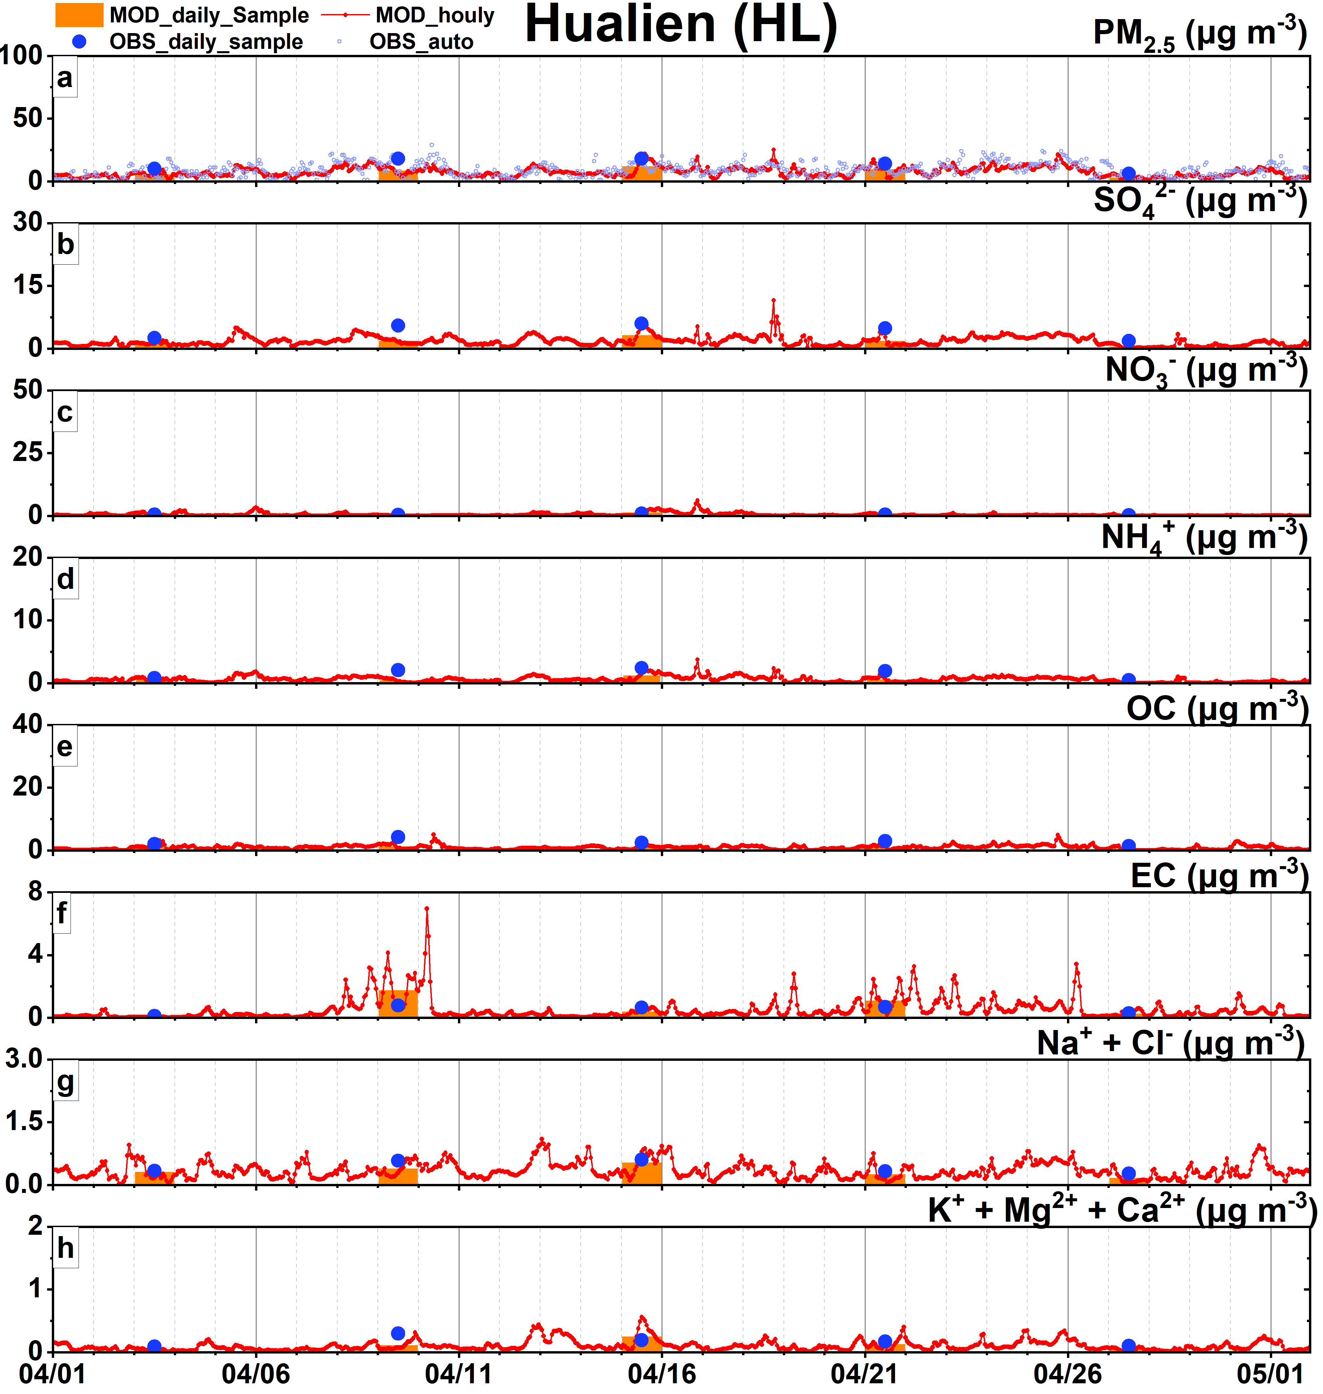
Fig. S7-6. The time series of modeled and observed PM_{2.5} and PM_{2.5} species at Hualien (HL) station in domain4.

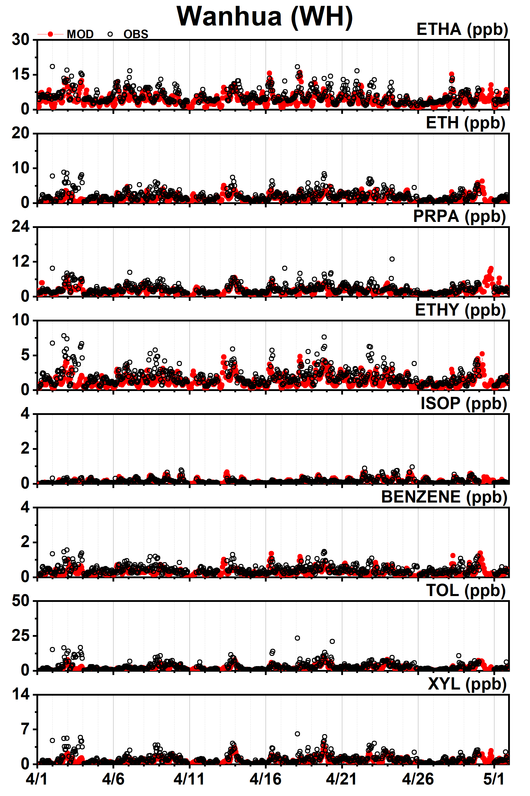
Fig. S8-1. The time series of modeled and observed VOCs at Wanhua (WH) station in domain4.
Fig. S8-3. The time series of modeled and observed VOCs at Pingzhen (PZ) station in domain4.
Fig. S8-2. The time series of modeled and observed VOCs at Tucheng (TuC) station in domain4
Fig. S8-4. The time series of modeled and observed VOCs at Zhongming (ZM) station in domain4.
Fig. S8-5. The time series of modeled and observed VOCs at Zhushan (ZuS) station in domain4.
Fig. S8-7. The time series of modeled and observed VOCs at Puzi (PuZ) station in domain4.
Fig. S8-6. The time series of modeled and observed VOCs at Taixi (TX) station in domain4.

Fig. S8-8. The time series of modeled and observed VOCs at Tainan (TN) station in domain4.
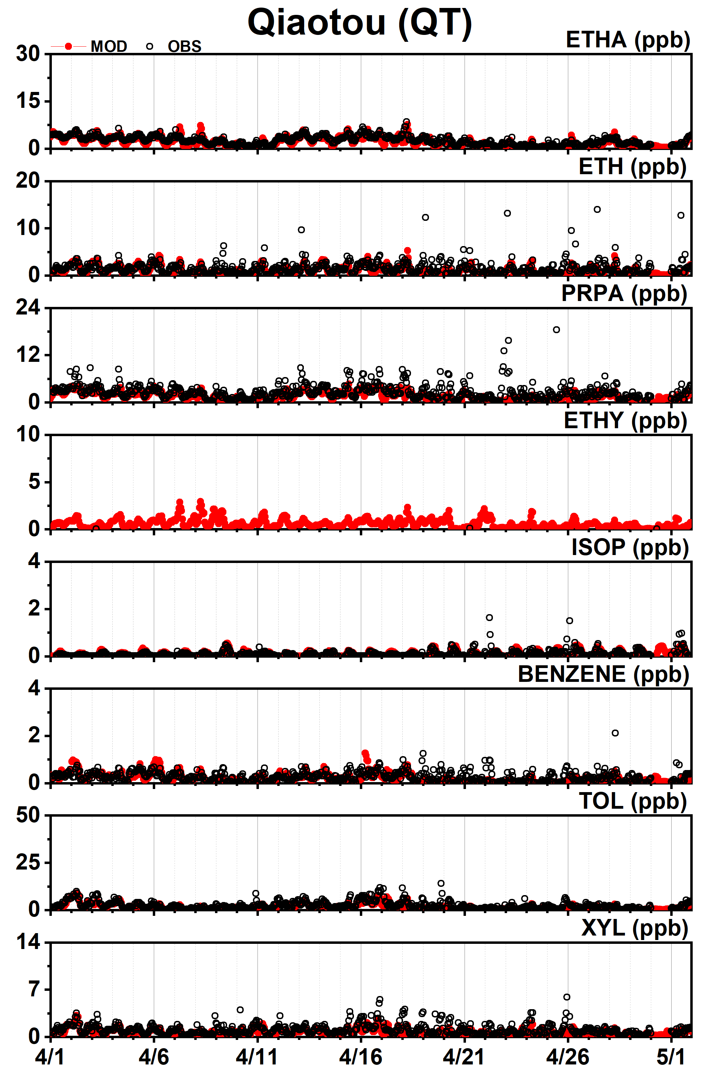
Fig. S8-9. The time series of modeled and observed VOCs at Qiaotou (QT) station in domain4.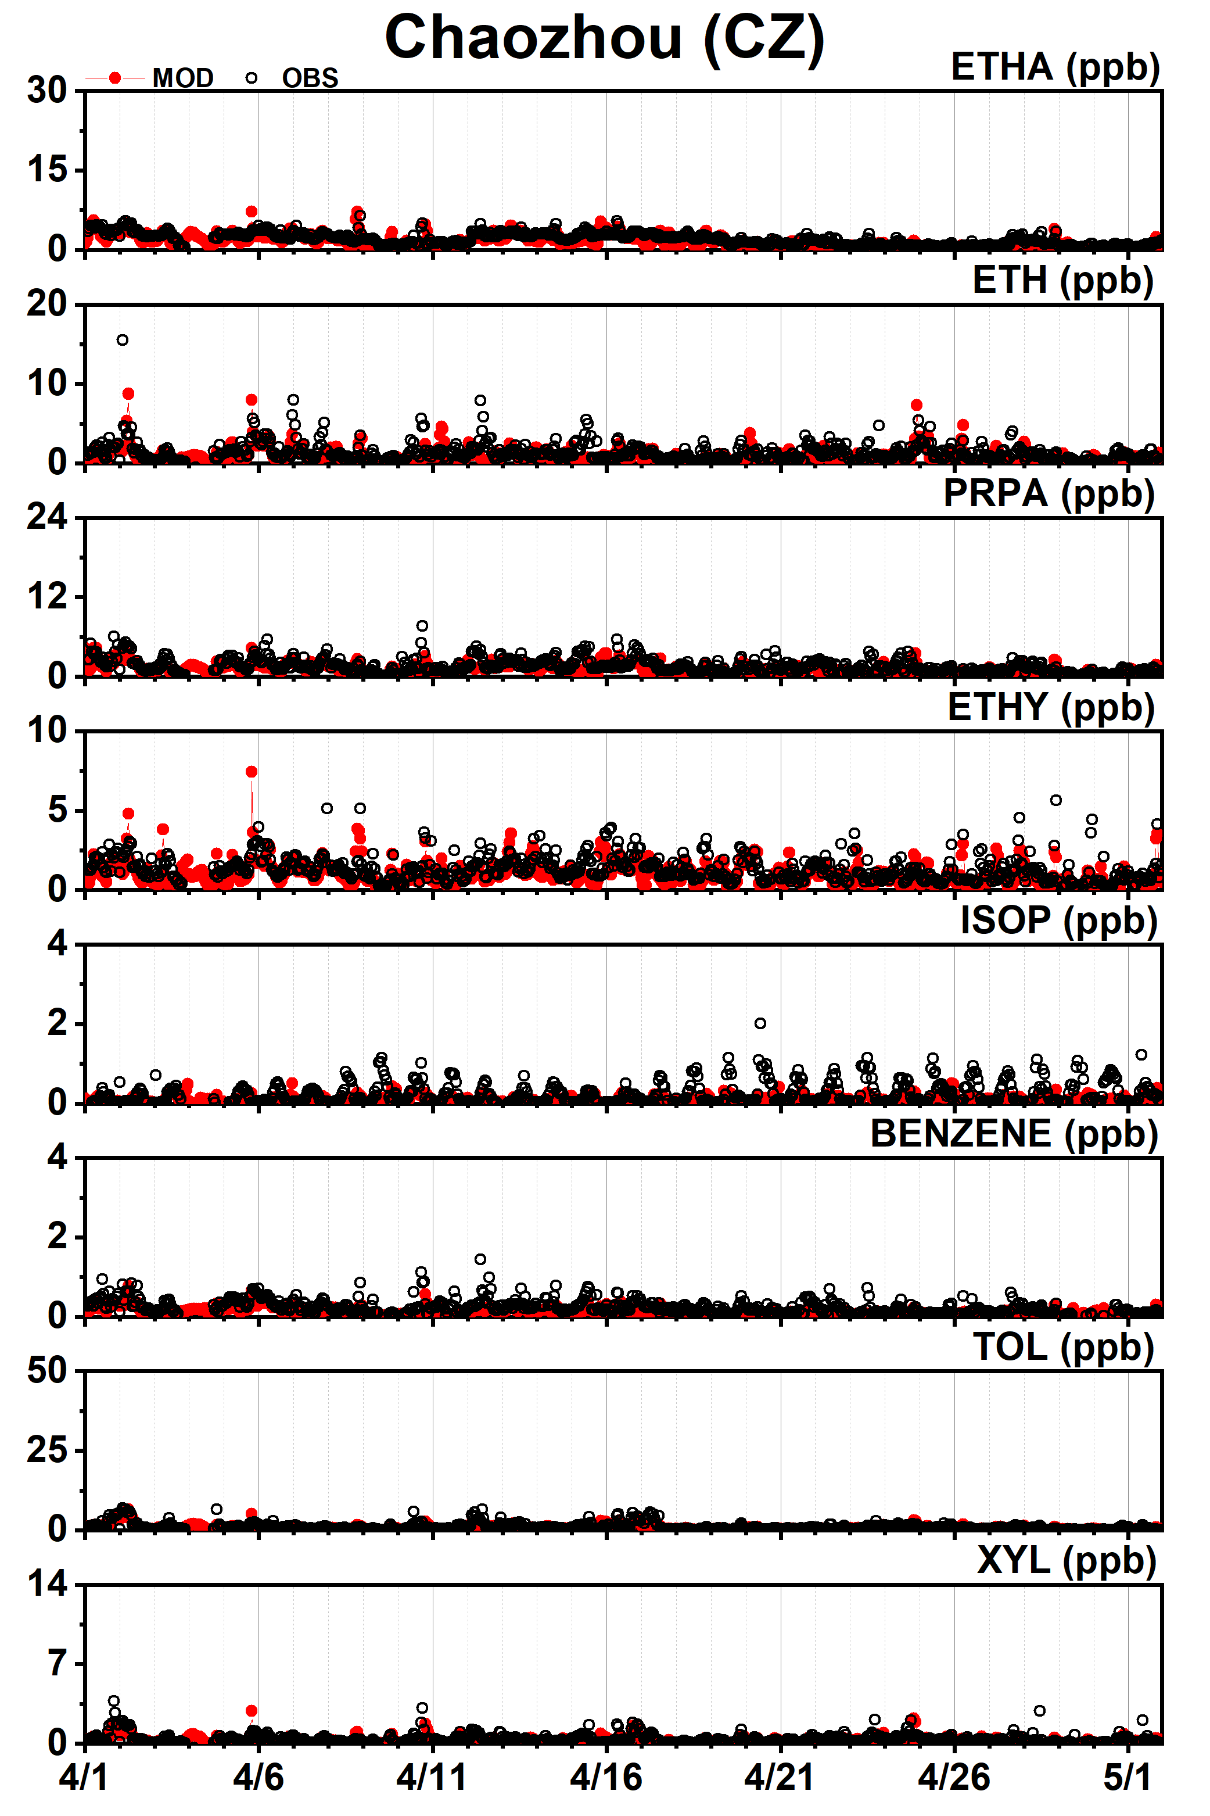
Fig. S8-11. The time series of modeled and observed VOCs at Chaozhou (CZ) station in domain4.
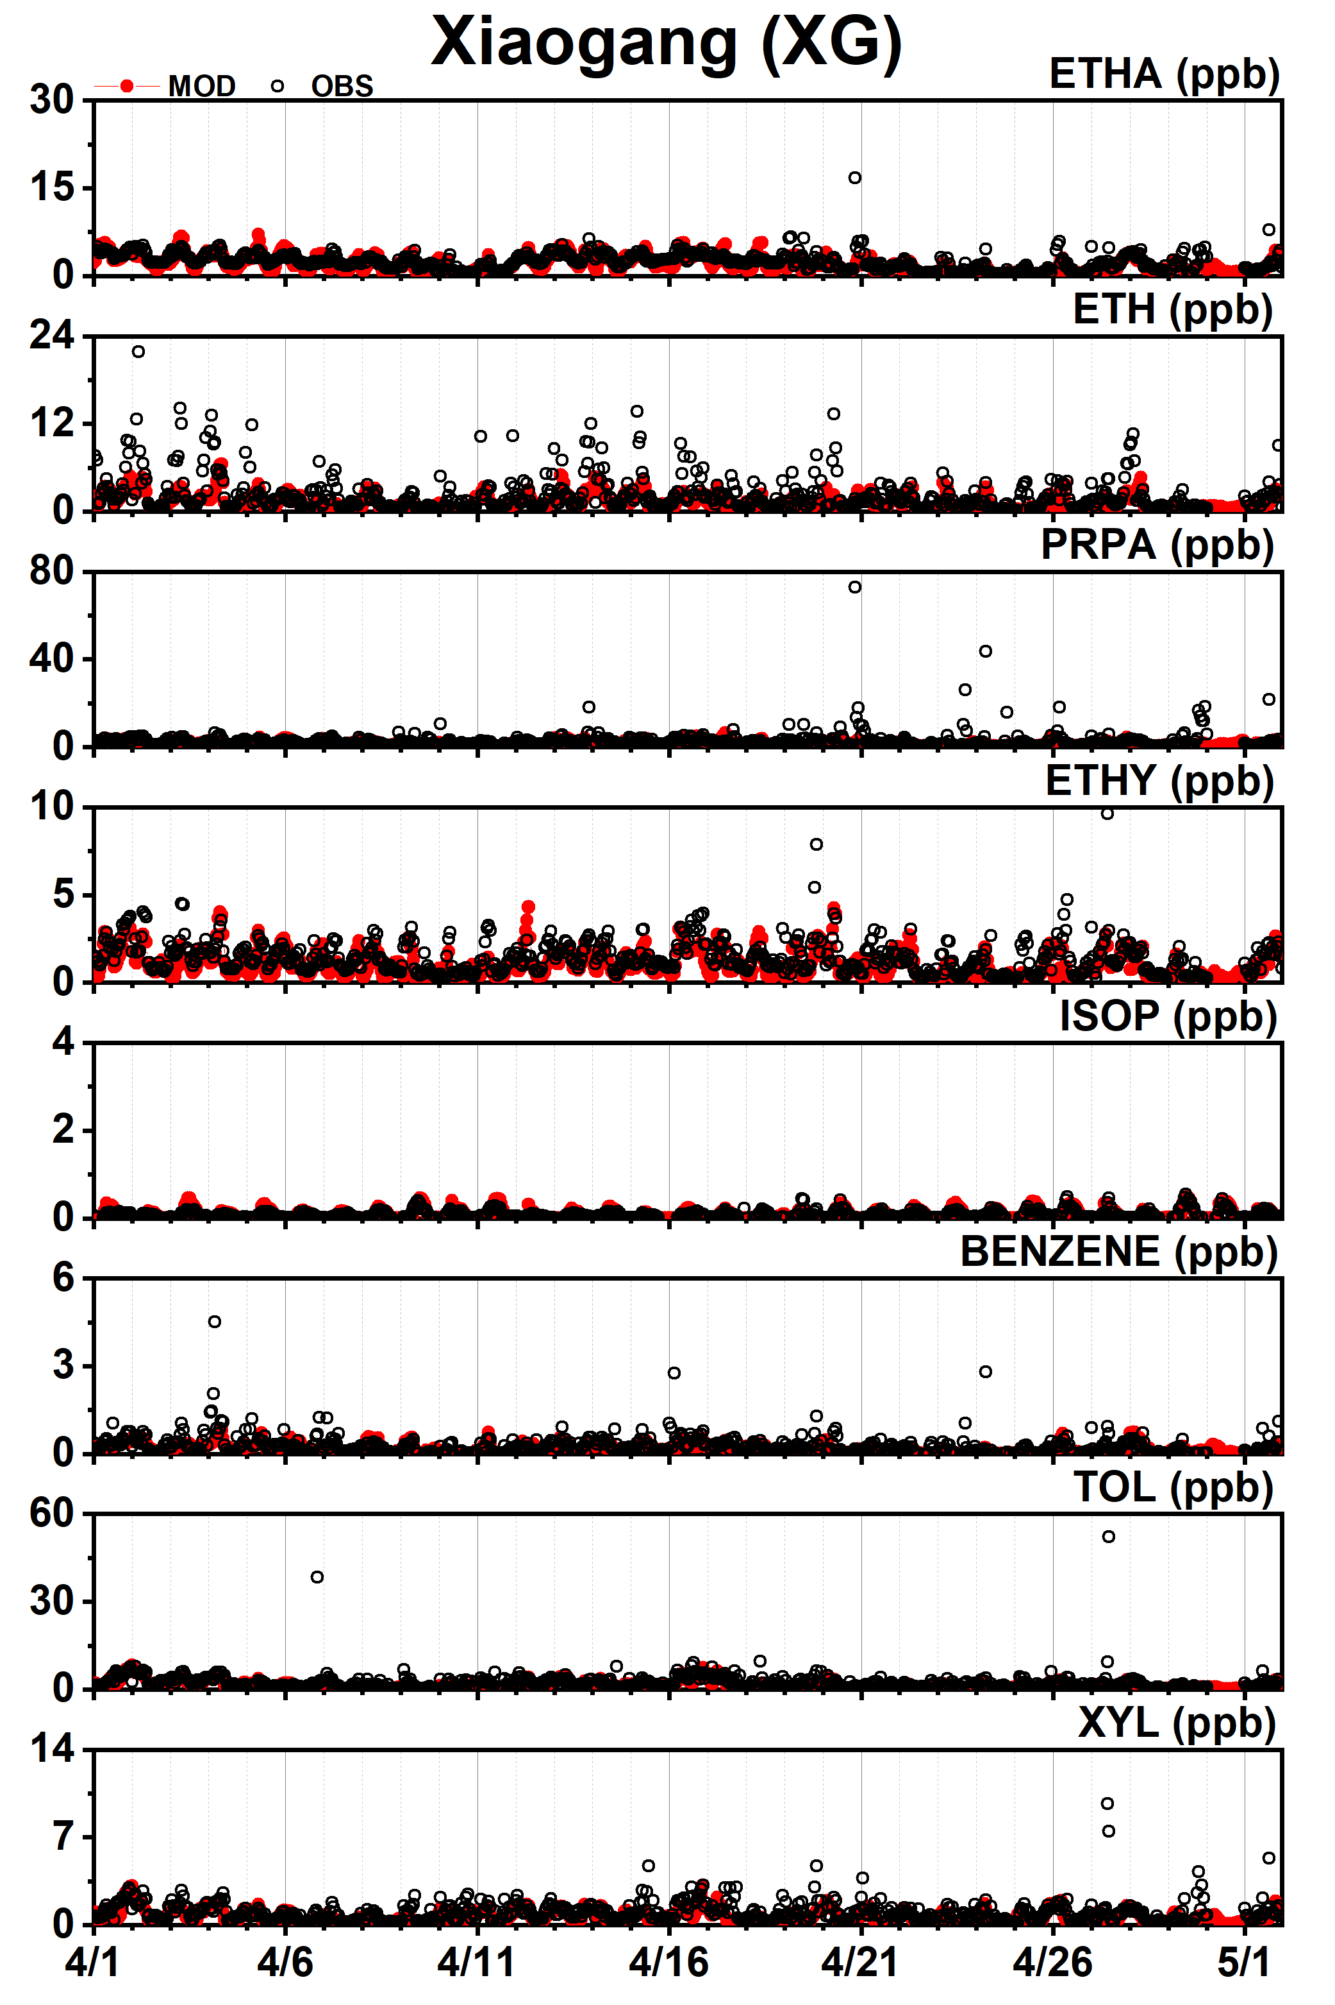
Fig. S8-10. The time series of modeled and observed VOCs at Xiaogang (XG) station in domain4.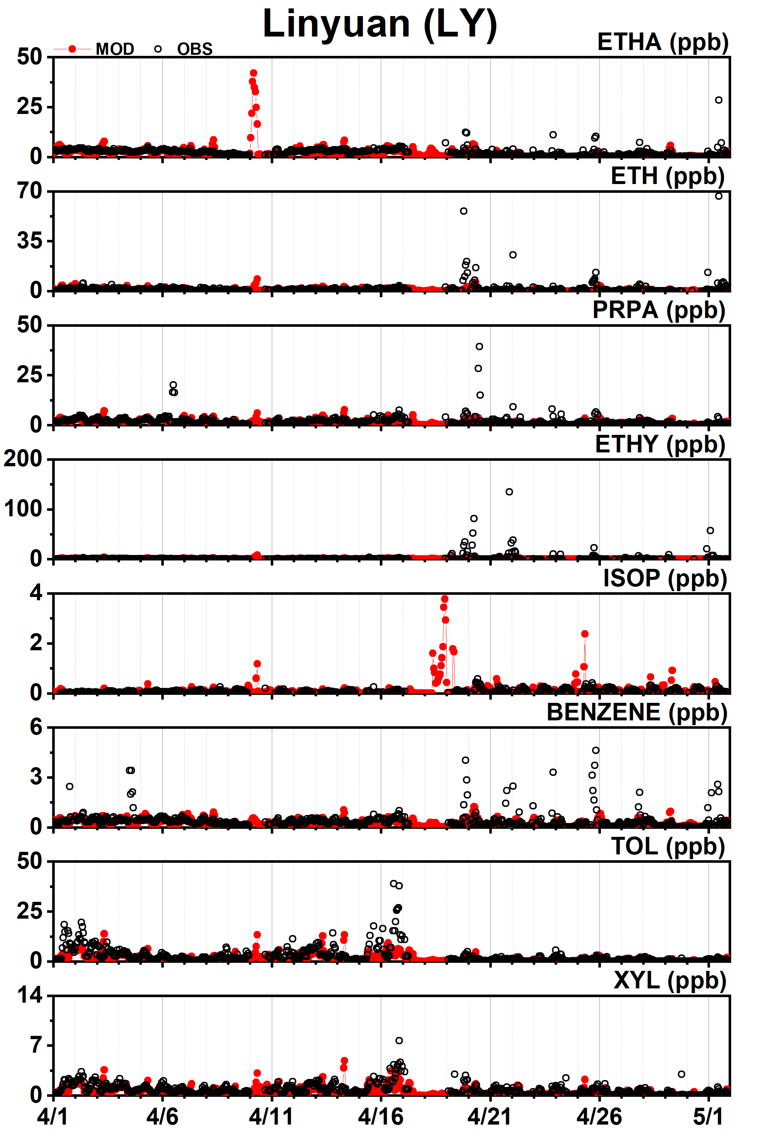
Fig. S8-12. The time series of modeled and observed VOCs at Linyuan (LY) station in domain4.

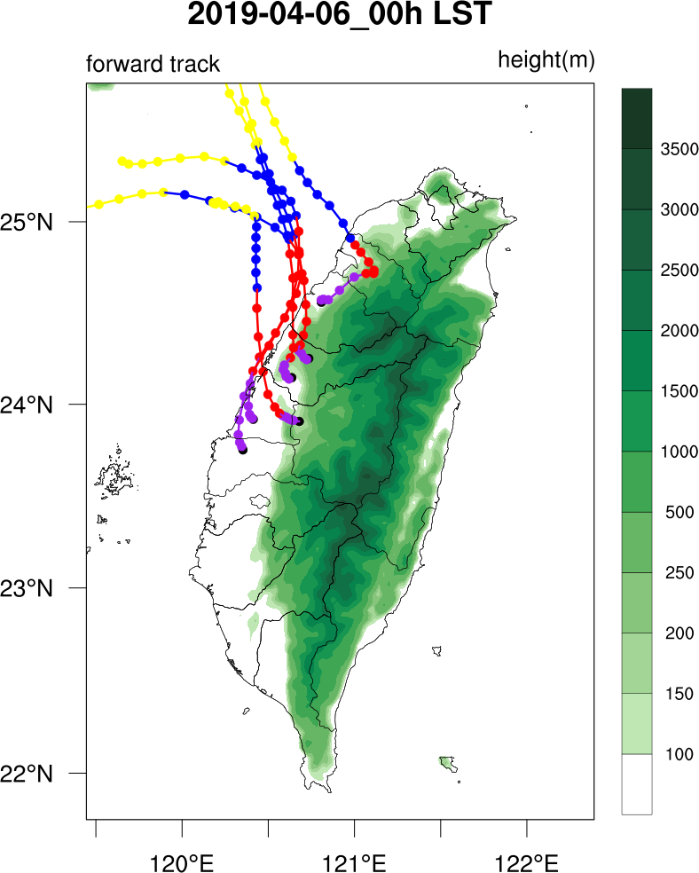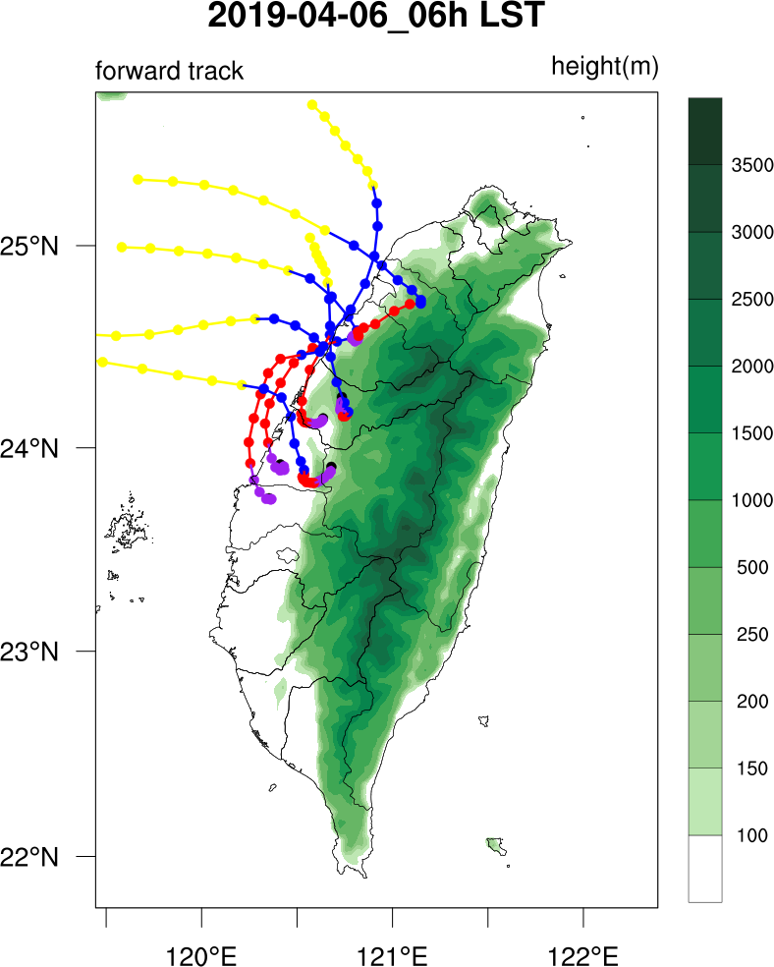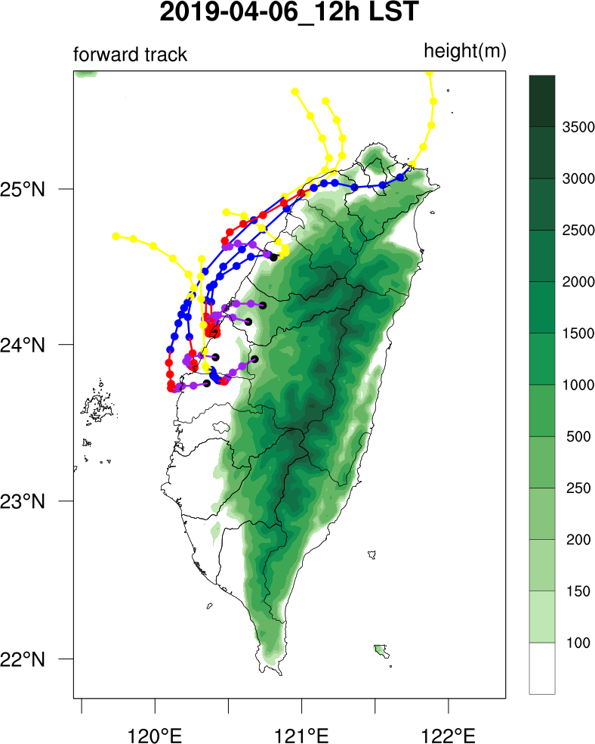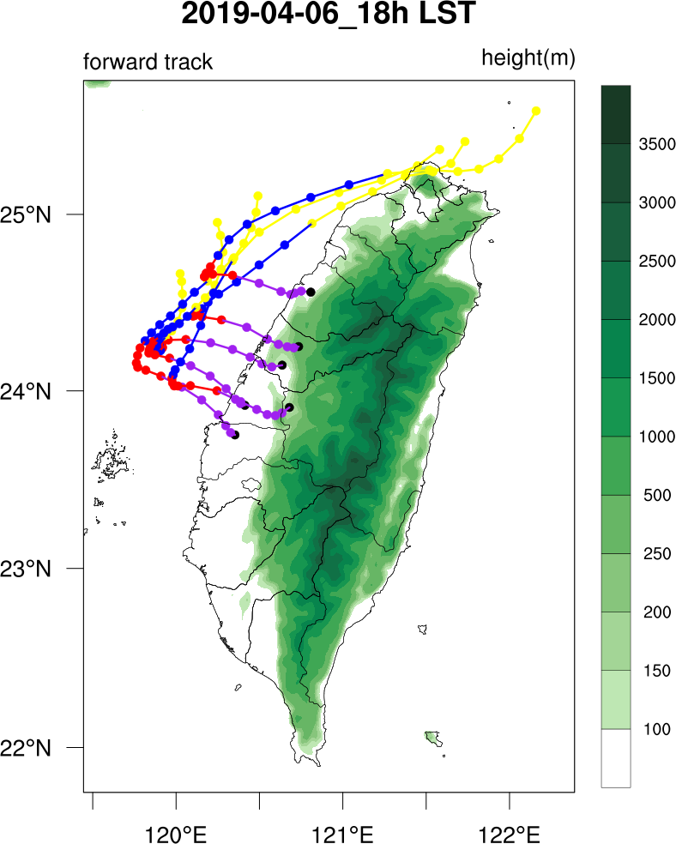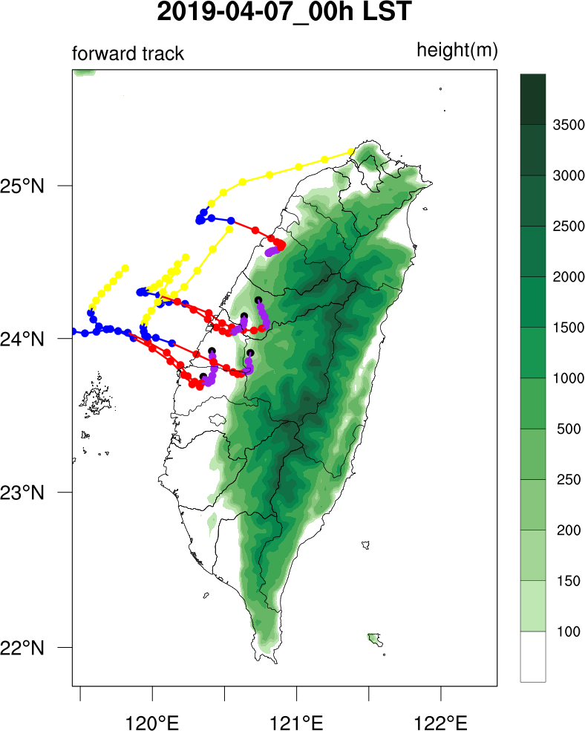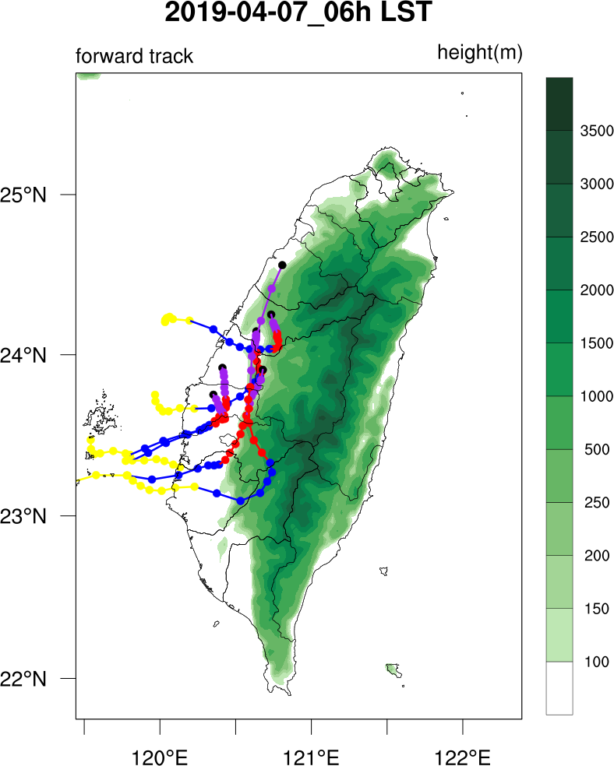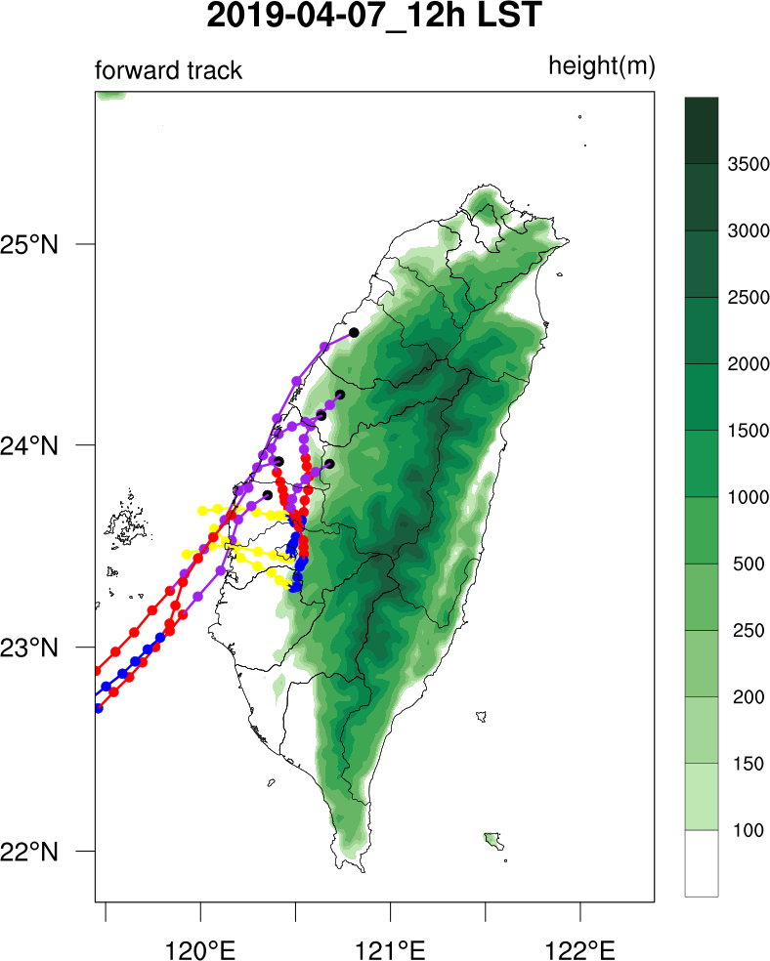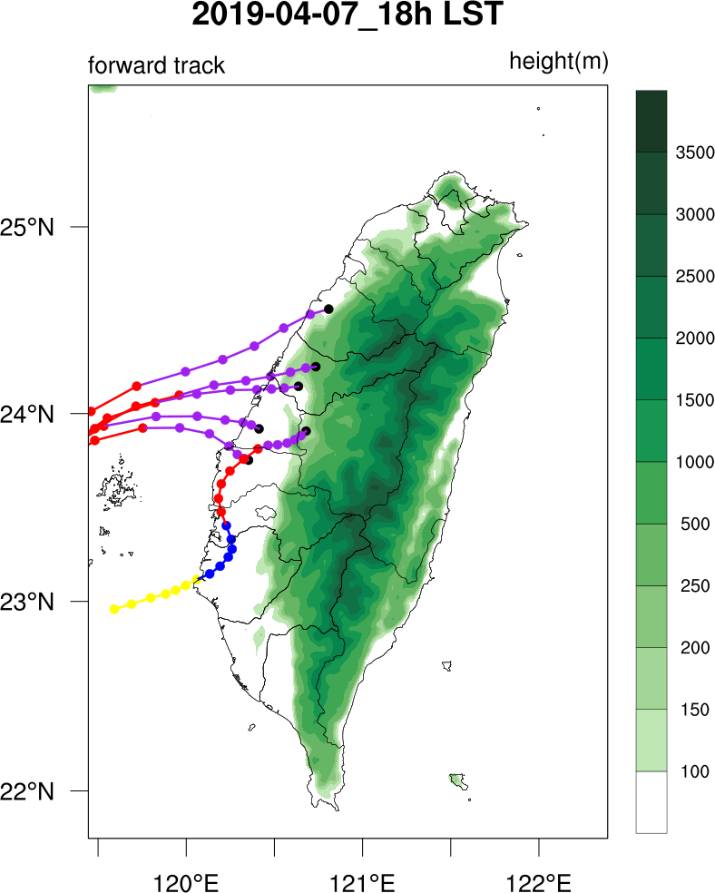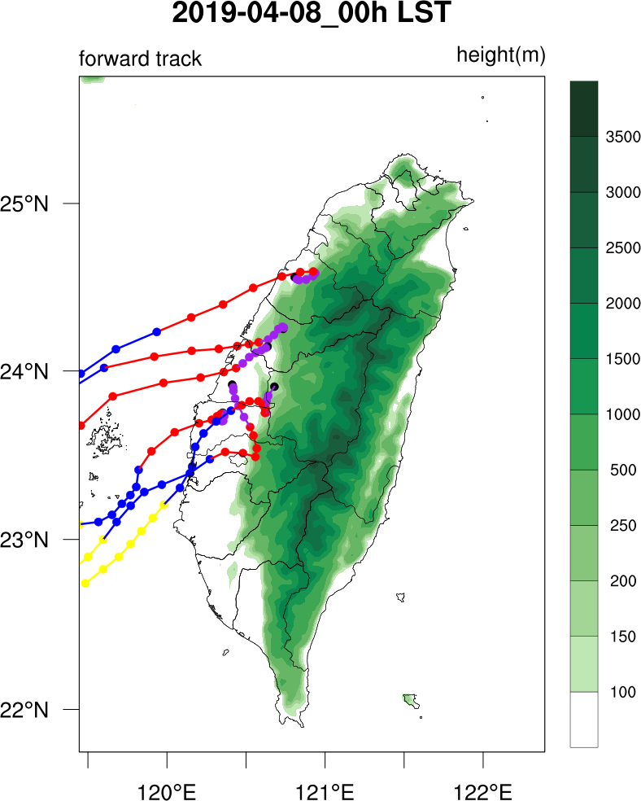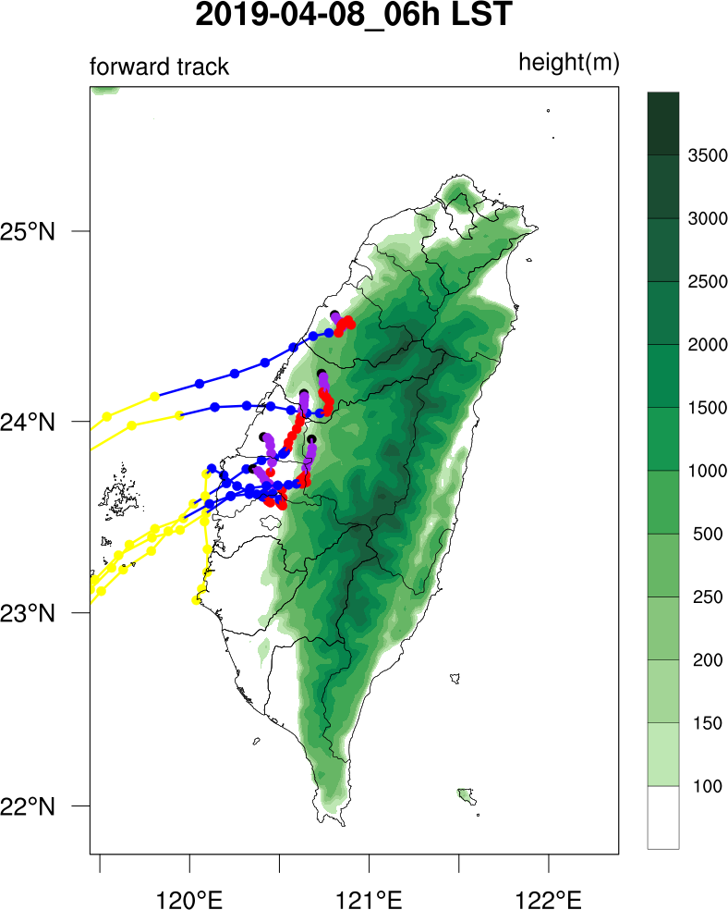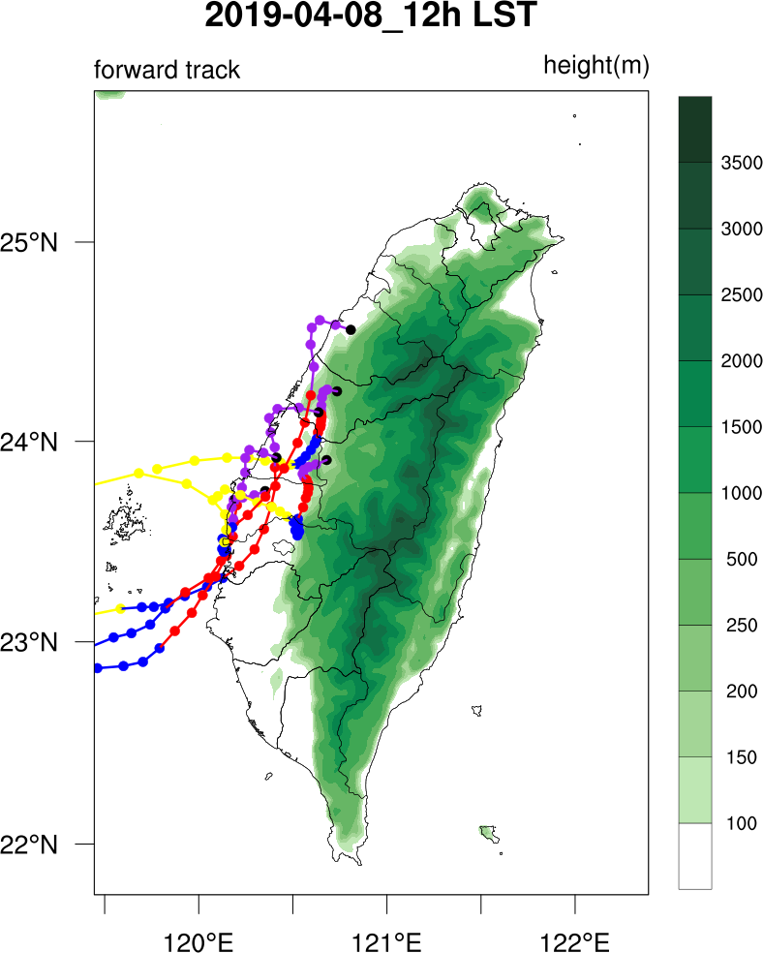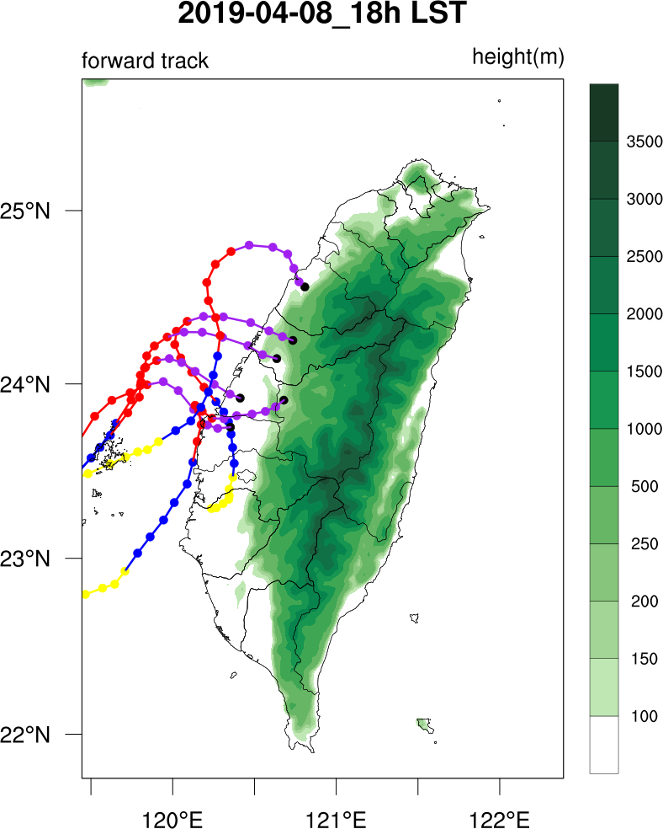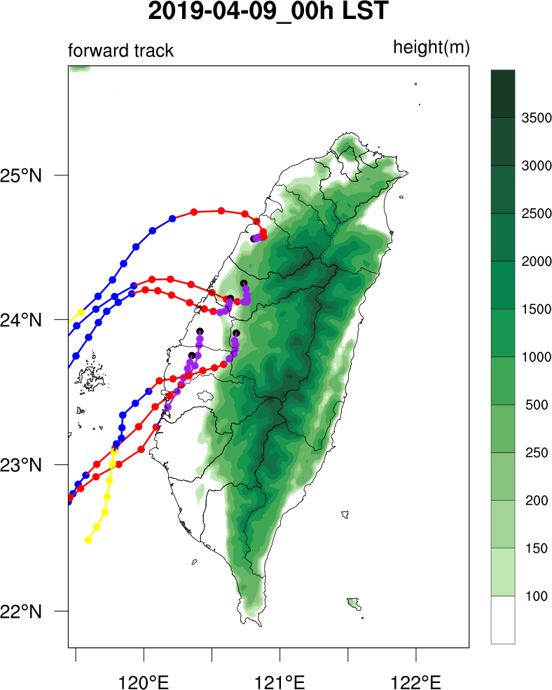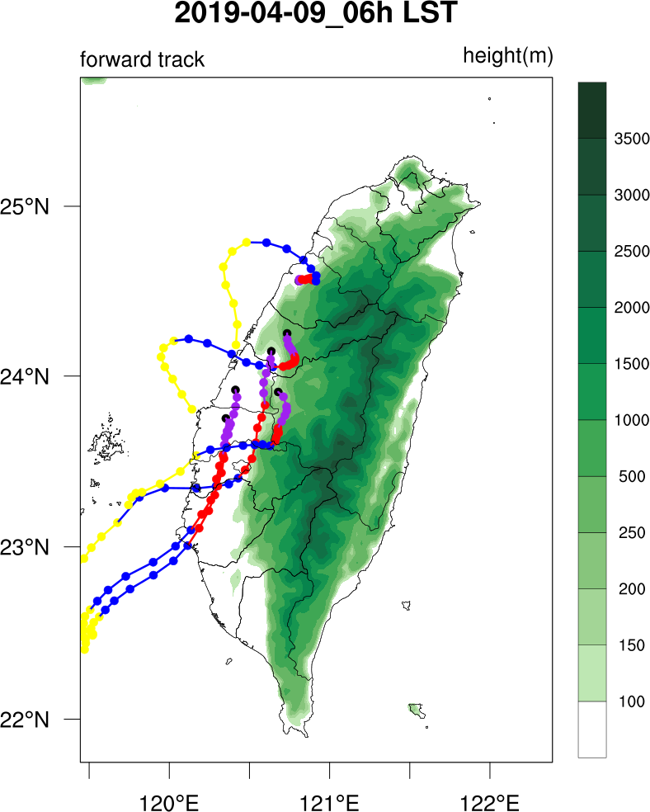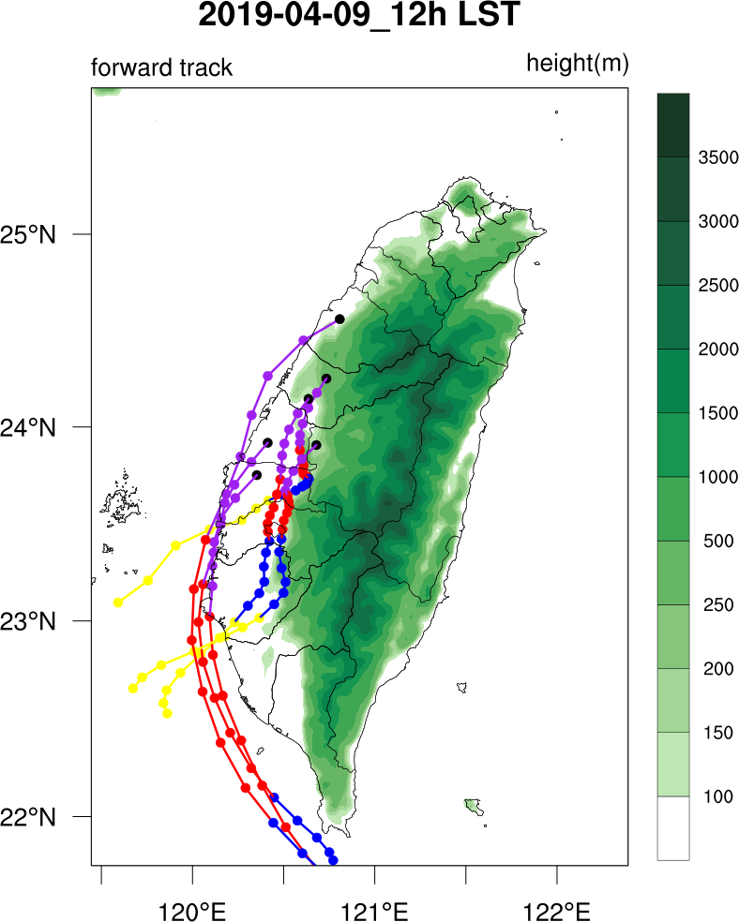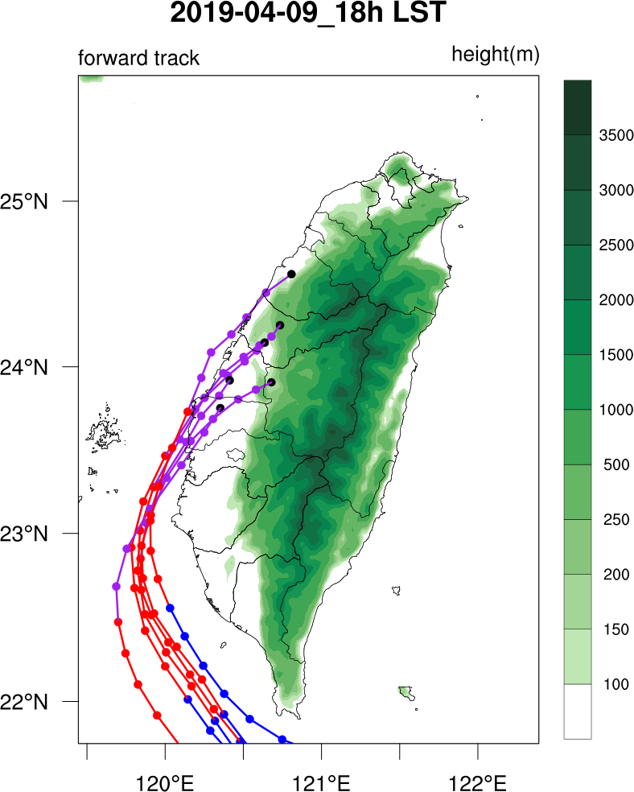
(p)
(j)
(g)
(i)
(k)
(l)
(m)
(n)
(o)
(e)
(f)
(h)
(a)
(b)
(c)
(d)
Fig. S9. Backward trajectories from Miaoli, Fengyuan, Zhongming, Erlin, Lunbei, and Nantou Stations, calculated every six hours from April 6 to 9, 2019, starting at 00:00, 06:00, 12:00, and 18:00 LST for each day: (a) – (d) April 6, (e) – (h) April 7, (i) – (l) April 8, and (m) – (p) April 9, 2019.

(a1) Mouli Station(ML) (b1)Fengyuan Station (FY) (c1) Zhongming Station (ZM) (d1) Erlin Station (EL) (e1) Lunbei Station (LB) (f1) Nantou Station (NT)
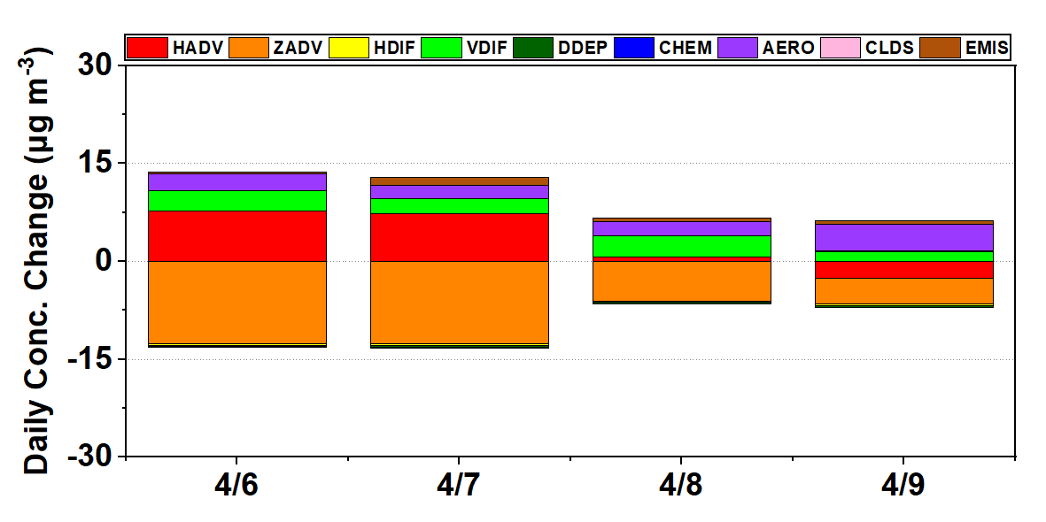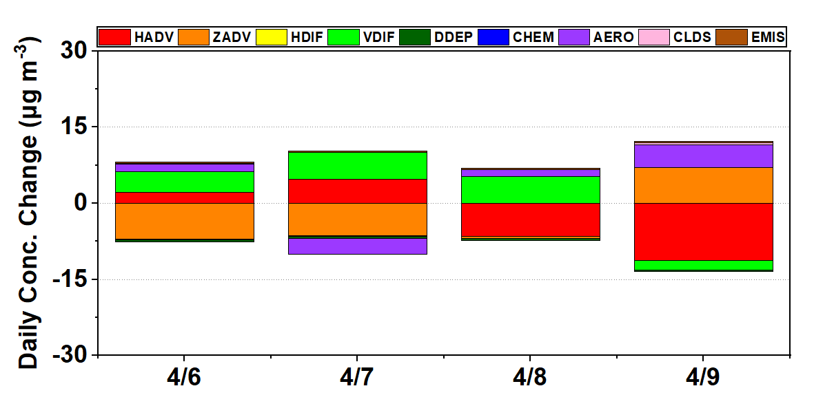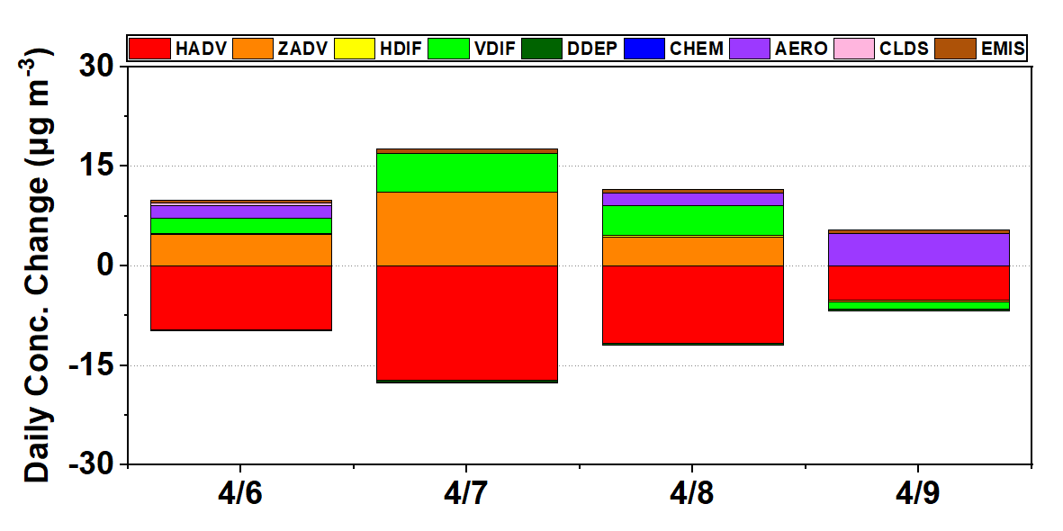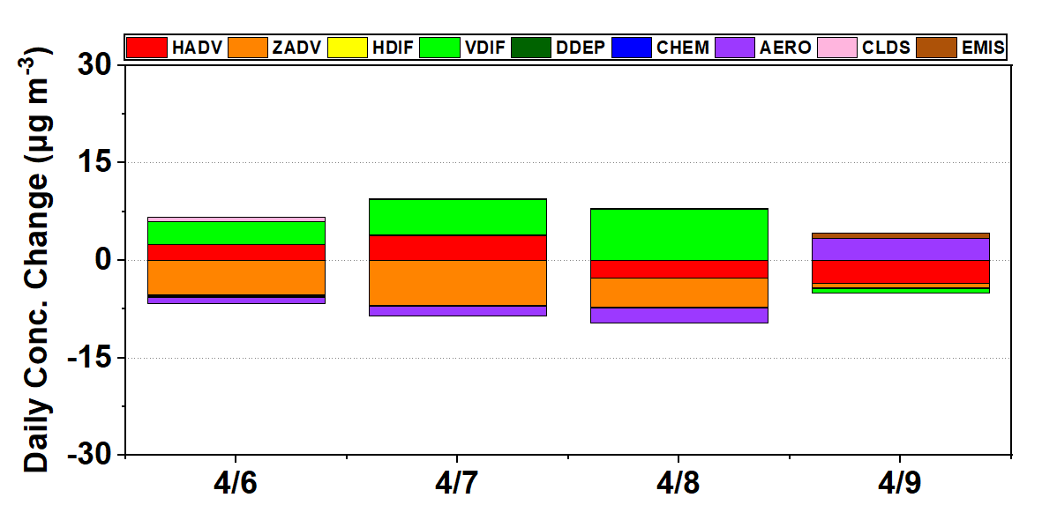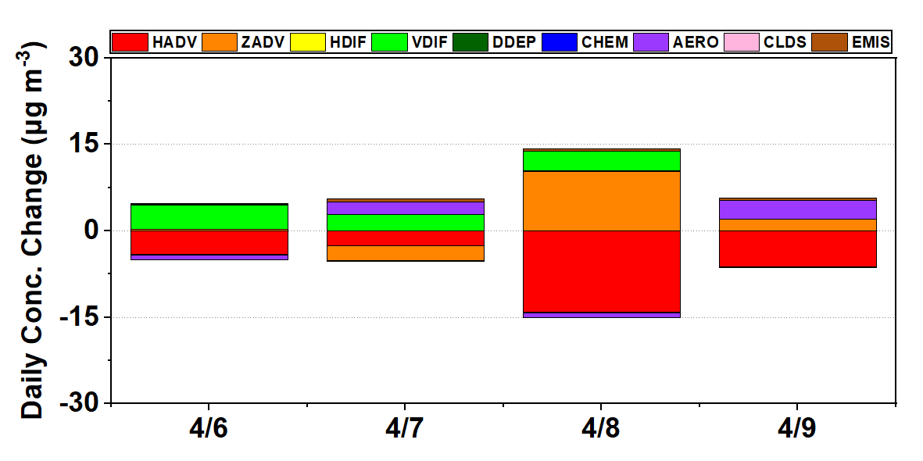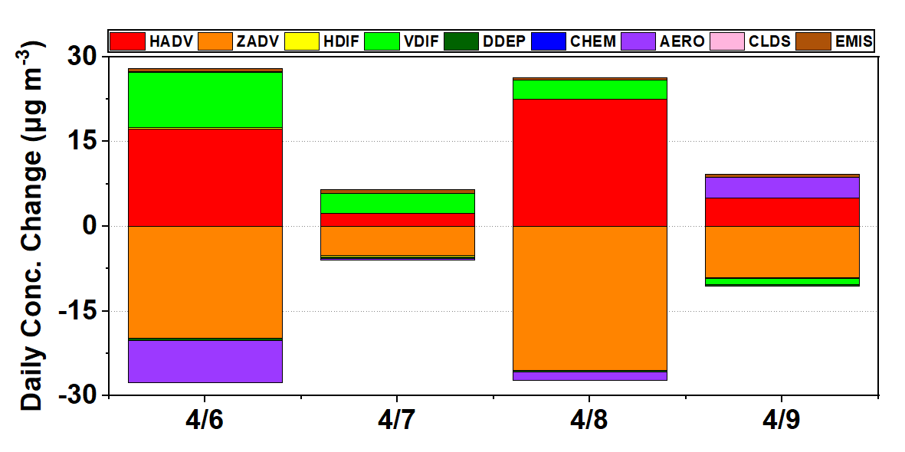
(a2) Mouli Station(ML) (b2)Fengyuan Station (FY) (c2) Zhongming Station (ZM) (d2) Erlin Station (EL) (e2) Lunbei Station (LB) (f2) Nantou Station (NT)
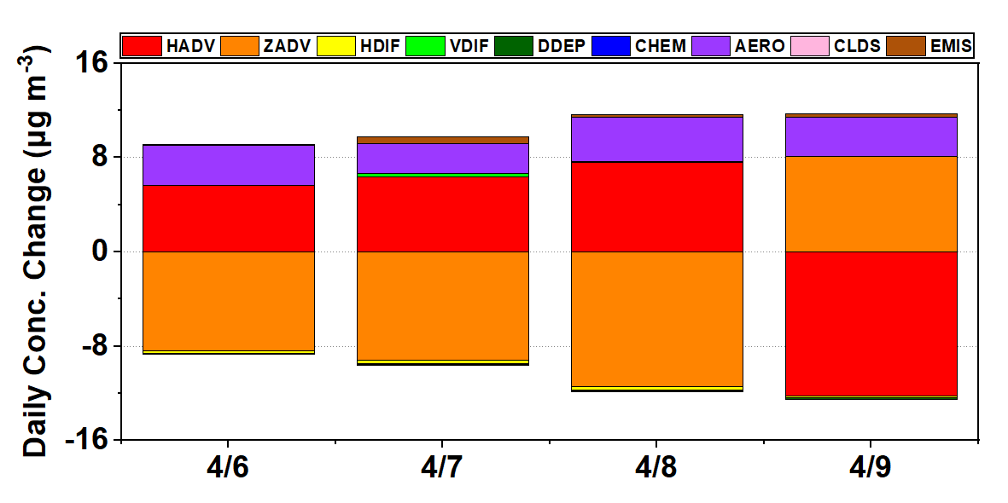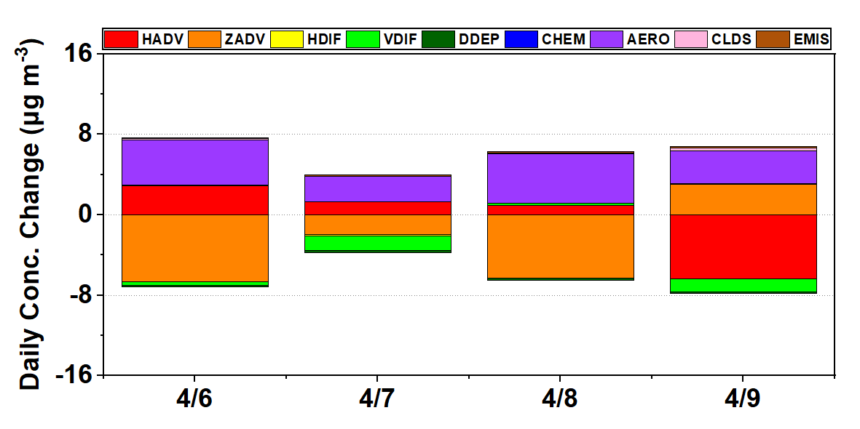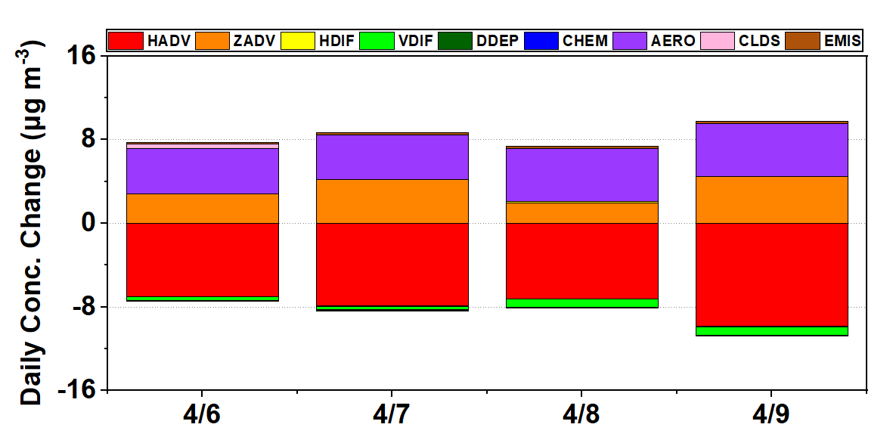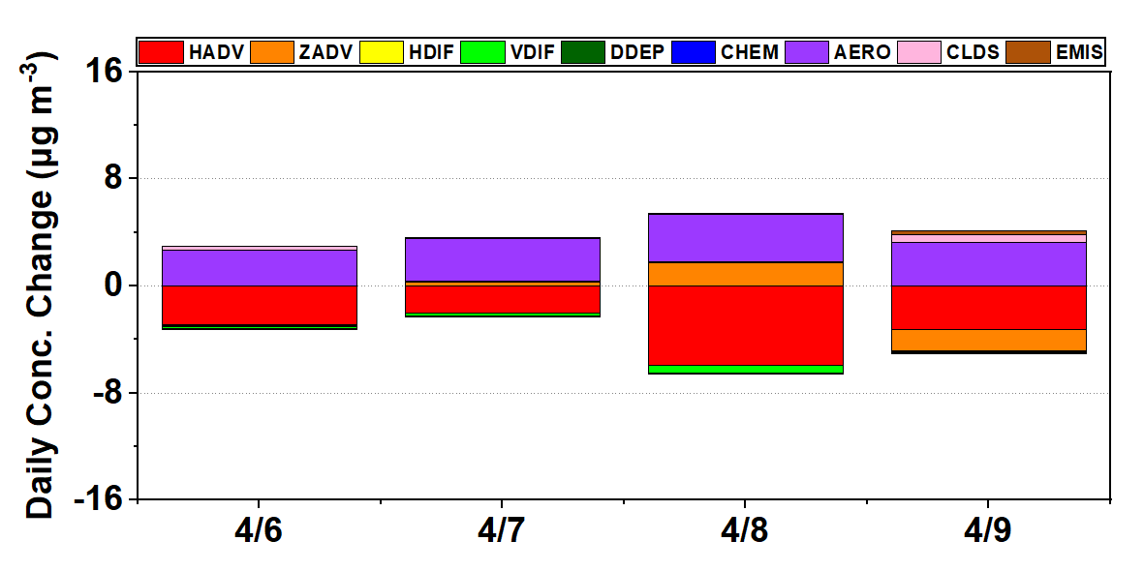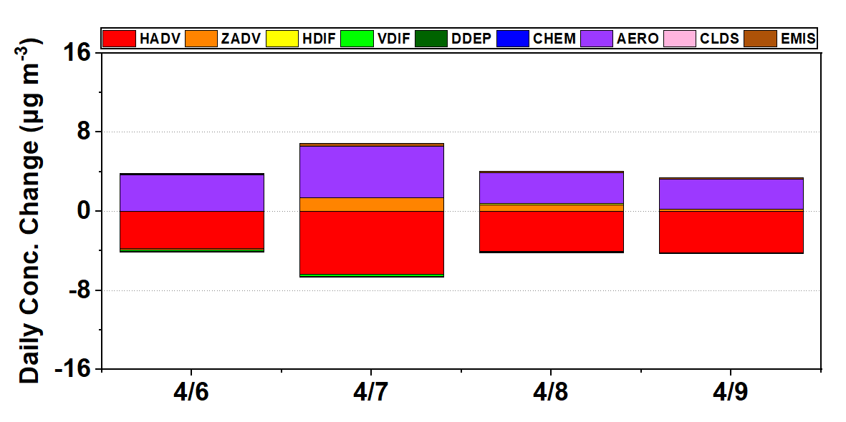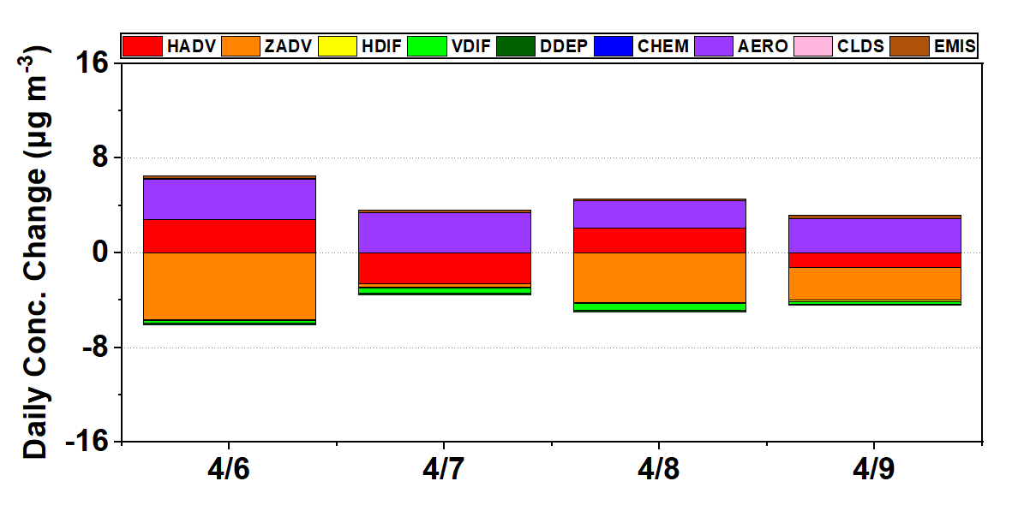
(a3) Mouli Station(ML) (b3)Fengyuan Station (FY) (c3) Zhongming Station (ZM) (d3) Erlin Station (EL) (e3) Lunbei Station (LB) (f4) Nantou Station (NT)
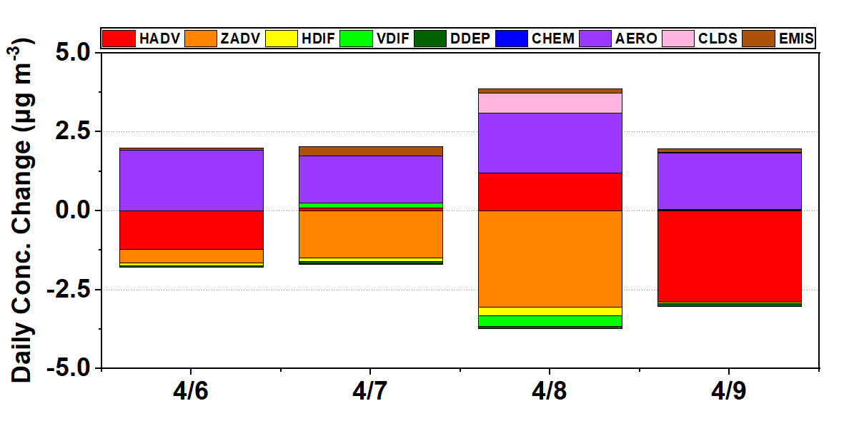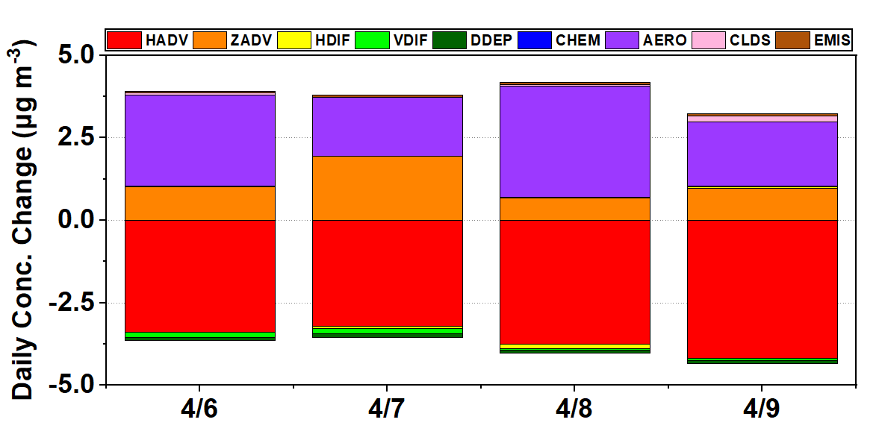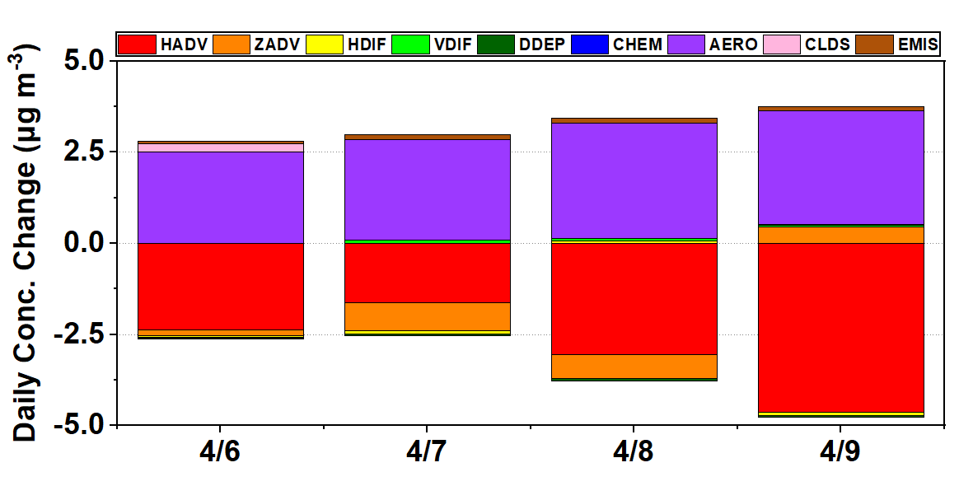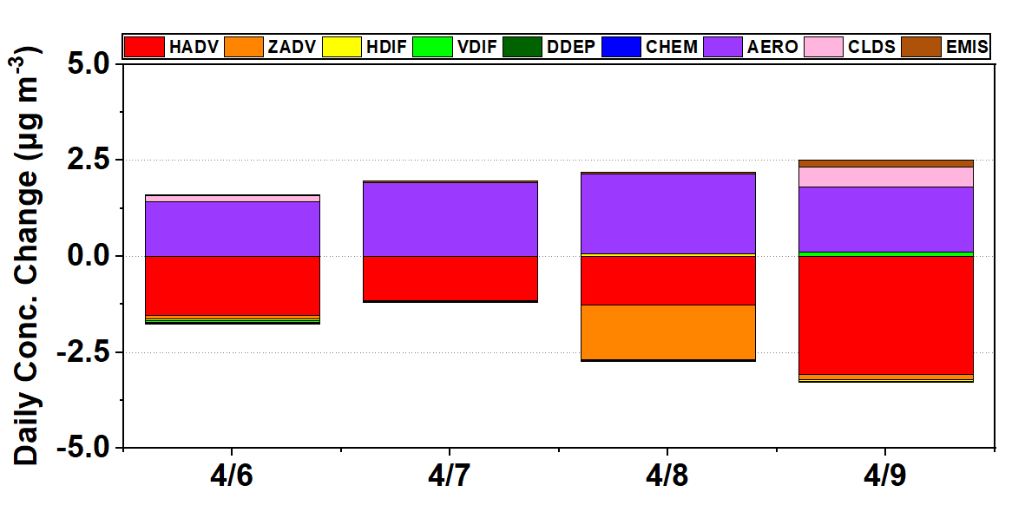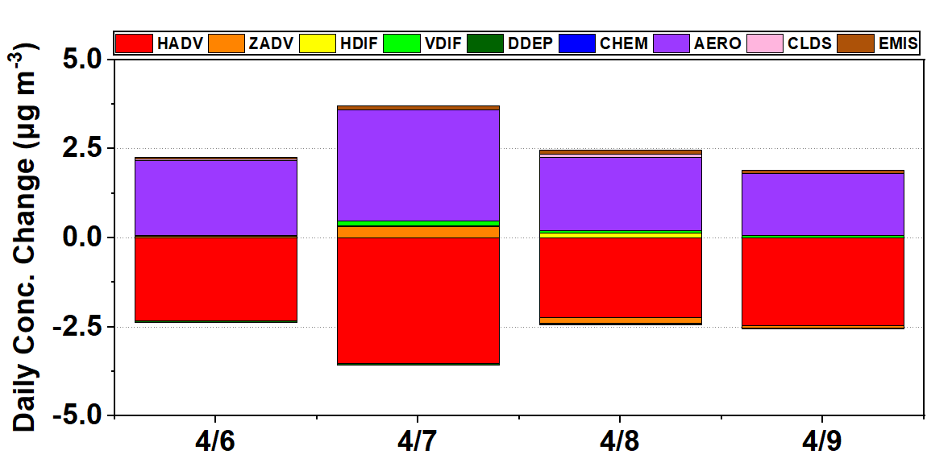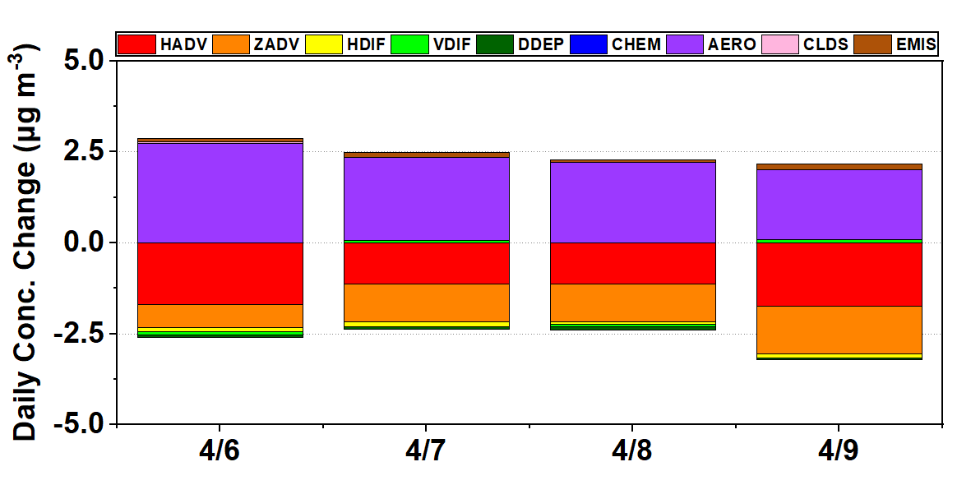
(a4) Mouli Station(ML) (b4)Fengyuan Station (FY) (c4) Zhongming Station (ZM) (d4) Erlin Station (EL) (e4) Lunbei Station (LB) (f4) Nantou Station (NT)
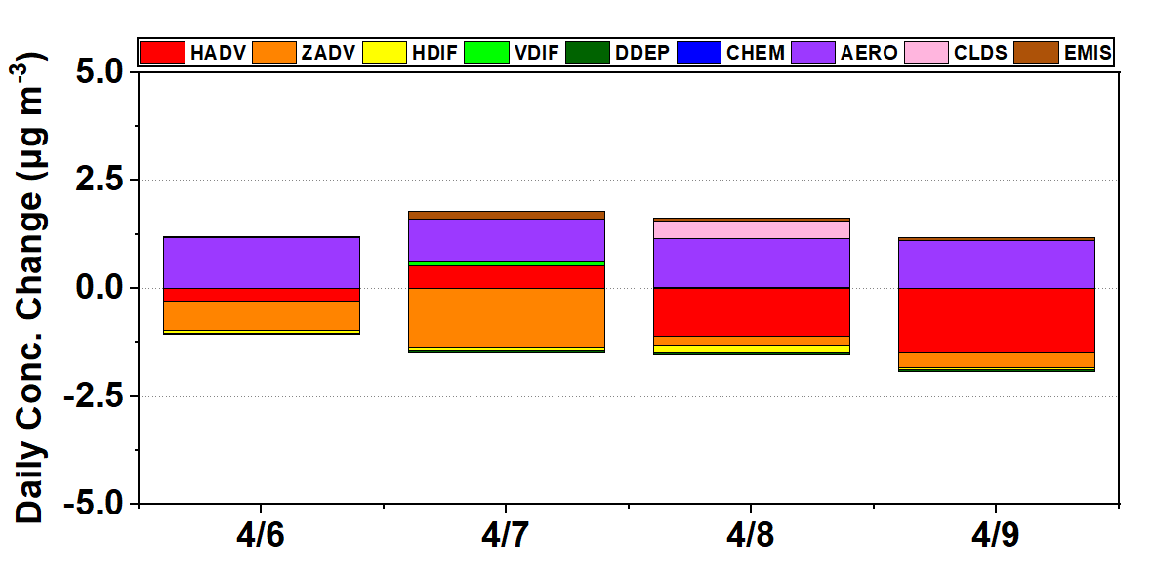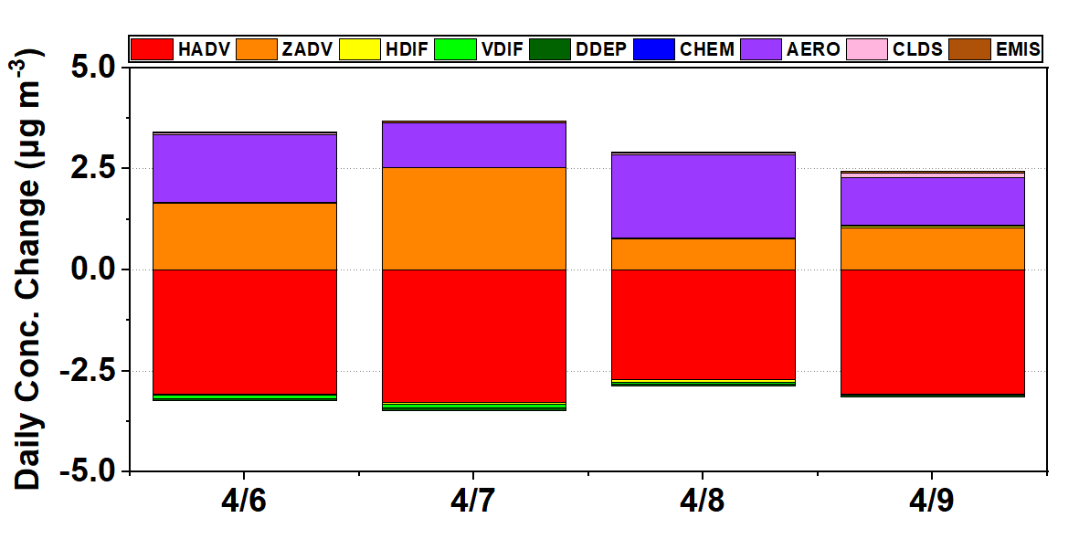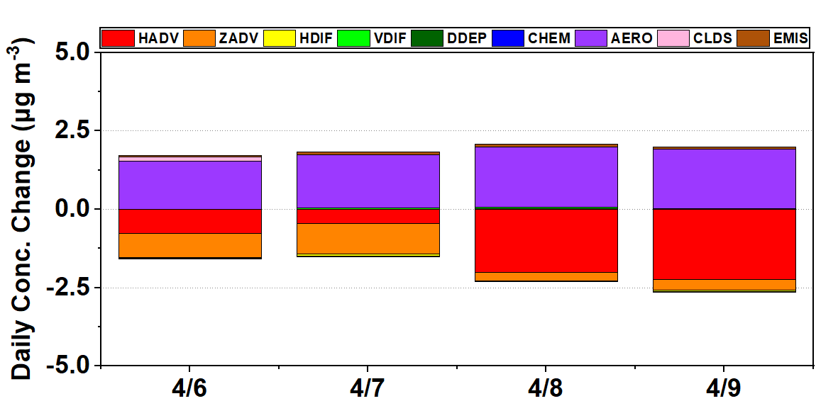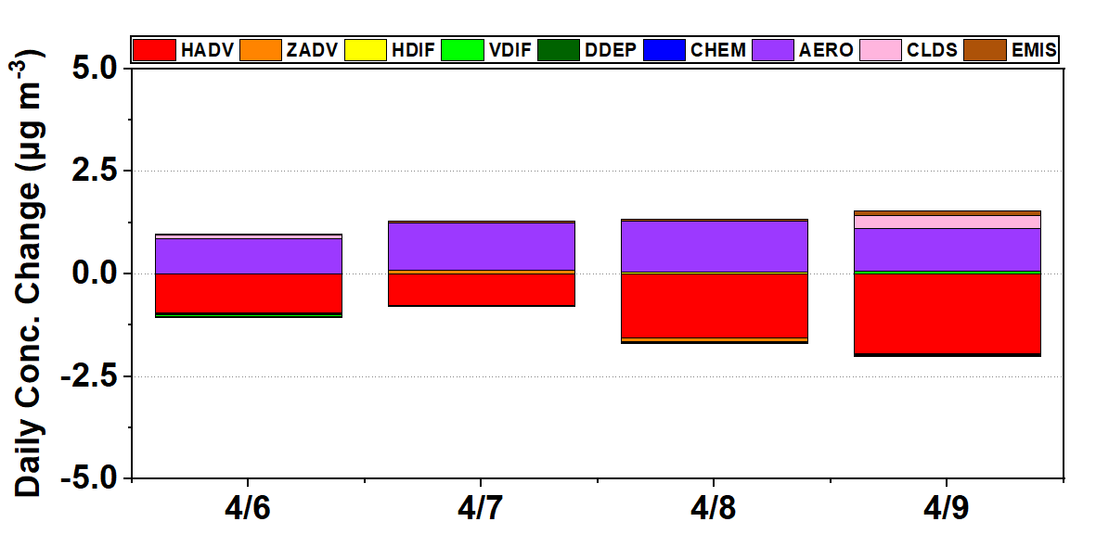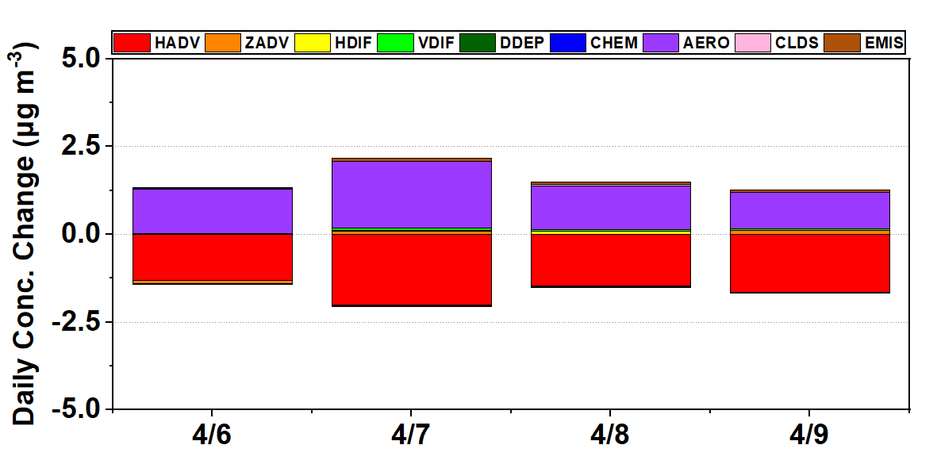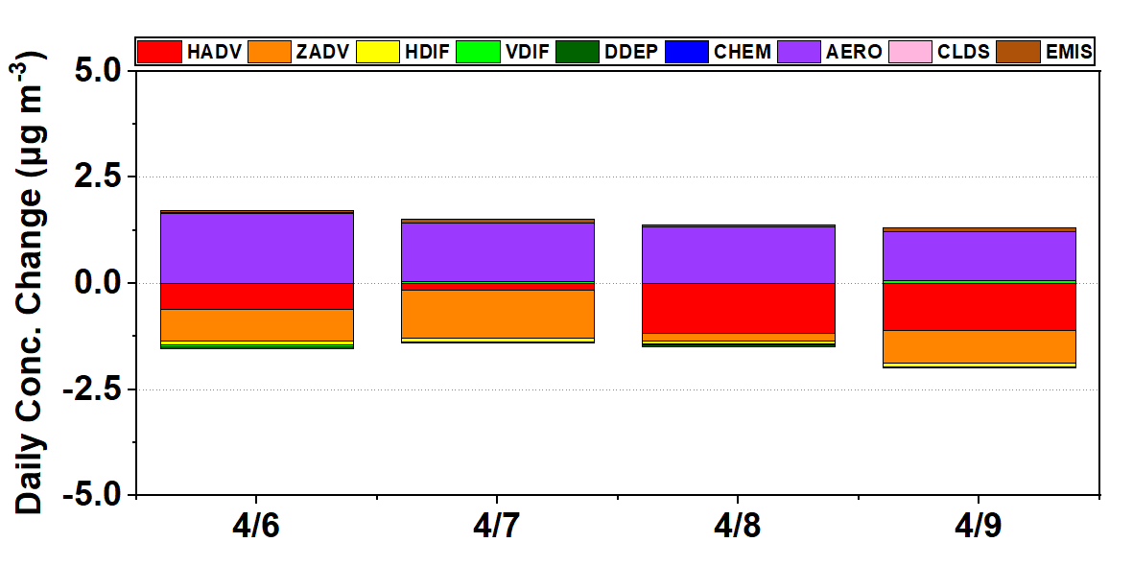
Fig. S10. Daily average contribution of the process analysis at the model heights of the lower (1)10, (2)15 , (3)20, and (4)25 layers. The stations were the (a) Miaoli (ML), (b) Fengyuan (FY), (c) Zhongming (ZM), (d) Erlin (EL), (e) Lunbei (LB), and (f) Nantou (NT) Stations on April 6, 7, 8, and 9, 2019. HADV, ZADV, HDIF, VDIF, DDEP, CHEM, AERO, CLDS, and EMIS denote horizontal advection, vertical advection, horizontal diffusion, vertical diffusion, dry deposition, chemical processes, aerosol processes, cloud processes, and emissions, respectively.

(a) Miaoli Station (ML) (b) Fengyuan Station (FY)
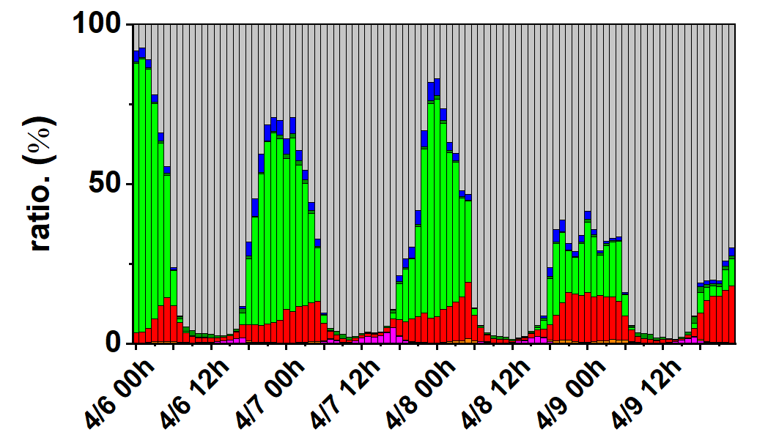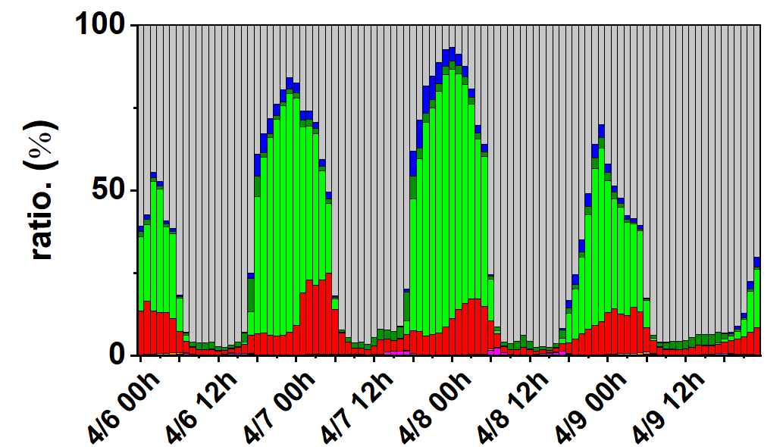
(c) Zhongming Station (ZM) (d) Erlin Station (EL)
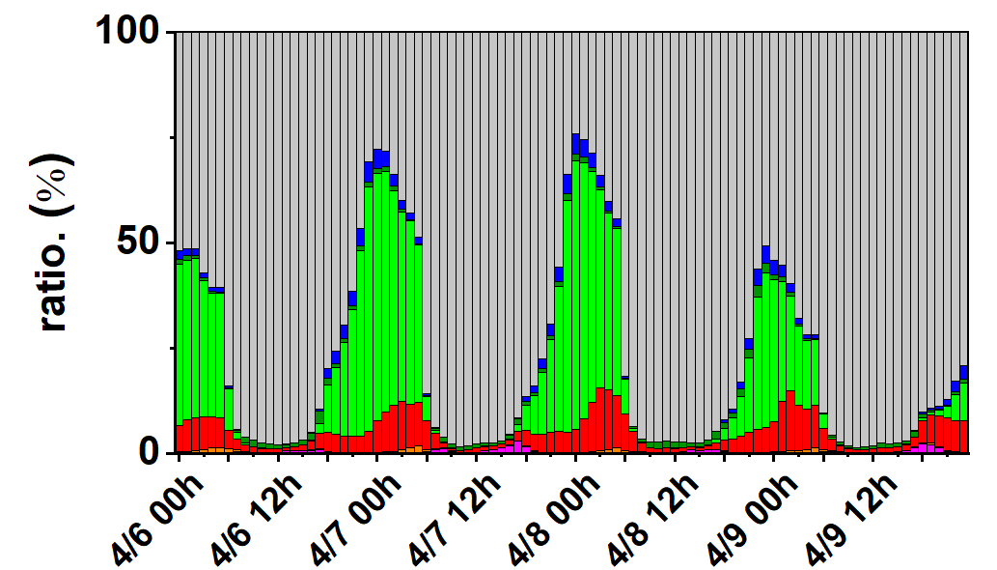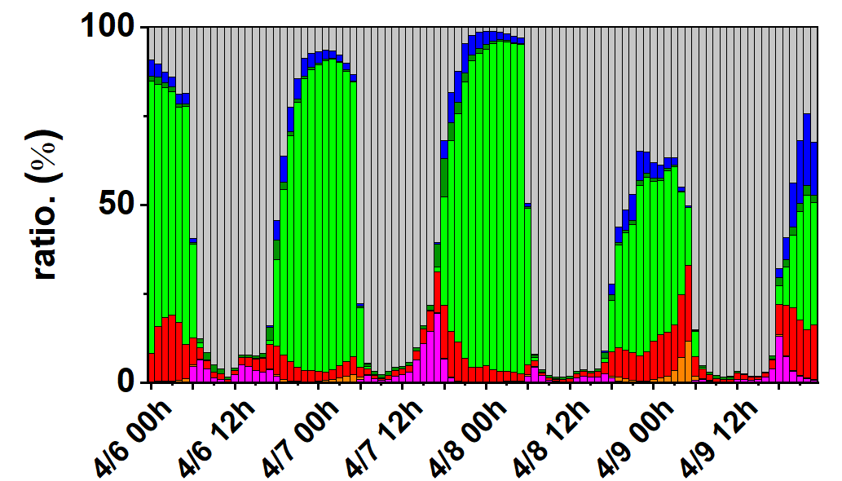
(e) Lunbei Station (LB) (f) Nantou Station (NT)
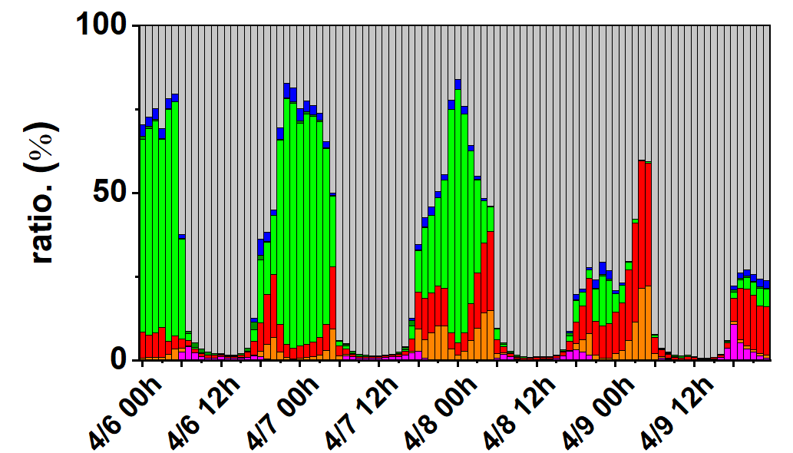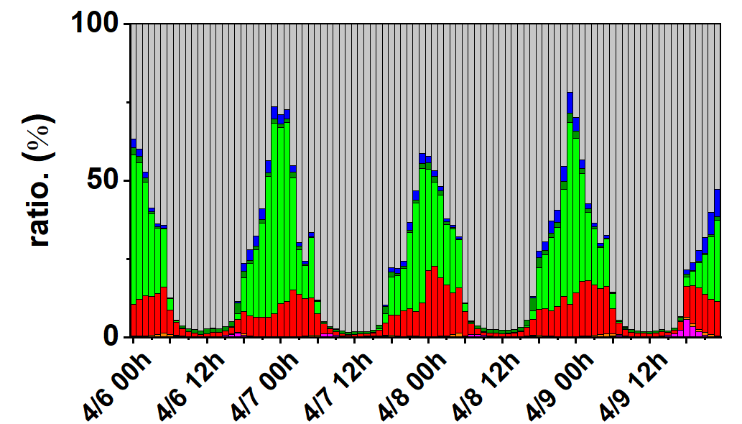
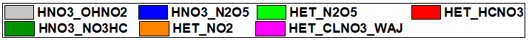
Fig. S11. Attribution to HNO₃ formation pathways at the (a) Miaoli (ML), (b) Fengyuan (FY), (c) Zhongming (ZM), (d) Erlin (EL), (e) Lunbei (LB), and (f) Nantou (NT) Stations on April 6, 7, 8, and April 9, 2019. HNO3_OHNO2, HNO3_N2O5, HET_N2O5, HET_HCNO3, HNO3_NO3HC, HET_NO2 and HET_CLNO3_WAJ denote the HNO₃ formation reactions in Section 2.5.2.

(a) Miaoli (ML) (b) Fengyuan (FY)
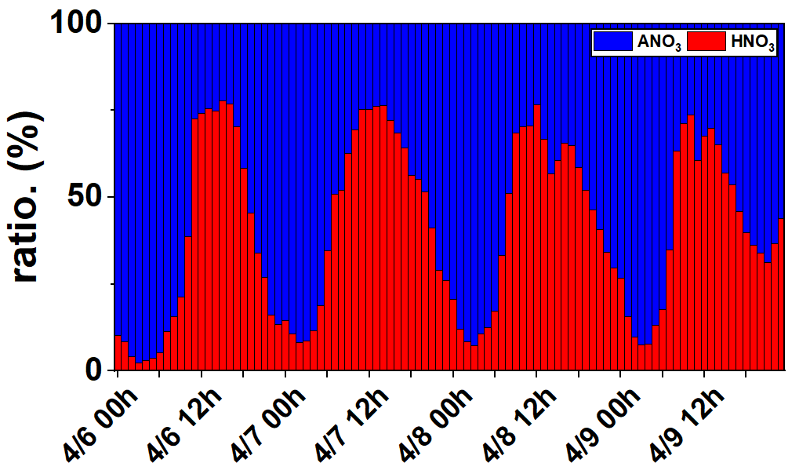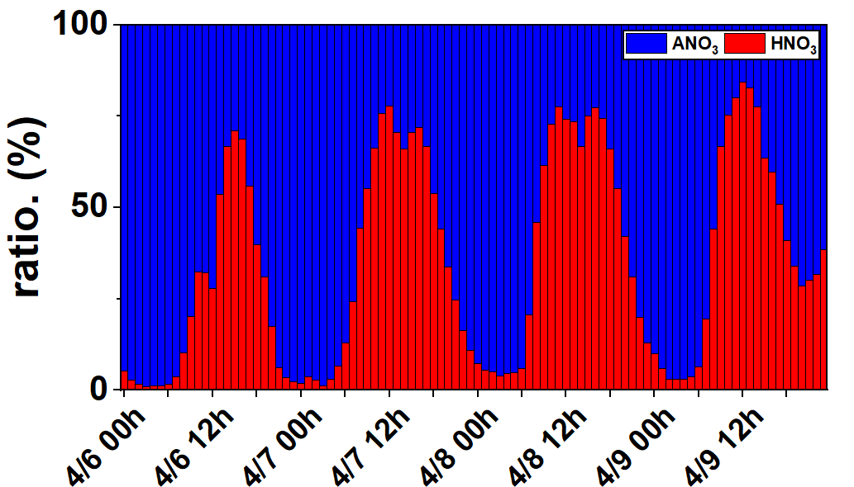
(c) Zhongming (ZM) (d) Erlin (EL)
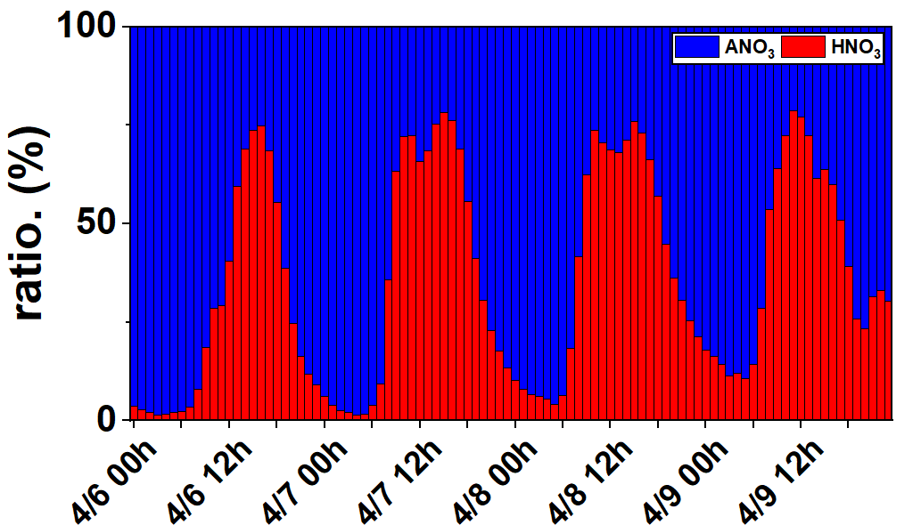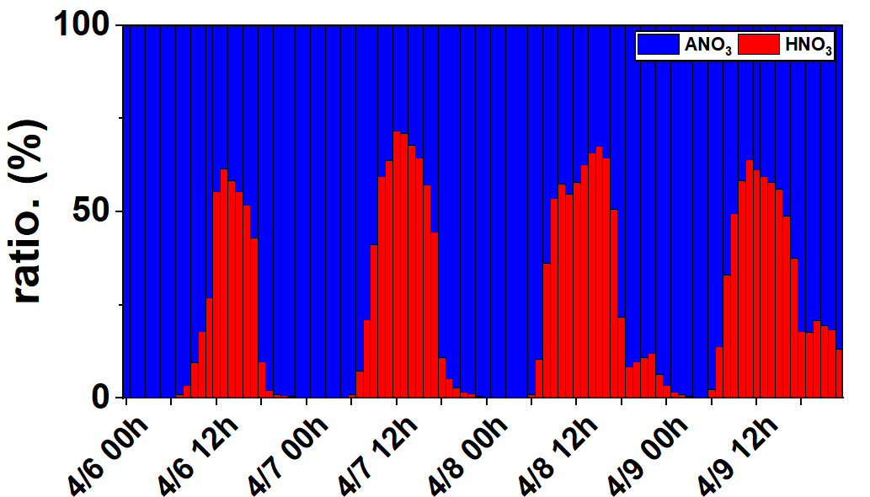
(e) Lunbei (LB) (f) Nantou (NT)
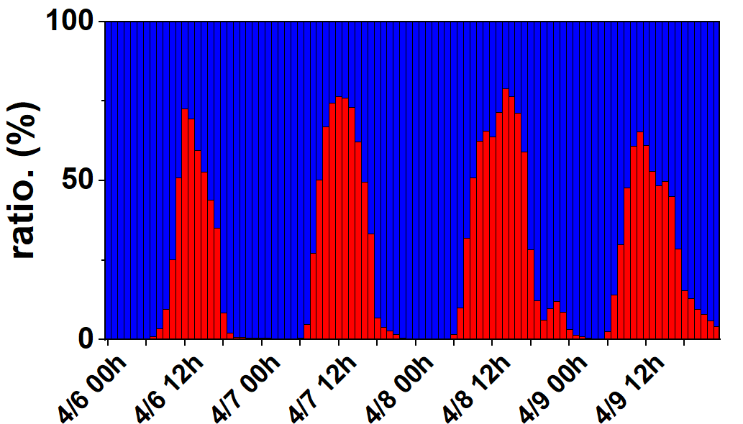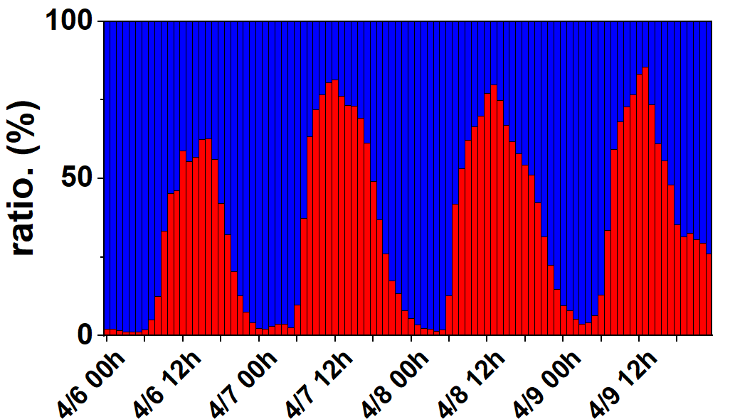
Fig. S12. The percentage speciation of gas-phase (HNO₃) and aerosol-phase (ANO₃) nitrate at (a) Miaoli (ML), (b) Fengyuan (FY), (c) Zhongming (ZM), (d) Erlin (EL), (e) Lunbei (LB) and (f) Nantou (NT) stations on April 6, 7, 8, and April 9, 2019.

(a) Miaoli (ML) (b) Fengyuan (FY)
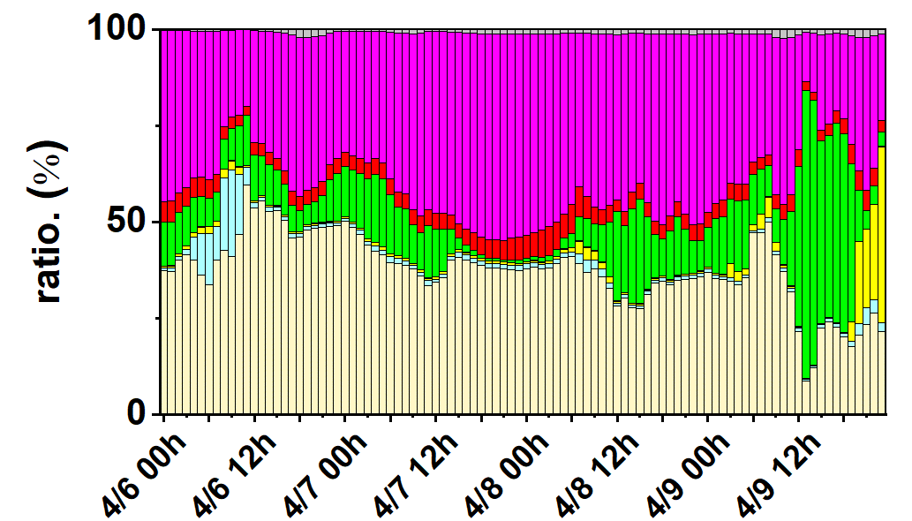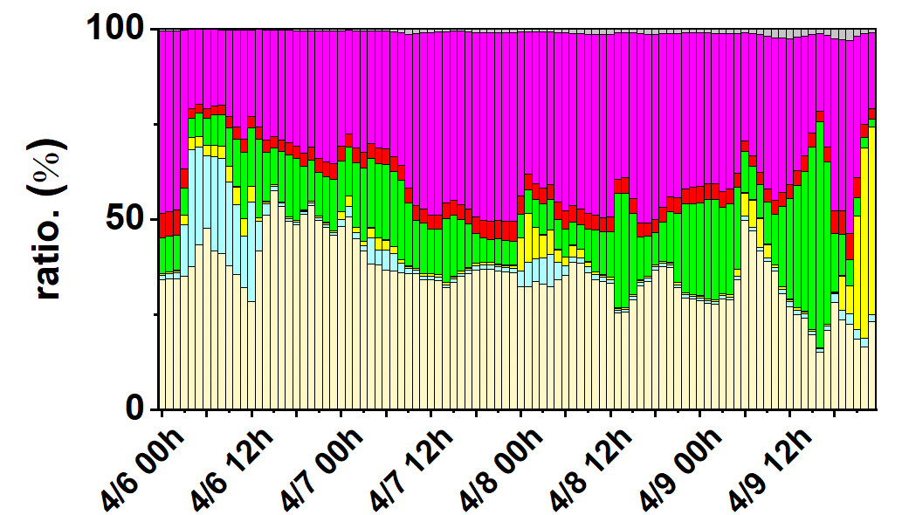
(c) Zhongming (ZM) (d) Erlin (EL)
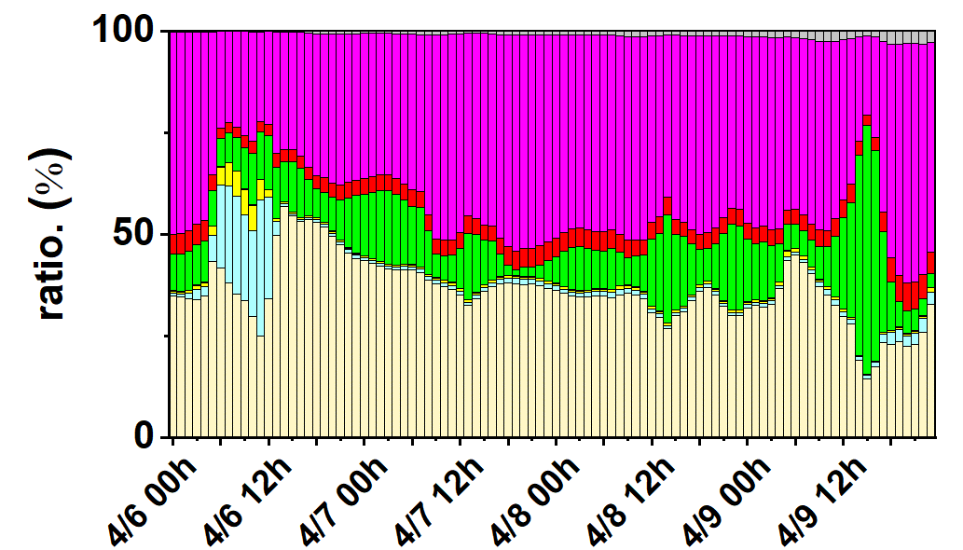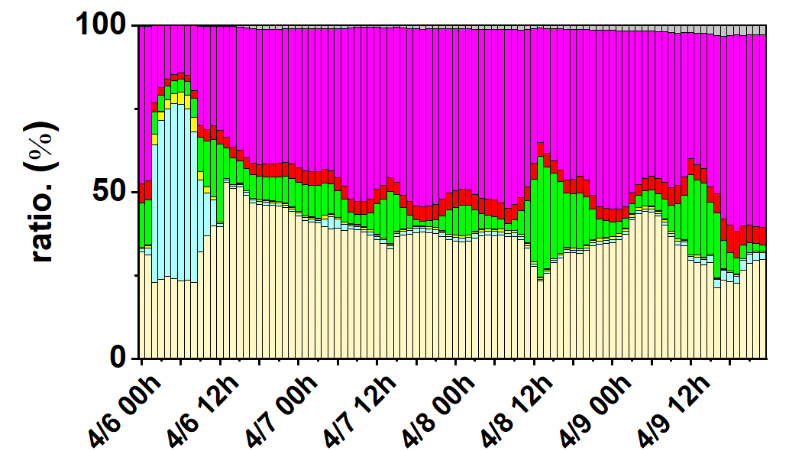
(e) Lunbei (LB) (f) Nantou (NT)
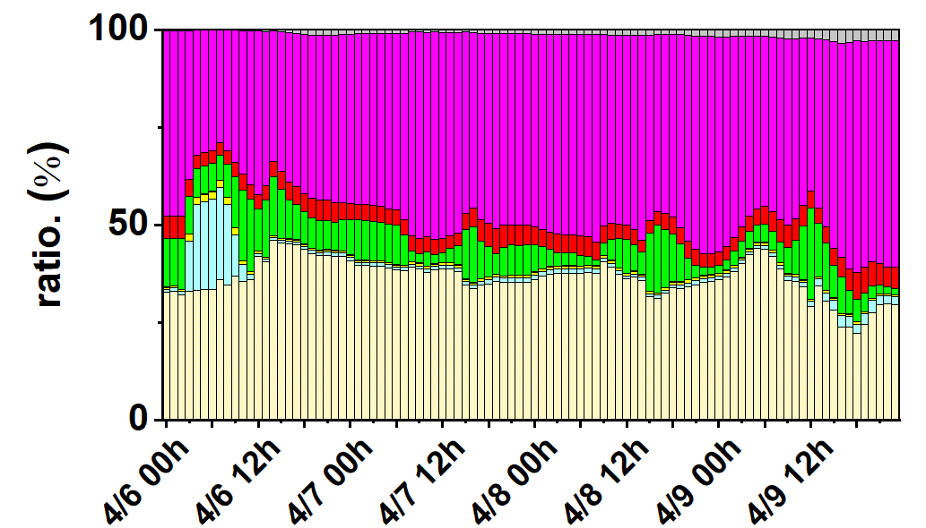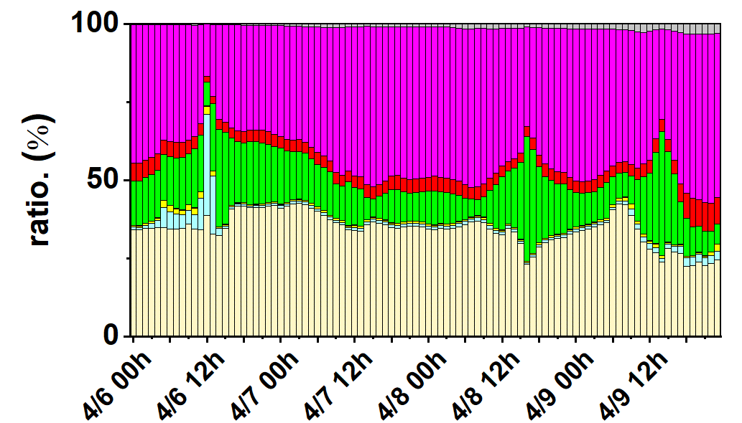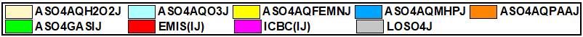
Fig. S13. The percentage of attribution to sulfur tracking method (STM) species at (a) Miaoli (ML), (b) Fengyuan (FY), (c) Zhongming (ZM), (d) Erlin (EL), (e) Lunbei (LB) and (f) Nantou (NT) stations on April 6, 7, 8, and April 9 2019. ASO4AQH2O2J, ASO4AQO3J, ASO4AQFEMNJ, ASO4AQMHPJ, ASO4AQPAAJ, ASO4GASJ, EMIS(J), and ICBC(J) represent the eight SO₄²⁻ in accumulation mode, while ASO4GASI, EMIS(I), and ICBC(I) are the three SO₄²⁻ in Aitken model. LOSO4J denotes the sum of nine organic sulfate items in the accumulation mode.

(a) Miaoli (ML) (b) Fengyuan (FY)
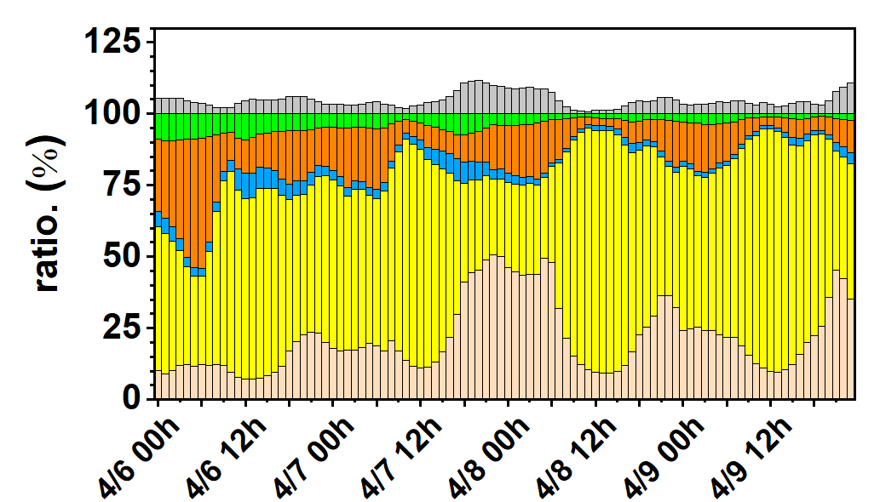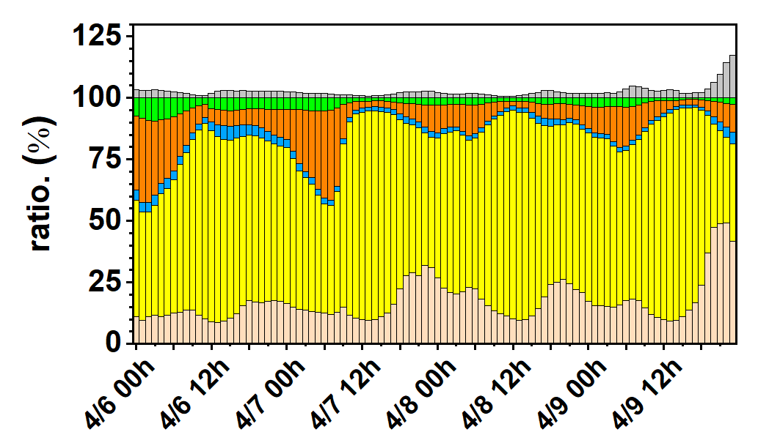
(c) Zhongming (ZM) (d) Erlin (EL)
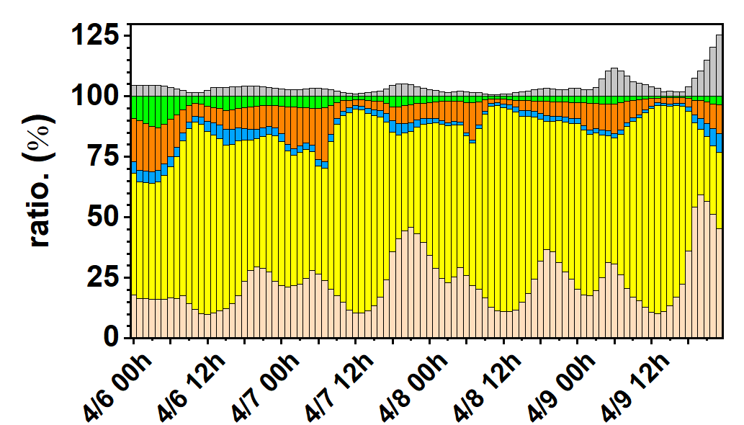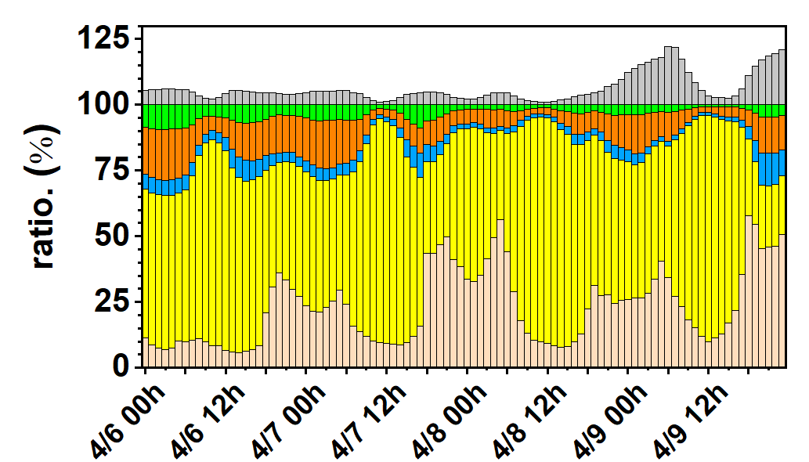
(e) Lunbei (LB) (f) Nantou (NT)
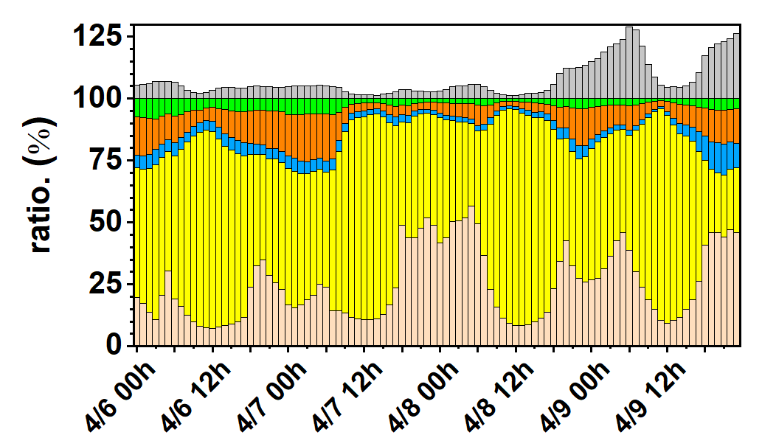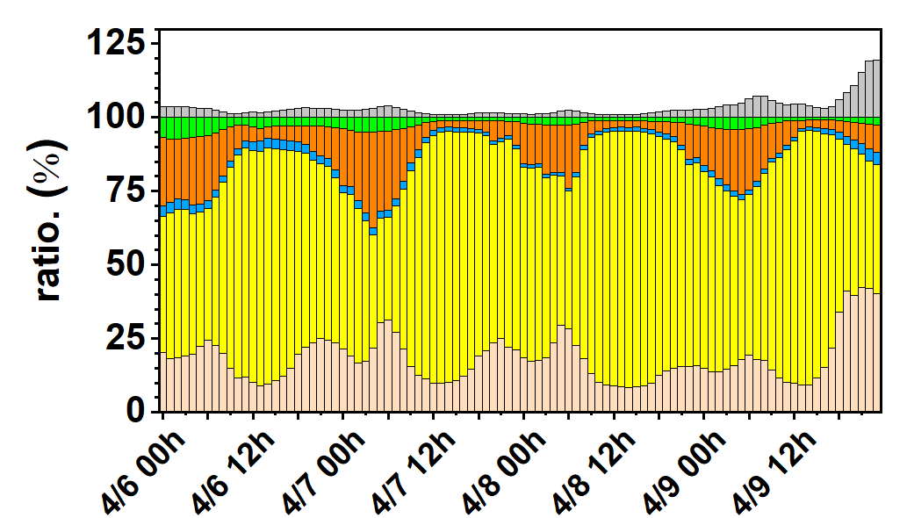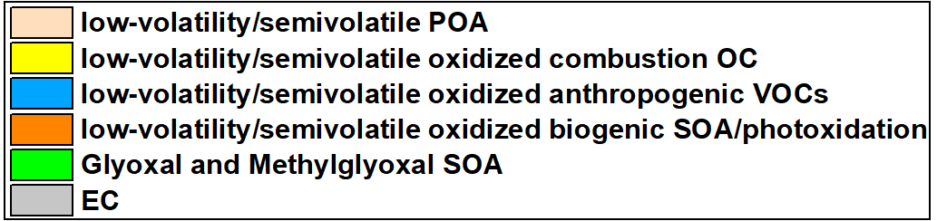
Fig. S14. The percentage of attribution to OC species and EC at the(a) Miaoli (ML), (b) Fengyuan (FY), (c) Zhongming (ZM), (d) Erlin (EL), (e) Lunbei (LB) and (f) Nantou (NT) stations on April 6, 7, 8, and April 9, 2019.

