The plots (1-12) below show the actual vs. predicted values for each pollutant from the proposed algorithm, demonstrating the performance of the regression models.
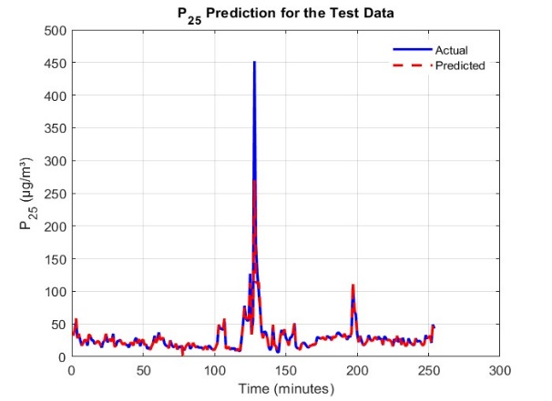
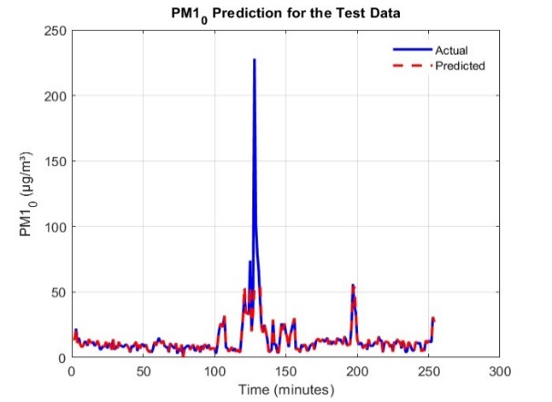

Fig. 2: Comparison of Predicted and Actual PM2.5 Values for Apartment Building
Fig. 1: Comparison of Predicted and Actual PM1.0 Values for Apartment Building
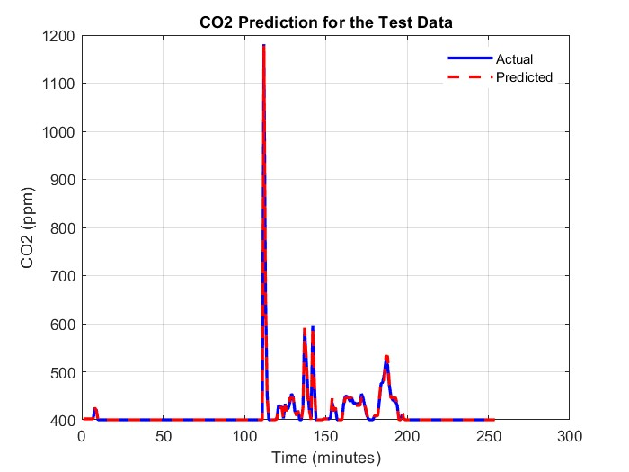
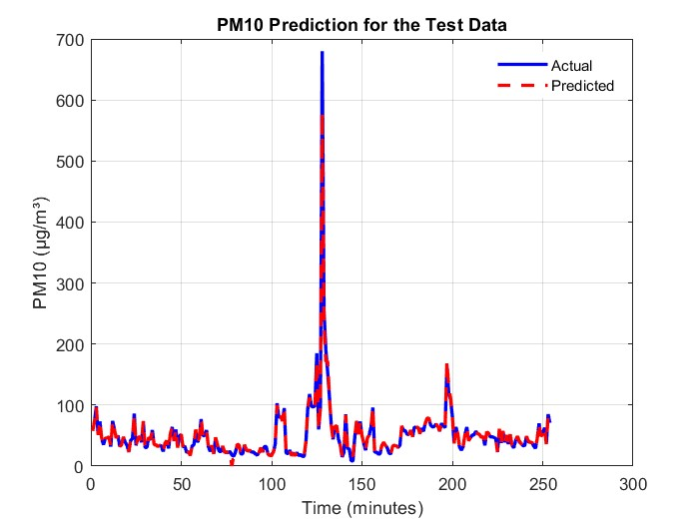
Fig. 4: Comparison of Predicted and Actual CO2 Values for Apartment Building
Fig. 3: Comparison of Predicted and Actual PM10 Values for Apartment Building

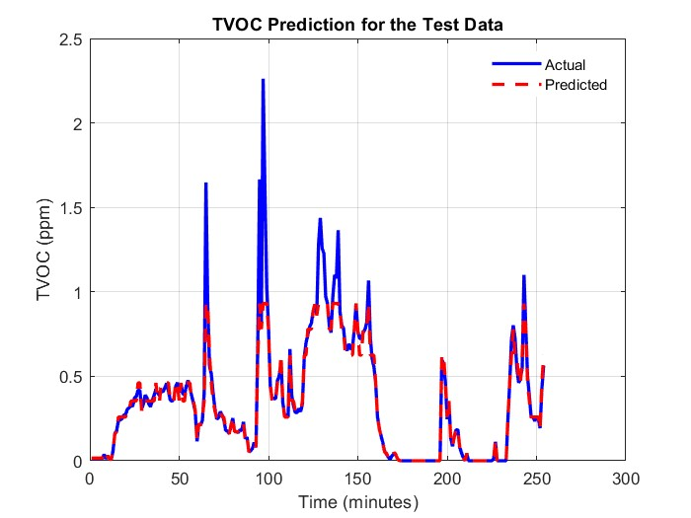
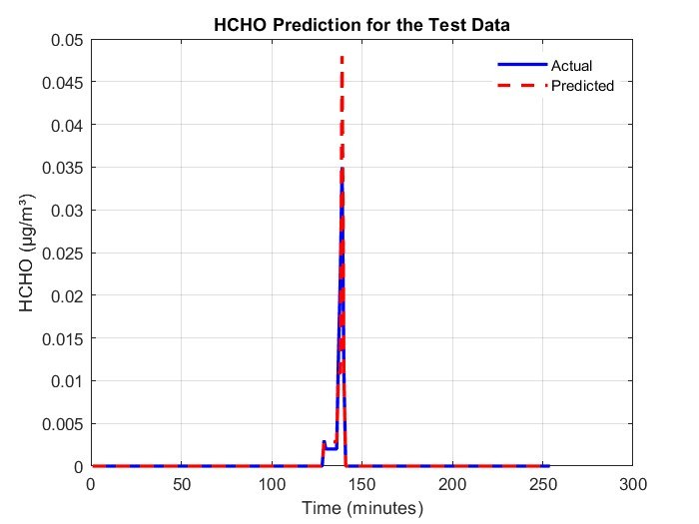
Fig. 5: Comparison of Predicted and Actual HCHO Values for Apartment Building
Fig. 6: Comparison of Predicted and Actual TVOC Values for Apartment Building
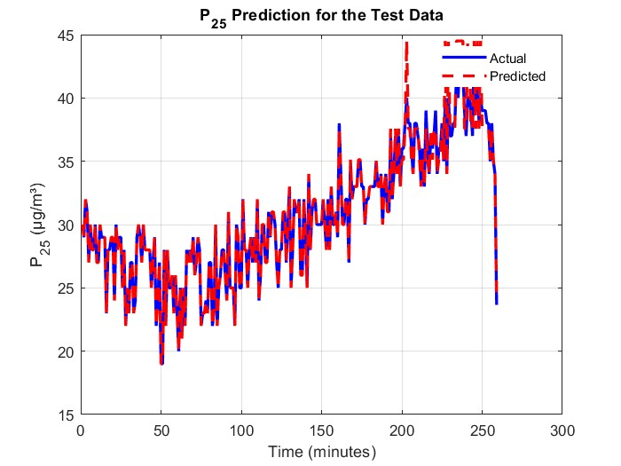
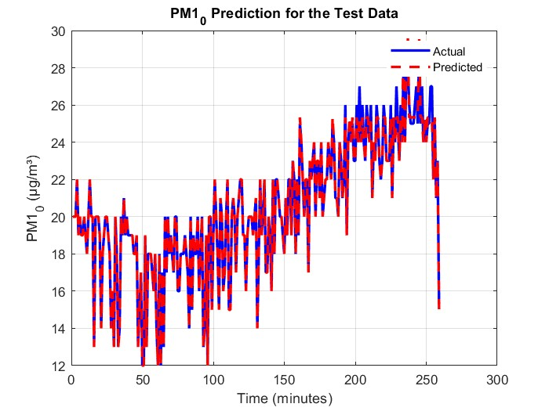

Figure 8: Comparison of Predicted and Actual PM2.5 Values for Villa
Figure 7: Comparison of Predicted and Actual PM1.0 Values for Villa

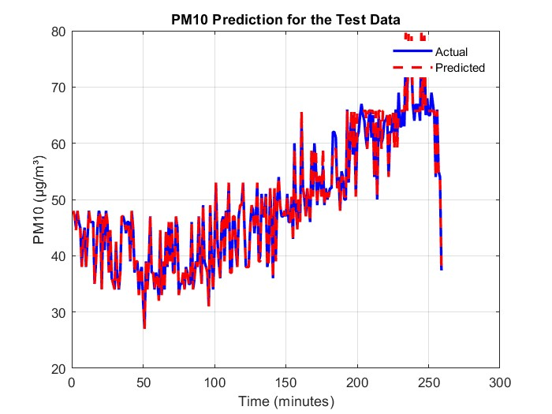
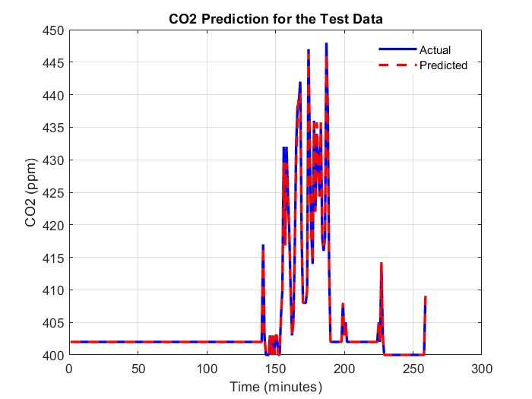
Fig. 10: Comparison of Predicted and Actual CO2 Values for Villa
Fig. 9: Comparison of Predicted and Actual PM10 Values for Villa
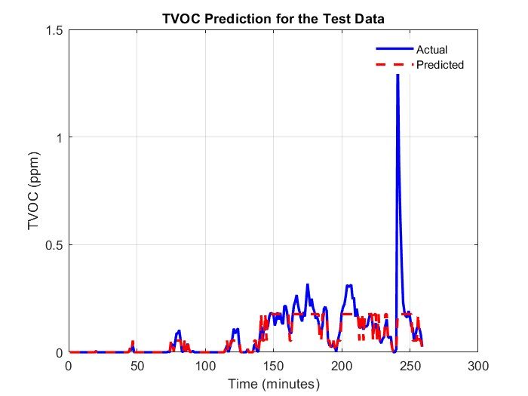
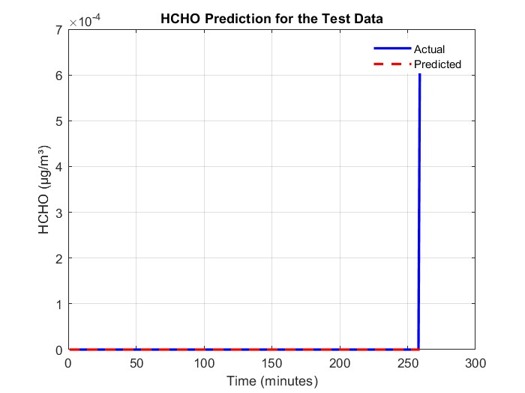

Fig. 12: Comparison of Predicted and Actual TVOC Values for Villa
Fig. 11: Comparison of Predicted and Actual HCHO Values for Villa

