- EXPERIMENTAL SETUP

The ASHRAE 52.2 method is a standard procedure used to evaluate the efficiency of HVAC filters in removing particles within a specific size range. The use of smaller flat sheets of filter media with diameters of 27 mm instead of square HVAC filters, along with two small filter holders, a different approach to achieving particle removal efficiency. This approach has advantages in terms of cost, space utilization, and ease to achieve a sufficient concentration of particulate matter (Shi et al., 2013).
The block diagram of various components used in the experimental setup is shown in Fig. S1. The SMPS aerosol flow rate (0.2, 0.59, and 0.9 L·min⁻¹) refers to the instrument’s sampling conditions and is independent of the face velocity (FV) across the test filter. The SMPS sampling probe was operated under consistent flow conditions to avoid bias in the measurement process.

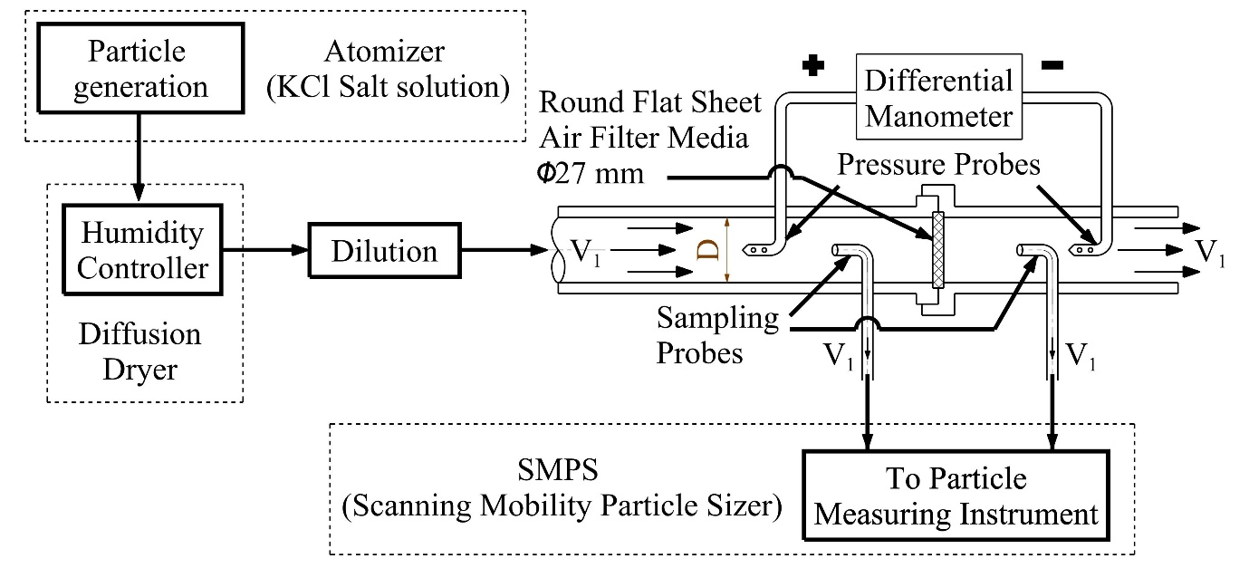
Fig S1. The block diagram of various components for the testing setup, with a detailed setup of the air filter holder.

The face velocity across the filters (0.2, 0.5, and 0.8 m/s) was controlled by adjusting the total flow rate through the filter test section (3, 8.5, and 13 L·min⁻¹, respectively) using a rotameter. A 50% dilution with highly pure nitrogen gas (99.997%) was employed for each case.

  - Particle Generation System

The filter media under study were tested to capture the particles generated using an atomizer, as given previously. It functions by atomizing a salt solution and evaporating the solvent to produce dried particles of salts dissolved in deionized water. The sub-micron particle generated using the atomizer works on the principle of the Bernoulli effect for atomization of any liquid solution with solvent evaporation in order to obtain salt particles in the mainstream of minimum RH. Particularly the solution was used with salt and deionized water, is continuously drawn with pressure difference from a glass bottle at the atomization section with capillary action (rise of water due to pressure difference) where solution is atomized using air jet generated by compressed air expansion through orifice section. This process of atomization provides the droplet formations with a standard deviation of <2. The droplet size and particle number concentration were regulated by the volume flow rate of compressed air. Hence, bigger particles are removed in inertial impaction mechanism at the wall of the solution reservoir. The smaller droplets follow the stream towards the diffusion dryer to absorb the water and dries wet aerosols below 40% RH. Hence, one dry aerosolized particle gets generated theoretically from a liquid solution (Stabile et al., 2013).

2. Design of Custom-built Air Filter Holder

In Fig. S2, a detailed design drawing of the air filter holder used in this study. This particular design facilitates the easy collection of samples from the stream path of particles while also meeting the isokinetic requirement. Additionally, the filter holder has been assembled with pressure probes. The purpose of this design minimizes the risk of non-uniform particle distribution and ensures efficient filtration throughout the cross-section. The filter holder was designed with a consistent diameter of 27 mm throughout its cross-section, from the inlet to the outlet. However, most filter holders available from Pall manufacturers are designed in a conical shape (Dang et al., 2021). These conical filter holders have smaller diameters at the inlet and outlet. The design should also facilitate easy collection of samples from the stream path of particles and meet the isokinetic requirement for accurate sampling. The upstream side length is 10 times the diameter of the tube (27 mm) for uniform development of the flow (Çengel, 2007).
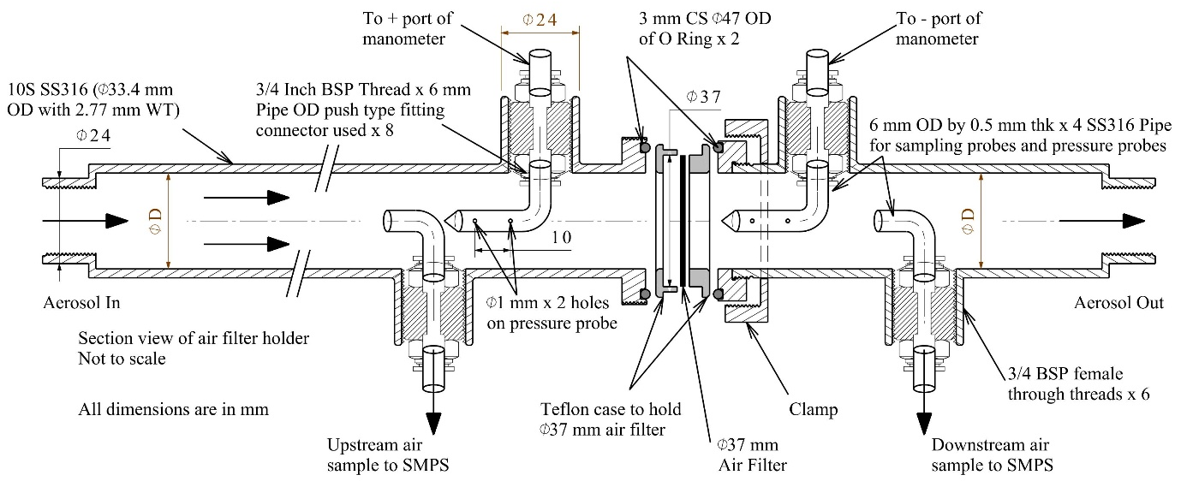
Fig. S2. Detailed design of filter holder for air filter testing
The filter holder design mentioned above is to address isokinetic sampling by inserting sample probes at the centre of the tube section in the upstream and downstream sides of the air filter media. Isokinetic sampling ensures that the air velocity through the filter holder is the same as the inlet air velocity inside the sample probe and ensures accurate sampling. Similarly, pressure probes are added to measure the static pressure or differential pressure across the filter media to assess the pressure drop across the filter and its impact on airflow. Selecting the appropriate filter media is crucial for achieving high particle removal efficiency, minimizing pressure drop, and optimizing electricity consumption in air purifiers.

2.1. Isokinetic sampling
The inlet diameter (D₁) of the filter holder was 27 mm, and airflow was regulated using a rotameter to achieve face velocities (V₁) of 0.2, 0.5, and 0.8 m/s. The sampling probe, with a diameter (D₂) of 5 mm, was positioned to ensure that the velocity through the probe matched the main flow stream. To maintain the desired face velocities (V₁), the SMPS aerosol flow rates were set to 0.2, 0.59, and 0.9 L·min⁻¹ corresponding to velocities of 0.2, 0.5, and 0.8 m/s, respectively.
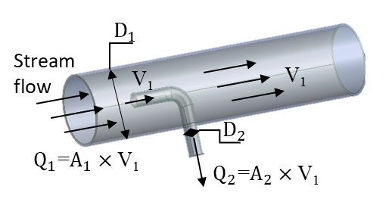
Fig S3. The detailed description of the geometry of sample probe inserted in air filter holder for isokinetic sampling carried out with SMPS.
The relation between flow rates and dimeters while keeping velocity same for channel and sample probe can be written as given in Eq. (S1):
$\frac{Q_{1}}{Q_{2}}\text{=}\frac{A_{1}}{A_{2}}=\frac{D_{1}^{2}}{D_{2}^{2}}$ (S1)
Where Q₁ is the flow rate through the channel; Q₂ is the instrument flow rate; D₁ is the diameter of the stream flow channel; D₂ is the diameter of the sample probe.
The observed variation in upstream particle size distributions (PSDs) with different face velocities is primarily due to changes in the aerosol generation rate from the Collison nebulizer and the associated dilution conditions.

3. Single Fibre Efficiency for Mechanical Fibrous Filters

To calculate the single fiber efficiency of the tested fibrous filter of mechanical collection effects carried out in the model. This study investigated the theoretical particle efficiency, E_{theo}, due to mechanical effect of KCl salt the fibrous filter using single fiber theory as given in Eq. (S2) (Wang et al. 2011):

$E_{theo}=1-exp\left(\frac{-4E_{T}αL}{πd_{f}\left(1-α\right)}\right)$ (S2)
Where, α is the solidity of the filter, t is the thickness of the filter, d_{f} is the fiber diameter in the filter media, E_{T} is the total single fiber efficiency and L is the thickness of the filter.
For calculating efficiency, the Kuwabara model is used for calculating single fibre efficiency. Single fibre efficiency using the boundary layer approach and the Kuwabara viscous flow field (Lee and Liu, 1980).
The removal efficiency of the filter by using the Kuwabara model for the calculation of single fibre efficiency is described as given in Eq. (S3):
$η=\left[2.6×{\left(\frac{1-α}{K}\right)}^{\frac{1}{3}}×{P_{e}}^{-\frac{2}{3}}\right]+\left[\left(\frac{1-α}{K}\right)×\left(\frac{R^{2}}{1+R}\right)\right]$ (S3)
Where; $η$ is single fibre efficiency, α is the packing density or solidity of the filter, m³; u is the filtration velocity, m/s; Pe is Peclet number; $P_{e}=\frac{ud_{f}}{d}$, R is Interception parameter; $R=\frac{d_{p}}{d_{f}}$, d_{p} is the particle diameter, µm; d_{f} is the fibre diameter, µm; d is the diffusion coefficient of particles; $d=\frac{k T C}{3 π µ dp}$; K is the Kuwabara's hydrodynamic factor; $K=-\frac{1}{2}\ln{α}-\frac{3}{4}+ α-\frac{α^{2}}{4}$.
The first term on the right-hand side of the single fibre efficiency equation describes the efficiency due to Brownian diffusion, and the second term describes that due to interception (Berry et al., 2023).
Using the Knudsen-Weber equation given in Eq. (S4) (Lee and Liu, 1980):
$C=1+a\frac{λ}{D_{p}}+b\frac{λ}{D_{p}}exp\left(-c\frac{D_{p}}{λ}\right)$ (S4)
Where a, b, c = 2.492, 0.84 and 0.435 respectively
Interception of diffusing particles (η_{id}) is used to calculate Stokes number as given in Eq. (S5).
$Stk=\frac{ρ_{p}d_{p}^{2}C_{c}u}{18μd_{f}}$η_{id}, (S5)
where u is face velocity, $ρ_{p}$ is KCl density, $d_{p}$ is the particle mobility diameter, $C_{c}$ is the Cunningham slip correction factor and $μ$ is the air viscosity (Ns/m²) from Wang et al. (2011).
The single fiber efficiency model with interaction term due to interception and diffusing particles, impaction and electrostatic attraction deposition on the tested filter for a fibrous filter was carried out as given in Eq. (S6).
$E_{T}=1-\left(1-η\right)\left(1-η_{I}\right)\left(1-η_{q}\right)$$E_{T}=1-\left(1-η\right)\left(1-η_{i}\right)\left(1-η_{q}\right)$$E_{T}=1-η\left(1-η_{i}\right)\left(1-η_{q}\right)$$E_{T}=1-(1-η)\left(1-η_{dr}\right)\left(1-η_{i}\right)\left(1-η_{q}\right)$,$E_{T}=1-\left(1-η\right)\left(1-η_{I}\right)\left(1-η_{q}\right)$ | (S6)

Where E_{T} is the total single-fiber efficiency, η is the efficiency due to diffusion and interception, η_{dr} is the interaction term due to interception and diffusing particles as given in Eq. (S7).
$η_{dr}=\frac{{1.24 R}^{2/3}}{{(K×Pe)}^{1/2}}$,$E_{T}=1-\left(1-η\right)\left(1-η_{I}\right)\left(1-η_{q}\right)$ | (S7)

η_{i} is the efficiency due to particle impaction on the fiber media as given in Eq. (S8).
$η_{i}=\frac{1}{{\left(2K\right)}^{2}}\left[\left(29.6-28α^{0.62}\right)R^{2}-27.5R^{2.8}\right]Stk$,$E_{T}=1-\left(1-η\right)\left(1-η_{I}\right)\left(1-η_{q}\right)$ | (S8)

Stk is the stokes number; $Stk=\frac{ρ_{p}d_{p}^{2}C_{c}u}{18μd_{f}}$, ρ_{p} is the particle density; ρ_{p} =1.98 g/cc for KCl, and η_{q} is the efficiency due to electrostatic attraction deposition for neutralized particles is given in Eq (S8).
For uncharged particles passing through bipolarly charged fibers, deposition is primarily governed by the dielectrophoretic effect, particularly for larger particle sizes. Since the particles are electrically neutral, Coulombic interactions are negligible, and the dielectrophoretic mechanism dominates particle capture. The dielectrophoretic deposition efficiency, η_{q,} was calculated as given in Eq. (S8):
$E_{T}=1-\left(1-η\right)\left(1-η_{I}\right)\left(1-η_{q}\right)$$E_{qC}={\left(\frac{1-α}{Ku}\right)}^{1/8}\frac{πN_{CD}}{1+2π{N_{CD}}^{1/4}}$$E_{qC}={\left(\frac{1-α}{Ku}\right)}^{1/8}\frac{πN_{C}}{1+2π{N_{C}}^{1/4}}$$N_{C}=\frac{C_{c}σq}{3πμε_{0}\left(1+ε_{f}\right)d_{p}U_{0}}$$η_{qD}={\left(\frac{1-α}{Ku}\right)}^{2/5}\frac{πN_{D}}{1+2π{N_{D}}^{2/3}}$$η_{q}={\left(\frac{1-α}{Ku}\right)}^{2/5}\frac{πN_{D}}{1+2π{N_{D}}^{2/3}}$$η_{q}={\left(\frac{1-α}{Ku}\right)}^{2/5}\frac{πN_{D}}{1+2π{N_{D}}^{2/3}}$$η_{q}={\left(\frac{1-α}{K}\right)}^{2/5}\frac{πN_{D}}{1+2π{N_{D}}^{2/3}}$,$N_{C}=\frac{C_{c}σq}{3πμε_{0}\left(1+ε_{f}\right)d_{p}U_{0}}$$E_{T}=1-\left(1-η\right)\left(1-η_{I}\right)\left(1-η_{q}\right)$ | (S8)

Where N_{D} is a dimensionless parameter for uncharged particles through a bipolarly charged fibrous filter can be calculated as given in Eq. (S9):
$E_{T}=1-\left(1-η\right)\left(1-η_{I}\right)\left(1-η_{q}\right)$$E_{qC}={\left(\frac{1-α}{Ku}\right)}^{1/8}\frac{πN_{CD}}{1+2π{N_{CD}}^{1/4}}$$E_{qC}={\left(\frac{1-α}{Ku}\right)}^{1/8}\frac{πN_{C}}{1+2π{N_{C}}^{1/4}}$$N_{C}=\frac{C_{c}σq}{3πμε_{0}\left(1+ε_{f}\right)d_{p}U_{0}}$$η_{qD}={\left(\frac{1-α}{Ku}\right)}^{2/5}\frac{πN_{D}}{1+2π{N_{D}}^{2/3}}$$N_{D}=\frac{2C_{c}σ^{2}{d_{p}}^{2}}{3με_{0}{\left(1+ε_{f}\right)}^{2}d_{f}U_{0}}\left(\frac{ε_{p}-1}{ε_{p}+2}\right)$$N_{D}=\frac{2C_{c}σ^{2}{d_{p}}^{2}}{3με_{0}{\left(1+ε_{f}\right)}^{2}d_{f}u}\left(\frac{ε_{p}-1}{ε_{p}+2}\right)$$N_{D}=\frac{2C_{c}σ^{2}{d_{p}}^{2}}{3με_{0}{\left(1+ε_{f}\right)}^{2}d_{f}u}\left(\frac{ε_{p}-1}{ε_{p}+2}\right)$,$N_{C}=\frac{C_{c}σq}{3πμε_{0}\left(1+ε_{f}\right)d_{p}U_{0}}$$E_{T}=1-\left(1-η\right)\left(1-η_{I}\right)\left(1-η_{q}\right)$ | (S9)

Where σ is the charge density (C/m²), ε_{f} is the fabric dielectric constant (1.5 for the polypropylene of current media) and ε₀ is the permittivity of the vacuum (8.85×10⁻¹² C²/Nm²). and ε_{p} is the relative permittivity of the particle, which is 4.81 for KCl in current study. In the model, the KCl salt particles were considered as spherical particles.

3.1. Preparation of salt solutions
The De-Ionized (DI) water (Model: Indion lab Q ultra) with an electrical resistivity of 18 Mho was used to prepare various inorganic salt solutions. Common inorganic salts for filter testing were used such as sodium chloride (NaCl), potassium chloride (KCl), and calcium chloride (CaCl₂) having molar mass of 58, 75 and 111 g.mol⁻¹, density of 2.2, 2.0 and 2.2 g/cc and water solubility of 359, 344 and 745 g.L⁻¹, respectively. These salt solutions of various concentrations (0.02, 0.2, and 1 Molar) were prepared by weighing salts using a laboratory weighing balance (Model: CY 224C, Make: ACZET Pvt. Ltd., Mumbai, Maharashtra, India). The NaCl, KCl and CaCl₂ test solutions mass concentrations at 0.02 M are 1.16, 1.48 and 2.22 gsalt.L⁻¹, at 0.2 M are 11.6, 14.8 and 22.2 gsalt.L⁻¹, and at 1 M are 58 and 74 and 111 gsalt.L⁻¹ respectively. Similarly, the NaCl, KCl and CaCl₂ test solutions mass percentage (w/w%) at 0.02 M are 0.116, 0.148 and 0.222 %, at 0.2 M are 1.16, 1.48 and 2.22 %, and at 1 M are 5.8 and 7.4 and 11.1 % respectively.

3.1.1. Effect of flow rates and salt concentration on particle size distribution
The CaCl₂, NaCl, and KCl salts were compared for selecting a representative salt to challenge air filter media with varying molar concentrations.

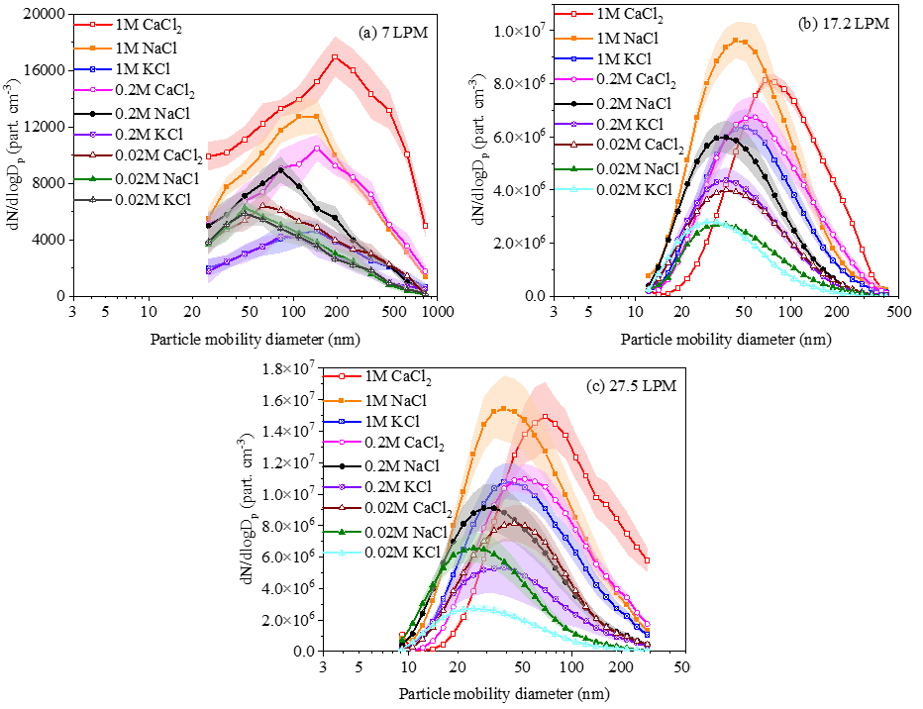
Fig. S4. Particle number concentration (µg/m³) with mobility diameter (nm) using SMPS for various salts at flow rate (a) 7, (b) 17.2 and (c) 27.5 LPM
To determine the inlet concentration for the testing, these three salts were tested at three molar concentrations (1, 0.2 and 0.02 M) with varying flow rates as shown in Fig. S4, for the particle mobility diameter of 30 to 700, 12 to 400 and 10 to 300 nm at flow rates of 7, 17.2 and 27.5 LPM respectively. These flow rates corresponds to 0.2, 0.5 and 0.8 m/s respectively. The results obtained from SMPS were plotted with the particle number concentration (#/cc) on Y- axis and the mobility diameter (nm) in X-axis. The measurements were obtained using the SMPS instrument. As shown in Fig. S4 it is observed for a 7 LPM flow rate, the particle number concentration lies within 10,000 #/cc. As the concentration increases, the particle concentration also increases, as the salt solution contains more particles.
As shown in Fig. S4(a), for a flow rate of 7 LPM and at 1M concentration, CaCl₂ exhibits the highest particle number concentration with mode at 193.93±44.20 nm. NaCl and KCl show lower concentrations, with a mode at 123.48±21.46 and 118.76±19.43 nm respectively. While, 0.2M concentration, all three salts demonstrate reduced particle concentrations compared to 1M, with CaCl₂ maintaining the highest concentration 12,000 #/cc, followed by NaCl and KCl. At a 0.02M concentration, there is a further reduction in particle number concentrations for all salts, with a CaCl₂ particle concentration of 8000 #/cc exhibiting a higher concentration than NaCl and KCl, which have relatively similar concentrations. This shows that higher molar concentrations of the salts result in higher particle number concentrations, with CaCl₂ consistently showing the highest concentrations across all particle sizes and concentrations, followed by NaCl and KCl. This indicates the typical particle concentrations formed by each salt solution under the specified molar concentrations.
In Fig. S4(b), a similar trend has been observed as compared to Fig. S4(a) with an increase in particle concentrations. As shown in Fig. S4(b), the data was acquired using SMPS at a face velocity of 0.5 m/s and 17.2 LPM flow rate. At a 1M salt solution, CaCl₂ gives the highest particle number concentration of 11×10⁶ #/cc, for mode at 69.53±10.77 nm. NaCl and KCl show lower concentrations, with mode of 46.52±3.72 and 50.05±0.90 nm respectively. For the 0.2M concentration, all three salts demonstrate reduced particle concentrations compared to their 1M salts, with CaCl₂ maintaining the highest concentration of 7×10⁶ #/cc with a mode at 56.6±1.71 nm, followed by NaCl and KCl are 35.05±3.17 and 36.64±1.65 respectively. At a 0.02M concentration, further reduction in particle number concentrations is observed for all salts, with CaCl₂ still exhibiting a higher concentration of 4×106 #/cc at 40.02±2.63 nm than NaCl and KCl at 26.65±0.88; KCl: 31.38±1.43 nm. Hence it clearly shows that the salts resulted in higher particle number concentrations, with CaCl₂ consistently showing the highest concentrations across all particle sizes and concentrations, followed by NaCl and KCl salts.
Fig. S4(c) shows a similar trend for tested salts with lower molarity as shown in Fig. S4(a) and Fig. S4(b). As given in Fig. S4(c), at a 1M concentration, CaCl₂ demonstrates the highest particle number concentration of 16×106 #/cc, with a mode of 65.75±6.1 nm. NaCl and KCl display lower concentrations with mode at 37.77±2.35 and 43.6±3.18 nm respectively. For the 0.2M concentration, all three salts show reduced particle concentrations compared to their 1M salts, with CaCl₂ maintaining the highest concentration of 11.3×10⁶ #/cc, followed by NaCl and KCl. At a 0.02M concentration, there is a further reduction in particle number concentrations for all salts, with CaCl₂ continuing to exhibit higher concentrations than NaCl and KCl salts.
In all conditions of flow rates, CaCl₂ consistently showed the highest particle number concentrations, followed by NaCl and KCl. As the molar concentration of the salts decreased from 1M to 0.02M, the particle number concentrations also diminished across all flow rates. The PSDs for each salt showed peaks from 30 to 120 nm, with CaCl₂ maintaining a higher concentration compared to NaCl and KCl at similar particle sizes. The mode values indicated a decreasing trend in particle concentrations with increasing face velocities, highlighting the inverse relationship between face velocity and particle number concentration across different salt concentrations as summarized in Table S1. The solubility in water at 20℃ for CaCl₂, NaCl and KCl are 745, 359 and 344 g/L respectively were considered as varying their results. These findings underscore the influence of salt type, molar concentration, and flow rate on the PSD and concentration, providing insights into the behaviour of aerosolized salt particles under varying experimental conditions.

Table S1. Modes in nm for CaCl₂, NaCl, and KCl salt solutions (1, 0.2 and 0.02M) at face velocity of 0.2, 0.5 and 0.8 m/s.
Concentration  (Molar) | Salts | Face Velocity (m/s)
 | Salts | 0.2 | 0.5 | 0.8
1 | CaCl₂ | 193.93±44.20 | 69.53±10.77 | 65.75±6.17
1 | NaCl | 123.48±21.46 | 46.52±3.72 | 37.77±2.35
1 | KCl | 118.76±19.43 | 50.05±0.90 | 43.6±3.18
0.2 | CaCl₂ | 112.45±16.58 | 56.6±1.71 | 50.63±4.17
0.2 | NaCl | 89.7±30.33 | 35.05±3.17 | 29.7±30
0.2 | KCl | 82±26.86 | 36.64±1.65 | 33.31±1.91
0.02 | CaCl₂ | 65.03±8.60 | 40.02±2.63 | 43.72±1.88
0.02 | NaCl | 47.8±10.99 | 26.65±0.88 | 25.16±1.46
0.02 | KCl | 51.4±8.79 | 31.38±1.43 | 27.07±2.02

The results showed that different salts and molar concentrations led to variations in particle number concentrations and distributions, with CaCl₂ and NaCl salts providing higher concentrations than KCl salt. The highest mode is observed for CaCl₂ followed by NaCl and KCl for all concentrations within 20% uncertainties. The performance of air filter media under representative concentrations in microenvironments was assessed using KCl rather than the other two salts, which exhibited lower mode and higher particle number size distributions. The CaCl₂ and NaCl salts were found to provide higher number concentrations at low diameter ranges compared to KCl salt.
As concentration increases the mode values also increases for the tested salts. As velocity increases the mode decrement has been observed. Particle number concentrations were measured for different salt and molar concentrations of the solution, showing a decrease in concentration with more diluted solutions. The evaporation of water resulted in a larger volume of salt precipitating in more concentrated solutions, leading to a decrease in particle number concentration. The comparison for mode values between NaCl and KCl salts are within 5% uncertainties and 2 standard deviations where KCl tends to lower side representing the usual particles present in the microenvironments. Considering this to generate nano-particles for commercial residential air cleaners filter media testing, unhazardous to human health, KCl particles has been used inline suggestion from the ISO-16890 (Yit et al., 2020).

REFERENCES

Berry, G., Beckman, I. and Cho, H. (2023). A comprehensive review of particle loading models of fibrous air filters. J. Aerosol Sci., 167, p.106078. https://doi.org/10.1016/j.jaerosci.2022.106078
Çengel, Y.A. (2007). Heat and Mass Transfer.
Dang, A.J., Kumfer, B.M., Bertroche, J.T., Glidden, J.O., Oxford, C.R., Jammalamadaka, U., Ruppert-Stroescu, M., Scott, A.R., Morris, J.A., Gan, C., Hu, J., King, B., Dhanraj, D.I.A., Choudhary, S., Biswas, P., Axelbaum, R.L., Meacham, K.W. and Williams, B.J. (2021). Challenges in Predicting the Filtration Performance of a Novel Sewn Mask: Scale-up from Filter Holder to Mannequin Measurements. Aerosol Air Qual. Res., 21(6), p.200629. https://doi.org/10.4209/aaqr.200629
Lee, K.W. and Liu, B.Y.H. (1980). On the Minimum Efficiency and the Most Penetrating Particle Size for Fibrous Filters. J. Air Pollut. Control Assoc., 30(4), pp.377–381. doi:https://doi.org/10.1080/00022470.1980.10464592
Shi, H., Kondragunta, S., & Li, J. (2013). Impact of nanoparticles on filtration performance of fibrous filters. J. Nanopart. Res., 15(11), 2069
Stabile, L., Trassierra, C. V., Dell’Agli, G., & Buonanno, G. (2013). Ultrafine Particle Generation through Atomization Technique: The Influence of the Solution. Aerosol Air Qual. Res., 13(6), 1667–1677. https://doi.org/10.4209/aaqr.2013.03.0085
Wang, J., Kim, S. C., & Pui, D. Y. H. (2011). Measurement of multi-wall carbon nanotube penetration through a screen filter and single-fiber analysis. J. Nanopart. Res., 13(10), 4565–4573. https://doi.org/10.1007/s11051-011-0415-y

