Supplementary Information

Spatial and Seasonal Variation of Nitric Acid (HNO₃) and Understanding the Formation of NH₄NO₃ in the HNO₃–NH₃ system in Korea

Dabeen Jung ª, Jeongin Song ª, Kyunghoon Kim ª, Seokwon Kang ª, Yoonseo Kim ª, Song-Chul Hong ^{b}, Jae-Bum Lee ^{b}, Seok-Jun Seo ^{c}, Kwangyul Lee ^{c}, Jong-Sung Park ^{c, *}, Mijung Song ^{d}, Na Rae Choi ^{e}, Taehyoung Lee ^{a,} *

ª National Department of Environmental Science, Hankuk University of Foreign Studies, Yongin, 17035, Republic of Korea
^{b} Air Quality Forecasting Center, National Institute of Environmental Research, Incheon, 22689, Republic of Korea
^{c} Air Quality Research Division, National Institute of Environmental Research, Incheon, 22689, Republic of Korea
^{d} Department of Earth and Environmental Sciences, Jeonbuk National University, Jeonju, 54896, Republic of Korea
^{e} Department of Environmental Engineering, Kangwon National University, Chuncheon, 24341, Republic of Korea

Comparison between Semi-Real-Time HNO₃ System and Denuder Method
To evaluate the reliability of the semi-real-time HNO₃ measurement system, a comparative experiment was conducted using an annular denuder system (URG). The purpose of this intercomparison was to quantitatively assess the accuracy and consistency between the two measurement methods. A 25 mm PTFE filter was installed at the inlet of the denuder to remove particulate matter. The denuder operated under the same flow rate conditions as the semi-real-time system (2.5 LPM) and collected samples continuously for approximately 18 to 23 h. The denuder tubes were coated with a solution consisting of 10 g sodium carbonate (Na₂CO₃), 8 mL glycerol, 500 mL deionized (DI) water, and 500 mL methanol (Stanier et al., 2012; Jones et al., 2008; Yu et al., 2005). This coating selectively absorbs HNO₃ and was applied to the inner walls of the denuder tubes for 40 min, followed by a drying process using nitrogen (N₂) gas for another 40 min. After sampling, the collected samples were extracted using 20 mL of DI water. The analysis was performed using ion chromatography, with a 100 µL sample loop used for injection.
The semi-real-time HNO₃ system reported concentrations that were approximately 11% higher than those obtained using the denuder method, but a strong correlation was observed between the two methods, with a coefficient of determination (R²) of 0.99 (Fig. S1). These results confirm that the semi-real-time system employed in this study provides highly reliable HNO₃ measurements.

Fig. S1. Comparison between the semi-real-time HNO₃ measurement system (IC system) and the annular denuder method. The strong correlation (R² = 0.99) indicates high agreement between the two systems. The comparison is based on 14 data points, and the regression line is given as y=1.1099x.

QC/QA
QC/QA procedures were conducted for the semi-real-time HNO₃ monitoring system. Calibration was conducted approximately every three weeks using standard solutions of Br⁻ and NO₃⁻. In addition, Br⁻ and NO₃⁻ check standards were measured once daily. The analysis was conducted based on the equations presented in Principles of Instrumental Analysis by Skoog et al. (2017). The minimum detection limit (MDL) was determined from blank samples. During periods with exceptionally low MDL values—such as Ansan in Fall 2022 and Baengnyeong in Fall 2023—the blank concentrations were either close to zero or nearly identical across replicates, with average values of 0.002 ± 0.0004 ppb and 0.016 ± 0.002 ppb, respectively. Excluding these low-blank periods, the average blank concentrations across other campaigns ranged from 0.02 to 0.13 ppb. Accuracy was assessed using check standards based on both absolute and relative errors, while precision was evaluated using the coefficient of variation (CV).

$$MDL ≥ t × S_{b} × \sqrt{\frac{N_{1} + N_{2}}{N_{1} × N_{2}}}$$ | (Eq. S1)
t = value of t for 95% confidence level
S_{b} = Standard deviation of blanks
N₁ = The number of blank measurements
N₂ = The number of blank points

$$S_{b} = \sqrt{S_{1}^{2} + S_{2}^{2} + S_{3}^{2} + ⋯}$$ | (Eq. S2)
S_{i} = Standartd deviation of each blank measurements

$$S = \sqrt{\frac{\sum{{(x_{i} - \overline{x})}^{2}}}{N -1}}$$ | (Eq. S3)
N = The number of data points
$x_{i}$ = Each of the values of the data
$\overline{x}$ = The mean of $x_{i}$
$$Absolute error (E) = \overline{x} - x_{t}$$ | (Eq. S4)
$\overline{x}$ = Observed value
$x_{t}$ = True value

$$Relative error \left(E\right)= \frac{\overline{x} - x_{t}}{x_{t}} ×100$$ | (Eq. S5)
$\overline{x}$ = Observed value
$x_{t}$ = True value

$$CV= \frac{S}{\overline{x}} ×100$$ | (Eq. S6)
S = Standard deviation
$\overline{x}$ = The average of check standards

Table S1. Quality control and quality assurance (QC/QA) for Seoul, Ansan, Gwangju and Baengnyeong HNO₃
Sites | Period | MDL | Accuracy |  | Precision
Sites | Period | MDL | Absolute  error | Relative  error (%) | CV (%)
Seoul | 2021 Summer | 0.03 | 0.50 | 3.31 | 1.29
Seoul | 2021 Fall | 0.03 | 0.75 | 5.01 | 1.27
Seoul | 2022 Winter | 0.10 | -1.04 | 5.23 | 1.05
Ansan | 2022 Fall | 0.001 | -0.49 | 2.43 | 1.02
Ansan | 2023 Fall | 0.03 | 1.42 | 4.72 | 0.64
Ansan | 2023 Winter | 0.06 | -3.73 | 9.33 | 0.55
Ansan | 2024 Summer | 0.04 | 0.22 | 1.11 | 0.99
Ansan | 2024 Fall | 0.11 | 0.22 | 1.11 | 0.99
Ansan | 2025 Spring | 0.05 | -1.69 | 8.48 | 1.09
Gwangju | All Seasons | 0.08 | -0.98 | 4.89 | 1.05
Baengnyeong | 2022 Fall | 0.08 | 0.20 | 1.38 | 1.31
Baengnyeong | 2023 Fall | 0.003 | 1.03 | 3.42 | 0.65
Baengnyeong | 2023 Winter | 0.03 | -1.53 | 3.82 | 0.52
Baengnyeong | 2024 Summer | 0.04 | -1.24 | 6.21 | 1.06
Baengnyeong | 2024 Fall | 0.005 | -1.04 | 5.22 | 1.05
Baengnyeong | 2025 Spring | 0.07 | -1.69 | 8.50 | 1.09
*Minimum Detection Limit(MDL) Unit: ppb
Measurement Information
Table S2. Summary of Site Information and Instrument Deployment for PM and Gas-phase Compounds (Note: In Ansan, instruments with specified dates operated only during those periods; unspecified ones were used otherwise.)
Site | Type | Sampling Periods | Instrument
Site | Type | Sampling Periods | PM Composition | Gas
Baengnyeong Island  (37.97°N, 124.63°E) | Background | 1 - 30 November 2022  14 October - 24 November 2023  2 - 31 December 2023  1 - 31 August 2024  15 October - 15 November 2024  1-30 April 2025 | AIM*  (2022 – 2023, PM_{2.5})  HR-ToF-AMS  (2024 – 2025, NR-PM_{1.0}) | HUFS (HNO₃)  Picarro, G2103 (NH₃)*  Teledyne, T200 (NO, NO₂, NO_{X})*  Teledyne, T400 (O₃)*
Ansan  (37.32°N, 126.83°E) | Urban |  | AIM*  (2022 – 2023, PM_{2.5})  HR-ToF-AMS  (2024 – 2025, NR-PM_{2.5}) | HUFS (HNO₃)  Picarro, G2103 (NH₃)*  LGR, GLA331 EAA (NH₃)  (Apr., 2025)  Thermo Scientific, iQ Series 42 (NO, NO₂, NO_{X})*  Teledyne, T200 (NO, NO₂, NO_{X})  (Dec. 2023 / Oct–Nov. 2024 / Apr. 2025)  Thermo Scientific, iQ Series 49 (O₃)*
Gwangju  (35.23°N, 126.85°E) | Urban | 4 May - 31 December 2021 | AIM*  (PM_{2.5}) | HUFS (HNO₃)  Picarro, G2103 (NH₃)*  Kentec, Mezus 210 (NO, NO₂, NO_{X})*  Kentec, Mezus 410 (O₃)*
Seoul  (37.46°N, 127.03°E) | Urban | 17 August - 15 September 2021  7 - 27 February 2022 | HR-ToF-AMS**  (NR-PM_{1.0}) | HUFS (HNO₃)  LGR, GLA331 EAA (NH₃)  Ecotech, Serinus 40 (NO, NO₂, NO_{X}, O₃)**  Ecotech, Serinus 10 (O₃)**
* Data provided by NIER (National Institute of Environmental Research)
** Data provided by SIHE (Seoul Institute of Health and Environment)

Table S3. Site- and season-specific Spearman correlation coefficients (ρ) between NO₂ and NH₃
Sites | Seasons | Correlation coefficient (Spearman’s ρ) | Number of Samples
Seoul | Summer | 0.256 | 353
Seoul | Fall | 0.064 | 287
Seoul | Winter | 0.311 | 522
Ansan | Spring | 0.200 | 685
Ansan | Summer | -0.078 | 717
Ansan | Fall | 0.321 | 941
Ansan | Winter | 0.508 | 721
Gwangju | Spring | 0.239 | 655
Gwangju | Summer | 0.044 | 1871
Gwangju | Fall | 0.134 | 1932
Gwangju | Winter | 0.347 | 708
Baengnyeong | Spring | 0.081 | 658
Baengnyeong | Summer | 0.029 | 703
Baengnyeong | Fall | 0.369 | 982
Baengnyeong | Winter | 0.578 | 521

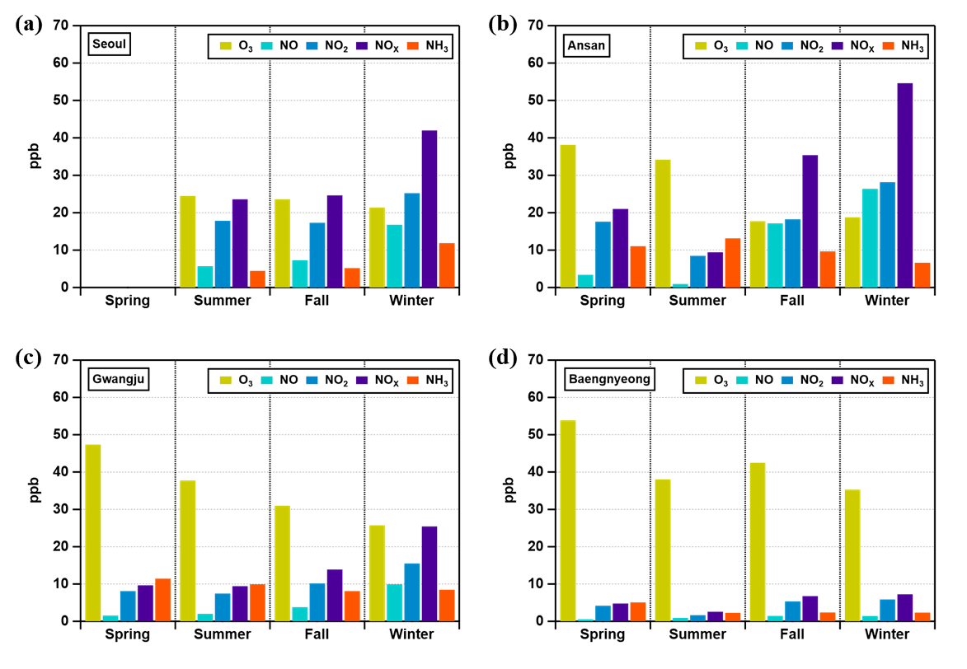
Fig. S2. Seasonal variation in the concentrations of O₃, NO, NO₂, NO_{X}, and NH₃ measured at (a) Seoul, (b) Ansan, (c) Gwangju, and (d) Baengnyeong Island. Data represent seasonal averages during the measurement periods at each site.
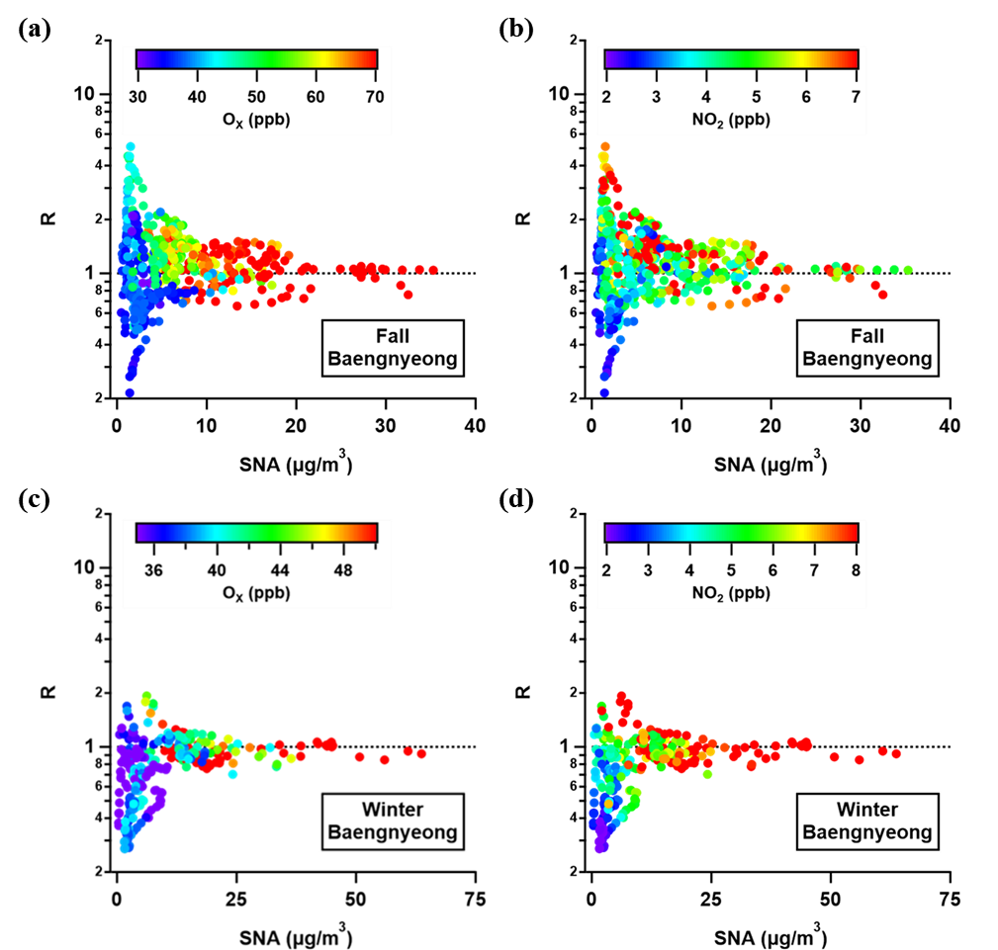
Fig. S3. HNO₃ and NH₃ limitations for identifying NH₄NO₃ formation at Baengnyeong Island in fall and winter, colored by O_{X} and NO₂ concentrations; (a) R vs. SNA colored by O_{X} in fall; (b) R vs. SNA colored by NO₂ in fall; (c) R vs. SNA colored by O_{X} in winter; (d) R vs. SNA colored by NO₂ in winter.
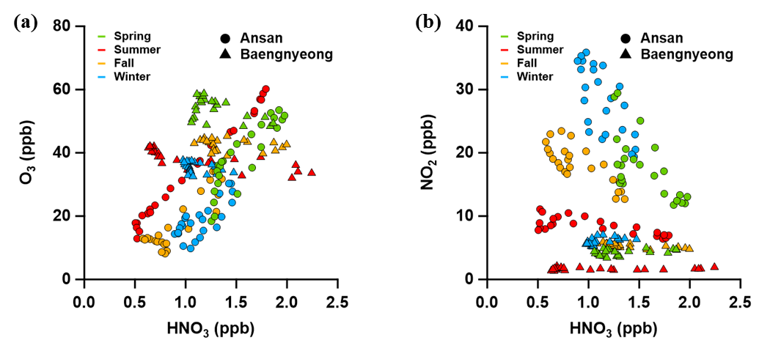
Fig. S4. Correlation between HNO₃ and (a) O₃, and (b) NO₂ based on diurnal patterns observed in Ansan and Baengnyeong. Each color represents a different season.
References
Jones, A., Wolff, E., Salmon, R., Bauguitte, S.-B., Roscoe, H., Anderson, P., Ames, D., Clemitshaw, K., Fleming, Z.L., Bloss, W., 2008. Chemistry of the Antarctic Boundary Layer and the Interface with Snow: an overview of the CHABLIS campaign. Atmospheric chemistry and physics. 8(14), 3789-3803.
Skoog, D.A.; Holler, F.J.; Crouch, S.R. Principles of Instrumental Analysis, 7th ed.; Cengage Learning: Boston, 2017.
Stanier, C., Singh, A., Adamski, W., Baek, J., Caughey, M., Carmichael, G., Edgerton, E., Kenski, D., Koerber, M., Oleson, J., 2012. Overview of the LADCO winter nitrate study: hourly ammonia, nitric acid and PM 2.5 composition at an urban and rural site pair during PM 2.5 episodes in the US Great Lakes region. Atmospheric chemistry and physics. 12(22), 11037-11056.
Yu, X.-Y., Lee, T., Ayres, B., Kreidenweis, S.M., Collett Jr, J.L., Malm, W., 2005. Particulate nitrate measurement using nylon filters. Journal of the Air & Waste Management Association. 55(8), 1100-1110.

