Supplementary Information

Exploring Environmental and Temporal Performances of Machine Learning Models for Calibration of a Low-Cost PM_{2.5} Sensor

Roshan Wathore^{1,2 *,} Sharvari Wanjari³, Abhishek Chakraborty⁴, Nitin Labhasetwar^{1,2}

¹Academy of Scientific and Innovative Research (AcSIR), Ghaziabad, Uttar Pradesh 201002, India
²CSIR-National Environmental Engineering Research Institute, CSIR-NEERI, Nagpur – 440020, India
³Department of Computer Science and Engineering, Indian Institute of Technology Kharagpur, Kharagpur 721302, West Bengal, India
⁴Department of Environmental Science & Engineering, Indian Institute of Technology Bombay, Powai, Mumbai 400076, India

∗ Corresponding author. E-mail address: r.wathore@neeri.res.in

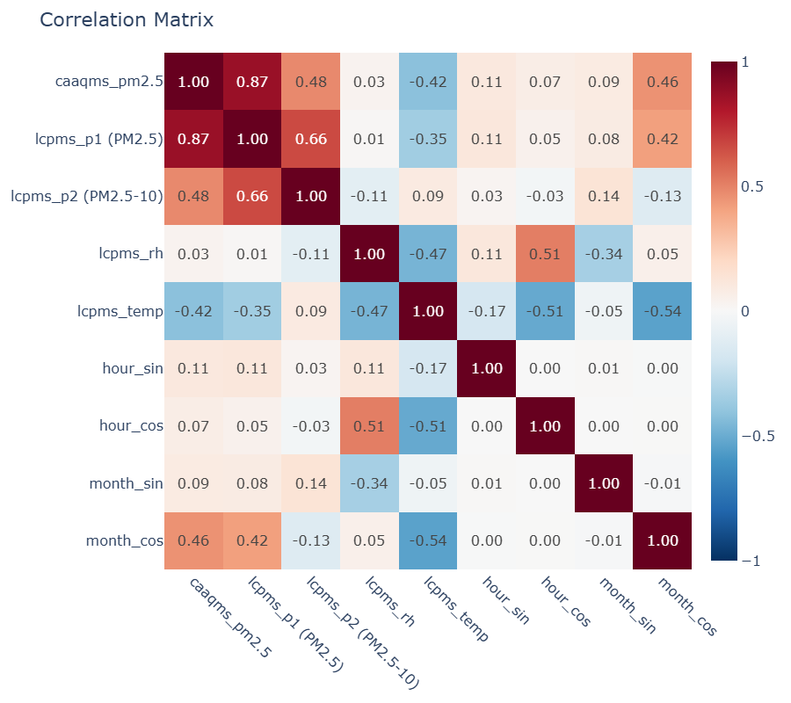Fig. S1. Correlation matrix of the target variable (caaqms_pm2.5) and model inputs used for this study.

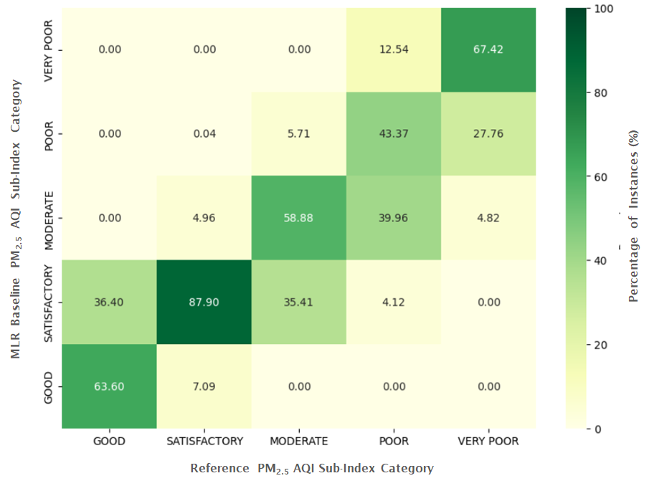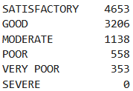

Fig. S2. PM_{2.5} AQI sub-index confusion matrix for the linear baseline calibration model. Appended table shows the sorted distribution of AQI categories as per the reference data.

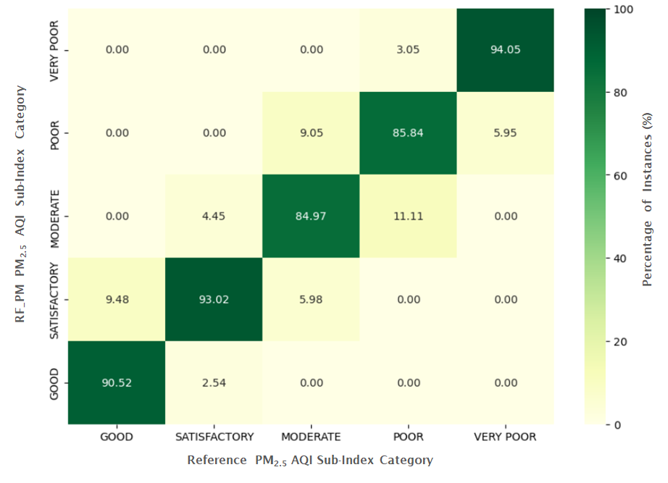
Fig. S3. PM_{2.5} AQI sub-index confusion matrix for the Random Forest 6 parameter month (RF_6PM) calibration model
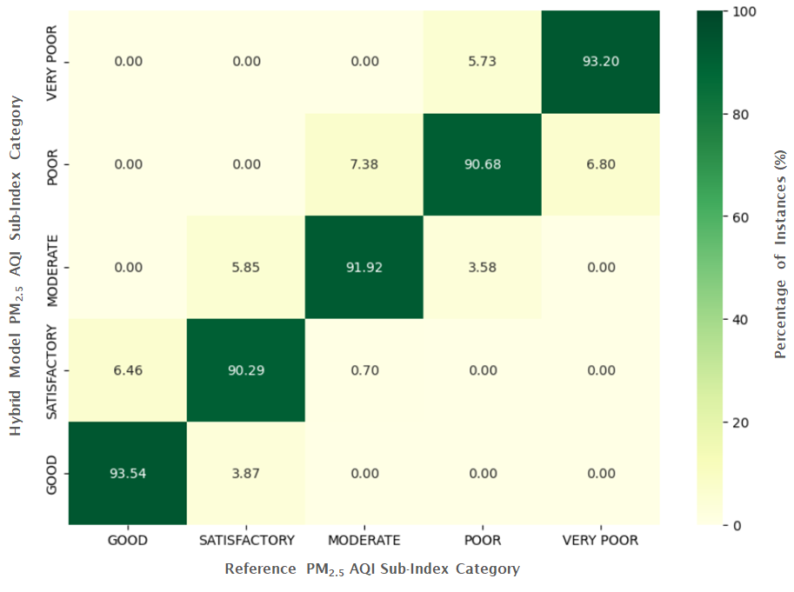
Fig. S4. PM_{2.5} AQI sub-index confusion matrix for the hybrid calibration model

