Supplementary Figure S1: Schematic of Wormian bones in cranial sutures and fontanelles adapted from Hauser & De Stefano (1989), used with permission.

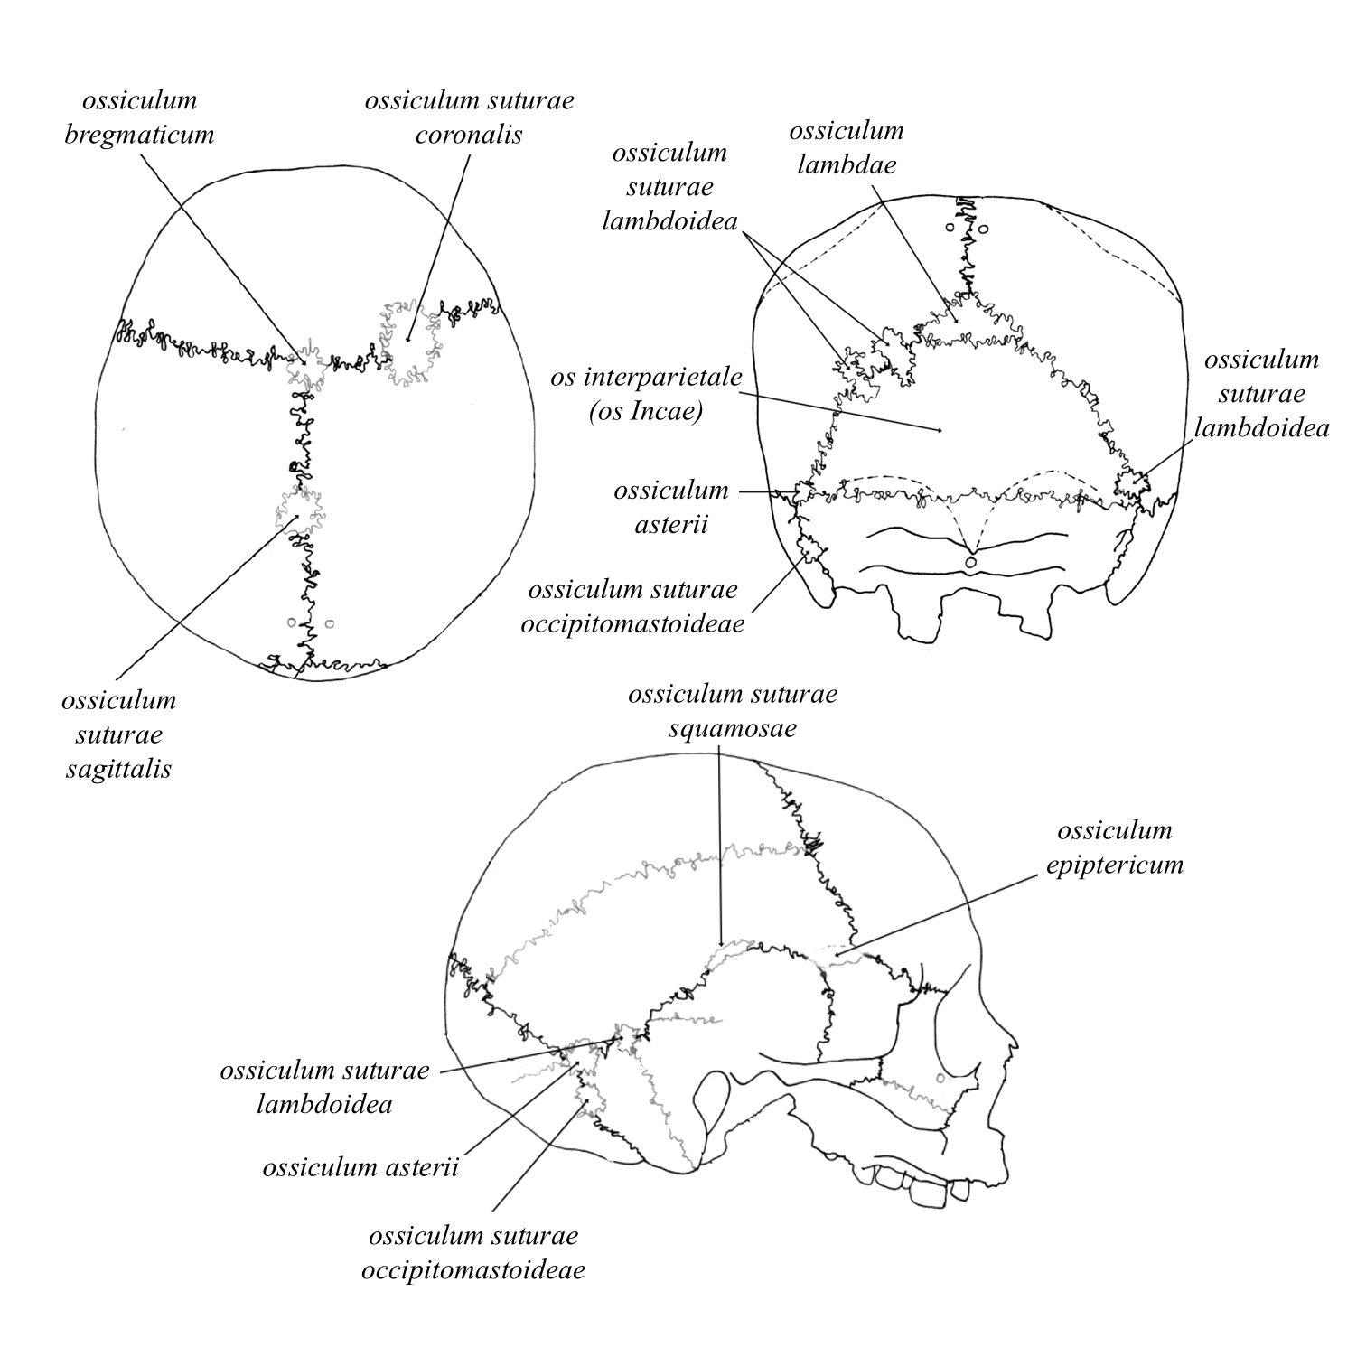
Supplementary Figure S2: Schematic of ossa preinterparietalia (single, bipartitum, tripartitum)

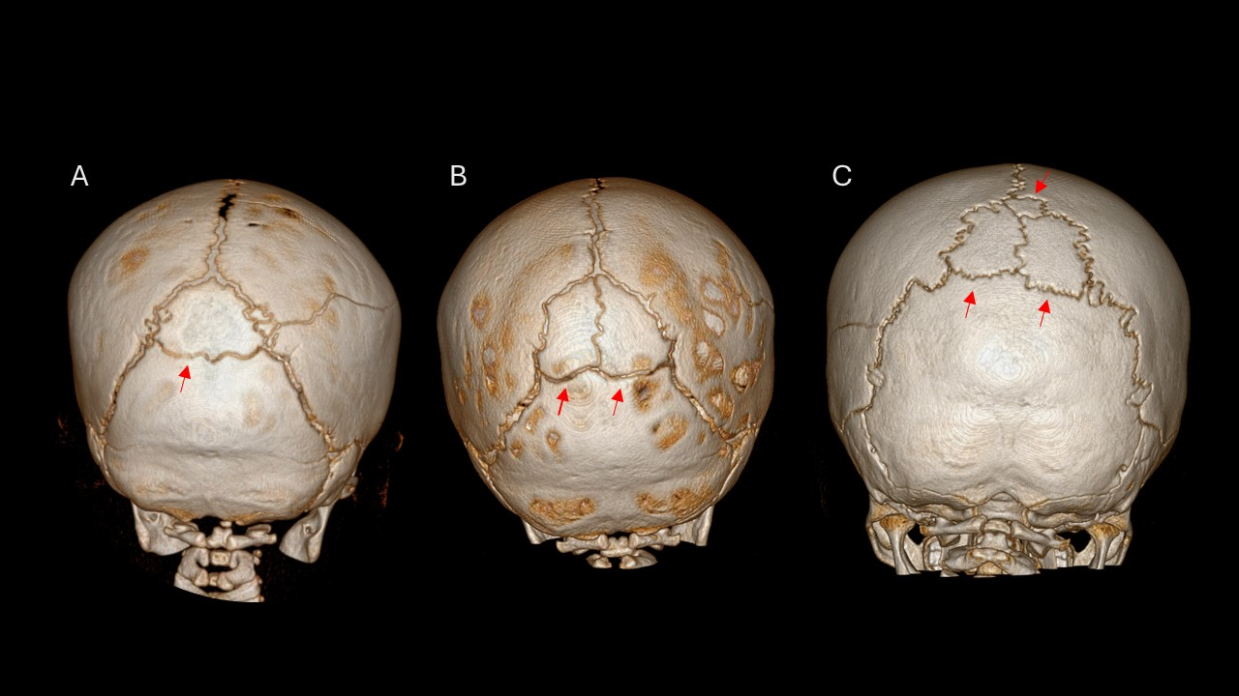
Legend: (A) os preinterparietale; (B) os preinterparietale bipartitum; (C) os preinterparietale tripartitum
Supplementary Figure S3. Bland–Altman plot showing intra-rater agreement for cranial index measurements per scan, based on repeat readings by the same rater.

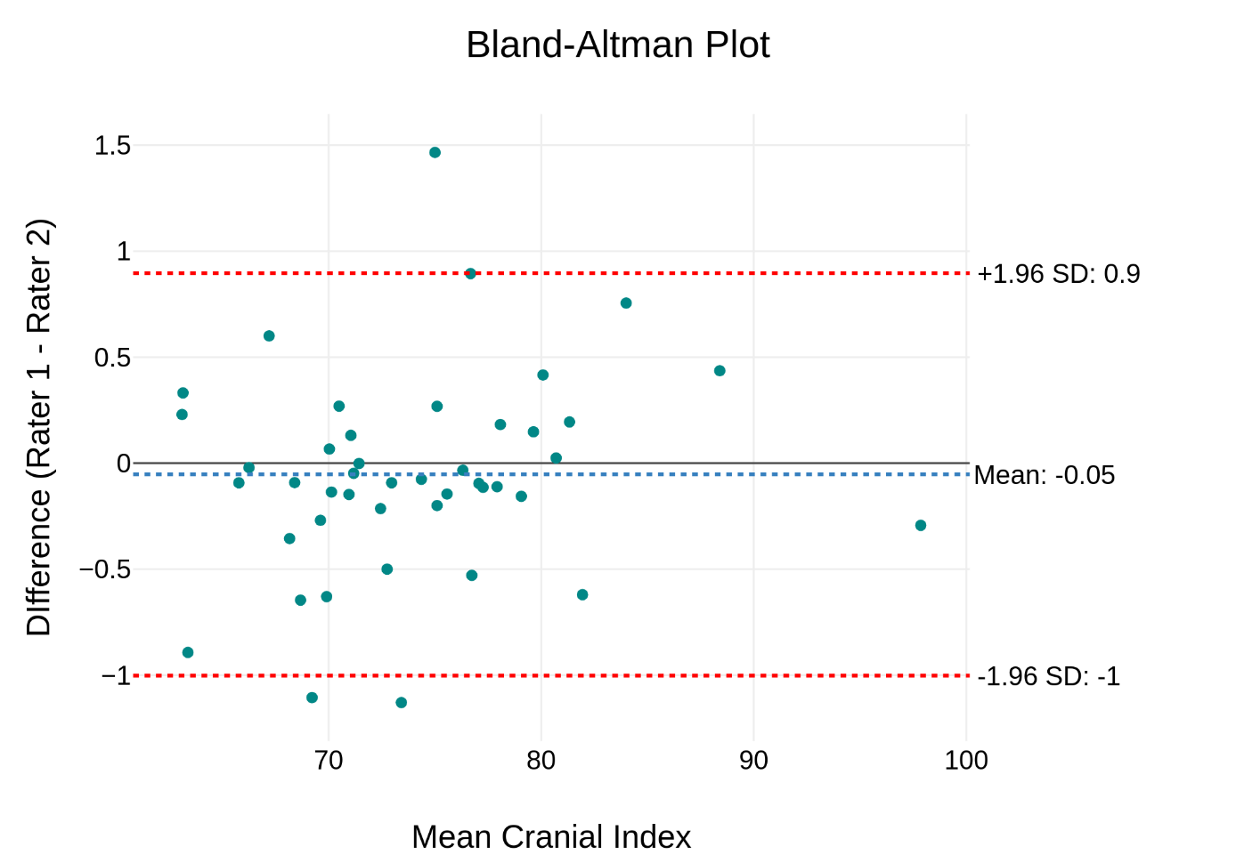

Supplementary Figure S4. Bland-Altman plot showing intra-rater agreement for count of supernumerary bones per scan.
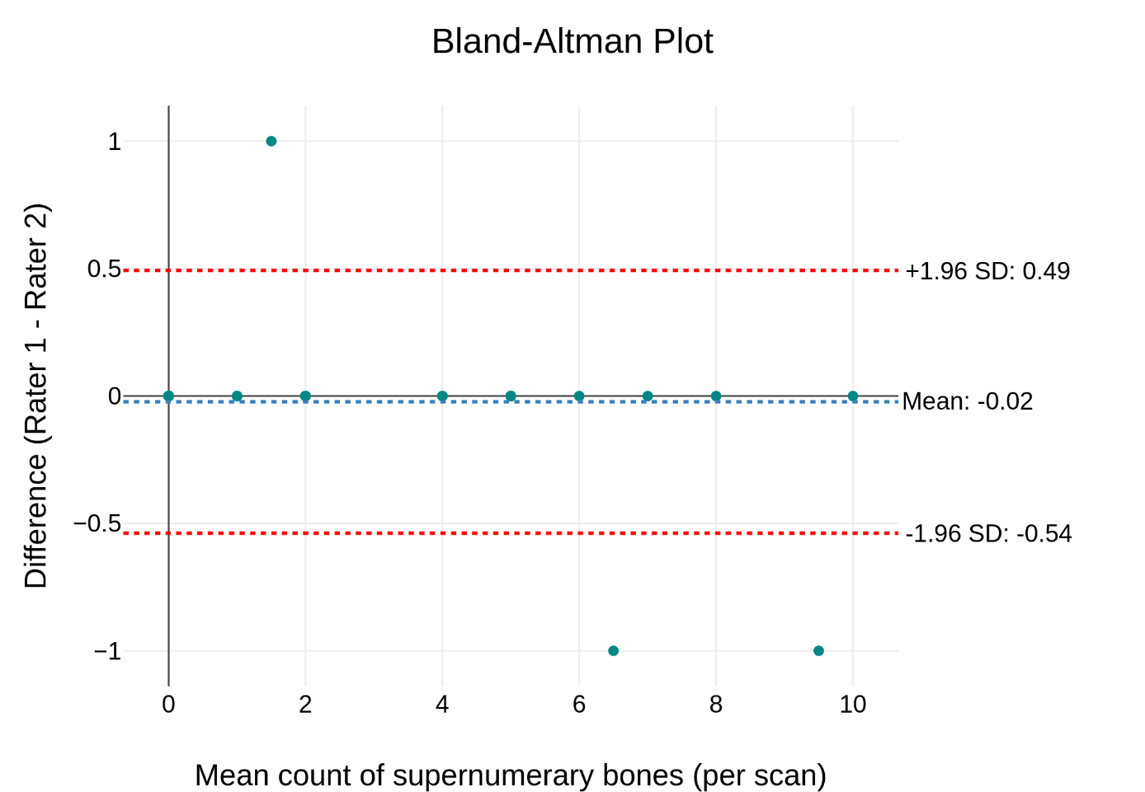

Supplementary Table S1: Prevalence of at least one accessory cranial bone by age group (≤24 months)
Age group (months) | Controls |  |  | Scaphocephaly |  |  | p-value | Adjusted p-value
Age group (months) | Absent n (%) | Present n (%) | Total N | Absent n (%) | Present n (%) | Total N | p-value | Adjusted p-value
0.00 – 3.99 | 45 (75.00) | 15 (25.00) | 60 | 1 (3.70) | 26 (96.30) | 27 | 0.0001 | 0.0005 **
4.00 – 6.99 | 38 (55.07) | 31 (44.93) | 69 | 7 (20.00) | 28 (80.00) | 35 | 0.0007 | 0.0035 **
7.00 – 9.99 | 46 (52.27) | 42 (47.73) | 88 | 6 (35.29) | 11 (64.71) | 17 | 0.2897 | 1.0000
10.00 – 12.99 | 27 (54.00) | 23 (46.00) | 50 | 2 (33.33) | 4 (66.67) | 6 | 0.4141 | 1.0000
13.00 – 24.00 | 49 (60.49) | 32 (39.51) | 81 | 3 (33.33) | 6 (66.67) | 9 | 0.1596 | 0.7980
Note: p-values from Fisher’s exact test; Bonferroni-adjusted p-values across five age-group comparisons (** significance at adjusted p < 0.05; equivalent to α = 0.01).

Supplementary Table S2: Prevalence of accessory cranial bones in children ≤12 months

Bone type | Scaphocephaly (n=84) | Controls  (n=259) | p (Fisher) | OR [95% CI]
o. sut. coronalis | 4 (4.8%) | 2 (0.8%) | 0.034 | 6.43 [1.16–35.7]
o. sut. sagittalis | 0 | 22 (8.5%) | 0.003** | 0.0625 [0.00375–1.04]*
o. sut. lambdoideae | 40 (47.6%) | 88 (34.0%) | 0.028 | 1.77 [1.07–2.91]
o. sut. squamosae | 22 (26.2%) | 0 | <0.001** | 187 [11.2–3122]*
o. sut. occipitomastoideae | 3 (3.6%) | 4 (1.5%) | 0.369 | 2.36 [0.518–10.8]
o. metopicum | 1 (1.2%) | 0 | 0.245 | 9.32 [0.376–231]*
o. bregmaticum | 5 (5.6%) | 4 (1.5%) | 0.043 | 4.03 [1.06–15.4]
o. lambdae | 6 (7.1%) | 30 (11.6%) | 0.309 | 0.587 [0.236–1.46]
o. obelicum | 0 | 3 (1.2%) | <0.001** | 0.434 [0.0222–8.48]*
o. asterii | 20 (23.8%) | 7 (2.7%) | <0.001** | 11.3 [4.59–27.8]
o. epiptericum | 31 (36.9%) | 18 (6.9%) | <0.001** | 7.83 [4.08–15.0]
o. incisurae parietalis | 13 (15.5%) | 14 (5.4%) | 0.005 | 3.20 [1.44–7.13]
os preinterparietale I | 7 (8.3%) | 21 (8.1%) | 1.000 | 1.03 [0.422–2.52]
os preinterparietale II | 18 (21.4%) | 4 (1.5%) | <0.001** | 17.4 [5.69–53.1]
os preinterparietale III | 0 | 2 (0.8%) | 1.000 | 0.609 [0.029–12.8] *
Note: o.: ossiculum; o. sut.: ossiculum suturarum; Type I: single; Type II: bipartitum; Type III: tripartitum; p-values from Fisher’s exact test; * odds ratios (OR) and 95% confidence intervals (CI) were computed using the Haldane–Anscombe correction when a zero cell occurred; ** statistically significant after Bonferroni correction for 15 comparisons (α = 0.05/15 = 0.0033).

Supplementary Table S3: Logistic Regression Parameter Estimates and Collinearity Diagnostics
Model | Predictor | β (log-odds) | SE | Z | p-value | VIF | Tolerance
Baseline | Age (months) | –0.217 | 0.046 | –4.69 | <.001 | 1.62 | 0.616
 | Cranial index | –0.399 | 0.047 | –8.59 | <.001 | 1.08 | 0.922
 | Anterior fontanelle status | –2.344 | 0.501 | –4.68 | <.001 | 1.60 | 0.623
Extended | Age (months) | –0.211 | 0.054 | –3.88 | <.001 | 1.70 | 0.587
 | Cranial index | –0.418 | 0.055 | –7.58 | <.001 | 1.34 | 0.745
 | Anterior fontanelle status | –2.478 | 0.584 | –4.25 | <.001 | 1.66 | 0.601
 | O. epiptericum present | 2.059 | 0.722 | 2.85 | 0.004 | 1.09 | 0.915
 | O. asterii present | 3.865 | 0.898 | 4.30 | <.001 | 1.26 | 0.791
 | Bipartite preinterparietale II | 2.845 | 1.081 | 2.63 | 0.008 | 1.04 | 0.963

Note: β = estimated log-odds; SE = standard error of β; Z = Wald Z-statistic; p-value from Wald test. VIF/Tolerance assess collinearity (all VIFs < 2 indicate low collinearity).

