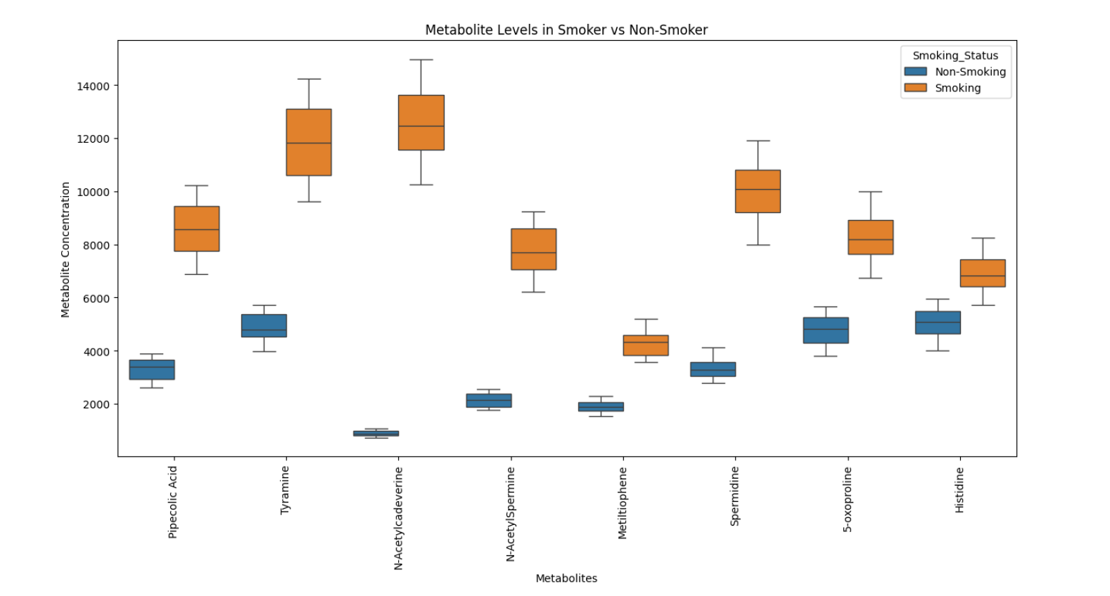
Figure S1: Box plots of metabolite abundances in smokers and nonsmokers. The plots illustrate the distribution of semi-quantitative abundance signals for the metabolites that differed significantly between the two groups. Boxes represent the interquartile range, the central line indicates the median, and whiskers indicate the spread of the data.

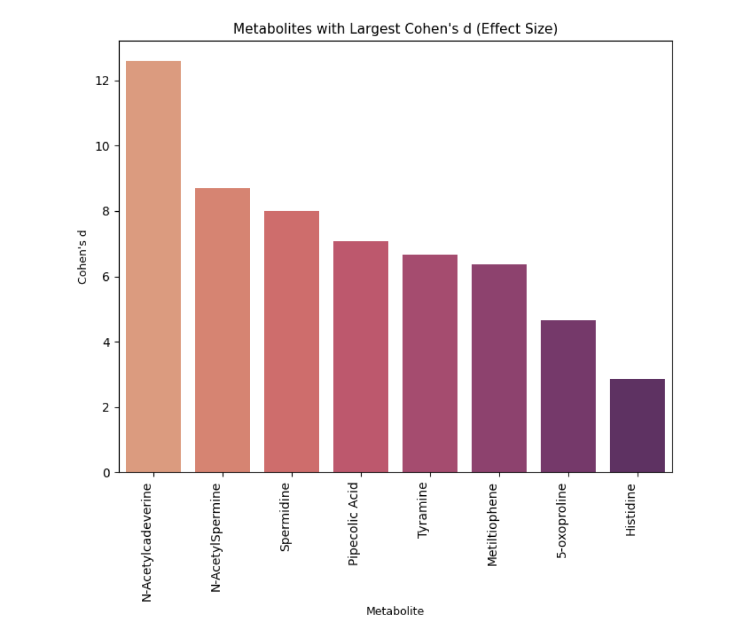
Figure S2: Cohen’s d effect sizes for metabolites differing between smokers and nonsmokers. The analysed metabolites are orderd according the Cohen’s d value.The largest effect sizes were observed for N-acetylcadaverine, N-acetylspermine, and spermidine, indicating a significant separation between the two groups.

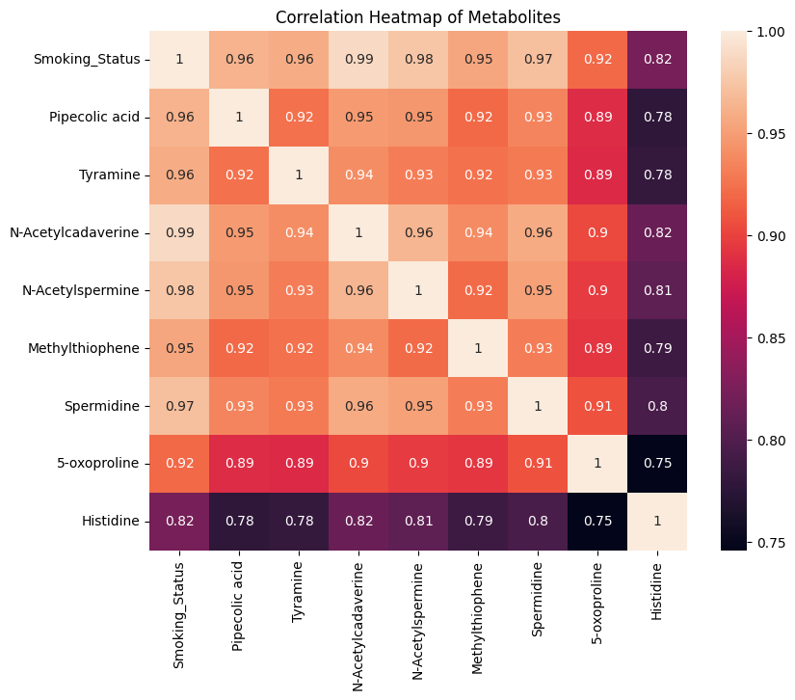
Figure S3: Correlation heatmap of metabolites. Lighter shades correspond to higher correlation.

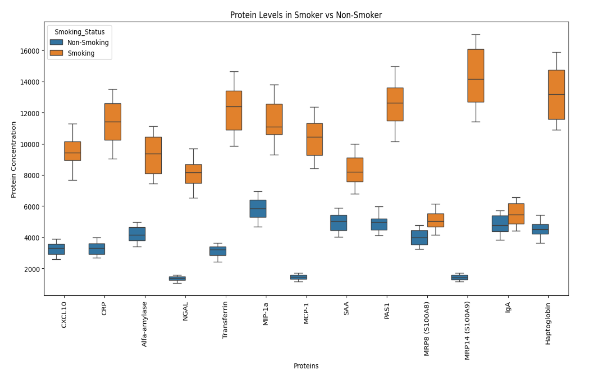
Figure S4: Box plots of protein abundances in smokers and nonsmokers. The plots illustrate the distribution of semi-quantitative abundance signals for the proteins that differed significantly between the two groups. Boxes represent the interquartile range, the central line indicates the median, and whiskers indicate the spread of the data.

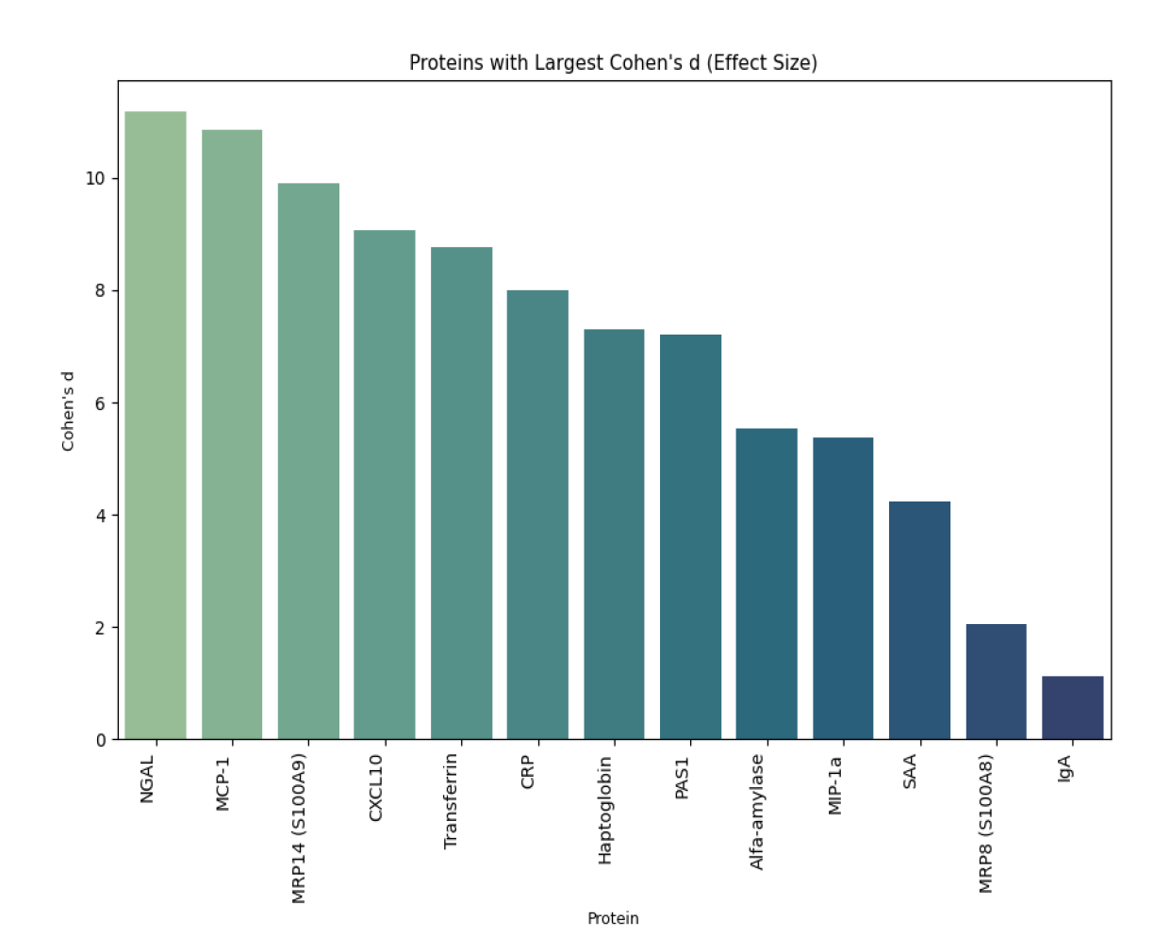
Figure S5: Cohen’s d effect sizes for proteins differing between smokers and nonsmokers. The analysed proteins are orderd according the Cohen’s d value.The largest effect sizes were observed for NGAL and MCP-1, indicating a significant separation between the two groups.

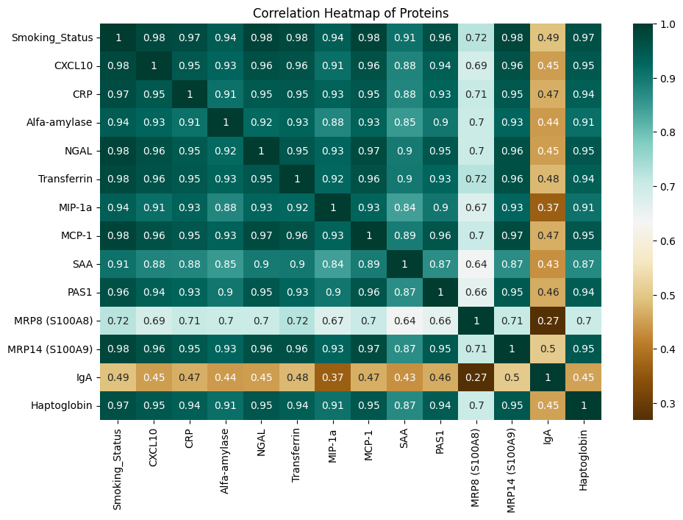
Figure S6: Correlation heatmap of proteins. Lighter shades correspond to higher correlation.

Characteristics |  | Smokers (N=54) |  | Nonsmokers (N=54)
Daily Oral Hygiene Ritual | Low | 31 | 57% | 27 | 50%
Daily Oral Hygiene Ritual | Normal | 23 | 43% | 27 | 50%
Usage of Mouthwash | YES | 25 | 46% | 23 | 43%
Usage of Mouthwash | NO | 29 | 54% | 31 | 57%
Presence of Oral Health Conditions | Tooth Decay | 32 | 59% | 35 | 65%
Presence of Oral Health Conditions | Gingivitis | 6 | 11% | 11 | 20%
Presence of Oral Health Conditions | Inflammation of Oral Cavity | 3 | 6% | 1 | 2%
Presence of Oral Health Conditions | Dry Mouth | 2 | 4% | 5 | 9%
Presence of Oral Health Conditions | No symptoms | 18 | 33% | 10 | 19%
Laryngitis  (frequency per year) | 0 | 24 | 44% | 26 | 48%
Laryngitis  (frequency per year) | 1 | 6 | 11% | 12 | 22%
Laryngitis  (frequency per year) | 2 | 11 | 20% | 11 | 20%
Laryngitis  (frequency per year) | 3 | 5 | 9% | 3 | 6%
Laryngitis  (frequency per year) | > 3 | 8 | 15% | 2 | 4%
Bronchitis  (frequency per year) | 0 | 36 | 67% | 35 | 65%
Bronchitis  (frequency per year) | 1 | 8 | 15% | 15 | 28%
Bronchitis  (frequency per year) | 2 | 7 | 13% | 4 | 7%
Bronchitis  (frequency per year) | 3 | 1 | 2% | 0 | 0%
Bronchitis  (frequency per year) | > 3 | 2 | 4% | 0 | 0%
Digestion problems | YES | 14 | 26% | 19 | 35%
Digestion problems | NO | 40 | 74% | 35 | 65%
Allergies | YES | 24 | 44% | 21 | 39%
Allergies | NO | 30 | 56% | 33 | 61%

Table S1: Questionnaire-based comparison of smokers and nonsmokers

Parameters |  | Smokers | Nonsmokers
number of participants |  | (N=54) | (N=54)
gender | female no. (%) | 28 (52%) | 42 (78%)
 | male no. (%) | 26 (48%) | 12 (22%)
age | mean ±SD | 21 ±1.9 | 22 ±2
Table S2: Demographic characteristics of the study participants

Characteristics | Smokers (n = 54)
type of tobacco product | number of participants | %
Cigarettes only | 22 | 41
E-cigarettes only | 11 | 20
Nicotine Pouches only | 11 | 20
Mixed | 10 | 19
Frequency per day
Less than 5 | 20 | 37
5 times | 20 | 37
10 times | 7 | 13
More than 10 times | 7 | 13
Table S3: Distribution of tobacco product use and frequency among smokers.

