Supplement materials

Table 4: Model evaluation
S.N | Criteria | Threshold | Sensitivity | Specificity | TSS | Kappa | NMI | phi | ppv | npv | ccr | Prevalence
1 | sp=se | 0.647 | 0.747 | 0.747 | 0.494 | 0.456 | 0.177 | 0.466 | 0.573 | 0.867 | 0.747 | 0.407
2 | max(se+sp) | 0.643 | 0.780 | 0.725 | 0.505 | 0.457 | 0.185 | 0.472 | 0.563 | 0.879 | 0.742 | 0.433
3 | min(cost) | 0.728 | 0.004 | 1.000 | 0.004 | 0.006 | 0.003 | 0.055 | 1.000 | 0.689 | 0.689 | 0.001
4 | minROCdist | 0.643 | 0.780 | 0.725 | 0.505 | 0.457 | 0.185 | 0.472 | 0.563 | 0.879 | 0.742 | 0.433
5 | max(kappa) | 0.654 | 0.683 | 0.799 | 0.482 | 0.466 | 0.174 | 0.468 | 0.607 | 0.847 | 0.763 | 0.351
6 | max(ppv+npv) | 0.716 | 0.035 | 1.000 | 0.035 | 0.048 | 0.021 | 0.157 | 1.000 | 0.695 | 0.699 | 0.011
7 | ppv=npv | 0.682 | 0.361 | 0.950 | 0.311 | 0.364 | 0.124 | 0.407 | 0.766 | 0.766 | 0.766 | 0.147
8 | max(NMI) | 0.575 | 0.989 | 0.453 | 0.442 | 0.333 | 0.210 | 0.441 | 0.451 | 0.989 | 0.620 | 0.685
9 | max(ccr) | 0.666 | 0.551 | 0.878 | 0.429 | 0.451 | 0.159 | 0.455 | 0.672 | 0.811 | 0.776 | 0.256
10 | prevalence | 0.659 | 0.630 | 0.832 | 0.462 | 0.462 | 0.167 | 0.462 | 0.630 | 0.832 | 0.769 | 0.312

Note:
sp = specificity; se = sensitivity; max(se+sp) = maximum sum of sensitivity and specificity; min(cost) = minimum misclassification cost; minROCdist = minimum distance to ROC plot corner (0,1); max(kappa) = maximum Cohen’s Kappa; max(ppv+npv) = maximum sum of positive and negative predictive values; ppv = positive predictive value; npv = negative predictive value; ppv=npv = threshold where PPV equals NPV; max(NMI) = maximum normalized mutual information; max(ccr) = maximum correct classification rate; prevalence = observed prevalence-based threshold.

Table 5: Each model evaluation
Model | ID | AUC | COR | Deviance
GLM | 1 | 0.871 | 0.502 | 0.591
GLM | 2 | 0.889 | 0.474 | 0.470
GLM | 3 | 0.889 | 0.448 | 0.498
GLM | 4 | 0.87 | 0.485 | 0.525
GLM | 5 | 0.89 | 0.49 | 0.483
GLM | 6 | 0.889 | 0.396 | 0.465
GLM | 7 | 0.886 | 0.501 | 0.420
GLM | 8 | 0.883 | 0.51 | 0.517
GLM | 9 | 0.914 | 0.545 | 0.409
GLM | 10 | 0.897 | 0.509 | 0.439
MaxEnt | 11 | 0.907 | 0.57 | 0.573
MaxEnt | 12 | 0.913 | 0.543 | 0.518
MaxEnt | 13 | 0.929 | 0.615 | 0.441
MaxEnt | 14 | 0.908 | 0.572 | 0.532
MaxEnt | 15 | 0.917 | 0.58 | 0.483
MaxEnt | 16 | 0.925 | 0.554 | 0.495
MaxEnt | 17 | 0.924 | 0.569 | 0.425
MaxEnt | 18 | 0.933 | 0.616 | 0.482
MaxEnt | 19 | 0.916 | 0.555 | 0.484
MaxEnt | 20 | 0.927 | 0.584 | 0.427
RF | 21 | 0.952 | 0.733 | 0.395
RF | 22 | 0.957 | 0.74 | 0.298
RF | 23 | 0.967 | 0.755 | 0.299
RF | 24 | 0.966 | 0.768 | 0.335
RF | 25 | 0.969 | 0.768 | 0.298
RF | 26 | 0.975 | 0.756 | 0.272
RF | 27 | 0.968 | 0.739 | 0.285
RF | 28 | 0.972 | 0.772 | 0.315
RF | 29 | 0.96 | 0.719 | 0.313
RF | 30 | 0.958 | 0.758 | 0.295
BRT | 31 | 0.903 | 0.594 | 0.600
BRT | 32 | 0.929 | 0.6 | 0.445
BRT | 33 | 0.939 | 0.639 | 0.471
BRT | 34 | 0.918 | 0.62 | 0.526
BRT | 35 | 0.939 | 0.659 | 0.462
BRT | 36 | 0.951 | 0.616 | 0.425
BRT | 37 | 0.942 | 0.626 | 0.439
BRT | 38 | 0.926 | 0.601 | 0.527
BRT | 39 | 0.923 | 0.572 | 0.472
BRT | 40 | 0.915 | 0.6 | 0.456

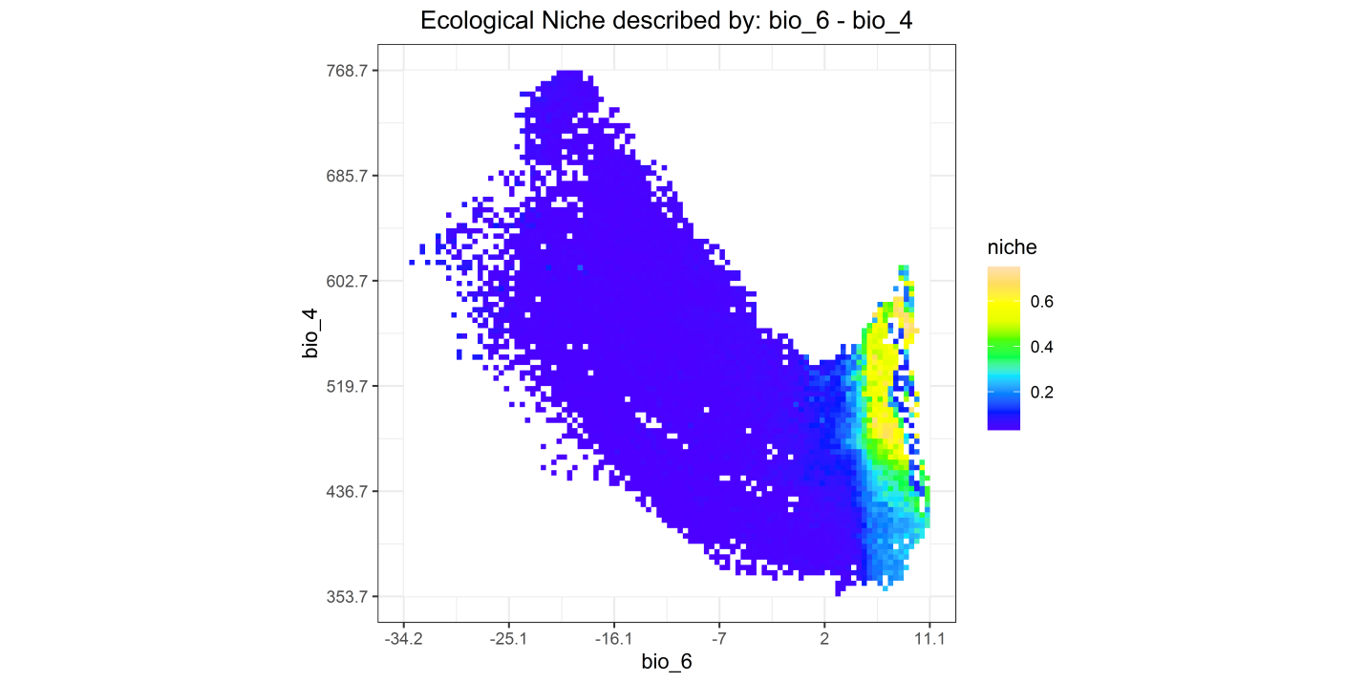
Figure 7: Figure showing ecological niche described by: bio_6-bio_4

