Supporting Information
Site-Selective Ru Doping in Spinel Co₃O₄ Unlocks Dual-Site Synergy for Acidic Water Electrolysis
Yumeng Wang¹, Yaling Zhang¹, Shiyao Chen¹, Yameng Fan², Jian Peng³, Tofik Ahmed Shifa⁴, Yaping Li¹*, Alberto Vomiero⁴, Fengmei Wang¹*, and Xiaoming Sun¹*
¹State Key Laboratory of Chemical Resource Engineering, College of Chemistry, Beijing University of Chemical Technology, Beijing 100029, P. R. China.
²School of Science, RMIT University, Melbourne, VIC 3000, Australia
³Eastern Institute for Advanced Study, Eastern Institute of Technology, Ningbo, 315200, China.
⁴Department of Molecular Sciences and Nanosystems, Ca’ Foscari University of Venice Via Torino 155,30172 Venezia Mestre, Italy.
Correspondence: Yaping Li, E-mail:liyp@mail.buct.edu.cn.
Fengmei Wang: wangfm@buct.edu.cn.
Xiaoming Sun: sunxm@mail.buct.edu.cn
Experimental Section
Materials. Cobalt(Ⅱ) nitrate (Co(NO3)₂·6H₂O, AR), was purchased from Shanghai Aladdin Biochemical Technology Co., Ltd. Ruthenium tri-chloride hydrate (RuCl₃·xH₂O, content (as Ru) % 35.0−38.0) was purchased from Shenyang Nonferrous Metals Research Institute Co., Ltd. and no further purification was required. Carbon cloth was purchased from Toray Industries, Inc.
Catalyst Preparation. Oct-Ru_{x}Co_{3-x}O₄ with Ru substituted at the octahedral sites of Co₃O₄, was prepared through electrodeposition followed by cation exchange. Briefly, 1.41 g of Co(NO₃)₂·6H₂O was dissolved in 100 mL of deionized water to form the electrolyte. A standard three-electrode system was employed, consisting of an Ag/AgCl electrode as reference electrode, a graphite rod as counter electrode, and a carbon cloth (2 × 2 cm², precleaned by ethanol and deionized water) as the working electrode. Electrodeposition was performed at −1 V (vs. Ag/AgCl electrode) for 15 min to deposit a Co(OH)₂ precursor onto the carbon cloth (i.e., Co(OH)₂/CC). The resulting Co(OH)₂/CC was thoroughly rinsed with deionized water dried at 80 °C for 12 h, and then calcined in air at 300 °C for 3 h to obtain Co₃O₄/CC. For cation exchange, the Co₃O₄/CC precursor was immersed in an aqueous solution of RuCl₃ (0.3 mg/mL) in a glass vial, which was heated at 60 °C for 9 h. The product was repeatedly washed with deionized water and annealed at 300 °C for 3 h in a tube furnace, yielding Oct-Ru_{0.13}Co_{2.87}O₄/CC with partial substitution of octahedral Co by Ru. The Ru content in the Oct-Ru_{x}Co_{3-x}O₄ was tuned by varying the concentration of RuCl₃ solution and quantified by Inductively Coupled Plasma Mass spectrometry (ICP-MS). As a comparison, Co₃O₄/CC sample was prepared under the same procedure, except for the absence of cation exchange treatment. Tet-Ru_{x}Co_{3-x}O₄ with Ru substitution at tetrahedral Co sites, was synthesized through a one-step electrodeposition method. The electrolyte was prepared by dissolving different ratio of RuCl₃·xH₂O and Co(NO₃)₂·6H₂O in 100 mL deionized water. Using the same three-electrode configuration, cyclic electrodeposition was conducted between −1.2 V and −0.2 V (vs. Ag/AgCl) for 80 cycles. The as-obtained RuCo(OH)ₓ/CC precursor was washed extensively with deionized water and annealed at 300 °C for 3 h under inert atmosphere to produce Tet-Ru_{x}Co_{3-x}O₄/CC.
Structural Characterizations. The morphology of the samples characterized by scanning electron microscope (SEM，JEM 2100F, Japan) at an acceleration voltage of 5 kV. The elemental information was observed by energy dispersive X-ray spectroscopy (EDS) equipped with the SEM. The content of the elements in the samples was analyzed quantitatively by ICP-MS (iCAP 7400, Thermo Fisher). The crystal characteristics of the samples was tasted by Rigaku D/max 2500 X-ray diffractometer, the angle range of the test is 10-90° and the scan rate was 10° min⁻¹. The chemical states of different element of the samples were collected by an X-ray photoelectron spectrometer (ESCALAB 250). The Raman spectra of the samples were collected by using a LabRAM Odyssey equipped with a diode laser operating at 633 nm. Microstructure observation was characterized by high-resolution transmission electron microscopy (HR-TEM) using a double aberration-corrected field emission gun transmission electron microscope Titan 80−300 at a voltage of 200 kV. The K-edge XAS spectra of Ru and Co were acquired at the 1W1B station of the Beijing Institute of High Energy Physics.
Electrocatalyst Characterizations. The electrochemical tests were performed in a three-electrode system at room temperature (25℃) in O₂-saturated 0.5 M H₂SO₄ electrolyte solution in an electrochemical workstation (Chenhua, CHI760E). The catalyst on CC was cut into a 1×1cm² film as the working electrode, while a platinum sheet and a saturated calomel electrode (SCE) served as the counter and reference electrodes, respectively. All the potentials shown in our research were calibrated with the reversible hydrogen electrode (RHE). The cyclic voltammetry (CV) curve tests were recorded in a potential window ranging from 0.8 V to 1.8 V vs SCE at a scan rate of 50 mV s⁻¹. Then the Linear sweep voltammetry (LSV) curve of the catalyst was performed at a scan rate of 5 mV s⁻¹ in the voltage range of 0.8 V to 1.8V vs SCE. A chronopotentiometry (CP) test was performed at a room temperature @ 10 mA·cm⁻². The solution resistance (R_{s}) was collected by electrochemical impedance spectra (EIS) in the frequency range from 0.01 Hz to 10 kHz at the potential of 1.5 V.
The Membrane Electrode Assembly of PEM device was prepared by the catalyst coating membrane (CCM) method. The 20 wt % commercial platinum carbon catalyst powder was first dispersed in a mixture of isopropyl alcohol, deionized water and Nafion solution (5 wt %). The ink was sprayed onto the Nafion 117 proton exchange membrane. The catalyst on CC was hot-pressed onto the proton exchange membrane at 120 °C. Titanium felt and carbon paper were used as gas diffusion layers for the anode and cathode, respectively.
Theoretical Calculations. All DFT calculations were performed using the Viena Ab initio Simulation Package (VASP). The projector augmented wave (PAW) pseudopotential with the PBE generalized gradient approximation (GGA) exchange correlation function was utilized in the computations.¹ The cutoff energy of the plane waves basis set was 450 eV and a Monkhorst-pack mesh of 2×2×1 was used in K- sampling.² All structures were spin polarized and all atoms were fully relaxed with the energy convergence tolerance of 10-4 eV per atom, and the final force on each atom was < 0.05 eV Å⁻¹. In order to improve the accuracy of model calculation, the DFT+U calculation method was used to describe the correlation of 3d transition metal system. According to previous work, the U value could be selected as 3.3 for Co³ and 2.0 for Ru.⁴
The adsorption energy of reaction intermediates, can be computed using the following Equation⁵:
$${\text{ΔG}}_{\text{ads}}\text{ =}{\text{E}}_{\text{ads}}\text{- E*+ Δ}{\text{E}}_{\text{ZPE}}\text{ – TΔS}$$
Where Eads is the calculated adsorption energy for the OH*, O*, OOH*, O*- OH*, O*- O* intermediates, and E* is the binding energy of the corresponding intermediates, ΔEZPE is the zero-point energy change, ΔS is the entropy change, T is the temperature (T = 298.15 K). The values of ΔEZPE and ΔS were obtained by vibration frequency calculation.

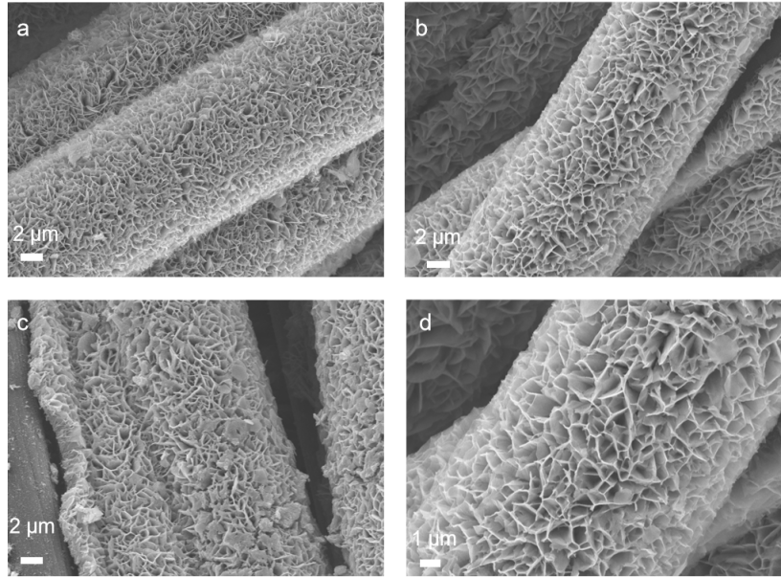
Fig S1. SEM images of (a) Oct-Ru_{0.08}Co_{2.92}O₄,(b) Oct-Ru_{0.47}Co_{2.53}O₄ and (c)Oct-Ru_{0.59}Co_{2.41}O₄ (d) Co₃O₄ nanosheet arrays synthesized on the carbon cloth.
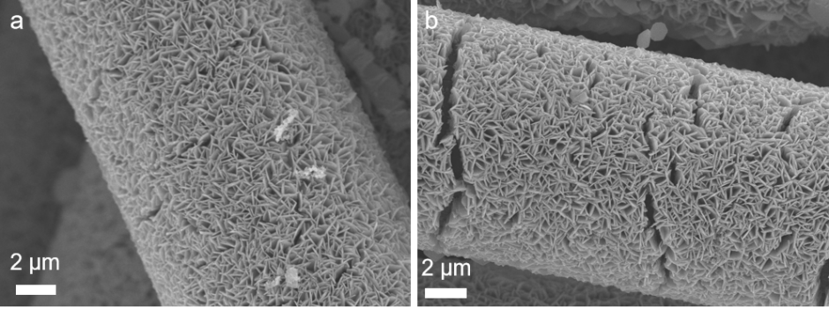
Fig S2. SEM images of (a) Tet-Ru_{0.07}Co_{2.93}O₄ and (b)Tet-Ru_{0.42}Co_{2.58}O₄ nanosheet arrays synthesized on the carbon cloth.
Fig S3. SEM images of Co₃O₄ nanosheet arrays synthesized on the carbon cloth.
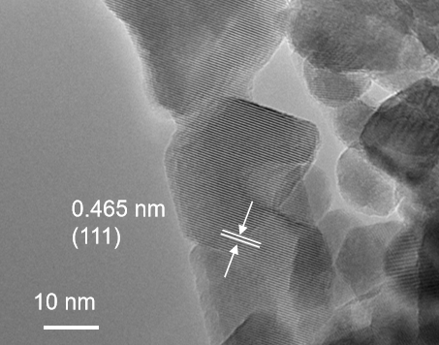
Fig S4.HR-TEM images of the Co₃O₄ sample.
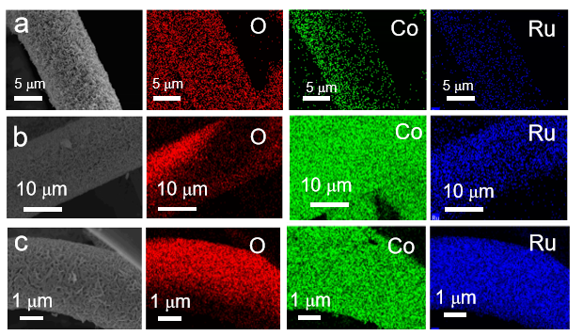
Fig S5. The EDS mapping images of the Oct-Ru_{x}Co_{3-x}O₄ samples. (a) Oct-Ru_{0.08}Co_{2.92}O₄; (b) Oct-Ru_{0.47}Co_{2.53}O₄ and (c) Oct-Ru_{0.59}Co_{2.41}O₄.
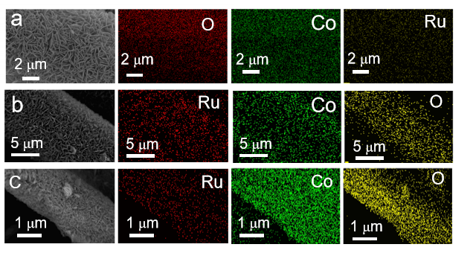
Fig S6. The EDS mapping images of the Tet-Ru_{x}Co_{3-x}O₄ samples. (a) Tet-Ru_{0.07}Co_{2.92}O₄; (b) Tet-Ru_{0.18}Co_{2.53}O₄ and (c) Tet-Ru_{0.42}Co_{2.58}O₄.
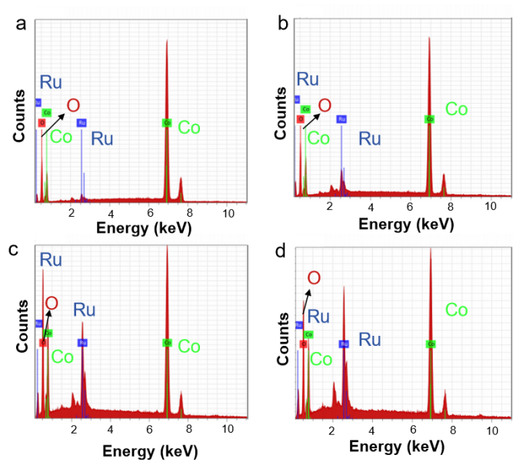
Fig S7. The EDS spectra collected from Oct-Ru_{x}Co_{3-x}O₄ samples. (a) Oct-Ru_{0.08}Co_{2.92}O₄; (b) Oct-Ru_{0.13}Co_{2.87}O₄; (c) Oct-Ru_{0.47}Co_{2.53}O₄ and (d) Oct-Ru_{0.59}Co_{2.41}O₄.
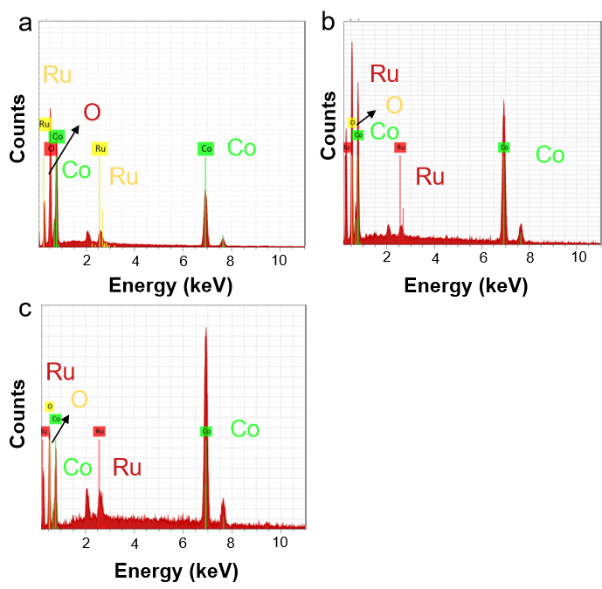
Fig S8. The EDS spectra collected from Oct-Ru_{x}Co_{3-x}O₄ samples. (a) Tet-Ru_{0.07}Co_{2.92}O₄; (b) Tet-Ru_{0.18}Co_{2.53}O₄; (c) Tet-Ru_{0.42}Co_{2.58}O₄.
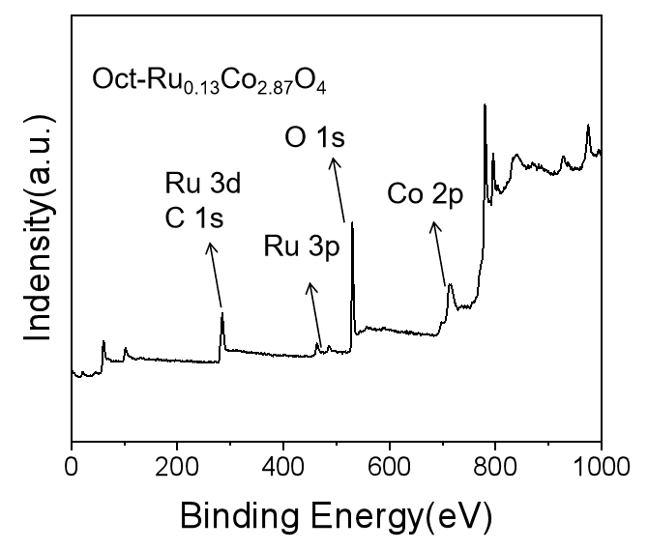
Fig S9. Full XPS survey spectra collected from theOct-Ru_{0.13}Co_{2.87}O₄ sample.
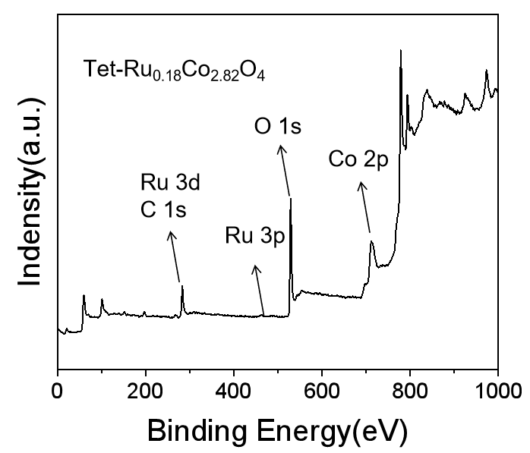
Fig S10. Full XPS survey spectra collected from the Tet-Ru_{0.18}Co_{2.82}O₄ sample.
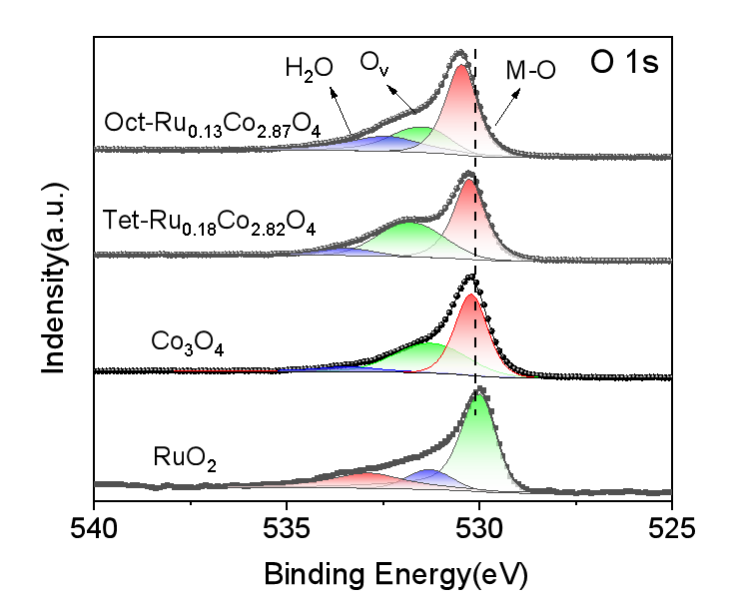
Fig S11. O 1s scan analysis of the Oct-Ru_{0.13}Co_{2.87}O₄ and Tet-Ru_{0.18}Co_{2.82}O₄, compared with the Co₃O₄ and RuO₂ as the references.
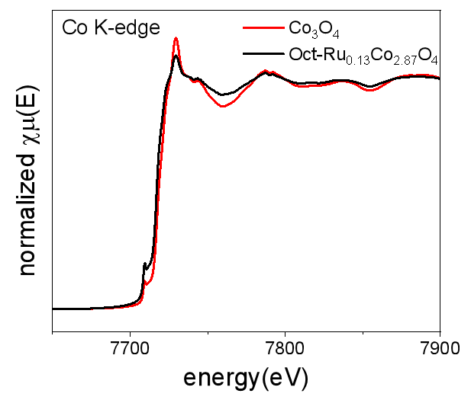
Fig S12. Co K-edge EXAFS spectra of the Oct-Ru_{0.13}Co_{2.87}O₄ compared with the Co₃O₄ sample.
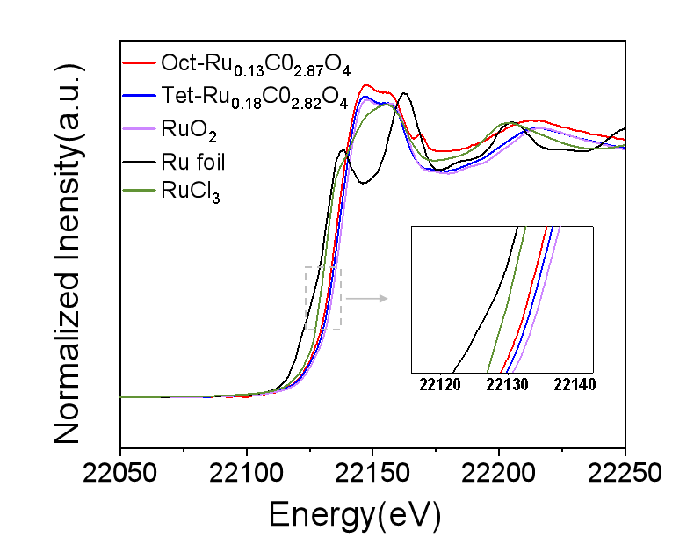
Fig S13. Ru K-edge EXAFS spectra of the Oct-Ru_{0.13}Co_{2.87}O₄ and Tet-Ru_{0.18}Co_{2.82}O₄ samples with the RuO₂, Ru foil and RuCl₃ as the references.
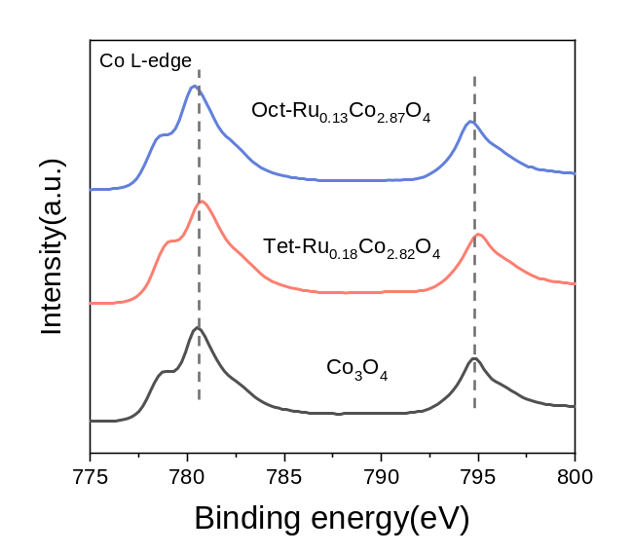
Fig S14. Co L-edge XAS spectra of the Oct-Ru_{0.13}Co_{2.87}O₄, Tet-Ru_{0.18}Co_{2.82}O₄ and Co₃O₄ sample.

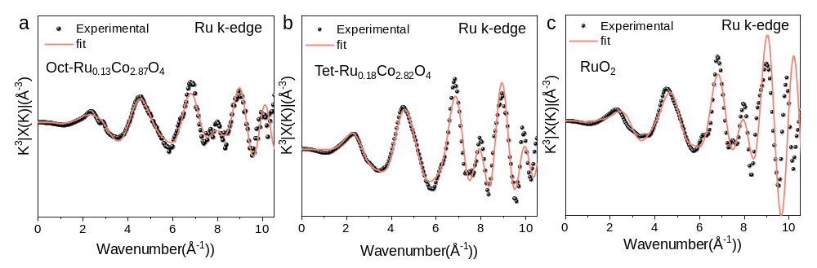
Fig S15. Ru K-edge EXAFS spectra in K space of the (a) Oct-Ru_{0.13}Co_{2.87}O₄, (b) Tet-Ru_{0.18}Co_{2.82}O₄ and (c) RuO₂ sample.
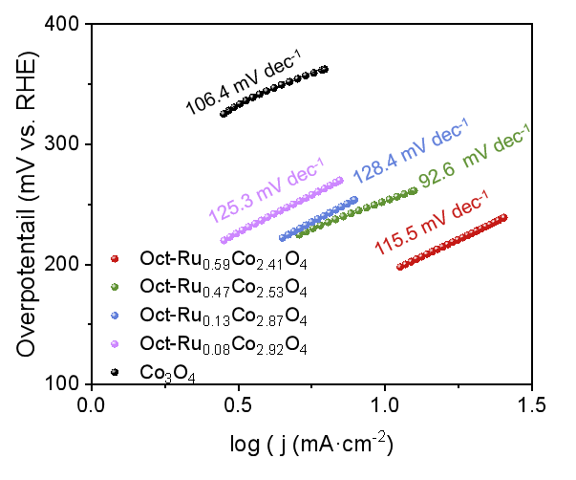
Fig S16. Tafel plots of various Oct-Ru_{x}Co_{3-x}O₄ (x=0.08, 0.13, 0.47, 0.59) and Co₃O₄ electrodes.
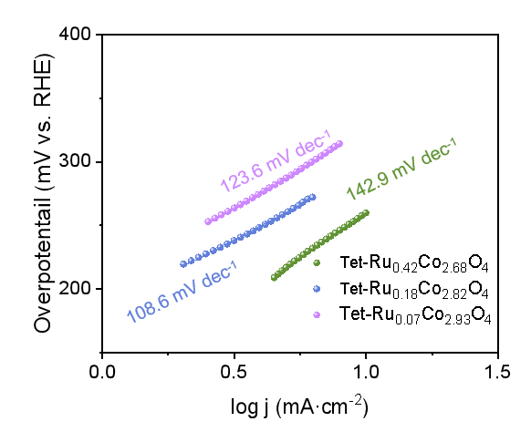
Fig S17. Tafel plots of various Tet-Ru_{x}Co_{3-x}O₄ (x=0.07, 0.18, 0.42) electrodes, compared with the Co₃O₄ electrode.
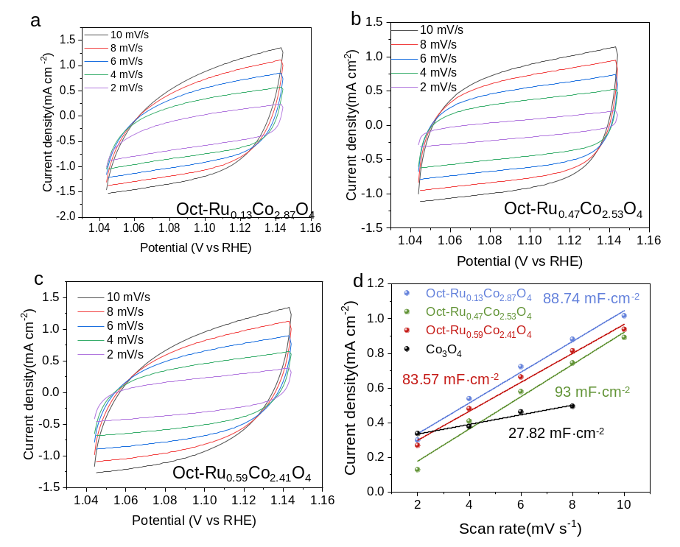
Fig S18. Electrochemical double-layer capacitance (C_{dl}) of Oct-Ru_{x}Co_{3-x}O₄ and Co₃O₄. (a-c) Representative CV curves collected at different scan rates of 2-10 mV s⁻¹ under the potential range of 1.044 -1.144 V vs. RHE of Oct-Ru_{x}Co_{3-x}O₄ (x=0.13, 0.47, 0.59). (d) C_{dl} values calculated from the CV curves.
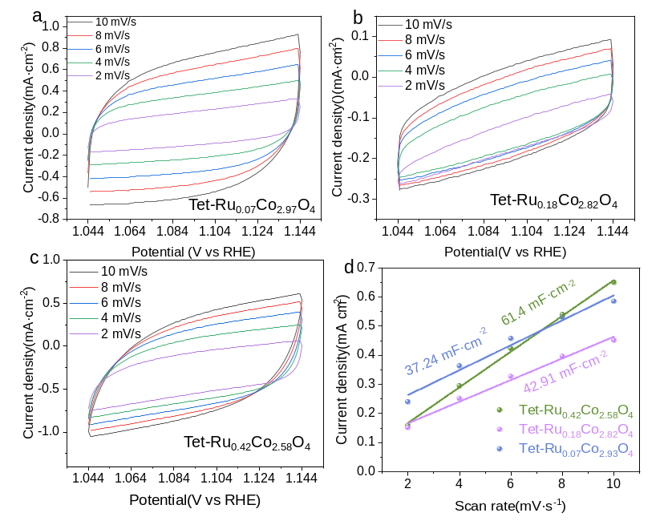
Fig S19. Electrochemical double-layer capacitance (C_{dl}) of Oct-Ru_{x}Co_{3-x}O₄ and Co₃O₄. (a-c) Representative CV curves collected at different scan rates of 2-10 mV s⁻¹ under the potential range of 1.044 -1.144 V vs. RHE of Oct-Ru_{x}Co_{3-x}O₄ (x=0.07, 0.18, 0.42). (d) C_{dl} values calculated from the CV curves.
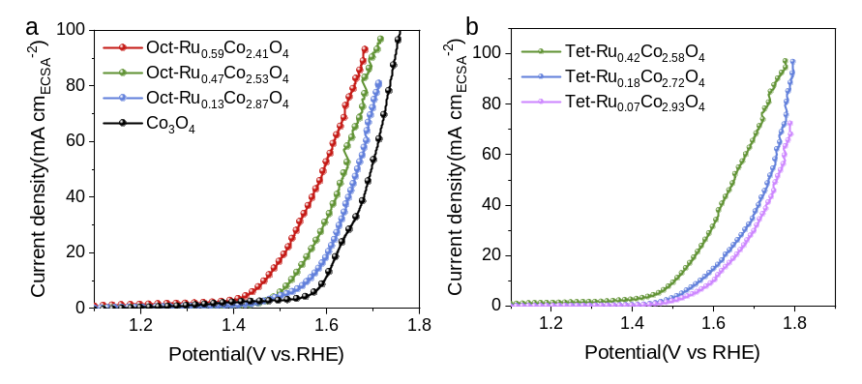
Fig S20. LSV curves normalized to ECSA of (a) Oct-Ru_{x}Co_{3-x}O₄, (b) Tet-Ru_{x}Co_{3-x}O₄ and Co₃O₄ samples. The electrochemically active surface area (ECSA) of the catalysts was estimated from the electrochemical double-layer capacitance (C_{dl}) of the catalytic surface using a specific equation (ECSA=C_{dl}/C_{s}), whereas Cs value is 0.035 mF cm⁻² in acid electrolyte.
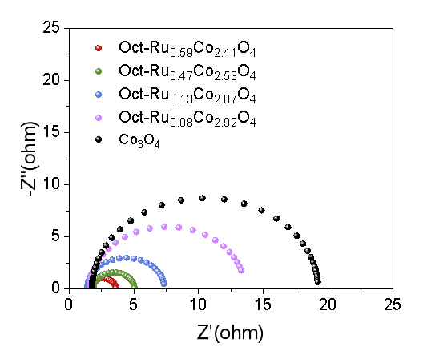
Fig S21. EIS plots collected from various Oct-Ru_{x}Co_{3-x}O₄ (x=0.08, 0.13, 0.47, 0.59) and Co₃O₄ electrodes, inset, the simulative equivalent circuit.
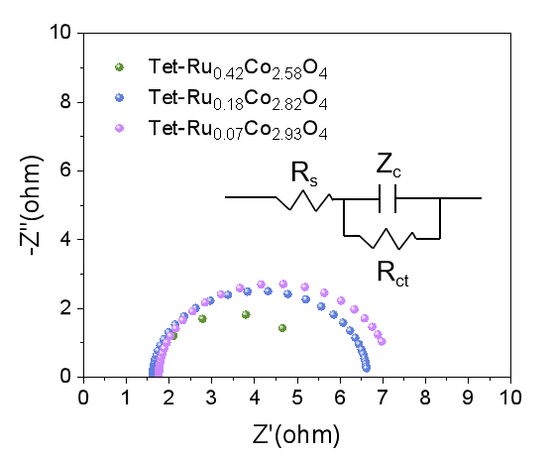
Fig S22. EIS plots collected from various Tet-Ru_{x}Co_{3-x}O₄ (x=0.08, 0.18, 0.42) electrodes, compared with the Co₃O₄ electrode, inset, the simulative equivalent circuit.
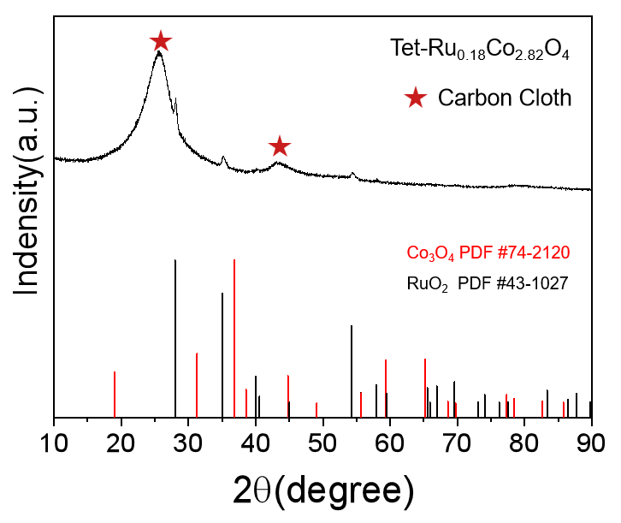
Fig S23. XRD pattern collected from Tet-Ru_{0.18}Co_{2.82}O₄ sample after the stability test at 10 mA cm⁻² for 50 h.
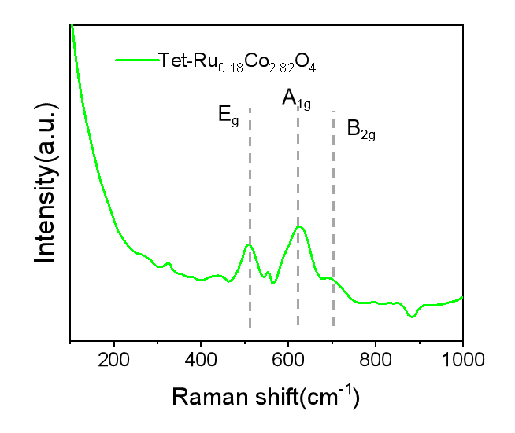
Fig S24. Raman pattern collected from Tet-Ru_{0.18}Co_{2.82}O₄ sample after the stability test at 10 mA cm⁻² for 50 h.
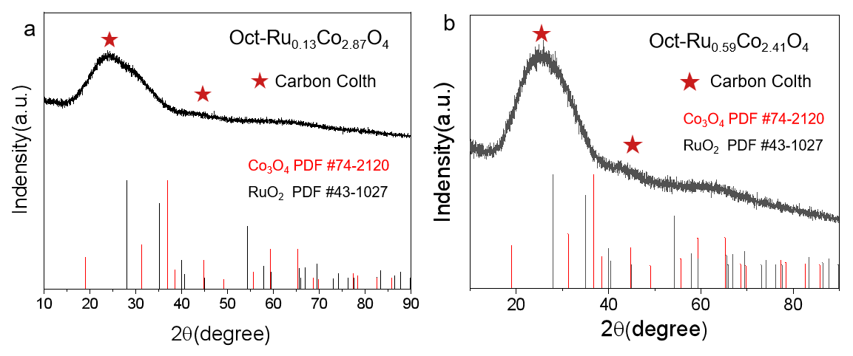
Fig S25. XRD spectra of (a) Oct-Ru_{0.13}Co_{2.87}O₄ and (b) Oct-Ru_{0.59}Co_{2.41}O₄ after the stability test at 10 mA cm⁻² for 240 h and 135h .
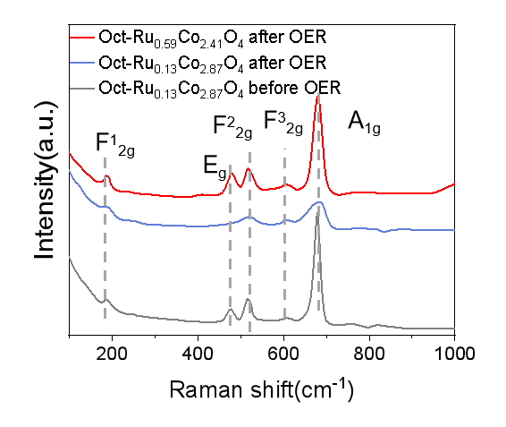
Fig S26. Raman spectra collected from fresh Oct-Ru_{0.13}Co_{2.87}O₄, Oct-Ru_{0.13}Co_{2.87}O₄ and Oct-Ru_{0.59}Co_{2.41}O₄ sample after the stability test at 10 mA cm⁻² for 240 h and 135h.
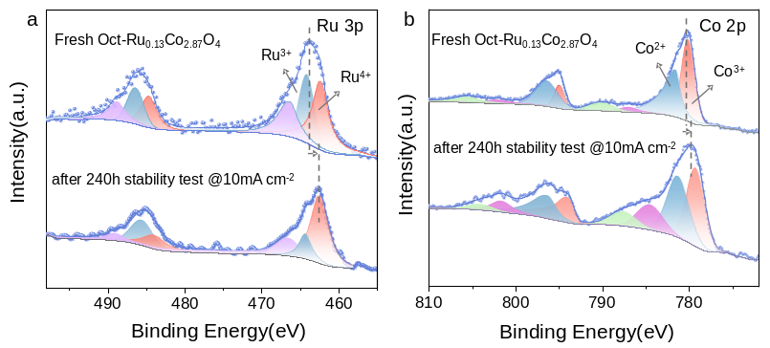
Fig S27. (a) Ru 3p and (b) Co 2p XPS spectra collected from the fresh Oct-Ru_{0.13}Co_{2.87}O₄ catalyst and the sample after the stability test at 10 mA cm⁻² for 240 h.
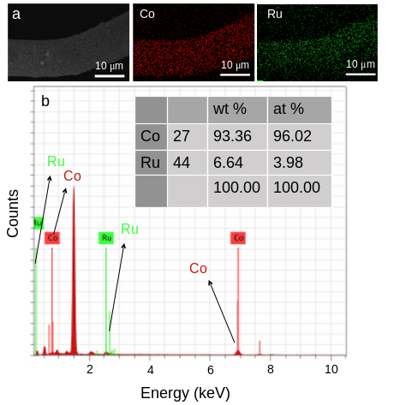
Fig S28. (a) The EDS mapping images, (b) and inset the EDS result of the Oct-Ru_{0.13}Co_{2.87}O₄ sapmle after the stability test at 10 mA cm⁻² for 240 h.
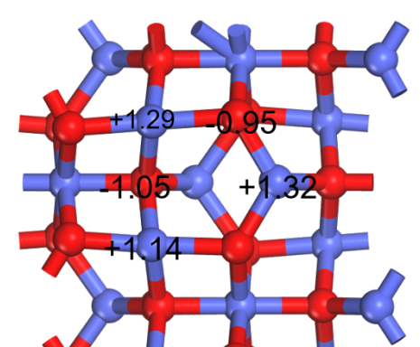
Fig S29. Bader charge distribution calculated from Co₃O₄ model.
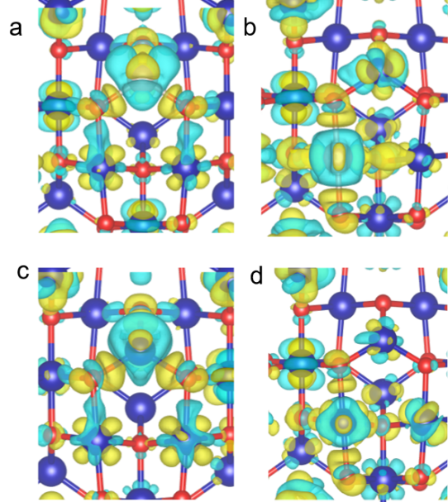
Fig S30. Bader charge density calculated on (a)Oct-Ru_{0.13}Co_{2.87}O₄ (b)Tet-Ru_{0.13}Co_{2.87}O₄ (c) and (d) Co₃O₄ models (bule ball: Co or Ru, red ball: O)
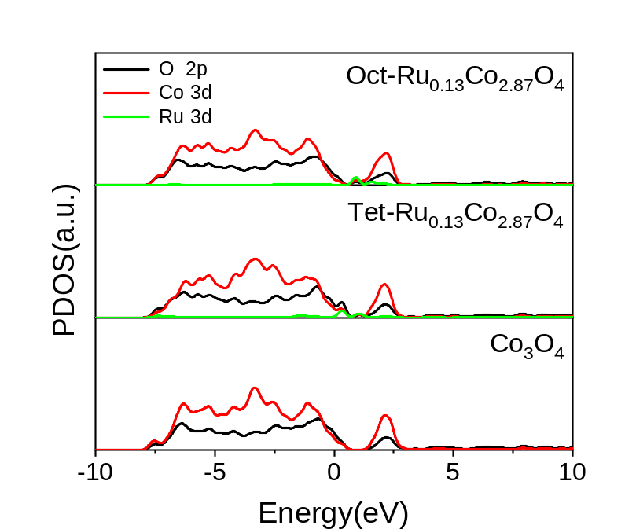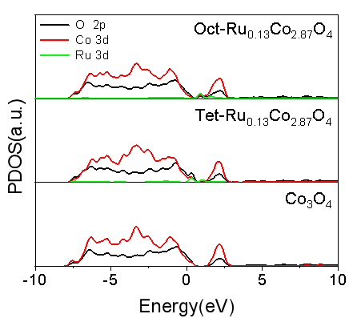
Fig S31. Co 3d, O 2p, and Ru 4d PDOS spectra of Oct-Ru_{0.13}Co_{2.87}O₄, Tet-Ru_{0.13}Co_{2.87}O₄ and Co₃O₄ models.

Table S1 The ratio of Co and Ru in various Oct-Ru_{x}Co_{3-x}O₄ (x=0.07, 0.13, 0.47, 0.59) measured through ICP-OES.
 |  | Oct-Ru_{0.08}Co_{2.92}O₄ | Oct-Ru_{0.13}Co_{2.87}O₄ | Oct-Ru_{0.47}Co_{2.53}O₄ | Oct-Ru_{0.59}Co_{2.41}O₄
ppm | Ru | 0.289 | 0.236 | 1.326 | 3.183
ppm | Co | 6.137 | 3.049 | 4.154 | 7.571

Table S2 The ratio of Co and Ru in various Tet-Ru_{x}Co_{3-x}O₄ (x=0.08, 0.18,0.42)measured by ICP-OES.
 | Tet-Ru_{0.08}Co_{2.92}O₄ |  | Tet-Ru_{0.18}Co_{2.82}O₄ | Tet-Ru_{0.42}Co_{2.58}O₄
ppm | Ru | 0.112 | 0.497 | 1.821
ppm | Co | 2.752 | 4.522 | 6.532

Table S3. Comparison of overpotential and stability @10mA cm⁻² of the Oct-Ru_{0.13}Co_{2.87}O₄ electrocatalyst with and other reported acidic OER electrocatalysts.
Electrocatalyst | Electrolyte | overpotential  (mV @ 10 mA cm⁻²) | Stability  (h @ 10 mA cm⁻²) | Reference
Oct-Ru_{0.13}Co_{2.87}O₄ | 0.5 M H₂SO₄ | 240 | 234 | This work
IrOx-B | 0.1 M HClO₄ | 292 | 10 | [6]
Ir-doped WO₃ | 0.5 M H₂SO₄ | 258 | 60 | [7]
Ir SAs-NiCo₂O₄ NSs | 0.5 M H₂SO₄ | 240 | 70 | [8]
Ir-MnO₂ | 0.5 M H₂SO₄ | 280 | 100 | [9]
Ir_{0.06}Co_{2.94}O₄ | 0.1 M HClO₄ | 300 | 200 | [10]
RuCu | 0.5 M H₂SO₄ | 270 | 20 | [11]
IrSAE-CMO | 0.5 M H₂SO₄ | 235 | 25 | [12]
Ir_{0.3}Mo_{0.7}O₈ | 0.1 M HClO₄ | 345 | 11 | [13]
Ir-Co₃O₄ | 0.5 M H₂SO₄ | 236 | 30 | [14]
Ru-SA/Ti₃C₂T_{x} | 0.1 M HClO₄ | 290 | 32 | [15]
IrO2/MnO₂ | 0.5 M H₂SO₄ | 310 | 80 | [16]
La₃IrO₇-SLD | 0.1 M HClO₄ | 296 | 17 | [17]
LaMn-Co₃O₄ | 0.5 M H₂SO₄ | 353 | 80 | [18]
PdCu/Ir/C | 0.5 M H2SO₄ | 283 | 15 | [19]
IrBa-Co₃O₄ | 0.5 M H₂SO₄ | 295 | 100 | [20]

REFERENCE
1 Perdew, J. P. et al. Atoms, molecules, solids, and surfaces: Applications of the generalized gradient approximation for exchange and correlation. Physical Review B 46, 6671-6687, doi:10.1103/PhysRevB.46.6671 (1992).
2 Monkhorst, H. J. & Pack, J. D. Special points for Brillouin-zone integrations. Physical Review B 13, 5188-5192, doi:10.1103/PhysRevB.13.5188 (1976).
3 Wang, L., Maxisch, T. & Ceder, G. Oxidation energies of transition metal oxides within the GGA+U framework. Physical Review B 73, 195107, doi:10.1103/PhysRevB.73.195107 (2006).
4 Yang, H.-C., Gong, B.-C., Liu, K. & Lu, Z.-Y. J. J. o. P. C. M. Quasi-degenerate magnetic states in α-RuCl₃. 31, 025803 (2018).
5 Rossmeisl, J., Logadottir, A. & Nørskov, J. K. Electrolysis of water on (oxidized) metal surfaces. Chemical Physics 319, 178-184, doi:10.1016/j.chemphys.2005.05.038 (2005).
6 Cheng, Z., Pi, Y., Shao, Q. & Huang, X. Boron-doped amorphous iridium oxide with ultrahigh mass activity for acidic oxygen evolution reaction. Science China Materials 64, 2958-2966, doi:10.1007/s40843-021-1687-5 (2021).
7 Li, P., Duan, X., Kuang, Y. & Sun, X. Iridium in Tungsten Trioxide Matrix as an Efficient Bi-Functional Electrocatalyst for Overall Water Splitting in Acidic Media. Small 17, 2102078, doi:10.1002/smll.202102078 (2021).
8 Yin, J. et al. Iridium Single Atoms Coupling with Oxygen Vacancies Boosts Oxygen Evolution Reaction in Acid Media. Journal of the American Chemical Society 142, 18378-18386, doi:10.1021/jacs.0c05050 (2020).
9 Sun, Y., Chen, J., Liu, L., Chi, H. & Han, H. The mechanism of OER activity and stability enhancement in acid by atomically doped iridium in γ-MnO₂. Chinese Journal of Catalysis 69, 99-110, doi:10.1016/S1872-2067(24)60201-9 (2025).
10 Shan, J. et al. Short-Range Ordered Iridium Single Atoms Integrated into Cobalt Oxide Spinel Structure for Highly Efficient Electrocatalytic Water Oxidation. Journal of the American Chemical Society 143, 5201-5211, doi:10.1021/jacs.1c01525 (2021).
11 Li, Y. et al. Donutlike RuCu Nanoalloy with Ultrahigh Mass Activity for Efficient and Robust Oxygen Evolution in Acid Solution. ACS Applied Energy Materials 2, 7483-7489, doi:10.1021/acsaem.9b01459 (2019).
12 Kumar, A. et al. Iridium Single-Atom-Ensembles Stabilized on Mn-Substituted Spinel Oxide for Durable Acidic Water Electrolysis. Advanced Materials 36, 2401648, doi:10.1002/adma.202401648 (2024).
13 Tariq, M. et al. Unraveling the Beneficial Electrochemistry of IrO₂/MoO₃ Hybrid as a Highly Stable and Efficient Oxygen Evolution Reaction Catalyst. ACS Sustainable Chemistry & Engineering 6, 4854-4862, doi:10.1021/acssuschemeng.7b04266 (2018).
14 Zhu, Y. et al. Iridium single atoms incorporated in Co₃O₄ efficiently catalyze the oxygen evolution in acidic conditions. Nature Communications 13, 7754, doi:10.1038/s41467-022-35426-8 (2022).
15 Peng, X. et al. Trifunctional Single-Atomic Ru Sites Enable Efficient Overall Water Splitting and Oxygen Reduction in Acidic Media. Small 16, 2002888, doi:10.1002/smll.202002888 (2020).
16 Wang, F. et al. IrO₂/MnO₂ metal oxide-support interaction enables robust acidic water oxidation. Journal of Colloid and Interface Science 683, 160-169, doi:10.1016/j.jcis.2024.12.033 (2025).
17 Qin, Q. et al. Gettering La Effect from La₃IrO₇ as a Highly Efficient Electrocatalyst for Oxygen Evolution Reaction in Acid Media. Advanced Energy Materials 11, 2003561, doi:10.1002/aenm.202003561 (2021).
18 Chong, L. et al. La- and Mn-doped cobalt spinel oxygen evolution catalyst for proton exchange membrane electrolysis. Science 380, 609-616, doi:10.1126/science.ade1499 (2023).
19 Li, M. et al. Exclusive Strain Effect Boosts Overall Water Splitting in PdCu/Ir Core/Shell Nanocrystals. Angewandte Chemie International Edition 60, 8243-8250, doi:10.1002/anie.202016199 (2021).
20 Huo, M. et al. Barium-induced compressive strain engineering in low-iridium Co₃O₄ spinel for high-efficiency acidic oxygen evolution. Chemical Engineering Journal 519, 165555, doi:10.1016/j.cej.2025.165555 (2025).

