Supporting Information

Untargeted metabolic profiling of Zygophyllum Coccineum plant near the Red Sea for phytochemical investigation by GC-MS, LC-MS, and NMR
Upendra Singh¹, Hanan Almahasheer², Abdul-Hamid Emwas*³ and Mariusz Jaremko*⁴

¹Division of Biological and Environmental Sciences and Engineering (BESE), King Abdullah University of Science and Technology (KAUST), Thuwal, Makkah, 23955-6900, Saudi Arabia
²Department of Biology, College of Science, Imam Abdulrahman Bin Faisal University (IAU), Dammam 31441-1982, Saudi Arabia
³Core Lab of NMR, King Abdullah University of Science and Technology (KAUST), Thuwal, Makkah, 23955-6900, Saudi Arabia
Email: abdelhamid.emwas@kaust.edu.sa
⁴Smart-Health Initiative (SHI) and Red Sea Research Center (RSRC), Division of Biological and Environmental Sciences and Engineering (BESE), King Abdullah University of Science and Technology (KAUST), Thuwal, Makkah, 23955-6900, Saudi Arabia
Email: mariusz.jaremko@kaust.edu.sa

Contents
Table S1. A list of Metabolites extracted from Zygophyllum (Z) coccineum leaves sample in a solution of acetonitrile, and water by GC-MS.
Figure S1. GC-MS metabolomics heat map analysis of Z. coccineum leaves sample in a solution of acetonitrile, and water.
Table S2. A list of Metabolites extracted from Z. coccineum leaves sample in a solution of isopropanol, methanol, and water by GC-MS.
Figure S2. GC-MS metabolomics heat map analysis of Z. coccineum leaves sample in a solution of Isopropanol, methanol, and water.
Table S3. A list of Metabolites extracted from Z. coccineum leaves sample in a solution of methanol, and water by GC-MS.
Figure S3. GC-MS metabolomics heat map analysis of Z. coccineum leaves sample in a solution of methanol, and water.
Figure S4. GC-MS mass spectra of a few compounds.
Figure S5. 2D J-RES expanded spectra of Z. coccineum leaves samples extracted in the solution of acetonitrile, and water.
Figure S6. 2D J-RES expanded spectra of Z. coccineum leaves samples extracted in the solution of isopropanol, methanol, and water.
Figure S7. 2D J-RES expanded spectra of Z. coccineum leaves samples extracted in the solution of methanol, and water.
Figure S8. 1D ¹³C ss-NMR spectra of Z. coccineum leaves samples from all locations.
Table S4. A list of Metabolites extracted from Z. coccineum leaves sample in a solution of acetonitrile, and water by LC-MS.
Figure S9. LC-MS metabolomics heat map analysis of Z. coccineum leaves sample in a solution of acetonitrile, and water.
Table S5. A list of Metabolites extracted from Z. coccineum leaves sample in a solution of isopropanol, methanol, and water by LC-MS.
Figure S10. LC-MS metabolomics heat map analysis of Z. coccineum leaves sample in a solution of isopropanol, methanol, and water.
Table S6. A list of Metabolites extracted from Z. coccineum leaves sample in a solution of methanol, and water by LC-MS.
Figure S11. LC-MS metabolomics heat map analysis of Z. coccineum leaves sample in a solution of methanol, and water.
Figure S12. LC-MS mass spectra of a few compounds.

Table S1. Metabolites were extracted in a solution of acetonitrile, and water from the leaves of Z. coccineum was collected from different places around the Red Sea. Identified metabolites are one hundred twenty-two belonging to different classes as amino acids, carbohydrates, organic acids, and natural products by GC-MS.

Sr. No. | Metabolite Name | Rt(min)
1. | (-)-Epinephrine (Adrenaline) | 16.906
2. | (R)-3-Hydroxybutyric acid | 12.64
3. | (S)-Dihydroorotate | 12.431
4. | 1,4-Butanediamine | 13.766
5. | 1-Decanol | 10.729
6. | 1-Methylhistamine | 13.139
7. | 2'-Desoxyuridine | 8.396
8. | 2-Furoic acid | 6.287
9. | 2-Hydroxybutyric acid | 9.248
10. | 2-Hydroxyglutaric acid | 16.061
11. | 2-Hydroxyisocaproic acid | 9.658
12. | 2-Ketobutyric acid, enol | 11.574
13. | 2-Methyl-pentanedioic acid | 15.025
14. | 3,4-Dihydroxyphenylglycol | 21.52
15. | 3-Iodo-L-tyrosine | 6.554
16 | 3-Methyl-2-oxovaleric acid | 8.815
17. | 4-Coumaric acid | 14.323
18. | 4-Hydroxy-3-methoxyphenylglycol | 16.488
19. | 4-Hydroxymandelic acid | 15.705
20. | 4-Hydroxyphenyllactic acid | 11.9
21. | Acetoacetic acid | 18.719
22. | Acetylsalicylic acid | 9.147
23. | beta-Aminoisobutyric acid | 10.142
24. | Caprylic acid | 15.519
25. | Capsaicin | 21.198
26. | Citric acid | 14.672
27. | Cuminol | 26.222
28. | D-(-)-Citramalic acid | 10.673
29. | D-(-)-Tagatose | 10.745
30. | D-(+)-Cellobiose | 22.797
31. | D-(+)-Galacturonic acid | 19.713
32. | D-(+)-Mannose | 15.526
33. | D-(+)-Xylose | 11.158
34. | Deoxyribose | 15.877
35. | D-Gluconic acid | 16.38
36. | D-Gluconolactone | 14.119
37. | Dihydropicamic acid | 13.98
38. | Dihydroxyacetone | 14.953
39. | DL-Normetanephrine | 9.31
40. | DL-Norvaline | 10.998
41. | DL-Phenylalanine | 11.982
42. | D-Mannitol | 16.378
43. | D-Psicofuranose | 23.224
44. | Dulcitol | 19.596
45. | Epioxandrolone | 10.585
46. | Fructose | 22.951
47. | Fructose-1,6-bisphosphate | 20.009
48. | Fucose | 11.471
49. | GABA | 11.405
50. | Galactaric acid, (R, S, R, S) | 16.817
51. | Galactose | 15.664
52. | Gentisic acid | 14.168
53. | Glucopyranose | 19.653
54. | Glucose | 16.713
55. | Glyceric acid | 8.876
56. | Glycerol | 8.15
57. | Glycine | 8.558
58. | Guaicol | 7.511
59. | Homocysteine thiolactone | 10.339
60. | Homovanillic acid | 14.112
61. | Isocitrate | 12.791
62. | Isomaltose | 23.086
63. | Itaconic acid | 11.632
64. | L-(-)-Arabitol | 20.212
65. | L-(+)-Rhamnopyranose | 19.555
66. | L-Alanine | 8.562
67. | L-Asparagine | 7.026
68. | L-Aspartic acid | 15.342
69. | Leucine | 8.109
70. | L-Hydroxyproline, (E) | 10.724
71. | Lignoceric acid | 12.959
72. | L-Serine | 7.906
73. | L-Threonine | 8.405
74. | L-Tryptophan | 17.727
75. | L-Valine | 7.362
76. | Malic acid | 19.559
77. | Malonic acid | 15.774
78. | Maltose | 25.093
79. | Mandelic acid | 14.318
80. | Melibiose | 22.886
81. | meso-Erythritol | 8.413
82. | Mesterolone P | 7.88
83. | Methasterone P | 18.82
84. | Methyl galactoside | 22.954
85. | Methyl vanillate | 12.801
86. | Mevalonolactone | 8.186
87. | Myoinositol | 17.308
88. | Myristic acid | 14.949
89. | N, N-Dimethylglycine | 15.803
90. | N-Acetyl-D-glucosamine | 17.096
91. | N-Acetyl-L-alanine | 8.065
92. | N-alpha-Acetyl-L-lysine | 8.043
93. | N-Methylnicotinamide | 10.802
94. | Octopamine | 13.699
95. | Oxalic acid | 8.665
96. | p-Coumaric acid | 14.322
97. | Phenylethylamine | 12.225
98. | Picolinic acid | 8.765
99. | Prenol | 11.673
100. | Proline | 8.447
101. | Propylene glycol | 12.795
102. | Protocatechuic acid | 21.323
103. | Pyrocatechol | 13.635
104. | Pyruvate | 11.377
105. | Quinic acid | 15.043
106. | Rhamnose | 13.617
107. | Ribitol | 11.77
108. | Ribose | 15.995
109. | Scyllo-inositol | 15.41
110. | Serotonin | 10.343
111. | Sorbose | 15.303
112. | Succinic acid | 11.429
113. | Sucralose | 8.151
114. | Sucrose | 21.808
115. | Tartronic acid | 14.655
116. | Thymidine | 12.255
117. | trans-Aconitic acid | 14.624
118. | Trehalose | 22.45
119. | Tyrosine | 7.35
120. | Uridine | 19.686
121. | Vanillic acid | 14.053
122. | Xylulose | 10.797

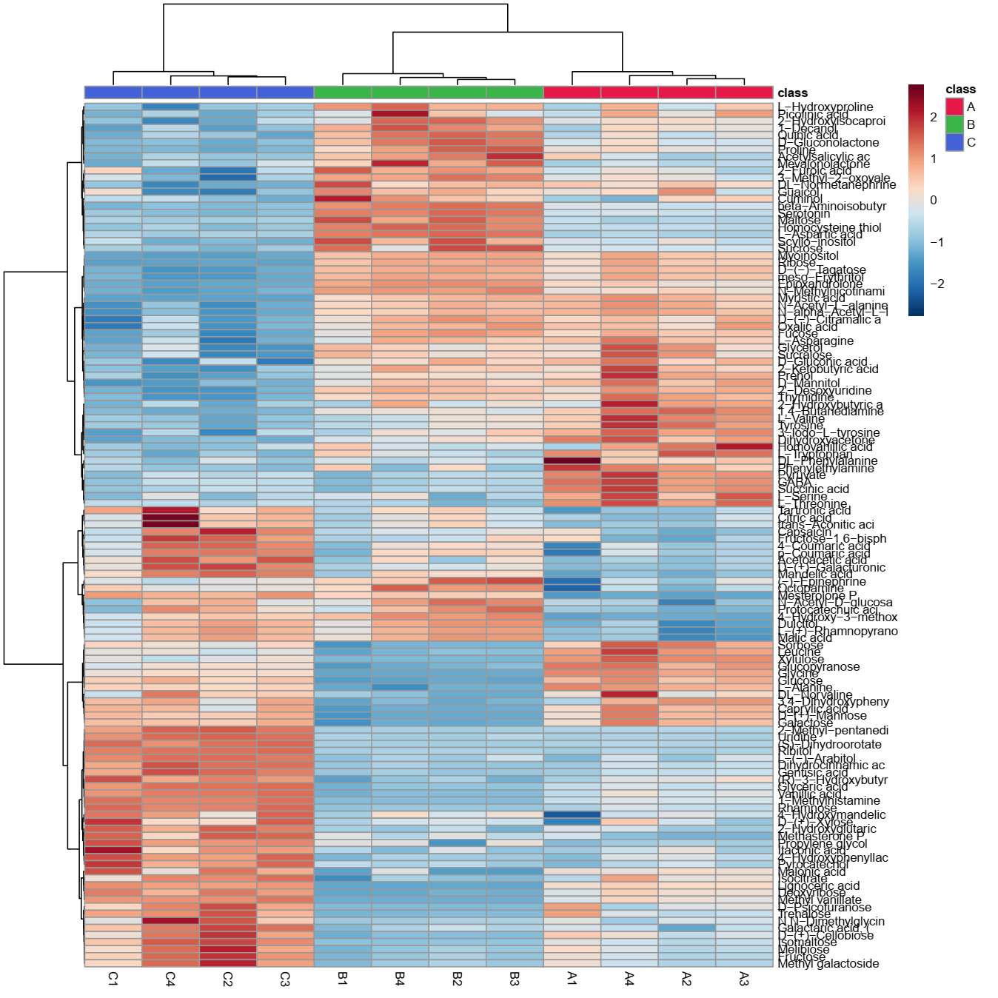
Fig. S1. GC-MS metabolomics heat map analysis. The row indicates the metabolite, while the column represents the replicates of samples extracted in a solution of acetonitrile and water from the leaves of Z. coccineum from various locations. Concentration-decreasing metabolites were shown in blue, whereas concentration-increasing metabolites were shown in red. When compared to the average, the brightness of each color corresponded to the size of the difference.

Table S2. Metabolites were extracted in the solution of isopropanol, methanol, and water from the leaves of Z. coccineum collected from different places around the Red Sea. Identified metabolites are eighty-five belonging to different classes as amino acids, organic acids, carbohydrates, and natural products by GC-MS.
Sr. No. | Metabolite Name | Rt (min)
1. | (R)-3-Hydroxybutyric acid | 15.236
2. | 1-Decanol | 11.89
3. | 2,3-Diaminopropanoic acid | 14.942
4. | 2'-Desoxyuridine | 21.755
5. | 2-Hydroxyglutaric acid | 20.216
6. | 2-Ketobutyric acid, enol | 13.556
7. | 2-Ketoisocaproic acid | 9.828
8. | 3-Iodo-L-tyrosine | 12.865
9. | 3-Methyl-2-oxovaleric acid | 14.063
10. | 4-Hydroxyphenyllactic acid | 11.902
11. | 4-Methyl-5-thiazoleethanol | 9.372
12. | 5-Hydroxytryptophan | 18.685
13. | alpha-Tocopherol | 25.185
14. | Arabinose isomer | 20.039
15. | Benzeneacetic acid | 8.453
16. | beta-Alanine | 10.137
17. | Caprylic acid | 15.519
18. | Cuminol | 10.996
19. | Cys-Gly | 6.8
20. | D-(+)-Cellobiose isomer | 21.111
21. | D-(+)-Galacturonic acid | 15.344
22. | D-(+)-Xylose | 12.873
23. | D-Chiro-inositol | 15.999
24. | Deoxyribose | 14.94
25. | D-Galactopyranosyl phosphate | 14.114
26. | Dihydroxyacetone | 12.978
27. | D-Mannitol | 15.747
28. | Dulcitol | 19.592
29. | Epioxandrolone | 10.578
30. | Fucose isomer | 13.619
31. | GABA | 11.408
32. | Galactaric acid, (R,S,R,S) | 15.955
33. | Galactose isomer | 17.432
34. | Gallic acid | 15.995
35. | Gentisic acid | 23.065
36. | Glucopyranose | 18.112
37. | Glucose isomer | 15.632
38. | Glycerol | 13.289
39. | Hydrocaffeic acid | 15.904
40. | Iminodiacetic acid | 15.732
41. | Isomaltose isomer | 23.251
42. | Itaconic acid | 10.861
43. | L-(-)-Arabitol | 15.994
44. | L-(+)-Rhamnopyranose isomer | 21.792
45. | Lignoceric acid | 21.748
46. | L-Serine | 9.752
47. | Malic acid | 10.803
48. | Malonic acid | 15.518
49. | Mannose isomer | 16.25
51. | meso-Erythritol | 11.014
52. | Methyl galactoside | 19.652
53. | Mevalonolactone | 7.364
54. | Myoinositol | 17.304
55. | N,N-Dimethylglycine | 16.027
56. | N-Acetyl-D-glucosamine isomer | 17.153
57. | N-Acetyl-L-alanine | 8.065
58. | Norfenefrine | 8.068
59. | Oxalic acid | 16.552
60. | Oxandrolone | 11.734
61. | p-Coumaric acid | 15.879
62. | Pipecolinic acid | 9.313
63. | Prenol | 18.828
64. | Proline | 13.53
65. | Propylene glycol | 12.772
66. | Pyrocatechol | 16.586
67. | Pyrogallol | 12.186
68. | Pyruvic acid | 11.57
69. | Quinolinic acid | 13.098
70. | Rhamnose isomer | 11.431
71. | Ribose isomer | 17.572
72. | Ribulose isomer | 10.794
73. | Scyllo-inositol | 16.589
74. | Serotonin | 10.521
75. | Sorbose isomer | 15.232
76. | Succinic acid | 23.254
77. | Sucralose | 12.921
78. | Sucrose | 16.14
79. | Tartronic acid | 14.65
80. | Thymidine | 9.463
81. | Tyramine | 15.614
82. | Undecanoic acid | 12.806
83. | Uridine | 19.681
84. | Vanillin | 12.76
85. | Xylulose | 10.665

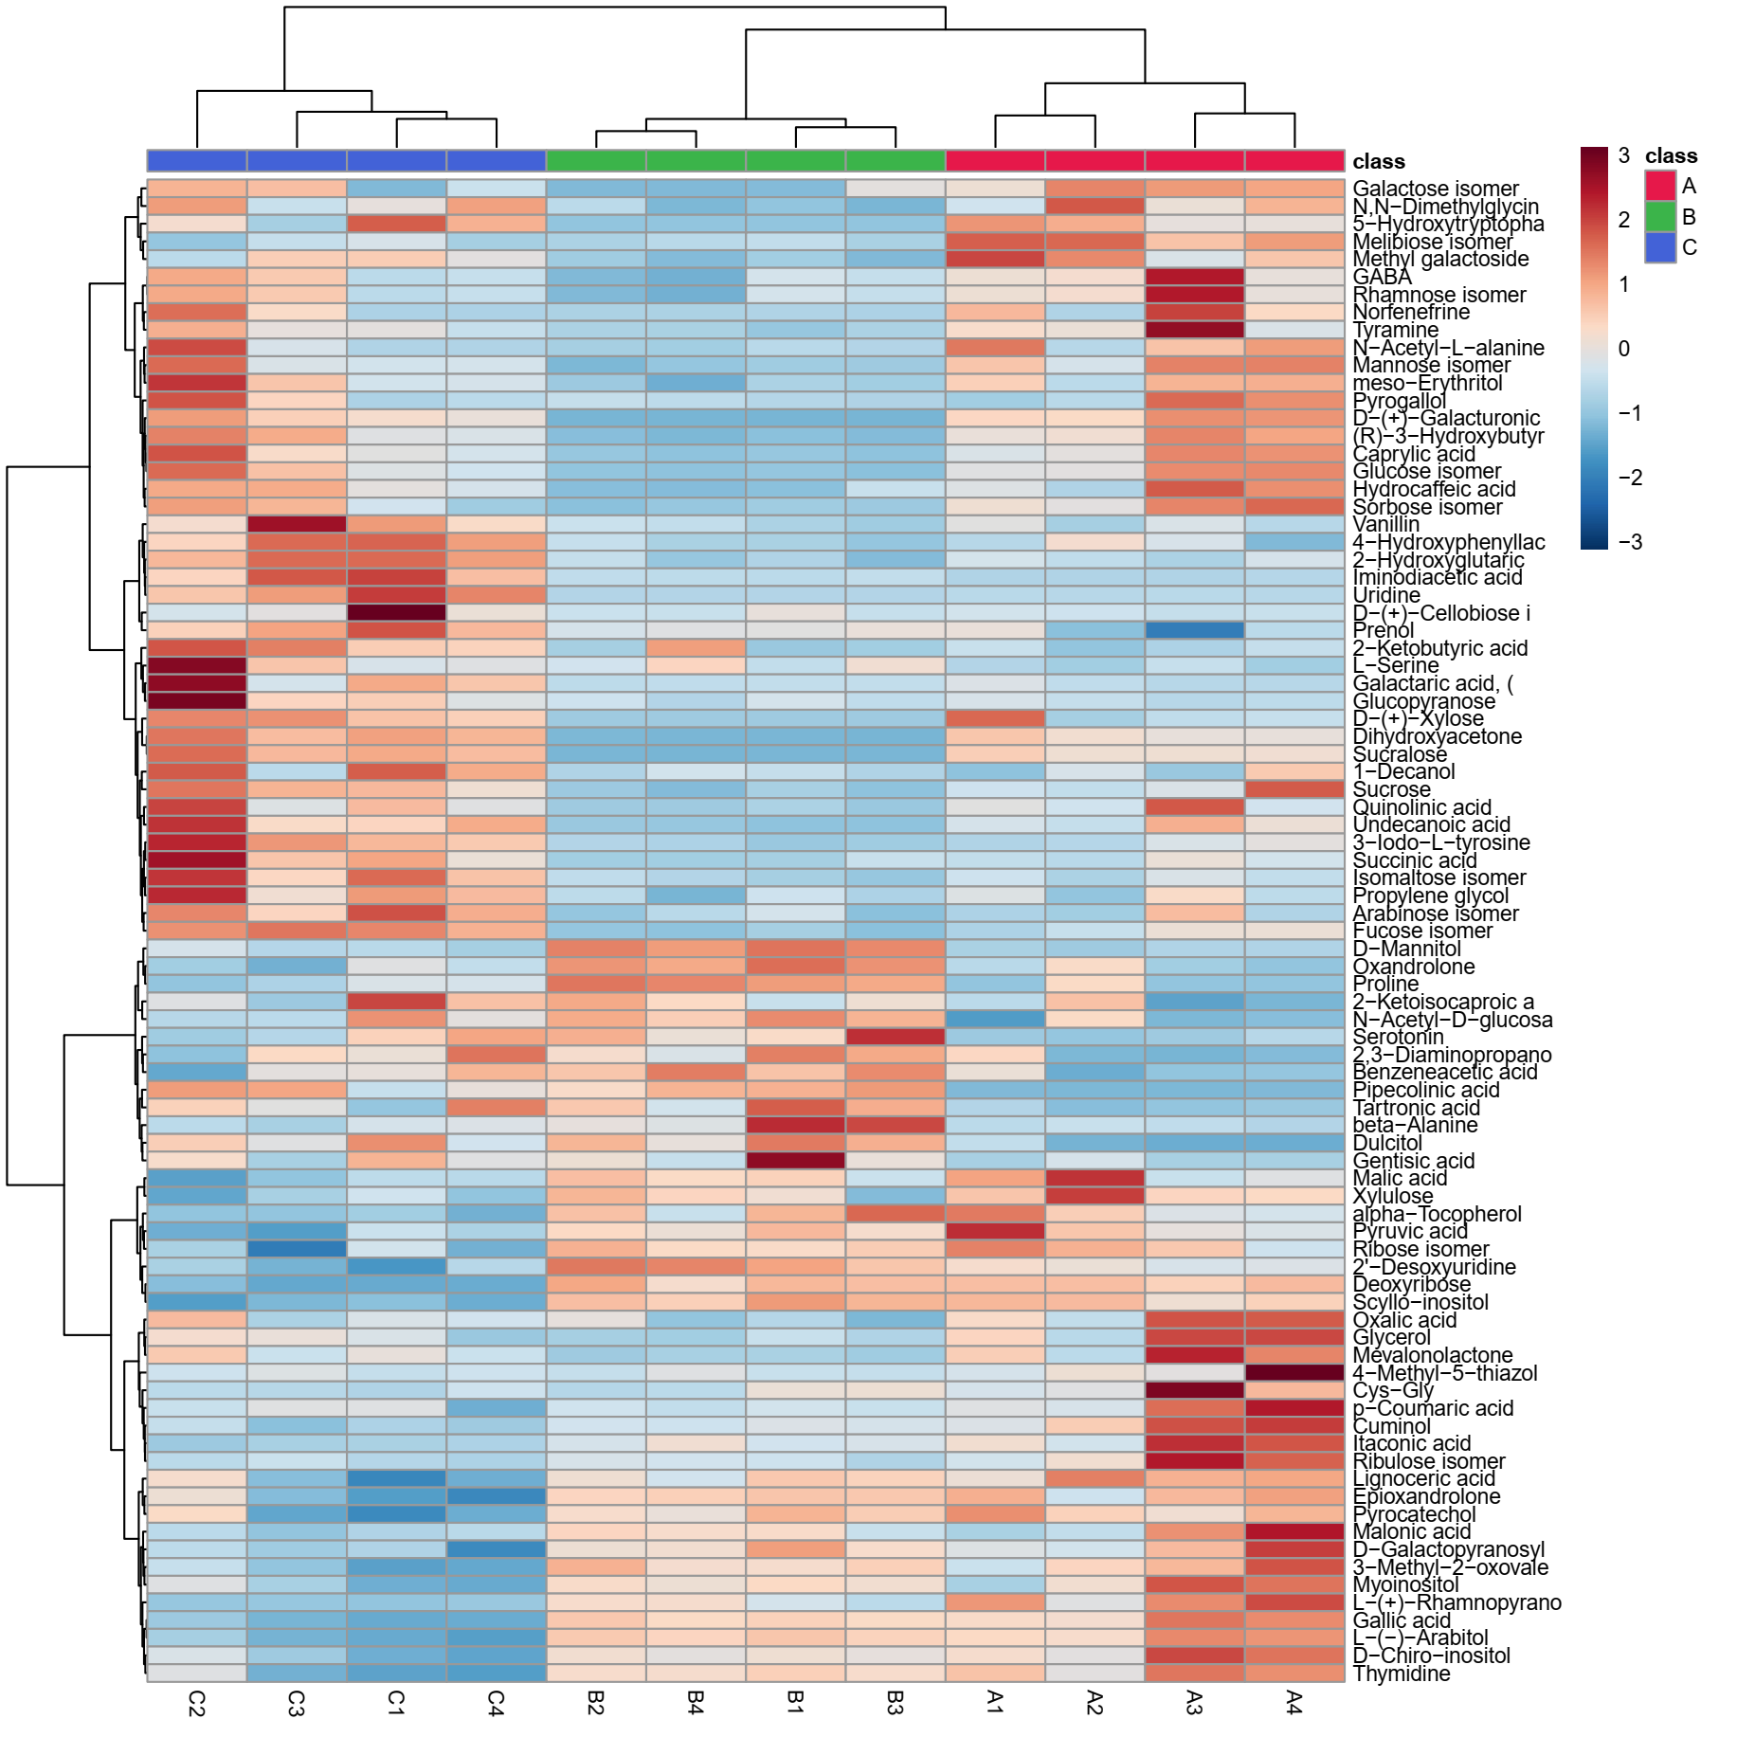
Fig. S2. GC-MS metabolomics heat map analysis. The row indicates the metabolite, while the column represents the replicates of samples extracted in a solution of isopropanol, methanol, and water from the leaves of Z. coccineum from various locations. Concentration-decreasing metabolites were shown in blue, whereas concentration-increasing metabolites were shown in red. When compared to the average, the brightness of each color corresponded to the size of the difference.

Table S3. Metabolites were extracted in the solution of methanol, and water from the leaves of Z. coccineum was collected from different places around the Red Sea. Identified metabolites are one hundred eleven belonging to different classes such as amino acids, carbohydrates, organic acids, and natural products by GC-MS.

Sr. No. | Metabolite Name | Rt (min)
1. | (R)-3-Hydroxybutyric acid | 7.882
2. | 1,4-Butanediamine | 13.766
3. | 1-Decanol | 10.39
4. | 2-Amino-2-methyl-1,3-propanediol | 7.21
5. | 2-Aminobutanoic acid | 13.469
6. | 2'-Desoxyuridine | 22.6
7. | 2-Hydroxybutyric acid | 9.257
8. | 3,4-Dihydroxyphenylglycol | 16.91
9. | 3-Hydroxydodecanoic acid | 12.724
10. | 3-Methyl-2-oxovaleric acid | 21.16
11. | 4-Hydroxy-3-methoxyphenyl glycol | 16.493
12. | 4-Hydroxybenzoic acid | 12.558
13. | 5-Hydroxytryptophan | 18.688
14. | 5-Methylcytosine | 11.399
15. | Adonitol | 13.646
16. | Arabinose | 17.381
17. | Benzamide | 10.204
18. | Benzoic acid | 13.971
19. | beta-Aminoisobutyric acid | 8.557
20. | Caprylic acid | 21.741
21. | Capsaicin | 22.611
22. | Cuminol | 12.684
23. | Cysteine | 11.699
24. | D-(-)-Citramalic acid | 10.675
25. | D-(+)-Cellobiose isomer | 23.086
26. | D-(+)-Xylose | 12.96
27. | D-Chiro-inositol | 17.311
28. | Deoxyribose | 11.162
29. | D-Galactopyranosyl phosphate | 14.12
30. | D-Gluconic acid | 16.38
31. | D-Gluconolactone | 13.812
32. | Dihydroxyacetone | 11.583
33. | DL-Normetanephrine | 10.34
34. | D-Mannitol | 15.83
35. | D-Psicofuranose | 16.385
36. | Dulcitol | 19.601
37. | D-Xylose | 14.252
38. | Etamivan | 14.058
39. | Ethylmalonic acid | 12.009
40. | Ferulic acid | 17.301
41. | Fluoxymesterone | 10.584
42. | Fucose | 14.073
43. | GABA | 11.41
44. | Galactaric acid, (R,S,R,S) | 14.631
45. | Galactose | 23.913
46. | Geraniol | 10.586
47. | Glucitol | 22.612
48. | Glucopyranose | 19.216
49. | Glucose | 16.715
50. | Glyceric acid | 8.878
51. | Glycerol | 17.694
52. | Heptanoic acid | 19.033
53. | Isocitrate | 15.076
54. | Isomaltose | 23.423
55. | Itaconic acid | 9.222
56. | L-(-)-Arabitol | 13.591
57. | L-(+)-Rhamnopyranose | 20.578
58. | L-Aspartic acid | 15.888
59. | Leucine | 8.105
60. | Levoglucosan | 20.041
61. | L-Hydroxyproline | 21.018
62. | Lignoceric acid | 12.851
63. | L-Pyroglutamic acid | 12.223
64. | Malonic acid | 15.563
65. | Maltose | 18.236
66. | Mandelic acid | 11.086
67. | Mannose | 17.289
68. | Melibiose | 21.078
69. | Mesterolone P | 13.466
70. | Methyl galactoside | 23.862
71. | Methyl vanillate | 12.799
72. | Methylmaleic acid | 19.008
73. | Methylmalonic acid | 15.268
74. | Myoinositol | 16.591
75. | N, N-Dimethylglycine | 16.02
76. | N-alpha-Acetyl-L-lysine | 15.021
77. | N-alpha-Acetyl-ornithine | 13.138
78. | N-Formylglycine | 17.544
79. | N-Methylnicotinamide | 10.806
80. | O-Acetyl-L-serine | 17.206
81. | Oxaloacetate | 10.799
82. | Oxandrolone | 11.73
83. | p-Cresol | 6.548
84. | Phenylethanolamine | 10.56
85. | Phloretic acid | 9.958
86. | Phloroglucinol | 13.189
87. | Phosphorylethanolamine | 8.088
88. | Prenol | 10.185
89. | Propylene glycol | 12.722
90. | Pyrocatechol | 13.641
91. | Pyruvate | 7.971
92. | Rhamnose | 13.557
93. | Ribitol | 11.159
94. | Ribose | 15.348
95. | Ribulose | 10.796
96. | Scyllo-inositol | 16.054
97. | Serotonin | 11.033
98. | Sorbose | 15.203
99. | Succinic acid | 8.67
100. | Sucralose | 14.957
101. | Sucrose | 22.45
102. | Tartronic acid | 11.775
103. | Thymidine | 12.253
104. | Trehalose | 22.508
105. | Tyramine | 15.618
106. | Uridine | 19.824
107. | Vanillic acid | 14.052
108. | Vanillylmandelic acid | 20.218
109. | Xylitol | 20.219
110. | Xylose | 12.032
111. | Xylulose | 15.806

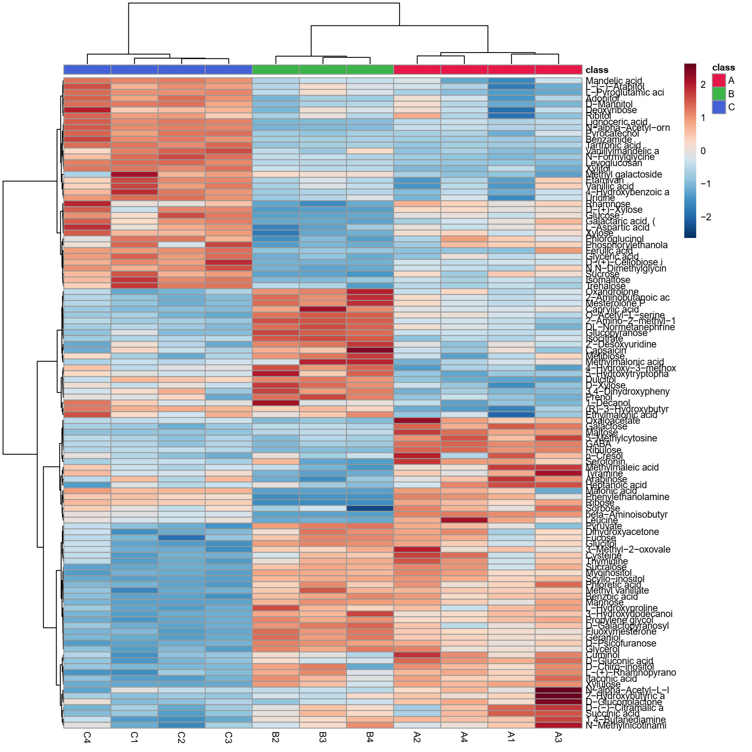
Fig. S3. GC-MS metabolomics heat map analysis. The row indicates the metabolite, while the column represents the replicates of samples extracted in a solution of methanol and water from the leaves of Z. coccineum from various locations. Concentration-decreasing metabolites were shown in blue, whereas concentration-increasing metabolites were shown in red. When compared to the average, the brightness of each color corresponded to the size of the difference.
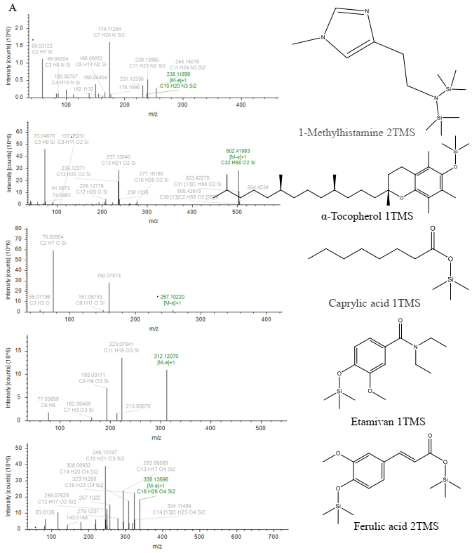

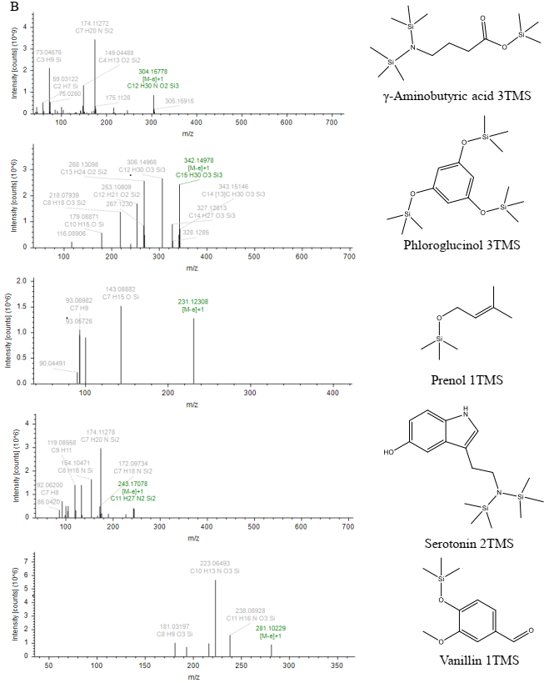
Fig. S4. Displays the mass spectra in two sections (A), and (B) from GC-MS of a few selected identified compounds extracted from all types of solvents in the plant samples.

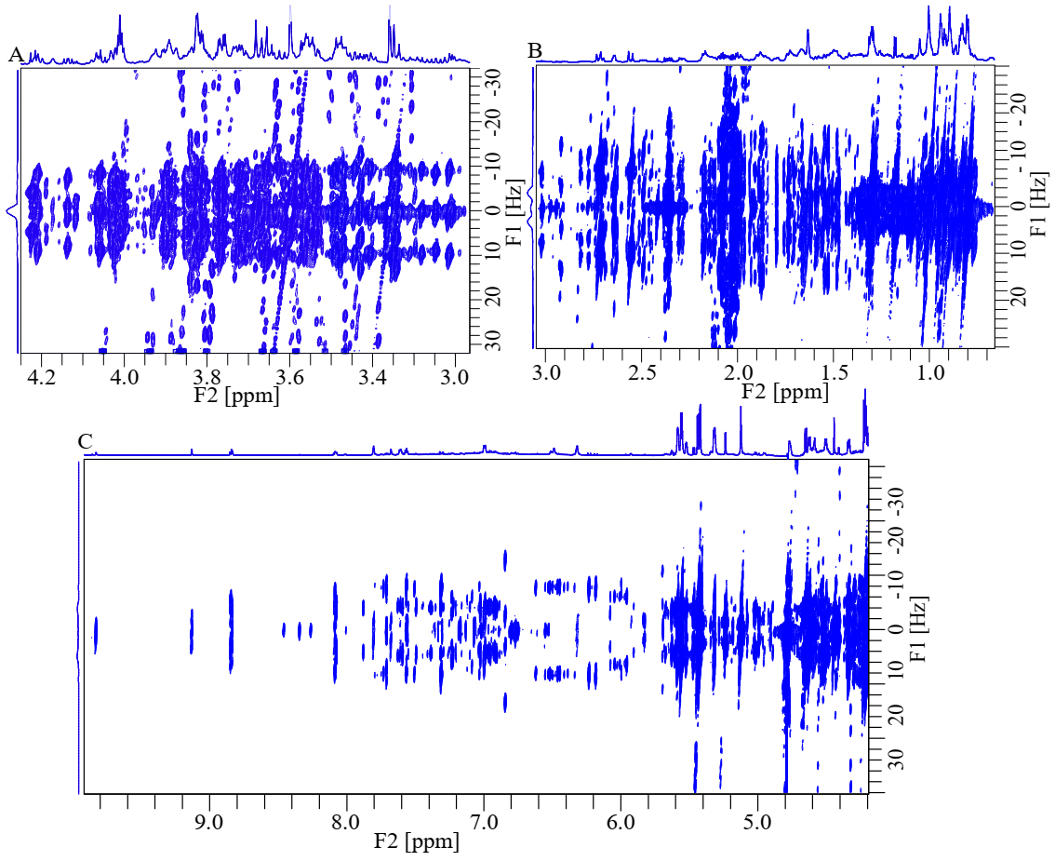
Fig. S5. A, B, and C display the 2D J-RES expanded spectra from regions 0.70 to 3.15 ppm, 3.16 to 4.25 ppm, and 4.26 to 9.84 ppm, respectively of Z. coccineum leaves samples extracted in the solution of acetonitrile, and water.

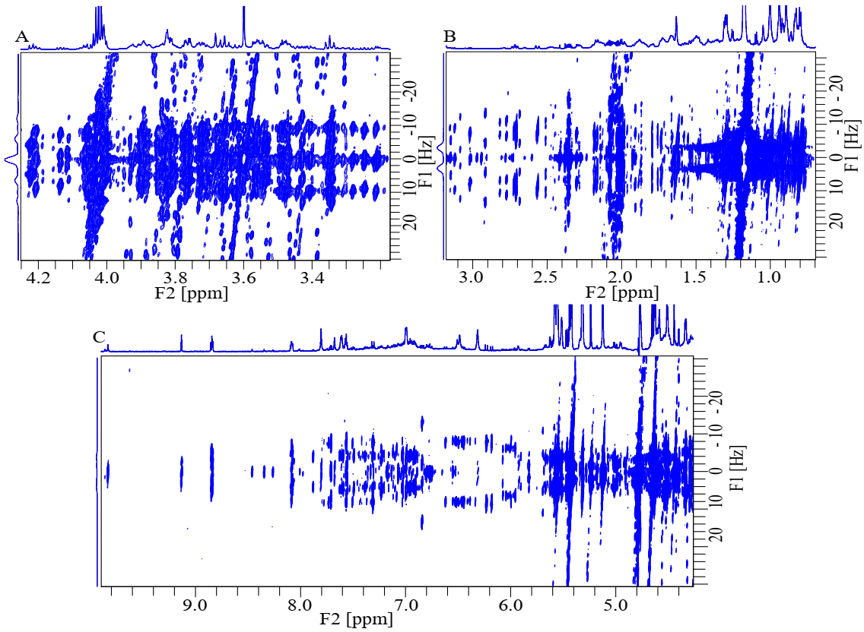
Fig. S6. A, B, and C display the 2D J-RES expanded spectra from regions 0.70 to 3.15 ppm, 3.16 to 4.25 ppm, and 4.26 to 9.84 ppm, respectively of Z. coccineum leaves samples extracted in the solution of isopropanol, methanol, and water.

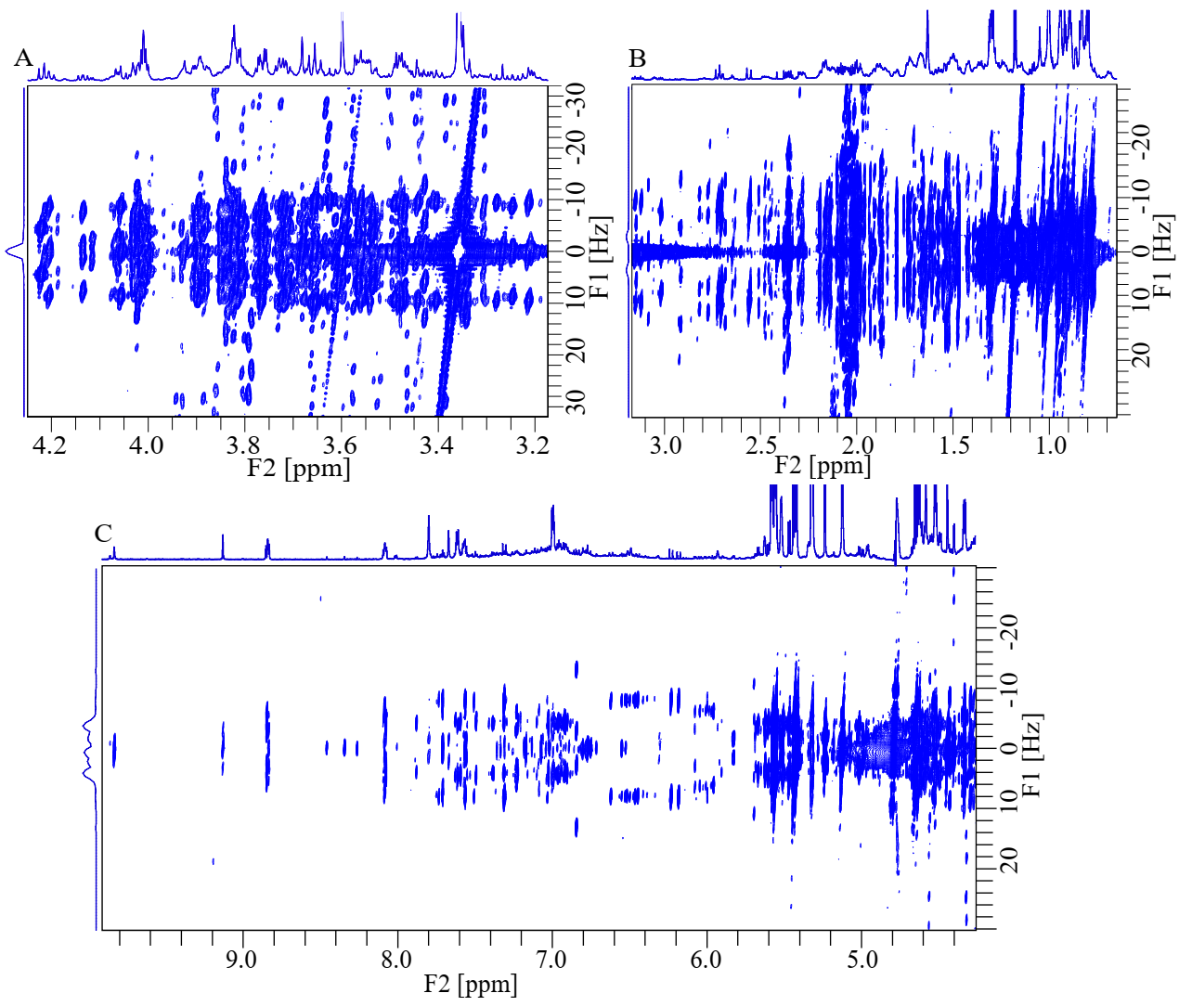
Fig. S7. A, B, and C display the 2D J-RES expanded spectra from regions 0.70 to 3.15 ppm, 3.16 to 4.25 ppm, and 4.26 to 9.84 ppm, respectively of Z. coccineum leaves samples extracted in the solution of methanol, and water.

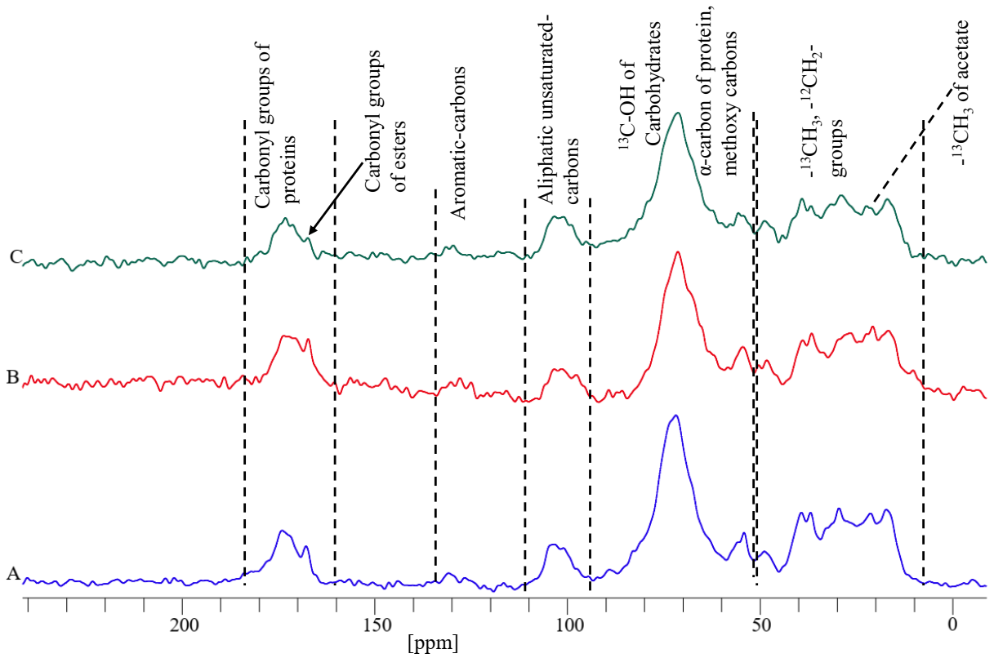
Fig. S8. A, B, and C represent the locations of collecting Z. coccineum leaves and 1D ¹³C ss-NMR spectra resulting in the peak intensities of different functional groups of compounds divided in the different regions.

Table S4. Metabolites were extracted in a solution of acetonitrile, and water from the leaves of Z. coccineum was collected from different places around the Red Sea. Identified metabolites are one hundred one belonging to different classes as amino acids, carbohydrates, organic acids, and natural products by LC-MS in both positive and negative modes.

Sr. No. | Metabolite Name | Molecular Weight | RT (min)
1. | Seneciphylline | C18 H23 N O5 | 7.267
2. | Protirelin | C16 H22 N6 O4 | 7.795
3. | Pregnanediol-3-glucuronide | C27 H44 O8 | 8.864
4. | Phytosphingosine | C18 H39 N O3 | 7.393
5. | Oleanolic acid | C30 H48 O3 | 8.33
6. | octinoxate | C18 H26 O3 | 7.529
7. | NP-001596 | C16 H30 O4 | 7.36
8. | Nandrolone | C18 H26 O2 | 9.101
9. | N, N-Bis(2-hydroxyethyl) dodecanamide | C16 H33 N O3 | 8.4
10. | Militarinone A | C26 H37 N O6 | 8.257
11. | MFCD05863969 | C21 H38 O4 | 9.307
12. | messagenin | C29 H48 O3 | 11.302
13. | L-α-PALMITIN | C19 H38 O4 | 9.676
14. | ionene | C13 H18 | 10.42
15. | Hydrocortisone Valerate | C26 H38 O6 | 9.694
16. | Hydrocortisone caproate | C27 H40 O6 | 9.982
17. | Embelin | C17 H26 O4 | 7.779
18. | Doradexanthin | C40 H54 O3 | 12.273
19. | Docosatrienoic acid | C22 H38 O2 | 10.495
20. | Demethylphylloquinone | C30 H44 O2 | 11.998
21. | Citraurin | C30 H40 O2 | 11.631
22. | Cedefingol | C20 H41 N O3 | 8.086
23. | 9-Oxo-ODE | C18 H30 O3 | 9.433
24. | 8-Epiiridodial glucoside | C16 H26 O7 | 7.579
25. | 8,10-Heptacosanedione | C27 H52 O2 | 11.803
26. | 5-Pentylresorcinol | C11 H16 O2 | 11.644
27. | 5-O-methyl embelin | C18 H28 O4 | 8.721
28. | 4-Ketomyxol | C40 H54 O4 | 12.103
29. | 3-dehydroecdysone | C27 H42 O6 | 9.976
30. | 3-BHA | C11 H16 O2 | 12.004
31. | 3-(3,4-Dimethoxyphenyl)-N-[2-(1-hydroxy-3-methoxy-4-oxo-2,5-cyclohexadien-1-yl)ethyl]propanamide | C20 H25 N O6 | 8.537
32. | 20S-Protopanaxatriol | C30 H52 O4 | 12.305
33. | 2-{[(2R,3S,4R,5R)-5-(6-Amino-9H-purin-9-yl)-3,4-dihydroxytetrahydro-2-furanyl]methyl}-4-hydroxybutanimidic acid | C14 H20 N6 O5 | 7.582
34. | 13-apo-beta-carotenone | C18 H26 O | 10.59
35. | 1-Methyl-4-(1-methyl-2-propenyl)-benzene | C13 H18 | 7.73
36. | (8E)-2-Amino-8-octadecene-1,3,4-triol | C18 H37 N O3 | 7.521
37. | (6R,10S)-13-[(2S)-6-Hydroxy-2,5,7,8-tetramethyl-3,4-dihydro-2H-chromen-2-yl]-2,6,10-trimethyltridecanoic acid | C29 H48 O4 | 12.34
38. | (4E)-5-Hydroxy-4-{(2E,4E,6R)-1-hydroxy-6-[(3R,4R,6R)-6-hydroxy-1,4,8-trimethyl-2,9-dioxabicyclo[3.3.1]non-7-en-3-yl]-4-methyl-2,4-heptadien-1-ylidene}-2,4-dihydro-3H-pyrrol-3-one | C22 H29 N O6 | 7.747
39. | (3R,6'R)-3',4',5',18'-Tetradehydro-5',6'-dihydro-beta,beta-caroten-3-ol | C40 H54 O | 12.432
40. | (3beta,5xi,9xi,22beta)-3,24-Dihydroxy-22,29-epoxyoleana-11,13(18)-dien-29-one | C30 H44 O4 | 8.269
41. | (3beta,24R,24'R)-fucosterol epoxide | C29 H48 O2 | 12.122
42. | (3'Z)-3-Hydroxy-3',4'-didehydro-beta,psi-caroten-4-one | C40 H52 O2 | 10.794
43. | (2R)-3-(Phosphonooxy)-2-[(9Z)-9-tetradecenoyloxy]propyl palmitate | C33 H63 O8 P | 10.262
44. | (24S)-3alpha,7alpha,24-trihydroxy-5beta-cholestan-26-al | C27 H46 O4 | 10.765
45. | (20Z)-20-Nonacosene-2,4-dione | C29 H54 O2 | 12.185
46. | (1S,4S,5R,10S,13S,17S,19S,20R)-10-hydroxy-4,5,9,9,13,19,20-heptamethyl-24-oxahexacyclo[....]tetracos-15-en-23-one | C30 H46 O3 | 7.653
47. | (1R,2S,5aR,5bR,7aS,10R,12bR)-2-Hydroxy-10-isopropenyl-3,3,5a,5b,12b-pentamethyloctadecahydrodicyclopenta[a,i]phenanthrene-1,7a(1H)-dicarboxylic acid | C30 H46 O5 | 7.997
48. | (18Z)-18-Heptacosene-2,4-dione | C27 H50 O2 | 11.779
49. | (13'cis,15cis)-2',3',4',5'-Tetradehydro-5',6'-dihydro-beta,beta-caroten-3-ol | C40 H54 O | 12.837
50. | (11cis,15cis)-5,5',8,8'-Tetrahydro-5,8:5',8'-diepoxy-beta,beta-carotene-3,3'-diol | C40 H56 O4 | 11.14
51. | (10Z,14E,16E)-10,14,16-Octadecatrien-12-ynoic acid | C18 H26 O2 | 7.982
52. | (10S)-Juvenile hormone III diol | C16 H28 O4 | 8.026
53. | (+)-Eudesmin | C22 H26 O6 | 7.747
54. | YK6000000 | C12 H20 O6 | 6.004
55. | Vanillic acid 4-sulfate | C8 H8 O7 S | 5.892
56. | Spinasaponin A | C42 H66 O14 | 6.915
57. | Oryzalin | C12 H18 N4 O6 S | 5.007
58. | Orobol | C15 H10 O6 | 6.847
59. | NP-012048 | C42 H66 O15 | 5.819
60. | NP-003039 | C30 H46 O5 | 8.405
61. | MFCD20527305 | C24 H22 O15 | 5.411
62. | L-Cysteinesulfinic acid | C3 H7 N O4 S | 5.816
63. | Isonocardicin C | C23 H26 N4 O8 | 5.877
64. | Indole-3-carboxilic acid-O-sulphate | C9 H7 N O5 S | 7.234
65. | Hydrocortisone butyrate (JP15/USP) | C25 H36 O6 | 8.498
66. | Gentiopicrin | C16 H20 O9 | 5.349
67. | Ferulic acid 4-sulfate | C10 H10 O7 S | 6.435
68. | Echimidine | C20 H31 N O7 | 5.5
69. | digoxin | C41 H64 O14 | 6.894
70. | Digitoxin | C41 H64 O13 | 7.527
71. | DHM | C15 H12 O8 | 6.317
72. | D-(+)-Glucose | C6 H12 O6 | 4.96
73. | Cefuroxime | C16 H16 N4 O8 S | 5.825
74. | Caffeic acid 3-sulfate | C9 H8 O7 S | 6.395
75. | Azelaic acid | C9 H16 O4 | 6.394
76. | [7-Hydroxy-1-(4-hydroxy-3,5-dimethoxyphenyl)-3-(hydroxymethyl)-6,8-dimethoxy-1,2,3,4-tetrahydro-2-naphthalenyl]methyl hydrogen sulfate | C22 H28 O11 S | 6.454
77. | [3-(Sulfooxy)phenyl]acetic acid | C8 H8 O6 S | 5.704
78.  79. | 9-HOTE  6-O-Sulfo-alpha-D-galactopyranose | C18 H30 O3  C6 H12 O9 S | 8.457  6.833
80. | 6"-O-Acetylisoquercitrin | C23 H22 O13 | 5.411
81. | 4a,10-Dihydroxy-2,2,6a,6b,9,9,12a-heptamethyl-2,3,4,4a,6,6a,6b,7,8,8a,9,10,11,12,12a,12b,13,14b-octadecahydro-5(1H)-picenone | C29 H46 O3 | 8.406
82. | 4-Ethyl-2-hydroxy-6-methoxyphenyl hydrogen sulfate | C9 H12 O6 S | 5.907
83. | 4-(3-Hydroxybutyl)-2-methoxyphenyl hydrogen sulfate | C11 H16 O6 S | 6.589
84. | 4-(2-Hydroxyethyl)phenyl hydrogen sulfate | C8 H10 O5 S | 5.619
85. | 3-Methyl-2-buten-1-yl hydrogen sulfate | C5 H10 O4 S | 6.263
86. | 3-Methoxy-5,7,3',4'-tetrahydroxy-flavone | C16 H12 O7 | 6.887
87. | 3-[5-Hydroxy-8-(2-hydroxy-2-propanyl)-2-oxo-8,9-dihydro-2H-furo[2,3-h]chromen-4-yl]propyl hydrogen sulfate | C17 H20 O9 S | 5.408
88. | 3-[3-Methoxy-4-(sulfooxy)phenyl]propanoic acid | C10 H12 O7 S | 6.182
89. | 3-[(1E)-3-Hydroxy-1-propen-1-yl]phenyl hexopyranosiduronic acid | C15 H18 O8 | 5.174
90. | 2-Hydroxy-4-(7-hydroxy-3,5-dimethoxy-4-oxo-4H-chromen-2-yl)benzyl beta-D-glucopyranoside | C24 H26 O12 | 5.614
91. | 2-Hydroxy-3-[4-(sulfooxy)phenyl]propanoic acid | C9 H10 O7 S | 5.463
92. | 2-Hydroxy-3-[3-methoxy-4-(sulfooxy)phenyl]propanoic acid | C10 H12 O8 S | 5.258
93. | 2-Hydroxy-1-(7-hydroxy-1-oxo-1H-isochromen-3-yl)butyl hydrogen sulfate | C13 H14 O8 S | 6.332
94. | 2-(6'-methylthio)hexylmalic acid | C11 H20 O5 S | 8.529
95. | 2-(2-Carboxyethyl)-4-methyl-5-pentyl-3-furoic acid | C14 H20 O5 | 6.103
96. | 10-desacetyltaxuyunnanin C | C26 H38 O7 | 8.533
97. | 10,16-Dihydroxyhexadecanoic acid | C16 H32 O4 | 6.971
98. | 1-Palmitoyl-2-hydroxy-sn-glycero-3-PE | C21 H44 N O7 P | 8.889
99. | (3S,9S,14aR)-3,6-Dimethyl-9-{6-[(2S)-2-oxiranyl]-6-oxohexyl}decahydropyrrolo[1,2-a][1,4,7,10]tetraazacyclododecine-1,4,7,10-tetrone | C21 H32 N4 O6 | 5.081
100. | (2S,4R,9a'S)-4-(2-Acetyl-4-oxo-3(4H)-quinazolinyl)-1'-hydroxy-2',2'-dimethyl-1',9a'-dihydro-3H-spiro[furan-2,9'-imidazo[1,2-a]indole]-3',5(2'H,4H)-dione | C25 H22 N4 O6 | 5.961
101. | (2E)-N-(3-Aminopropyl)-3-(4-hydroxyphenyl)-N-(4-{[(2E)-3-(4-hydroxyphenyl)-2-propenoyl](3-{[(2E)-3-(4-hydroxyphenyl)-2-propenoyl]amino}propyl)amino}butyl)  acrylamide | C37 H44 N4 O6 | 9.531

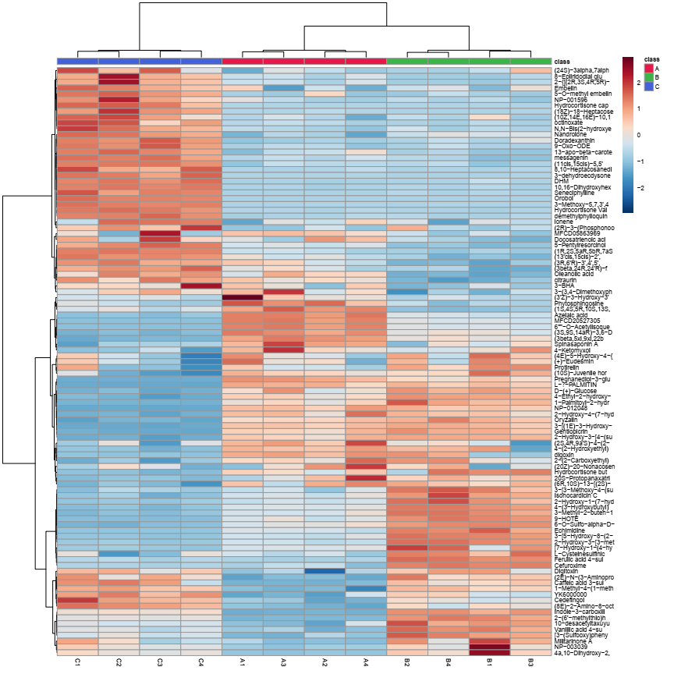
Fig. S9. LC-MS in positive and negative modes metabolomics heat map analysis. The row indicates the metabolite, while the column represents the replicates of samples extracted in a solution of acetonitrile and water from the leaves of Z. coccineum from various locations. Considerably decreasing concentrations of metabolites were shown in blue, whereas concentration-increasing metabolites were shown in red. When compared to the average, the brightness of each color corresponded to the size of the difference.
Table S5. Metabolites were extracted in a solution of isopropanol, methanol, and water from the leaves of Z. coccineum collected from different places around the Red Sea. Identified metabolites are one hundred belonging to different classes as amino acids, carbohydrates, organic acids, and natural products by LC-MS in both positive and negative modes.
Sr. No. | Metabolite Name | Molecular Weight | RT (min)
1. | Stearidonic acid | C18 H28 O2 | 9.449
2. | Seneciphylline | C18 H23 N O5 | 7.29
3. | Quillaic Acid | C30 H46 O5 | 8.157
4. | Phytosphingosine | C18 H39 N O3 | 7.414
5. | PC(18:3(9Z,12Z,15Z)/18:2(9Z,12Z)) | C44 H78 N O8 P | 10.428
6. | OXOGESTONE PHENPROPIONATE | C29 H38 O3 | 8.9
7. | Oleanolic acid | C30 H48 O3 | 8.389
8. | Militarinone A | C26 H37 N O6 | 8.272
9. | MFCD06656300 | C40 H54 O3 | 8.424
10. | Methyl 5-{(3aS,5R,6R,6aS)-5-hydroxy-6-[(1E,3R)-3-hydroxy-1-octen-1-yl]-1,3a,4,5,6,6a-hexahydro-2-pentalenyl}pentanoate | C22 H36 O4 | 10.786
11. | Methyl (4aS,4bR,5aS,6aS,7R,9aS,9bR,10R)-4a,6a-dimethyl-2,5'-dioxo-2,4,4',4a,5',5a,6,6a,8,9,9a,9b,10,11-tetradecahydro-3H,3'H-spiro[cyclopenta [7,8] phenanthrol [4b,5-b]oxirene-7,2'-furan]-10-carboxylate | C24 H30 O6 | 8.275
12. | Messagenin | C29 H48 O3 | 11.318
13. | Melatonin | C13 H16 N2 O2 | 7.556
14. | LECITHIN | C42 H80 N O8 P | 12.55
15. | ionene | C13 H18 | 10.439
16. | Hydrocortisone Valerate | C26 H38 O6 | 9.707
17. | glycidyl oleate | C21 H38 O3 | 10.677
18. | Doradexanthin | C40 H54 O3 | 12.293
19. | Cedefingol | C20 H41 N O3 | 8.105
20. | anacardic acid | C22 H36 O3 | 10.084
21. | 8-Epiiridodial glucoside | C16 H26 O7 | 7.602
22. | 4-Ketomyxol | C40 H54 O4 | 10.223
23. | 3-BHA | C11 H16 O2 | 12.024
24. | 20S-Protopanaxatriol | C30 H52 O4 | 12.2
25. | 2-Hydroxy-3-(phosphonooxy) propyl (15Z)-15-tetracosenoate | C27 H53 O7 P | 9.985
26. | 2',5,8'-Trihydroxy-5,6-dihydro-3,6-epoxy-beta,kappa-caroten-6'-one | C40 H56 O5 | 11.827
27. | 1-palmitoyl-2-[(9Z,12Z,15Z)-octadecatrienoyl]-sn-glycero-3-phosphocholine | C42 H78 N O8 P | 11.724
28. | (6R,10S)-13-[(2S)-6-Hydroxy-2,5,7,8-tetramethyl-3,4-dihydro-2H-chromen-2-yl]-2,6,10-trimethyltridecanoic acid | C29 H48 O4 | 12.367
29. | (3R,6'R)-3',4',5',18'-Tetradehydro-5',6'-dihydro-beta,beta-caroten-3-ol | C40 H54 O | 12.453
30. | (3beta,5xi,9xi,22beta)-3,24-Dihydroxy-22,29-epoxyoleana-11,13(18)-dien-29-one | C30 H44 O4 | 8.316
31. | (3beta,24R,24'R)-fucosterol epoxide | C29 H48 O2 | 12.143
32. | (3'Z)-3-Hydroxy-3',4'-didehydro-beta,psi-caroten-4-one | C40 H52 O2 | 10.707
33. | (2E,4Z,6Z,8E,10Z,12E,14E,16Z)-1-(4-Hydroxy-1,2,2-trimethylcyclopentyl)-17-(6-hydroxy-4,4,7a-trimethyl-2,4,5,6,7,7a-hexahydro-1-benzofuran-2-yl)-4,8,12-trimethyl-2,4,6,8,10,12,14,16-octadecaoctaen-1-on  e | C40 H56 O4 | 12.461
34. | (2E,4E,6E,8E,10E,12E,14E)-15-(4-Hydroxy-2,6,6-trimethyl-1-cyclohexen-1-yl)-4,9,13-trimethyl-2,4,6,8,10,12,14-pentadecaheptaenal | C27 H36 O2 | 10.357
35. | (1S,4S,5R,10S,13S,17S,19S,20R)-10-hydroxy-4,5,9,9,13,19,20-heptamethyl-24-oxahexacyclo[...]tetracos-15-en-23-one | C30 H46 O3 | 7.683
36. | YK6000000 | C12 H20 O6 | 6.051
37. | vicenin 2 | C27 H30 O15 | 5.251
38. | Vanillic acid 4-sulfate | C8 H8 O7 S | 5.932
39. | Tozadenant | C19 H26 N4 O4 S | 6.224
40. | streptonigrin | C25 H22 N4 O8 | 6.16
41. | Spinasaponin A | C42 H66 O14 | 7.151
42. | Sinapinic acid | C11 H12 O5 | 5.136
43. | sinapaldehyde glucoside | C17 H22 O9 | 5.087
44. | Petasitenine | C19 H27 N O7 | 6.534
45. | Oryzalin | C12 H18 N4 O6 S | 5.03
46. | Orobol | C15 H10 O6 | 6.923
47. | NP-019498 | C28 H32 O16 | 5.24
48. | NP-003039 | C30 H46 O5 | 8.022
49. | MFCD20527305 | C24 H22 O15 | 5.501
50. | Methyl (2E)-3-(2-hydroxy-4-methoxyphenyl) acrylate | C11 H12 O4 | 6.156
51. | L-Cysteinesulfinic acid | C3 H7 N O4 S | 5.765
52. | Isocitric acid | C6 H8 O7 | 5.237
53. | Indole-3-carboxilic acid-O-sulphate | C9 H7 N O5 S | 7.102
54. | Imidazole-4-acetaldehyde | C5 H6 N2 O | 5.163
55. | Hesperidin | C28 H34 O15 | 5.348
56. | Ferulic acid 4-sulfate | C10 H10 O7 S | 6.494
57. | Febuprol | C13 H20 O3 | 6.16
58. | Echimidine | C20 H31 N O7 | 5.491
59. | Docosanedioic acid | C22 H42 O4 | 11.361
60. | Digitoxin | C41 H64 O13 | 7.634
61. | D-(+)-Galactose | C6 H12 O6 | 4.937
62. | Caffeic acid 3-sulfate | C9 H8 O7 S | 6.486
63. | Azelaic acid | C9 H16 O4 | 6.489
64. | Apocynin | C9 H10 O3 | 6.163
65. | Acanthoside B | C28 H36 O13 | 5.194
66. | [7-Hydroxy-1-(4-hydroxy-3,5-dimethoxyphenyl)-3-(hydroxymethyl)-6,8-dimethoxy-1,2,3,4-tetrahydro-2-naphthalenyl]methyl hydrogen sulfate | C22 H28 O11 S | 6.455
67. | [3-(Sulfooxy)phenyl]acetic acid | C8 H8 O6 S | 5.738
68. | 9-HOTE | C18 H30 O3 | 8.488
69. | 6-[(1S,3aR,4S,6aR)-4-(1,3-Benzodioxol-5-yl)tetrahydro-1H,3H-furo[3,4-c]furan-1-yl]-1,3-benzodioxol-5-yl 6-O-beta-D-glucopyranosyl-beta-D-glucopyranoside | C32 H38 O17 | 5.366
70. | 6"-O-Acetylisoquercitrin | C23 H22 O13 | 5.407
71. | 4-Ethyl-2-hydroxy-6-methoxyphenyl hydrogen sulfate | C9 H12 O6 S | 5.95
72. | 4-(3-Hydroxybutyl)-2-methoxyphenyl hydrogen sulfate | C11 H16 O6 S | 6.67
73. | 4-(2-Hydroxyethyl)phenyl hydrogen sulfate | C8 H10 O5 S | 5.642
74. | 4,8-Dihydroxy-17-methoxy-10-oxo-2-oxatricyclo[13.2.2.1~3,7~]icosa-1(17),3(20),4,6,15,18-hexaen-14-yl hydrogen sulfate | C20 H22 O9 S | 7.664
75. | 3-Methyl-2-buten-1-yl hydrogen sulfate | C5 H10 O4 S | 6.317
76. | 3-Methoxy-5,7,3',4'-tetrahydroxy-flavone | C16 H12 O7 | 6.965
77. | 3-[5-Hydroxy-8-(2-hydroxy-2-propanyl)-2-oxo-8,9-dihydro-2H-furo[2,3-h]chromen-4-yl]propyl hydrogen sulfate | C17 H20 O9 S | 5.423
78. | 3-[3-Methoxy-4-(sulfooxy)phenyl]propanoic acid | C10 H12 O7 S | 5.962
79. | 3-[(1E)-3-Hydroxy-1-propen-1-yl]phenyl hexopyranosiduronic acid | C15 H18 O8 | 5.194
80. | 3,8,15-Trihydroxy-16,17-dimethoxy-9-oxotricyclo[12.3.1.1~2,6~]nonadeca-1(18),2(19),3,5,14,16-hexaen-7-yl hydrogen sulfate | C21 H24 O10 S | 7.494
81. | 3,16,21,23,28-Pentahydroxyolean-12-en-22-yl (2Z)-2-methyl-2-butenoate | C35 H56 O7 | 7.755
82. | 2-Propylglutaric acid | C8 H14 O4 | 5.781
83. | 2-Hydroxy-6-methoxy-4-vinylphenyl hydrogen sulfate | C9 H10 O6 S | 6.054
84. | 2-Hydroxy-4-(7-hydroxy-3,5-dimethoxy-4-oxo-4H-chromen-2-yl)benzyl beta-D-glucopyranoside | C24 H26 O12 | 5.621
85. | 2-Hydroxy-3-[4-(sulfooxy)phenyl]propanoic acid | C9 H10 O7 S | 5.525
86. | 2-Hydroxy-3-[3-methoxy-4-(sulfooxy)phenyl]propanoic acid | C10 H12 O8 S | 5.276
87. | 2-Hydroxy-1-(6-hydroxy-1-oxo-1H-isochromen-3-yl)butyl hydrogen sulfate | C13 H14 O8 S | 6.519
88. | 2-Ethylhexyl sulfate | C8 H18 O4 S | 9.291
89. | 2-(6'-methylthio)hexylmalic acid | C11 H20 O5 S | 8.557
90. | 2-(2-Carboxyethyl)-4-methyl-5-pentyl-3-furoic acid | C14 H20 O5 | 6.161
91. | 2,3-Dihydro-1-benzofuran-2-carboxylic acid | C9 H8 O3 | 4.91
92. | 10,16-Dihydroxyhexadecanoic acid | C16 H32 O4 | 7.058
93. | 1-Caffeoyl-beta-D-glucose | C15 H18 O9 | 5.045
94. | 1-[5-Hydroxy-8-(2-hydroxy-2-propanyl)-2-oxo-8,9-dihydro-2H-furo[2,3-h]chromen-4-yl]propyl hydrogen sulfate | C17 H20 O9 S | 4.9
95. | 1-(3-Methoxyphenyl)-3-(2,4,6-trihydroxyphenyl)-2-propanyl hydrogen sulfate | C16 H18 O8 S | 5.16
96. | (3β,5ξ,9ξ,18ξ)-28-Hydroxy-28-oxoolean-12-en-3-yl 6-deoxy-α-L-mannopyranosyl-(1->3)-[β-D-xylopyranosyl-(1->2)]-β-D-glucopyranosiduronic acid | C47 H74 O17 | 7.396
97. | (3S,9S,14aR)-3,6-Dimethyl-9-{6-[(2S)-2-oxiranyl]-6-oxohexyl}decahydropyrrolo[1,2-a][1,4,7,10]tetraazacyclododecine-1,4,7,10-tetrone | C21 H32 N4 O6 | 5.148
98. | (3beta,5xi,9xi,22beta)-3,24-Dihydroxy-22,29-epoxyoleana-11,13(18)-dien-29-one | C30 H44 O4 | 12.452
99. | (2S,4R,9a'S)-4-(2-Acetyl-4-oxo-3(4H)-quinazolinyl)-1'-hydroxy-2',2'-dimethyl-1',9a'-dihydro-3H-spiro[furan-2,9'-imidazo[1,2-a]indole]-3',5(2'H,4H)-dione | C25 H22 N4 O6 | 6.015
100. | (2E)-N-(3-Aminopropyl)-3-(4-hydroxyphenyl)-N-(4-{[(2E)-3-(4-hydroxyphenyl)-2-propenoyl](3-{[(2E)-3-(4-hydroxyphenyl)-2-propenoyl]amino}propyl)amino}butyl)acrylamide | C37 H44 N4 O6 | 9.534

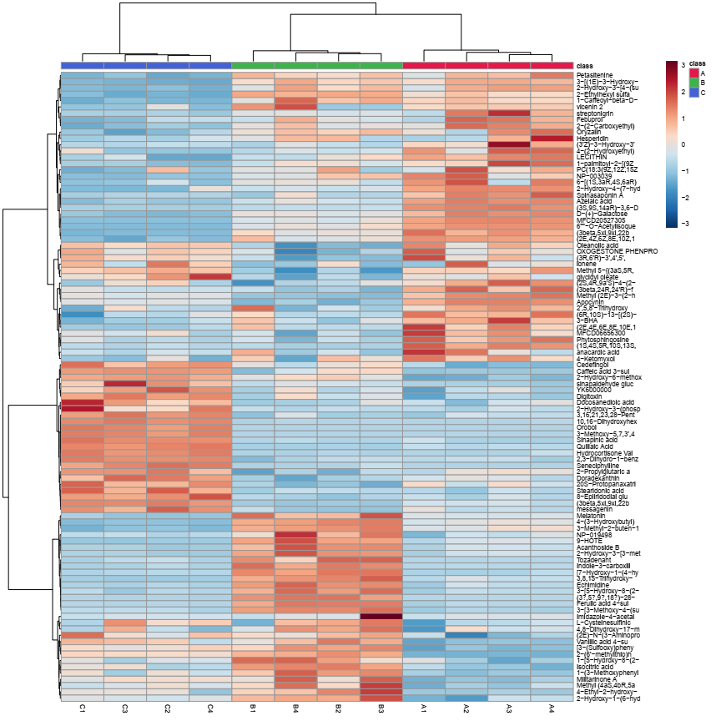
Fig. S10. LC-MS in positive and negative modes metabolomics heat map analysis. The row indicates the metabolite, while the column represents the replicates of samples extracted in a solution of isopropanol, methanol, and water from the leaves of Z. coccineum from various locations. Considerably decreasing concentrations of metabolites were shown in blue, whereas concentration-increasing metabolites were shown in red. When compared to the average, the brightness of each color corresponded to the size of the difference.
Table S6. Metabolites were extracted in a solution of methanol, and water from the leaves of Z. coccineum collected from different places around the Red Sea. Identified metabolites are one hundred two belonging to different classes as amino acids, carbohydrates, organic acids, and natural products by LC-MS in both positive and negative modes.
Sr. No. | Metabolite Name | Molecular Weight | RT (min)
1. | Phytosphingosine | C18 H39 N O3 | 7.404
2. | Nandrolone | C18 H26 O2 | 9.104
3. | MFCD06656300 | C40 H54 O3 | 8.414
4. | Messagenin | C29 H48 O3 | 11.303
5. | Melatonin | C13 H16 N2 O2 | 7.54
6. | Homosalate | C16 H22 O3 | 7.395
7. | Erucamide | C22 H43 N O | 12.212
8. | Echinenone | C40 H54 O | 12.435
9. | Cyclo(leucylprolyl) | C11 H18 N2 O2 | 7.205
10. | Betulinicaldehyde | C30 H48 O2 | 7.535
11. | Azinphos-ethyl | C12 H16 N3 O3 P S2 | 7.458
12. | 8-Epiiridodial glucoside | C16 H26 O7 | 7.589
13. | 2-Pyridylacetic acid | C7 H7 N O2 | 13.688
14. | 2',5,8'-Trihydroxy-5,6-dihydro-3,6-epoxy-beta,kappa-caroten-6'-one | C40 H56 O5 | 10.898
15. | 13-hydroxy-alpha-tocopherol | C29 H50 O3 | 11.787
16. | 11-Deoxocucurbitacin I | C30 H44 O6 | 11.71
17. | 1-Methyl-4-(1-methyl-2-propenyl)-benzene | C13 H18 | 7.731
18. | 1-alpha-linolenoyl-sn-glycerol | C21 H36 O4 | 8.87
19. | 1-(4-Methoxyphenyl)-4-methyl-3-pentanyl hydrogen sulfate | C13 H20 O5 S | 8.604
20. | (9cis,9'cis,11cis,11'cis,13cis)-3,3',4'-Trihydroxy-beta,beta-caroten-4-one | C40 H54 O4 | 8.109
21. | (8E)-2-Amino-8-octadecene-1,3,4-triol | C18 H37 N O3 | 7.533
22. | (3R,6'R)-3',4',5',18'-Tetradehydro-5',6'-dihydro-beta,beta-caroten-3-ol | C40 H54 O | 12.629
23. | (3beta,5xi,9xi,22beta)-3,24-Dihydroxy-22,29-epoxyoleana-11,13(18)-dien-29-one | C30 H44 O4 | 8.239
24. | (3beta,24R,24'R)-fucosterol epoxide | C29 H48 O2 | 12.098
25. | (3'Z)-3-Hydroxy-3',4'-didehydro-beta,psi-caroten-4-one | C40 H52 O2 | 10.687
26. | (2Z)-3-(3,4,5-Trimethoxyphenyl)-2-propen-1-yl acetate | C14 H18 O5 | 7.841
27. | (2R,2'R)-2,2',3,3'-Tetrahydroxy-beta,beta-caroten-4-one | C40 H54 O5 | 7.938
28.  - | (2E)-N-(3-Aminopropyl)-3-(4-hydroxyphenyl)-N-(4-{[(2E)-3-(4-hydroxyphenyl)-2-propenoyl](3-{[(2E)-3-(4-hydroxyphenyl)-2-propenoyl]amino}propyl)amino}butyl)acrylamide | C37 H44 N4 O6  - | 9.736  -
29. | (24E)-3,22-Diacetoxy-15-hydroxy-7-methoxylanosta-8,24-dien-26-oic acid | C35 H54 O8 | 9.11
30. | (1S,4S,5R,10S,13S,17S,19S,20R)-10-hydroxy-4,5,9,9,13,19,20-heptamethyl-24-oxahexacyclo[......]tetracos-15-en-23-one | C30 H46 O3 | 7.655
31. | (1R,2S,5aR,5bR,7aS,10R,12bR)-2-Hydroxy-10-isopropenyl-3,3,5a,5b,12b-pentamethyloctadecahydrodicyclopenta[a,i]phenanthrene-1,7a(1H)-dicarboxylic acid | C30 H46 O5 | 8.222
32. | (13'cis,15cis)-2',3',4',5'-Tetradehydro-5',6'-dihydro-beta,beta-caroten-3-ol | C40 H54 O | 13.165
33. | (+)-Sesamolinol | C20 H20 O7 | 7.345
34. | YK6000000 | C12 H20 O6 | 6.03
35. | Vanillic acid 4-sulfate | C8 H8 O7 S | 5.908
36. | Tozadenant | C19 H26 N4 O4 S | 6.032
37. | Spinasaponin A | C42 H66 O14 | 7.055
38. | Petasitenine | C19 H27 N O7 | 6.48
39. | p-Cresylsulfate | C7 H8 O4 S | 6.625
40. | Oryzalin | C12 H18 N4 O6 S | 5.032
41. | Orobol | C15 H10 O6 | 6.864
42. | Neohesperidin | C28 H34 O15 | 5.137
43. | N-{3-[(4-{(Z)-[(2,3-Dihydroxyphenyl) (hydroxy)methylene]amino}butyl){[2-(2,3-dihydroxyphenyl)-5-methyl-4,5-dihydro-1,3-oxazol-4-yl]carbonyl}amino]propyl}-2,3-dihydroxybenzenecarboximidic acid | C32 H36 N4 O10 | 6.48
44. | Myristyl sulfate | C14 H30 O4 S | 11.742
45. | Mitoxantrone | C22 H28 N4 O6 | 5.456
46. | MFCD20527305 | C24 H22 O15 | 5.428
47. | Methyl (2E)-3-(2-hydroxy-4-methoxyphenyl) acrylate | C11 H12 O4 | 6.125
48. | LT9970000 | C14 H21 N O3 | 9.507
49. | L-Cysteinesulfinic acid | C3 H7 N O4 S | 5.808
50. | Isocitric acid | C6 H8 O7 | 5.257
51. | Indole-3-carboxilic acid-O-sulphate | C9 H7 N O5 S | 7.299
52. | Gentiopicrin | C16 H20 O9 | 5.363
53. | Gemfibrozil | C15 H22 O3 | 10.646
54. | Ferulic acid 4-sulfate | C10 H10 O7 S | 6.496
55. | Febuprol | C13 H20 O3 | 6.113
56. | Eucommin A | C27 H34 O12 | 6.003
57. | DHM | C15 H12 O8 | 6.371
58. | Dalpanin | C26 H30 O12 | 5.091
59. | Coniferyl ferulate | C20 H20 O6 | 6.4
60. | Chryso-obtusin glucoside | C25 H28 O12 | 5.136
61. | Cefuroxime | C16 H16 N4 O8 S | 5.299
62. | Caffeic acid 3-sulfate | C9 H8 O7 S | 6.473
63. | Apocynin | C9 H10 O3 | 6.138
64. | [7-Hydroxy-1-(4-hydroxy-3,5-dimethoxyphenyl)-3-(hydroxymethyl)-6,8-dimethoxy-1,2,3,4-tetrahydro-2-naphthalenyl]methyl hydrogen sulfate | C22 H28 O11 S | 6.395
65. | [3-(Sulfooxy)phenyl]acetic acid | C8 H8 O6 S | 5.737
66. | 9-HOTE | C18 H30 O3 | 8.512
67. | 6-O-Sulfo-alpha-D-galactopyranose | C6 H12 O9 S | 6.889
68. | 6-Methoxy-4-oxo-3-(2,4,5-trimethoxyphenyl)-4H-chromen-7-yl 6-O-[(2R,3R,4R)-3,4-dihydroxy-4-(hydroxymethyl)tetrahydro-2-furanyl]-alpha-L-idopyranoside | C30 H36 O16 | 5.191
69. | 6-[(1S,3aR,4S,6aR)-4-(1,3-Benzodioxol-5-yl)tetrahydro-1H,3H-furo[3,4-c]furan-1-yl]-1,3-benzodioxol-5-yl 6-O-beta-D-glucopyranosyl-beta-D-glucopyranoside | C32 H38 O17 | 5.887
70. | 6"-O-Acetylisoquercitrin | C23 H22 O13 | 5.427
71 | 4-Ethyl-2-hydroxy-6-methoxyphenyl hydrogen sulfate | C9 H12 O6 S | 5.955
72. | 4-(3-Hydroxybutyl)-2-methoxyphenyl hydrogen sulfate | C11 H16 O6 S | 6.641
73. | 4-(2-Hydroxyethyl)phenyl hydrogen sulfate | C8 H10 O5 S | 5.663
74. | 4,14-Dihydroxy-17-methoxy-10-oxo-2-oxatricyclo[13.2.2.1~3,7~]icosa-1(17),3(20),4,6,15,18-hexaen-8-yl hydrogen sulfate | C20 H22 O9 S | 7.146
75. | 3-Methyl-2-buten-1-yl hydrogen sulfate | C5 H10 O4 S | 6.347
76. | 3-Methoxy-5,7,3',4'-tetrahydroxy-flavone | C16 H12 O7 | 6.91
77. | 3-[5-Hydroxy-8-(2-hydroxy-2-propanyl)-2-oxo-8,9-dihydro-2H-furo[2,3-h]chromen-4-yl]propyl hydrogen sulfate | C17 H20 O9 S | 5.431
78. | 3-[4-Methoxy-3-(sulfooxy)phenyl]propanoic acid | C10 H12 O7 S | 6.237
79. | 3-[4-(Sulfooxy)phenyl]acrylic acid | C9 H8 O6 S | 6.252
80. | 3-[3-Methoxy-4-(sulfooxy)phenyl]propanoic acid | C10 H12 O7 S | 6.0
81. | 3-[(1E)-3-Hydroxy-1-propen-1-yl]phenyl hexopyranosiduronic acid | C15 H18 O8 | 5.191
82. | 3,7,15-Trihydroxy-16,17-dimethoxy-9-oxotricyclo[12.3.1.1~2,6~]nonadeca-1(18),2(19),3,5,14,16-hexaen-8-yl hydrogen sulfate | C21 H24 O10 S | 7.413
83. | 3,3'-Dihydroxy-6,6'-bis(hydroxymethyl)-4H,4'H-2,2'-bipyran-4,4'-dione | C12 H10 O8 | 6.194
84. | 3,16,21,23,28-Pentahydroxyolean-12-en-22-yl (2Z)-2-methyl-2-butenoate | C35 H56 O7 | 7.737
85. | 2-Propylglutaric acid | C8 H14 O4 | 5.769
86. | 2-Hydroxy-6-methoxy-4-vinylphenyl hydrogen sulfate | C9 H10 O6 S | 6.061
87. | 2-Hydroxy-4-(7-hydroxy-3,5-dimethoxy-4-oxo-4H-chromen-2-yl)benzyl beta-D-glucopyranoside | C24 H26 O12 | 5.567
88. | 2-Hydroxy-3-[4-(sulfooxy)phenyl]propanoic acid | C9 H10 O7 S | 5.481
89 | 2-Hydroxy-1-(7-hydroxy-1-oxo-1H-isochromen-3-yl)butyl hydrogen sulfate | C13 H14 O8 S | 6.183
90. | 2-Hydroxy-1-(6-hydroxy-1-oxo-1H-isochromen-3-yl)butyl hydrogen sulfate | C13 H14 O8 S | 6.485
91. | 2-Ethylhexyl sulfate | C8 H18 O4 S | 9.305
92. | 2-[2-Oxo-9-(sulfooxy)-8,9-dihydro-2H-furo[2,3-h]chromen-8-yl]-2-propanyl 3-methyl-2-butenoate | C19 H20 O9 S | 6.961
93. | 2-(6'-methylthio)hexylmalic acid | C11 H20 O5 S | 8.562
94. | 10,16-Dihydroxyhexadecanoic acid | C16 H32 O4 | 7.012
95. | 1-Palmitoyl-2-hydroxy-sn-glycero-3-PE | C21 H44 N O7 P | 8.93
96. | 1-O-(indol-3-ylacetyl)-beta-D-glucose | C16 H19 N O7 | 5.048
97. | 1-O-(4-coumaroyl)-beta-D-glucose | C15 H18 O8 | 6.779
98. | 1-(4-Methoxyphenyl)-4-methyl-3-pentanyl hydrogen sulfate | C13 H20 O5 S | 7.377
99. | 1,2-di-O-sinapoyl-beta-D-glucose | C28 H32 O14 | 5.491
100. | (3S,9S,14aR)-3,6-Dimethyl-9-{6-[(2S)-2-oxiranyl]-6-oxohexyl}decahydropyrrolo[1,2-a][1,4,7,10]tetraazacyclododecine-1,4,7,10-tetrone | C21 H32 N4 O6 | 5.085
101. | (3beta,5beta,12beta,17xi)-3-{[2,6-Dideoxy-beta-D-ribo-hexopyranosyl-(1->4)-2,6-dideoxy-beta-D-ribo-hexopyranosyl-(1->4)-2,6-dideoxy-beta-D-ribo-hexopyranosyl]oxy}-12,14-dihydroxycard-20(22)-enolide | C41 H64 O14 | 6.858
102. | (2E)-4-{3-[2-(2,4-Dihydroxyphenyl)-2-oxoethyl]-4,6-dihydroxy-2-methoxyphenyl}-2-methyl-2-buten-1-yl hydrogen sulfate | C20 H22 O10 S | 6.436
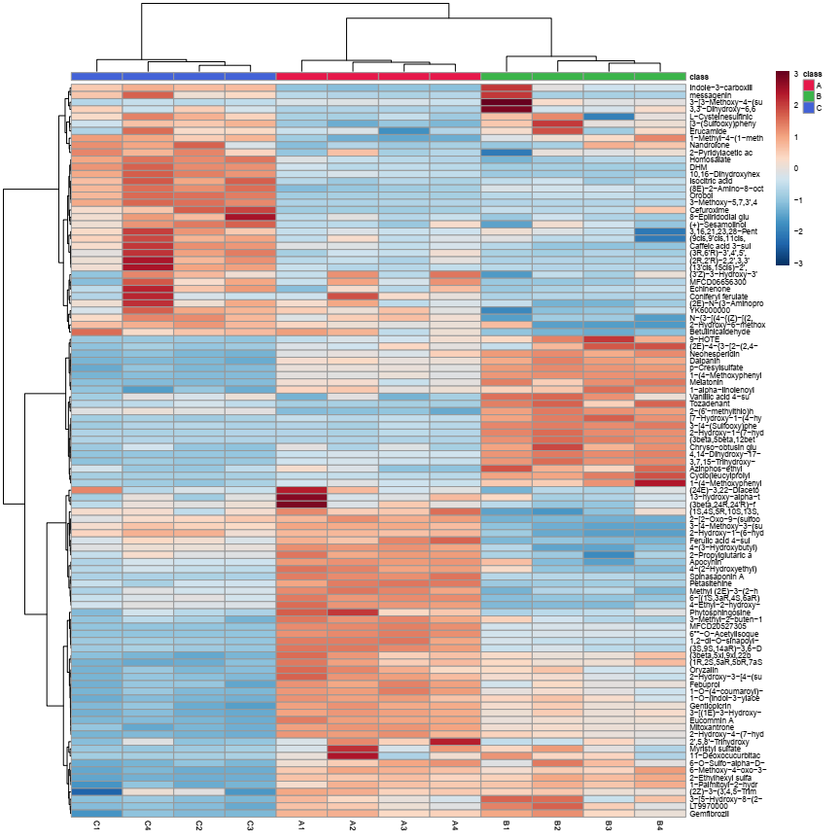
Fig. S11. LC-MS in positive and negative modes metabolomics heat map analysis. The row indicates the metabolite, while the column represents the replicates of samples extracted in a solution of methanol and water from the leaves of Z. coccineum from various locations. Considerably decreasing concentrations of metabolites were shown in blue, whereas concentration-increasing metabolites were shown in red. When compared to the average, the brightness of each color corresponded to the size of the difference.

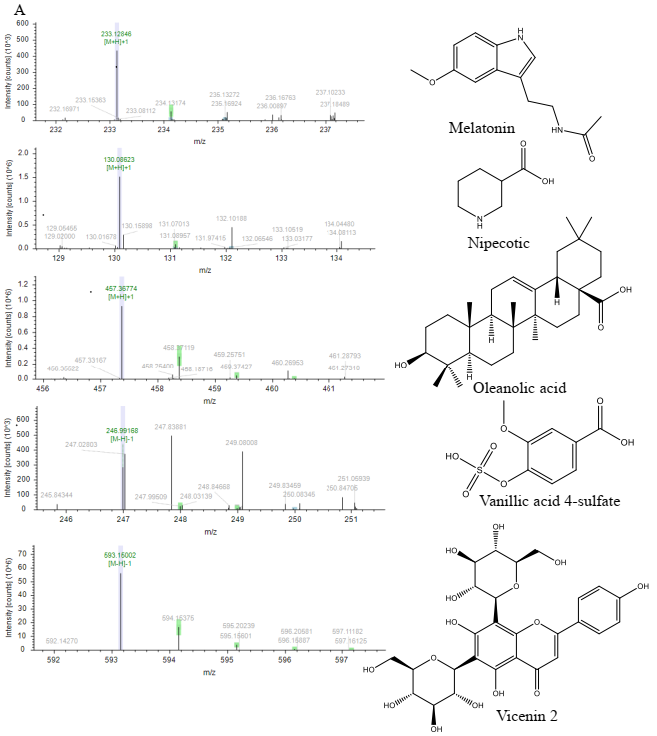

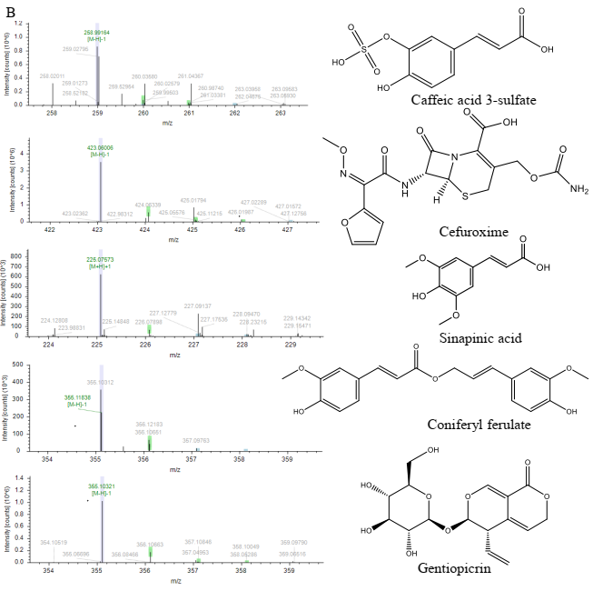
Fig. S12. Displays the mass spectra of LC-MS of a few selected identified compounds from all types of extracted solvents in two sections as (A), and (B).

