Supporting Information

Cytotoxic Assay
The cells were cultured in RPMI-1640 medium with 10% fetal bovine serum. Antibiotics were added 100 units/ml penicillin and 100 μg/ml streptomycin at 37 °C in a 5% CO2 incubator. The cells were seeded in a 96-well plate at a density of 1.0x10⁴ cells/well at 37 °C for 48 h under 5% CO₂, both of the tested compounds and Dasatinib (reference) were dissolved in DMSO to a final concentration of 0.05% in the culture medium and incubated for 48 h. Cells were fixed by adding ice-cold 50% trichloroacetic acid (TCA) and incubating for 1 h at 4 °C. After incubation, the plates were washed with distilled water, air-dried and stained with SRB solution (0.4%, w/v, in 1% acetic acid) for 10 min at room temperature. Discard the medium. Fixed with 10% trichloroacetic acid (TCA) 150 μl/well for 1h at 4 ºC. Wash by water 3 times (TCA) reduce SRB protein binding). Wells will be stained by SRB 70 μl/well for 10 min at room temperature with 0.4%. 70 μl/well [keep in dark place]. Wash with acetic acid 1% to remove unbound dye (end point: colorless drainage). The plates will be air dried 24 h. The dye will be solubilized with 50 μl/well of 10 m Mtris base (pH 7.4) for 5 min on a shaker at 1600 rpm.

Table S1. The DFT dihedral angle data of the investigated compounds.
 | 5a |  | 5b |  | 5c |  | 5d |  | 8
C(21)-C(22)-C(23)-C(18) | 0.9 | C(21)-C(22)-C(23)-C(18) | 1.0 | C(21)-C(22)-C(23)-C(18) | 0.9 | C(21)-C(22)-C(23)-C(18) | -0.8 | C(14)-N(15)-C(16)-C(12) | 0.0
C(20)-C(21)-C(22)-C(23) | -0.8 | C(20)-C(21)-O(24)-C(25) | -179.6 | C(20)-C(21)-C(22)-C(23) | -0.9 | C(20)-C(21)-N(24)-O(25) | 35.4 | C(14)-N(15)-C(16)-O(17) | -180.0
C(19)-C(20)-C(21)-C(22) | -0.5 | C(22)-C(21)-O(24)-C(25) | 0.2 | Cl(24)-C(21)-C(22)-C(23) | 179.4 | C(20)-C(21)-N(24)-O(26) | -171.2 | N(13)-C(14)-N(15)-C(16) | 0.0
C(18)-C(19)-C(20)-C(21) | 1.7 | C(20)-C(21)-C(22)-C(23) | -0.8 | C(19)-C(20)-C(21)-C(22) | -0.5 | C(22)-C(21)-N(24)-O(25) | -144.6 | S(18)-C(14)-N(15)-C(16) | -180.0
N(16)-C(18)-C(23)-C(22) | 177.6 | O(24)-C(21)-C(22)-C(23) | 179.4 | C(19)-C(20)-C(21)-Cl(24) | 179.3 | C(22)-C(21)-N(24)-O(26) | 8.8 | C(12)-N(13)-C(14)-N(15) | 0.0
C(19)-C(18)-C(23)-C(22) | 0.3 | C(19)-C(20)-C(21)-C(22) | -0.6 | C(18)-C(19)-C(20)-C(21) | 1.8 | C(20)-C(21)-C(22)-C(23) | -0.8 | C(12)-N(13)-C(14)-S(18) | 180.0
N(16)-C(18)-C(19)-C(20) | -178.8 | C(19)-C(20)-C(21)-O(24) | 179.2 | N(16)-C(18)-C(23)-C(22) | 177.5 | N(24)-C(21)-C(22)-C(23) | 179.2 | C(7)-C(12)-C(16)-N(15) | -180.0
C(23)-C(18)-C(19)-C(20) | -1.6 | C(18)-C(19)-C(20)-C(21) | 1.8 | C(19)-C(18)-C(23)-C(22) | 0.3 | C(19)-C(20)-C(21)-C(22) | 1.1 | C(7)-C(12)-C(16)-O(17) | 0.0
C(15)-N(16)-C(18)-C(19) | -48.6 | N(16)-C(18)-C(23)-C(22) | 177.3 | N(16)-C(18)-C(19)-C(20) | -178.8 | C(19)-C(20)-C(21)-N(24) | -178.8 | N(13)-C(12)-C(16)-N(15) | 0.0
C(15)-N(16)-C(18)-C(23) | 134.2 | C(19)-C(18)-C(23)-C(22) | 0.1 | C(23)-C(18)-C(19)-C(20) | -1.7 | C(18)-C(19)-C(20)-C(21) | 0.1 | N(13)-C(12)-C(16)-O(17) | 180.0
C(14)-C(15)-N(16)-C(18) | -10.0 | N(16)-C(18)-C(19)-C(20) | -178.6 | C(15)-N(16)-C(18)-C(19) | -48.1 | N(16)-C(18)-C(23)-C(22) | 179.3 | C(7)-C(12)-N(13)-C(14) | 180.0
O(17)-C(15)-N(16)-C(18) | 173.2 | C(23)-C(18)-C(19)-C(20) | -1.5 | C(15)-N(16)-C(18)-C(23) | 134.8 | C(19)-C(18)-C(23)-C(22) | 2.0 | C(16)-C(12)-N(13)-C(14) | 0.0
N(11)-C(14)-C(15)-N(16) | 121.7 | C(15)-N(16)-C(18)-C(19) | -54.1 | C(14)-C(15)-N(16)-C(18) | -9.5 | N(16)-C(18)-C(19)-C(20) | -179.0 | O(8)-C(9)-C(10)-C(11) | -179.9
N(11)-C(14)-C(15)-O(17) | -61.5 | C(15)-N(16)-C(18)-C(23) | 128.7 | O(17)-C(15)-N(16)-C(18) | 173.5 | C(23)-C(18)-C(19)-C(20) | -1.7 | C(3)-O(8)-C(9)-C(10) | 180.0
N(11)-N(12)-N(13)-C(9) | -0.1 | C(14)-C(15)-N(16)-C(18) | -6.8 | N(11)-C(14)-C(15)-N(16) | 119.9 | C(15)-N(16)-C(18)-C(19) | -138.6 | C(6)-C(7)-C(12)-N(13) | -180.0
C(10)-N(11)-C(14)-C(15) | 77.7 | O(17)-C(15)-N(16)-C(18) | 175.3 | N(11)-C(14)-C(15)-O(17) | -63.0 | C(15)-N(16)-C(18)-C(23) | 44.1 | C(6)-C(7)-C(12)-C(16) | 0.0
N(12)-N(11)-C(14)-C(15) | -98.1 | N(11)-C(14)-C(15)-N(16) | 120.7 | N(11)-N(12)-N(13)-C(9) | -0.1 | C(14)-C(15)-N(16)-C(18) | 8.8 | C(1)-C(6)-C(7)-C(12) | -180.0
C(10)-N(11)-N(12)-N(13) | 0.1 | N(11)-C(14)-C(15)-O(17) | -61.4 | C(10)-N(11)-C(14)-C(15) | 80.5 | O(17)-C(15)-N(16)-C(18) | -172.7 | C(5)-C(6)-C(7)-C(12) | 0.0
C(14)-N(11)-N(12)-N(13) | 176.7 | N(11)-N(12)-N(13)-C(9) | -0.3 | N(12)-N(11)-C(14)-C(15) | -94.7 | N(11)-C(14)-C(15)-N(16) | 36.9 | C(4)-C(5)-C(6)-C(1) | 0.0
C(9)-C(10)-N(11)-N(12) | -0.1 | C(10)-N(11)-C(14)-C(15) | 77.4 | C(10)-N(11)-N(12)-N(13) | 0.2 | N(11)-C(14)-C(15)-O(17) | -141.5 | C(4)-C(5)-C(6)-C(7) | -180.0
C(9)-C(10)-N(11)-C(14) | -176.2 | N(12)-N(11)-C(14)-C(15) | -97.6 | C(14)-N(11)-N(12)-N(13) | 176.2 | N(11)-N(12)-N(13)-C(9) | 0.0 | C(3)-C(4)-C(5)-C(6) | 0.0
C(8)-C(9)-N(13)-N(12) | 178.9 | C(10)-N(11)-N(12)-N(13) | 0.7 | C(9)-C(10)-N(11)-N(12) | -0.2 | C(10)-N(11)-C(14)-C(15) | 51.9 | C(2)-C(3)-O(8)-C(9) | -180.0
C(10)-C(9)-N(13)-N(12) | 0.0 | C(14)-N(11)-N(12)-N(13) | 176.6 | C(9)-C(10)-N(11)-C(14) | -175.7 | N(12)-N(11)-C(14)-C(15) | -130.5 | C(4)-C(3)-O(8)-C(9) | 0.0
C(8)-C(9)-C(10)-N(11) | -178.7 | C(9)-C(10)-N(11)-N(12) | -0.8 | C(8)-C(9)-N(13)-N(12) | 179.0 | C(10)-N(11)-N(12)-N(13) | -0.3 | C(2)-C(3)-C(4)-C(5) | 0.0
N(13)-C(9)-C(10)-N(11) | 0.1 | C(9)-C(10)-N(11)-C(14) | -176.2 | C(10)-C(9)-N(13)-N(12) | 0.0 | C(14)-N(11)-N(12)-N(13) | -178.3 | O(8)-C(3)-C(4)-C(5) | 180.0
N(5)-C(8)-C(9)-C(10) | -61.2 | C(8)-C(9)-N(13)-N(12) | -179.1 | C(8)-C(9)-C(10)-N(11) | -178.7 | C(9)-C(10)-N(11)-N(12) | 0.5 | C(1)-C(2)-C(3)-C(4) | 0.0
N(5)-C(8)-C(9)-N(13) | 120.2 | C(10)-C(9)-N(13)-N(12) | -0.2 | N(13)-C(9)-C(10)-N(11) | 0.1 | C(9)-C(10)-N(11)-C(14) | 178.2 | C(1)-C(2)-C(3)-O(8) | -180.0
C(3)-N(5)-C(8)-C(9) | 89.0 | C(8)-C(9)-C(10)-N(11) | 179.4 | N(5)-C(8)-C(9)-C(10) | -59.9 | C(8)-C(9)-N(13)-N(12) | -179.7 | C(2)-C(1)-C(6)-C(5) | 0.0
C(6)-N(5)-C(8)-C(9) | -91.8 | N(13)-C(9)-C(10)-N(11) | 0.6 | N(5)-C(8)-C(9)-N(13) | 121.4 | C(10)-C(9)-N(13)-N(12) | 0.4 | C(2)-C(1)-C(6)-C(7) | 180.0
C(3)-N(5)-C(6)-C(1) | -1.3 | N(5)-C(8)-C(9)-C(10) | 81.3 | C(3)-N(5)-C(8)-C(9) | 89.2 | C(8)-C(9)-C(10)-N(11) | 179.5 | C(6)-C(1)-C(2)-C(3) | 0.0
C(3)-N(5)-C(6)-O(7) | 178.1 | N(5)-C(8)-C(9)-N(13) | -100.1 | C(6)-N(5)-C(8)-C(9) | -91.4 | N(13)-C(9)-C(10)-N(11) | -0.5
C(8)-N(5)-C(6)-C(1) | 179.4 | C(3)-N(5)-C(8)-C(9) | 110.5 | C(3)-N(5)-C(6)-C(1) | -1.1 | N(5)-C(8)-C(9)-C(10) | -92.3
C(8)-N(5)-C(6)-O(7) | -1.2 | C(6)-N(5)-C(8)-C(9) | -71.5 | C(3)-N(5)-C(6)-O(7) | 178.3 | N(5)-C(8)-C(9)-N(13) | 87.7
N(2)-C(3)-N(5)-C(6) | -0.2 | C(3)-N(5)-C(6)-C(1) | -1.6 | C(8)-N(5)-C(6)-C(1) | 179.4 | C(3)-N(5)-C(8)-C(9) | 80.7
N(2)-C(3)-N(5)-C(8) | 179.1 | C(3)-N(5)-C(6)-O(7) | 178.1 | C(8)-N(5)-C(6)-O(7) | -1.2 | C(6)-N(5)-C(8)-C(9) | -102.3
S(4)-C(3)-N(5)-C(6) | -179.6 | C(8)-N(5)-C(6)-C(1) | -179.9 | N(2)-C(3)-N(5)-C(6) | -0.2 | C(3)-N(5)-C(6)-C(1) | -2.7
S(4)-C(3)-N(5)-C(8) | -0.3 | C(8)-N(5)-C(6)-O(7) | -0.2 | N(2)-C(3)-N(5)-C(8) | 179.3 | C(3)-N(5)-C(6)-O(7) | 176.4
C(1)-N(2)-C(3)-S(4) | -178.8 | N(2)-C(3)-N(5)-C(6) | 4.7 | S(4)-C(3)-N(5)-C(6) | -179.6 | C(8)-N(5)-C(6)-C(1) | 180.0
C(1)-N(2)-C(3)-N(5) | 1.8 | N(2)-C(3)-N(5)-C(8) | -177.1 | S(4)-C(3)-N(5)-C(8) | -0.2 | C(8)-N(5)-C(6)-O(7) | -0.9
N(2)-C(1)-C(6)-N(5) | 2.2 | S(4)-C(3)-N(5)-C(6) | -174.6 | C(1)-N(2)-C(3)-S(4) | -179.0 | N(2)-C(3)-N(5)-C(6) | 4.8
N(2)-C(1)-C(6)-O(7) | -177.2 | S(4)-C(3)-N(5)-C(8) | 3.6 | C(1)-N(2)-C(3)-N(5) | 1.6 | N(2)-C(3)-N(5)-C(8) | -177.9
C(6)-C(1)-N(2)-C(3) | -2.5 | C(1)-N(2)-C(3)-S(4) | 173.2 | N(2)-C(1)-C(6)-N(5) | 1.9 | S(4)-C(3)-N(5)-C(6) | -174.6
 |  | C(1)-N(2)-C(3)-N(5) | -6.1 | N(2)-C(1)-C(6)-O(7) | -177.5 | S(4)-C(3)-N(5)-C(8) | 2.6
 |  | N(2)-C(1)-C(6)-N(5) | -1.9 | C(6)-C(1)-N(2)-C(3) | -2.2 | C(1)-N(2)-C(3)-S(4) | 174.3
 |  | N(2)-C(1)-C(6)-O(7) | 178.4 |  |  | C(1)-N(2)-C(3)-N(5) | -5.1
 |  | C(6)-C(1)-N(2)-C(3) | 5.0 |  |  | N(2)-C(1)-C(6)-N(5) | -0.4
 |  |  |  |  |  | N(2)-C(1)-C(6)-O(7) | -179.4
 |  |  |  |  |  | C(6)-C(1)-N(2)-C(3) | 3.4
 | 9a |  | 9b |  | 9c |  | 9d
C(29)-C(30)-C(31)-C(26) | -1.7 | C(29)-C(30)-C(31)-C(26) | -1.8 | C(29)-C(30)-C(31)-C(26) | -1.7 | C(29)-C(30)-C(31)-C(26) | -1.6
C(28)-C(29)-C(30)-C(31) | 0.5 | C(28)-C(29)-O(32)-C(33) | -179.9 | C(28)-C(29)-C(30)-C(31) | 0.5 | C(28)-C(29)-N(32)-O(33) | 0.1
C(27)-C(28)-C(29)-C(30) | 0.8 | C(30)-C(29)-O(32)-C(33) | 0.0 | Cl(32)-C(29)-C(30)-C(31) | -179.3 | C(28)-C(29)-N(32)-O(34) | 178.8
C(26)-C(27)-C(28)-C(29) | -0.9 | C(28)-C(29)-C(30)-C(31) | 0.6 | C(27)-C(28)-C(29)-C(30) | 0.9 | C(30)-C(29)-N(32)-O(33) | 179.2
N(24)-C(26)-C(31)-C(30) | 178.9 | O(32)-C(29)-C(30)-C(31) | -179.3 | C(27)-C(28)-C(29)-Cl(32) | -179.4 | C(30)-C(29)-N(32)-O(34) | -2.1
C(27)-C(26)-C(31)-C(30) | 1.7 | C(27)-C(28)-C(29)-C(30) | 0.8 | C(26)-C(27)-C(28)-C(29) | -0.9 | C(28)-C(29)-C(30)-C(31) | 0.0
N(24)-C(26)-C(27)-C(28) | -177.7 | C(27)-C(28)-C(29)-O(32) | -179.3 | N(24)-C(26)-C(31)-C(30) | 178.8 | N(32)-C(29)-C(30)-C(31) | -179.1
C(31)-C(26)-C(27)-C(28) | -0.4 | C(26)-C(27)-C(28)-C(29) | -1.0 | C(27)-C(26)-C(31)-C(30) | 1.7 | C(27)-C(28)-C(29)-C(30) | 1.1
C(23)-N(24)-C(26)-C(27) | -133.4 | N(24)-C(26)-C(31)-C(30) | 179.2 | N(24)-C(26)-C(27)-C(28) | -177.6 | C(27)-C(28)-C(29)-N(32) | -179.7
C(23)-N(24)-C(26)-C(31) | 49.3 | C(27)-C(26)-C(31)-C(30) | 1.6 | C(31)-C(26)-C(27)-C(28) | -0.3 | C(26)-C(27)-C(28)-C(29) | -0.6
C(22)-C(23)-N(24)-C(26) | 7.6 | N(24)-C(26)-C(27)-C(28) | -177.9 | C(23)-N(24)-C(26)-C(27) | -133.5 | N(24)-C(26)-C(31)-C(30) | 179.1
O(25)-C(23)-N(24)-C(26) | -175.0 | C(31)-C(26)-C(27)-C(28) | -0.2 | C(23)-N(24)-C(26)-C(31) | 49.3 | C(27)-C(26)-C(31)-C(30) | 2.1
N(20)-C(22)-C(23)-N(24) | -117.6 | C(23)-N(24)-C(26)-C(27) | -126.7 | C(22)-C(23)-N(24)-C(26) | 7.3 | N(24)-C(26)-C(27)-C(28) | -178.1
N(20)-C(22)-C(23)-O(25) | 65.0 | C(23)-N(24)-C(26)-C(31) | 55.7 | O(25)-C(23)-N(24)-C(26) | -175.1 | C(31)-C(26)-C(27)-C(28) | -0.9
N(19)-N(20)-C(22)-C(23) | 116.5 | C(22)-C(23)-N(24)-C(26) | 7.6 | N(20)-C(22)-C(23)-N(24) | -116.8 | C(23)-N(24)-C(26)-C(27) | -141.4
C(21)-N(20)-C(22)-C(23) | -62.5 | O(25)-C(23)-N(24)-C(26) | -174.3 | N(20)-C(22)-C(23)-O(25) | 65.5 | C(23)-N(24)-C(26)-C(31) | 41.5
N(19)-N(20)-C(21)-C(10) | -0.1 | N(20)-C(22)-C(23)-N(24) | -117.1 | N(19)-N(20)-C(22)-C(23) | 111.0 | C(22)-C(23)-N(24)-C(26) | 7.7
C(22)-N(20)-C(21)-C(10) | 179.0 | N(20)-C(22)-C(23)-O(25) | 64.8 | C(21)-N(20)-C(22)-C(23) | -66.8 | O(25)-C(23)-N(24)-C(26) | -175.5
N(18)-N(19)-N(20)-C(21) | 0.1 | N(19)-N(20)-C(22)-C(23) | 117.8 | N(19)-N(20)-C(21)-C(10) | 0.1 | N(20)-C(22)-C(23)-N(24) | -115.9
N(18)-N(19)-N(20)-C(22) | -179.1 | C(21)-N(20)-C(22)-C(23) | -61.1 | C(22)-N(20)-C(21)-C(10) | 178.1 | N(20)-C(22)-C(23)-O(25) | 67.3
C(10)-N(18)-N(19)-N(20) | -0.1 | N(19)-N(20)-C(21)-C(10) | -0.1 | N(18)-N(19)-N(20)-C(21) | -0.1 | N(19)-N(20)-C(22)-C(23) | 103.8
C(13)-N(14)-C(15)-C(11) | 0.0 | C(22)-N(20)-C(21)-C(10) | 178.9 | N(18)-N(19)-N(20)-C(22) | -178.3 | C(21)-N(20)-C(22)-C(23) | -72.8
C(13)-N(14)-C(15)-O(16) | -180.0 | N(18)-N(19)-N(20)-C(21) | 0.1 | C(10)-N(18)-N(19)-N(20) | 0.0 | N(19)-N(20)-C(21)-C(10) | 0.2
N(12)-C(13)-N(14)-C(15) | 0.0 | N(18)-N(19)-N(20)-C(22) | -179.0 | C(13)-N(14)-C(15)-C(11) | 0.0 | C(22)-N(20)-C(21)-C(10) | 177.1
S(17)-C(13)-N(14)-C(15) | 180.0 | C(10)-N(18)-N(19)-N(20) | -0.1 | C(13)-N(14)-C(15)-O(16) | -180.0 | N(18)-N(19)-N(20)-C(21) | -0.1
C(11)-N(12)-C(13)-N(14) | 0.0 | C(13)-N(14)-C(15)-C(11) | 0.0 | N(12)-C(13)-N(14)-C(15) | 0.0 | N(18)-N(19)-N(20)-C(22) | -177.4
C(11)-N(12)-C(13)-S(17) | -180.0 | C(13)-N(14)-C(15)-O(16) | -179.9 | S(17)-C(13)-N(14)-C(15) | 180.0 | C(10)-N(18)-N(19)-N(20) | 0.0
C(7)-C(11)-C(15)-N(14) | -179.9 | N(12)-C(13)-N(14)-C(15) | 0.0 | C(11)-N(12)-C(13)-N(14) | 0.0 | C(13)-N(14)-C(15)-C(11) | 0.0
C(7)-C(11)-C(15)-O(16) | 0.1 | S(17)-C(13)-N(14)-C(15) | 180.0 | C(11)-N(12)-C(13)-S(17) | -179.9 | C(13)-N(14)-C(15)-O(16) | -179.9
N(12)-C(11)-C(15)-N(14) | 0.0 | C(11)-N(12)-C(13)-N(14) | -0.1 | C(7)-C(11)-C(15)-N(14) | -179.9 | N(12)-C(13)-N(14)-C(15) | 0.0
N(12)-C(11)-C(15)-O(16) | 180.0 | C(11)-N(12)-C(13)-S(17) | 180.0 | C(7)-C(11)-C(15)-O(16) | 0.0 | S(17)-C(13)-N(14)-C(15) | 179.9
C(7)-C(11)-N(12)-C(13) | 179.9 | C(7)-C(11)-C(15)-N(14) | -179.9 | N(12)-C(11)-C(15)-N(14) | 0.0 | C(11)-N(12)-C(13)-N(14) | 0.0
C(15)-C(11)-N(12)-C(13) | 0.0 | C(7)-C(11)-C(15)-O(16) | 0.0 | N(12)-C(11)-C(15)-O(16) | 180.0 | C(11)-N(12)-C(13)-S(17) | -179.9
C(9)-C(10)-C(21)-N(20) | 179.7 | N(12)-C(11)-C(15)-N(14) | -0.1 | C(7)-C(11)-N(12)-C(13) | 179.9 | C(7)-C(11)-C(15)-N(14) | -179.9
N(18)-C(10)-C(21)-N(20) | 0.0 | N(12)-C(11)-C(15)-O(16) | 179.8 | C(15)-C(11)-N(12)-C(13) | 0.0 | C(7)-C(11)-C(15)-O(16) | 0.0
C(9)-C(10)-N(18)-N(19) | -179.7 | C(7)-C(11)-N(12)-C(13) | 180.0 | C(9)-C(10)-C(21)-N(20) | 179.3 | N(12)-C(11)-C(15)-N(14) | 0.0
C(21)-C(10)-N(18)-N(19) | 0.0 | C(15)-C(11)-N(12)-C(13) | 0.1 | N(18)-C(10)-C(21)-N(20) | -0.1 | N(12)-C(11)-C(15)-O(16) | 179.9
O(8)-C(9)-C(10)-N(18) | -118.0 | C(9)-C(10)-C(21)-N(20) | 179.8 | C(9)-C(10)-N(18)-N(19) | -179.4 | C(7)-C(11)-N(12)-C(13) | 179.9
O(8)-C(9)-C(10)-C(21) | 62.4 | N(18)-C(10)-C(21)-N(20) | 0.0 | C(21)-C(10)-N(18)-N(19) | 0.1 | C(15)-C(11)-N(12)-C(13) | 0.0
C(3)-O(8)-C(9)-C(10) | 76.3 | C(9)-C(10)-N(18)-N(19) | -179.8 | O(8)-C(9)-C(10)-N(18) | -120.3 | C(9)-C(10)-C(21)-N(20) | 178.9
C(6)-C(7)-C(11)-N(12) | -180.0 | C(21)-C(10)-N(18)-N(19) | 0.0 | O(8)-C(9)-C(10)-C(21) | 60.3 | N(18)-C(10)-C(21)-N(20) | -0.2
C(6)-C(7)-C(11)-C(15) | -0.1 | O(8)-C(9)-C(10)-N(18) | -118.7 | C(3)-O(8)-C(9)-C(10) | 76.3 | C(9)-C(10)-N(18)-N(19) | -179.1
C(1)-C(6)-C(7)-C(11) | 179.5 | O(8)-C(9)-C(10)-C(21) | 61.5 | C(6)-C(7)-C(11)-N(12) | -180.0 | C(21)-C(10)-N(18)-N(19) | 0.2
C(5)-C(6)-C(7)-C(11) | -0.3 | C(3)-O(8)-C(9)-C(10) | 75.6 | C(6)-C(7)-C(11)-C(15) | -0.1 | O(8)-C(9)-C(10)-N(18) | -125.1
C(4)-C(5)-C(6)-C(1) | 0.1 | C(6)-C(7)-C(11)-N(12) | 179.8 | C(1)-C(6)-C(7)-C(11) | 179.7 | O(8)-C(9)-C(10)-C(21) | 55.8
C(4)-C(5)-C(6)-C(7) | 179.9 | C(6)-C(7)-C(11)-C(15) | -0.3 | C(5)-C(6)-C(7)-C(11) | -0.1 | C(3)-O(8)-C(9)-C(10) | 76.1
C(3)-C(4)-C(5)-C(6) | 0.2 | C(1)-C(6)-C(7)-C(11) | 179.5 | C(4)-C(5)-C(6)-C(1) | 0.1 | C(6)-C(7)-C(11)-N(12) | -179.9
C(2)-C(3)-O(8)-C(9) | 177.8 | C(5)-C(6)-C(7)-C(11) | -0.4 | C(4)-C(5)-C(6)-C(7) | 179.9 | C(6)-C(7)-C(11)-C(15) | 0.0
C(4)-C(3)-O(8)-C(9) | -1.7 | C(4)-C(5)-C(6)-C(1) | 0.1 | C(3)-C(4)-C(5)-C(6) | 0.2 | C(1)-C(6)-C(7)-C(11) | 179.7
C(2)-C(3)-C(4)-C(5) | -0.4 | C(4)-C(5)-C(6)-C(7) | 180.0 | C(2)-C(3)-O(8)-C(9) | 177.6 | C(5)-C(6)-C(7)-C(11) | -0.1
O(8)-C(3)-C(4)-C(5) | 179.1 | C(3)-C(4)-C(5)-C(6) | 0.1 | C(4)-C(3)-O(8)-C(9) | -2.0 | C(4)-C(5)-C(6)-C(1) | 0.0
C(1)-C(2)-C(3)-C(4) | 0.4 | C(2)-C(3)-O(8)-C(9) | 178.0 | C(2)-C(3)-C(4)-C(5) | -0.4 | C(4)-C(5)-C(6)-C(7) | 179.9
C(1)-C(2)-C(3)-O(8) | -179.2 | C(4)-C(3)-O(8)-C(9) | -1.6 | O(8)-C(3)-C(4)-C(5) | 179.2 | C(3)-C(4)-C(5)-C(6) | 0.2
C(2)-C(1)-C(6)-C(5) | -0.1 | C(2)-C(3)-C(4)-C(5) | -0.3 | C(1)-C(2)-C(3)-C(4) | 0.3 | C(2)-C(3)-O(8)-C(9) | 177.6
C(2)-C(1)-C(6)-C(7) | -180.0 | O(8)-C(3)-C(4)-C(5) | 179.2 | C(1)-C(2)-C(3)-O(8) | -179.3 | C(4)-C(3)-O(8)-C(9) | -2.0
C(6)-C(1)-C(2)-C(3) | -0.1 | C(1)-C(2)-C(3)-C(4) | 0.3 | C(2)-C(1)-C(6)-C(5) | -0.1 | C(2)-C(3)-C(4)-C(5) | -0.4
 |  | C(1)-C(2)-C(3)-O(8) | -179.3 | C(2)-C(1)-C(6)-C(7) | -179.9 | O(8)-C(3)-C(4)-C(5) | 179.2
 |  | C(2)-C(1)-C(6)-C(5) | -0.1 | C(6)-C(1)-C(2)-C(3) | -0.1 | C(1)-C(2)-C(3)-C(4) | 0.3
 |  | C(2)-C(1)-C(6)-C(7) | 180.0 |  |  | C(1)-C(2)-C(3)-O(8) | -179.3
 |  | C(6)-C(1)-C(2)-C(3) | -0.1 |  |  | C(2)-C(1)-C(6)-C(5) | -0.1
 |  |  |  |  |  | C(2)-C(1)-C(6)-C(7) | -179.9
 |  |  |  |  |  | C(6)-C(1)-C(2)-C(3) | -0.1

Table S2. The DFT bond length data of the investigated compounds.
 | 5a |  | 5b |  | 5c |  | 5d |  | 8
C(22)-C(23) | 1.40 | O(24)-C(25) | 1.43 | C(22)-C(23) | 1.40 | N(24)-O(26) | 1.30 | C(16)-O(17) | 1.22
C(21)-C(22) | 1.40 | C(22)-C(23) | 1.40 | C(21)-Cl(24) | 1.76 | N(24)-O(25) | 1.13 | N(15)-C(16) | 1.39
C(20)-C(21) | 1.40 | C(21)-O(24) | 1.37 | C(21)-C(22) | 1.40 | C(22)-C(23) | 1.39 | C(14)-S(18) | 1.66
C(19)-C(20) | 1.40 | C(21)-C(22) | 1.40 | C(20)-C(21) | 1.40 | C(21)-N(24) | 1.46 | C(14)-N(15) | 1.39
C(18)-C(23) | 1.40 | C(20)-C(21) | 1.41 | C(19)-C(20) | 1.40 | C(21)-C(22) | 1.40 | N(13)-C(14) | 1.37
C(18)-C(19) | 1.40 | C(19)-C(20) | 1.39 | C(18)-C(23) | 1.40 | C(20)-C(21) | 1.40 | C(12)-C(16) | 1.50
N(16)-C(18) | 1.43 | C(18)-C(23) | 1.40 | C(18)-C(19) | 1.40 | C(19)-C(20) | 1.39 | C(12)-N(13) | 1.41
C(15)-O(17) | 1.23 | C(18)-C(19) | 1.41 | N(16)-C(18) | 1.43 | C(18)-C(23) | 1.40 | C(10)-C(11) | 1.21
C(15)-N(16) | 1.37 | N(16)-C(18) | 1.43 | C(15)-O(17) | 1.23 | C(18)-C(19) | 1.41 | C(9)-C(10) | 1.46
C(14)-C(15) | 1.54 | C(15)-O(17) | 1.23 | C(15)-N(16) | 1.37 | N(16)-C(18) | 1.42 | O(8)-C(9) | 1.43
N(12)-N(13) | 1.31 | C(15)-N(16) | 1.37 | C(14)-C(15) | 1.54 | C(15)-O(17) | 1.23 | C(7)-C(12) | 1.36
N(11)-C(14) | 1.46 | C(14)-C(15) | 1.54 | N(12)-N(13) | 1.31 | C(15)-N(16) | 1.38 | C(6)-C(7) | 1.45
N(11)-N(12) | 1.36 | N(12)-N(13) | 1.31 | N(11)-C(14) | 1.46 | C(14)-C(15) | 1.54 | C(5)-C(6) | 1.41
C(10)-N(11) | 1.36 | N(11)-C(14) | 1.46 | N(11)-N(12) | 1.36 | N(12)-N(13) | 1.30 | C(4)-C(5) | 1.40
C(9)-N(13) | 1.37 | N(11)-N(12) | 1.36 | C(10)-N(11) | 1.36 | N(11)-C(14) | 1.45 | C(3)-O(8) | 1.37
C(9)-C(10) | 1.39 | C(10)-N(11) | 1.35 | C(9)-N(13) | 1.37 | N(11)-N(12) | 1.36 | C(3)-C(4) | 1.41
C(8)-C(9) | 1.50 | C(9)-N(13) | 1.37 | C(9)-C(10) | 1.39 | C(10)-N(11) | 1.36 | C(2)-C(3) | 1.41
C(6)-O(7) | 1.22 | C(9)-C(10) | 1.38 | C(8)-C(9) | 1.50 | C(9)-N(13) | 1.37 | C(1)-C(6) | 1.42
N(5)-C(8) | 1.47 | C(8)-C(9) | 1.50 | C(6)-O(7) | 1.21 | C(9)-C(10) | 1.38 | C(1)-C(2) | 1.39
N(5)-C(6) | 1.39 | C(6)-O(7) | 1.22 | N(5)-C(8) | 1.47 | C(8)-C(9) | 1.50
C(3)-N(5) | 1.40 | N(5)-C(8) | 1.47 | N(5)-C(6) | 1.39 | C(6)-O(7) | 1.21
C(3)-S(4) | 1.66 | N(5)-C(6) | 1.39 | C(3)-N(5) | 1.40 | N(5)-C(8) | 1.47
N(2)-C(3) | 1.36 | C(3)-N(5) | 1.41 | C(3)-S(4) | 1.66 | N(5)-C(6) | 1.40
C(1)-C(6) | 1.53 | C(3)-S(4) | 1.65 | N(2)-C(3) | 1.36 | C(3)-N(5) | 1.40
C(1)-N(2) | 1.45 | N(2)-C(3) | 1.37 | C(1)-C(6) | 1.53 | C(3)-S(4) | 1.67
 |  | C(1)-C(6) | 1.53 | C(1)-N(2) | 1.45 | N(2)-C(3) | 1.36
 |  | C(1)-N(2) | 1.45 |  |  | C(1)-C(6) | 1.53
 |  |  |  |  |  | C(1)-N(2) | 1.46
 | 9a |  | 9b |  | 9c |  | 9d
C(30)-C(31) | 1.40 | O(32)-C(33) | 1.43 | C(30)-C(31) | 1.40 | N(32)-O(34) | 1.30
C(29)-C(30) | 1.40 | C(30)-C(31) | 1.40 | C(29)-Cl(32) | 1.76 | N(32)-O(33) | 1.13
C(28)-C(29) | 1.40 | C(29)-O(32) | 1.37 | C(29)-C(30) | 1.40 | C(30)-C(31) | 1.39
C(27)-C(28) | 1.40 | C(29)-C(30) | 1.40 | C(28)-C(29) | 1.40 | C(29)-N(32) | 1.45
C(26)-C(31) | 1.40 | C(28)-C(29) | 1.41 | C(27)-C(28) | 1.40 | C(29)-C(30) | 1.40
C(26)-C(27) | 1.40 | C(27)-C(28) | 1.39 | C(26)-C(31) | 1.40 | C(28)-C(29) | 1.40
N(24)-C(26) | 1.43 | C(26)-C(31) | 1.40 | C(26)-C(27) | 1.40 | C(27)-C(28) | 1.39
C(23)-O(25) | 1.23 | C(26)-C(27) | 1.41 | N(24)-C(26) | 1.43 | C(26)-C(31) | 1.41
C(23)-N(24) | 1.37 | N(24)-C(26) | 1.43 | C(23)-O(25) | 1.23 | C(26)-C(27) | 1.41
C(22)-C(23) | 1.54 | C(23)-O(25) | 1.23 | C(23)-N(24) | 1.37 | N(24)-C(26) | 1.42
N(20)-C(22) | 1.46 | C(23)-N(24) | 1.37 | C(22)-C(23) | 1.54 | C(23)-O(25) | 1.23
N(20)-C(21) | 1.36 | C(22)-C(23) | 1.54 | N(20)-C(22) | 1.46 | C(23)-N(24) | 1.38
N(19)-N(20) | 1.36 | N(20)-C(22) | 1.46 | N(20)-C(21) | 1.36 | C(22)-C(23) | 1.54
N(18)-N(19) | 1.31 | N(20)-C(21) | 1.36 | N(19)-N(20) | 1.36 | N(20)-C(22) | 1.46
C(15)-O(16) | 1.22 | N(19)-N(20) | 1.36 | N(18)-N(19) | 1.31 | N(20)-C(21) | 1.36
N(14)-C(15) | 1.40 | N(18)-N(19) | 1.31 | C(15)-O(16) | 1.22 | N(19)-N(20) | 1.36
C(13)-S(17) | 1.66 | C(15)-O(16) | 1.22 | N(14)-C(15) | 1.40 | N(18)-N(19) | 1.31
C(13)-N(14) | 1.39 | N(14)-C(15) | 1.40 | C(13)-S(17) | 1.66 | C(15)-O(16) | 1.22
N(12)-C(13) | 1.37 | C(13)-S(17) | 1.66 | C(13)-N(14) | 1.39 | N(14)-C(15) | 1.40
C(11)-C(15) | 1.49 | C(13)-N(14) | 1.39 | N(12)-C(13) | 1.37 | C(13)-S(17) | 1.66
C(11)-N(12) | 1.41 | N(12)-C(13) | 1.37 | C(11)-C(15) | 1.49 | C(13)-N(14) | 1.39
C(10)-C(21) | 1.38 | C(11)-C(15) | 1.49 | C(11)-N(12) | 1.41 | N(12)-C(13) | 1.37
C(10)-N(18) | 1.37 | C(11)-N(12) | 1.41 | C(10)-C(21) | 1.38 | C(11)-C(15) | 1.49
C(9)-C(10) | 1.50 | C(10)-C(21) | 1.38 | C(10)-N(18) | 1.37 | C(11)-N(12) | 1.41
O(8)-C(9) | 1.44 | C(10)-N(18) | 1.37 | C(9)-C(10) | 1.50 | C(10)-C(21) | 1.38
C(7)-C(11) | 1.36 | C(9)-C(10) | 1.50 | O(8)-C(9) | 1.44 | C(10)-N(18) | 1.37
C(6)-C(7) | 1.45 | O(8)-C(9) | 1.44 | C(7)-C(11) | 1.36 | C(9)-C(10) | 1.50
C(5)-C(6) | 1.41 | C(7)-C(11) | 1.36 | C(6)-C(7) | 1.45 | O(8)-C(9) | 1.44
C(4)-C(5) | 1.39 | C(6)-C(7) | 1.45 | C(5)-C(6) | 1.41 | C(7)-C(11) | 1.36
C(3)-O(8) | 1.37 | C(5)-C(6) | 1.41 | C(4)-C(5) | 1.40 | C(6)-C(7) | 1.45
C(3)-C(4) | 1.41 | C(4)-C(5) | 1.39 | C(3)-O(8) | 1.37 | C(5)-C(6) | 1.41
C(2)-C(3) | 1.41 | C(3)-O(8) | 1.37 | C(3)-C(4) | 1.41 | C(4)-C(5) | 1.40
C(1)-C(6) | 1.42 | C(3)-C(4) | 1.41 | C(2)-C(3) | 1.41 | C(3)-O(8) | 1.37
C(1)-C(2) | 1.39 | C(2)-C(3) | 1.41 | C(1)-C(6) | 1.42 | C(3)-C(4) | 1.41
 |  | C(1)-C(6) | 1.42 | C(1)-C(2) | 1.39 | C(2)-C(3) | 1.41
 |  | C(1)-C(2) | 1.39 |  |  | C(1)-C(6) | 1.42
 |  |  |  |  |  | C(1)-C(2) | 1.39

Table S3. The DFT bond angle data of the investigated compounds.
 | 5a |  | 5b |  | 5c |  | 5d |  | 8
C(22)-C(23)-C(18) | 120.1 | C(25)-O(24)-C(21) | 118.3 | C(22)-C(23)-C(18) | 120.6 | O(26)-N(24)-O(25) | 120.0 | O(17)-C(16)-N(15) | 124.8
C(23)-C(22)-C(21) | 120.2 | C(22)-C(23)-C(18) | 121.0 | C(23)-C(22)-C(21) | 119.3 | O(26)-N(24)-C(21) | 114.3 | O(17)-C(16)-C(12) | 131.1
C(22)-C(21)-C(20) | 119.6 | C(23)-C(22)-C(21) | 119.6 | Cl(24)-C(21)-C(22) | 119.5 | O(25)-N(24)-C(21) | 120.0 | N(15)-C(16)-C(12) | 104.1
C(21)-C(20)-C(19) | 120.6 | O(24)-C(21)-C(22) | 124.7 | Cl(24)-C(21)-C(20) | 119.7 | C(22)-C(23)-C(18) | 120.2 | C(16)-N(15)-C(14) | 113.7
C(20)-C(19)-C(18) | 119.6 | O(24)-C(21)-C(20) | 115.8 | C(22)-C(21)-C(20) | 120.8 | C(23)-C(22)-C(21) | 119.0 | S(18)-C(14)-N(15) | 127.3
C(23)-C(18)-C(19) | 119.9 | C(22)-C(21)-C(20) | 119.5 | C(21)-C(20)-C(19) | 119.8 | N(24)-C(21)-C(22) | 122.3 | S(18)-C(14)-N(13) | 128.1
C(23)-C(18)-N(16) | 118.4 | C(21)-C(20)-C(19) | 120.6 | C(20)-C(19)-C(18) | 120.0 | N(24)-C(21)-C(20) | 116.1 | N(15)-C(14)-N(13) | 104.6
C(19)-C(18)-N(16) | 121.6 | C(20)-C(19)-C(18) | 120.2 | C(23)-C(18)-C(19) | 119.5 | C(22)-C(21)-C(20) | 121.7 | C(14)-N(13)-C(12) | 113.5
C(18)-N(16)-C(15) | 131.0 | C(23)-C(18)-C(19) | 119.2 | C(23)-C(18)-N(16) | 118.5 | C(21)-C(20)-C(19) | 118.9 | C(16)-C(12)-N(13) | 104.1
O(17)-C(15)-N(16) | 121.5 | C(23)-C(18)-N(16) | 119.0 | C(19)-C(18)-N(16) | 121.9 | C(20)-C(19)-C(18) | 120.3 | C(16)-C(12)-C(7) | 133.5
O(17)-C(15)-C(14) | 119.7 | C(19)-C(18)-N(16) | 121.7 | C(18)-N(16)-C(15) | 131.1 | C(23)-C(18)-C(19) | 119.8 | N(13)-C(12)-C(7) | 122.4
N(16)-C(15)-C(14) | 118.8 | C(18)-N(16)-C(15) | 130.6 | O(17)-C(15)-N(16) | 121.3 | C(23)-C(18)-N(16) | 122.1 | C(11)-C(10)-C(9) | 177.3
C(15)-C(14)-N(11) | 111.2 | O(17)-C(15)-N(16) | 121.7 | O(17)-C(15)-C(14) | 119.7 | C(19)-C(18)-N(16) | 118.0 | C(10)-C(9)-O(8) | 109.1
N(12)-N(13)-C(9) | 109.3 | O(17)-C(15)-C(14) | 119.6 | N(16)-C(15)-C(14) | 118.9 | C(18)-N(16)-C(15) | 132.7 | C(9)-O(8)-C(3) | 117.8
N(13)-N(12)-N(11) | 107.3 | N(16)-C(15)-C(14) | 118.6 | C(15)-C(14)-N(11) | 111.1 | O(17)-C(15)-N(16) | 120.1 | C(12)-C(7)-C(6) | 134.0
C(14)-N(11)-N(12) | 119.7 | C(15)-C(14)-N(11) | 110.9 | N(12)-N(13)-C(9) | 109.3 | O(17)-C(15)-C(14) | 118.6 | C(7)-C(6)-C(5) | 125.9
C(14)-N(11)-C(10) | 129.3 | N(12)-N(13)-C(9) | 109.3 | N(13)-N(12)-N(11) | 107.3 | N(16)-C(15)-C(14) | 121.4 | C(7)-C(6)-C(1) | 116.8
N(12)-N(11)-C(10) | 110.9 | N(13)-N(12)-N(11) | 107.4 | C(14)-N(11)-N(12) | 119.7 | C(15)-C(14)-N(11) | 116.7 | C(5)-C(6)-C(1) | 117.3
N(11)-C(10)-C(9) | 104.2 | C(14)-N(11)-N(12) | 119.7 | C(14)-N(11)-C(10) | 129.3 | N(12)-N(13)-C(9) | 109.4 | C(6)-C(5)-C(4) | 121.2
N(13)-C(9)-C(10) | 108.3 | C(14)-N(11)-C(10) | 129.3 | N(12)-N(11)-C(10) | 110.9 | N(13)-N(12)-N(11) | 107.5 | C(5)-C(4)-C(3) | 120.3
N(13)-C(9)-C(8) | 121.2 | N(12)-N(11)-C(10) | 110.8 | N(11)-C(10)-C(9) | 104.2 | C(14)-N(11)-N(12) | 119.4 | O(8)-C(3)-C(4) | 125.0
C(10)-C(9)-C(8) | 130.6 | N(11)-C(10)-C(9) | 104.3 | N(13)-C(9)-C(10) | 108.3 | C(14)-N(11)-C(10) | 130.0 | O(8)-C(3)-C(2) | 115.5
C(9)-C(8)-N(5) | 113.9 | N(13)-C(9)-C(10) | 108.3 | N(13)-C(9)-C(8) | 121.2 | N(12)-N(11)-C(10) | 110.6 | C(4)-C(3)-C(2) | 119.5
O(7)-C(6)-N(5) | 126.5 | N(13)-C(9)-C(8) | 122.0 | C(10)-C(9)-C(8) | 130.5 | N(11)-C(10)-C(9) | 104.4 | C(3)-C(2)-C(1) | 119.8
O(7)-C(6)-C(1) | 127.4 | C(10)-C(9)-C(8) | 129.7 | C(9)-C(8)-N(5) | 113.8 | N(13)-C(9)-C(10) | 108.2 | C(6)-C(1)-C(2) | 121.9
N(5)-C(6)-C(1) | 106.1 | C(9)-C(8)-N(5) | 113.6 | O(7)-C(6)-N(5) | 126.5 | N(13)-C(9)-C(8) | 121.9
C(8)-N(5)-C(6) | 122.9 | O(7)-C(6)-N(5) | 126.2 | O(7)-C(6)-C(1) | 127.4 | C(10)-C(9)-C(8) | 129.9
C(8)-N(5)-C(3) | 125.0 | O(7)-C(6)-C(1) | 127.3 | N(5)-C(6)-C(1) | 106.1 | C(9)-C(8)-N(5) | 113.7
C(6)-N(5)-C(3) | 112.1 | N(5)-C(6)-C(1) | 106.4 | C(8)-N(5)-C(6) | 123.0 | O(7)-C(6)-N(5) | 126.2
N(5)-C(3)-S(4) | 126.9 | C(8)-N(5)-C(6) | 122.4 | C(8)-N(5)-C(3) | 125.0 | O(7)-C(6)-C(1) | 127.7
N(5)-C(3)-N(2) | 106.6 | C(8)-N(5)-C(3) | 125.5 | C(6)-N(5)-C(3) | 112.1 | N(5)-C(6)-C(1) | 106.0
S(4)-C(3)-N(2) | 126.4 | C(6)-N(5)-C(3) | 112.1 | N(5)-C(3)-S(4) | 126.9 | C(8)-N(5)-C(6) | 122.8
C(3)-N(2)-C(1) | 113.4 | N(5)-C(3)-S(4) | 127.3 | N(5)-C(3)-N(2) | 106.6 | C(8)-N(5)-C(3) | 125.2
C(6)-C(1)-N(2) | 101.8 | N(5)-C(3)-N(2) | 106.2 | S(4)-C(3)-N(2) | 126.5 | C(6)-N(5)-C(3) | 111.9
 |  | S(4)-C(3)-N(2) | 126.5 | C(3)-N(2)-C(1) | 113.4 | N(5)-C(3)-S(4) | 126.9
 |  | C(3)-N(2)-C(1) | 113.2 | C(6)-C(1)-N(2) | 101.8 | N(5)-C(3)-N(2) | 106.8
 |  | C(6)-C(1)-N(2) | 101.7 |  |  | S(4)-C(3)-N(2) | 126.3
 |  |  |  |  |  | C(3)-N(2)-C(1) | 113.2
 |  |  |  |  |  | C(6)-C(1)-N(2) | 101.8
 | 9a |  | 9b |  | 9c |  | 9d
C(30)-C(31)-C(26) | 119.7 | C(33)-O(32)-C(29) | 118.3 | C(30)-C(31)-C(26) | 120.1 | O(34)-N(32)-O(33) | 122.7
C(31)-C(30)-C(29) | 120.6 | C(30)-C(31)-C(26) | 120.7 | C(31)-C(30)-C(29) | 119.7 | O(34)-N(32)-C(29) | 114.7
C(30)-C(29)-C(28) | 119.6 | C(31)-C(30)-C(29) | 119.9 | Cl(32)-C(29)-C(30) | 119.7 | O(33)-N(32)-C(29) | 122.6
C(29)-C(28)-C(27) | 120.2 | O(32)-C(29)-C(30) | 124.8 | Cl(32)-C(29)-C(28) | 119.5 | C(30)-C(31)-C(26) | 119.8
C(28)-C(27)-C(26) | 120.0 | O(32)-C(29)-C(28) | 115.8 | C(30)-C(29)-C(28) | 120.7 | C(31)-C(30)-C(29) | 119.4
C(31)-C(26)-C(27) | 119.9 | C(30)-C(29)-C(28) | 119.5 | C(29)-C(28)-C(27) | 119.3 | N(32)-C(29)-C(30) | 121.9
C(31)-C(26)-N(24) | 121.6 | C(29)-C(28)-C(27) | 120.2 | C(28)-C(27)-C(26) | 120.5 | N(32)-C(29)-C(28) | 116.6
C(27)-C(26)-N(24) | 118.4 | C(28)-C(27)-C(26) | 120.5 | C(31)-C(26)-C(27) | 119.5 | C(30)-C(29)-C(28) | 121.5
C(26)-N(24)-C(23) | 130.9 | C(31)-C(26)-C(27) | 119.2 | C(31)-C(26)-N(24) | 121.9 | C(29)-C(28)-C(27) | 118.8
O(25)-C(23)-N(24) | 121.5 | C(31)-C(26)-N(24) | 121.6 | C(27)-C(26)-N(24) | 118.5 | C(28)-C(27)-C(26) | 120.5
O(25)-C(23)-C(22) | 119.4 | C(27)-C(26)-N(24) | 119.2 | C(26)-N(24)-C(23) | 131.0 | C(31)-C(26)-C(27) | 119.8
N(24)-C(23)-C(22) | 119.0 | C(26)-N(24)-C(23) | 130.0 | O(25)-C(23)-N(24) | 121.4 | C(31)-C(26)-N(24) | 122.4
C(23)-C(22)-N(20) | 111.2 | O(25)-C(23)-N(24) | 121.9 | O(25)-C(23)-C(22) | 119.4 | C(27)-C(26)-N(24) | 117.8
N(20)-C(21)-C(10) | 104.2 | O(25)-C(23)-C(22) | 119.5 | N(24)-C(23)-C(22) | 119.1 | C(26)-N(24)-C(23) | 132.2
C(22)-N(20)-C(21) | 129.4 | N(24)-C(23)-C(22) | 118.5 | C(23)-C(22)-N(20) | 111.0 | O(25)-C(23)-N(24) | 120.7
C(22)-N(20)-N(19) | 119.7 | C(23)-C(22)-N(20) | 111.0 | N(20)-C(21)-C(10) | 104.3 | O(25)-C(23)-C(22) | 119.5
C(21)-N(20)-N(19) | 110.9 | N(20)-C(21)-C(10) | 104.2 | C(22)-N(20)-C(21) | 129.4 | N(24)-C(23)-C(22) | 119.7
N(20)-N(19)-N(18) | 107.2 | C(22)-N(20)-C(21) | 129.4 | C(22)-N(20)-N(19) | 119.7 | C(23)-C(22)-N(20) | 111.2
N(19)-N(18)-C(10) | 109.4 | C(22)-N(20)-N(19) | 119.6 | C(21)-N(20)-N(19) | 110.9 | N(20)-C(21)-C(10) | 104.3
O(16)-C(15)-N(14) | 124.7 | C(21)-N(20)-N(19) | 110.9 | N(20)-N(19)-N(18) | 107.2 | C(22)-N(20)-C(21) | 129.4
O(16)-C(15)-C(11) | 131.2 | N(20)-N(19)-N(18) | 107.2 | N(19)-N(18)-C(10) | 109.4 | C(22)-N(20)-N(19) | 119.7
N(14)-C(15)-C(11) | 104.1 | N(19)-N(18)-C(10) | 109.4 | O(16)-C(15)-N(14) | 124.7 | C(21)-N(20)-N(19) | 110.9
C(15)-N(14)-C(13) | 113.7 | O(16)-C(15)-N(14) | 124.7 | O(16)-C(15)-C(11) | 131.2 | N(20)-N(19)-N(18) | 107.3
S(17)-C(13)-N(14) | 127.3 | O(16)-C(15)-C(11) | 131.2 | N(14)-C(15)-C(11) | 104.1 | N(19)-N(18)-C(10) | 109.4
S(17)-C(13)-N(12) | 128.1 | N(14)-C(15)-C(11) | 104.1 | C(15)-N(14)-C(13) | 113.7 | O(16)-C(15)-N(14) | 124.7
N(14)-C(13)-N(12) | 104.6 | C(15)-N(14)-C(13) | 113.7 | S(17)-C(13)-N(14) | 127.3 | O(16)-C(15)-C(11) | 131.2
C(13)-N(12)-C(11) | 113.5 | S(17)-C(13)-N(14) | 127.3 | S(17)-C(13)-N(12) | 128.1 | N(14)-C(15)-C(11) | 104.1
C(15)-C(11)-N(12) | 104.1 | S(17)-C(13)-N(12) | 128.1 | N(14)-C(13)-N(12) | 104.6 | C(15)-N(14)-C(13) | 113.7
C(15)-C(11)-C(7) | 133.5 | N(14)-C(13)-N(12) | 104.6 | C(13)-N(12)-C(11) | 113.5 | S(17)-C(13)-N(14) | 127.3
N(12)-C(11)-C(7) | 122.3 | C(13)-N(12)-C(11) | 113.5 | C(15)-C(11)-N(12) | 104.1 | S(17)-C(13)-N(12) | 128.1
C(21)-C(10)-N(18) | 108.2 | C(15)-C(11)-N(12) | 104.1 | C(15)-C(11)-C(7) | 133.6 | N(14)-C(13)-N(12) | 104.6
C(21)-C(10)-C(9) | 130.0 | C(15)-C(11)-C(7) | 133.6 | N(12)-C(11)-C(7) | 122.3 | C(13)-N(12)-C(11) | 113.5
N(18)-C(10)-C(9) | 121.8 | N(12)-C(11)-C(7) | 122.3 | C(21)-C(10)-N(18) | 108.2 | C(15)-C(11)-N(12) | 104.1
C(10)-C(9)-O(8) | 113.9 | C(21)-C(10)-N(18) | 108.2 | C(21)-C(10)-C(9) | 130.0 | C(15)-C(11)-C(7) | 133.5
C(9)-O(8)-C(3) | 120.0 | C(21)-C(10)-C(9) | 130.1 | N(18)-C(10)-C(9) | 121.8 | N(12)-C(11)-C(7) | 122.3
C(11)-C(7)-C(6) | 134.1 | N(18)-C(10)-C(9) | 121.7 | C(10)-C(9)-O(8) | 113.9 | C(21)-C(10)-N(18) | 108.2
C(7)-C(6)-C(5) | 126.0 | C(10)-C(9)-O(8) | 114.0 | C(9)-O(8)-C(3) | 119.9 | C(21)-C(10)-C(9) | 130.0
C(7)-C(6)-C(1) | 116.8 | C(9)-O(8)-C(3) | 120.0 | C(11)-C(7)-C(6) | 134.1 | N(18)-C(10)-C(9) | 121.8
C(5)-C(6)-C(1) | 117.3 | C(11)-C(7)-C(6) | 134.2 | C(7)-C(6)-C(5) | 126.0 | C(10)-C(9)-O(8) | 113.7
C(6)-C(5)-C(4) | 121.4 | C(7)-C(6)-C(5) | 126.0 | C(7)-C(6)-C(1) | 116.8 | C(9)-O(8)-C(3) | 119.8
C(5)-C(4)-C(3) | 120.1 | C(7)-C(6)-C(1) | 116.8 | C(5)-C(6)-C(1) | 117.3 | C(11)-C(7)-C(6) | 134.1
O(8)-C(3)-C(4) | 125.3 | C(5)-C(6)-C(1) | 117.3 | C(6)-C(5)-C(4) | 121.4 | C(7)-C(6)-C(5) | 125.9
O(8)-C(3)-C(2) | 115.2 | C(6)-C(5)-C(4) | 121.4 | C(5)-C(4)-C(3) | 120.1 | C(7)-C(6)-C(1) | 116.8
C(4)-C(3)-C(2) | 119.5 | C(5)-C(4)-C(3) | 120.1 | O(8)-C(3)-C(4) | 125.3 | C(5)-C(6)-C(1) | 117.3
C(3)-C(2)-C(1) | 119.9 | O(8)-C(3)-C(4) | 125.3 | O(8)-C(3)-C(2) | 115.2 | C(6)-C(5)-C(4) | 121.4
C(6)-C(1)-C(2) | 121.8 | O(8)-C(3)-C(2) | 115.2 | C(4)-C(3)-C(2) | 119.5 | C(5)-C(4)-C(3) | 120.1
 |  | C(4)-C(3)-C(2) | 119.5 | C(3)-C(2)-C(1) | 119.9 | O(8)-C(3)-C(4) | 125.2
 |  | C(3)-C(2)-C(1) | 119.9 | C(6)-C(1)-C(2) | 121.8 | O(8)-C(3)-C(2) | 115.2
 |  | C(6)-C(1)-C(2) | 121.8 |  |  | C(4)-C(3)-C(2) | 119.5
 |  |  |  |  |  | C(3)-C(2)-C(1) | 119.9
 |  |  |  |  |  | C(6)-C(1)-C(2) | 121.8

Table S4. Mulliken’s atomic charges of explored hybrids.
 | 5a |  | 5b |  | 5c |  | 5d |  | 8 |  | 9a |  | 9b |  | 9c |  | 9d
C(1) | -0.355 | C(1) | -0.352 | C(1) | -0.355 | C(1) | -0.379 | C(1) | -0.347 | C(1) | -0.350 | C(1) | -0.350 | C(1) | -0.350 | C(1) | -0.350
N(2) | -0.440 | N(2) | -0.436 | N(2) | -0.439 | N(2) | -0.443 | C(2) | -0.379 | C(2) | -0.388 | C(2) | -0.388 | C(2) | -0.388 | C(2) | -0.389
C(3) | 0.122 | C(3) | 0.104 | C(3) | 0.121 | C(3) | 0.132 | C(3) | 0.455 | C(3) | 0.475 | C(3) | 0.475 | C(3) | 0.475 | C(3) | 0.475
S(4) | -0.244 | S(4) | -0.208 | S(4) | -0.243 | S(4) | -0.267 | C(4) | -0.399 | C(4) | -0.404 | C(4) | -0.404 | C(4) | -0.403 | C(4) | -0.401
N(5) | -0.147 | N(5) | -0.148 | N(5) | -0.147 | N(5) | -0.150 | C(5) | -0.364 | C(5) | -0.362 | C(5) | -0.363 | C(5) | -0.363 | C(5) | -0.362
C(6) | 0.319 | C(6) | 0.329 | C(6) | 0.320 | C(6) | 0.326 | C(6) | 0.342 | C(6) | 0.343 | C(6) | 0.343 | C(6) | 0.344 | C(6) | 0.344
O(7) | -0.330 | O(7) | -0.365 | O(7) | -0.329 | O(7) | -0.324 | C(7) | -0.353 | C(7) | -0.351 | C(7) | -0.350 | C(7) | -0.351 | C(7) | -0.351
C(8) | -0.429 | C(8) | -0.414 | C(8) | -0.429 | C(8) | -0.451 | O(8) | -0.321 | O(8) | -0.350 | O(8) | -0.350 | O(8) | -0.351 | O(8) | -0.352
C(9) | 0.190 | C(9) | 0.177 | C(9) | 0.192 | C(9) | 0.208 | C(9) | -0.213 | C(9) | -0.323 | C(9) | -0.321 | C(9) | -0.321 | C(9) | -0.319
C(10) | -0.289 | C(10) | -0.273 | C(10) | -0.288 | C(10) | -0.309 | C(10) | 0.120 | C(10) | 0.169 | C(10) | 0.167 | C(10) | 0.167 | C(10) | 0.165
N(11) | 0.036 | N(11) | 0.028 | N(11) | 0.039 | N(11) | 0.000 | C(11) | -0.461 | C(11) | 0.242 | C(11) | 0.242 | C(11) | 0.242 | C(11) | 0.243
N(12) | -0.155 | N(12) | -0.152 | N(12) | -0.158 | N(12) | -0.131 | C(12) | 0.246 | N(12) | -0.419 | N(12) | -0.419 | N(12) | -0.419 | N(12) | -0.419
N(13) | -0.174 | N(13) | -0.166 | N(13) | -0.173 | N(13) | -0.165 | N(13) | -0.419 | C(13) | 0.042 | C(13) | 0.041 | C(13) | 0.042 | C(13) | 0.041
C(14) | -0.485 | C(14) | -0.478 | C(14) | -0.489 | C(14) | -0.432 | C(14) | 0.041 | N(14) | -0.398 | N(14) | -0.398 | N(14) | -0.398 | N(14) | -0.398
C(15) | 0.329 | C(15) | 0.324 | C(15) | 0.331 | C(15) | 0.284 | N(15) | -0.397 | C(15) | 0.329 | C(15) | 0.329 | C(15) | 0.329 | C(15) | 0.329
N(16) | -0.503 | N(16) | -0.505 | N(16) | -0.503 | N(16) | -0.514 | C(16) | 0.330 | O(16) | -0.384 | O(16) | -0.385 | O(16) | -0.384 | O(16) | -0.383
O(17) | -0.370 | O(17) | -0.373 | O(17) | -0.365 | O(17) | -0.346 | O(17) | -0.385 | S(17) | -0.237 | S(17) | -0.237 | S(17) | -0.235 | S(17) | -0.231
C(18) | 0.381 | C(18) | 0.376 | C(18) | 0.394 | C(18) | 0.474 | S(18) | -0.226 | N(18) | -0.191 | N(18) | -0.193 | N(18) | -0.188 | N(18) | -0.185
C(19) | -0.333 | C(19) | -0.316 | C(19) | -0.327 | C(19) | -0.355 |  |  | N(19) | -0.149 | N(19) | -0.148 | N(19) | -0.152 | N(19) | -0.156
C(20) | -0.217 | C(20) | -0.342 | C(20) | -0.215 | C(20) | -0.296 |  |  | N(20) | 0.021 | N(20) | 0.018 | N(20) | 0.025 | N(20) | 0.034
C(21) | -0.238 | C(21) | 0.436 | C(21) | -0.041 | C(21) | 0.267 |  |  | C(21) | -0.289 | C(21) | -0.290 | C(21) | -0.285 | C(21) | -0.282
C(22) | -0.201 | C(22) | -0.385 | C(22) | -0.201 | C(22) | -0.314 |  |  | C(22) | -0.469 | C(22) | -0.456 | C(22) | -0.477 | C(22) | -0.500
C(23) | -0.363 | C(23) | -0.375 | C(23) | -0.356 | C(23) | -0.295 |  |  | C(23) | 0.326 | C(23) | 0.317 | C(23) | 0.330 | C(23) | 0.342
 |  | O(24) | -0.331 | Cl(24) | -0.073 | N(24) | 0.324 |  |  | N(24) | -0.501 | N(24) | -0.503 | N(24) | -0.503 | N(24) | -0.502
 |  | C(25) | -0.471 |  |  | O(25) | -0.353 |  |  | O(25) | -0.378 | O(25) | -0.382 | O(25) | -0.371 | O(25) | -0.355
 |  |  |  |  |  | O(26) | -0.305 |  |  | C(26) | 0.383 | C(26) | 0.369 | C(26) | 0.394 | C(26) | 0.450
 |  |  |  |  |  |  |  |  |  | C(27) | -0.362 | C(27) | -0.351 | C(27) | -0.354 | C(27) | -0.357
 |  |  |  |  |  |  |  |  |  | C(28) | -0.201 | C(28) | -0.327 | C(28) | -0.200 | C(28) | -0.315
 |  |  |  |  |  |  |  |  |  | C(29) | -0.237 | C(29) | 0.437 | C(29) | -0.041 | C(29) | 0.265
 |  |  |  |  |  |  |  |  |  | C(30) | -0.215 | C(30) | -0.397 | C(30) | -0.213 | C(30) | -0.334
 |  |  |  |  |  |  |  |  |  | C(31) | -0.319 | C(31) | -0.310 | C(31) | -0.311 | C(31) | -0.336
 |  |  |  |  |  |  |  |  |  |  |  | O(32) | -0.333 | Cl(32) | -0.069 | N(32) | 0.323
 |  |  |  |  |  |  |  |  |  |  |  | C(33) | -0.473 |  |  | O(33) | -0.321
 |  |  |  |  |  |  |  |  |  |  |  |  |  |  |  | O(34) | -0.315

Table S5. Docking results of new thiohydantoin-triazole hybrids.
Hybrid | Binding energy | Rmsd | Interaction with ligand | Types of  Interaction | Distance (Å)
5a | -9.1231 | 1.5093 | O11-atom of the thiohydantoin moiety with Met769  S14-atom of the thiohydantoin moiety with Gly772 | H-acceptor  H-acceptor | 3.23  4.40
5b | -7.7190 | 1.2568 | O1-atom of the amide group with His869  O11-atom of the thiohydantoin moiety with Gln870  The triazole-ring with Lys843 | H-acceptor  H-acceptor pi-H | 2.93  3.27  3.84
5c | -9.3567 | 1.9991 | S14-atom of the thiohydantoin moiety with Asn676  S14-atom of the thiohydantoin moiety with Arg807  CL24-atom with Arg752 | H-acceptor  H-acceptor  H-acceptor | 4.00  3.85  3.20
5d | -8.7484 | 1.0218 | N2-atom of the amide group with Pro675  N16-atom of the thiohydantoin moiety with Ala743  S14-atom of the thiohydantoin moiety with Ala678  S14-atom of the thiohydantoin moiety with Leu679  S14-atom of the thiohydantoin moiety with Arg752  The benzene-ring with Ala674 | H-donor  H-donor  H-acceptor  H-acceptor  H-acceptor  pi-H | 3.46  3.07  3.76  3.83  3.59  4.31
8 | -8.6182 | 1.7838 | S18-atom of the thiohydantoin moiety with Gln788 | H-acceptor | 4.28
9a | -8.5435 | 1.5579 | N24-atom of the amide group with Asp806  O25-atom of the amide group with Arg808 | H-donor  H-acceptor | 2.97  3.08
9b | -9.4039 | 1.1455 | N24-atom of the amide group with Asp806  N18-atom of the triazole-ring with Arg808 | H-donor  H-acceptor | 2.96  3.43
9c | -9.8459 | 1.8126 | N12-atom of the thiohydantoin moiety with Leu838  The benzene-ring with Ala678  The benzene-ring with Leu679 | H-donor  pi-H  pi-H | 3.16  3.68  4.26
9d | -10.1290 | 1.3568 | S17-atom of the thiohydantoin moiety with Arg807  O34-atom of the nitro group with Lys836  C 21-atom of the triazole-ring with Tyr740 | H-acceptor  H-acceptor  H-pi | 4.19  2.82  4.03
Dasatinib | -7.6594 | 1.9508 | The benzene-ring with Ala674 | pi-H | 4.47

Table S6. SwissADME results of the synthesized new thiohydantoin-triazole hybrids.
No | M.wt | Heavy  atoms | RT | HA | HD | TPSA | iLOGP | ESOL  Class | GI  absorption | BBB  permeant | Pgp | Lipinski  violations | Bio-  Score
5a | 330.36 | 23 | 6 | 4 | 2 | 124.24 | 1.86 | Very Soluble | High | No | No | 0 | 0.55
5b | 360.39 | 25 | 7 | 5 | 2 | 133.47 | 2.09 | Very Soluble | Low | No | Yes | 0 | 0.55
5c | 364.81 | 24 | 6 | 4 | 2 | 124.24 | 1.95 | Soluble | High | No | No | 0 | 0.55
5d | 375.36 | 26 | 7 | 6 | 2 | 170.06 | 1.49 | Very Soluble | Low | No | Yes | 1 | 0.55
8 | 258.3 | 18 | 3 | 2 | 2 | 82.45 | 2.11 | Soluble | High | No | No | 0 | 0.55
9a | 434.47 | 31 | 8 | 5 | 3 | 142.26 | 2.64 | Soluble | Low | No | Yes | 0 | 0.55
9b | 464.5 | 33 | 9 | 6 | 3 | 151.49 | 2.35 | Soluble | Low | No | Yes | 0 | 0.55
9c | 468.92 | 32 | 8 | 5 | 3 | 142.26 | 2.39 | Moderate | Low | No | Yes | 0 | 0.55
9c | 479.47 | 34 | 9 | 7 | 3 | 188.08 | 1.78 | Soluble | Low | No | Yes | 1 | 0.55
Where, M.wt: molecular weight, M iLog P: lipophilicity parameter, HBA: hydrogen bond acceptor, HBD: hydrogen bond donor, TPSA: topological polar surface area, RT: rotatable bonds.
HOMO | LUMO
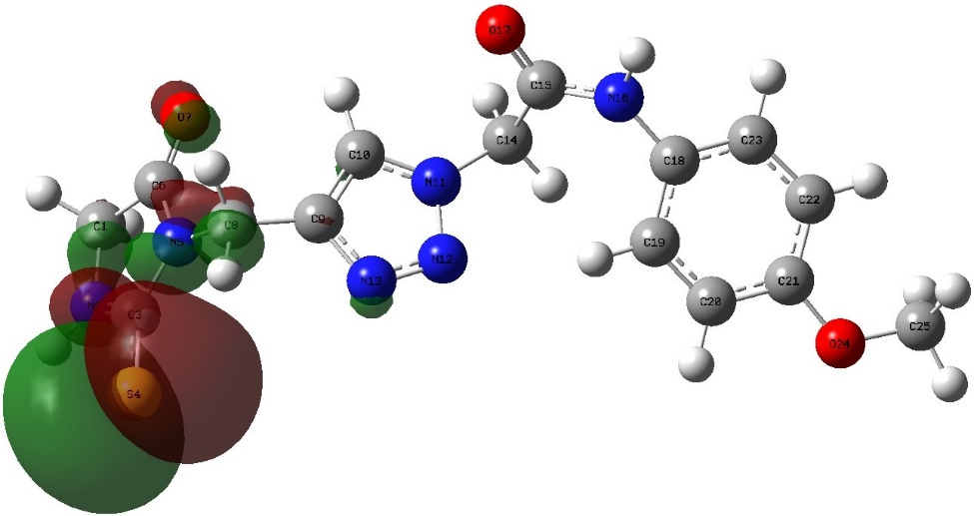 | 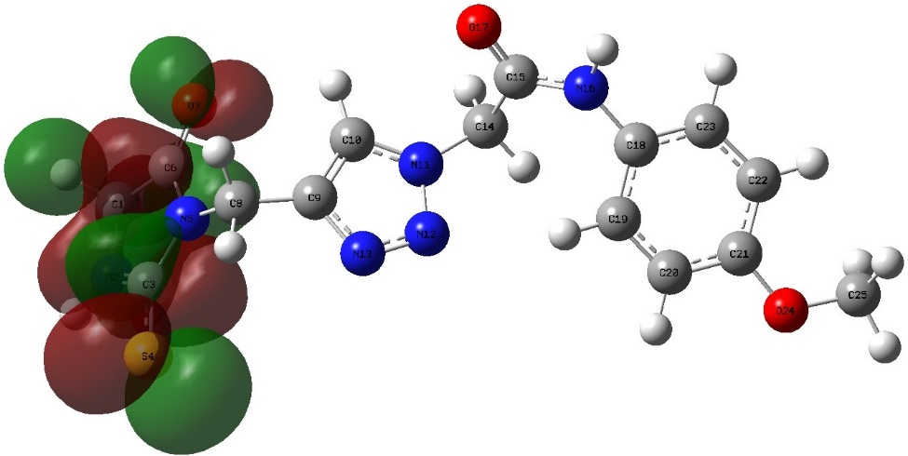
5b
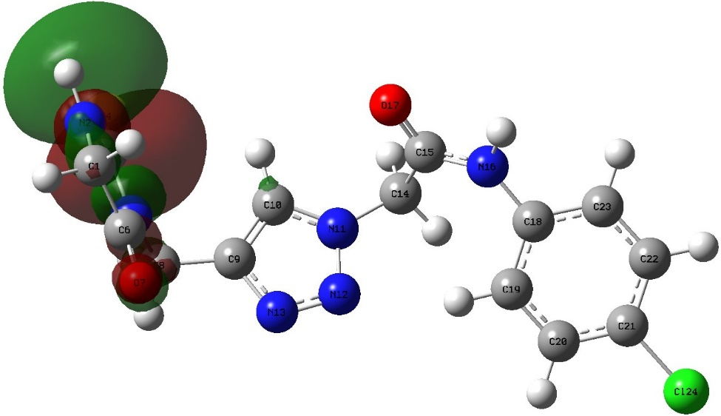 | 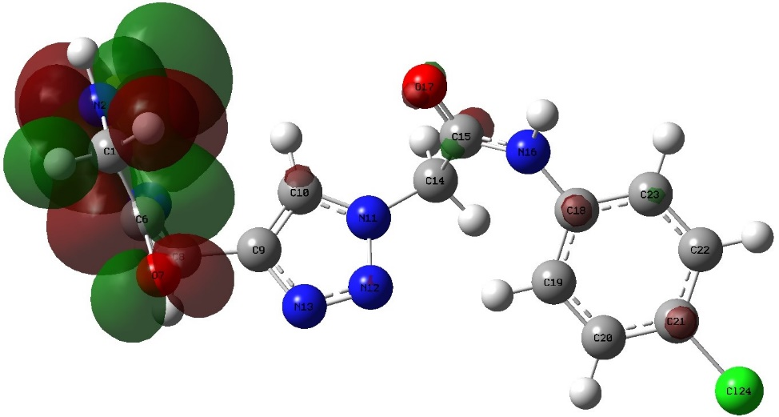
5c
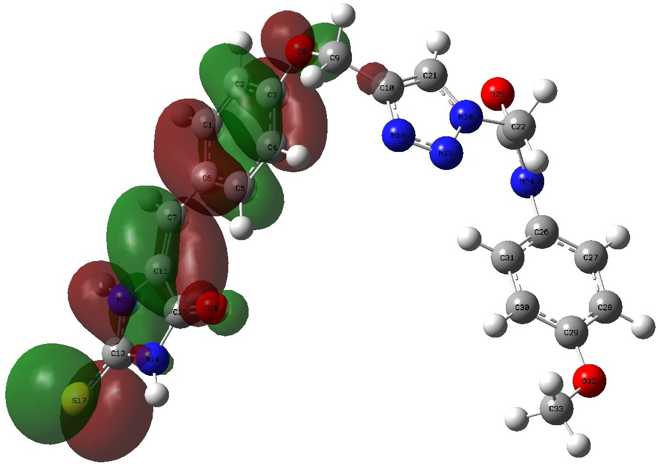 | 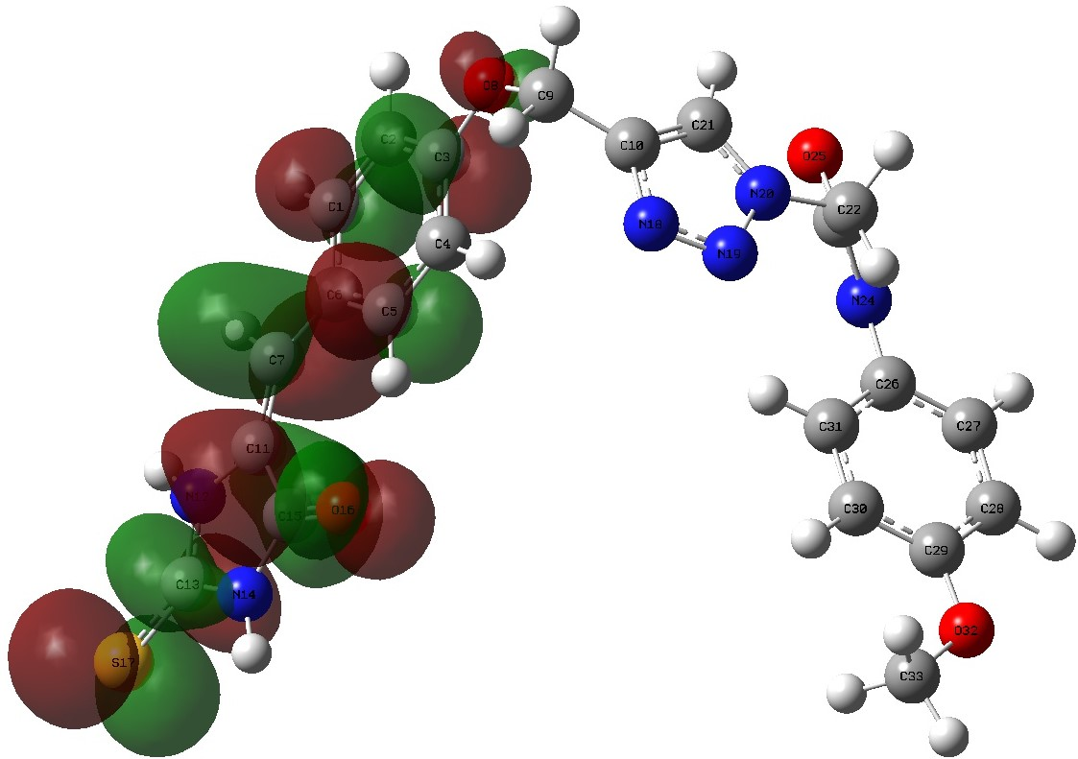
9b
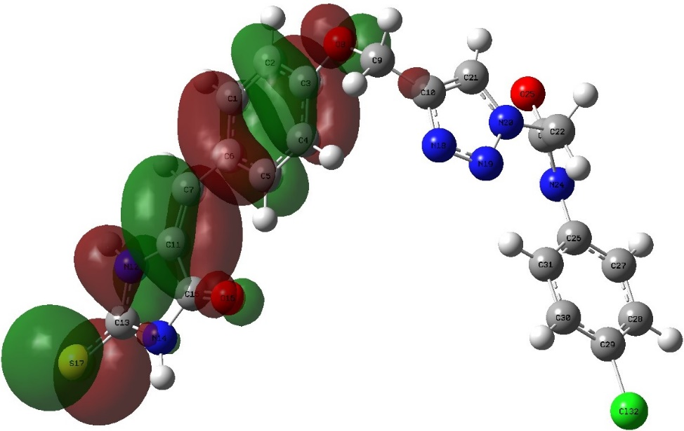 | 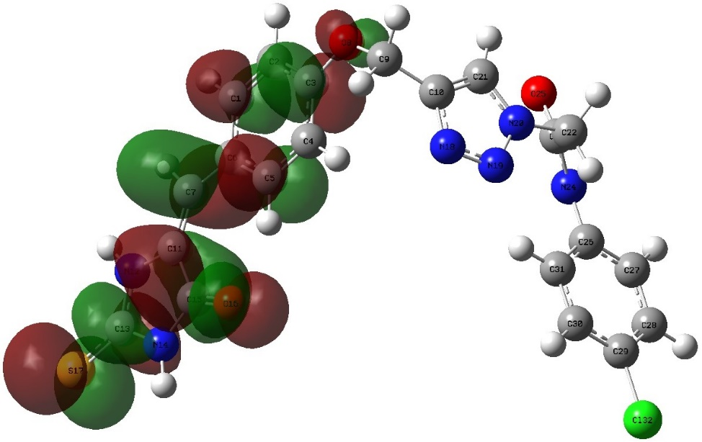
9c
Figure S1. The 3D-plot of FMO’s for compounds 5b-c, and 9b-c.

2D | 3D |  | Surface Map
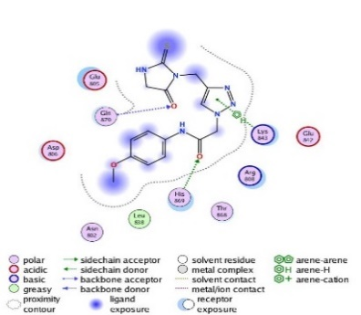 | 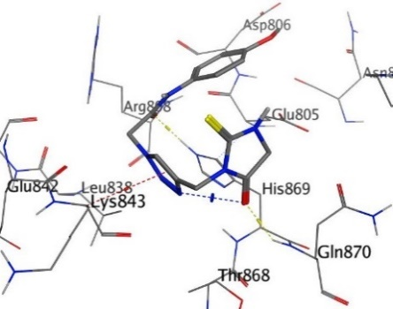 |  | 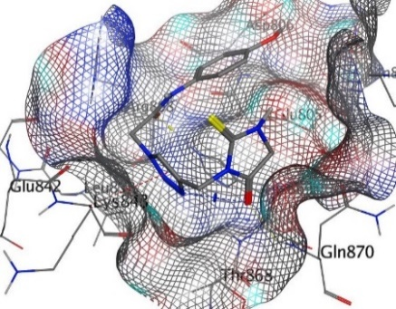
5b
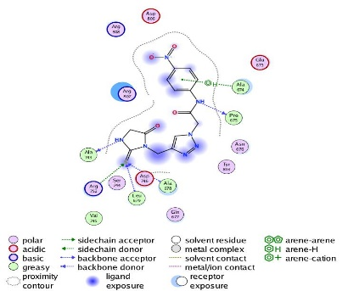 | 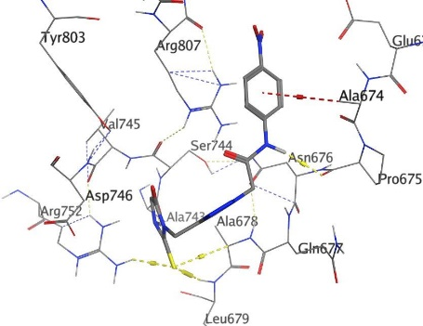 |  | 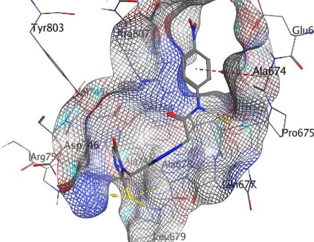
5d
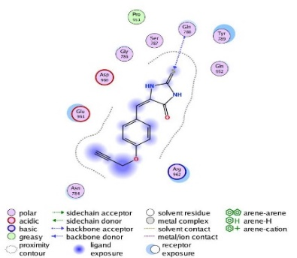 | 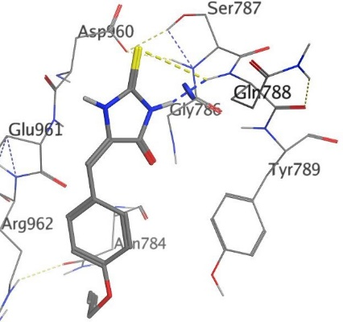 |  | 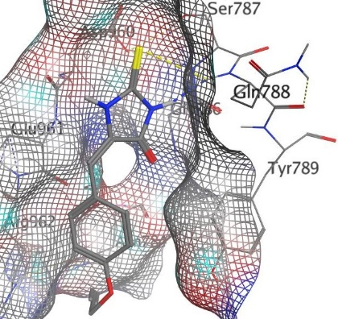
8
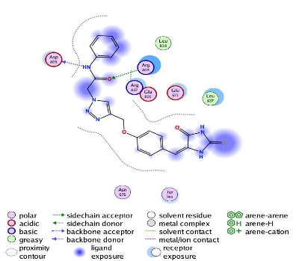 | 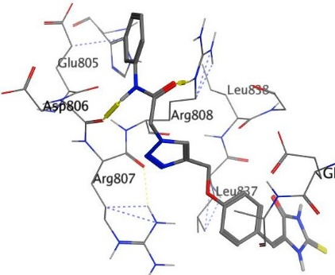 |  | 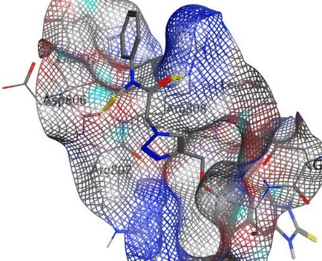
9a
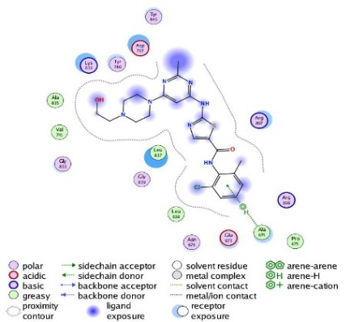 |  | 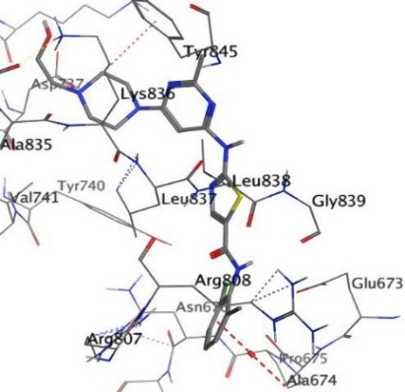 |  | 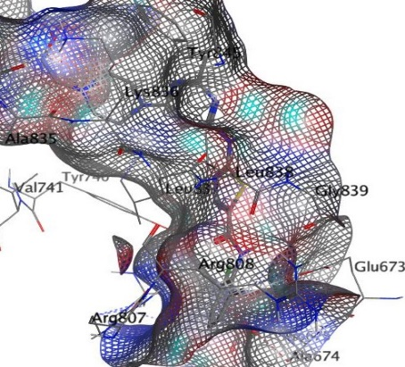
Dasatinib
Figure S2. Binding images between hybrids 5b, 5d, 8, 9a and Dasatinib with PDB: 1M17.

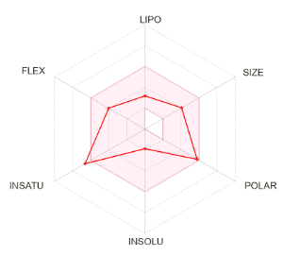 | 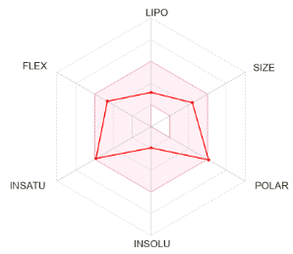 | 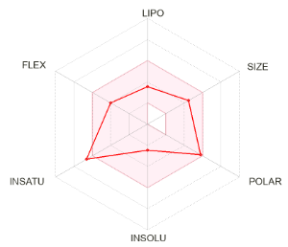 | 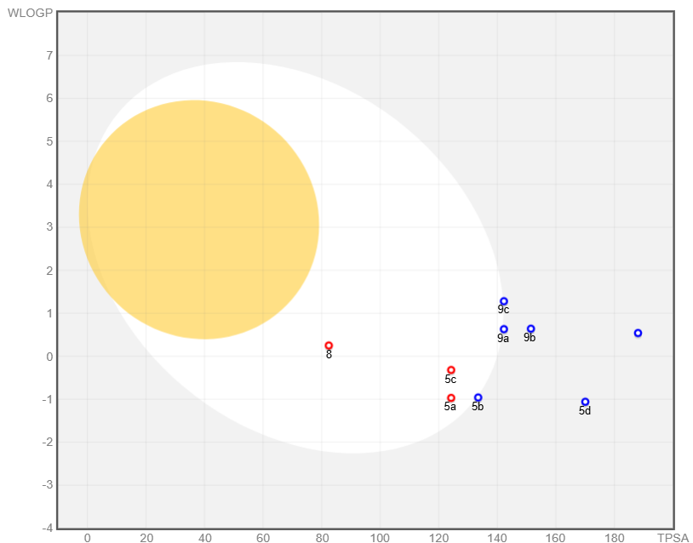
5a | 5b | 5c
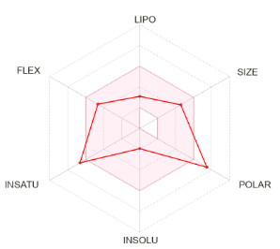 | 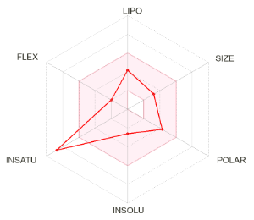 | 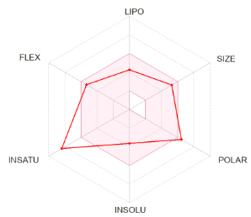
5d | 8 | 9a
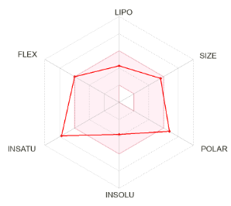 | 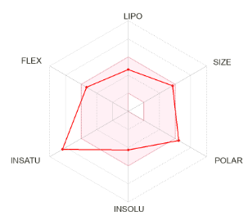 | 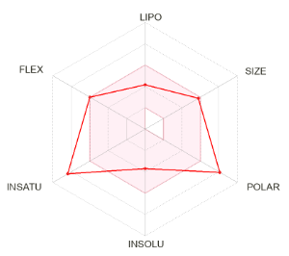
9b | 9c | 9d
Figure S3. Radar chart and boiled egg of the new thiohydantoin-triazole hybrids.

Figure S4. ¹H-NMR spectrum of compound 5a.

Figure S5. ¹³C-NMR spectrum of compound 5a.

Figure S6. ¹H-NMR spectrum of compound 5b.

Figure S7. ¹³C-NMR spectrum of compound 5b.

Figure S8. ¹H-NMR spectrum of compound 5c.

Figure S9. ¹³C-NMR spectrum of compound 5c.

Figure S10. ¹H-NMR spectrum of compound 5d.

Figure S11. ¹³C-NMR spectrum of compound 5d.

Figure S12. ¹H-NMR spectrum of compound 8.

Figure S13. ¹³C-NMR spectrum of compound 8.

Figure S14. ¹H-NMR spectrum of compound 9a.

Figure S15. ¹³C-NMR spectrum of compound 9a.

Figure S16. ¹H-NMR spectrum of compound 9b.

Figure S17. ¹³C-NMR spectrum of compound 9b.

Figure S18. ¹H-NMR spectrum of compound 9c.

Figure S19. ¹³C-NMR spectrum of compound 9c.

Figure S20. ¹H-NMR spectrum of compound 9d.

Figure S21. ¹³C-NMR spectrum of compound 9d.

